HACKUP TECHNOLOGY PVT. LTD.

INTERNSHIP: AI-Powered SOC & Digital Forensics

WEEK 3 — PROJECT REPORT

BY:

Vijitha S (24233)

B.SC.,CS(SSS)

PROJECT 5: DISK INVESTIGATION

PROJECT TITLE :
Students recover deleted files and analyze metadata using Autopsy.

Project Overview
This project is about disk investigation using Autopsy, an open-source digital forensics tool. Students learn the complete forensic process by creating a case, loading a disk image, recovering deleted files, and checking file details inside a Kali Linux virtual machine.

Objectives
- Open Autopsy and create a new investigation case
- Add a host and import a .dd disk image file
- Analyze folders, files, and file system information
- Recover deleted files and check their properties
- Perform keyword searches using ASCII and Unicode
- Generate MD5 hashes to verify file integrity

Tools & Environment
- Tool: Autopsy
- Operating System: Kali Linux inside Oracle VirtualBox
- Disk Image: test4.dd (5.1 MB ext2 partition image)
- Commands Used: sudo autopsy, dd, mkfs.ext2

Key Concepts
- File Carving: Recovering deleted files from unused disk space
- Metadata Analysis: Checking timestamps, inode details, and file information
- Hash Database: Using MD5 hashes to verify file integrity
- Keyword Search: Finding text using ASCII and Unicode search methods
- Evidence Locker: Secure storage location used by Autopsy at /var/lib/autopsy
Step-by-Step Procedure
Step 1: launch Autopsy
- Open Terminal in Kali Linux
- Type the command: sudo autopsy
- Autopsy starts on port 9999
- Open a web browser
- Go to: http://localhost:9999/autopsy
- The Forensic Browser interface opens

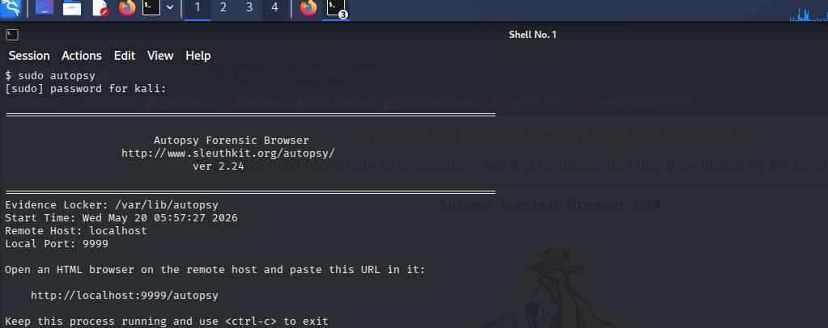

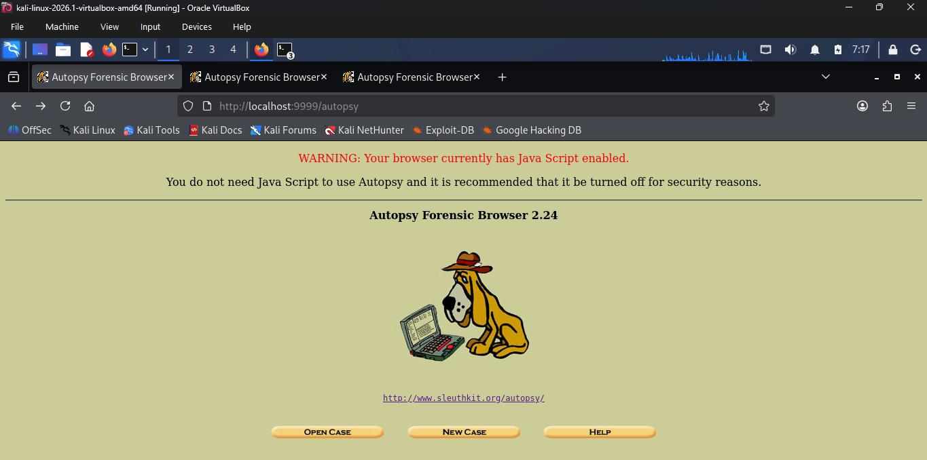

Step 2: Create a New Case
Open Autopsy home screen and click “New Case”. Enter the case name as pro105, add an optional description, and type the investigator name. Then create the case. Autopsy will create the case folder and configuration file in /var/lib/autopsy/pro105/.
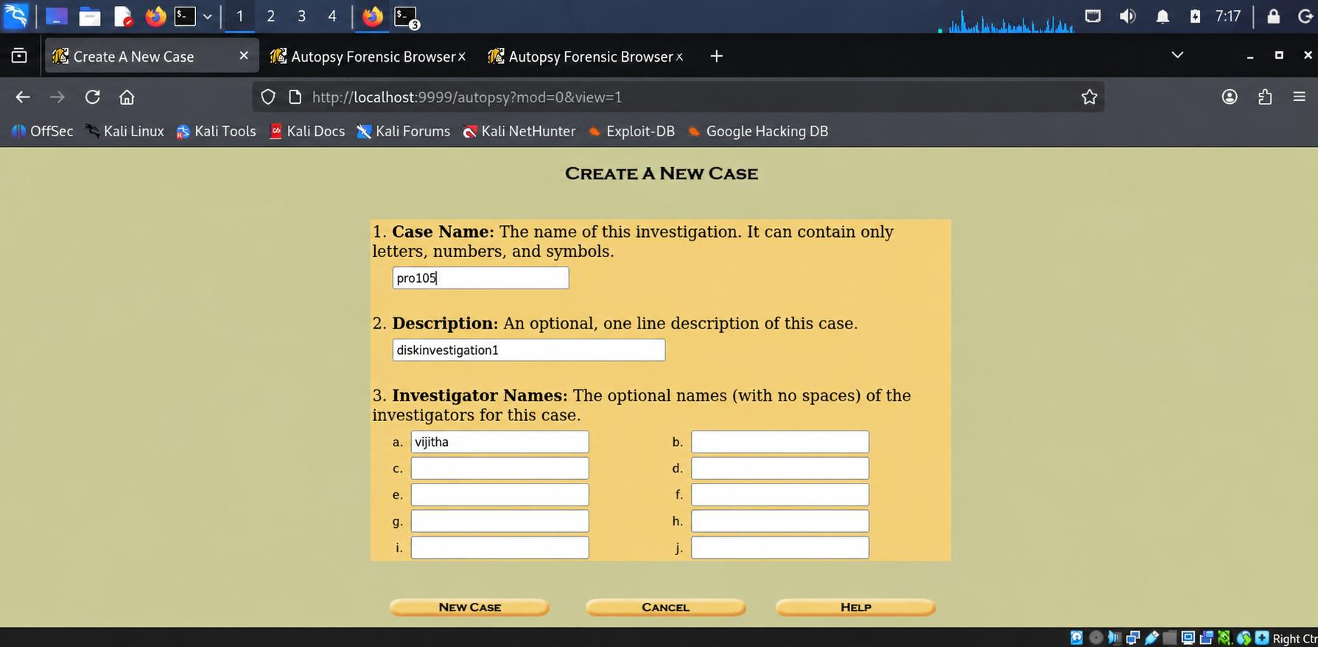
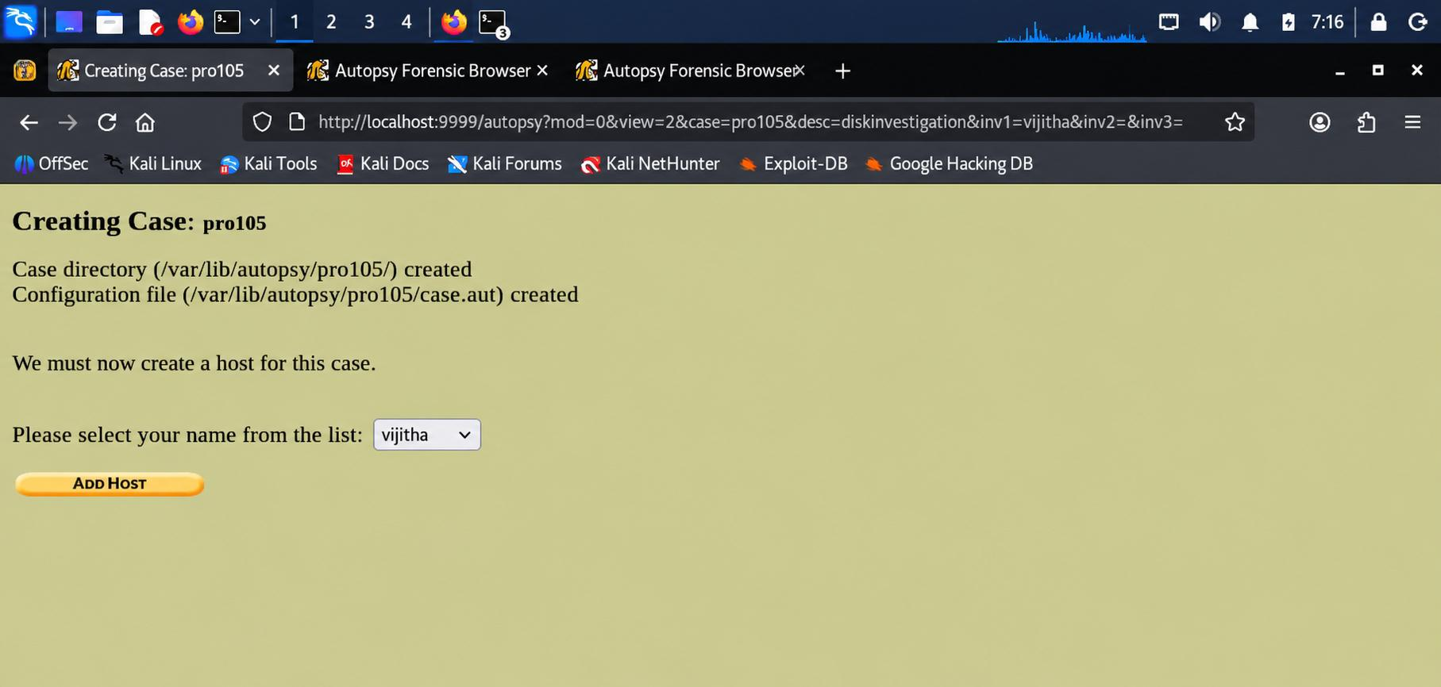

Step 3: Add a Host
A host means the computer being investigated. Enter the host name as host1. You can also set the timezone if needed. Autopsy creates a host folder inside the case folder.
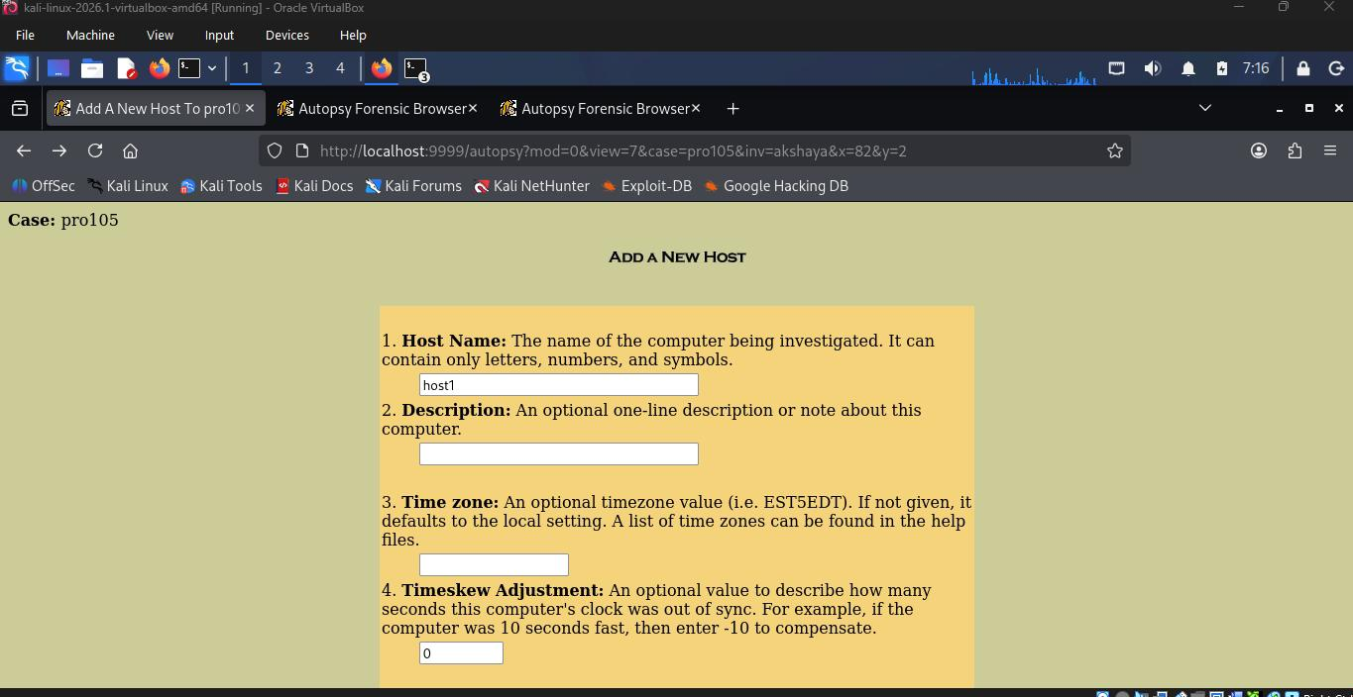
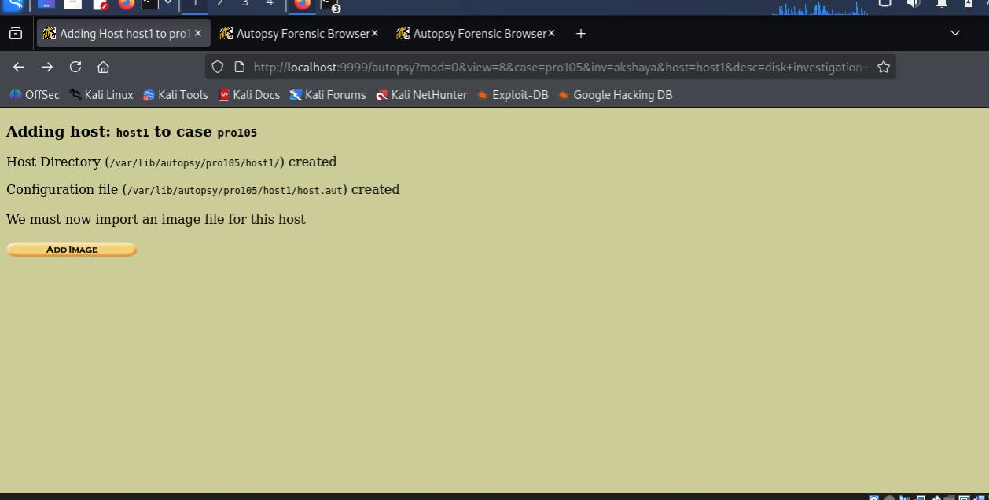

Step 4: Add a Disk Image
Create a test disk image using the dd and mkfs.ext2 commands in terminal. Then open Autopsy and enter the image file path /root/image.dd. Select Partition as the type and choose Symlink so the image file will not be copied.
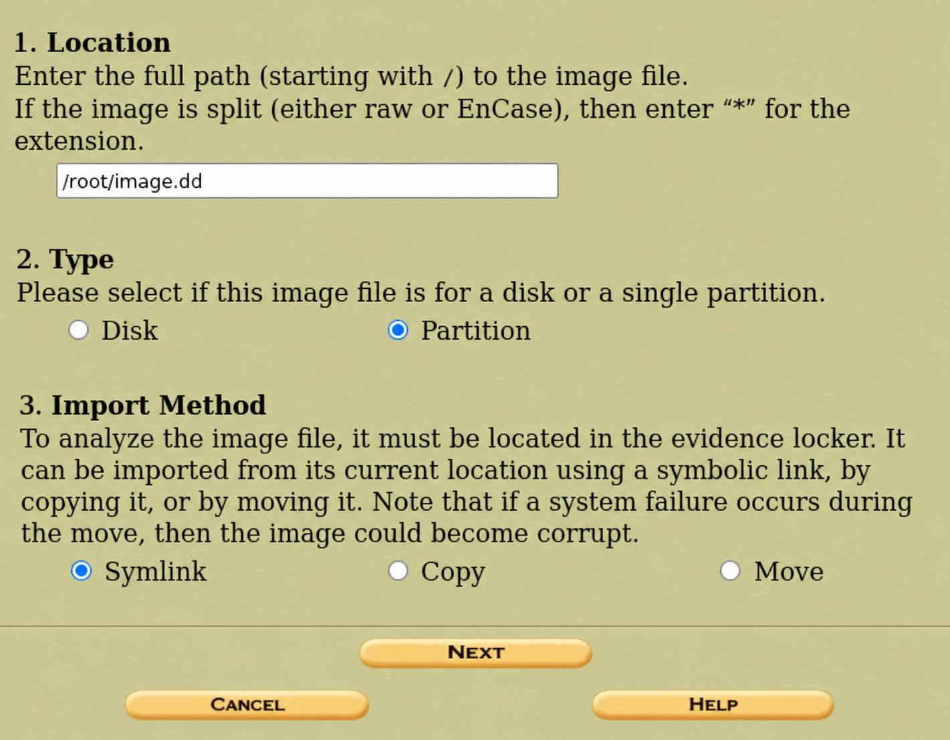
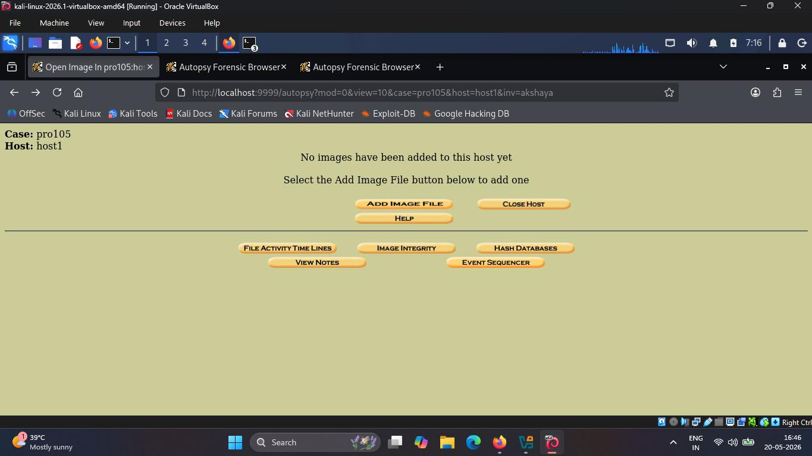

Step 5: Create the Disk Image
Terminal commands were used to create a 5.1 MB disk image file and format it with the ext2 file system before adding it to Autopsy.
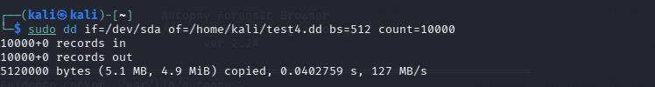
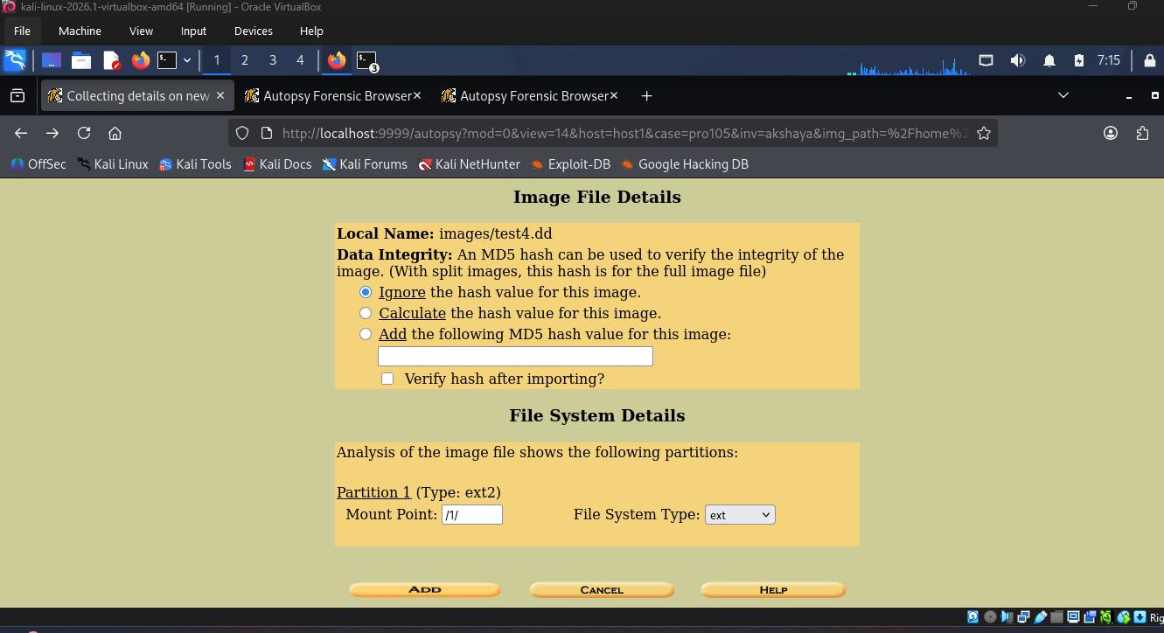

Step 6: Image Details and Verification
Autopsy reads the disk image and finds the ext2 partition. It can also create or check the MD5 hash to verify file integrity. The file system details are checked before analysis starts.
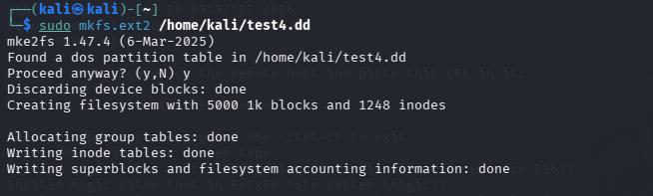

Step 7: Analyze the File System
Click Analyze after importing the image. The File Analysis tab opens and shows file details like file name, type, size, timestamps, UID, GID, and inode number.
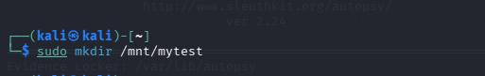

Step 8: Browse Directories
Use the Directory Seek panel to open folders like $OrphanFiles to view deleted or orphan files. Some deleted files may show errors because part of the data was overwritten.
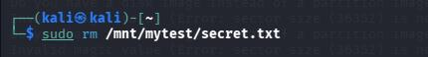
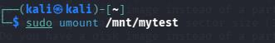

Step 9: File Name and Keyword Search
Autopsy has a Keyword Search option to search text inside the disk image using ASCII or Unicode. The results show where the keyword was found.

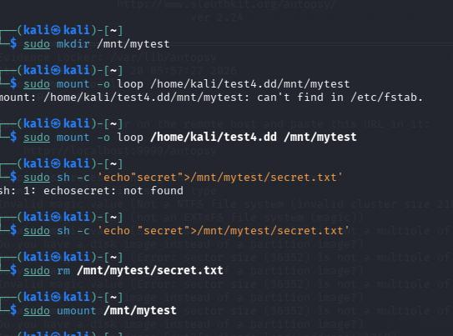

Step 10: Additional Analysis Tabs
Autopsy also has tools like Timeline, Image Integrity, Hash Database, Notes, and Event Sequencer. These help in checking file activity and investigation details.
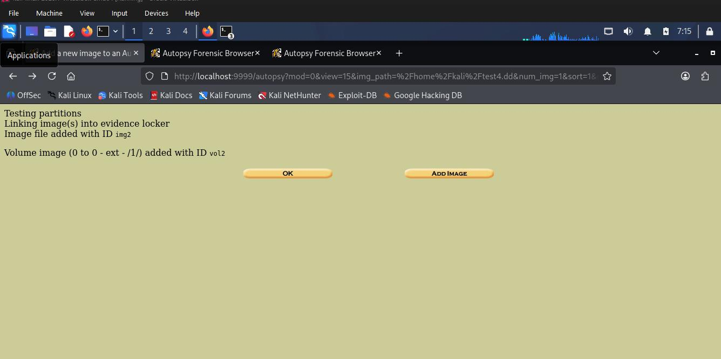

Step 11: File System Details
Autopsy shows information like Volume ID, last written time, source operating system, and ext2 file system details. This confirms the image was created on a Linux system.
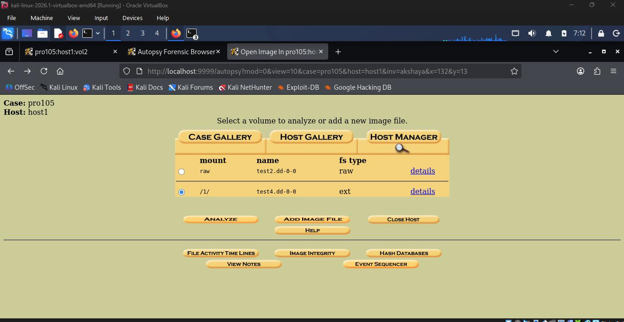
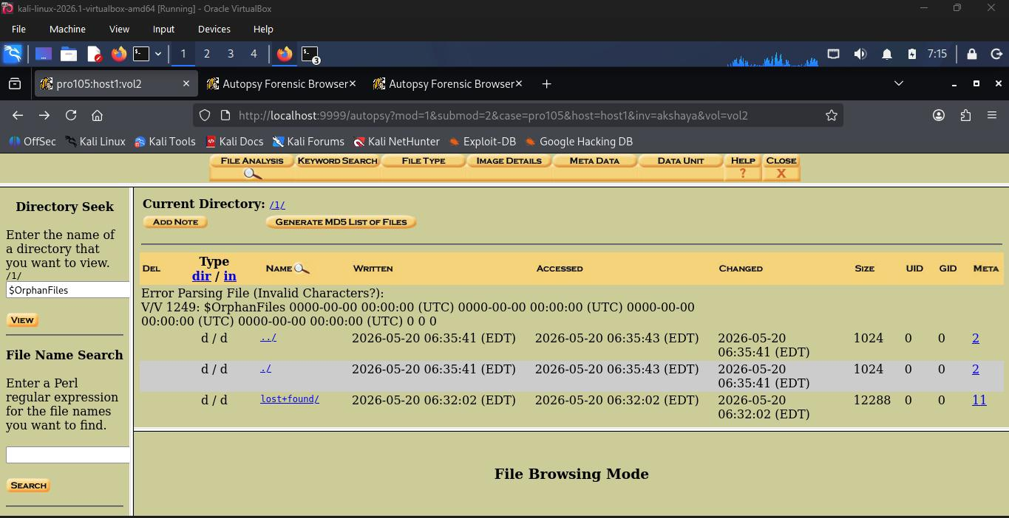

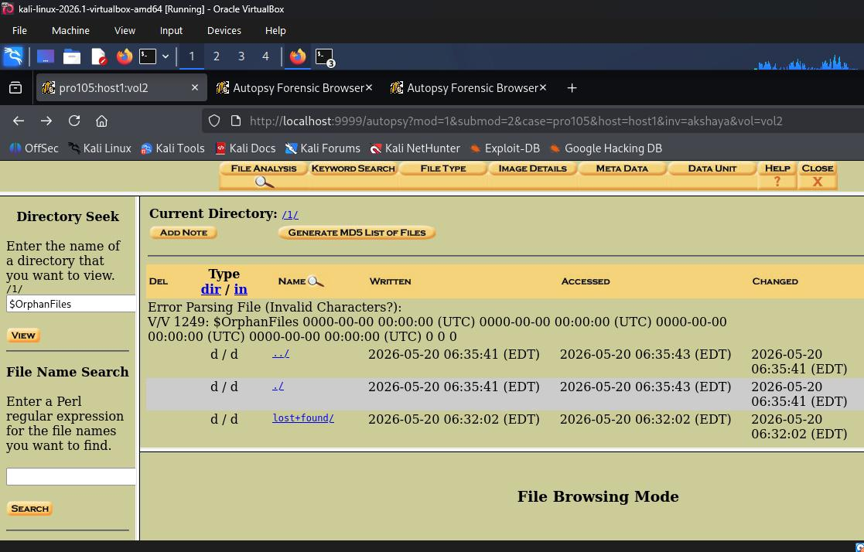

Additional Screenshots
The following screenshots document additional steps and analysis views captured during the investigation.
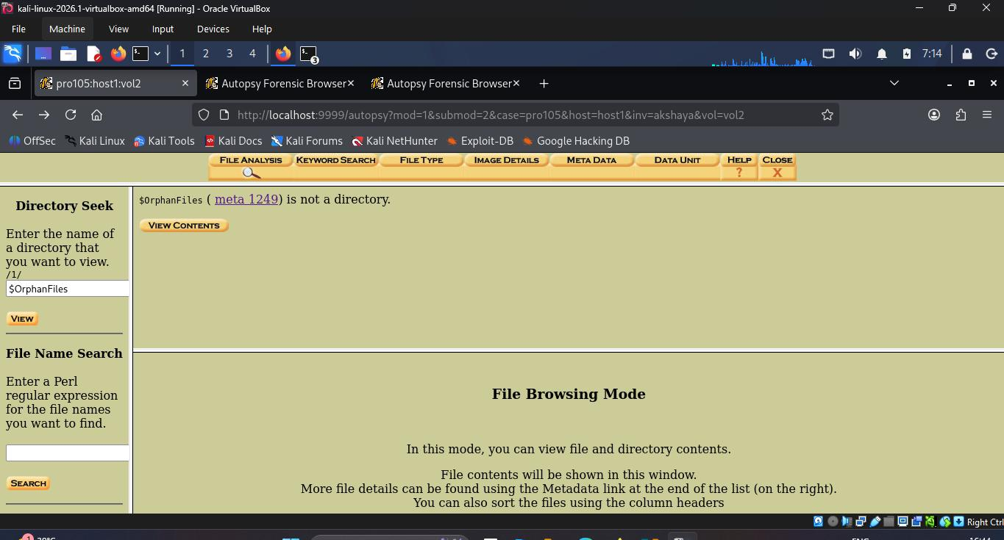
File Analysis view — file browsing with directory structure

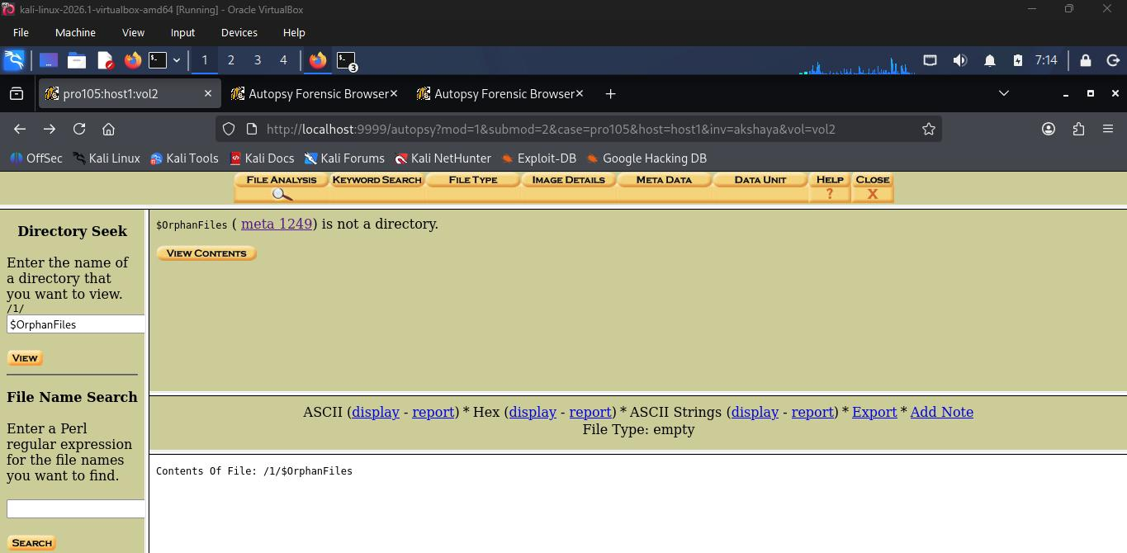
File Analysis — browsing file entries with complete metadata
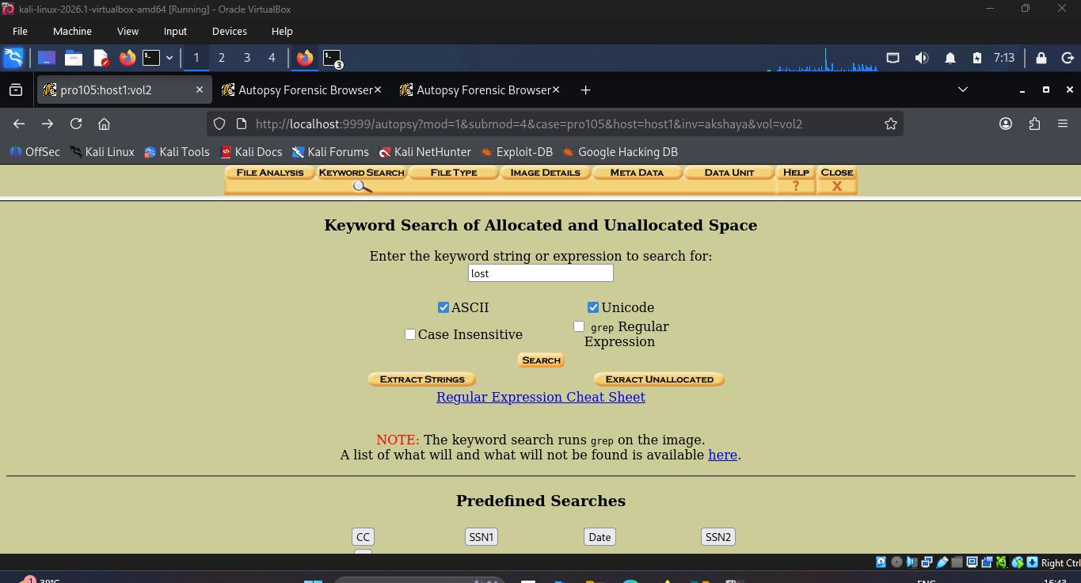
File Analysis — examining specific file attributes and timestamps

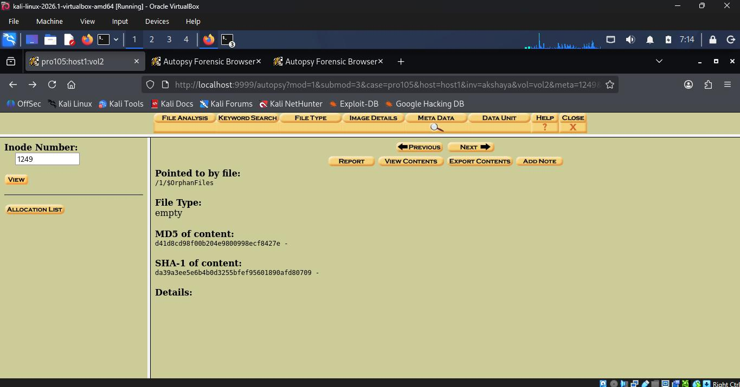
File Analysis — additional directory contents
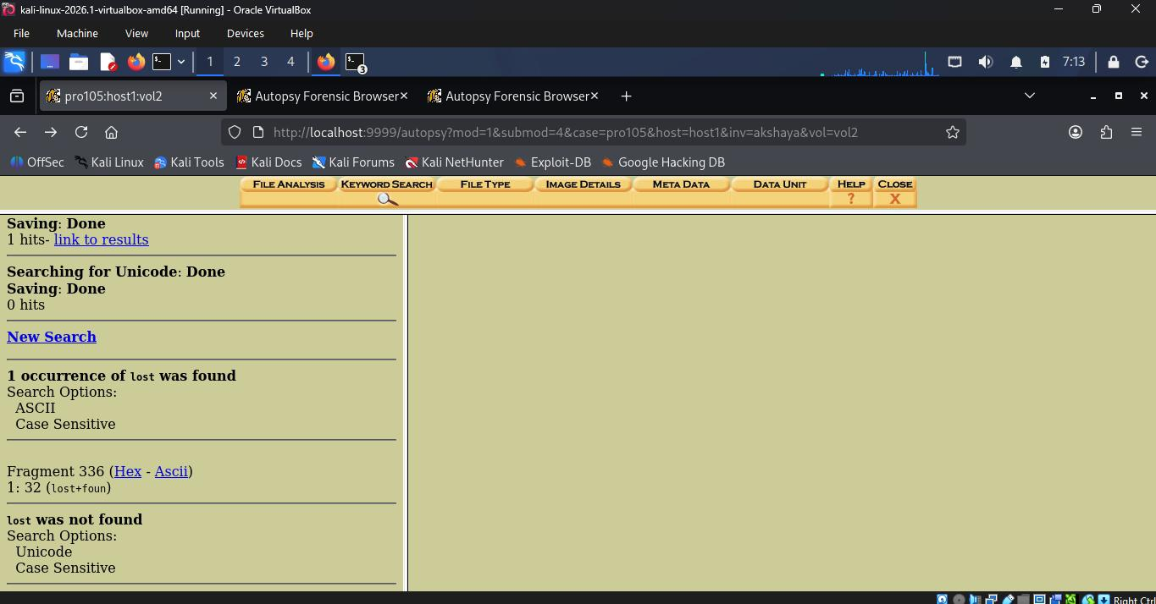
File Analysis — file listing with size and inode information
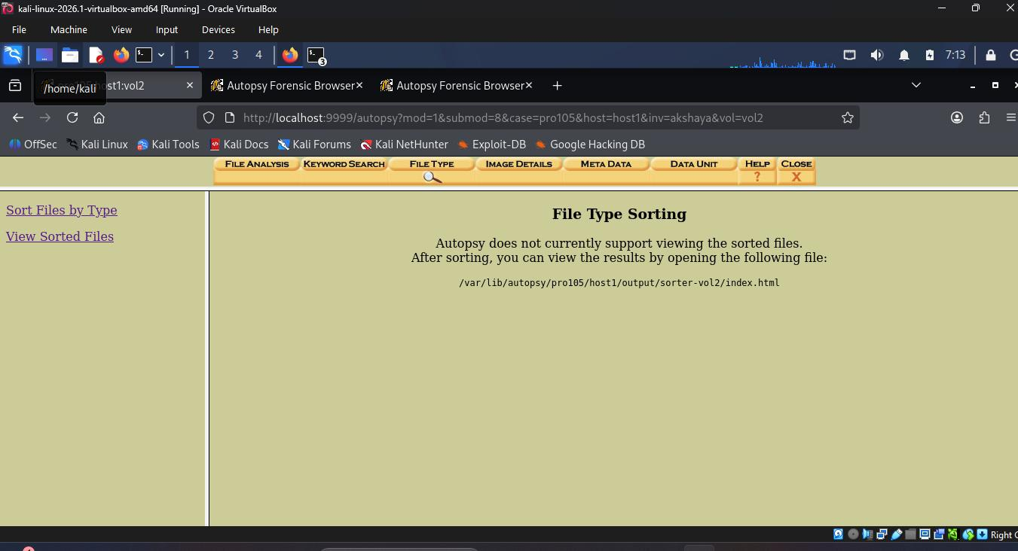
File Analysis — browsing deeper directory levels
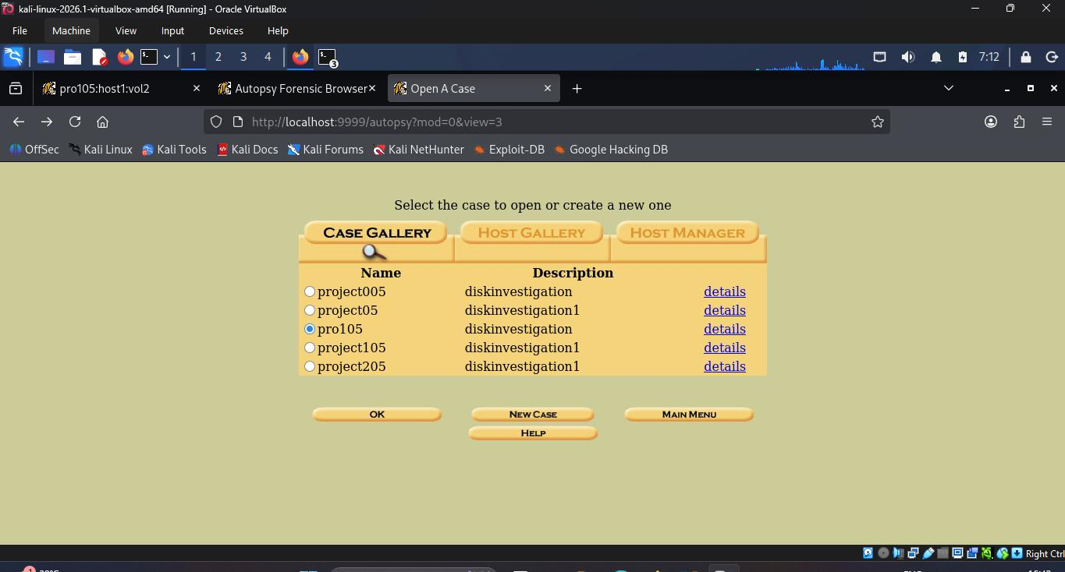
Keyword search results and file content analysis
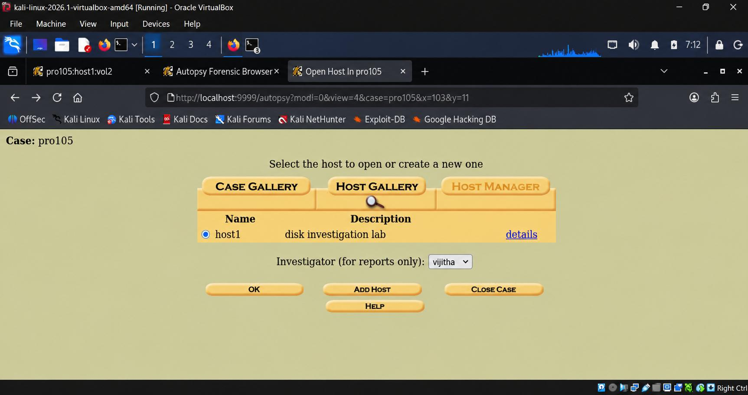
Additional analysis view in Autopsy
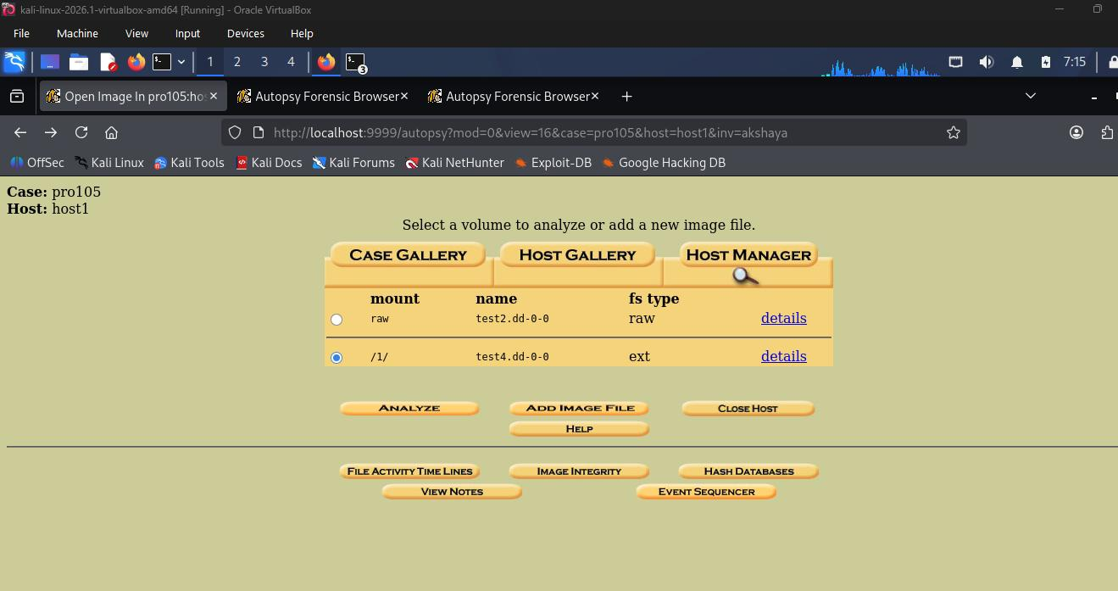
File browsing — additional metadata inspection
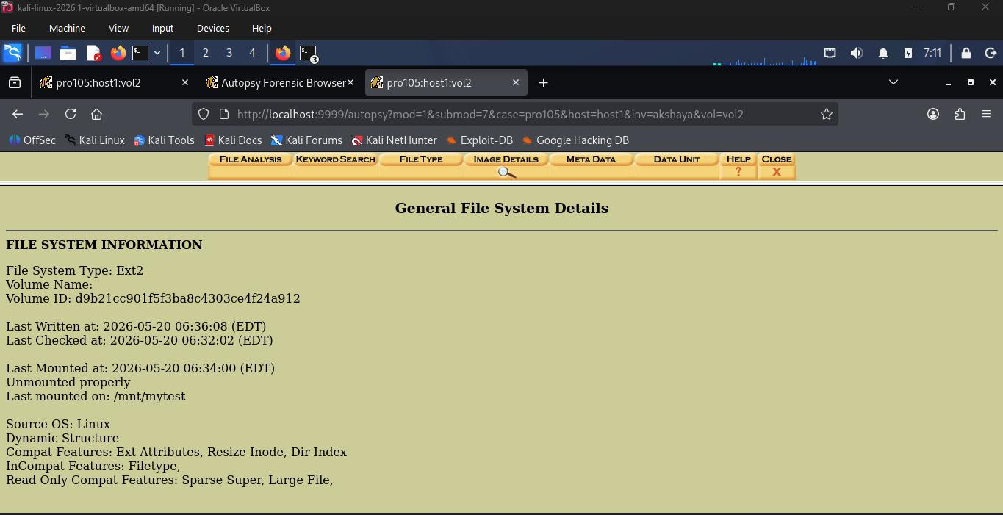
Analysis results summary view
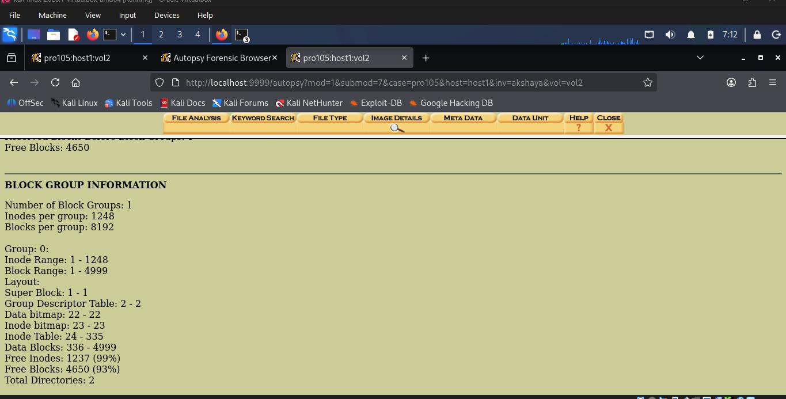
Final analysis view — complete investigation results
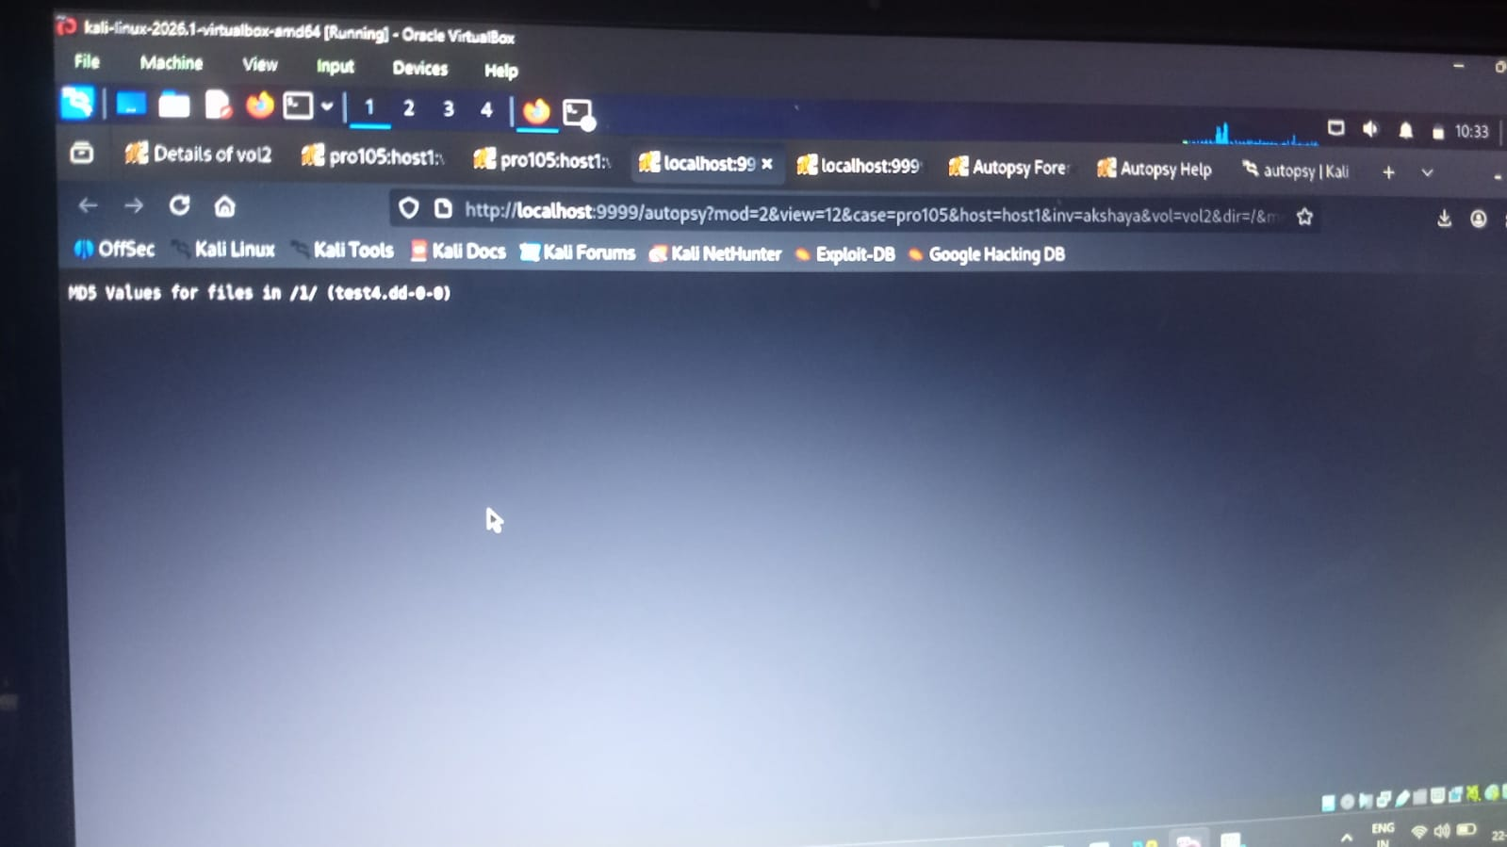
File system summary and analysis completion
Conclusion
This project explained the complete forensic investigation process using Autopsy on Kali Linux. Main tasks completed in this project are:
• Successfully launched Autopsy and created a forensic case (pro105)
• Created a 5.1 MB ext2 disk image using dd and mkfs.ext2
• Imported the disk image into Autopsy and analyzed the ext2 file system
• Checked file and folder metadata such as write, access, and change timestamps
• Found deleted and orphan files in the $OrphanFiles directory
• Performed keyword searches using ASCII and Unicode
• Verified file system details and confirmed Linux origin and disk integrity
Autopsy is an easy and useful tool for digital forensic investigation. It helps investigators analyze file systems, recover deleted files, and search disk contents. This project also showed the importance of evidence protection, hash verification, and proper forensic documentation.

