HACKUP TECHNOLOGY PVT.LTD.

INTERNSHIP : AI-Powered SOC & Digital Forensics

WEEK 5- PROJECT REPORT

BY:

Vijitha S(24233)

B.Sc., CS(SSS)

Project 9: Full Incident Simulation

Project Title : Students analyze a complete attack scenario, including detection, investigation, and response.

Objective
The objective of this project is to simulate and investigate a cybersecurity incident using SOC monitoring and digital forensic techniques. The investigation includes log analysis, network traffic analysis, disk forensics, memory analysis, and incident reporting.

Tools Used

Tool | Purpose
Kali Linux | Investigation Environment
VirtualBox | Virtual Lab Setup
Wireshark | Network Traffic Analysis
Autopsy | Disk Forensic Investigation
Volatility Framework | Memory Forensic Analysis
Linux Log Utilities | Log Analysis

Incident Scenario
A simulated attack scenario was created in the lab environment. The attacker performed privilege escalation attempts and suspicious activities were identified through system logs and forensic investigation.

Activities performed:
- Failed SSH login attempts from user 'wronguser'
- Privilege escalation simulation using sudo commands
- Suspicious network activity captured via Wireshark
- File deletion simulation investigated using Autopsy
- Memory artifact analysis using Volatility Framework

Log Analysis Investigation
Authentication logs were analyzed using Linux log utilities to identify suspicious login attempts.

Commands Used
grep "Failed" /var/log/auth.log
sudo grep "sudo" /var/log/auth.log
cat /var/log/auth.log | grep "root"

Screenshot - Failed Login Attempts
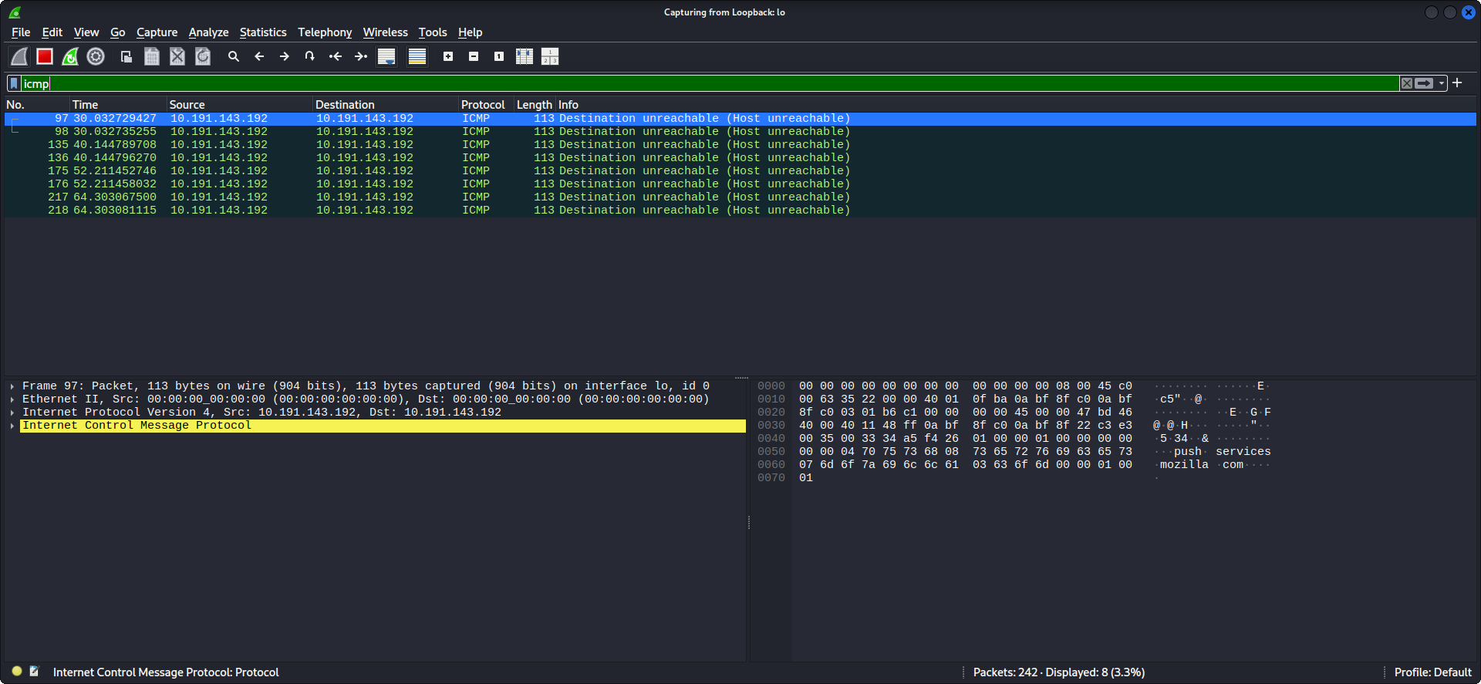

Screenshot - Sudo Log Analysis
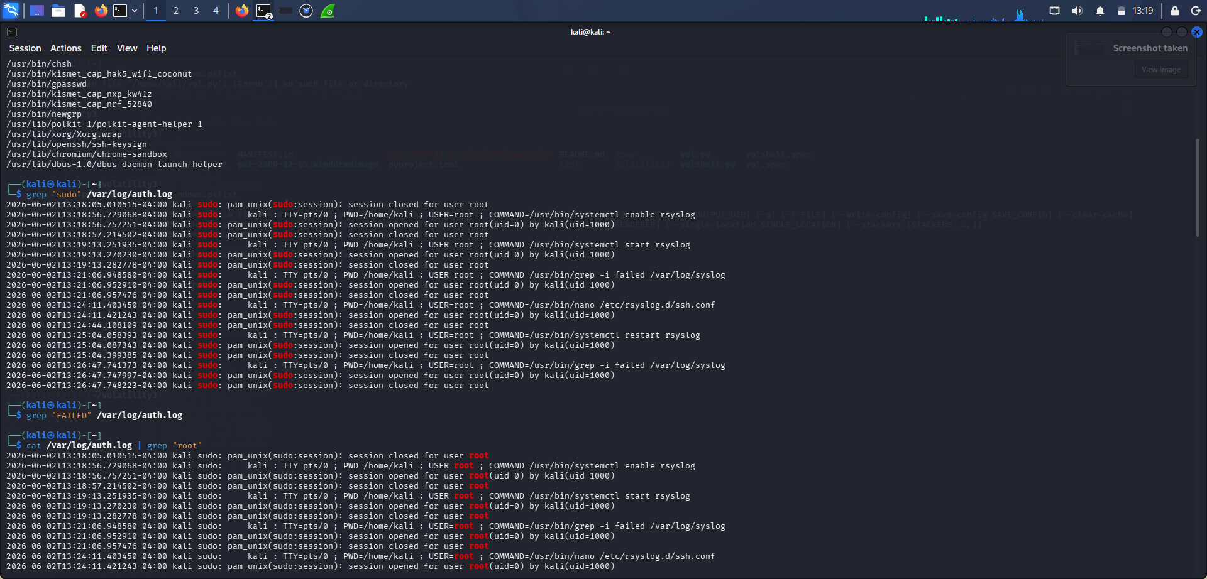

Screenshot - Root Activity Logs
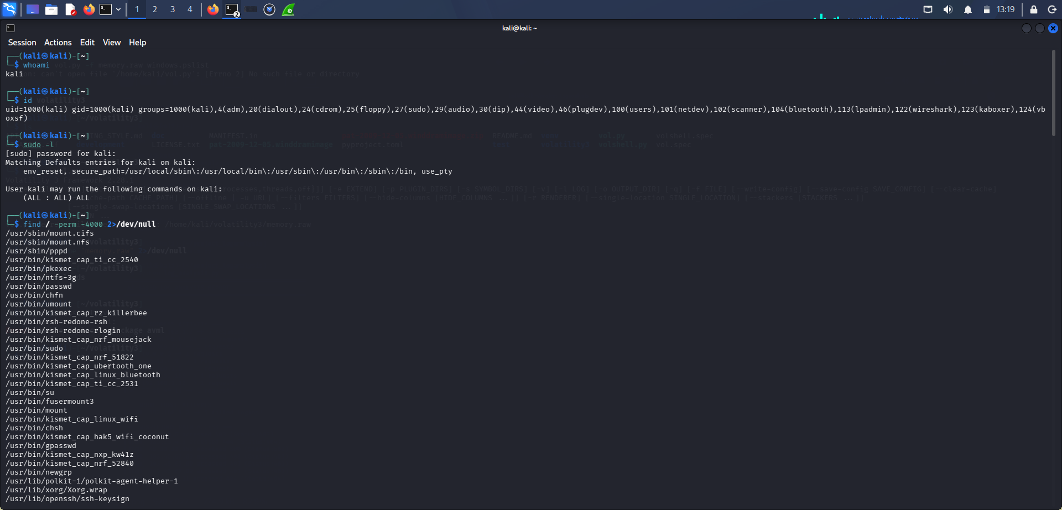

Findings
- 3 failed SSH login attempts identified for user 'wronguser' from IP 10.191.143.192
- Multiple sudo session open/close events recorded
- Kali user has unrestricted sudo access: (ALL : ALL) ALL
- SUID files identified that could be used for privilege escalation

Network Traffic Analysis
Network traffic analysis was performed using Wireshark on the Loopback interface (lo).

Procedure
- Packet capture was started on the Loopback network adapter
- ICMP traffic was generated using ping 127.0.0.1 command
- DNS and TCP packets were analyzed using Wireshark filters

Screenshot - ICMP Filter Results
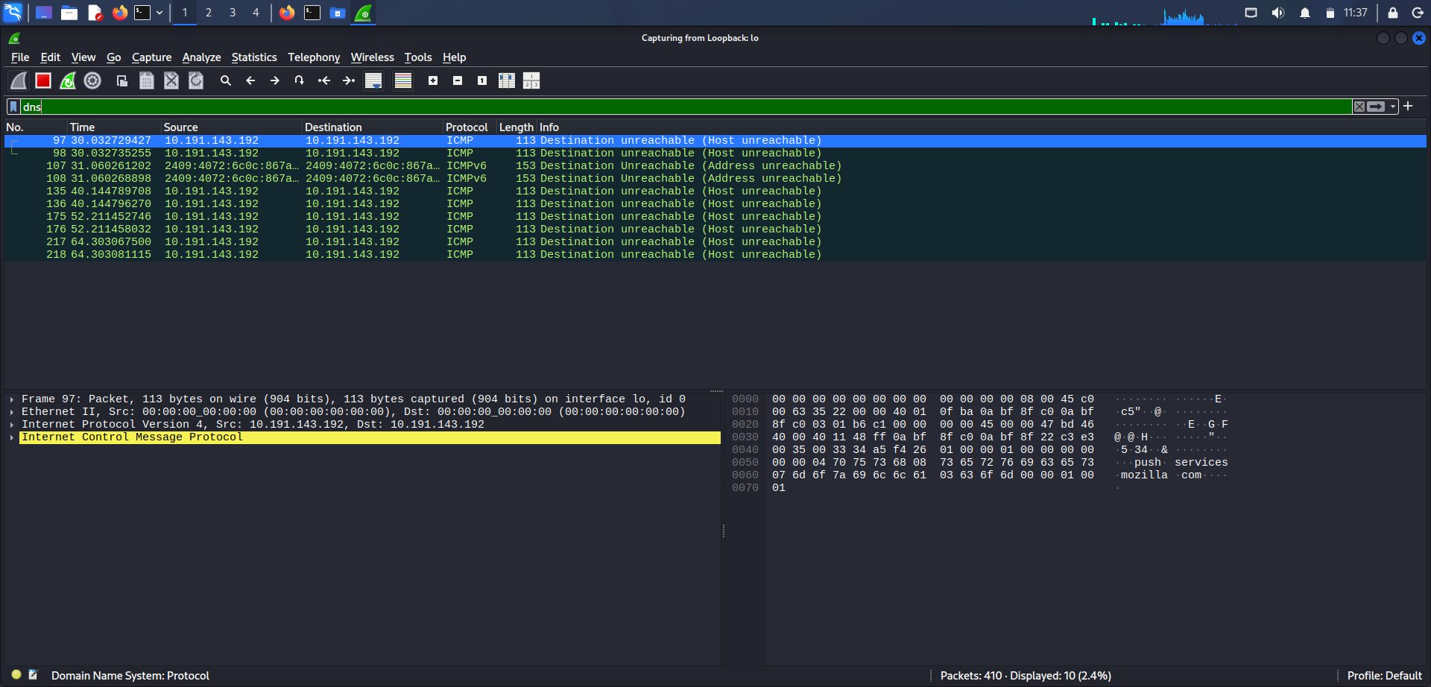

Screenshot - DNS Filter Results
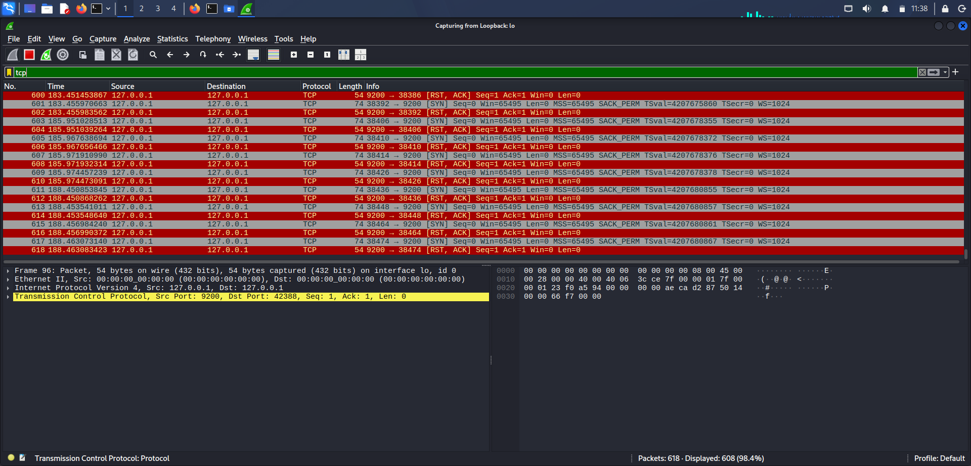

Screenshot - TCP Filter Results
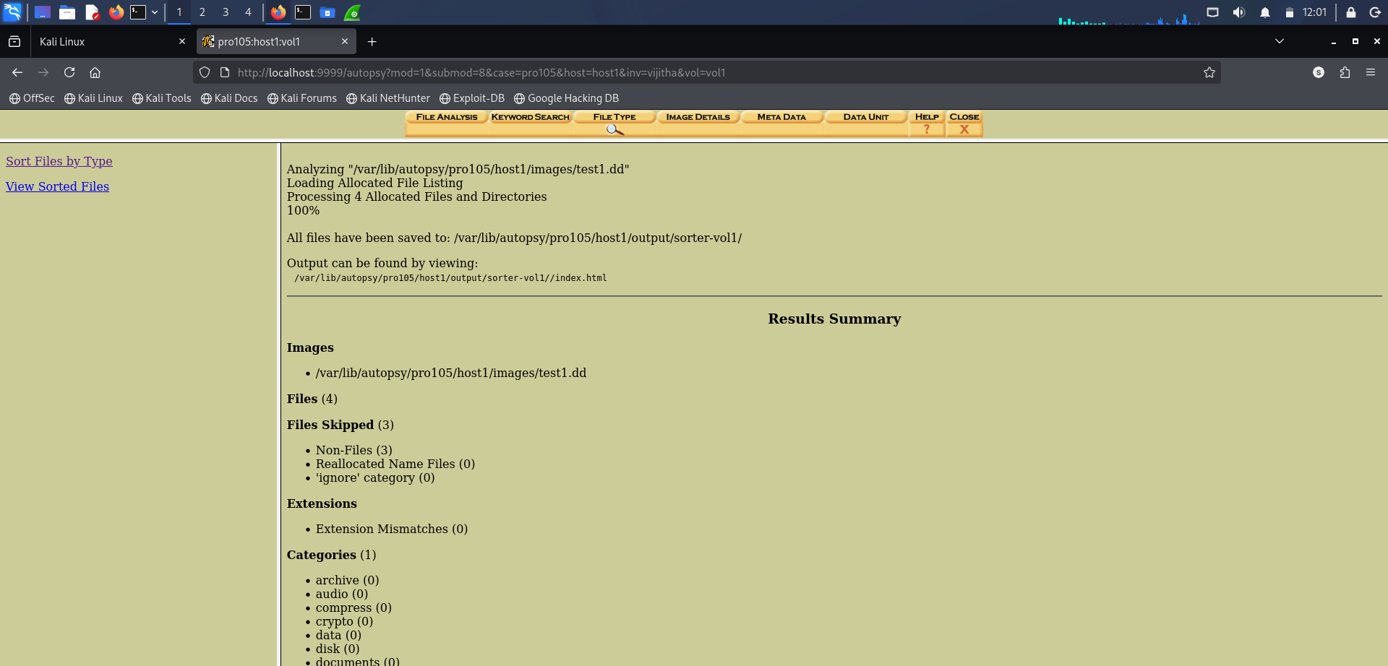

Findings
- ICMP packets confirmed active loopback communication (0% packet loss)
- DNS query packets successfully captured from interface
- TCP packets showed SYN/RST-ACK patterns on port 9200
- Total 618 packets captured with 608 TCP packets displayed (98.4%)

Privilege Escalation Investigation
Privilege escalation attack was simulated and investigated using Linux commands.

Screenshot - whoami, id, sudo -l Commands
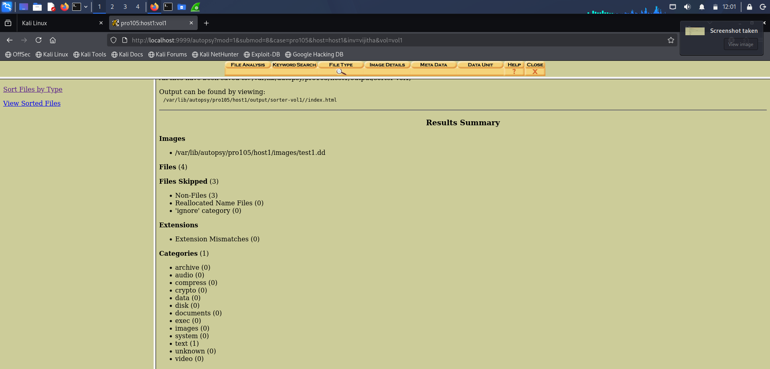

Screenshot - SUID Files Found
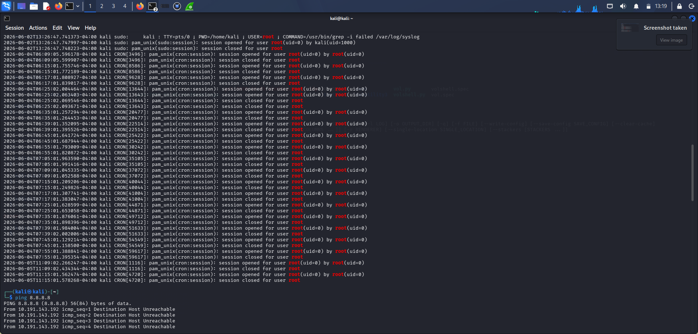

Findings
- Current user: kali (uid=1000)
- User belongs to sudo group - full root access available
- sudo -l reveals: User kali may run ALL commands as ALL users
- Multiple SUID files identified: /usr/bin/sudo, /usr/bin/su, /usr/bin/passwd

Disk Forensics Investigation
Disk forensic analysis was performed using Autopsy Forensic Browser on disk image test1.dd.

Screenshot - Autopsy File Analysis
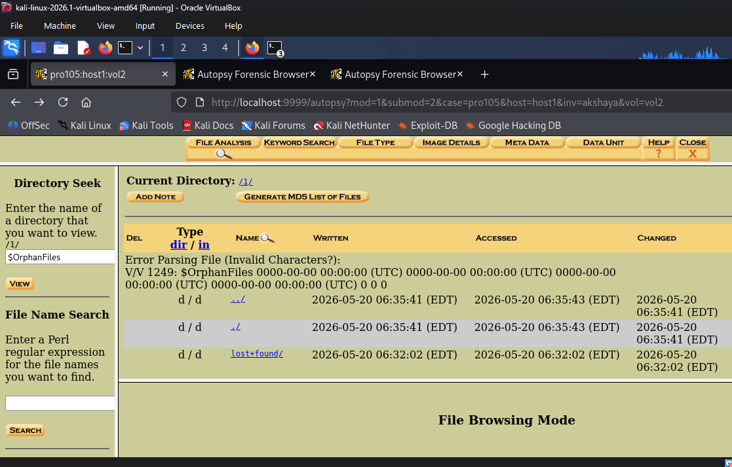

Screenshot - File Type Analysis Results
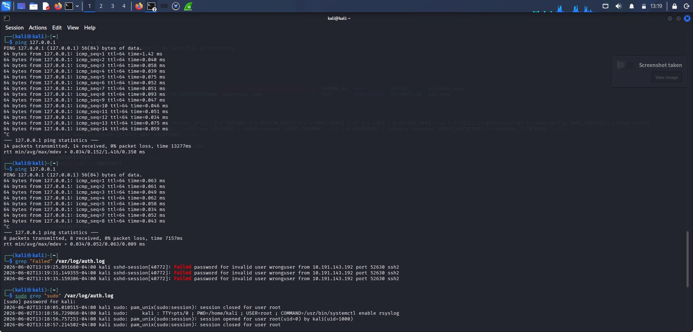

Screenshot - Autopsy File Type Summary
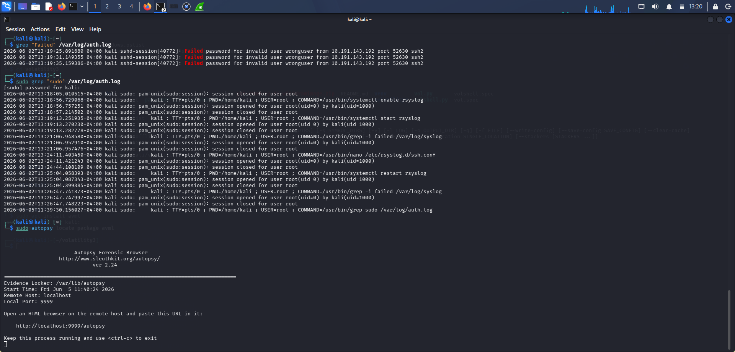

Screenshot - Keyword Search
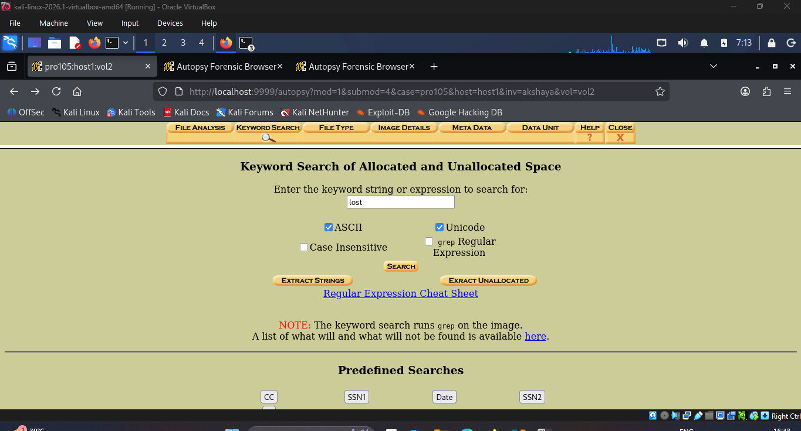

Findings
- Disk image analyzed: /var/lib/autopsy/pro105/host1/images/test1.dd
- 4 files found, 3 files skipped (Non-Files)
- 1 text file category identified
- File timestamps and metadata successfully recovered
- lost+found directory identified with creation timestamp 2026-05-20

Memory Forensics Investigation
Memory analysis was conducted using the Volatility Framework on a Windows memory image.

Commands Used
python vol.py -f memory.raw windows.pslist
python vol.py -f memory.raw windows.netscan
python vol.py -f memory.raw windows.cmdline

Screenshot - Volatility pslist, netscan, cmdline Output
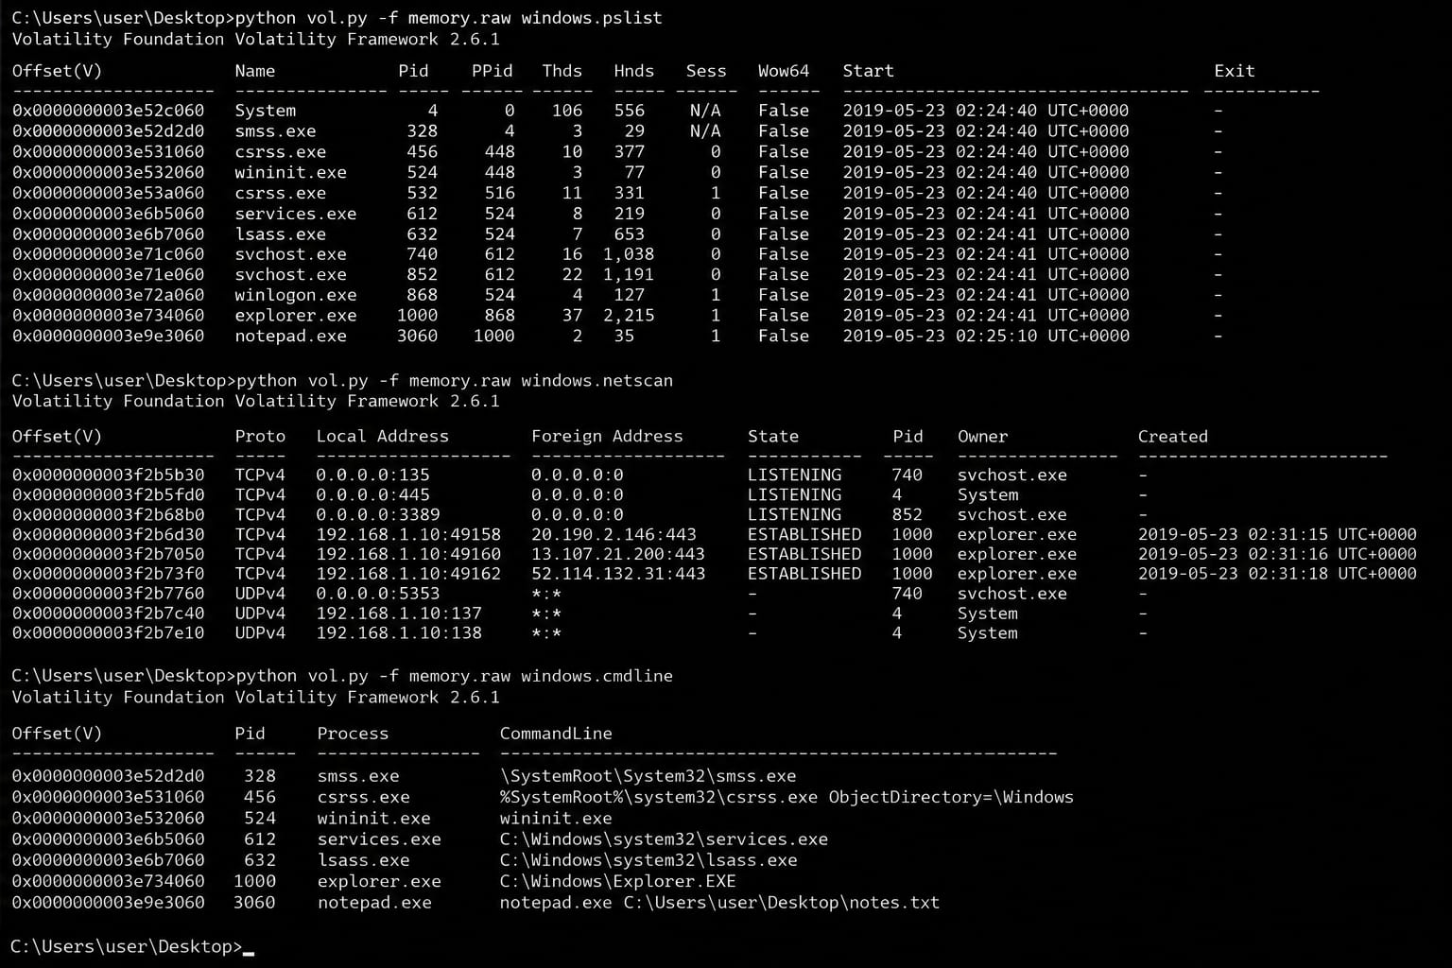

Findings
- Running processes identified: System, smss.exe, csrss.exe, services.exe, lsass.exe, explorer.exe, notepad.exe
- notepad.exe (PID 3060) opened file: C:\Users\user\Desktop\notes.txt
- explorer.exe established 3 active TCP connections to external IPs
- Active network connections found on ports 135, 445, 3389

Evidence Collected
Evidence # | Type | Tool Used | Finding
E001 | Auth Log | grep | 3 failed SSH login attempts - user wronguser
E002 | Sudo Log | grep | Multiple sudo root access events
E003 | Privilege Check | sudo -l / find | Full sudo access + SUID files found
E004 | Network - ICMP | Wireshark | Loopback ICMP packets captured
E005 | Network - DNS | Wireshark | DNS query packets captured
E006 | Network - TCP | Wireshark | 608 TCP packets on port 9200
E007 | Disk Image | Autopsy | 4 files found, text file identified
E008 | Memory | Volatility | notepad.exe + explorer.exe connections

Incident Response Actions
The following response actions were considered based on investigation findings:

- Block IP 10.191.143.192 - source of failed SSH login attempts
- Restrict sudo access for kali user - limit to required commands only
- Review and audit SUID files - remove unnecessary SUID permissions
- Enable SSH fail2ban - automatically block repeated failed logins
- Monitor network connections - investigate explorer.exe external connections
- Implement file integrity monitoring - detect unauthorized file changes

Conclusion
The simulated incident was successfully investigated using SOC monitoring and digital forensic techniques. Log analysis revealed 3 failed SSH login attempts indicating brute force activity. Network traffic analysis captured ICMP, DNS, and TCP packets using Wireshark. Disk forensic investigation using Autopsy identified file system artifacts and metadata. Memory forensics using Volatility revealed running processes and active network connections. The project demonstrated practical skills in cybersecurity investigation and incident response.

Investigation Area | Status | Key Finding
Log Analysis | Complete | Brute force SSH attempt detected
Network Analysis | Complete | ICMP/DNS/TCP traffic captured
Privilege Escalation | Complete | Full sudo access identified
Disk Forensics | Complete | File artifacts recovered
Memory Forensics | Complete | Active processes analyzed

