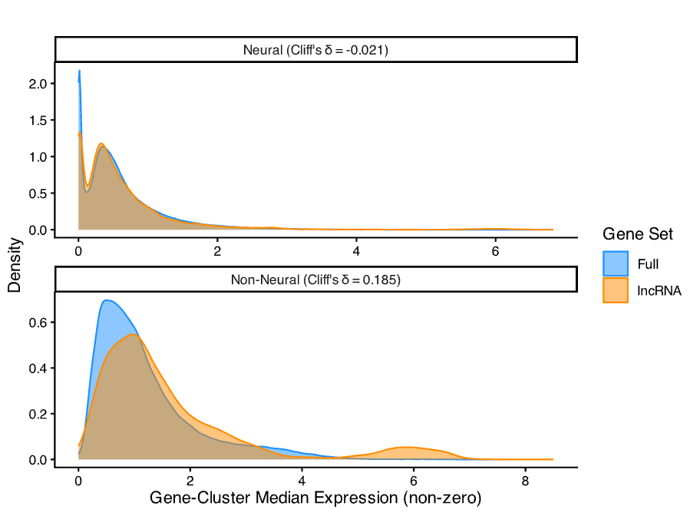
Cluster Medians
Type | Zero Proportion: lncRNA vs Full (%) | Difference in Zero Proportion  (95% CI) | Median of Non-Zero Values:  lncRNA vs Full | Difference in Medians | Cliff's δ
Neural | 79.41% vs 61.40% | 18.01%  (17.81%, 18.20%) | 0.440 vs 0.463 | -0.024 | -0.021
Non-Neural | 88.75% vs 84.22% | 4.54%  (4.15%, 4.91%) | 1.189 vs 0.955 | 0.233 | 0.185

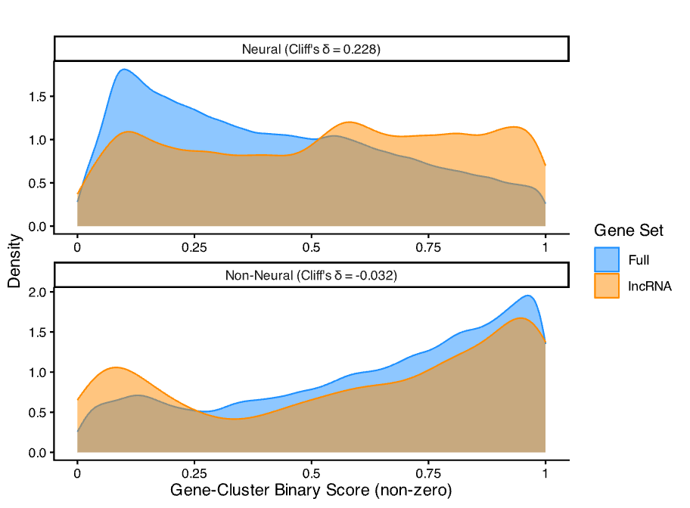
Binary Scores
Type | Zero Proportion: lncRNA vs Full (%) | Difference in Zero Proportion  (95% CI) | Median of Non-Zero Values:  lncRNA vs Full | Difference in Medians | Cliff's δ
Neural | 79.42% vs 61.44% | 17.98%  (17.78%, 18.17%) | 0.556 vs 0.375 | 0.181 | 0.228
Non-Neural | 88.78% vs 84.23% | 4.55%  (4.17%, 4.92%) | 0.670 vs 0.694 | -0.024 | -0.032

