CREDIT CARD FRAUD DETECTION

Raj Mehta
Taranpreet Singh
Smriti Vimal

BIA​​678

Professor ​​David​​ Belanger
Spring​​ 2018

Contents

BACKGROUND 3
MOTIVATION 3
DATA DESCRIPTION 4
DATA PREPROCESSING 4
ALGORITHMS USED 7
PERFORMANCE OF ALGORITHMS 7
SPARK LOCAL MACHINE 7
SPARK CLUSTER 9
RESULTS and CONCLUSIONS 11
FUTURE WORK 12
REFERENCES 12
APPENDIX 13

BACKGROUND

With the ever-growing digital currency, banking and financial industries are facing severe challenges in the form of fraudulent transactions. Credit card fraud is a classic example of them. According to CreditDonkey.com, 46% of Americans have fallen victim to credit card fraud in the past five years, and it is estimated that losses from credit card fraud exceeded $24 billion in 2016. The number of fraudulent transactions is usually a very low fraction of the total transactions. Hence the task of detecting fraud transactions in an accurate and efficient manner is difficult and challengeable. Therefore, development of efficient methods which can distinguish rare fraud activities from billions of legitimate transactions is critical. The data for the transactions by credit cards, is massive, sometimes in Petabytes. To store and analyze this data in a normal RDBMS is very difficult and inefficient way. By the time, a fraud is predicted, the transaction has already been processed. To deal with this issue, we explore how different statistical and machine learning models perform in terms of accuracy and scaling in the parallel distributed computing environment.

MOTIVATION

The motivation for doing an academic project on Credit Card Fraud Detection is because this use case is a befitting example of how Machine Learning can help us solve Big Data problems. With trillions of currency-less transactions of being done every day, using machine learning to recognize patterns of transactions and detecting anomalies in them is a classic example of how technology can help us in day-to-day life.
The project uses algorithms ranging from Logistic Regression to Gradient Boosting to understand how different machine learning algorithms scale in the Big Data world.

DATA DESCRIPTION

The data set has been taken from Kaggle - https://www.kaggle.com/mlg-ulb/creditcardfraud .
The dataset contains transactions made by credit cards in September 2013 by European cardholders. This dataset presents transactions that occurred in two days, in which only 492 are fraud transactions out of 284,807 transactions.
The dataset is highly unbalanced, the positive class (frauds) account for 0.172% of all transactions.
It contains only numerical input variables which are the result of a PCA transformation. Due to confidentiality issues, information about original features has not been provided. Features V1, V2, ... V28 are the principal components obtained with PCA, the only features which have not been transformed with PCA are 'Time' and 'Amount'. Feature 'Time' contains the seconds elapsed between each transaction and the first transaction in the dataset. The feature 'Amount' is the transaction Amount, this feature can be used for example-dependent cost-sensitive learning. Feature 'Class' is the response variable and it takes value 1 in case of fraud and 0 otherwise.

DATA PREPROCESSING

The feature amount has been normalized and feature time is dropped for the analysis. All other variables are used for modelling without any transformation.

Data After Preparation

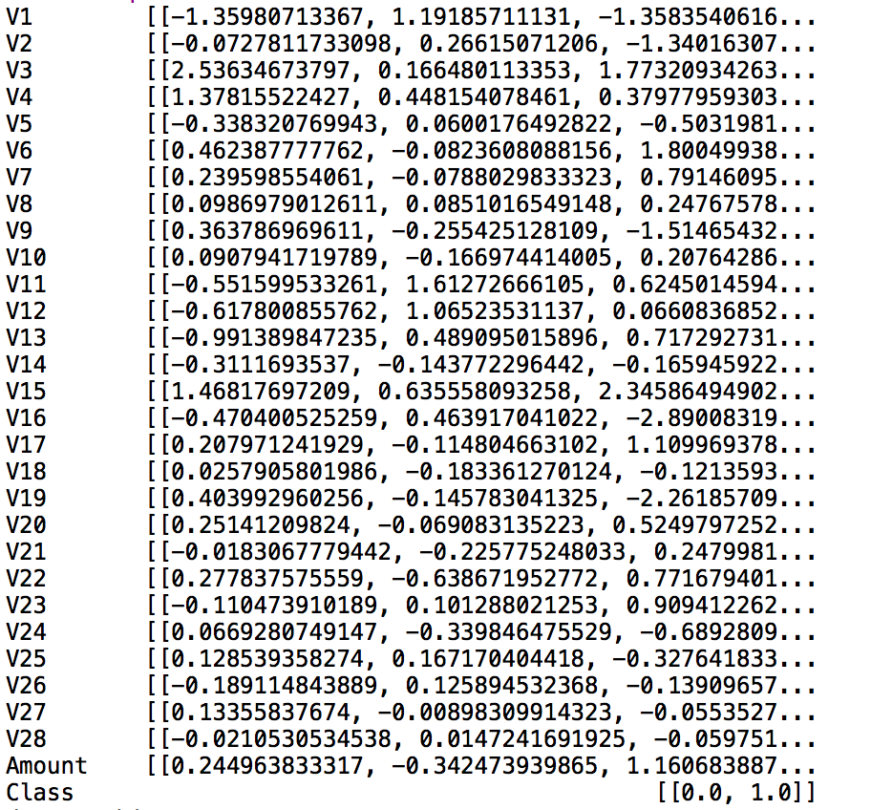

V1 to V28 are Principle components and Class is the target variable.

ALGORITHMS USED
For classifying a transaction as fraudulent, we have implemented the following Machine learning models on Spark -
- Decision Tree
- Support Vector Machine
- Gradient Boosting
- Random Forest
- Logistic Regression
To infer how the above models fare in the Big Data context, we scaled the data to try every model on 20%, 40%, 60%, 80% and 100% of the dataset.
Computational Time and the Area Under the ROC Curve are measured for different models and data proportions to understand the impact of the data size on model’s performance.

PERFORMANCE OF ALGORITHMS

SPARK LOCAL MACHINE
Computational Time
In this section we have explored the time taken by each model to train and predict the dependent variable – Class in this case. As mentioned above, this is done for 5 different scales of data – 0.20, 0.40, 0.60, 0.80 and 1.0(all data in this case)
On the Spark Local machine, we find the below pattern of behavior for the different models:
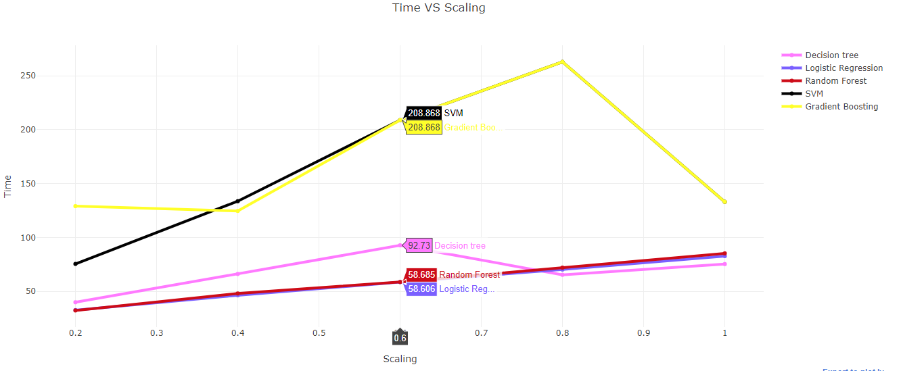
Time is measured in seconds. From the above graph, we can infer that the time taken to compute the data increases with the increase in the scaling. The flick in the gradient boosting algorithm at 80% data size can be attributed to random sample selection though this needs to be explore further.

Model Performance
In this section we have explored the performance of the different classification algorithms on different scales of the dataset. We use AUC metric for this. AUC is an abbreviation for area under the curve. It is used in classification analysis to determine which of the used models predicts the classes best.

AUC Vs Scaling – Spark Local machine

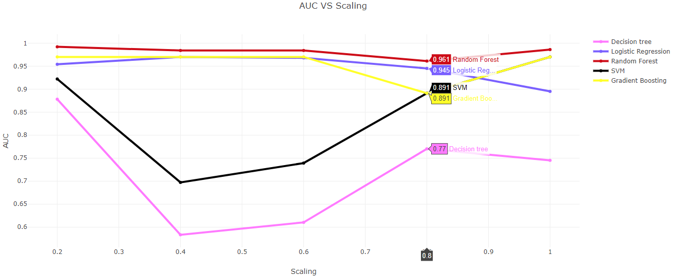
From the above graph, we can infer that the AUC of the model stays consistent with the increase in the scaling except for Decision tree and SVM.

SPARK CLUSTER
To compare the performance of the Spark Local Machine and Cluster, we implement the following models on cluster:
- Decision Tree
- Gradient Boosting
- Random Forest
- Logistic Regression
Support Vector Classification has not been done on the Cluster as the cluster did not support the Spark 2.3 version of SVC algorithm.

Computational Time
On the Cluster, the time taken to train and predict the class values on test data is higher than that on local. This could be attributed to the difference in system configuration.
Time Vs Scaling – Cluster
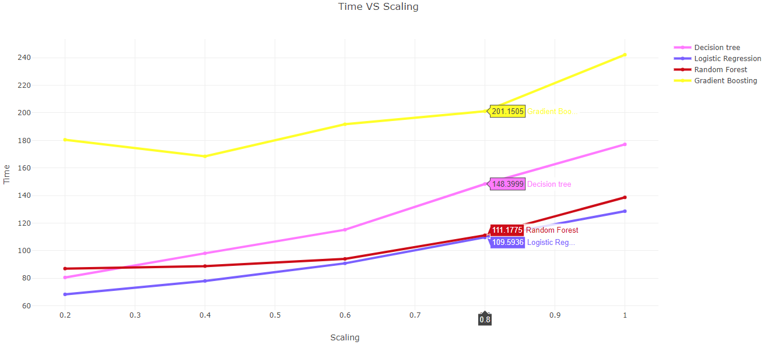
We find that the time to predict the fraud transactions increases almost linearly with scaling. The performance of Gradient Boost and Random Forest in terms of computational terms on scaling is better than Logistic Regression and Decision Tree. However, absolutely speaking Gradient Boost takes almost double the time as compared to other algorithms for the same scale factor.

Model Behavior for Scaling
AUC Vs Scaling – Cluster
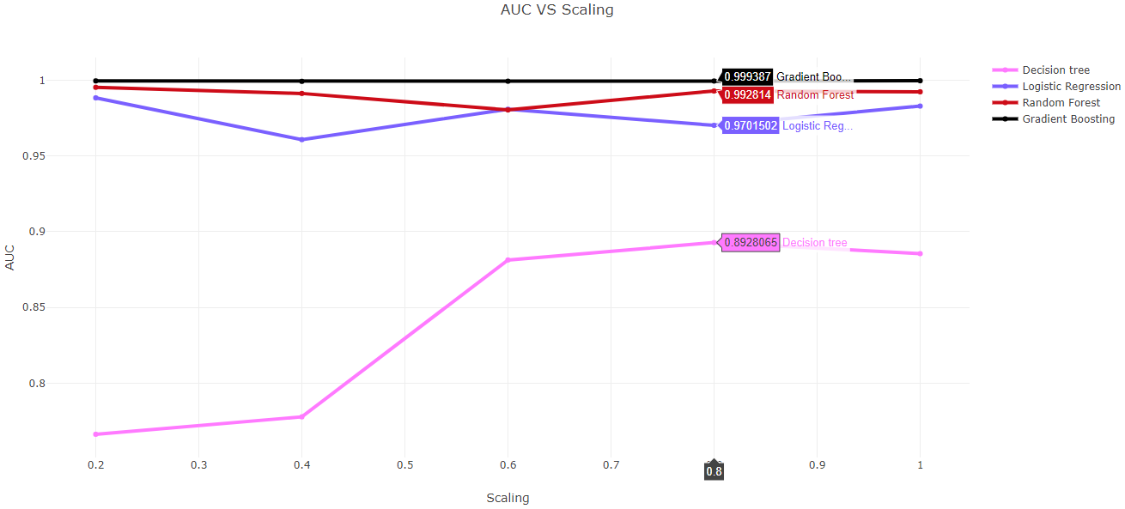
In terms of performance of models in AUC metric, it is noticed that there is a consistent AUC score for the all models except Decision Tree. Gradient Boost’s performance is consistent across scales and is the highest. Random Forest also has a good AUC with a benefit of having lesser computational time vis a vis Gradient Boost.

RESULTS and CONCLUSIONS
With the above results it is noted that models which have higher AUC metric take higher computational time. This is consistent for both local spark installation as well as distributed computing. Gradient Boosting outperforms other models in AUC but takes maximum time as well. In terms of AUC, it performs better on distributed environment when compared to single machine behavior. It is easy to note that Random Forest has the right balance of computational time and AUC – It’s performance is robust across local machine and cluster. In terms of scaling, it can be inferred that as compared to Logistic Regression and Decision Tree, Random Forest and Gradient Boosting do an excellent job at scaling.

Thus, we concluded that the models perform better on cluster vs the local if the data is big. As scaling increases, the performance on cluster improves. It can be said that Random Forest is the recommended model based on above analysis. All the models are more robust on cluster than Local machine.

FUTURE WORK
We would like to explore and compare algorithms such as Neural Networks and XGBoost against the current performance of Gradient Boosting and Random Forest. As it is an imbalanced classification problem, we would also like to understand how SMOTE techniques can be done in Spark RDD set up. This will basically over-sample the minority class and under-sample the majority class. With a more balanced dataset we can get a better picture of false positives and false negatives of the analysis. In addition, it would be a nice idea to execute the above models on the Google Cloud Big Data platform to level out the current differences in system configurations.

REFERENCES

1. https://www.datacamp.com/community/tutorials/apache-spark-tutorial-machine-learning

2. https://mapr.com/blog/churn-prediction-pyspark-using-mllib-and-ml-packages/

3. https://spark.apache.org/docs/2.2.0/ml-pipeline.html

4.https://www.dezyre.com/apache-spark-tutorial/pyspark-tutorial

APPENDIX

PySpark Code:
Decision Tree –
# -*- coding: utf-8 -*-
"""
Created on Tue May 1 09:13:08 2018

@author: rmehta@stevens.edu
@author: svimal@stevens.edu
@author: tsingh3@stevens.edu
"""
# Decision tree
#W
import pyspark
from pyspark.sql import SQLContext
from pyspark import SparkContext
from pyspark.ml.evaluation import BinaryClassificationEvaluator
from pyspark.ml.linalg import DenseVector
import time
from pyspark.sql import SQLContext
from pyspark import SparkContext
from pyspark.ml import Pipeline
from pyspark.ml.feature import IndexToString, StringIndexer, VectorIndexer
from pyspark.sql import SparkSession
import pandas as pd
import numpy as np
spark = SparkSession.builder.config("spark.sql.shuffle.partitions", "50").getOrCreate()
spark.sparkContext.setLogLevel("WARN")
df2 = spark.read.format('com.databricks.spark.csv').options(header='true', inferschema='true').load('hdfs://Master:9000/home/biagroup27/creditPrep.csv')

from pyspark.ml import Pipeline
from pyspark.ml.classification import DecisionTreeClassifier
from pyspark.ml.feature import StringIndexer, VectorIndexer
from pyspark.ml.evaluation import MulticlassClassificationEvaluator

# Load the data stored in LIBSVM format as a DataFrame.
#data = spark.read.format("libsvm").load("creditprep.csv")
from pyspark.sql.functions import *
df1 = df2.select('Class','Amount','V1','V2','V3','V4','V5','V6','V7','V8','V9','V10','V11','V12','V13','V14','V15','V16','V17','V18','V19','V20','V21','V22','V23','V24','V25','V26','V27','V28')

fraction=[]
aucList=[]
runTime=[]
#Starts here
i = 56962
while i <= 284810:

df = df1.limit(i)
startTimeQuery = time.time()
input_data = df.rdd.map(lambda x: (x[0], DenseVector(x[1:])))

# Replace `df` with the new DataFrame
data = spark.createDataFrame(input_data, ["label", "features"])

# Index labels, adding metadata to the label column.
# Fit on whole dataset to include all labels in index.
labelIndexer = StringIndexer(inputCol="label", outputCol="indexedLabel").fit(data)
# Automatically identify categorical features, and index them.
# We specify maxCategories so features with > 4 distinct values are treated as continuous.
featureIndexer = VectorIndexer(inputCol="features", outputCol="indexedFeatures").fit(data)

# Split the data into training and test sets (30% held out for testing)
(trainingData, testData) = data.randomSplit([0.7, 0.3])

# Train a DecisionTree model.
dt = DecisionTreeClassifier(labelCol="indexedLabel", featuresCol="indexedFeatures")

# Chain indexers and tree in a Pipeline
pipeline = Pipeline(stages=[labelIndexer, featureIndexer, dt])

# Train model. This also runs the indexers.
model = pipeline.fit(trainingData)

# Make predictions.
predictions = model.transform(testData)
endTimeQuery = time.time()
runTimeQuery = endTimeQuery - startTimeQuery
# Evaluate model
evaluator = BinaryClassificationEvaluator(rawPredictionCol="rawPrediction")
frac=i*100/df2.count()
auc=evaluator.evaluate(predictions)
print("Subset selected for data is:",(frac),"AUC is:",auc,"Run Time", runTimeQuery)
fraction.append(frac)
runTime.append(runTimeQuery)
aucList.append(auc)

i = i + 56962

print(fraction,runTime,aucList)

Logistic Regression-
# -*- coding: utf-8 -*-
"""
Created on Tue May 1 09:13:08 2018

@author: rmehta@stevens.edu
@author: svimal@stevens.edu
@author: tsingh3@stevens.edu
"""
# Logistic Regression
#W
import pyspark
from pyspark.sql import SQLContext
from pyspark import SparkContext
from pyspark.ml.evaluation import BinaryClassificationEvaluator
from pyspark.ml.linalg import DenseVector
import time
from pyspark.sql import SQLContext
from pyspark import SparkContext
from pyspark.ml import Pipeline
from pyspark.ml.feature import IndexToString, StringIndexer, VectorIndexer
from pyspark.sql import SparkSession
import pandas as pd
import numpy as np
from pyspark.ml.classification import LogisticRegression
spark = SparkSession.builder.config("spark.sql.shuffle.partitions", "50").getOrCreate()
spark.sparkContext.setLogLevel("WARN")
df2 = spark.read.format('com.databricks.spark.csv').options(header='true', inferschema='true').load('hdfs://Master:9000/home/biagroup27/creditPrep.csv')

from pyspark.ml import Pipeline
from pyspark.ml.classification import DecisionTreeClassifier
from pyspark.ml.feature import StringIndexer, VectorIndexer
from pyspark.ml.evaluation import MulticlassClassificationEvaluator

# Load the data stored in LIBSVM format as a DataFrame.
#data = spark.read.format("libsvm").load("creditprep.csv")
from pyspark.sql.functions import *
df1 = df2.select('Class','Amount','V1','V2','V3','V4','V5','V6','V7','V8','V9','V10','V11','V12','V13','V14','V15','V16','V17','V18','V19','V20','V21','V22','V23','V24','V25','V26','V27','V28')

fraction=[]
aucList=[]
runTime=[]
#Starts here
i = 56962
while i <= 284810:

df = df1.limit(i)
startTimeQuery = time.time()
# Define the `input_data`
input_data = df.rdd.map(lambda x: (x[0], DenseVector(x[1:])))

# Replace `df` with the new DataFrame
df = spark.createDataFrame(input_data, ["label", "features"])

from pyspark.sql.functions import rand
df = df.orderBy(rand())
train_data, test_data = df.randomSplit([0.8, 0.2],seed=1234)

mlr = LogisticRegression(labelCol="label", featuresCol="features", maxIter=10)

# Fit the model
mlrModel = mlr.fit(train_data)
predictions = mlrModel.transform(test_data)
endTimeQuery = time.time()
runTimeQuery = endTimeQuery - startTimeQuery
# Evaluate model
evaluator = BinaryClassificationEvaluator(rawPredictionCol="rawPrediction")
frac=i*100/df2.count()
auc=evaluator.evaluate(predictions)
print("Subset selected for data is:",(frac),"AUC is:",auc,"Run Time", runTimeQuery)
fraction.append(frac)
runTime.append(runTimeQuery)
aucList.append(auc)

i = i + 56962

print(fraction,runTime,aucList)

Random Forest
# -*- coding: utf-8 -*-
"""
Created on Tue May 1 09:13:08 2018

@author: rmehta@stevens.edu
@author: svimal@stevens.edu
@author: tsingh3@stevens.edu
"""
# Random Forest tree
#W
import pyspark
from pyspark.sql import SQLContext
from pyspark import SparkContext
from pyspark.ml.evaluation import BinaryClassificationEvaluator
from pyspark.ml.linalg import DenseVector
import time
from pyspark.sql import SQLContext
from pyspark import SparkContext
from pyspark.ml import Pipeline
from pyspark.ml.feature import IndexToString, StringIndexer, VectorIndexer
from pyspark.sql import SparkSession
import pandas as pd
import numpy as np
from pyspark.ml.classification import RandomForestClassifier
spark = SparkSession.builder.config("spark.sql.shuffle.partitions", "50").getOrCreate()
spark.sparkContext.setLogLevel("WARN")
df2 = spark.read.format('com.databricks.spark.csv').options(header='true', inferschema='true').load('hdfs://Master:9000/home/biagroup27/creditPrep.csv')

from pyspark.ml import Pipeline
from pyspark.ml.classification import DecisionTreeClassifier
from pyspark.ml.feature import StringIndexer, VectorIndexer
from pyspark.ml.evaluation import MulticlassClassificationEvaluator

# Load the data stored in LIBSVM format as a DataFrame.
#data = spark.read.format("libsvm").load("creditprep.csv")
from pyspark.sql.functions import *
df1 = df2.select('Class','Amount','V1','V2','V3','V4','V5','V6','V7','V8','V9','V10','V11','V12','V13','V14','V15','V16','V17','V18','V19','V20','V21','V22','V23','V24','V25','V26','V27','V28')

fraction=[]
aucList=[]
runTime=[]
#Starts here

i = 56962
while i <= 284810:

#df.printSchema()
df = df1.limit(i)
startTimeQuery = time.time()
# Define the `input_data`
input_data = df.rdd.map(lambda x: (x[0], DenseVector(x[1:])))

# Replace `df` with the new DataFrame
df = spark.createDataFrame(input_data, ["label", "features"])

# Index labels, adding metadata to the label column.
# Fit on whole dataset to include all labels in index.
labelIndexer = StringIndexer(inputCol="label", outputCol="indexedLabel").fit(df)
# Automatically identify categorical features, and index them.
# We specify maxCategories so features with > 4 distinct values are treated as continuous.
featureIndexer = VectorIndexer(inputCol="features", outputCol="indexedFeatures").fit(df)

from pyspark.sql.functions import rand
df = df.orderBy(rand())

train_data, test_data = df.randomSplit([0.8, 0.2],seed=1234)

# Fit the model
rf = RandomForestClassifier(labelCol="indexedLabel", featuresCol="indexedFeatures", numTrees=10)
#labelConverter = IndexToString(inputCol="prediction", outputCol="predictedLabel",labels=labelIndexer.labels)

# Chain indexers and forest in a Pipeline
pipeline = Pipeline(stages=[labelIndexer, featureIndexer, rf])

# Train model. This also runs the indexers.
model = pipeline.fit(train_data)
predictions = model.transform(test_data)
endTimeQuery = time.time()
runTimeQuery = endTimeQuery - startTimeQuery
# Evaluate model
evaluator = BinaryClassificationEvaluator(rawPredictionCol="rawPrediction")
frac=i*100/df2.count()
auc=evaluator.evaluate(predictions)
print("Subset selected for data is:",(frac),"AUC is:",auc,"Run Time", runTimeQuery)
fraction.append(frac)
runTime.append(runTimeQuery)
aucList.append(auc)

i = i + 56962

print(fraction,runTime,aucList)

Gradient Boost

# -*- coding: utf-8 -*-
"""
Created on Tue May 1 09:13:08 2018

@author: rmehta@stevens.edu
@author: svimal@stevens.edu
@author: tsingh3@stevens.edu
"""
# GB
#W
import pyspark
from pyspark.sql import SQLContext
from pyspark import SparkContext
from pyspark.ml.evaluation import BinaryClassificationEvaluator
from pyspark.ml.linalg import DenseVector
import time
from pyspark.sql import SQLContext
from pyspark import SparkContext
from pyspark.ml import Pipeline
from pyspark.ml.feature import IndexToString, StringIndexer, VectorIndexer
from pyspark.sql import SparkSession
import pandas as pd
import numpy as np
from pyspark.ml.classification import RandomForestClassifier
spark = SparkSession.builder.config("spark.sql.shuffle.partitions", "50").getOrCreate()
spark.sparkContext.setLogLevel("WARN")
df2 = spark.read.format('com.databricks.spark.csv').options(header='true', inferschema='true').load('hdfs://Master:9000/home/biagroup27/creditPrep.csv')

from pyspark.ml import Pipeline
from pyspark.ml.classification import DecisionTreeClassifier
from pyspark.ml.feature import StringIndexer, VectorIndexer
from pyspark.ml.evaluation import MulticlassClassificationEvaluator
from pyspark.ml.classification import GBTClassifier
# Load the data stored in LIBSVM format as a DataFrame.
#data = spark.read.format("libsvm").load("creditprep.csv")
from pyspark.sql.functions import *
df1 = df2.select('Class','Amount','V1','V2','V3','V4','V5','V6','V7','V8','V9','V10','V11','V12','V13','V14','V15','V16','V17','V18','V19','V20','V21','V22','V23','V24','V25','V26','V27','V28')

fraction=[]
aucList=[]
runTime=[]
accuracyList=[]
#Starts here

i = 56962
while i <= 284810:

#df.printSchema()
df = df1.limit(i)
startTimeQuery = time.time()
# Define the `input_data`
input_data = df.rdd.map(lambda x: (x[0], DenseVector(x[1:])))

# Replace `df` with the new DataFrame
df = spark.createDataFrame(input_data, ["label", "features"])

# Index labels, adding metadata to the label column.
# Fit on whole dataset to include all labels in index.
labelIndexer = StringIndexer(inputCol="label", outputCol="indexedLabel").fit(df)
# Automatically identify categorical features, and index them.
# We specify maxCategories so features with > 4 distinct values are treated as continuous.
featureIndexer = VectorIndexer(inputCol="features", outputCol="indexedFeatures").fit(df)

from pyspark.sql.functions import rand
df = df.orderBy(rand())

train_data, test_data = df.randomSplit([0.8, 0.2],seed=1234)

mlr = GBTClassifier(labelCol="label", featuresCol="features", maxIter=10)
# Fit the model
mlrModel = mlr.fit(train_data)
predictions = mlrModel.transform(test_data)

endTimeQuery = time.time()
runTimeQuery = endTimeQuery - startTimeQuery
# Evaluate model
evaluatorGB = MulticlassClassificationEvaluator(
labelCol="label", predictionCol="prediction", metricName="accuracy")
accuracy = evaluatorGB.evaluate(predictions)
print("Grdient Boost Test Error = %g" % (1.0 - accuracy))

frac=i*100/df2.count()
auc=evaluatorGB.evaluate(predictions)
print("Subset selected for data is:",(frac),"Accuracy is:",accuracy,"Run Time", runTimeQuery)

fraction.append(frac)
runTime.append(runTimeQuery)
aucList.append(auc)
accuracyList.append(accuracy)

i = i + 56962

print(fraction,runTime,aucList,accuracyList)

