**Project Name: HouseHelpers**

**Project Member:**

**INAMDAR SOHAIL 220343120037**

**NAIR ADITYA 220343120003**

**SHINDE SUJEET 220343120102**

**GOBADE SADANAND 220343120036**

**Abstract:**

The main objective of our project is to develop a platform that will help people in Metro-cities to find and hire helpers according to their needs.It came in our mind after, we ourselves faced a lot of hurdles just to find a cook in city. And we saw these cook were exploited by brokers which meant they are not getting their hard earned money completely.

So our project is able to provide convenience to those who are in need for helpers like “ Nanny, Cook, Gardener, Pet service etc.” It will reduce the time and complexity in order to find helpers in Metro-Cities.

We could have information about best helpers available in nearby area and to help others we could give feedback and reviews as well.

It will help poor helpers to get earnings and get their deserving reviews from their employer without any interference of Intermediaries.This will enhance the searching procedure for those who have very hectic schedule due to their job or personal life.

**Implementation Technologies:**

1. **Spring Boot Framework:**

Spring Boot provides a good platform for Java developers to develop a stand-alone and production-grade spring application that you can **just run**. You can get started with minimum configurations without the need for an entire Spring configuration setup.

You can choose Spring Boot because of the features and benefits it offers as given here −

* It provides a flexible way to configure Java Beans, XML configurations, and Database Transactions.
* It provides a powerful batch processing and manages REST endpoints.
* In Spring Boot, everything is auto configured; no manual configurations are needed.
* It offers annotation-based spring application
* Eases dependency management
* It includes Embedded Servlet Container

**1.1 Features of Spring Boot Framework:**

**Web Development**

It is well suited Spring module for web application development. We can easily create a self-contained HTTP server using embedded Tomcat, Jetty or Undertow. We can use the spring-boot- starter-web module to start and running application quickly.

**SpringApplication**

It is a class which provides the convenient way to bootstrap a spring application which can be started from main method.

**Application Events and Listeners**

Spring Boot uses events to handle variety of tasks. It allows us to create factories file that are used to add listeners. we can refer it by using ApplicationListener key.

**Admin Support**

Spring Boot provides the facility to enable admin related features for the application. It is used to access and manage application remotely. We can enable it by simply using spring.application.admin.enabled property.

**Externalized Configuration**

Spring Boot allows us to externalize our configuration so that we can work with the same application in different environments. Application use YAML files to externalize configuration.

**1.2 Advantages of Spring Boot Framework:**

**1.Spring Boot works well with several servlet containers**

Spring Boot works well with some of the most popular embedded servlet containers. Spring Boot uses [Tomcat](https://www.adservio.fr/post/tomcat-performance-best-practices) as its default, but you can easily swap it for Jetty, Undertow, Resin, and Wildfly. You get to choose the option that improves the specific types of functionality that concern you most.

**2. Bootstrapping saves memory space**

Spring Boot uses Boot Initializer to compile the source language. This bootstrapping technique makes it possible for users to save space on their devices and load applications quickly.

**3. Decreased boilerplate code**

Spring Boot’s in-memory database and embedded server (Tomcat) decrease or eliminate the boilerplate code typically needed to set up an application.Without lots of boilerplate code, development teams can shorten their development times and update cycles, leading to more satisfied users and more productive employees. It’s yet another of the advantages of Spring Boot that helps developers save time.

**4. No XML configuration required**

Spring project developers can choose to use annotations or XML configurations. The option to avoid XML configurations appeals to a lot of software engineers who don’t want to go through the extra steps required.

1. **The JDBC Template**

The central class of the Spring JDBC abstraction framework is the **JdbcTemplate** class that includes the most common logic in using the JDBC API to access data, such as handling the creation of connection, statement creation, statement execution, and release of resource. The**Jdbc-Template**class can be found in the **org.springframework.jdbc.core**package.

The **JdbcTemplate** class instances are thread-safe once configured. A single **JdbcTemplate** can be configured and injected into multiple DAOs.

We can use the **JdbcTemplate** to execute the different types of SQL statements. **Data Manipulation Language** (**DML**) is used for inserting, retrieving, updating, and deleting the data in the database such as **SELECT**, **INSERT**, or **UPDATE** statements

**2.1** **MySQL**

MySQL, the most popular Open Source SQL database management system, is developed, distributed, and supported by Oracle Corporation.

**Features of MySQL:**

* **MySQL is a database management system.**

A database is a structured collection of data. It may be anything from a simple shopping list to a picture gallery or the vast amounts of information in a corporate network. To add, access, and process data stored in a computer database, you need a database management system such as MySQL Server. Since computers are very good at handling large amounts of data, database management systems play a central role in computing, as standalone utilities, or as parts of other applications.

* **MySQL databases are relational.**

A relational database stores data in separate tables rather than putting all the data in one big storeroom. The database structures are organized into physical files optimized for speed. The logical model, with objects such as databases, tables, views, rows, and columns, offers a flexible programming environment.

* **MySQL software is Open Source.**

Open Source means that it is possible for anyone to use and modify the software. Anybody can download the MySQL software from the Internet and use it without paying anything.

* **The MySQL Database Server is very fast, reliable, scalable, and easy to use.**

MySQL Server was originally developed to handle large databases much faster than existing solutions and has been successfully used in highly demanding production environments for several years. Although under constant development, MySQL Server today offers a rich and useful set of functions. Its connectivity, speed, and security make MySQL Server highly suited for accessing databases on the Internet.

* **MySQL Server works in client/server or embedded systems.**

The MySQL Database Software is a client/server system that consists of a multithreaded SQL server that supports different back ends, several different client programs and libraries, administrative tools, and a wide range of application programming interfaces (APIs).

1. **Hardware and Software Requirements (Minimum):**

**Hardware:**

1. Intel i5 processor 3rd generation or later / AMD Ryzen 5 2nd generation or later

2. 4 GB ddr3 ram.

3. Windows 10 Home edition or later.

4. 200 GB Sata HDD Space

5. Data Connection 20 mbps

**Software:**

1. Eclipse Oxygen
2. MySQL Workbench
3. Google Chrome
4. Maven Dependencies
5. Visual Studio Code

**4.ER Diagram:**

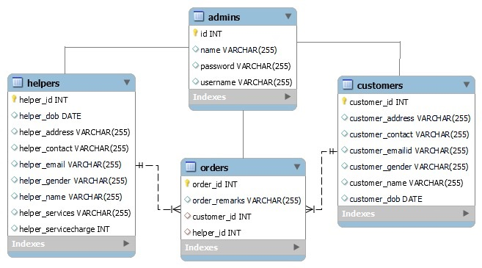

**5.Table Structures:**

**Admin Table:**

`admins` (

`id` int NOT NULL AUTO_INCREMENT,

`name` varchar(255) DEFAULT NULL,

`password` varchar(255) DEFAULT NULL,

`username` varchar(255) DEFAULT NULL,

PRIMARY KEY (`id`)

) ;

**Customers Table:**

`customers` (

`customer_id` int NOT NULL AUTO_INCREMENT,

`customer_name` varchar(255) NOT NULL,

`customer_gender` varchar(20) NOT NULL,

`customer_dob` date NOT NULL,

`customer_contact` varchar(45) NOT NULL,

`customer_address` varchar(255) NOT NULL,

`customer_emailid` varchar(45) NOT NULL,

PRIMARY KEY (`customer_id`)

)

**Helpers Table:**

`helpers` (

`helper_id` int NOT NULL AUTO_INCREMENT,

`helper_name` varchar(255) NOT NULL,

`helper_dob` date NOT NULL,

`helper_address` longtext NOT NULL,

`helper_contact` varchar(50) NOT NULL,

`helper_email` varchar(255) NOT NULL,

`helper_services` varchar(255) NOT NULL,

`helper_servicecharge` int NOT NULL,

`helper_gender` varchar(255) DEFAULT NULL,

PRIMARY KEY (`helper_id`)

)

**Orders Table:**

`orders` (

`order_id` int NOT NULL AUTO_INCREMENT,

`customer_id` int NOT NULL,

`helper_id` int NOT NULL,

PRIMARY KEY (`order_id`),

KEY `FK_cid_idx` (`customer_id`),

KEY `FK_hid_idx` (`helper_id`),

CONSTRAINT `FK_cuid` FOREIGN KEY (`customer_id`) REFERENCES `customers` (`customer_id`),

CONSTRAINT `FK_heid` FOREIGN KEY (`helper_id`) REFERENCES `helpers` (`helper_id`)

)

**6.UML Diagrams:**

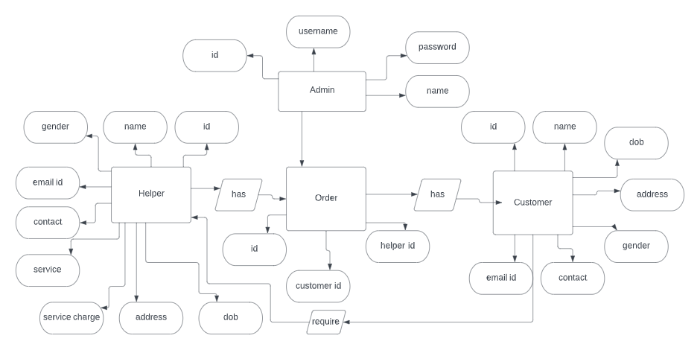

**7.End to End Flow of Application:**

**User:**

* 1. User(Customer) will login to the portal or will have to register if he is not a registered user.
  2. After registration User will login to Dashboard page
  3. From that page User can click on the services button and reach the next details form page.
  4. From the given list user can hire helpers according to their need.
  5. User(Helper) will login to the portal or will have to register if he is not a registered user.
  6. After registration User will login to Dashboard page.
  7. On this page user can see which customer has hired them.

**Admin:**

1. Admin will login as Admin from the ‘**Admin login**’ page and will be able to see the customers list,helpers list and orders placed.
2. Admin can Manage the orders,customers and helpers.

**8.Future Scope of Project**

1.For time being our project is limited to Pune only but as our success grow we are going to explore in other metro cities as well.

2.Furthermore will be adding more services as per users demands.

**Thank You!**