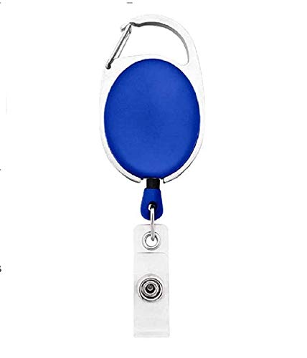

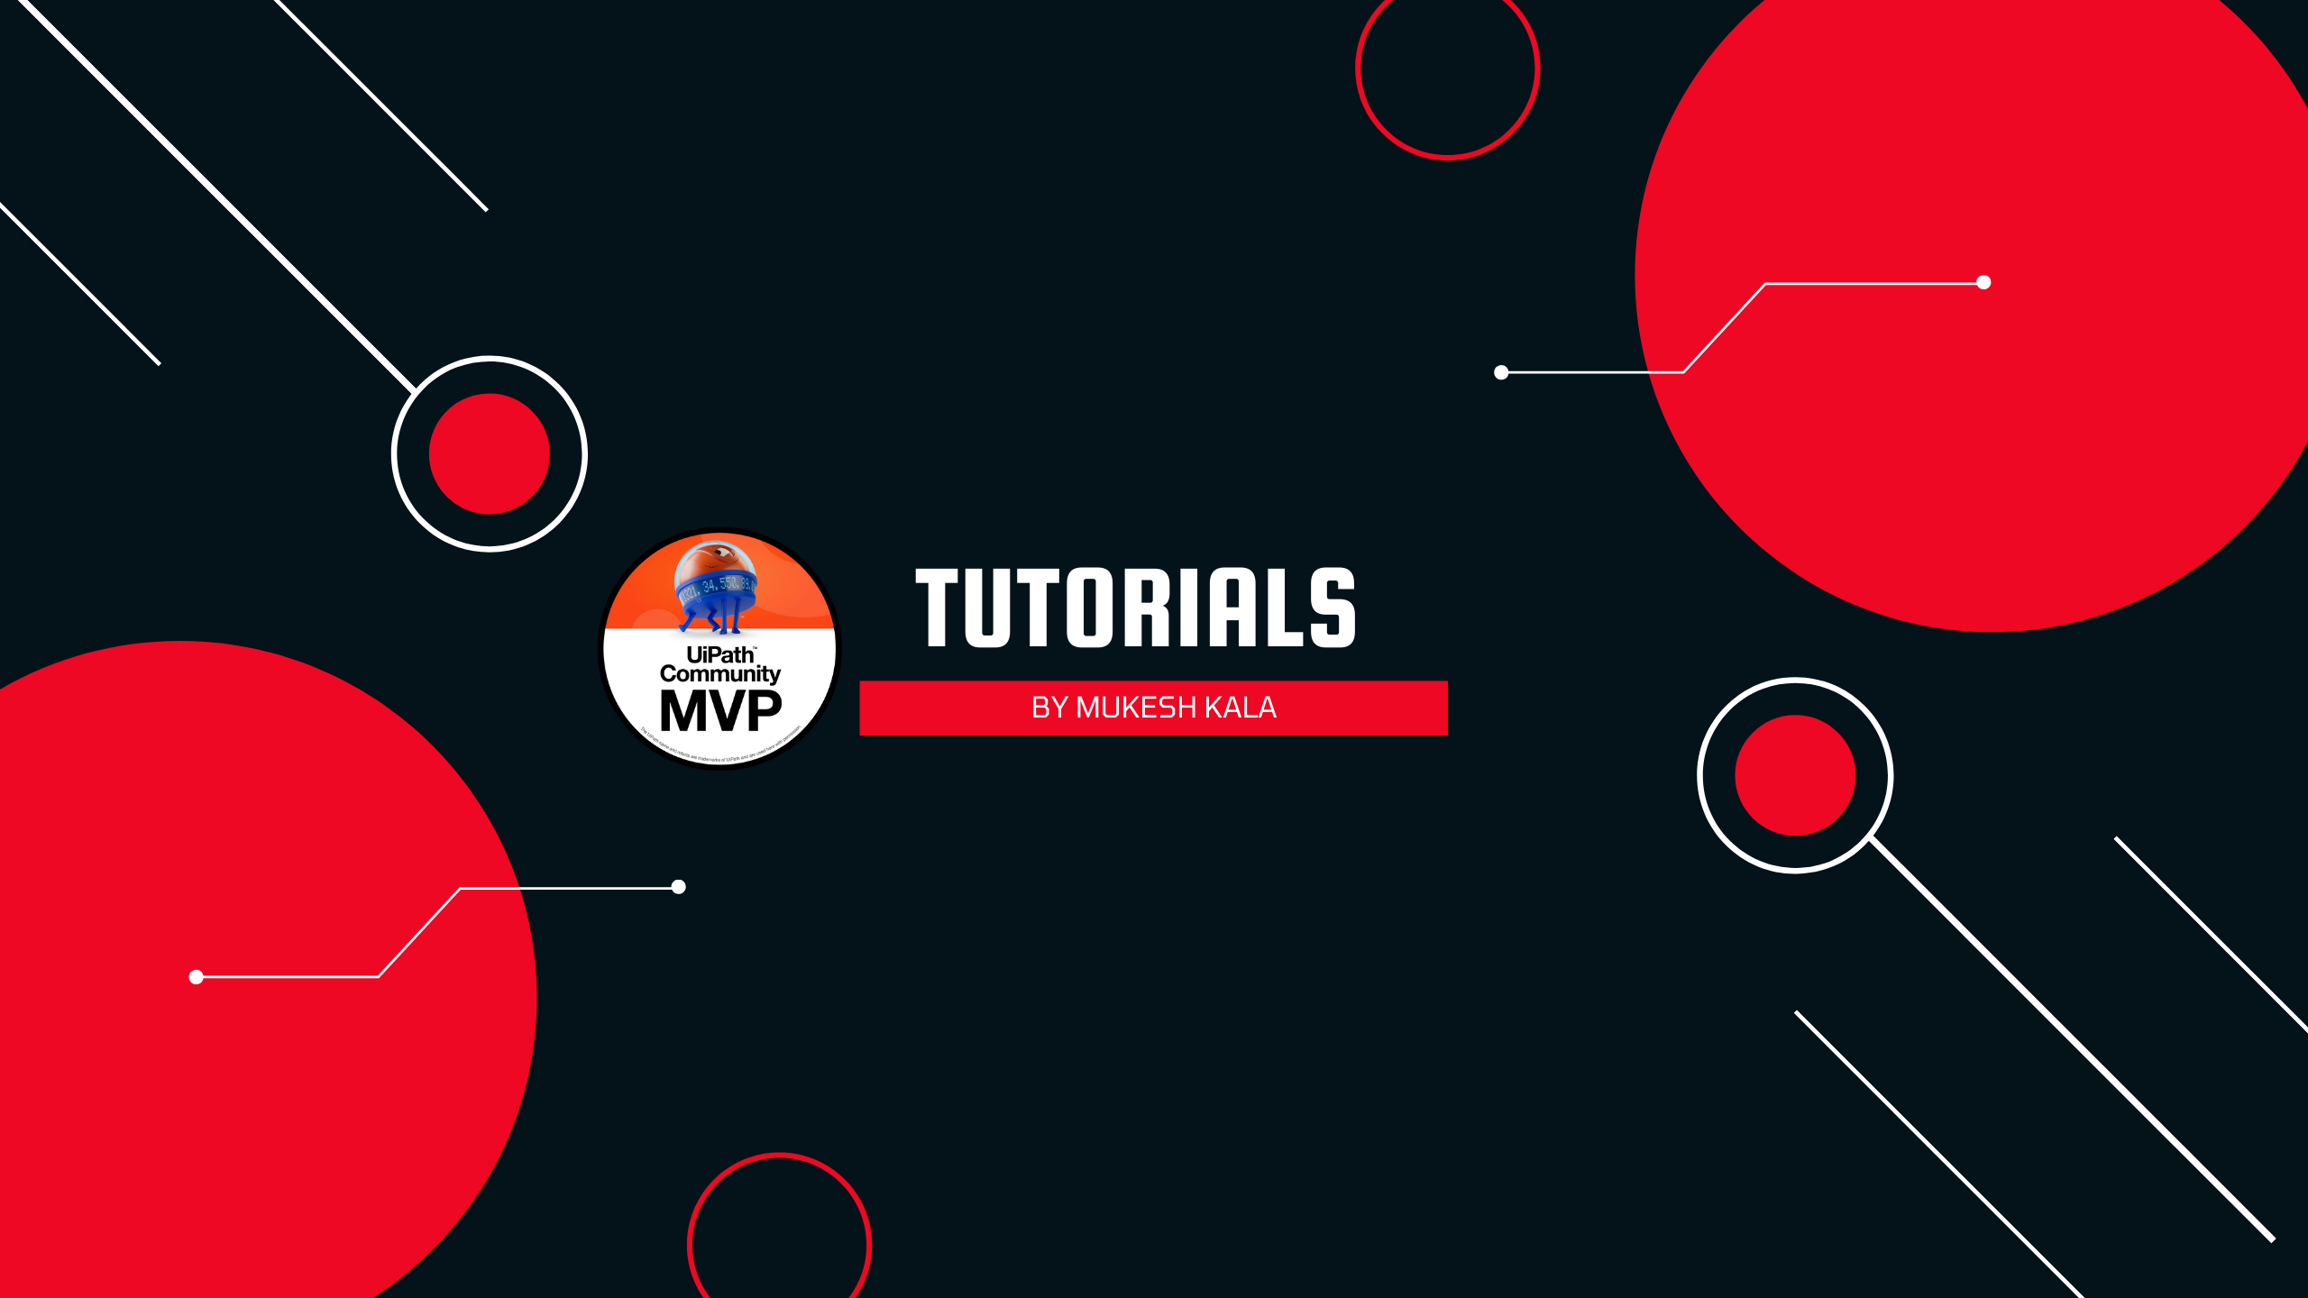

|  |  |
| --- | --- |
| **Sarah Neighbors** | PHOTO |
| **Purchase** |
| **14-Mar-22** |
| **B +ve** |
| **9988776655** |

Questions / Queries – Drop an email to mailmukeshkala@gmail.com