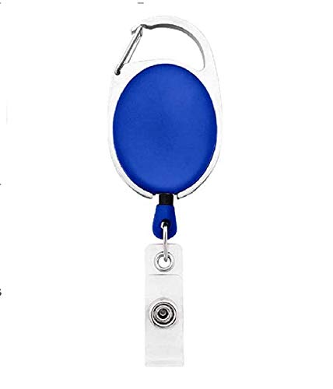



|  |  |
| --- | --- |
| **Robert Conner** | PHOTO |
| **Marketing** |
| **20-Feb-22** |
| **O -ve** |
| **9988776655** |

Questions / Queries – Drop an email to mailmukeshkala@gmail.com