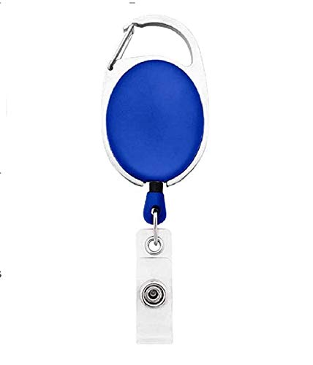



|  |  |
| --- | --- |
| **Sharon Becerra** | PHOTO |
| **Finance** |
| **17-Feb-22** |
| **O +ve** |
| **9988776655** |

Questions / Queries – Drop an email to mailmukeshkala@gmail.com