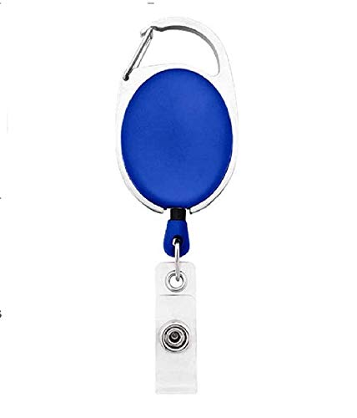



|  |  |
| --- | --- |
| **Rosie Pica** | PHOTO |
| **Finance** |
| **19-Jan-22** |
| **A -ve** |
| **9988776655** |

Questions / Queries – Drop an email to mailmukeshkala@gmail.com