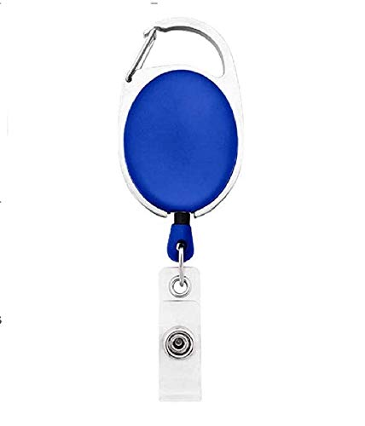

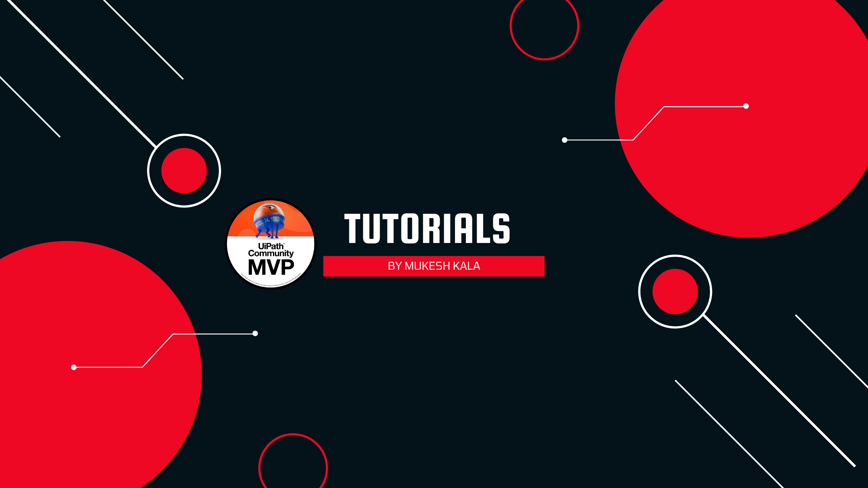

|  |  |
| --- | --- |
| **Angelia Cartee** | PHOTO |
| **Sales** |
| **21-Feb-22** |
| **AB -ve** |
| **9988776655** |

Questions / Queries – Drop an email to mailmukeshkala@gmail.com