Exploratory Data Analysis (EDA) Project
Student Academic Performance Dataset

1. Introduction
This report presents an exploratory data analysis (EDA) of a student academic performance dataset containing 200 student records. The objective is to uncover patterns and trends in student marks and identify the key factors that influence academic performance, using statistical summaries and visualizations.
The dataset includes information on study hours, attendance percentage, sleep hours, parental support level, gender, and marks scored in Math, Science, and English.

2. Dataset Overview
Attribute | Description
StudentID | Unique identifier for each student
Gender | Male / Female
StudyHours_perDay | Average hours spent studying per day
Attendance_pct | Class attendance percentage
SleepHours | Average hours of sleep per day
ParentalSupport | Low / Medium / High
Math_Marks, Science_Marks, English_Marks | Subject-wise marks (0-100)
Average_Marks | Mean of the three subject marks

Total records: 200 students. A small number of missing values were found in SleepHours (6 records) and English_Marks (6 records); these were imputed with the column median for visualization purposes.

3. Statistical Summary
Metric | Value
Mean Average Marks | 86.89
Std. Deviation | 7.69
Top Scorer | S1136 (100 marks)
Lowest Scorer | S1044 (58.1 marks)
Students scoring 90+ | 38.5%
Students scoring below 50 | 0%

4. Visual Analysis

4.1 Distribution of Average Marks
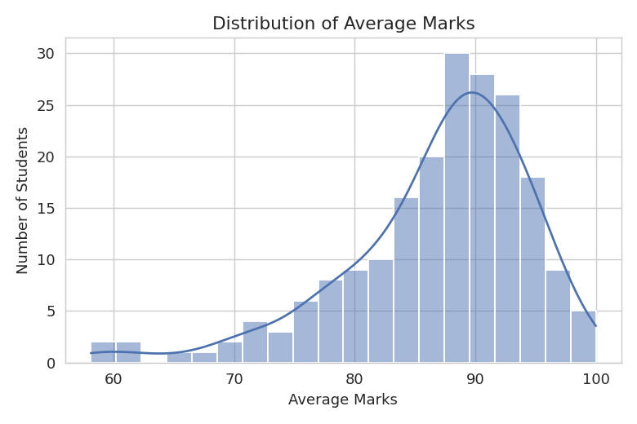
Figure 1: Most students score between 80-95, indicating an overall strong-performing cohort.

4.2 Correlation Heatmap
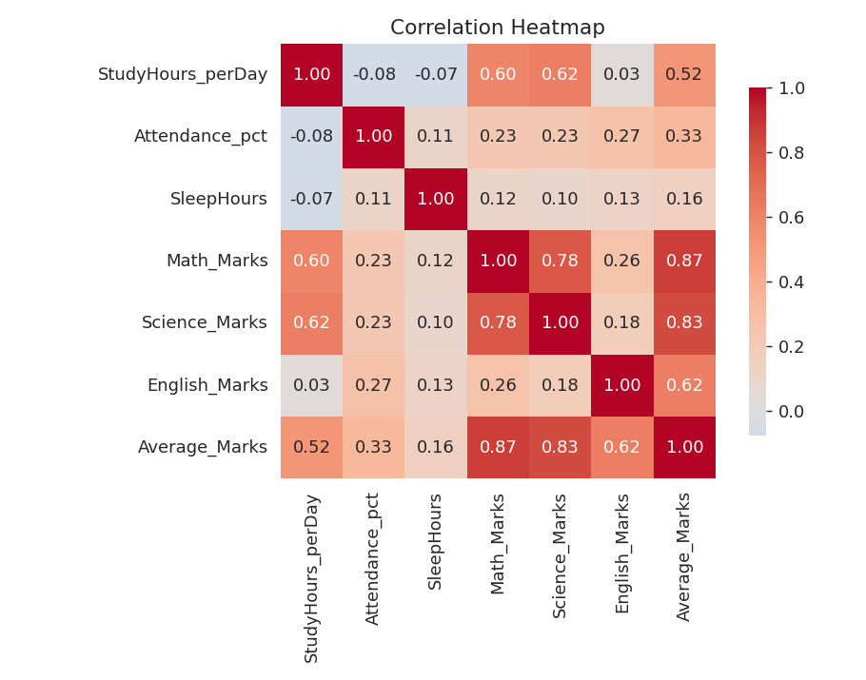
Figure 2: Correlation between numeric variables and marks.

4.3 Study Hours vs Average Marks
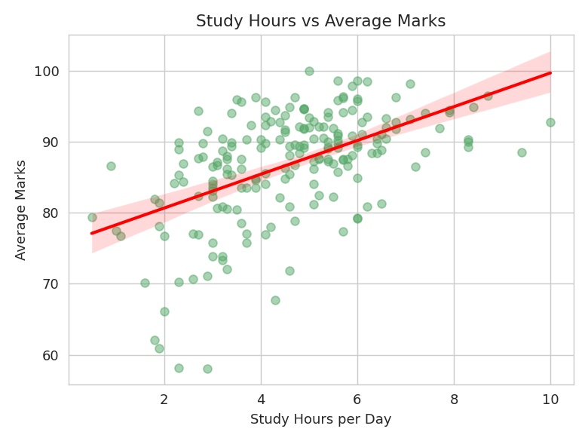
Figure 3: Positive correlation (r = 0.52) — more study hours associate with higher marks.

4.4 Attendance vs Average Marks
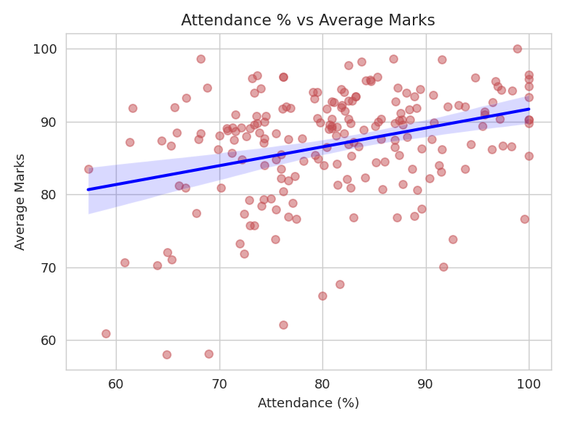
Figure 4: Moderate positive correlation (r = 0.33) between attendance and marks.

4.5 Parental Support vs Average Marks
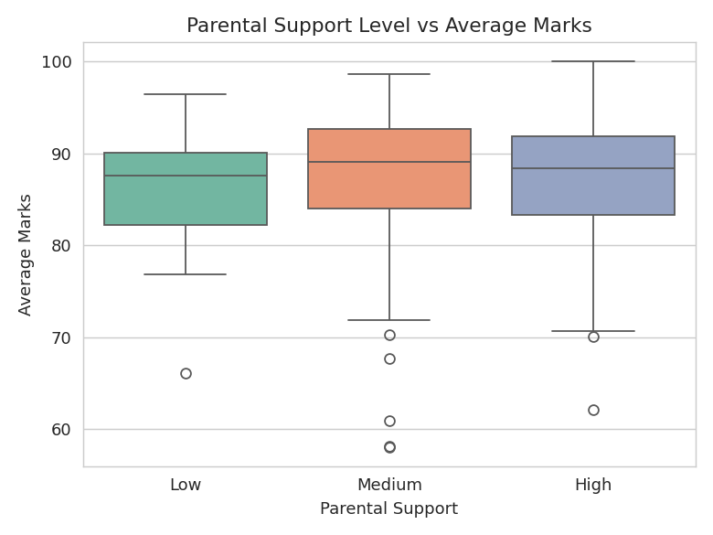
Figure 5: Distribution of marks across parental support levels.

4.6 Average Marks by Gender
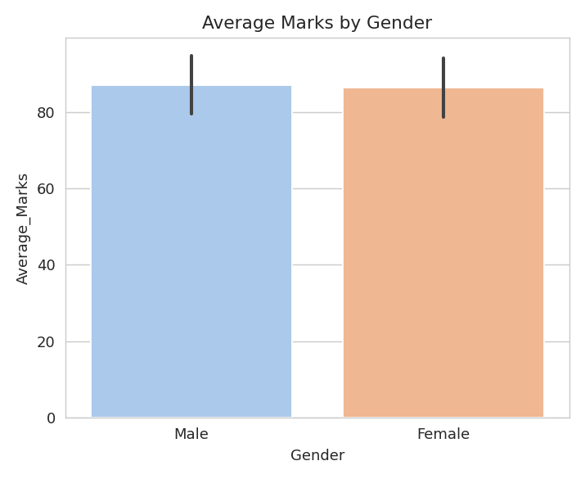
Figure 6: Comparison of average marks between male and female students.

5. Key Insights
- Study hours show the strongest correlation with performance (r = 0.52), making it the single biggest influencing factor among those studied.
- Attendance also positively correlates with marks (r = 0.33), reinforcing the value of regular class participation.
- Sleep hours show only a weak correlation (r = 0.16) with marks in this dataset, suggesting attendance and study time matter more than sleep duration alone.
- Parental support level shows only small differences in average marks (Low: 86.18, Medium: 87.23, High: 86.78), indicating it is not a dominant factor here.
- Gender-wise performance is fairly balanced (Male: 87.19, Female: 86.53), showing no major performance gap.
- 38.5% of students scored 90 or above, while 0% scored below 50, reflecting a generally high-performing group with a long lower tail.

6. Conclusion
The analysis shows that consistent study habits and regular attendance are the strongest predictors of academic success in this dataset, more so than sleep duration, parental support, or gender. Educational interventions aimed at improving daily study routines and class attendance are likely to have the greatest impact on student outcomes.
This project demonstrates the EDA workflow: data cleaning, statistical summarization, visualization, correlation analysis, and insight generation — culminating in a structured, presentable report.

