A3 – TOMCAT SERVER & SERVLET
- S. Vishakan CSE – C 18 5001 196

HTML Code:

<!DOCTYPE html>
<html>
<head>
<title>Simple Servlet Program</title>
<meta charset="utf-8">
<link rel="stylesheet" href="styles.css">
</head>

<body>
<h1>Welcome to Tomcat Servlet!</h1>
<hr><br>
<form action="servlet/Register" method="GET" action="echo">
<input type="text" name="uname" placeholder="John Doe"><br><br>
<input type="email" name="email" placeholder="johndoe@example.com"><br><br>
<br><br>
<input type="submit" value="Register">
<input type="reset" value="Clear">
</form>
</body>
</html>

Java Code:

import java.io.*;
import javax.servlet.ServletException;
import javax.servlet.*;
import javax.servlet.http.*;

public class Register extends HttpServlet{
public void doGet(HttpServletRequest request, HttpServletResponse response)
throws ServletException, IOException{

response.setContentType("text/html;charset=UTF-8");

PrintWriter out = response.getWriter();

try{
String uname= request.getParameter("uname").trim();
String email= request.getParameter("email").trim();
out.println("<!DOCTYPE html>");
out.println("<html>");
out.println("<head><title>Details Obtained</title></head>");
out.println("<body style='background-color: azure;'><h1 style='text-align: center;'>User Details</h1>");
out.println("<table style='border: 2px solid black;'><tr><th>Name</th><td>" + uname + "</td></ tr><tr><th>Email</th><td>" + email + "</td></tr></table>");
out.println("</body></html>");
}
finally{
out.close();
}

}
}

CSS Code:

body{
background-color: azure;
}

*{
font-size: 20px;
font-family: "Times New Roman", Times, serif;
}

h1{
font-size: 35px;
text-align: center;
color: blue;
}

table, td, th, tr{
border: 2px solid black;
text-align: center;
width: 75%;
border-collapse: collapse;
}

Web XML:

<web-app>
<servlet>
<servlet-name>Register</servlet-name>
<servlet-class>Register</servlet-class>
</servlet>

<servlet-mapping>
<servlet-name>Register</servlet-name>
<url-pattern>/servlet/Register</url-pattern>
</servlet-mapping>

<welcome-file-list>
<welcome-file>index.html</welcome-file>
</welcome-file-list>
</web-app>

Output:

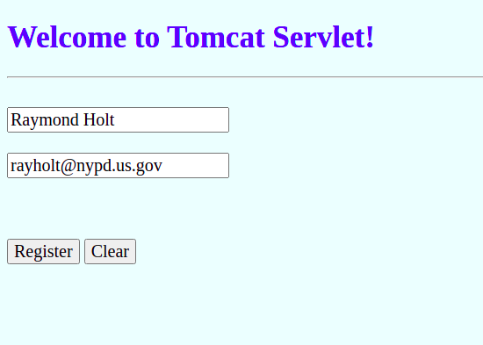

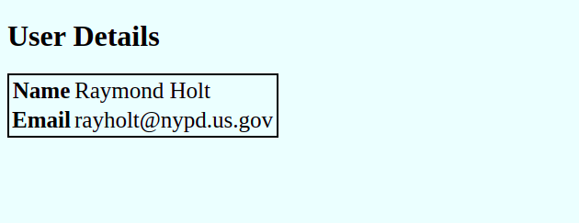

URL on Submit:

http://localhost:8080/servlet/servlet/Register?uname=Raymond+Holt&email=rayholt%40nypd.us.gov

