A4 – HTTP SESSION TRACKING
- S. Vishakan CSE – C 18 5001 196

HTML Code:

<html>
<head>
<title>HTTP Session</title>
<style>
body {background-color: powderblue;}
h1 {text-align: center; color: rebeccapurple;}
label {margin-right: auto; font-size: 25px; color: blue;}
input {margin-right: auto; font-size: 25px; color: red;}
</style>
</head>

<body>
<h1>HTTP Session Tracking</h1>
<div align="center">
<form action="ServletOne">
<label for="userName">User Name</label>
<input type="text" name="userName"><br><br>
<input type="submit" value="Let's Go!"/>
</form>
</div>
</body>
</html>

Java Code:

import javax.servlet.http.*;
import javax.servlet.*;
import javax.servlet.ServletException;
import java.io.*;

/*
HTTP Session creates a unique session ID for each different user (browser)
*/

public class ServletOne extends HttpServlet {
int hits; //variable for tracking user hits

public void doGet(HttpServletRequest request, HttpServletResponse response){
try{
response.setContentType("text/html");
PrintWriter out = response.getWriter();
HttpSession session = request.getSession(true); //new session
String u_name = request.getParameter("userName");
session.setAttribute("uname", u_name);
session.setMaxInactiveInterval(10);
//setting timeout of 10 seconds
if(session.getAttribute("hits") != null){
//not a new session, already counting hits
hits = (int) session.getAttribute("hits");
}
else{
//new session, initiate hits to 0
hits = 0;
}

hits++; //incrementing the number of hits
session.setAttribute("hits", hits); //store the value in an attribute

out.print("<h1>Welcome " + u_name + "!</h1><br>");
out.println("<h2>Your Session ID: " + session.getId() + "</h2><br>"); //printing session ID
out.println("<h2>Session Timeout: " + session.getMaxInactiveInterval() + " seconds</h2><br>");
out.println("<h2>Your Hits: " + hits + "</h2><br>");
out.close();
}
catch(Exception e){
System.out.println(e);
}
}
}

Web XML:

<web-app>
<servlet>
<servlet-name>ServletOne</servlet-name>
<servlet-class>ServletOne</servlet-class>
</servlet>
<servlet-mapping>
<servlet-name>ServletOne</servlet-name>
<url-pattern>/ServletOne</url-pattern>
</servlet-mapping>
</web-app>

Output:

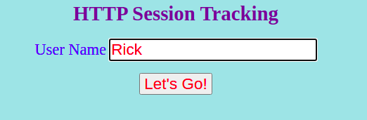

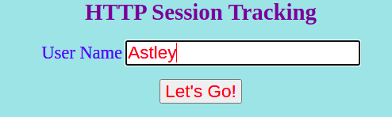

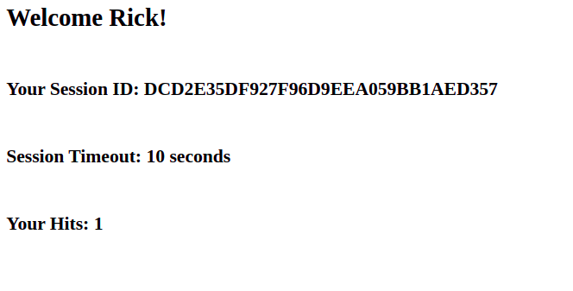
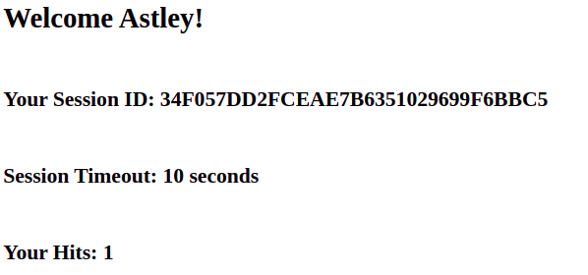
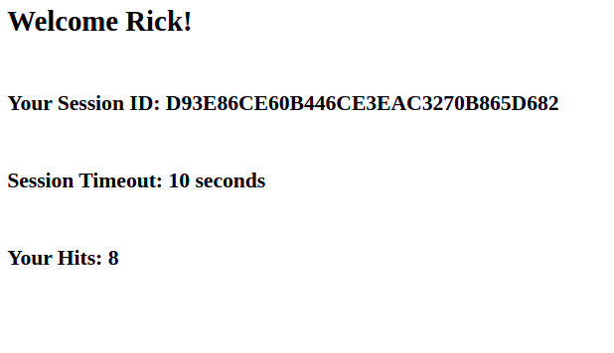
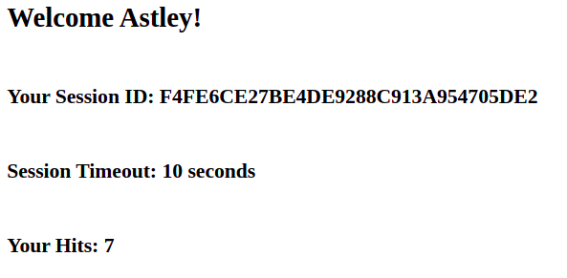

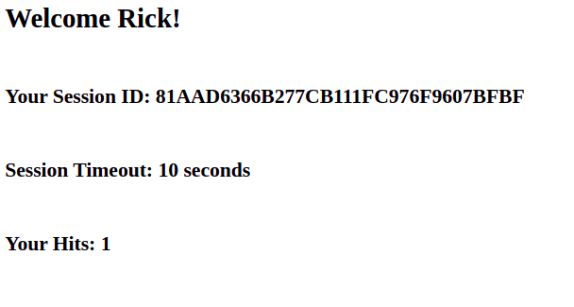

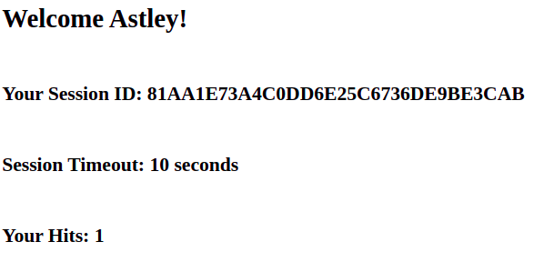
Inference:

Each browser(client) has its own unique HTTP SessionID which gets timed-out every 10 seconds following which a new session is instantiated with a different session ID. Each user has his/her own hits tracking variable unique to his/her session, which also gets purged after the session expires, and the tracker variable is re-initialized to 0 once again. Thus, multiple users are tracked by the servlet and each user’s actions are independent of the other users.

