*Implement the converge-cast algorithm as a recursion. [Input to the program is the root of the tree]*

*A tree is given in which each node has an integer (> 0 )value stored. Write a program so that*

*1- The root has the max values from all the nodes.*

*2- The root has all the values of all the nodes concatenated*

The folder contains 3 java files.

Node.java is the class for declaring object of type node.

Every node has a data variable and references to the left and right of the node

-🡪Tree.java is the driver class for finding the maximum value in the tree where input to the program is root.(Question 1

The tree constructed in the program has the following structure

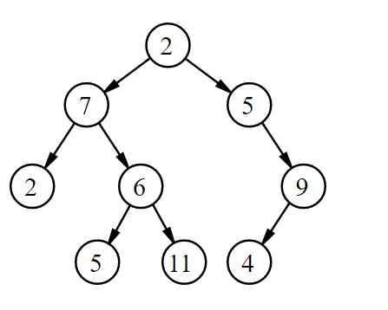

--> postorder.java is the driver program for question 2 . It outputs a list containing all the data inside every node of the tree, starting from root.

The traversal technique followed for this is post-order traversal from the root of the tree. Both programs share the common Node.java class for constructing nodes inside the tree.

To run the program :

1. Download Eclipse

2.Import folder

3.Run Tree.java: Question1

4.Run postorder.java: Question 2

Feel free to contact me for any further clarifications on the code or how to run the Java program.

______________________________________________________________________