FIT BUDDY
AI Fitness Plan Generator Using Gemini Models
Skill Wallet Project Documentation Format

Role | Name | Email Address
Team Leader | Visvappriya S | svishvappriya@gmail.com
Team Member | Majithra M | mmajithra2007@gmail.com
Team Member | Hemappriya | hemapriyas1803@gmail.com
Team Member | Sivapriya S | sivapriyasekar2008@gmail.com
Team Member | Vidharshana Manikandan | shanashana1281@gmail.com
Team ID: SWTID-2026-8325 • Team Size: 5
1. Topic Links
Python Flask: Flask web application development and routing
Google Gemini AI: Gemini model integration for AI-generated fitness plans and AI chat
HTML, CSS & Jinja2: Frontend pages and dynamic Flask templates
Python Programming: Application logic, calculations and services
SQLite & SQLAlchemy: User, fitness profile and fitness plan data storage
Git & GitHub: Version control and project repository
Virtual Environment: Python dependency and development environment setup
2. Pre-Requisites
- Python 3.x installed
- Python virtual environment configured
- Flask and required Python packages installed
- SQLite available through the application database setup
- Google Gemini API key configured in .env
- Basic knowledge of Python, HTML, CSS and Jinja2
- Git and GitHub account for source-code submission
3. Project Workflow
1. Model Selection and Architecture: Select Gemini model and define the Fit Buddy application architecture.
2. Core Functionalities Development: Develop fitness calculations, profile handling, AI plan generation, plan history and AI chat.
3. Flask Application Development: Implement Flask routes, authentication, database operations and Gemini service integration.
4. Frontend Development: Build responsive pages using HTML, CSS, Bootstrap-style components and Jinja2 templates.
5. Deployment: Prepare the project for local execution and GitHub-based project submission/deployment.
4. Epic 1: Model Selection and Architecture
Fit Buddy uses Google Gemini AI as the generative AI component. The application architecture connects the Flask backend, SQLite database, fitness calculations, user authentication, templates and Gemini service.
- Research and select a suitable Gemini model for text generation.
- Define the application flow from registration to fitness profile and AI plan generation.
- Define the database entities for users, fitness profiles and generated plans.
- Configure the development environment and environment variables.
5. Epic 2: Core Functionalities Development
The core functionality collects fitness information and converts it into a personalized weekly fitness plan. The application also supports plan history and an AI chat feature for questions about the current plan.
- User registration and login.
- Create and update a fitness profile.
- Calculate BMI, BMR and estimated maintenance calories.
- Generate a 7-day fitness plan using Gemini AI.
- Display workout, recovery, nutrition, progress and safety guidance.
- Store generated plans in SQLite.
- Provide AI chat for questions related to the generated plan.
6. Epic 3: Flask Application Development
The Flask backend acts as the main application layer. It manages authentication, database operations, profile processing, plan generation and AI chat requests.
- Configure Flask application and extensions.
- Implement authentication routes and login protection.
- Implement dashboard, profile, plan and admin routes.
- Connect SQLAlchemy with SQLite.
- Connect the Gemini service through the application service layer.
- Validate user access to fitness plans.
7. Epic 4: Frontend Development
The frontend provides a simple college-project-level interface for Fit Buddy. Jinja2 templates render the pages dynamically from Flask.
- Develop Home page.
- Develop Register and Login pages.
- Develop Create Fitness Profile / My Fitness Profile page.
- Develop Dashboard page.
- Develop AI Generated Plan page.
- Present 7-Day Workout, Recovery, Nutrition, Progress and Safety sections.
- Add AI Chat interface for plan-related questions.
- Maintain consistent responsive styling across pages.
8. Epic 5: Deployment
The project is prepared so that it can be run locally and maintained through GitHub. Environment variables and generated database files are kept outside source control.
- Create and activate Python virtual environment.
- Install dependencies from requirements.txt.
- Configure the .env file with the Gemini API key.
- Run the Flask application using run.py.
- Verify all main application pages and Gemini integration.
- Initialize Git and push the project to GitHub.
- Do not commit .env, API keys or local database files.
9. Project Structure
fit-buddy-ai/
├── app/
│ ├── __init__.py
│ ├── auth.py
│ ├── calculator.py
│ ├── extensions.py
│ ├── main.py
│ ├── models.py
│ ├── services/
│ │ └── gemini_service.py
│ ├── templates/
│ │ ├── base.html
│ │ ├── home.html
│ │ ├── login.html
│ │ ├── register.html
│ │ ├── profile.html
│ │ ├── dashboard.html
│ │ ├── plan.html
│ │ └── admin.html
│ └── static/
│ └── css/style.css
├── instance/fitbuddy.db
├── .env
├── .env.example
├── .gitignore
├── README.md
├── PROJECT_REPORT.md
├── requirements.txt
└── run.py
10. Application Flow
- Home → Register → Login
- Login → Create Fitness Profile / My Fitness Profile
- Fitness Profile → Dashboard
- Dashboard → Generate AI Fitness Plan
- AI Generated Plan → 7-Day Workout → Recovery → Nutrition → Progress & Safety
- AI Generated Plan → AI Chat
- Generated plans → Plan History / Dashboard
11. GitHub Submission
GitHub Repository: Add the team's actual GitHub repository URL here.
Suggested repository name: fit-buddy-ai
Important: Never commit the .env file, Gemini API key, or local SQLite database.
12. Conclusion
Fit Buddy demonstrates how Python Flask, SQLite and Google Gemini AI can be combined to create a simple personalized fitness planning web application. The project covers authentication, fitness profile management, health-related calculations, AI-generated weekly planning and an AI chat interface.
- The application follows a clear user flow from registration to personalized plan generation.
- The project provides a practical example of integrating Generative AI into a web application.
- The application is intended as a college project demonstration and provides general fitness guidance rather than medical advice.

Fit Buddy • College Student Project • Python Flask • SQLite • Google Gemini AI

13. Application Screenshots
The following screenshots document the main user interface and workflow of the Fit Buddy application, from the landing page and account creation through profile setup, dashboard, AI plan generation and AI chat.
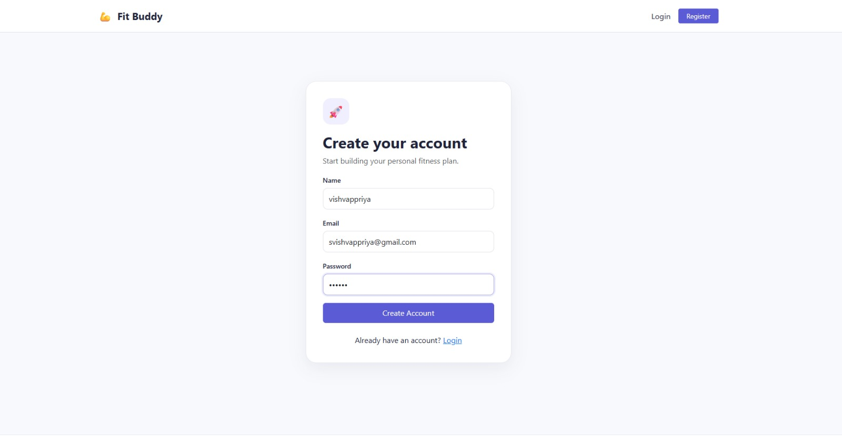
Figure 1. Fit Buddy Home Page

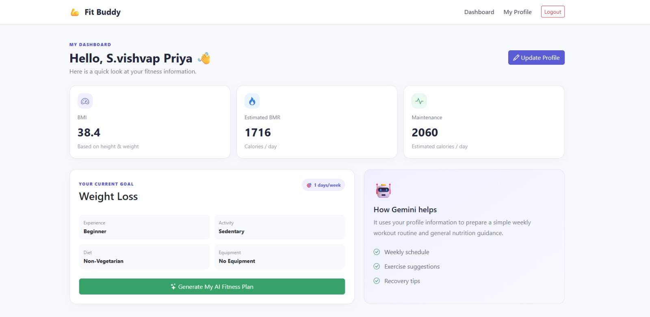
Figure 2. User Registration – Create Your Account

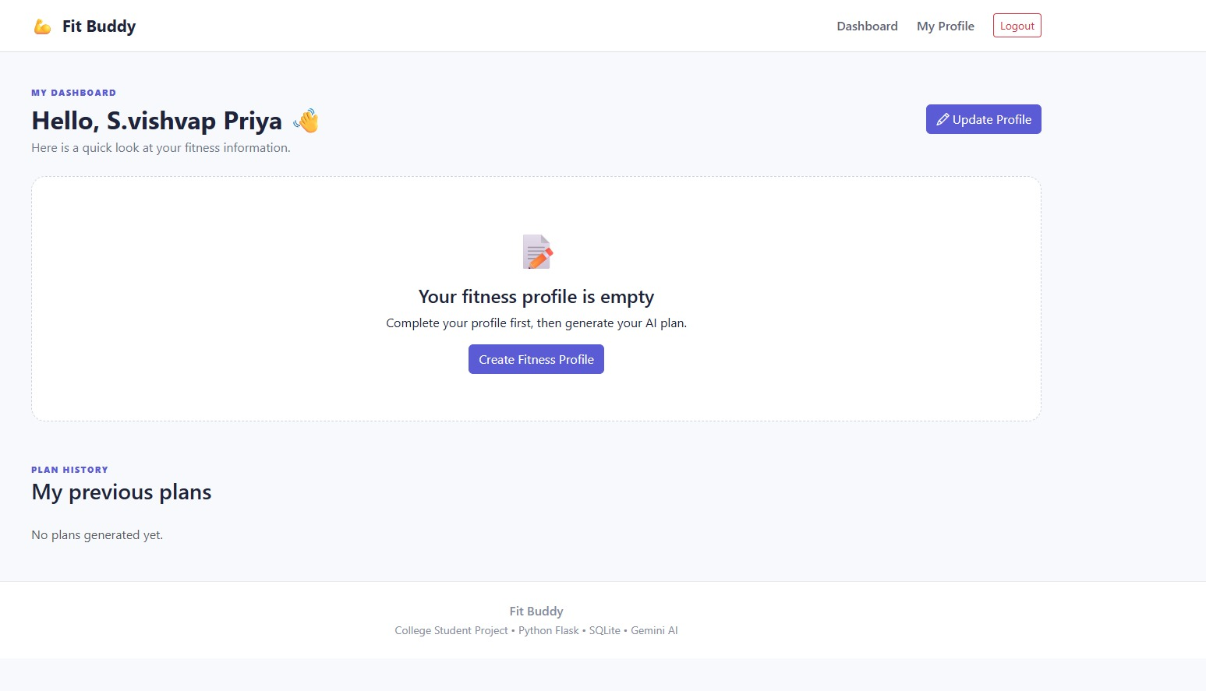
Figure 3. Fitness Profile – Enter Personal and Workout Details

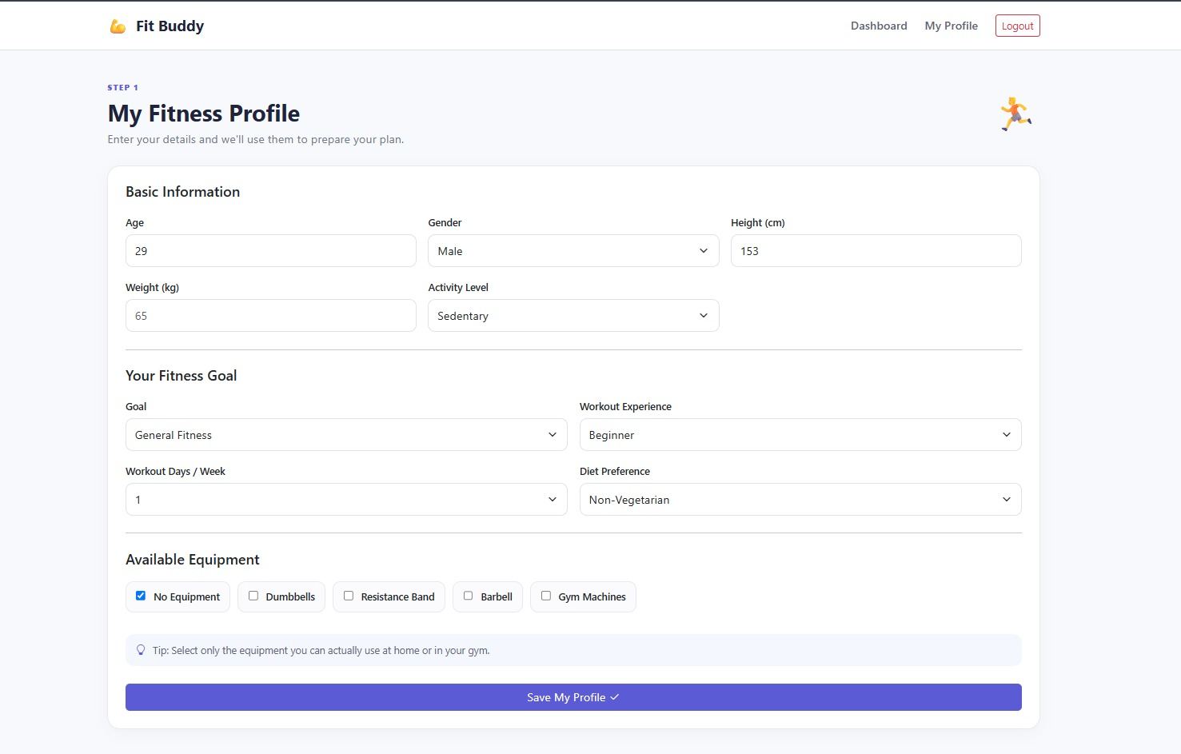
Figure 4. Dashboard – Fitness Summary and AI Plan Generation

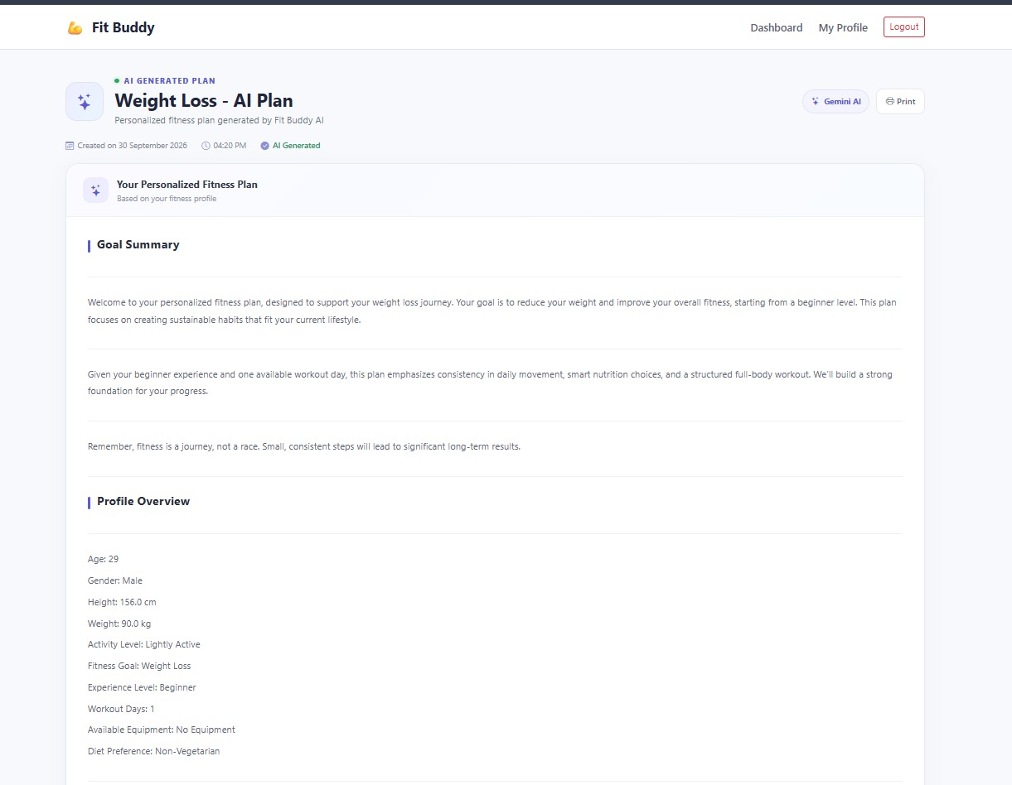
Figure 5. Dashboard – Empty Fitness Profile State

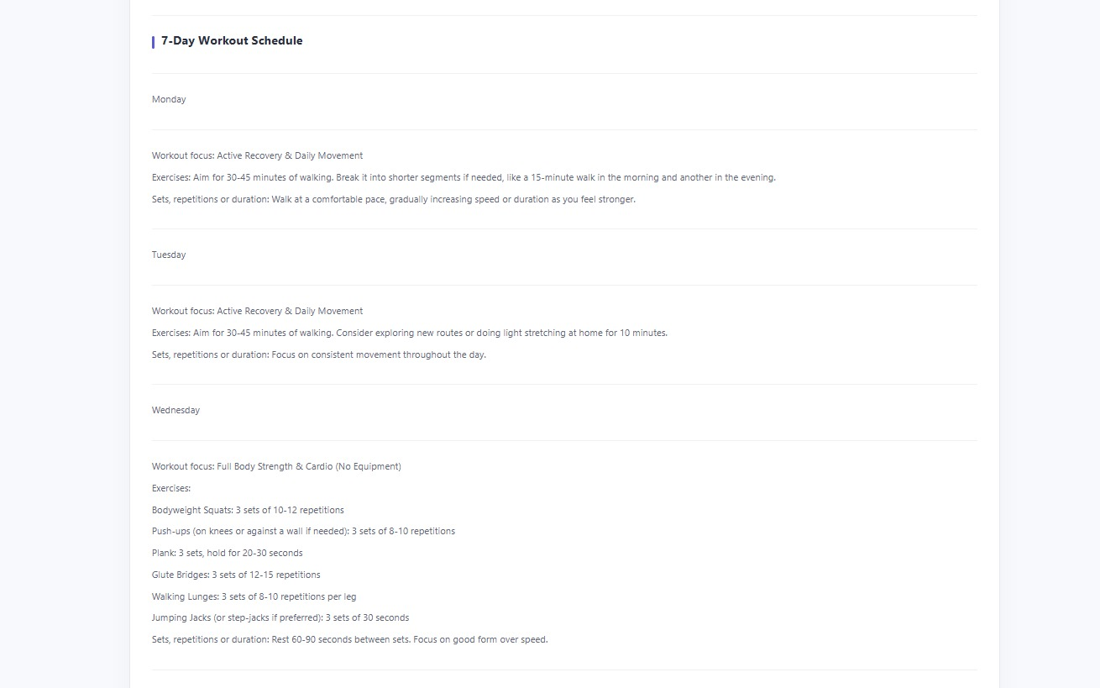
Figure 6. AI Generated Plan – Plan Overview

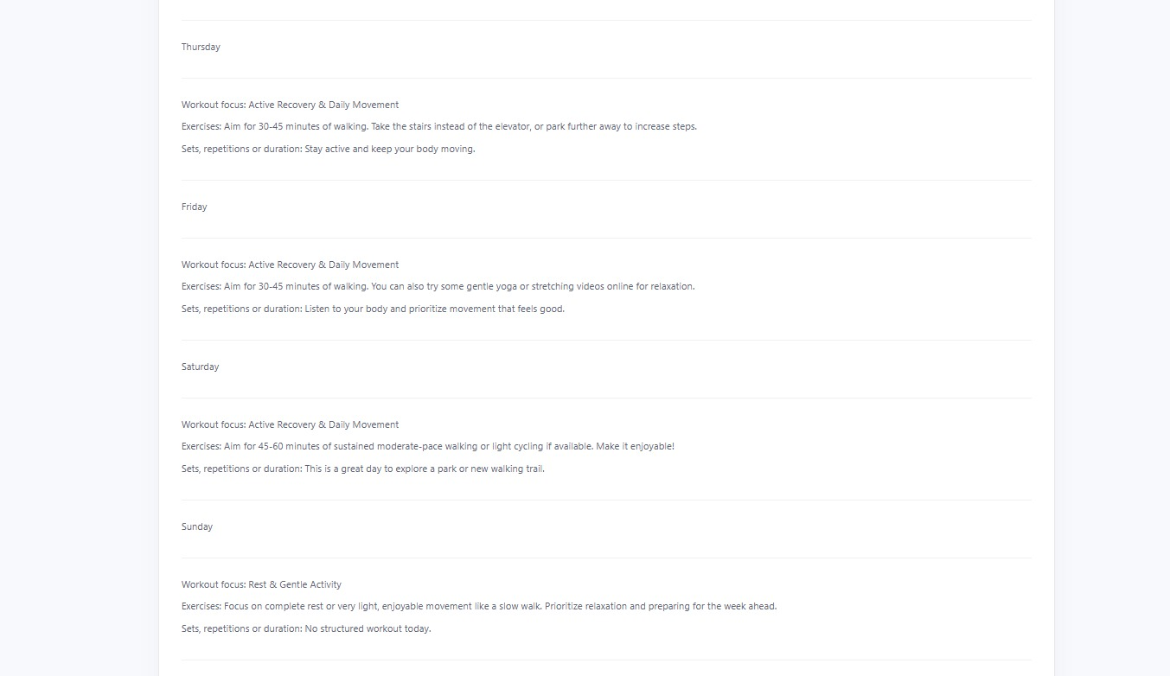
Figure 7. AI Generated Plan – 7-Day Workout Schedule (Part 1)

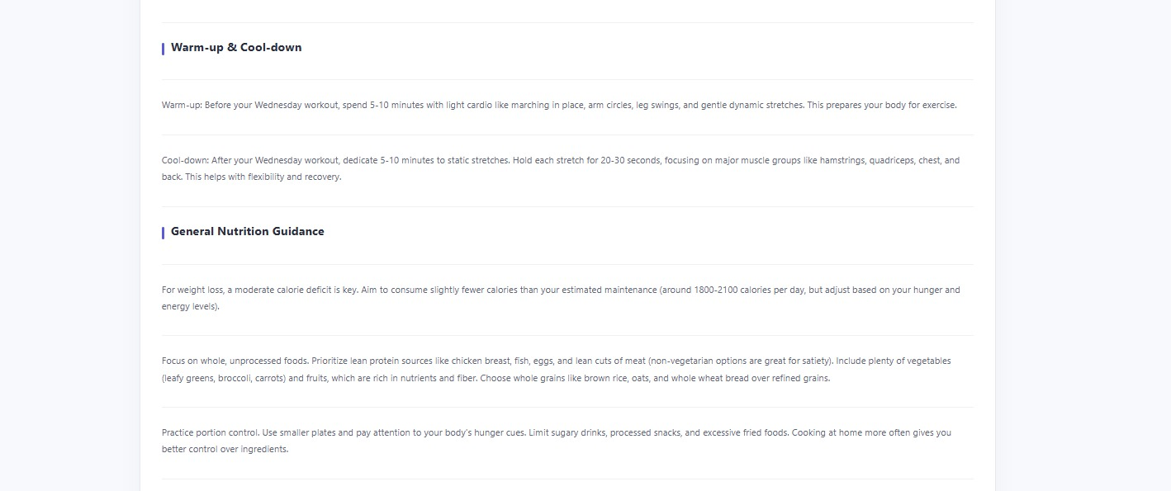
Figure 8. AI Generated Plan – 7-Day Workout Schedule (Part 2)

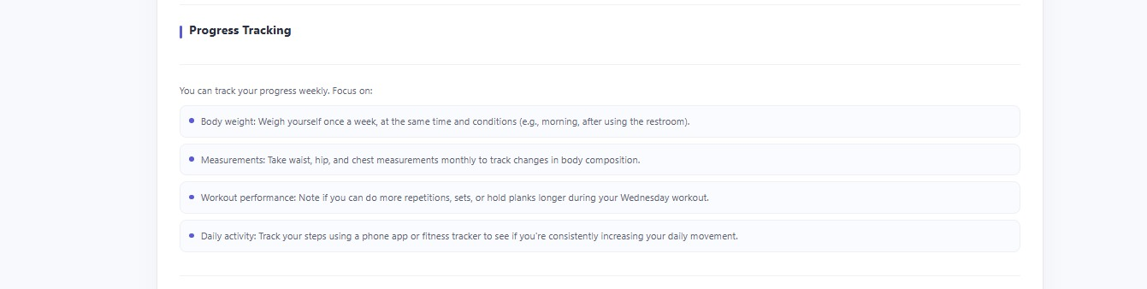
Figure 9. AI Generated Plan – Warm-up, Cool-down and Nutrition Guidance

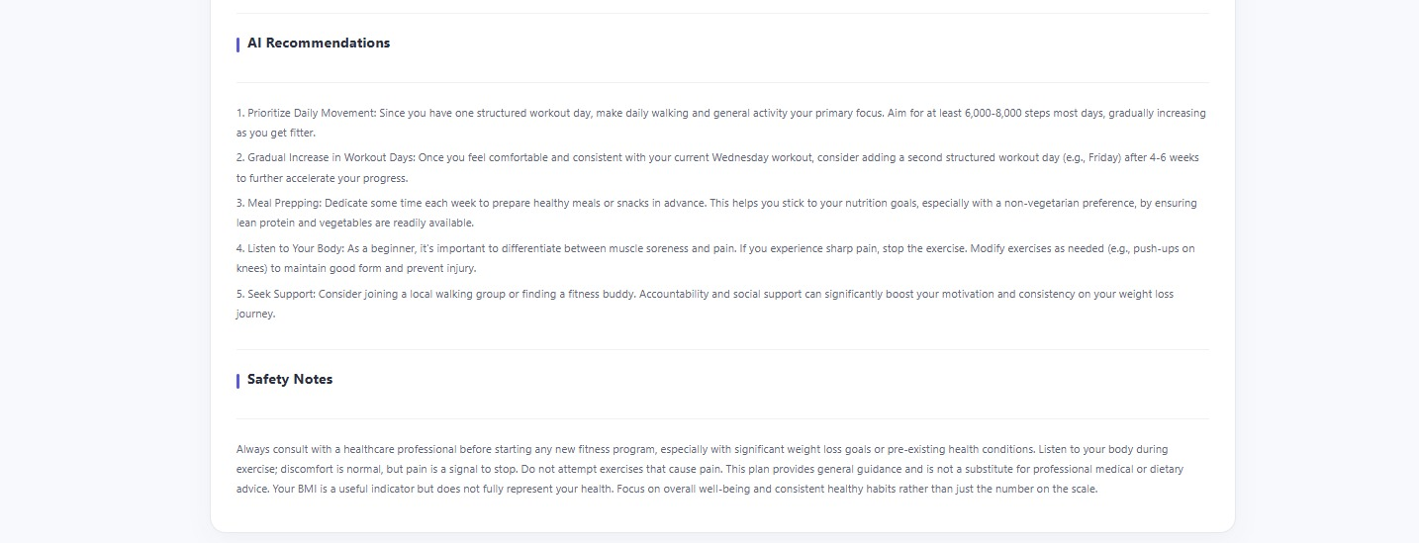
Figure 10. AI Generated Plan – Progress Tracking

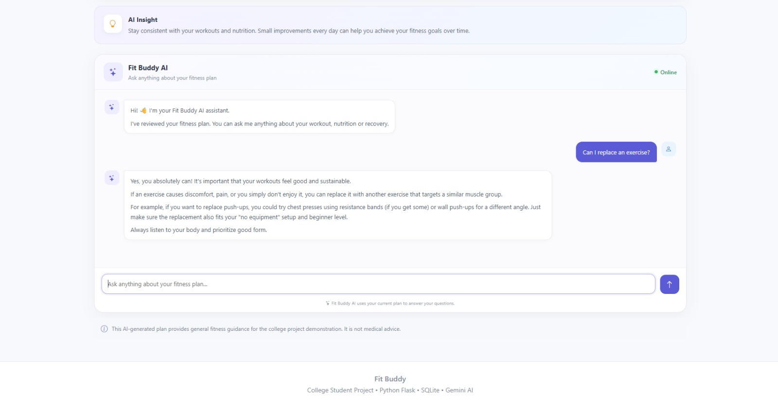
Figure 11. AI Generated Plan – AI Recommendations and Safety Notes

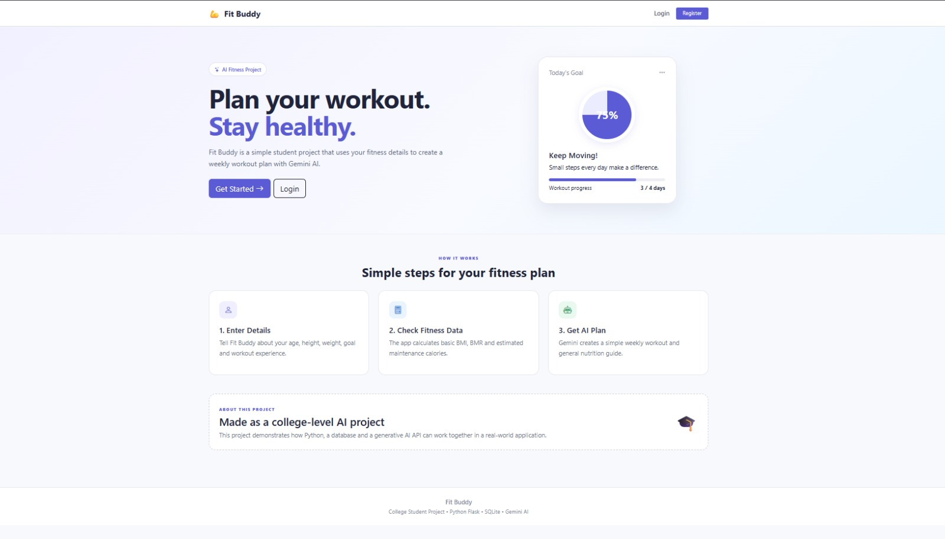
Figure 12. Fit Buddy AI – Plan Question and Answer Chat

Figure 13. User Registration – Additional Screenshot
Note: The screenshots are included as submitted for Skill Wallet documentation. The final registration screenshot is retained as an additional UI capture.

