PROBLEM : TO PURCHASE GROCERY ITEMS FROM YOUR FAVOURITE SHOPS FROM ONLINE

SOLUTION : PURCHASE THROUGH ATOZ

ABSTRACT:

CUSTOMERS CAN SELECT GROCERY ITEM FROM SINGLE SHOP OR FROM MULTIPLE SHOPS

1. RESTRICTING THE USER BY GEOGRAPHY

TYPES OF USERS:

1. ADMIN

2. GROCERY SHOPS

3. CUSTOMERS

4. DELIVERY PERSONS

ADMIN MODULE:
# NEED TO HAVE INDIVIDUAL LOGIN FOR EACH TYPE OF USERS TO MAINTAIN THEIR DATA SEPARATELY
# HAS THE ACCESS TO ADD OR REMOVE THE USER DETAILS IN THEIR LOGIN RESPECTIVELY

SHOP MODULE:
# SHOP HAS TO REGISTER THEMSELVES TO GET AN INSIGHT ABOUT OUR ATOZ
# SHOP HAS TO SELECT THE TYPES OF MEMBERSHIP AVAILABLE WITH US
# AFTER SELECTING SUITABLE MEMBERSHIP THEY WILL BE REDIRECTED TOWARDS PAYMENT PAGE
# RESTAURANT MAKES THE PAYMENT TO BECOME A MEMBER IN ATOZ
# PROFILE WILL BE CREATED FOR THE SHOP
# THERE WILL BE AN OPTION PROVIDED TO STOP THE SERVICE
# THE SHOP CAN PROPOSE THEIR NAME,SET A PROFILE PIC, ADD BANNERS AND ADD DESCRIPTION ABOUT THEM
# THE SHOP WILL BE ENABLED TO ADD THEIR MENUS
# THE SHOP CAN ADD THE CATEGORIES, COMBOS AND COST OF THE GROCERIES IN MENU PAGE
# THERE WILL BE OPTION TO TRACK THE ORDER
# SHOP WILL BE ENABLED TO INTERACT WITH CUSTOMERS AND WITH ADMIN
# ONCE EVERYTHING IS DONE THE SHOP IS READY TO SERVE THE CUSTOMERS
# SHOPS PROVIDING OFFER HAS TO BE STATED ON THEIR PAGE

CUSTOMER MODULE:
# CUSTOMER HAS TO REGISTER THEMSELVES TO USE ATOZ
# AFTER REGISTERED THEY HAVE TP LOGIN USING GMAIL OR USING PHNO
# PROFILE WILL BE CREATED FOR CUSTOMER
# IN THAT PROFILE U CAN PROPOSE THEIR NAME, SET A PROFILE PIC
# THEY CAN SEARCH BY SHOP NAME OR BY PRODUCT NAME
# AFTER SEARCHED THEY CAN ADD THEIR ITEMS TO CART
# OFFERS PROVIDED BY THE SHOP WILL BE AVAILBLE .THEY CAN SELECT BASED ON CONDITION
# THEY NEED TO CONFIRM THEIR CART BY CLICKING CONFIRM BUTTON
# THEY NEED TO SELECT PAYMENT METHOD
# FINALLY ORDER WILL BE PLACED AFTER SWIPPING PURCHASE BUTTON
# THEY CAN TRACK THEIR ORDER BY CLICKNG TRACK YOUR ORDER BUTTON
# THEY CAN CANCEL THEIR ORDER BY CLICKING CANCEL BUTTON
# IN YOUR PROFILE U CAN SEE YOUR ORDER HISTORY . IF U NEED SAME ORDER AGAIN U CAN REORDER FROM THERE BY CLICKING REORDER BUTTON
# IN YOUR PROFILE THERE WILL BE OPTION AVAILBLE FOR PRIME MEMBERSHIP.
# CUSTOMERS CAN BECOME PRIME MEMBERS BY SUBSCRIBING IT
# RATING OPTION WILL BE AVAILABLE FOR THE PRODUCT AFTER IT HAS BEEN DELIVERED TO THE CUSTOMER
# RATING OPTION FOR DELIVERY PERSON ALSO AVAILABLE
# THERE IS QUERY OPTION AVAILBLE IN WHICH CUSTOMER CAN CLEAR THEIR QUERIES WITH ATOZ

DELIVER PERSON:
# DELIVERY PERSON HAS TO REGISTER TO GET LOGIN ACCESS TO WORK IN ATOZ
# HE HAS TO CHOOSE TYPE OF MEMBERSHIP TO BECOME MEMBER IN ATOZ
# PROFILE WILL BE CREATED FOR THE DELIVERY PERSON
# THERE WILL BE AN OPTION PROVIDED TO STOP THE SERVICE
# HE CAN PROPOSE HIS NAME,SET A PROFILE PIC,AND ADD DESCRIPTION ABOUT HIM IN HIS PROFILE TAB
# DELIVERY PERSON WILL BE ALLOCATED WITH CERTAIN LOCATIONS
# ALL THE ORDERS RECIEVING FROM THAT LOCATION WILL BE FORWARDED TO THAT DELIVERY PERSON
# ONCE HE PICKED ORDER FROM THE SHOP HIS CONTACT NUMBER AND NAME WILL BE DISPLAYED TO THE CUSTOMER
# DELIVERY PERSON RATING WILL BE SHOWN IN HIS PROFILE

--------------------------------------------------------------------------------------------------------------------------------------

WORKFLOW

LOGIN PAGE:
*Facebook
*Google
*signup => send otp => confirm
*login
*forgot password => send email => confirm
*captcha
*help

Home page for user:
*ATOZ
*location
*search button
* cart button
* profile
Location page for user :
*current location using gps
* saved address
Search button page for user :
*search by shop name or item
* add items
Cart button page for user:
# IF NO ITEM PRESENT
* browse shops

# IF ANY ITEM ALREADY AVAILABLE IN CART
*apply coupon
*delivery instructions
*make payment => preferred payment method

Profile page for user:
*edit=>name/phno/email address
*address
*payments
*membership => select a plan
*help
*order history => reorder& rate order

Payments page (profie):
*saved cards => delete
* add new card => fill details => add card
* link account(like amazon pay , phonpe, paytm)

PAGES FOR SHOPS:
*home
*orders => orders history
*menus
*profile

Home page for shops:
*accept or decline order
* amount earned
*start/close
Orders page for shops:
*accepted orders list
*orders history
* order picked by
Menus page for shops
*upload pic
*add price
*add items/delete items
*your items
Profile page for shops:
*edit=>name/phno/email address
*address
*payments
*membership => select a plan
*help
*your ratings

Pages for Delivery person:
*home
*orders
*profile
Orders page for delivery person:
*View location
*call
*order history
profile page for delivey perosn:
*edit=>name/phno/email address
*address
*membership => select a plan
*help
*your ratings

Admin module:
*shop
*customer
*delivery person
Shop page for admin:
*list of shop => shop entire details
* membership details
* payments details
Customer page for admin:
*list of customers => customer entire details
*membership details

Delivery person page for admin:
*list of delivery person => deliverperson entire details
*payment details

WIRE FRAME:

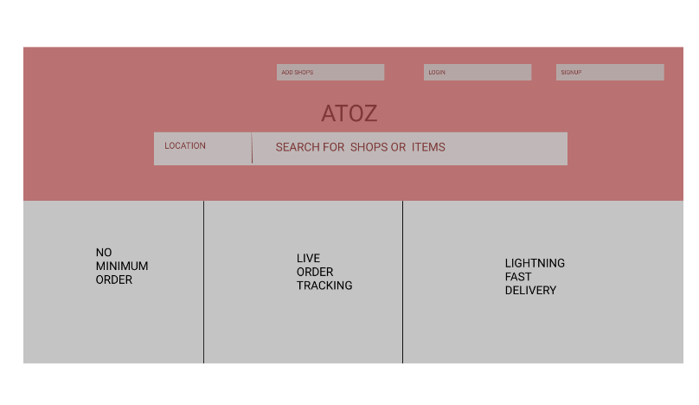
ATOZ PAGE

SIGNUP PAGE :
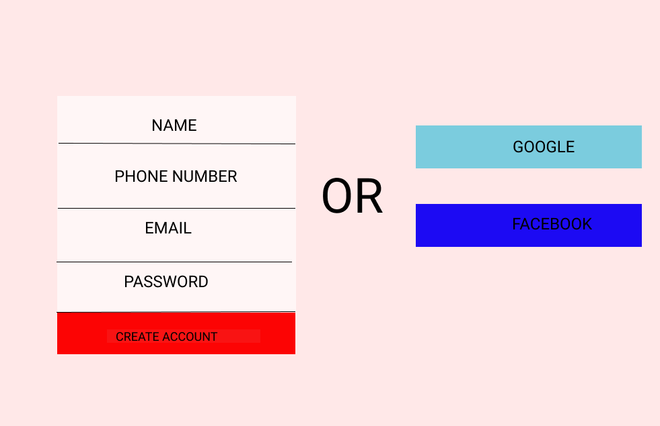
LOGIN PAGE
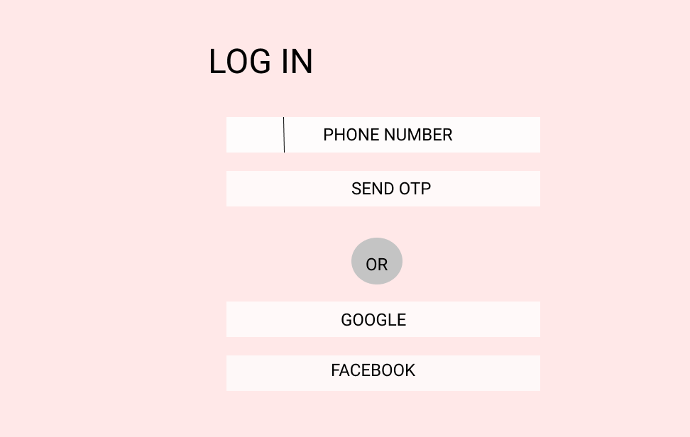
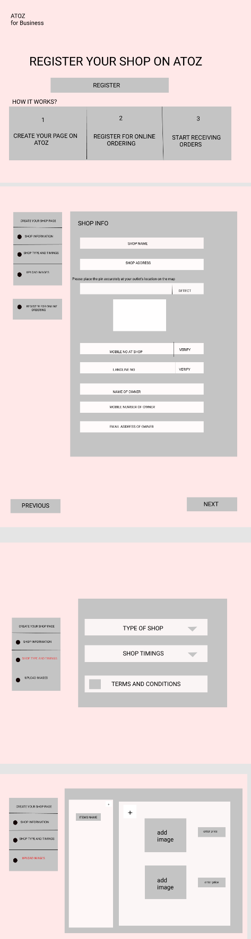
REGISTER SHOP TO ATOZ

HOME PAGE FOR SHOP

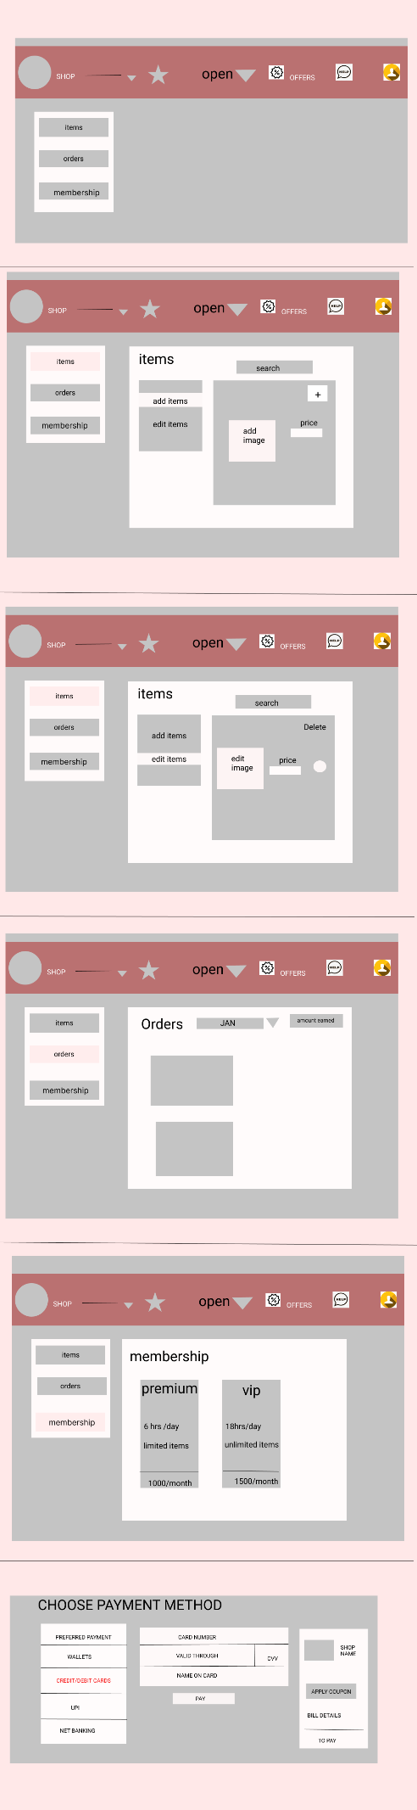

PAYMENT PAGE FOR SHOP

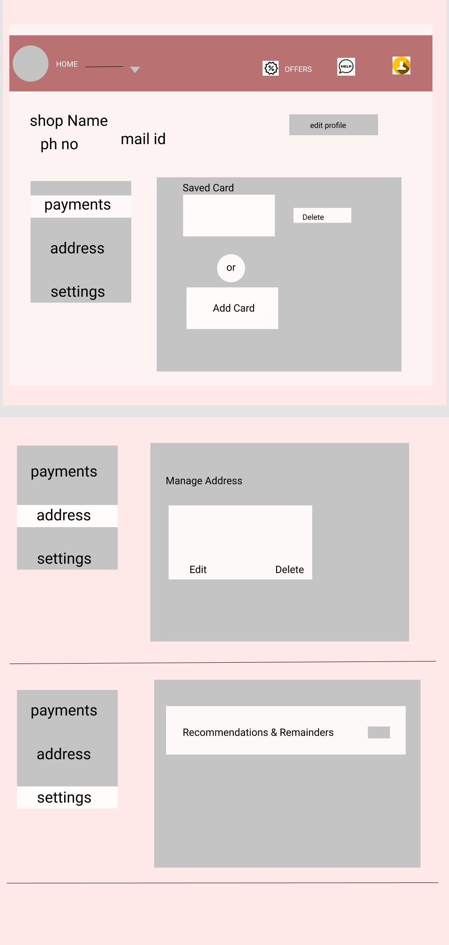
PROFILE PAGE FOR SHOP

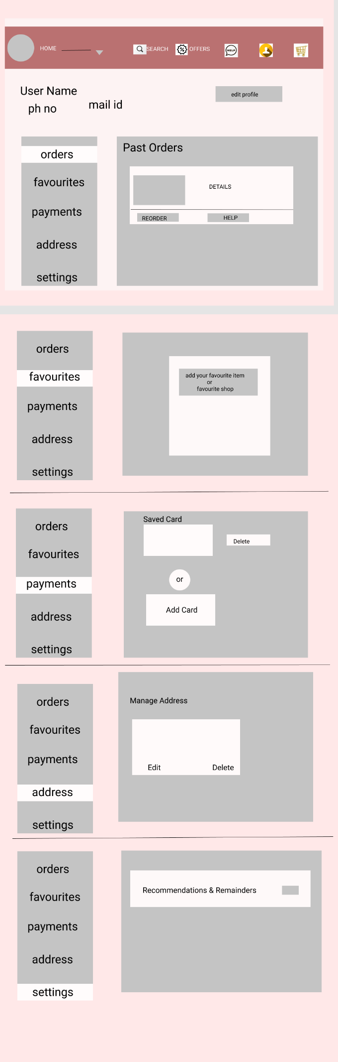
USER PROFILE PAGE

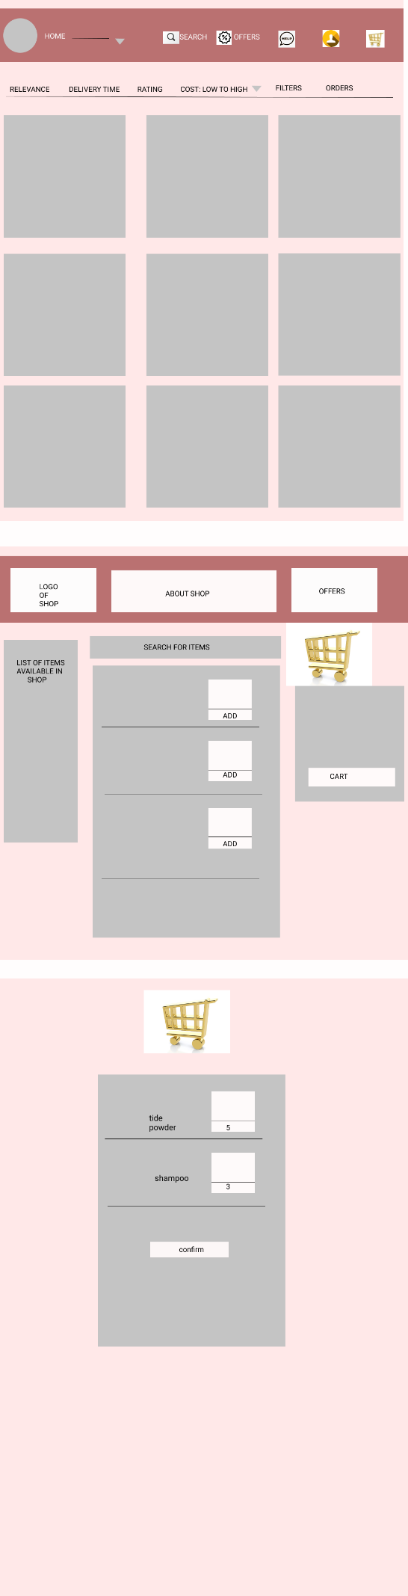
USER HOME PAGE

PAYMENT PAGE FOR USER
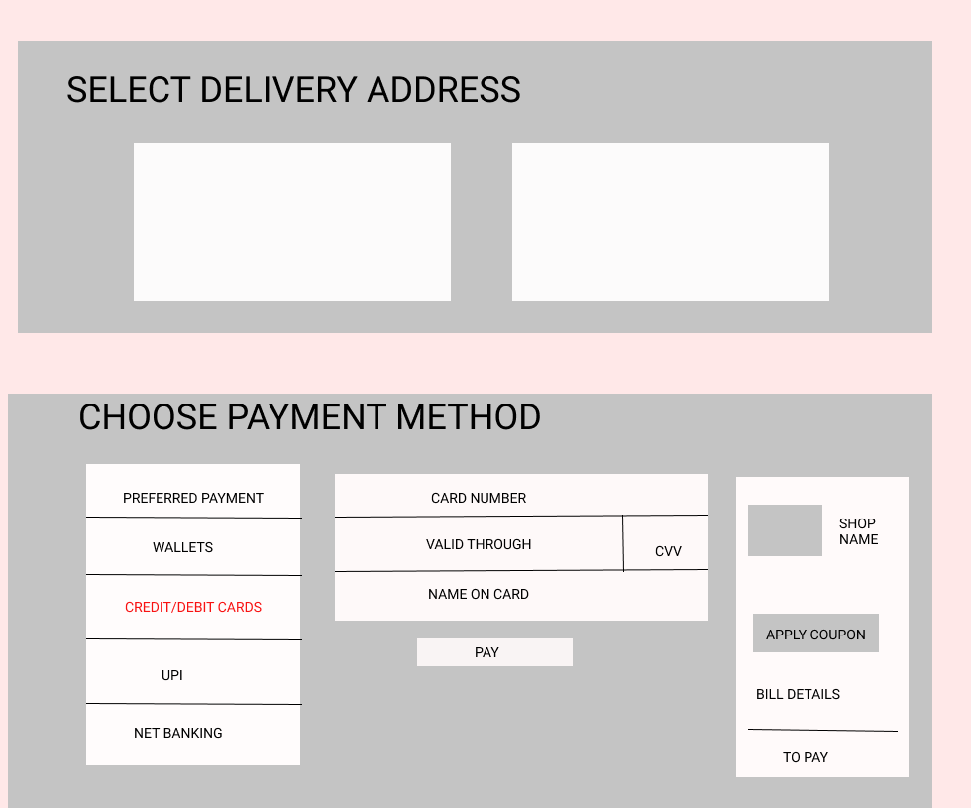

USER HELP PAGE

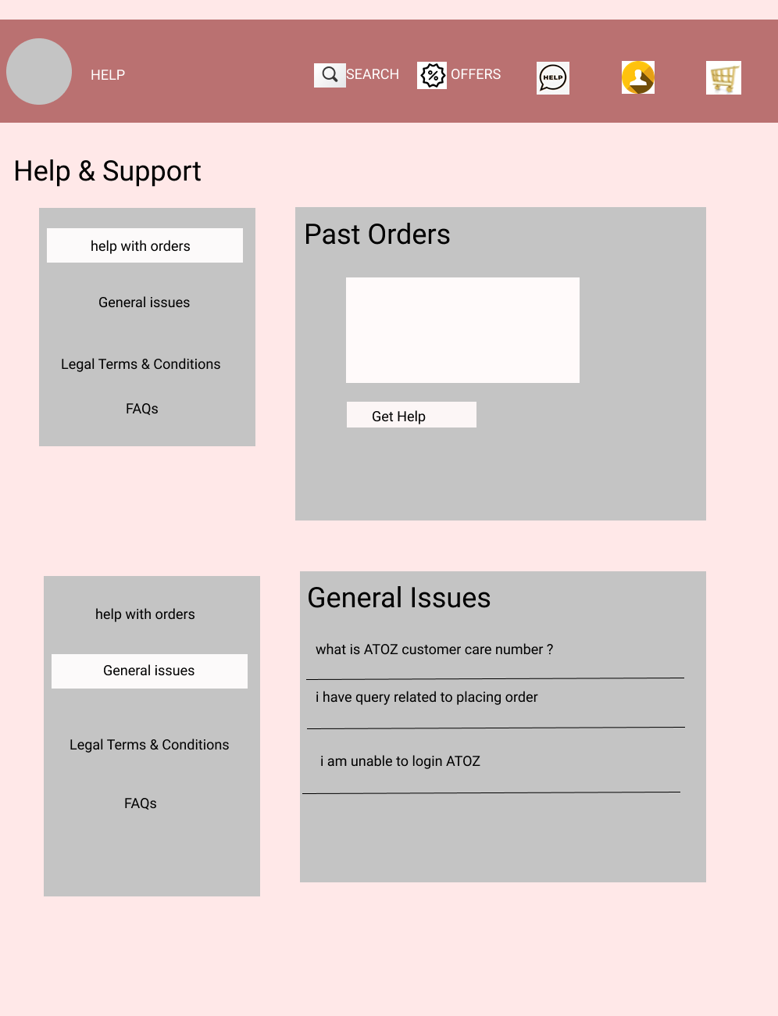

HOME PAGE FOR DELIVERY PERSON
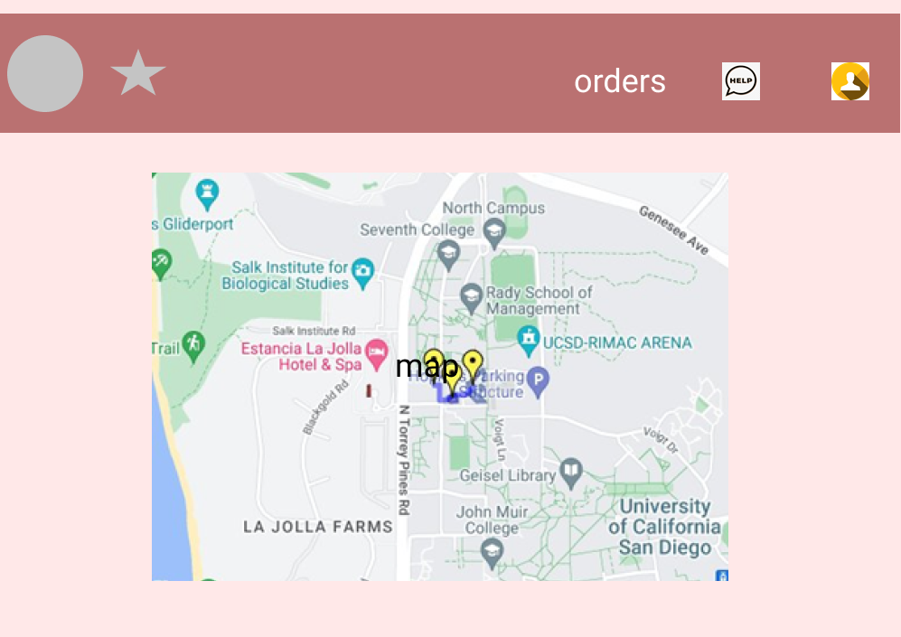

PROFILE PAGE FOR DELIVERY PERSON
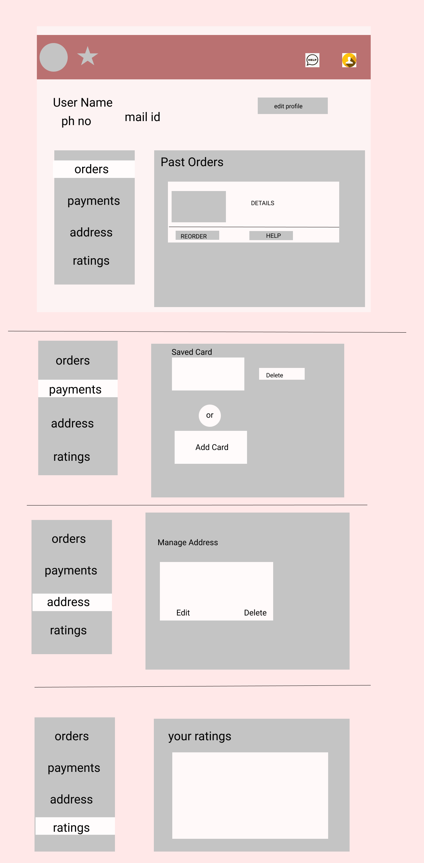

ORDER PAGE FOR DELIVERY PERSON
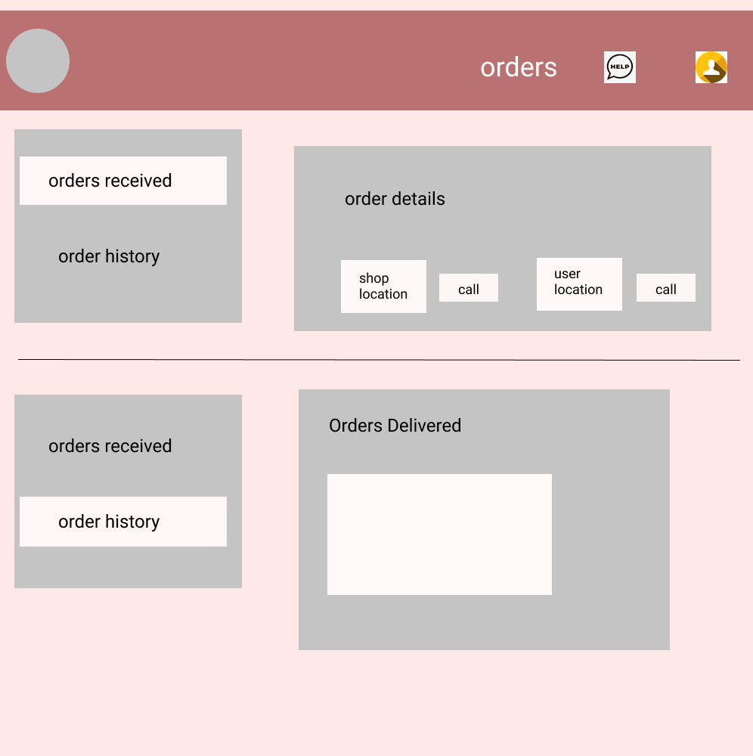

ADMIN PAGE
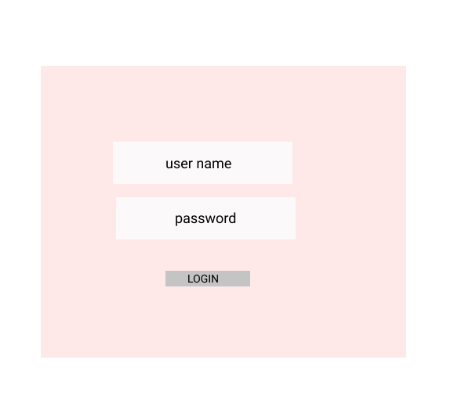

ADMIN HOME PAGE:
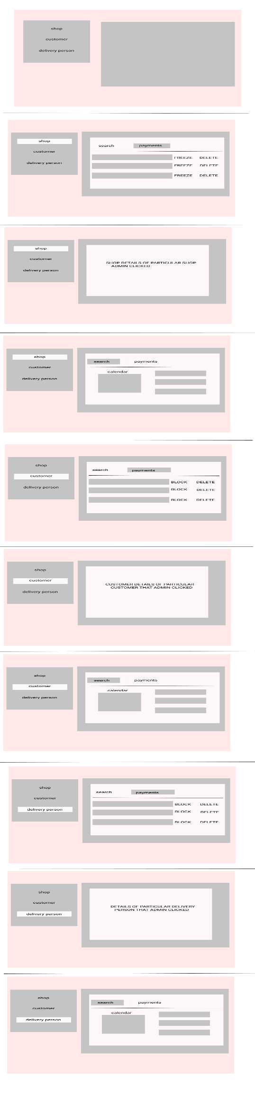

DATABASE DESIGN:

SIGNUP PAGE:
User name
User phno (PK)
User mail id
Password
Faceebook id
Google account id

LOGIN PAGE:
Phone number (PK)
Otp number
Google id
Facebook id

ADD SHOP :
SHOP NAME
SHOP ADDRESS
SHOP LOCATION
SHOP MOBILE NUMBER (PK)
SHOP LANDLINE NUMBER
NAME OF THE OWNER
MOBILE NUMBER OF THE OWNER
EMAIL ADDRESS OF THE OWNER
TYPE OF SHOP
SHOP TIMINGS

TYPE OF ITEMS
ID TYPE
EXAMPLE O1 OIL
W1 WHEAT
R1 RICE

SHOP ITEMS LIST
SHOP_ID (PK)
SHOP_ITEMS_ID
MEMBERSHIP
ITEM_ID (FK)
MENU_NAME
QTY
PRICE
PHOTO
DESCRIPTION

SHOP_ID SHOP_ITEMS_ID MEMBERSHIP ITEM_ID Menu_Name QTY Price Foto Description
Af_1 R001 VIP O1 GINGER OIL 1L 300 img Tasty
Af_2 R001 PREMIUM O2 FORTUNE OIL 1L 190 Img Good

ORDER DETAILS:
ORDER ID (PK)
ITEM_ID(FK)
CUSTOMER_ID
PRICE
DATE
TIME
QTY
ORDER ID ITEM ID CUS_ID DATE TIME QTY PRICE
1001 R1 1514 24/2/2022 4.30PM 1KG 200
1002 O1 5515 24/2/2022 5.30PM 1L 120

SHOP PAYMENT PAGE
PAYMENT ID(PK)
CUS_ID
AMOUNT
MONTH
YEAR

YEAR MONTH PAYMENT_ID CUS_ID AMOUNT
2020 5 565565 13584 5200
68484 43515 3500
46845 54352 450

