Zmień ten tytuł

## Plik - ['B01.png']

### Fragments [[[20, 20, 60, 60], [100, 100, 140, 140], [60, 60, 100, 100], [140, 140, 200, 200]]]

fragment [20, 20, 60, 60]

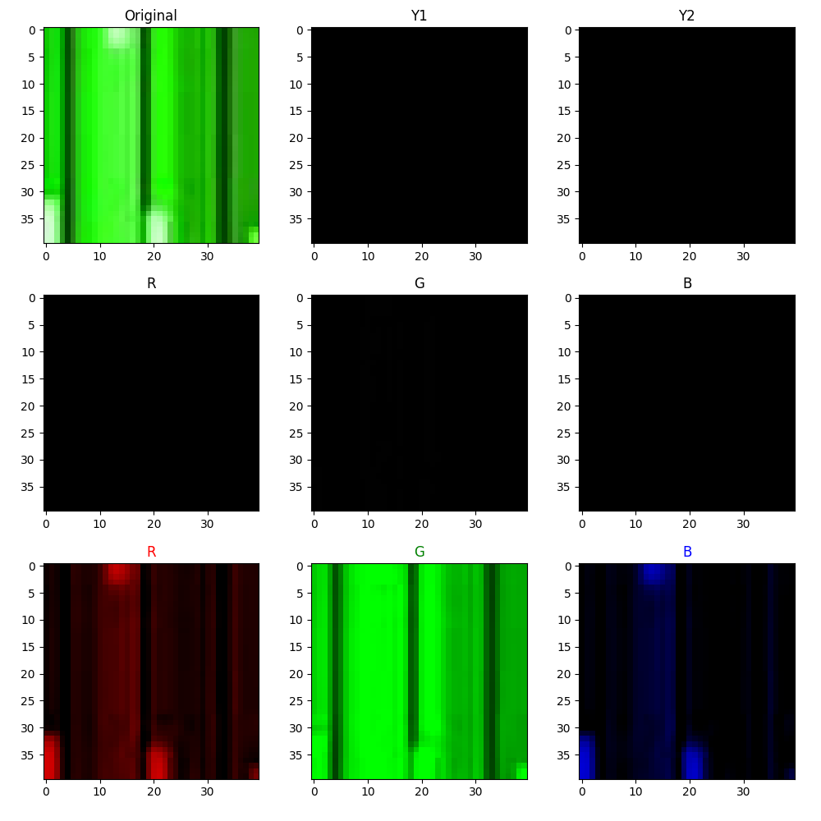

fragment [100, 100, 140, 140]

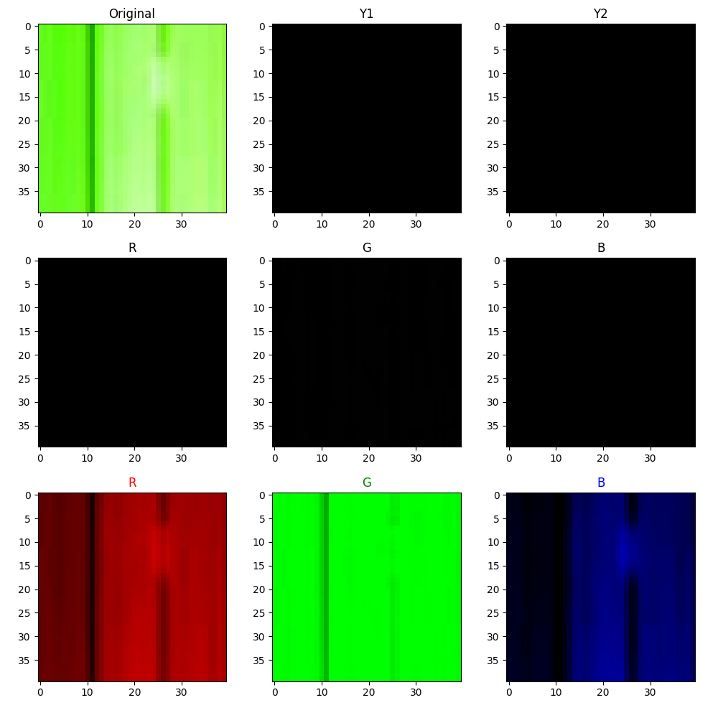

fragment [60, 60, 100, 100]

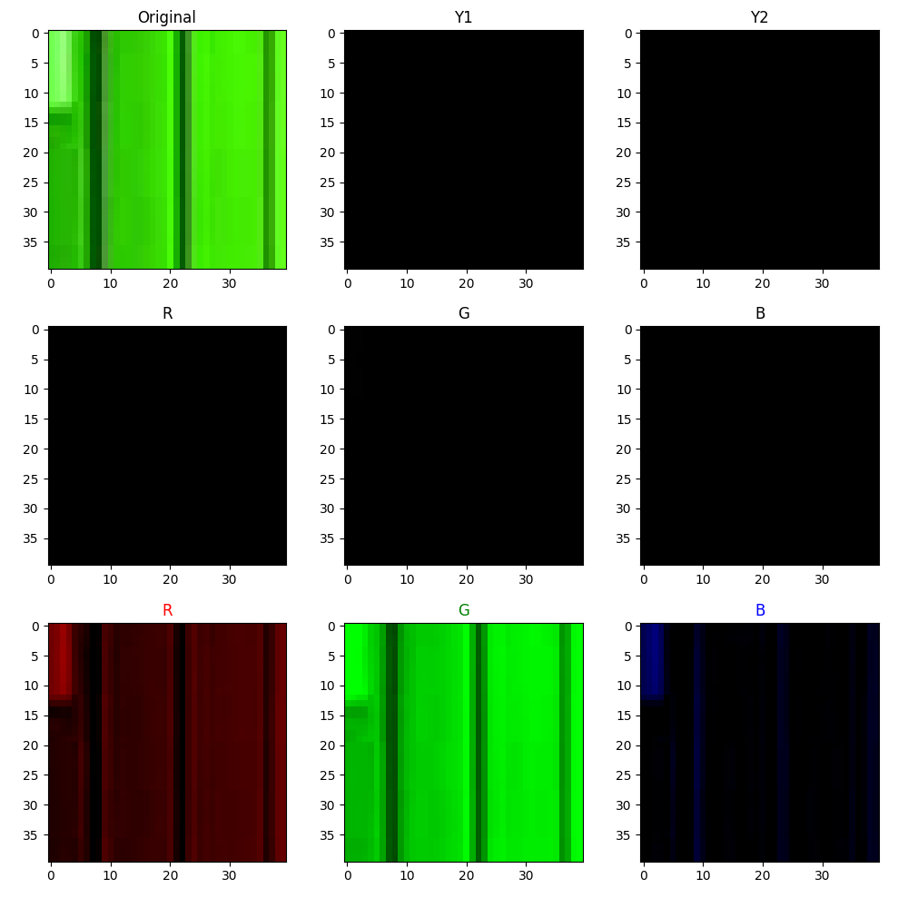

fragment [140, 140, 200, 200]

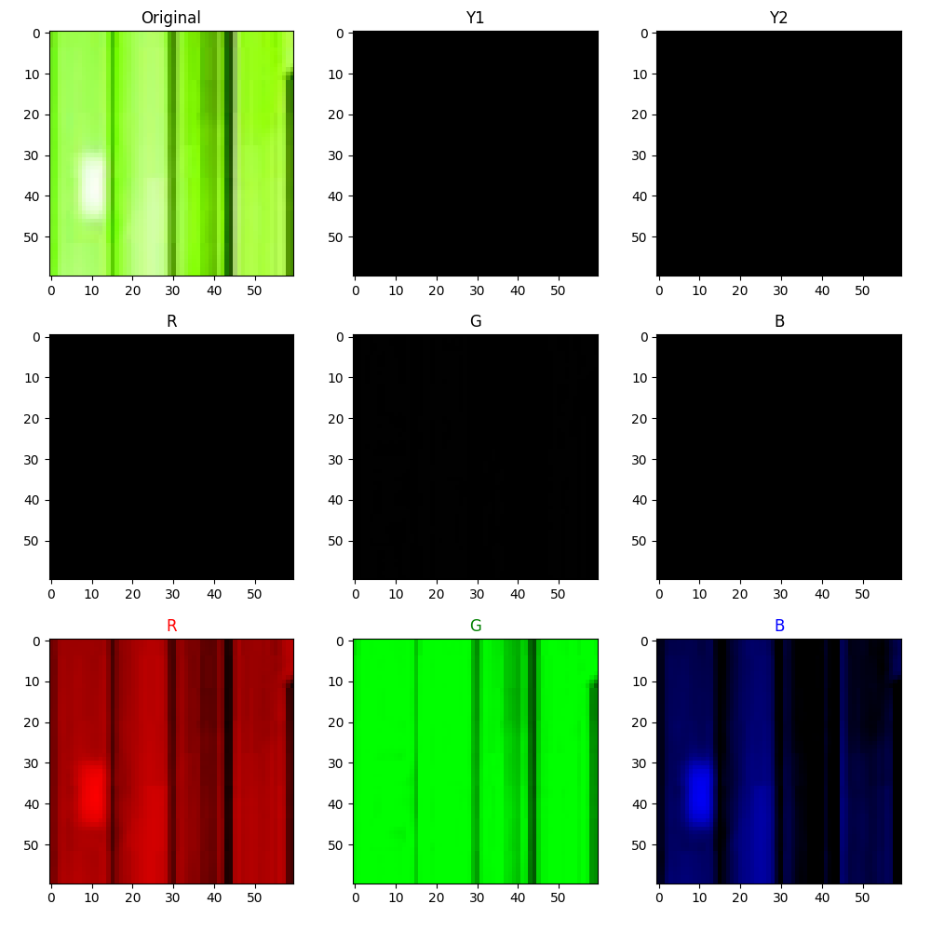

## Plik - ['B02.jpg']

### Fragments [[[20, 20, 60, 60], [100, 100, 140, 140], [50, 0, 500, 200]]]

fragment [20, 20, 60, 60]

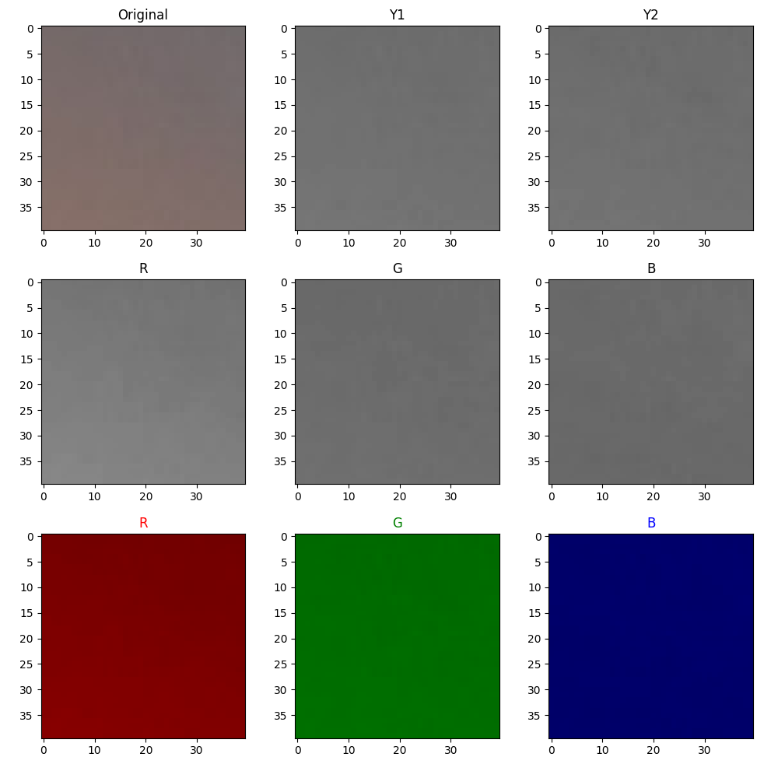

fragment [100, 100, 140, 140]

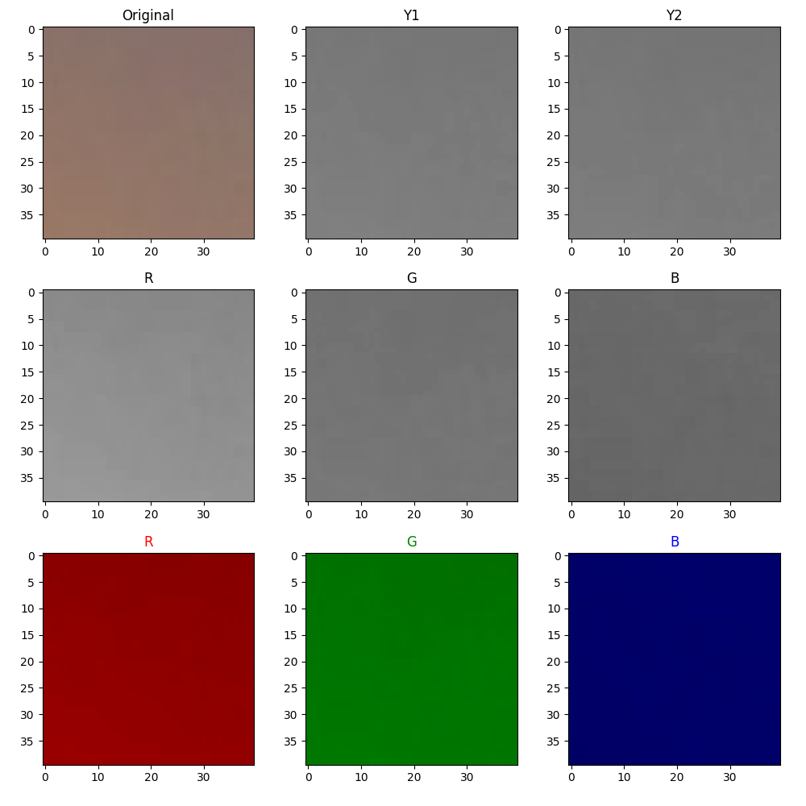

fragment [50, 0, 500, 200]

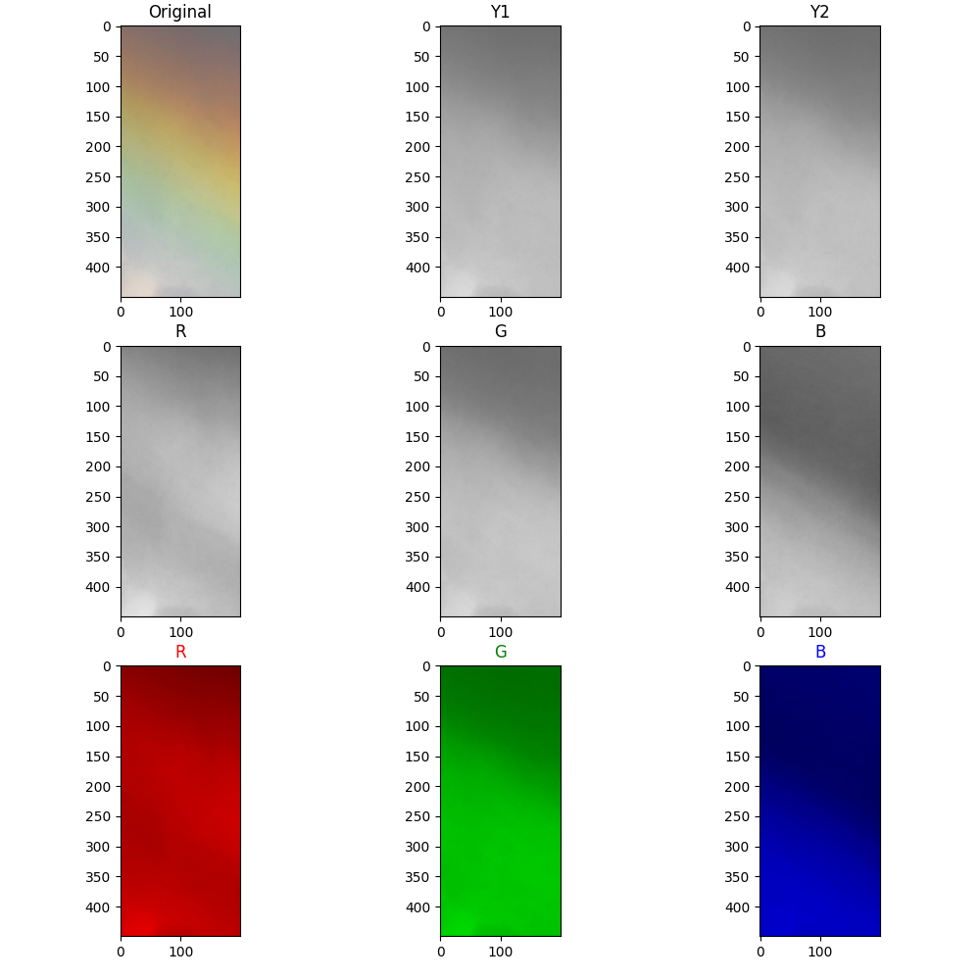

## Plik - ['A4.jpg']

### Fragments [[[2, 2, 6, 6], [10, 10, 14, 14], [5, 80, 50, 100]]]

fragment [2, 2, 6, 6]

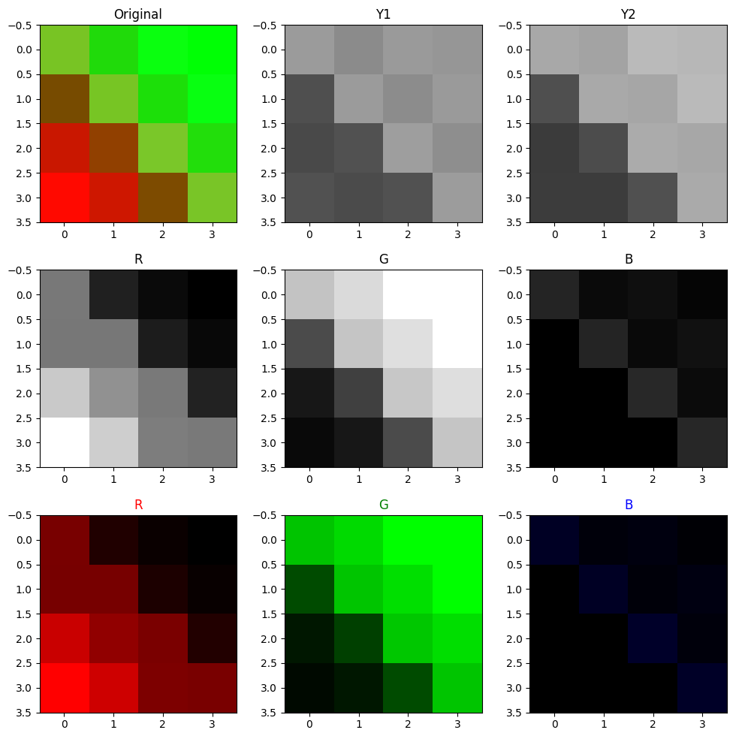

fragment [10, 10, 14, 14]

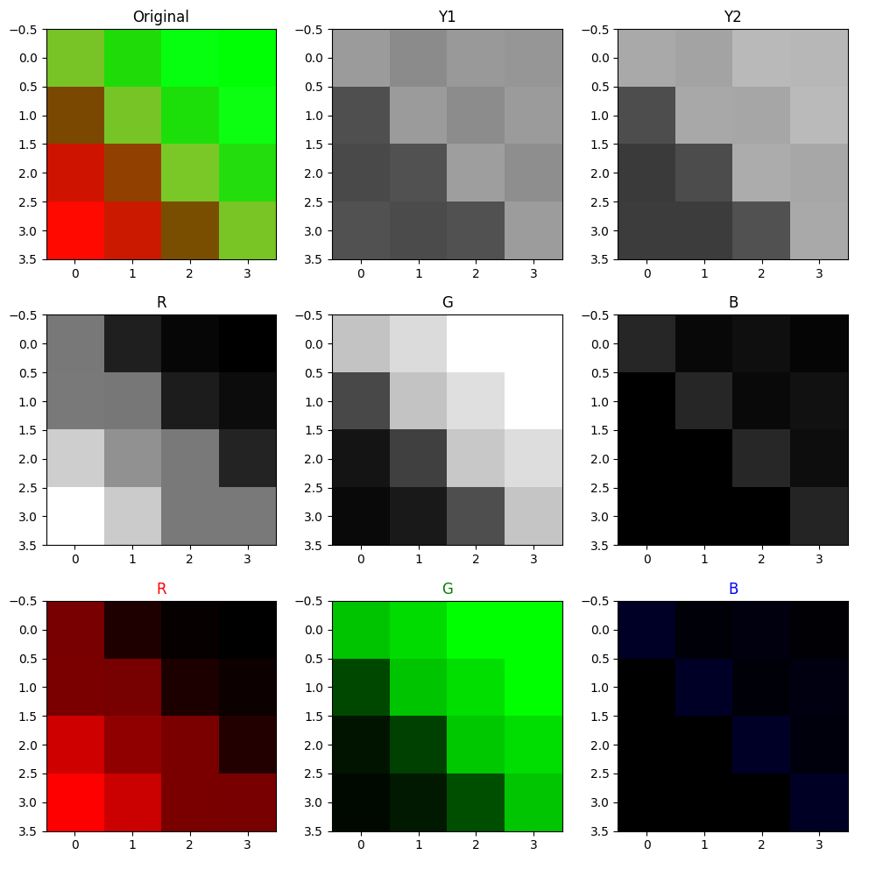

fragment [5, 80, 50, 100]

