Audio Quantization and Resampling Report

# File: sin_combined.wav

|  |  |  |
| --- | --- | --- |
| Modification | Max Frequency (Hz) | Max Amplitude (dB) |
| Original | 0.00 | 32.71 |
| 4-bit quant | 0.00 | 34.04 |
| 8-bit quant | 0.00 | 32.78 |
| 16-bit quant | 0.00 | 32.71 |
| 24-bit quant | 0.00 | 32.71 |
| Decimation 2 | 8031.50 | 28.76 |
| Decimation 4 | 3543.31 | 27.74 |
| Decimation 6 | 62.99 | 29.70 |
| Decimation 10 | 2003.15 | 27.38 |
| Decimation 24 | 826.77 | 30.95 |
| linear interp 2000Hz | 503.94 | 30.62 |
| cubic interp 2000Hz | 503.94 | 31.47 |
| linear interp 4000Hz | 440.94 | 27.47 |
| cubic interp 4000Hz | 440.94 | 27.92 |
| linear interp 8000Hz | 62.99 | 29.31 |
| cubic interp 8000Hz | 62.99 | 29.49 |
| linear interp 11999Hz | 3637.49 | 27.35 |
| cubic interp 11999Hz | 3637.49 | 27.76 |
| linear interp 16000Hz | 62.99 | 30.33 |
| cubic interp 16000Hz | 62.99 | 30.37 |
| linear interp 16953Hz | 66.74 | 27.87 |
| cubic interp 16953Hz | 8076.04 | 28.45 |
| linear interp 24000Hz | 8031.50 | 28.73 |
| cubic interp 24000Hz | 8031.50 | 28.75 |
| linear interp 41000Hz | 0.00 | 32.24 |
| cubic interp 41000Hz | 0.00 | 32.17 |

## Visualizations

### Original

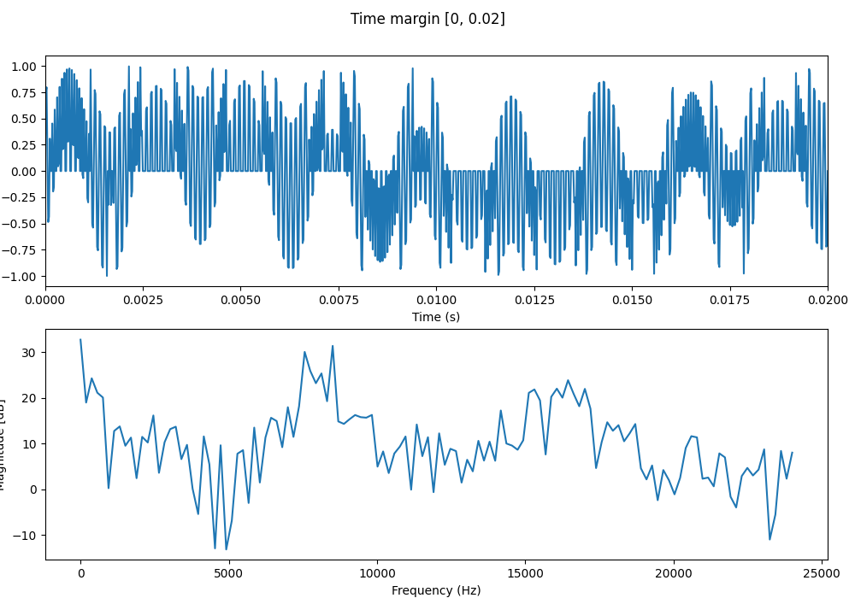

### 4-bit quant

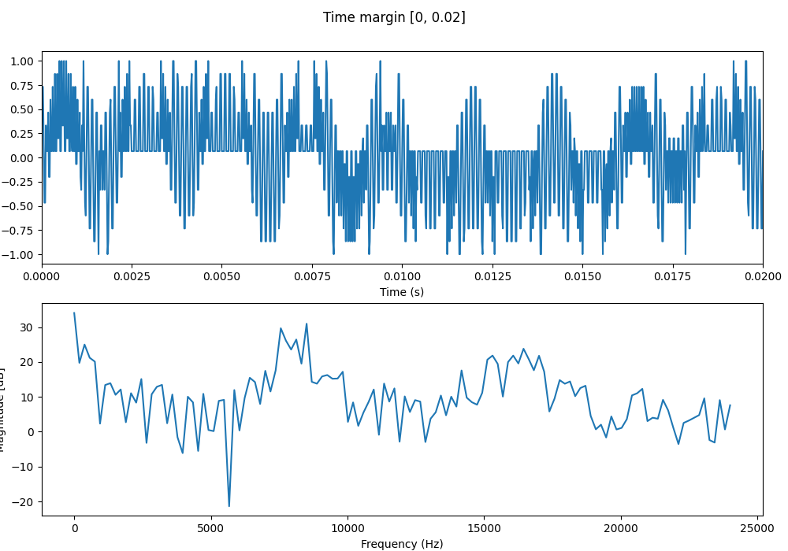

### 8-bit quant

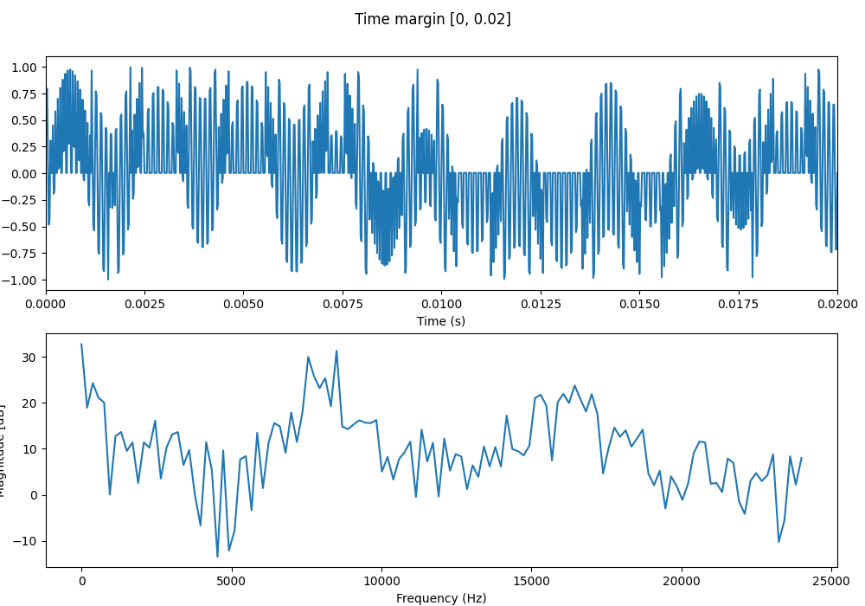

### 16-bit quant

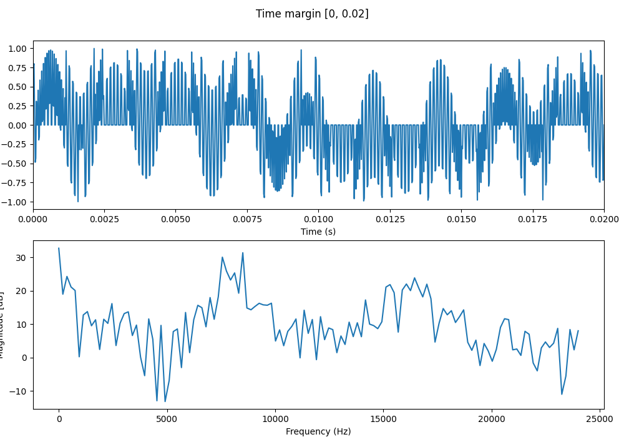

### 24-bit quant

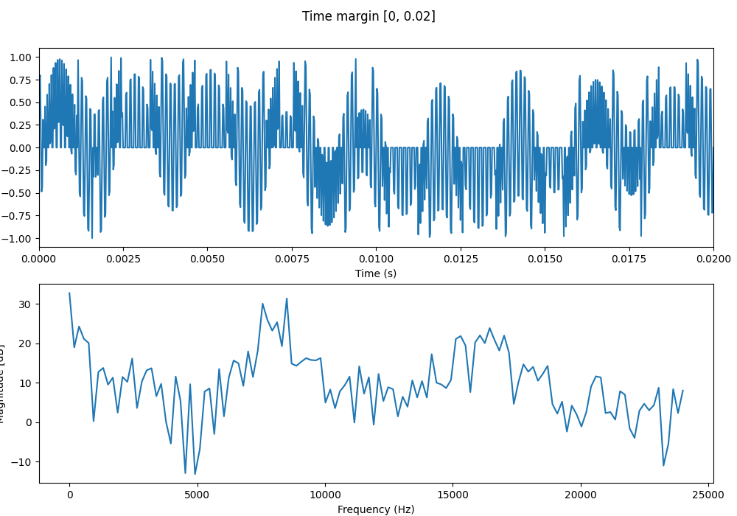

### Decimation 2

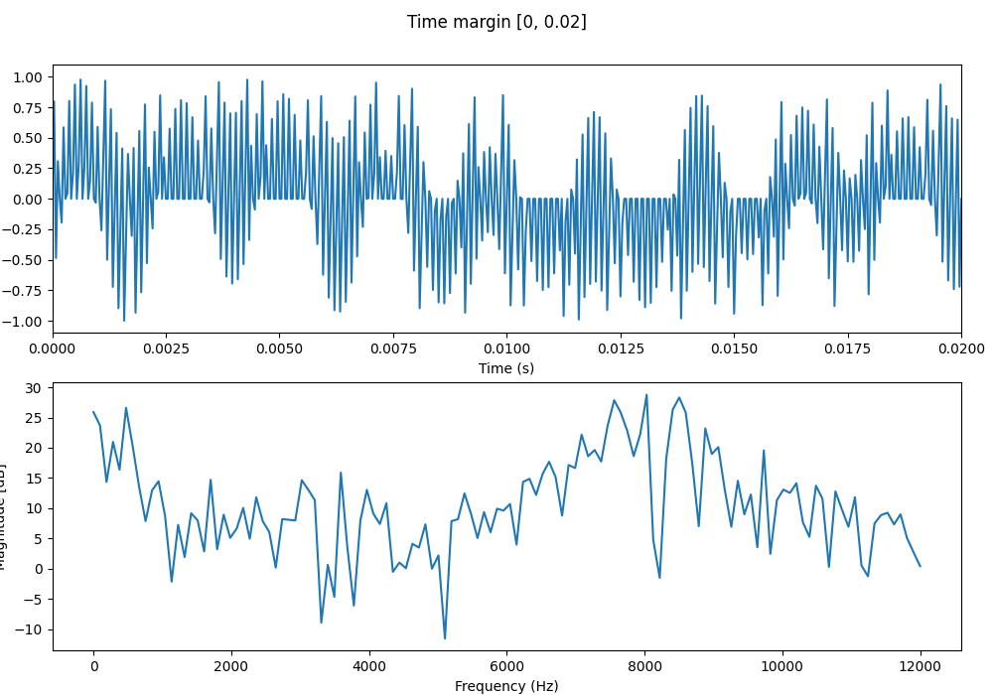

### Decimation 4

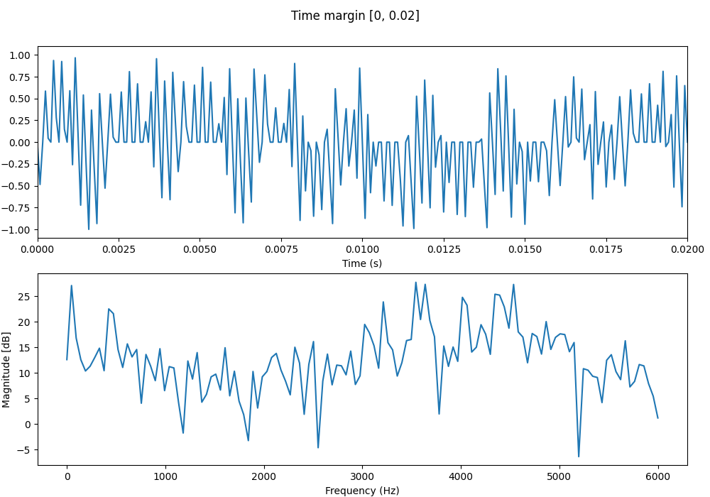

### Decimation 6

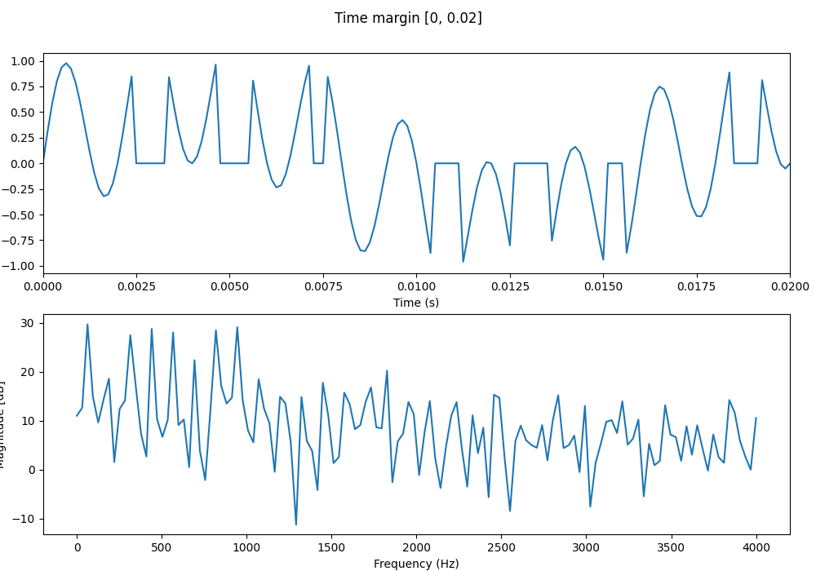

### Decimation 10

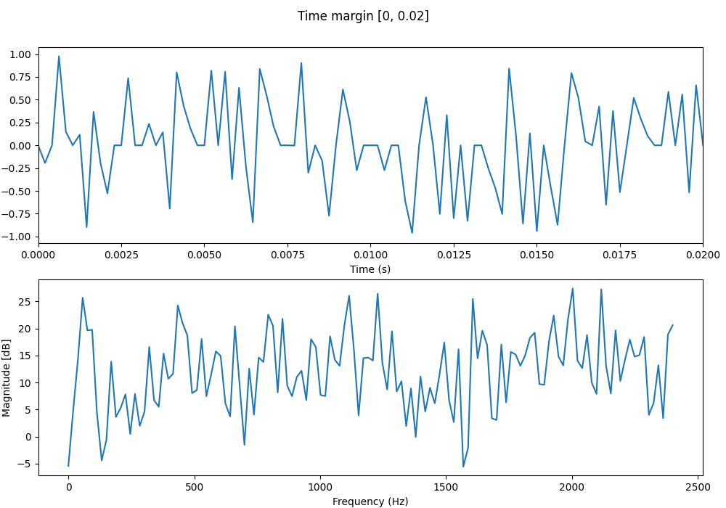

### Decimation 24

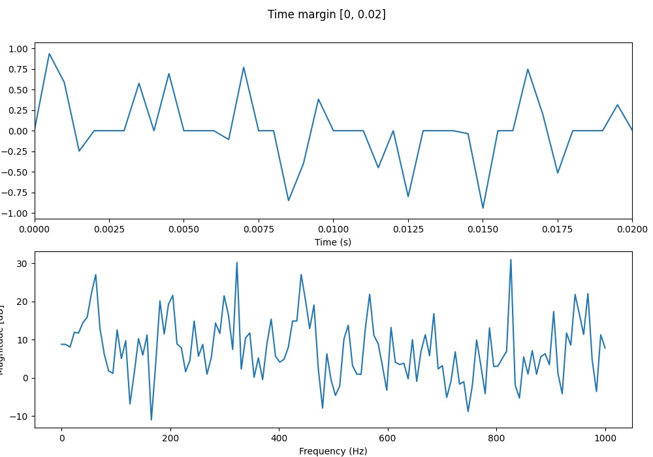

### linear interp 2000Hz

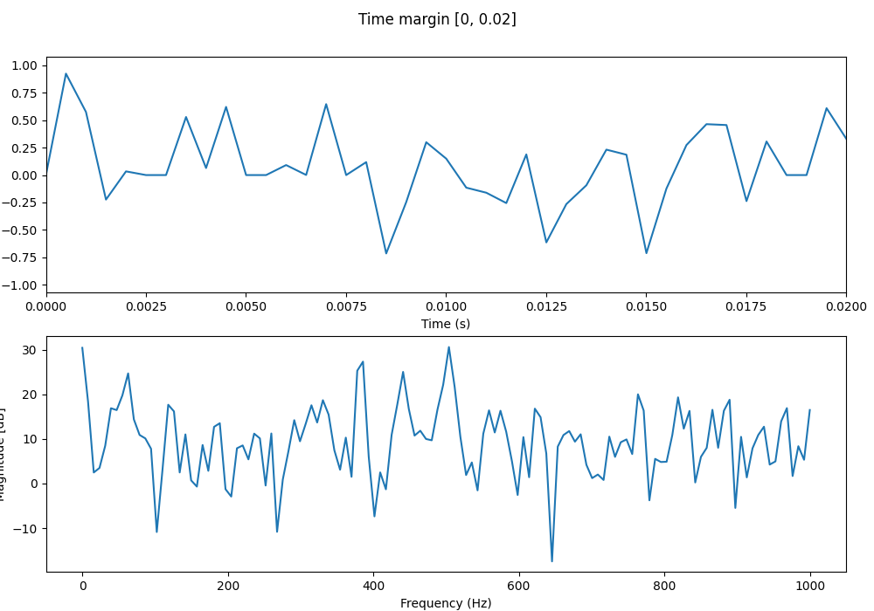

### cubic interp 2000Hz

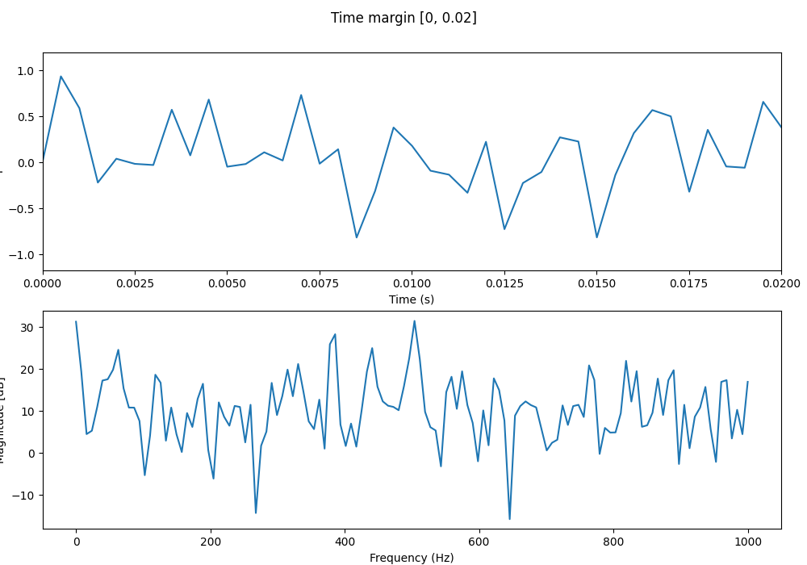

### linear interp 4000Hz

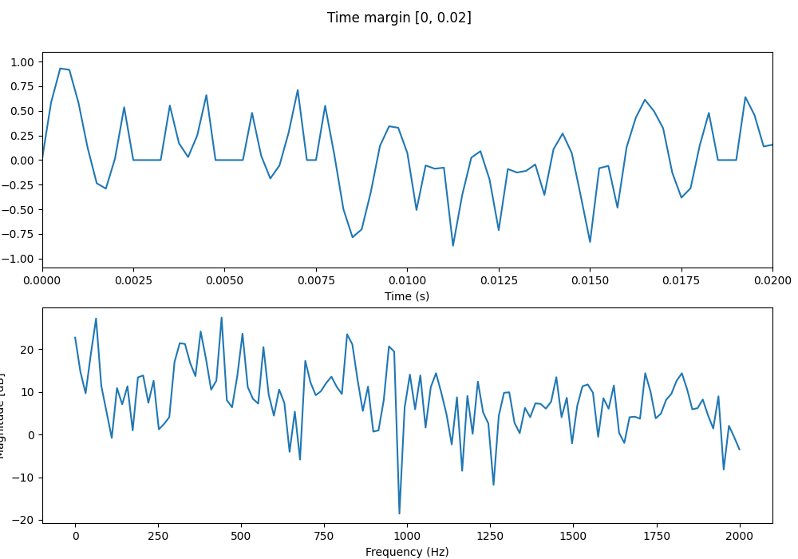

### cubic interp 4000Hz

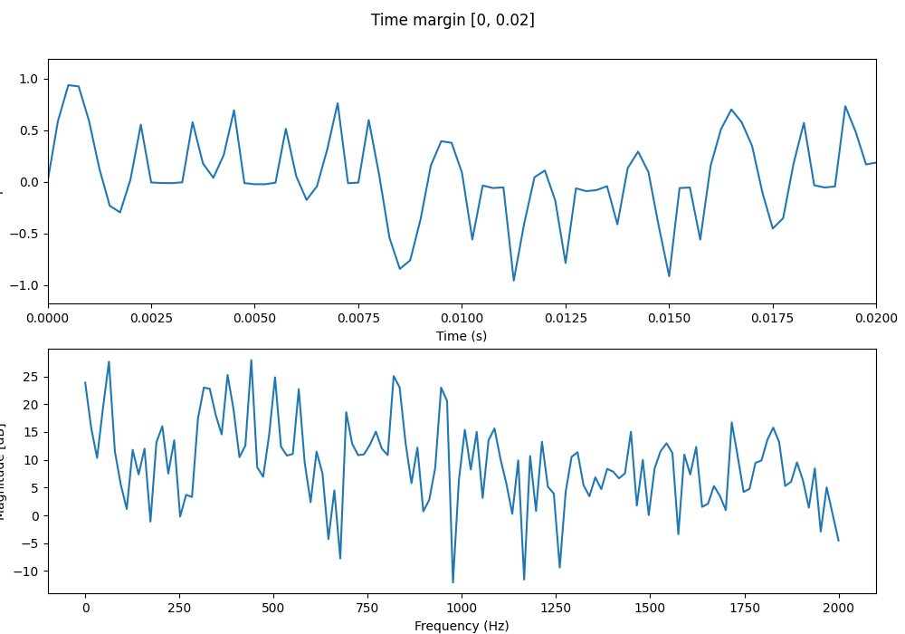

### linear interp 8000Hz

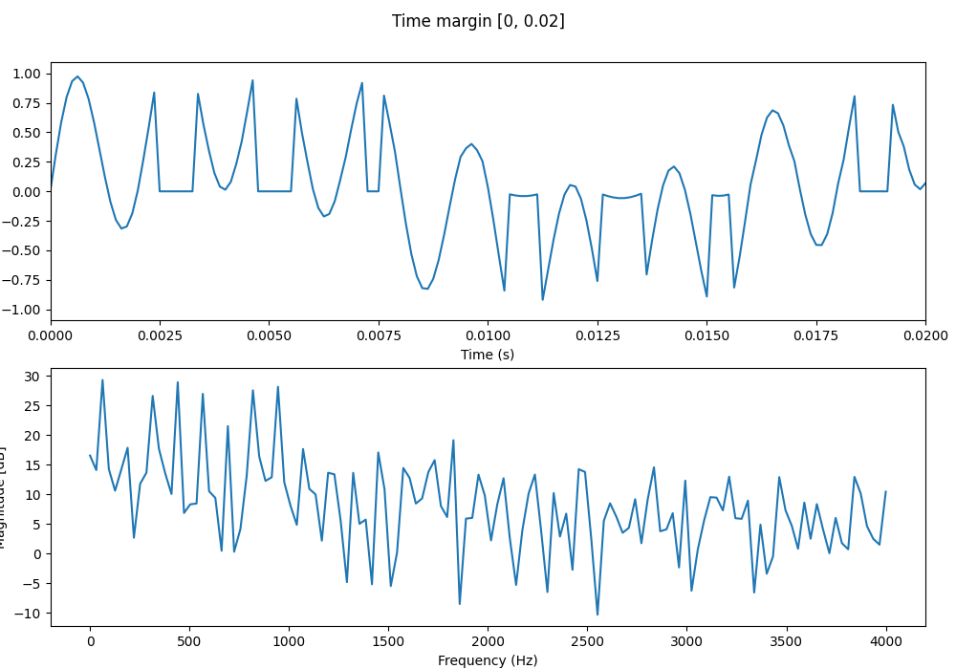

### cubic interp 8000Hz

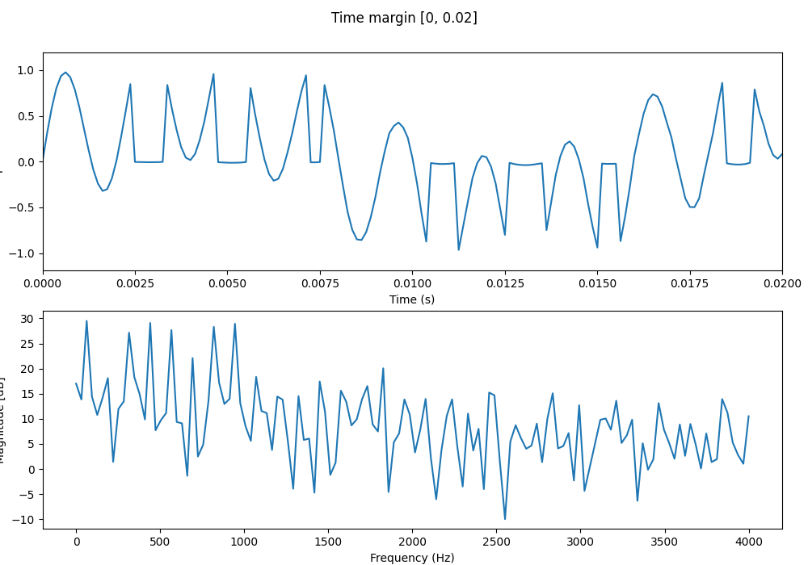

### linear interp 11999Hz

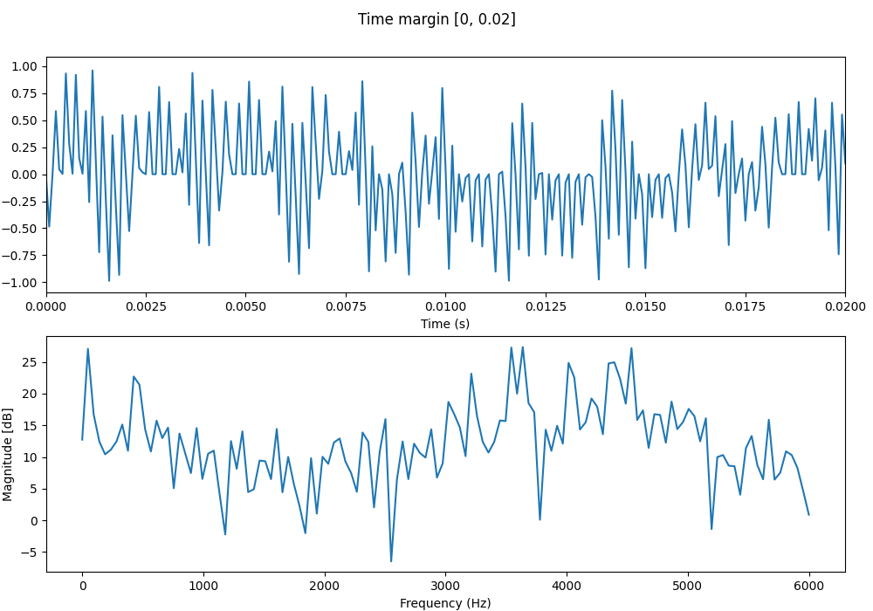

### cubic interp 11999Hz

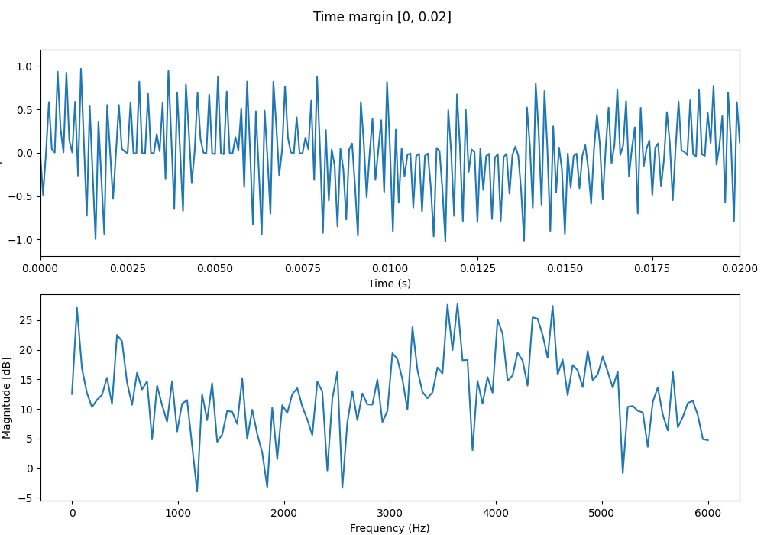

### linear interp 16000Hz

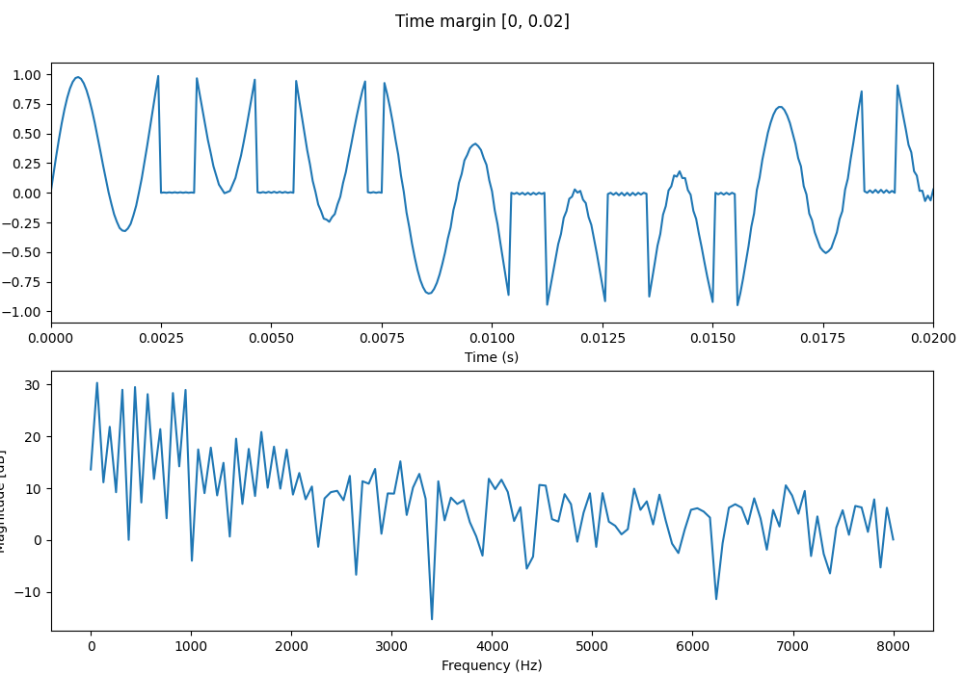

### cubic interp 16000Hz

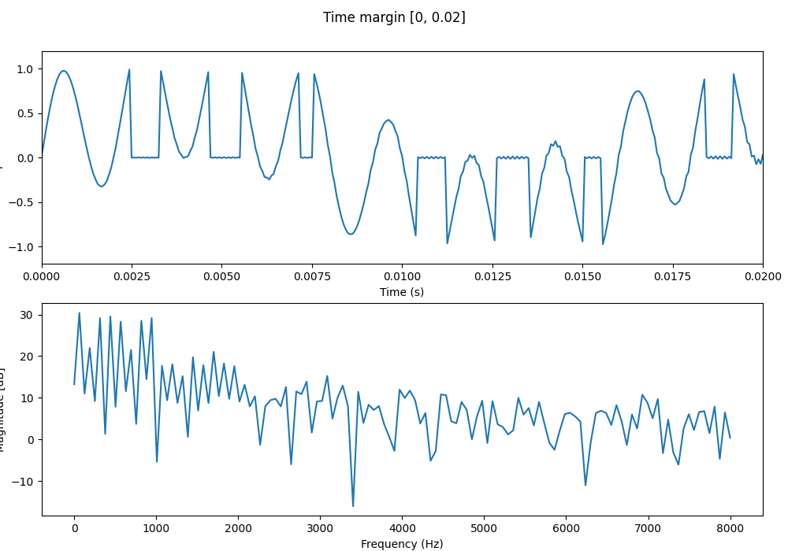

### linear interp 16953Hz

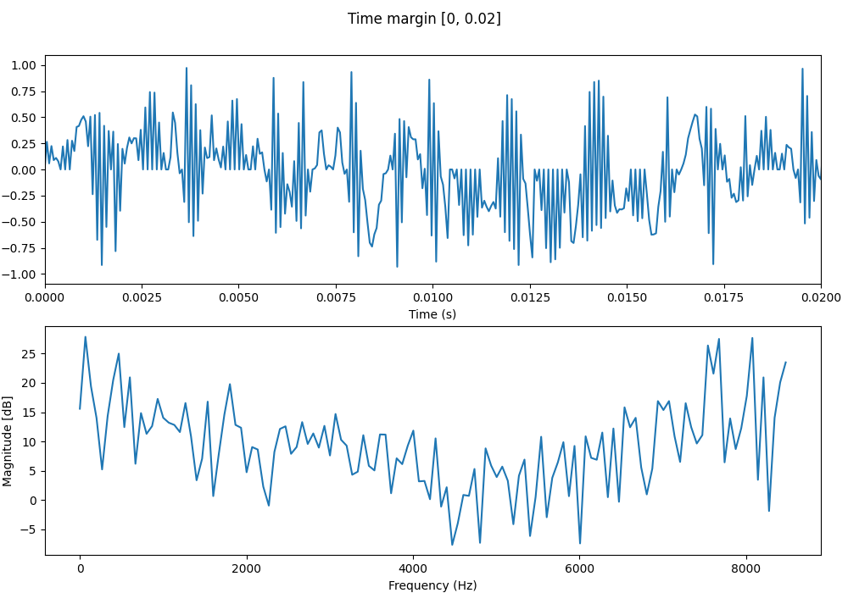

### cubic interp 16953Hz

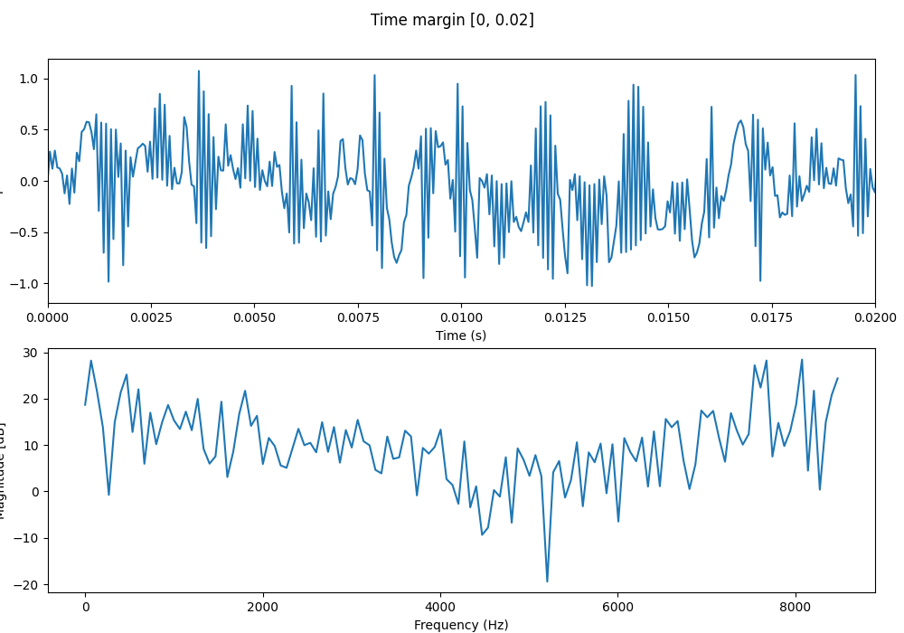

### linear interp 24000Hz

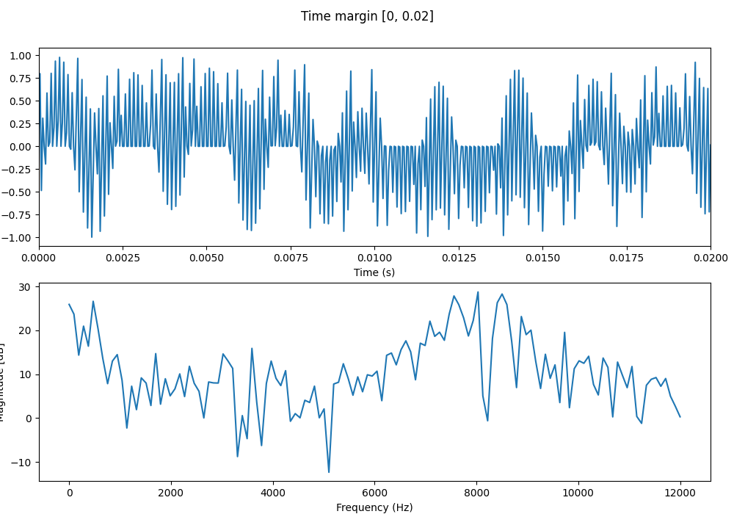

### cubic interp 24000Hz

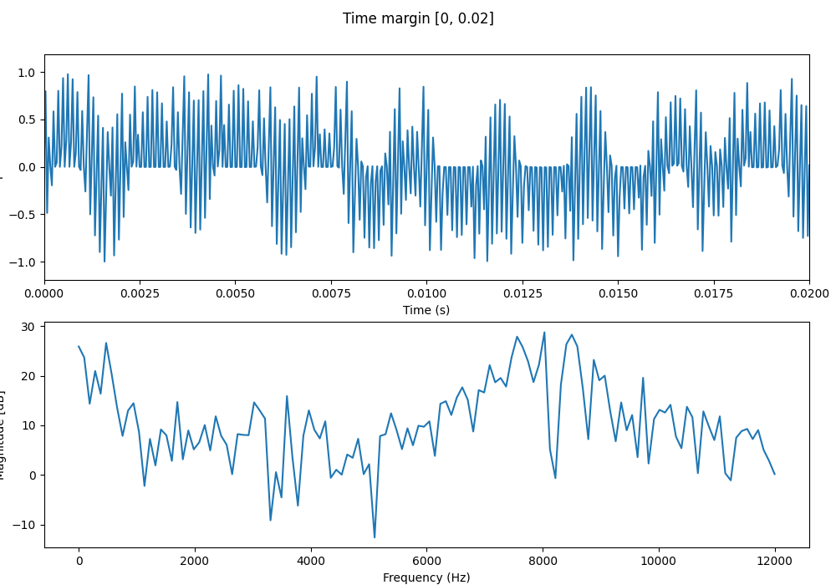

### linear interp 41000Hz

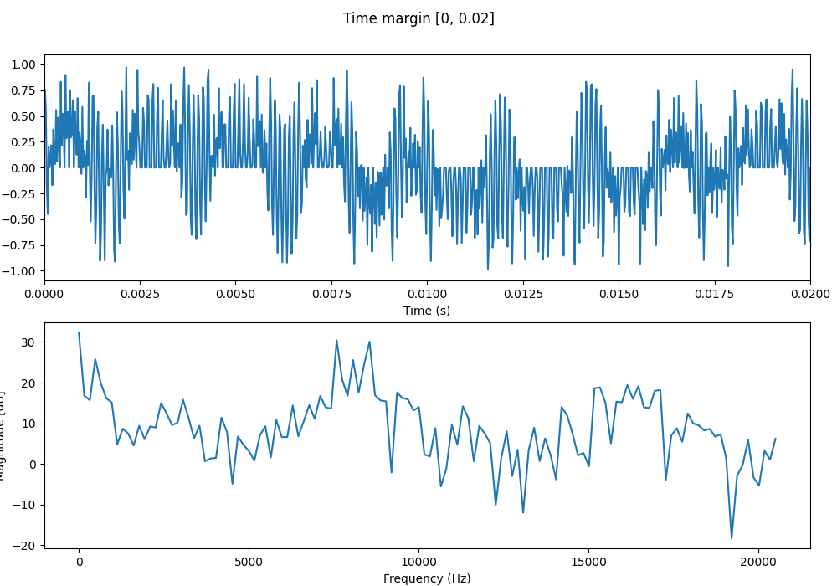

### cubic interp 41000Hz

