JPEG Compression Report

# Summary Table

|  |  |  |  |  |  |
| --- | --- | --- | --- | --- | --- |
| Image | Ratio | Q Table | Size After (%) | Compress Time | Decompress Time |
| color1.jpg | 4:4:4 | (QN, QN) | 1.3% | 3341.6 ms | 1315.1 ms |
| color1.jpg | 4:4:4 | (QY, QC) | 0.4% | 2457.0 ms | 1200.0 ms |
| color1.jpg | 4:2:2 | (QN, QN) | 1.0% | 1450.4 ms | 922.9 ms |
| color1.jpg | 4:2:2 | (QY, QC) | 0.3% | 1589.6 ms | 1032.4 ms |
| document1.jpg | 4:4:4 | (QN, QN) | 0.4% | 2162.2 ms | 1075.3 ms |
| document1.jpg | 4:4:4 | (QY, QC) | 0.3% | 2000.1 ms | 1028.5 ms |
| document1.jpg | 4:2:2 | (QN, QN) | 0.4% | 1158.8 ms | 762.8 ms |
| document1.jpg | 4:2:2 | (QY, QC) | 0.3% | 1100.8 ms | 659.0 ms |
| drawing1.jpg | 4:4:4 | (QN, QN) | 1.3% | 1826.3 ms | 764.9 ms |
| drawing1.jpg | 4:4:4 | (QY, QC) | 0.7% | 1795.9 ms | 831.4 ms |
| drawing1.jpg | 4:2:2 | (QN, QN) | 1.2% | 1176.8 ms | 603.6 ms |
| drawing1.jpg | 4:2:2 | (QY, QC) | 0.7% | 1292.3 ms | 664.1 ms |

# Compressed Image Comparisons

## File: color1.jpg

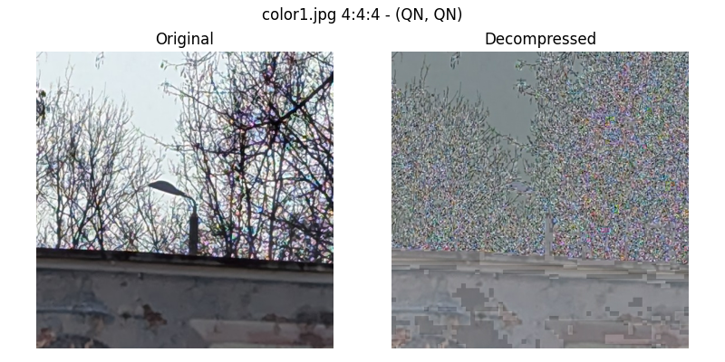

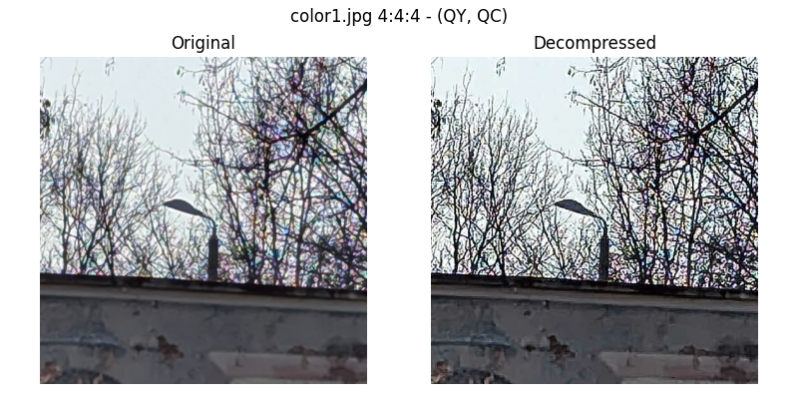

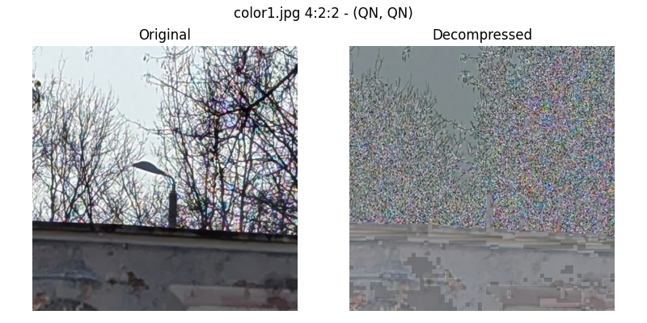

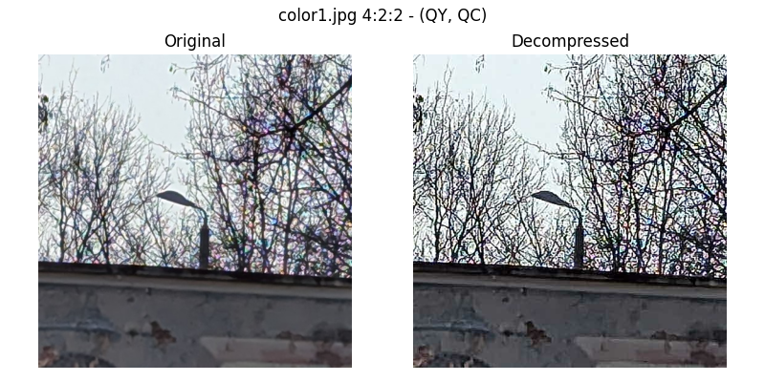

## File: document1.jpg

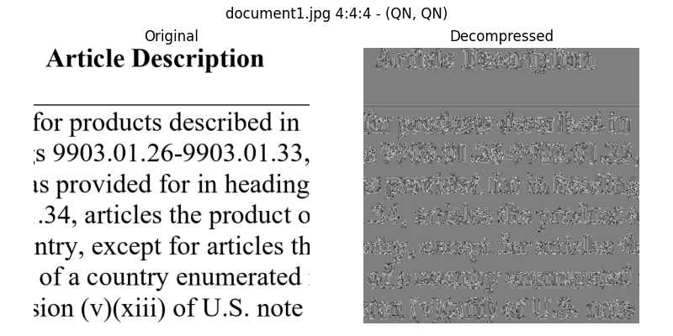

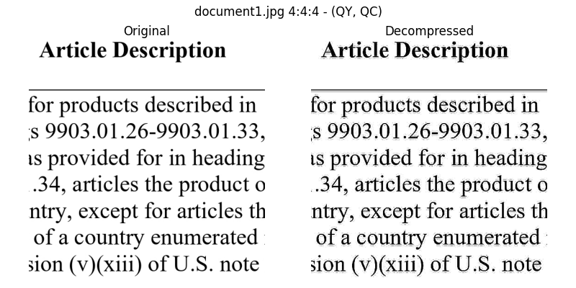

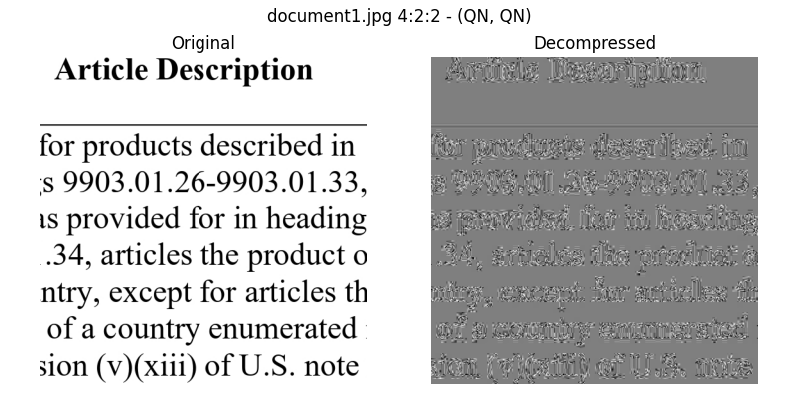

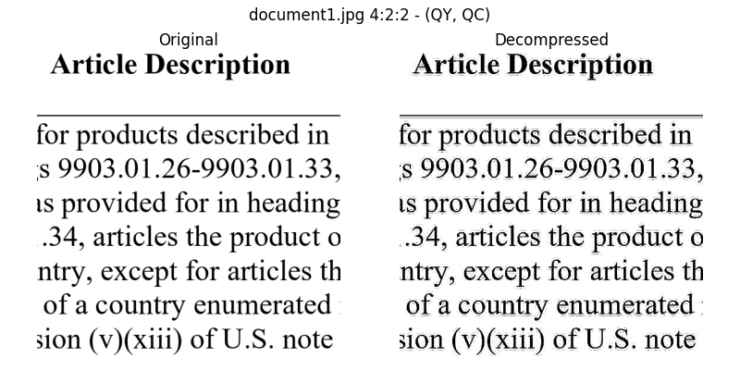

## File: drawing1.jpg

