php bin/magento setup:upgrade

php bin/magento setup:di:compile

php bin/magento indexer:reindex

php bin/magento cache:clean

php bin/magento cache:flush

php bin/magento setup:static-content:deploy -h

php bin/magento setup:db-declaration:generate-whitelist --module-name=Vendor_Sample(VendorName_ModuleName)

layout=”2columns-left”

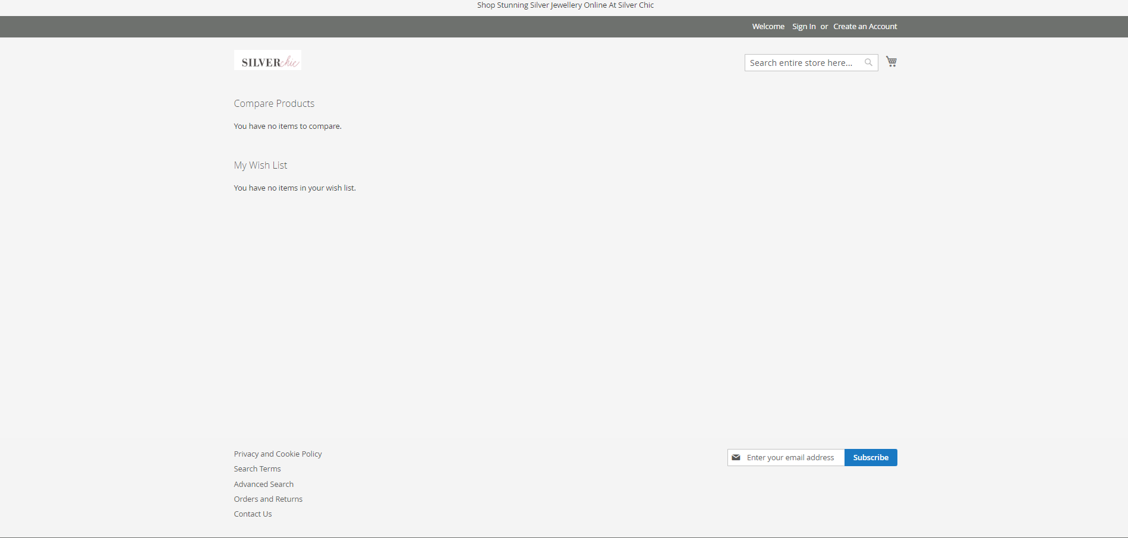

2 column-right

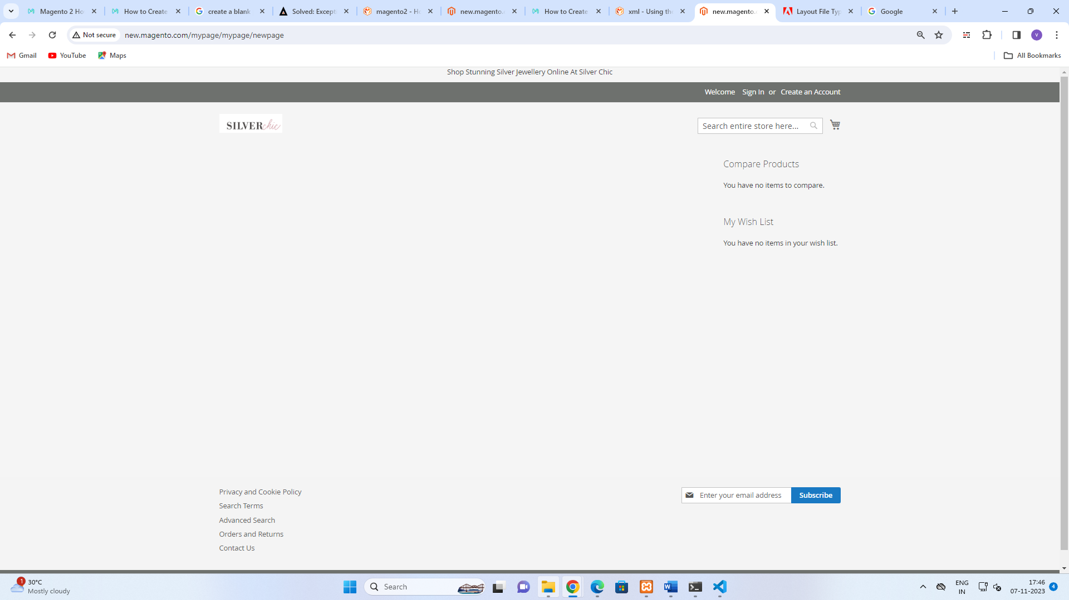

Input validation in magento2

Below is the step-by-step process on how to validate forms in Magento 2.

Step 1

First of all, we need to add **“data-mage-init”** attribute with **“validation”** alias in your form using the code below.

<form **class**="form my-form" action="" method="post" data-mage-init='{"validation":{}}'>

//Form code

</form>

The above validation alias will invoke JavaScript **lib/web/mage/validation/validation.js** which generally contains the logic of validation.

Step 2

Next, we need to add a validation rule in input fields.

Now, there are a total of 4 methods to add validation rules in the input fields of a form in Magento 2.

**Method #1 – Use Rule Name As an Attribute**

<input required="true" name="field" type="text" />

**Method #2 – Use Rule Name As Class Name**

<input **class**="input-text required" name="field" type="text" />

**Method #3 – Use “Data-Validate” Attribute**

<input data-validate='{"required":true}' name="field" type="text" />

**Method #4 – Set Rule in data-mage-init Attribute of Form Tag**

<form **class**="form my-form" action="" method="post" data-mage-init='{

"validation":{

"rules": {

"fieldname": {

"required":true

}

}

}

}'>

And that’s it! This is how you can validate forms in Magento 2.