SVITLANA VENT

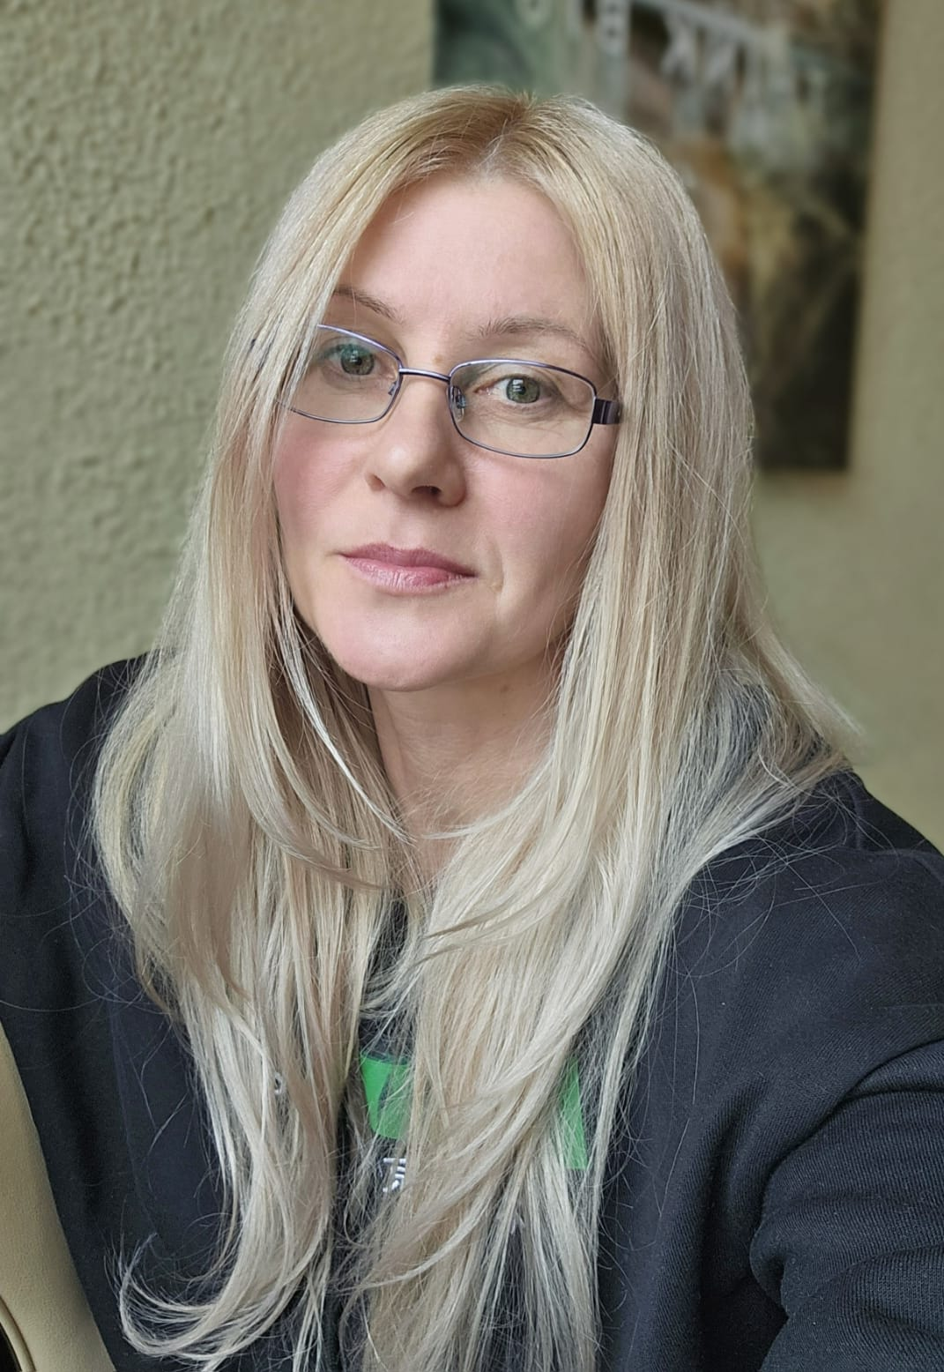
Summer Trainee – IT / Technology / UX
Finland | svitlana.vent77@gmail.com | +358 46 953 52 00

About me
Seeking a Summer Trainee position in IT / Technology / Design.
Second-year IT student enrolled in the Bachelor of Business Administration (BBA) in Software Engineering and Project Management at Turku University of Applied Sciences.
Interested in software development, frontend technologies, and UI/UX design, with a strong focus on usability, user experience, and collaboration.
Open to different IT-related roles and motivated to learn, develop technical skills, and contribute to real-world solutions in a large, international organization.

Education
Turku University of Applied Sciences (Turku AMK)
Bachelor of Business Administration (BBA)
Software Engineering and Project Management
2024 – present | 2nd year student
State University of Telecommunications, Ukraine
Engineering Degree
Telecommunication Systems and Networks
2002 – 2006

Technical Skills
Web & Frontend: HTML, CSS, JavaScript (basic), responsive layouts
Programming: Python (basic)
Databases: SQL (basic)
Operating Systems: Linux (basic)
Tools & Platforms: Git (basic), WordPress, PowerApps
UI / UX: Figma (wireframes, UI layouts, usability principles)

Languages
English – good working proficiency
Finnish – basic / developing
Ukrainian – native
Russian – fluent

Work Experience

OTP Bank, Ukraine | 2008–2014
Senior Sales Network Development Specialist
- Planned and implemented sales network development strategies
- Conducted market analysis and identified new customers
- Worked closely with partners and stakeholders
- Analysed results and prepared reports

UKR Telecom, Ukraine | 2005–2008
Telecommunications Engineer
- Installed, maintained, and optimised telecommunication systems
- Worked in team-based technical projects

Projects

Darts Score Counter (Web Application)
HTML, CSS, JavaScript
A browser-based web application for tracking darts game scores.
Role: UI/UX Designer & Frontend Contributor
- Designed the user interface and user flow with focus on clarity and usability
- Created UI layouts and visual structure
- Collaborated on frontend implementation
- Focused on intuitive and user-friendly interaction

Memory Cards Game for Children
Python
A simple educational game developed for children.
Role: Developer
- Implemented game logic using Python
- Designed child-friendly game flow and rules
- Focused on simplicity, clarity, and user experience

Website Redesign Concept (Figma)
UI/UX Design
A redesign concept for an existing website created in Figma.
Role: UI/UX Designer
- Redesigned website structure and layout
- Created wireframes and UI mockups
- Improved usability and visual consistency

My Recipes (PowerApps) – Group Project
Application Development
A mobile application for recipe management developed as a group project at Turku University of Applied Sciences.
Role: Developer
- Developed application features using PowerApps
- Implemented core functionality (search, filtering, editing)
- Worked with data handling and application logic
- Contributed to UI design and usability
- Collaborated in a team-based development environment

Personal Qualities
- Motivated and eager to learn
- Analytical and detail-oriented
- Collaborative and team-focused
- Responsible and proactive
- Comfortable working in international environments

