LAB 272
Working with Functions
AWS re/Start Programme
Estimated Duration: 45 minutes

Resource Names
The following values are used throughout this lab. All commands use these exact values.
Resource / Setting | Value
Database name | world
Tables used | world.country
DB user | root
DB password | re:St@rt!9
Total country rows | 239
Region | [Check top-right of AWS Management Console]
Local repo path | ~\Desktop\AWS-reStart-Journey\Labs\Databases\lab-272-working-with-functions
Screenshots folder | ~\Desktop\AWS-reStart-Journey\Labs\Databases\lab-272-working-with-functions\screenshots\

Before You Begin
IMPORTANT
CURLY QUOTES: Copying commands from Word or PDF can silently replace straight quotes with typographic curly quotes. MariaDB rejects these with authentication or syntax errors. Always type quotes manually — especially in re:St@rt!9.

IMPORTANT
PASTING EXTRA TEXT: Only paste the command itself. Pasting surrounding explanatory text causes bash: command not found or SQL syntax errors.

WARNING
SILENT WAIT: Commands that wait produce no output and block the terminal silently. This is normal — do not close the terminal.

WARNING
MARIADB CONTINUATION PROMPT: If you press Enter mid-statement, MariaDB shows -> instead of mysql>. Type a semicolon (;) and Enter to execute, or \c and Enter to cancel.

Task 1: Connect to the Command Host
In this task you connect to an EC2 instance (Command Host) containing the MariaDB client used throughout this lab.

- In the AWS Management Console, choose the Services menu. Under Compute, choose EC2.
- In the navigation pane, choose Instances.
- Next to the instance labelled Command Host, select the check box and choose Connect.
NOTE
If you do not see the Command Host, the lab may still be provisioning or you may be in the wrong Region.

- For Connect to instance, choose the Session Manager tab.
- Choose Connect to open a terminal window.
NOTE
If the Connect button is not available, wait a few minutes and try again.

- Configure the terminal:
CMD | sudo su

CMD | cd /home/ec2-user/

- Connect to the database server:
SQL | mysql -u root --password='re:St@rt!9'

OUTPUT
Welcome to the MariaDB monitor. Commands end with ; or \g.
Server version: 10.x.x MariaDB ...
MariaDB [(none)]>

TIP
If Session Manager becomes unresponsive, close it and reconnect. Then re-run: sudo su → cd /home/ec2-user/ → mysql -u root --password='re:St@rt!9'

Task 2: Query the world Database
In this task you use SELECT statements with built-in database functions to query the world database.

Show Databases
- Confirm the world database is available:
SQL | SHOW DATABASES;

OUTPUT
+--------------------+
| Database |
+--------------------+
| information_schema |
| mysql |
| performance_schema |
| world |
+--------------------+
4 rows in set (0.001 sec)

IMPORTANT
If the world database is not listed, contact your instructor — do not proceed.

SCREENSHOT 1 01_show_databases.png
SHOW DATABASES output — 4 rows in set (0.001 sec), world database confirmed.
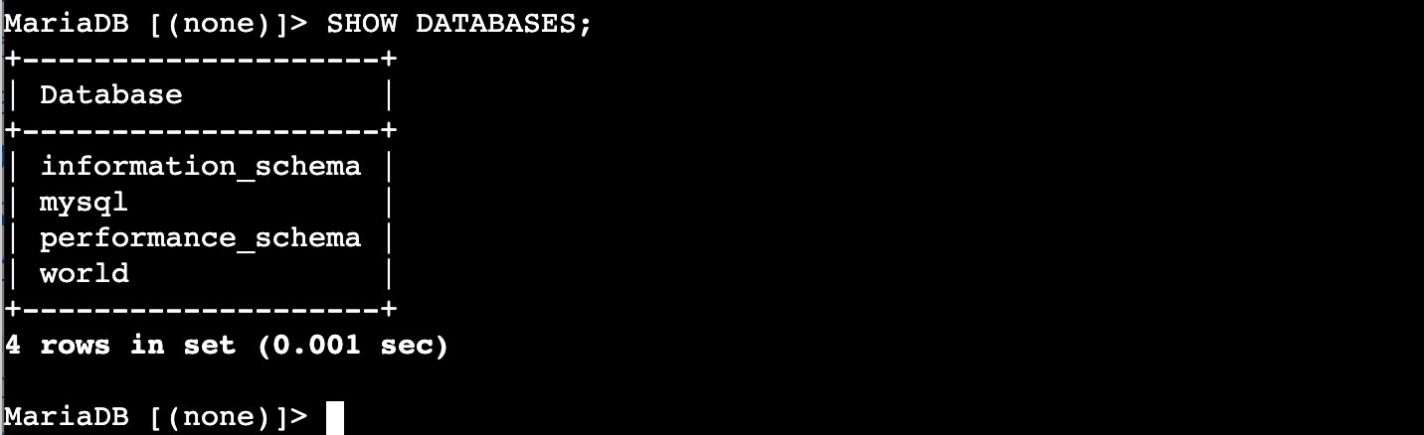

View the country Table
- Review the full contents of the country table:
SQL | SELECT * FROM world.country;

OUTPUT
239 rows in set (0.002 sec)

NOTE
This returns all 239 rows. Scroll through to understand column structure before applying functions.

SCREENSHOT 2 02_select_all_country.png
End of SELECT * output showing final rows and 239 rows in set (0.002 sec).
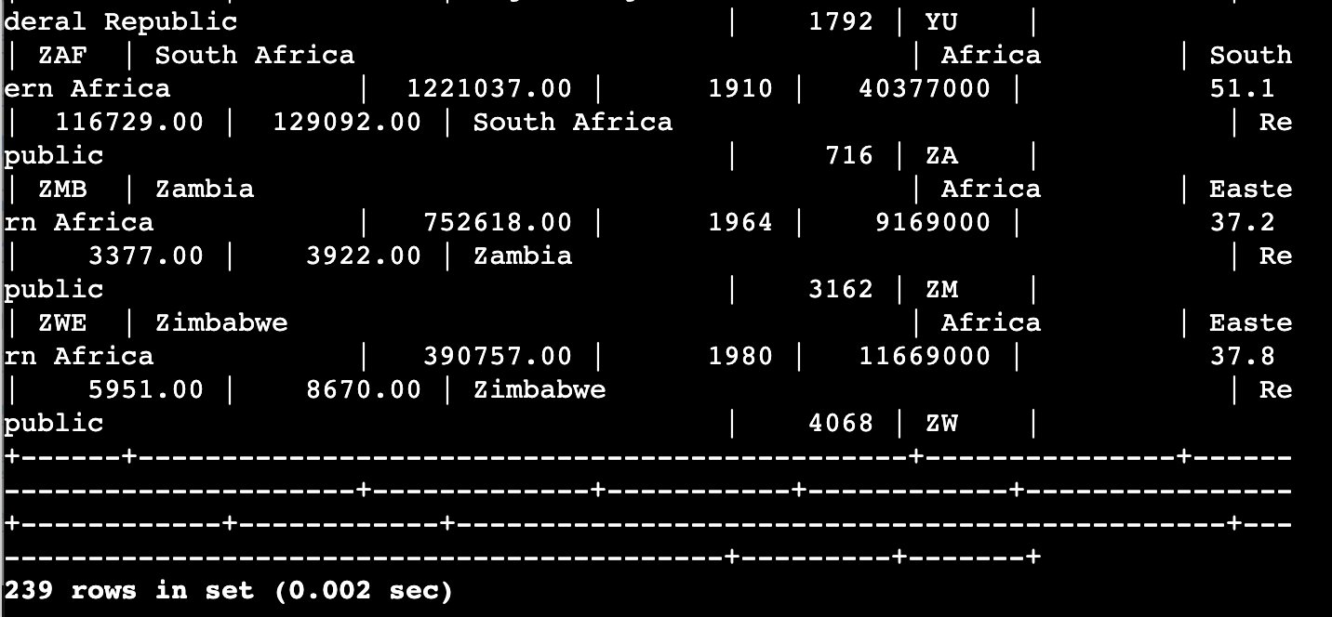

Aggregate Functions: SUM, AVG, MAX, MIN, COUNT
- Run aggregate functions across all rows in the country table:
SQL | SELECT sum(Population), avg(Population), max(Population), min(Population), count(Population) FROM world.country;

OUTPUT
| sum(Population) | avg(Population) | max(Population) | min(Population) | count(Population) |
| 6078749450 | 25434098.1172 | 1277558000 | 0 | 239 |
1 row in set (0.002 sec)

NOTE
SUM() — total: 6,078,749,450
AVG() — mean per country: 25,434,098.1172
MAX() — most populous: 1,277,558,000
MIN() — 0 (territories listed without population figures)
COUNT() — non-NULL rows: 239

SCREENSHOT 3 03_aggregate_functions.png
Single-row result: sum=6078749450 | avg=25434098.1172 | max=1277558000 | min=0 | count=239.
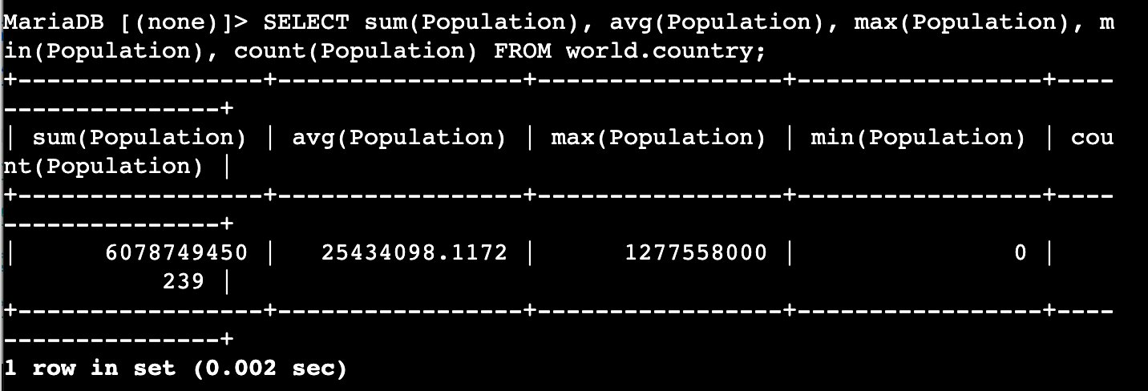

SUBSTRING_INDEX — Split a String
- Extract the first word of each region name:
SQL | SELECT Region, substring_index(Region, " ", 1) FROM world.country;

OUTPUT
239 rows — second column shows first word of each Region value.

NOTE
The space " " is the delimiter. Passing 1 returns everything before the first occurrence of that delimiter.

SCREENSHOT 4 04_substring_index_select.png
Two-column output: full Region on left, extracted first word on right (239 rows).
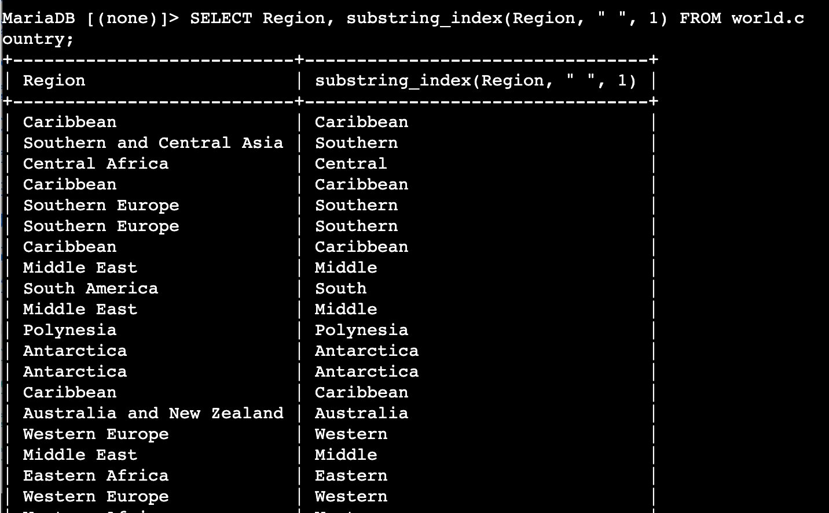

SUBSTRING_INDEX in a WHERE Clause
- Filter countries whose region begins with 'Southern':
SQL | SELECT Name, Region from world.country WHERE substring_index(Region, " ", 1) = "Southern";

OUTPUT
Countries in Southern Europe, Southern Africa, Southern and Central Asia returned.

SCREENSHOT 5 05_substring_index_where.png
Name and Region columns — all regions start with Southern (Afghanistan, Albania, Andorra…).
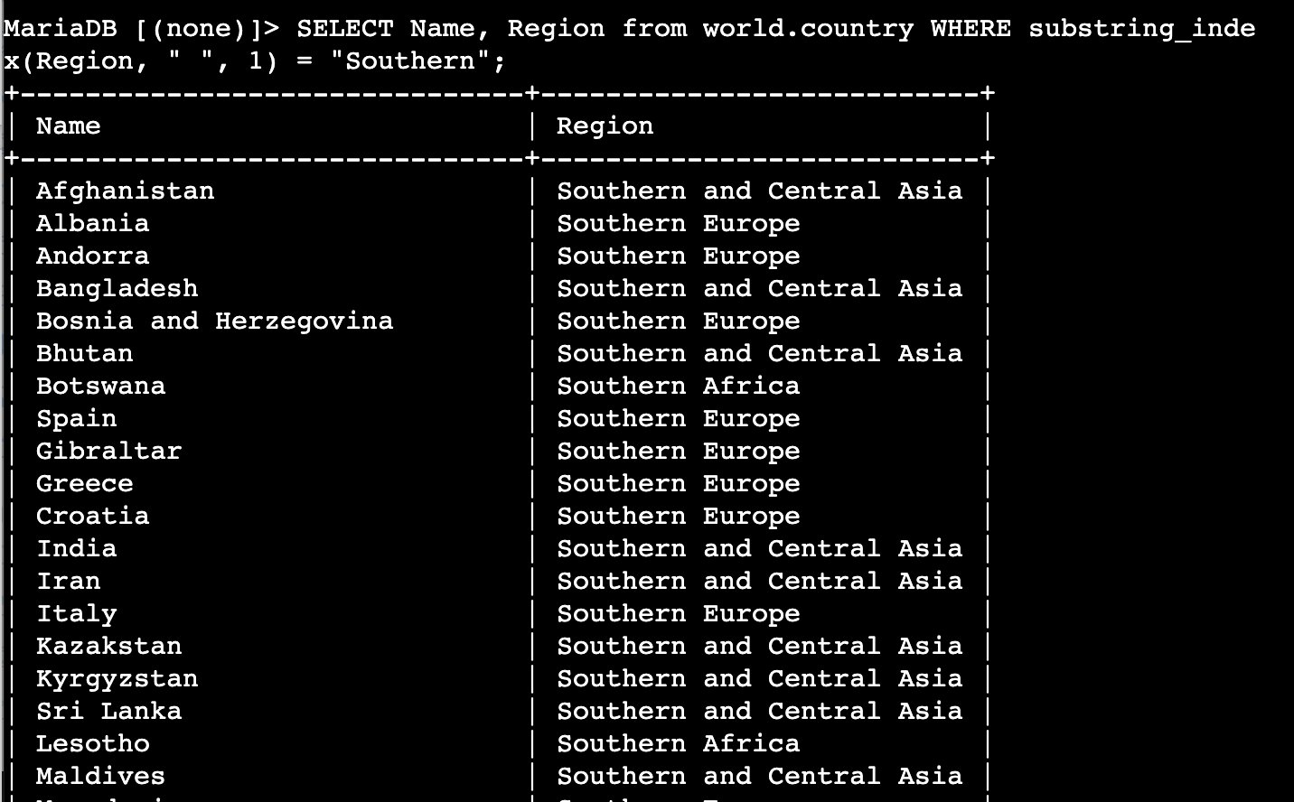

LENGTH and TRIM — Filter by String Length
- Return regions with fewer than 10 characters (duplicates visible):
SQL | SELECT Region FROM world.country WHERE LENGTH(TRIM(Region)) < 10;

OUTPUT
Many rows — Caribbean repeated many times, plus Polynesia and Melanesia.

NOTE
TRIM() strips leading/trailing spaces before LENGTH() counts. Without TRIM(), padded values would be miscounted.

SCREENSHOT 6 06_length_trim.png
Region column: Caribbean (repeated), Polynesia, Melanesia — duplicates clearly visible.
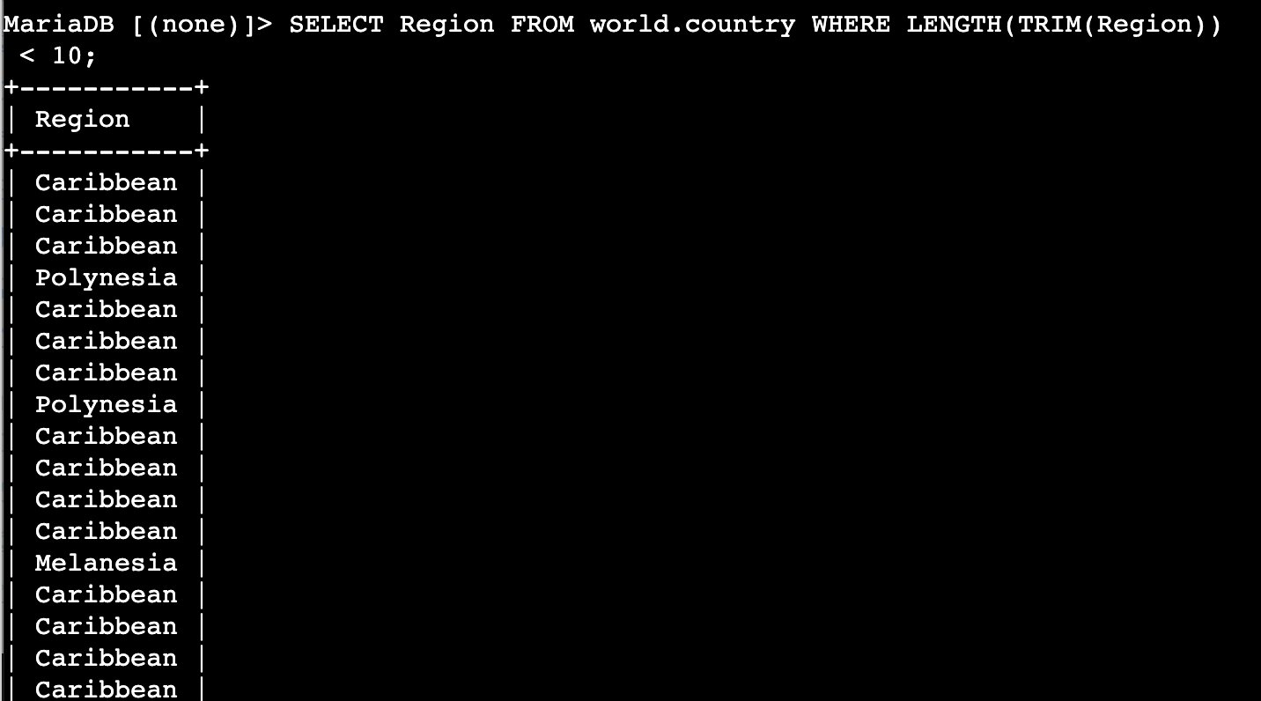

DISTINCT — Remove Duplicates
- Collapse repeated region names to unique values:
SQL | SELECT DISTINCT(Region) FROM world.country WHERE LENGTH(TRIM(Region)) < 10;

OUTPUT
+------------+
| Region |
+------------+
| Caribbean |
| Polynesia |
| Melanesia |
+------------+
3 rows in set (0.001 sec)

TIP
Exactly 3 unique regions qualify: Caribbean, Polynesia, Melanesia. DISTINCT collapsed many duplicate rows into 3.

SCREENSHOT 7 07_distinct_length_trim.png
3 rows in set (0.001 sec): Caribbean, Polynesia, Melanesia.
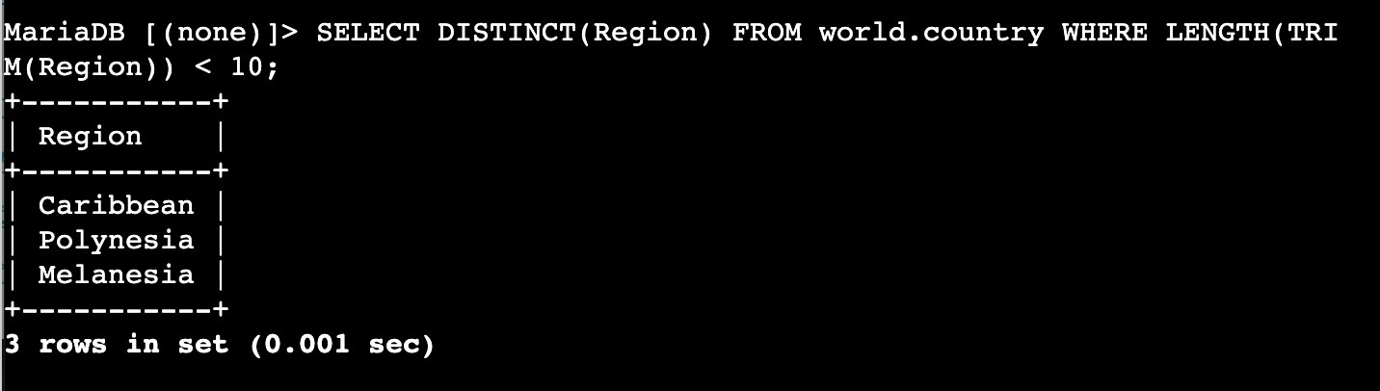

Challenge: Split Micronesia/Caribbean
- Return the Micronesia/Caribbean region split into two named columns:
SQL | SELECT Name,
SQL | substring_index(Region, "/", 1) as "Region Name 1",
SQL | substring_index(region, "/", -1) as "Region Name 2"
SQL | FROM world.country
SQL | WHERE Region = "Micronesia/Caribbean";

OUTPUT
+----------------------------------------+---------------+---------------+
| Name | Region Name 1 | Region Name 2 |
+----------------------------------------+---------------+---------------+
| United States Minor Outlying Islands | Micronesia | Caribbean |
+----------------------------------------+---------------+---------------+
1 row in set (0.000 sec)

NOTE
Using -1 returns everything after the last delimiter. Only United States Minor Outlying Islands has Micronesia/Caribbean as its region.

SCREENSHOT 8 08_challenge_query.png
1 row in set (0.000 sec): United States Minor Outlying Islands | Micronesia | Caribbean.
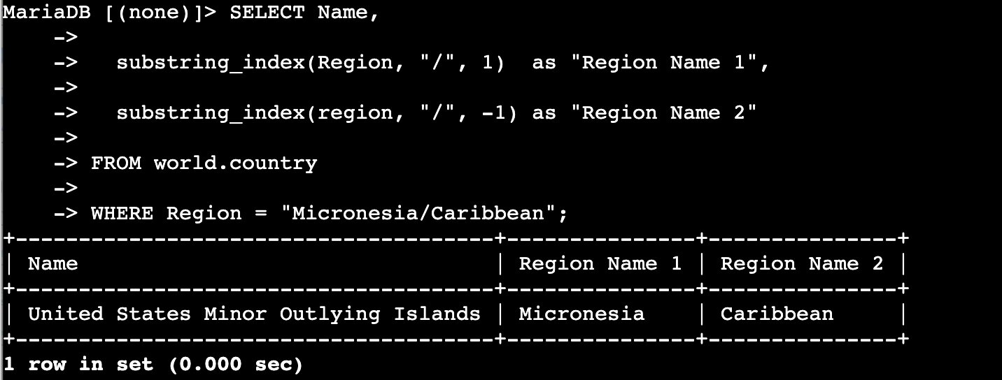

Screenshot Reference Summary
Screenshots folder: ~\Desktop\AWS-reStart-Journey\Labs\Databases\lab-272-working-with-functions\screenshots\
# | Filename | Task | What to capture
1 | 01_show_databases.png | Task 2 | SHOW DATABASES — 4 rows, world database confirmed
2 | 02_select_all_country.png | Task 2 | SELECT * FROM world.country — 239 rows in set
3 | 03_aggregate_functions.png | Task 2 | Aggregate result: sum=6078749450, avg=25434098.1172, max=1277558000, min=0, count=239
4 | 04_substring_index_select.png | Task 2 | Two-column output: Region | first word (239 rows)
5 | 05_substring_index_where.png | Task 2 | Filtered Southern regions — Name and Region columns
6 | 06_length_trim.png | Task 2 | Region column with duplicates — Caribbean, Polynesia, Melanesia
7 | 07_distinct_length_trim.png | Task 2 | 3 rows: Caribbean, Polynesia, Melanesia
8 | 08_challenge_query.png | Task 2 | 1 row: United States Minor Outlying Islands | Micronesia | Caribbean

Git — Stage, Commit, and Push
NOTE
Run these commands from your local repo root: ~\Desktop\AWS-reStart-Journey\Labs\Databases\lab-272-working-with-functions

GIT | cd ~\Desktop\AWS-reStart-Journey\Labs\Databases\lab-272-working-with-functions

GIT | git add .

GIT | git commit -m "Lab 272: Working with Functions — MariaDB SQL functions complete"

GIT | git push origin main

TIP
If your branch is not named 'main', replace 'main' with your actual branch name.

