Lab 262
Internet Protocols — Static and Dynamic Addresses
AWS re/Start Programme | Duration: 60 minutes | Region: us-west-2 (Oregon)

Resource Names Reference
Resource | Value
VPC | vpc-0c2c76f4572ccc85e (Lab VPC)
Public Subnet | subnet-0227522f1f0e55dd5 (Public Subnet 1)
Security Group | Linux Instance SG
Key Pair | vockey | RSA
Test Instance Name | test instance
Test Instance ID | i-0f05fe2f53bee1abb
Private IPv4 | 10.0.10.103 (static — never changed)
Dynamic Public IPv4 (1st run) | 44.249.61.24
Dynamic Public IPv4 (2nd run) | 44.255.198.4
Elastic IP (EIP) | 50.112.147.142
EIP Allocation ID | eipalloc-0f7fdf0c54b648dc4
EIP Association ID | eipassoc-022d0ed6577b10975
Network Interface | eni-0d576ae43d568e6eb
Region | us-west-2 (United States — Oregon)
Local Repo | ~/Desktop/AWS-reStart-Journey/Labs/Networking/lab-262-static-dynamic-addresses
Screenshots | ~/Desktop/AWS-reStart-Journey/Labs/Networking/lab-262-static-dynamic-addresses/screenshots/

Before You Begin
WARNING | Curly quotes: Copying commands from Word or PDF may silently convert straight quotes into typographic curly quotes. Always retype quotes manually if in doubt.

WARNING | Pasting extra text: Only paste the command itself. Pasting surrounding text causes unexpected errors.

WARNING | Silent waits: Instance state changes can take 30–60 seconds. Do not close the tab.

NOTE | EC2 console auto-refresh: Click the circular refresh icon if the instance state does not update after 30 seconds.

NOTE | UI display of stopped instance IP: When an instance without an EIP is stopped, the new AWS console may still show the last known public IP. The IP is genuinely released at network level — proof is that the address changes between restarts. With an EIP associated, the address correctly persists through stop/start.

Scenario Summary
Customer Bob (Cloud Admin) reports that his EC2 instance 'Public Instance' gets a new public IP every time he stops and restarts it, breaking connected resources. Root cause: auto-assigned public IPs are dynamic — AWS releases them on stop and assigns a new one on start.
Solution: allocate an Elastic IP (EIP) — a static public IPv4 tied to the account, not the instance state — and associate it with the instance.

Task 1: Investigate the Customer's Environment

Step 1 — Launch a test EC2 instance
- Open the AWS Management Console. Search for EC2 and select it.
- In the left navigation pane, choose Instances.
- Click Launch instances (top-right corner).
- Name and tags: In the Name field, enter test instance.
- Application and OS Images (AMI): Select Amazon Linux 2 AMI (HVM) — first option.
- Instance type: Select t3.micro.
- Key pair: Select vockey | RSA.
- Network settings — click Edit and set:
VPC: vpc-0c2c76f4572ccc85e (Lab VPC)
Subnet: subnet-0227522f1f0e55dd5 (Public Subnet 1)
Auto-assign public IP: set to Enable
Firewall (security groups): select Select an existing security group → Linux Instance SG
- Leave all remaining settings as default. Click Launch instance.

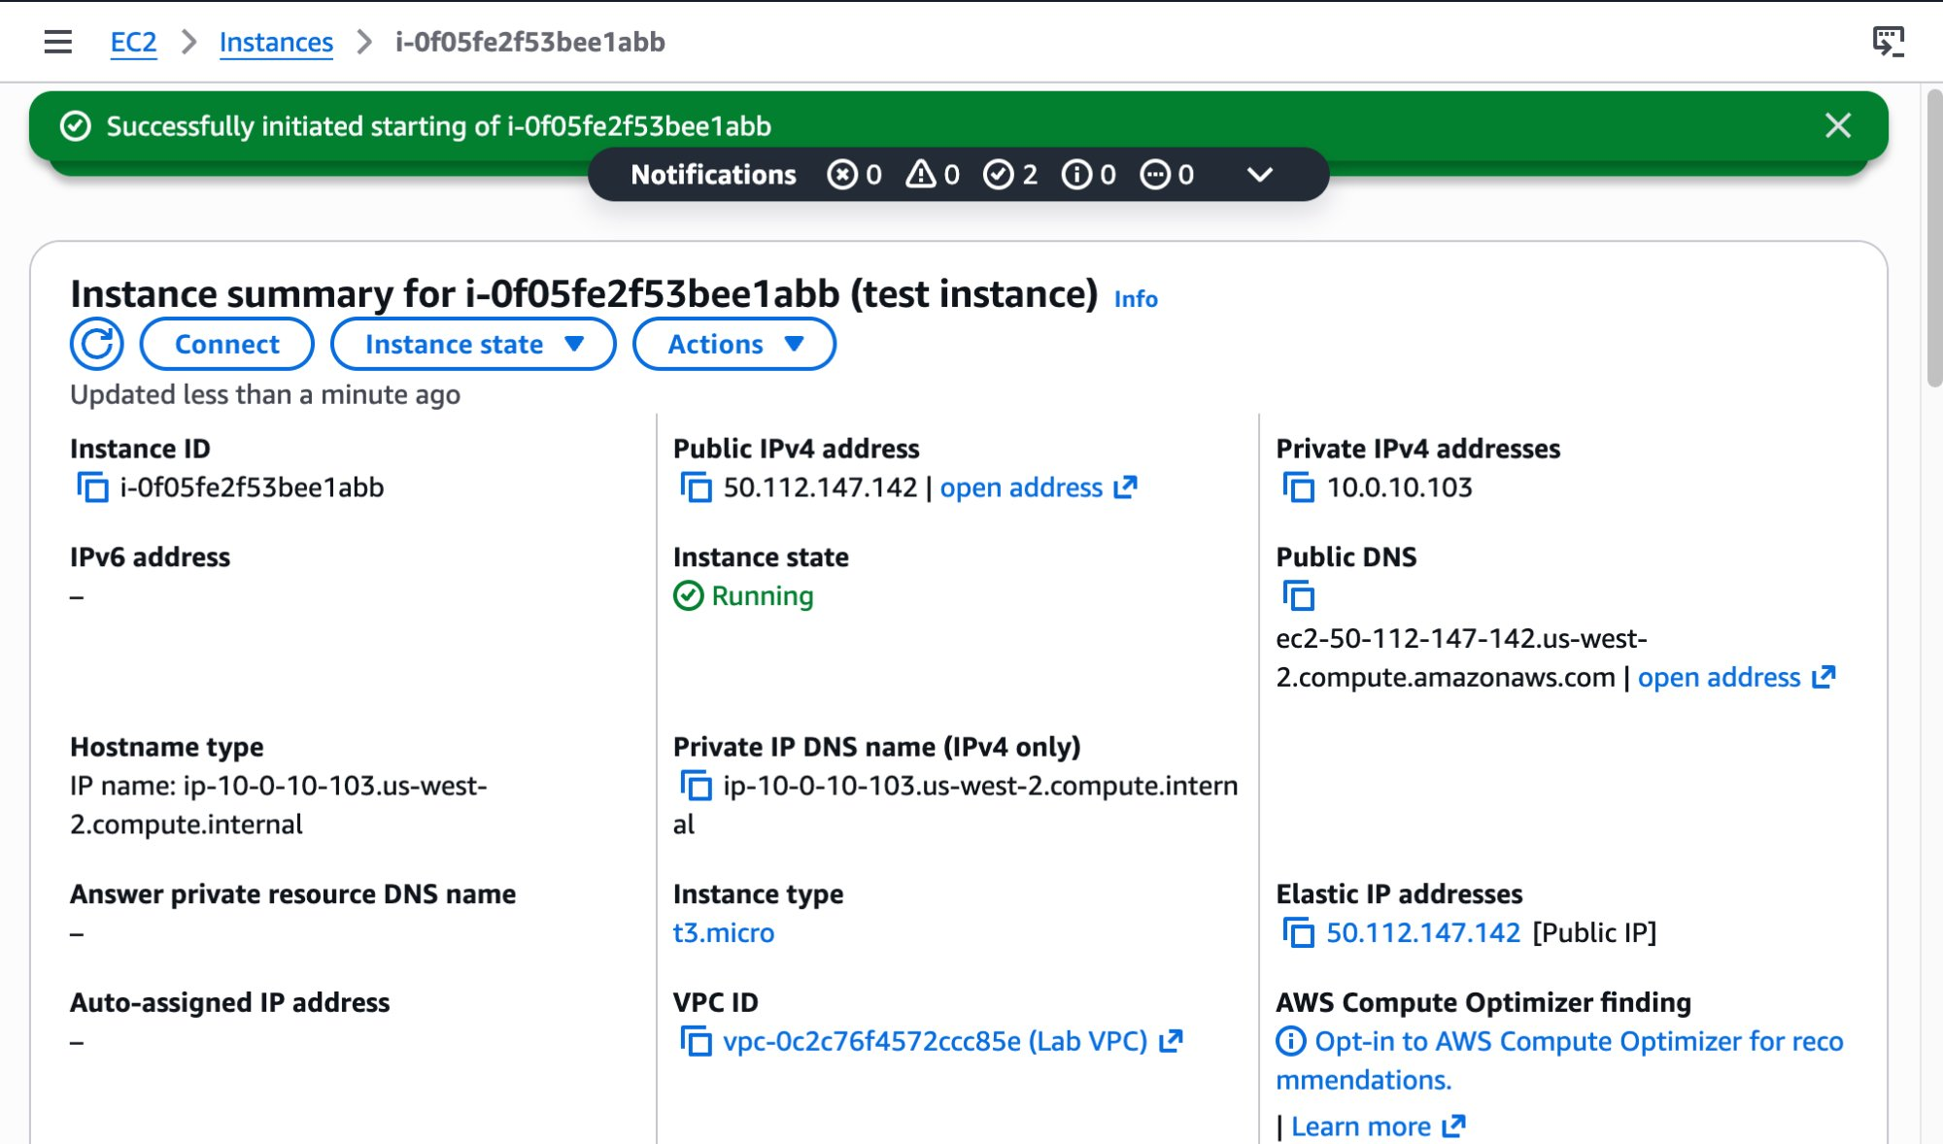

Step 2 — Observe dynamic IP behaviour
- Select test instance. Note the Public IPv4 address (44.249.61.24) and Private IPv4 address (10.0.10.103).
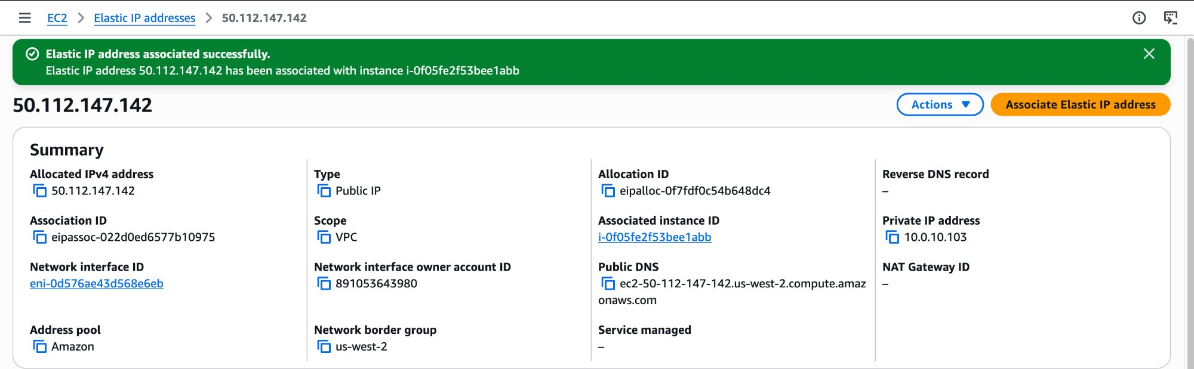

- Click Instance state → Stop instance. Wait until state = Stopped.
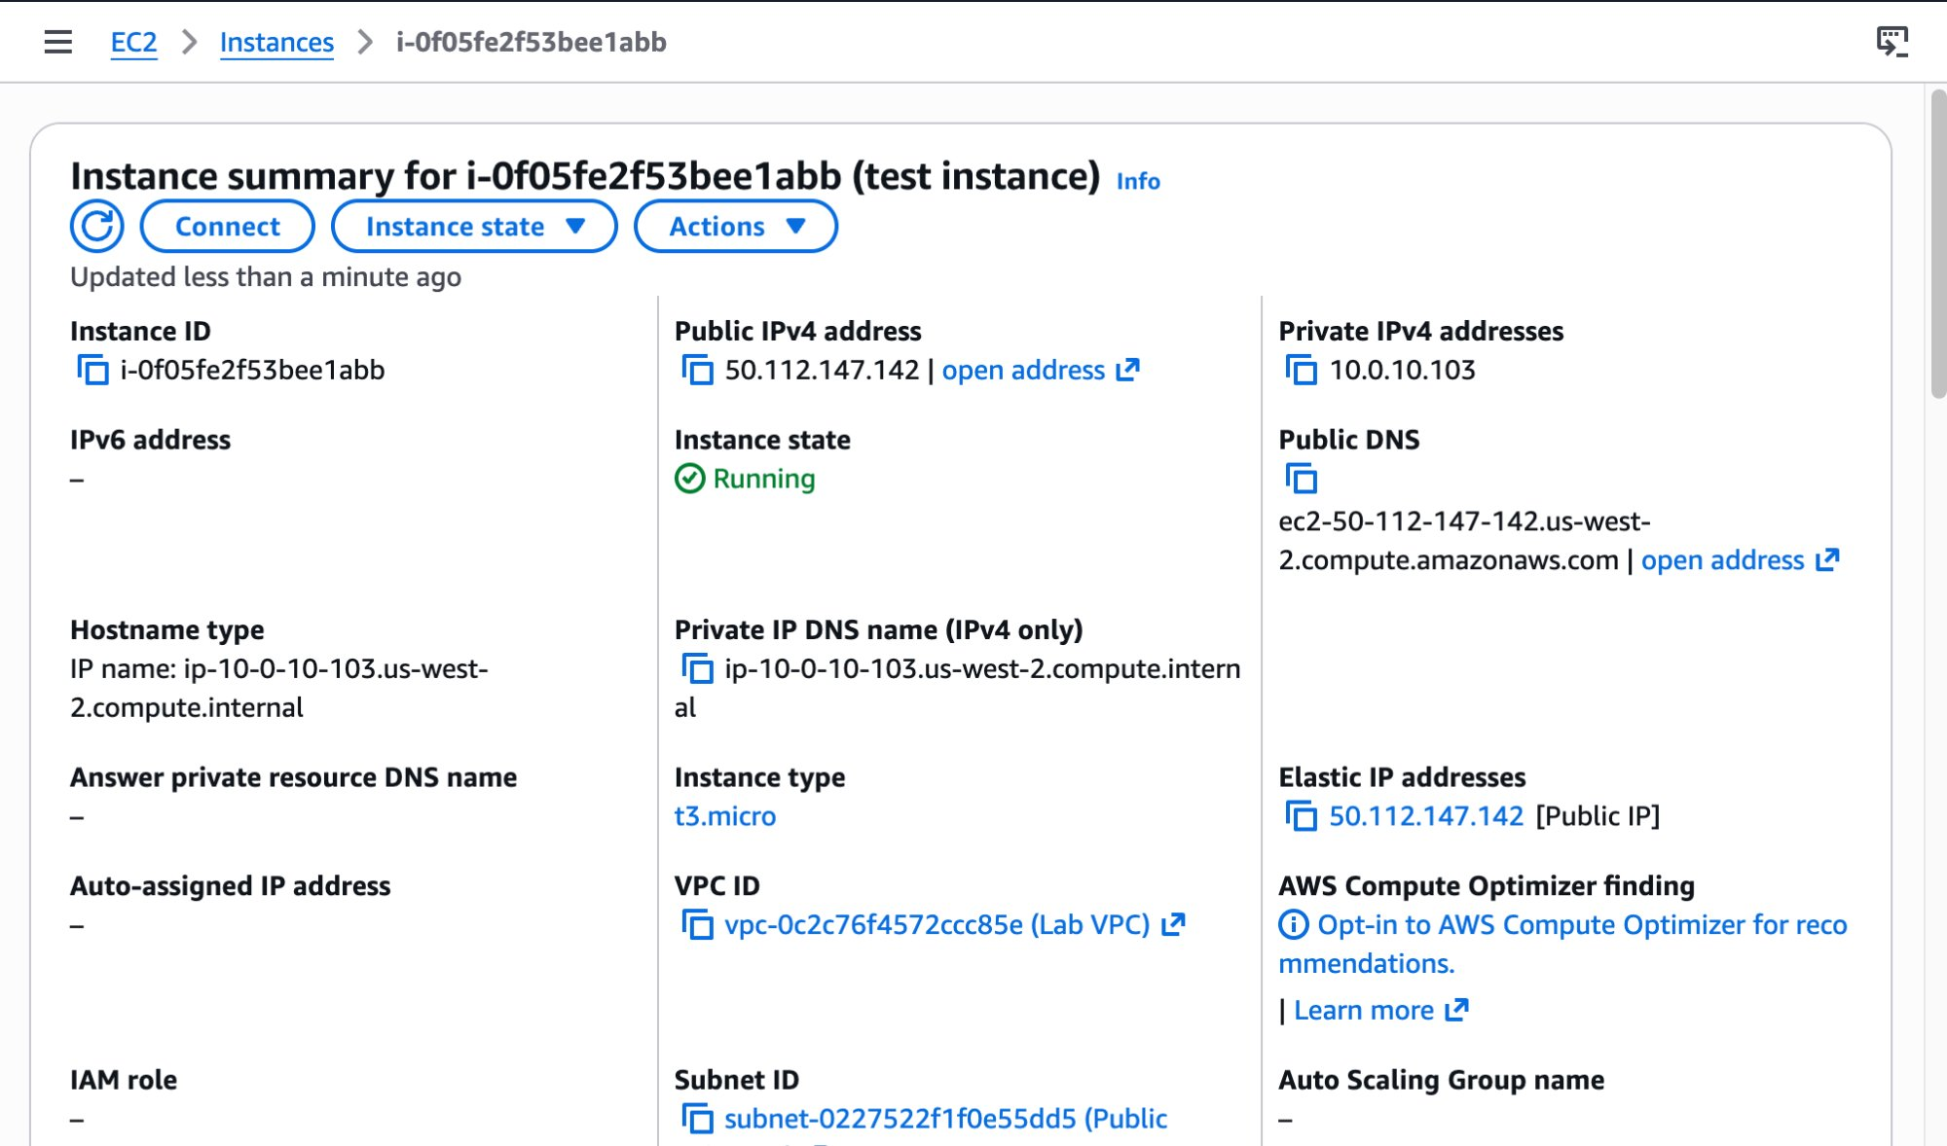

- Click Instance state → Start instance. Wait until state = Running.
- Observe: Public IPv4 address has changed to 44.255.198.4 — a different address from the AWS pool. Private IPv4 remains 10.0.10.103 — unchanged.

NOTE | This confirms the customer issue: the public IP is dynamic. AWS releases it on stop and assigns a new one on start. The private IP is always static for the life of the instance.

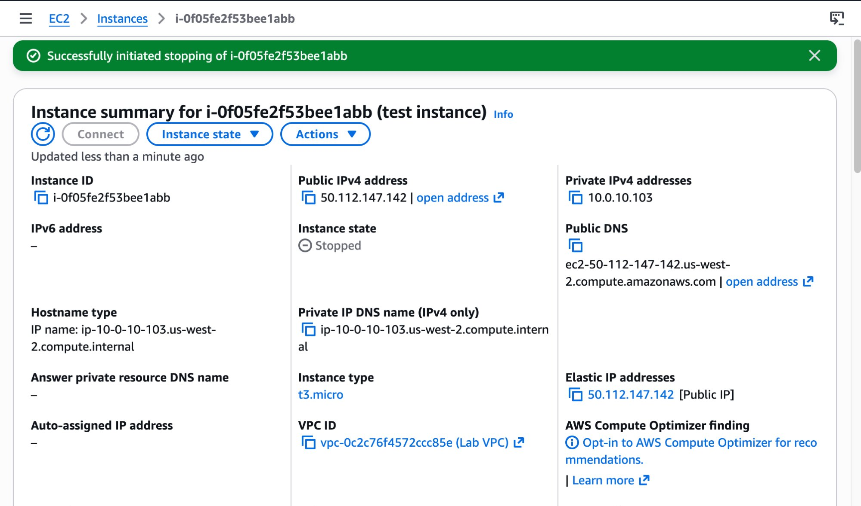

Step 3 — Allocate an Elastic IP
- In the left navigation pane, under Network & Security, choose Elastic IPs.
- Click Allocate Elastic IP address (top-right). Leave all settings as default. Click Allocate.
- Note the allocated EIP: 50.112.147.142 (Allocation ID: eipalloc-0f7fdf0c54b648dc4).

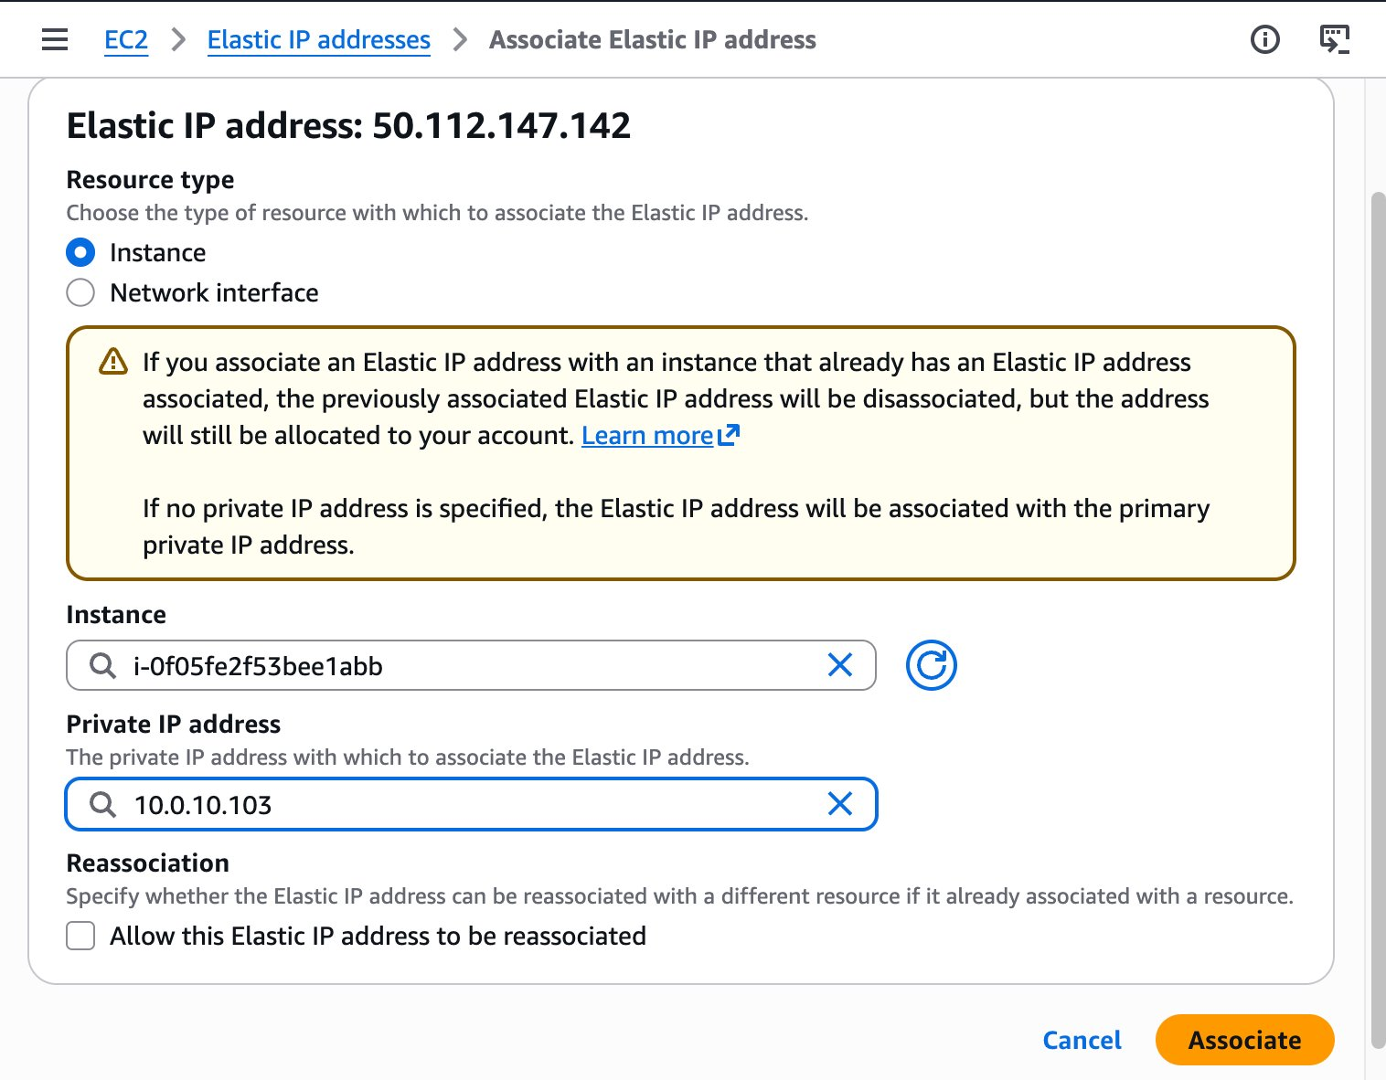

Step 4 — Associate the EIP to the test instance
- Select the checkbox for EIP 50.112.147.142. Click Actions → Associate Elastic IP address.
- Set: Resource type = Instance. Instance: select i-0f05fe2f53bee1abb (test instance). Private IP address: select 10.0.10.103. Click Associate.

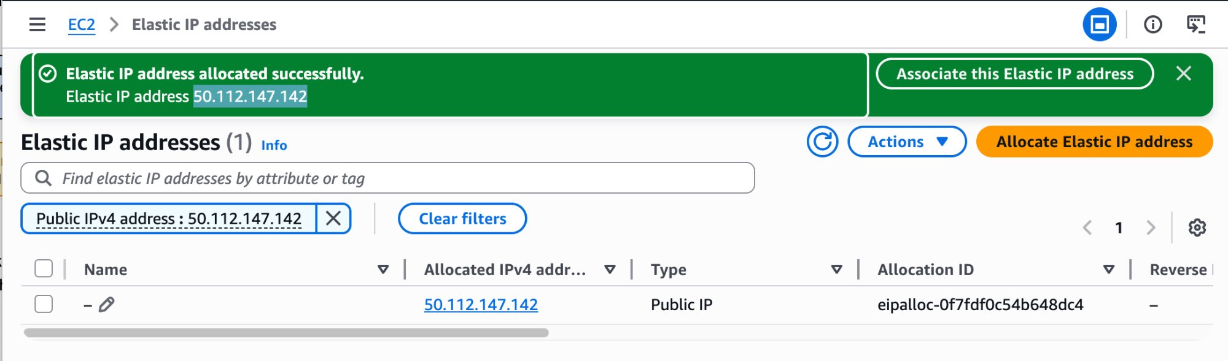

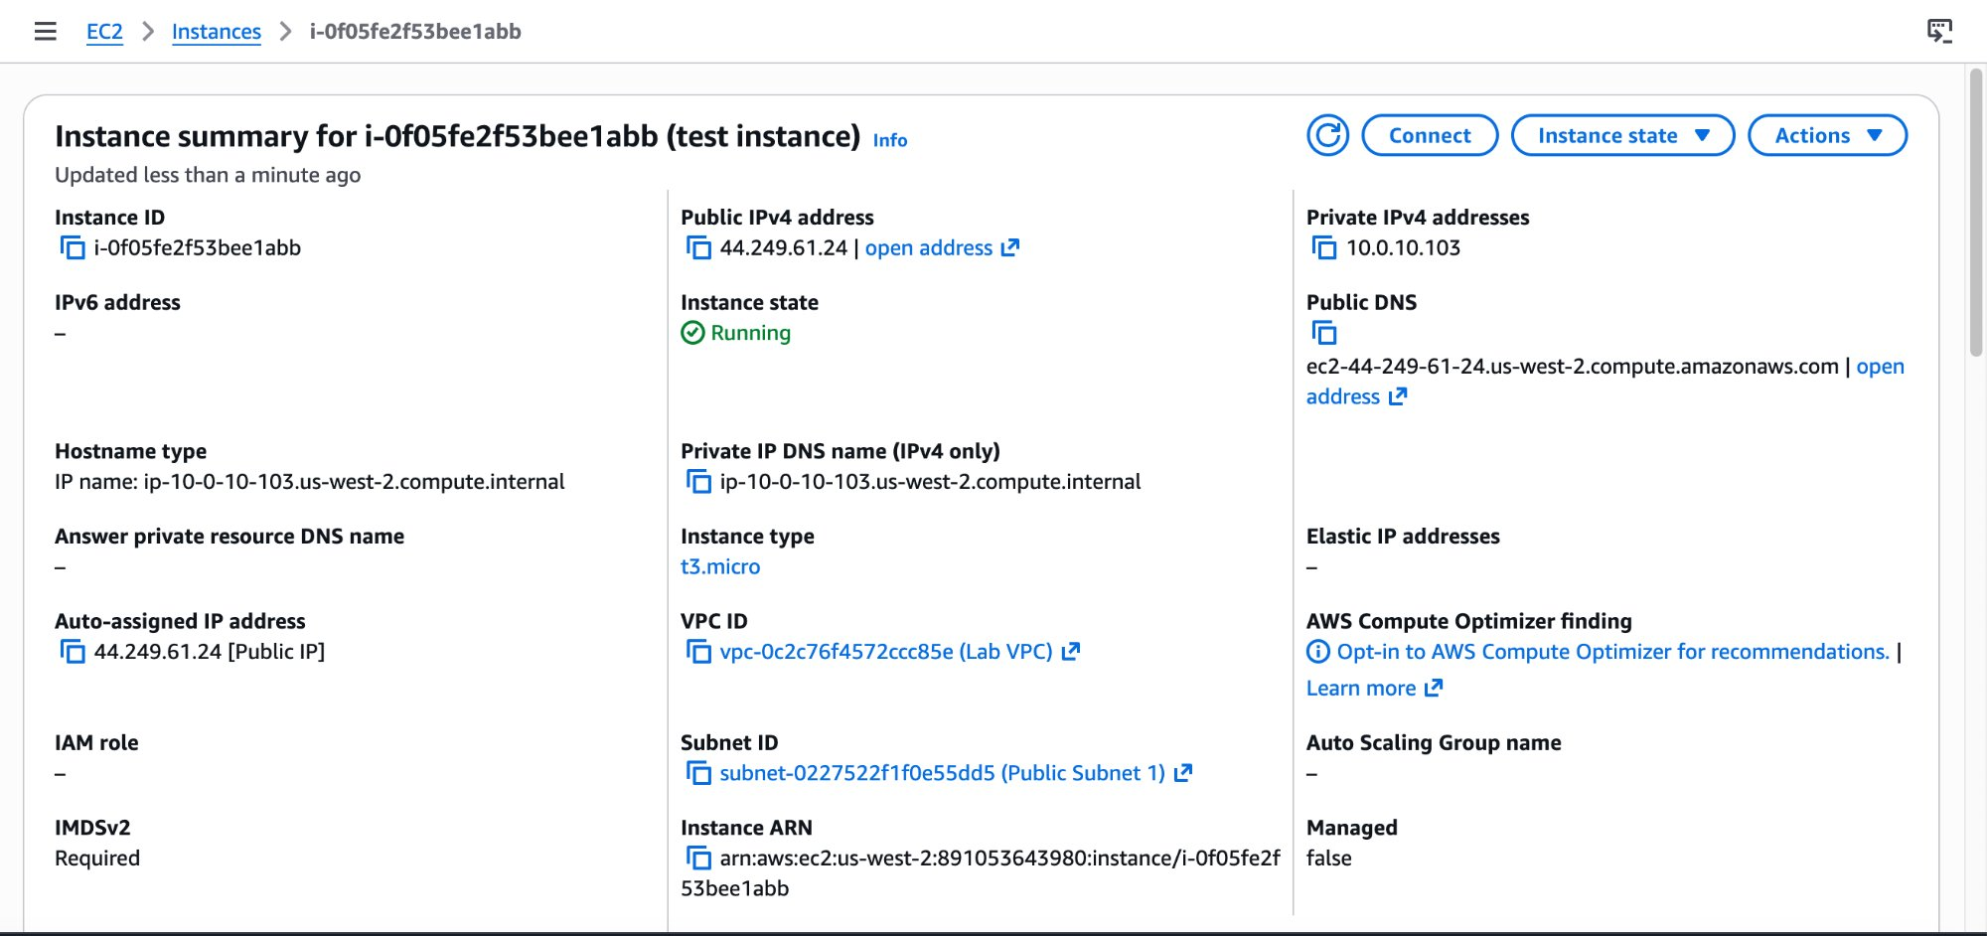

Step 5 — Verify static IP behaviour
- Navigate back to Instances. Select test instance. Confirm Public IPv4 address = 50.112.147.142 and Elastic IP addresses field also shows 50.112.147.142.
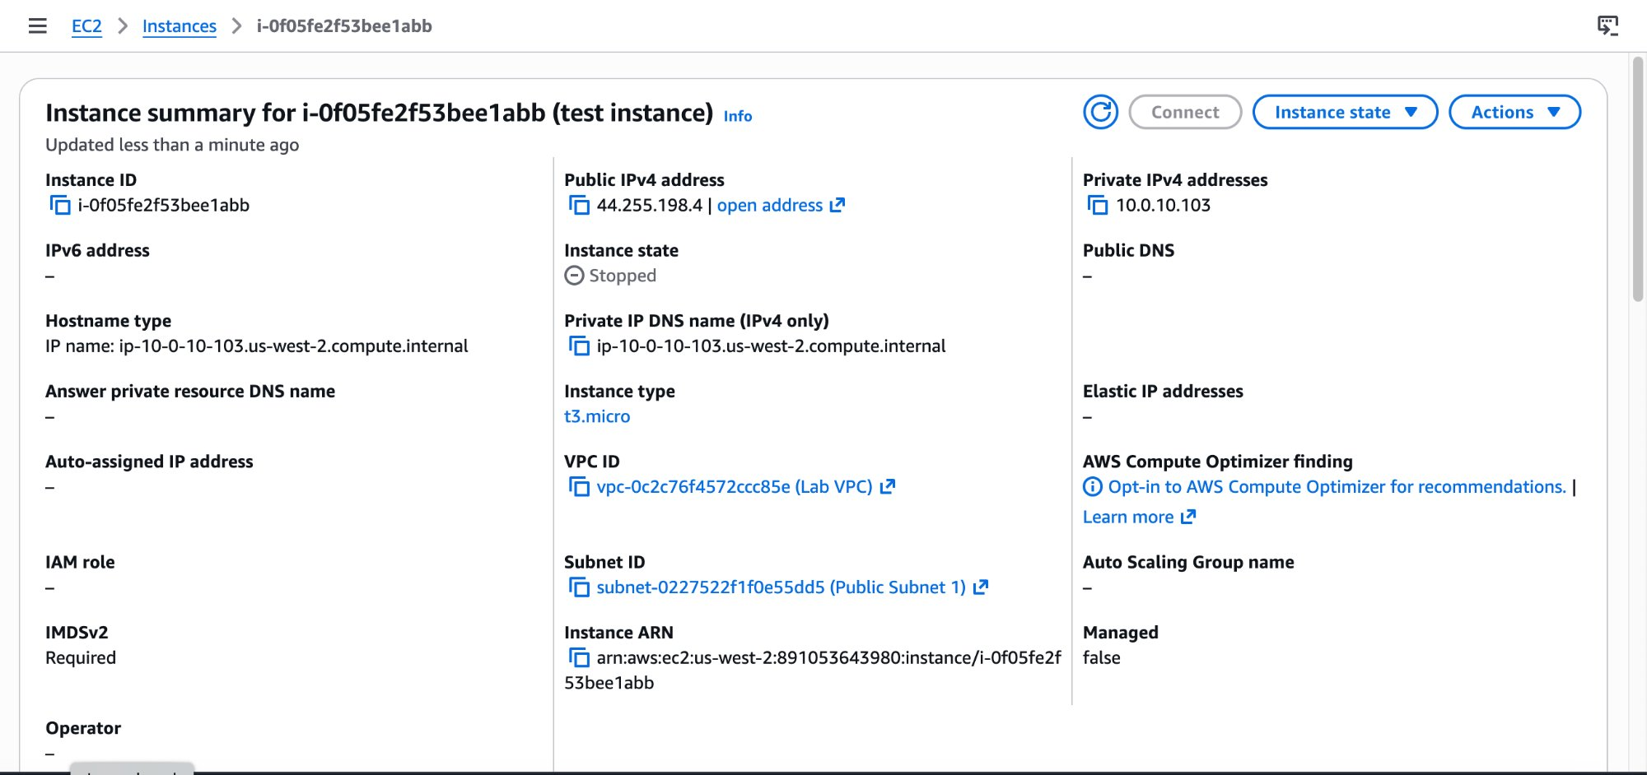

- Click Instance state → Stop instance. Wait until state = Stopped. Observe: EIP 50.112.147.142 is still shown in Elastic IP addresses — it is retained through the stop.
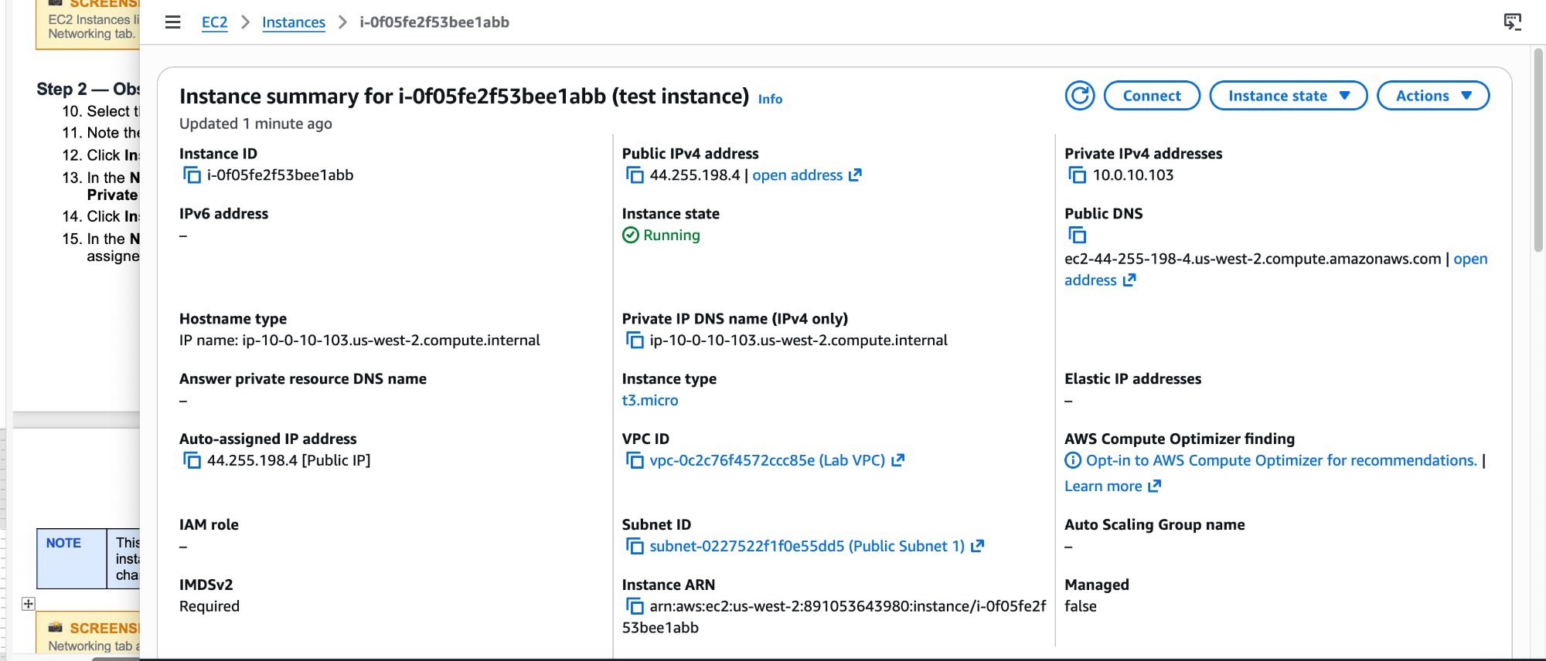

- Click Instance state → Start instance. Wait until state = Running. Confirm Public IPv4 address is still 50.112.147.142 — unchanged.

TIP | EIP confirmed static: the same address persists through the full stop/start cycle. The customer issue is resolved.

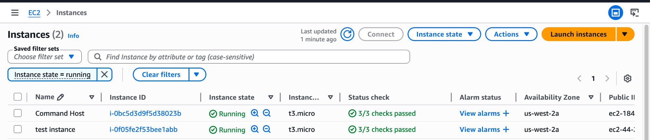

Additional Verification — Test Instance 2
To verify whether the IP display on a stopped instance was a UI cache issue or real behaviour, a second instance was launched with identical settings and the browser was fully closed and reopened after stopping it.
- Launch a second instance named test instance 2 with the same configuration as test instance. Note the initial Public IPv4 address.

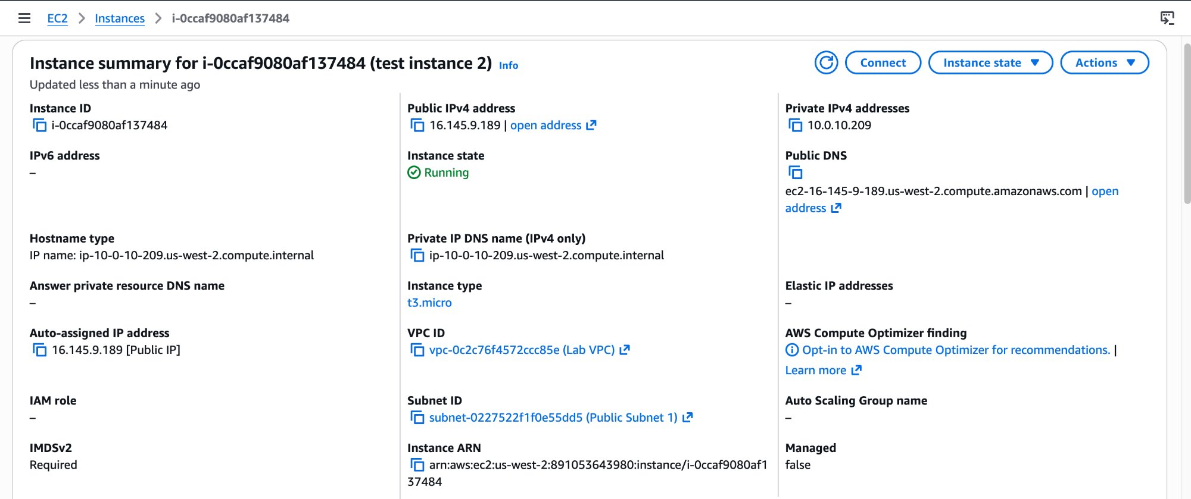

- Stop the instance. Close the browser entirely. Reopen the browser and navigate back to the instance summary.
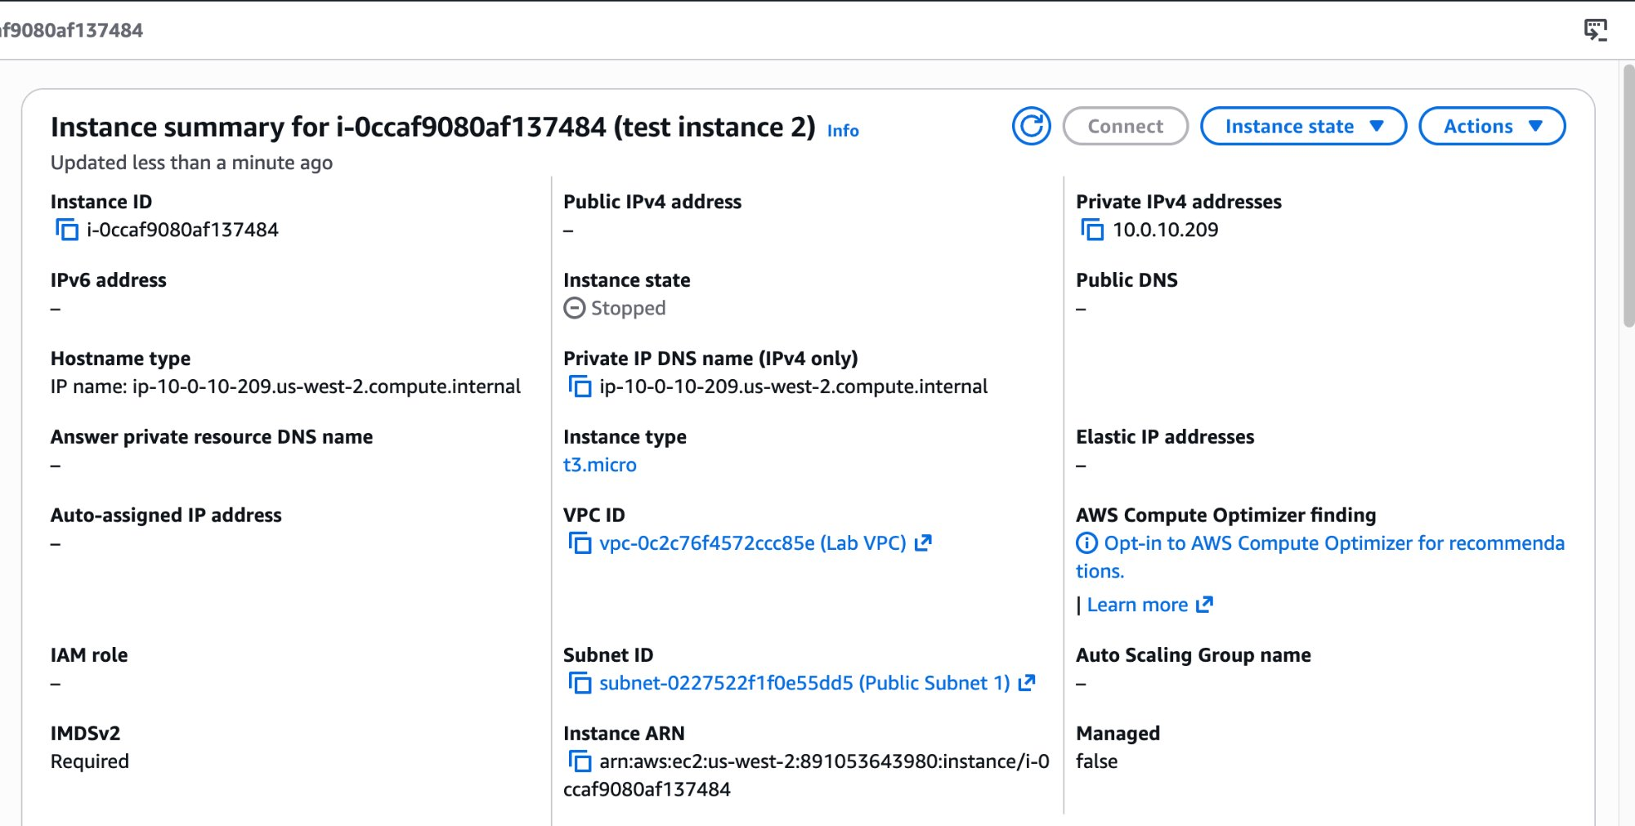

- Start the instance. Confirm a new Public IPv4 address is assigned.
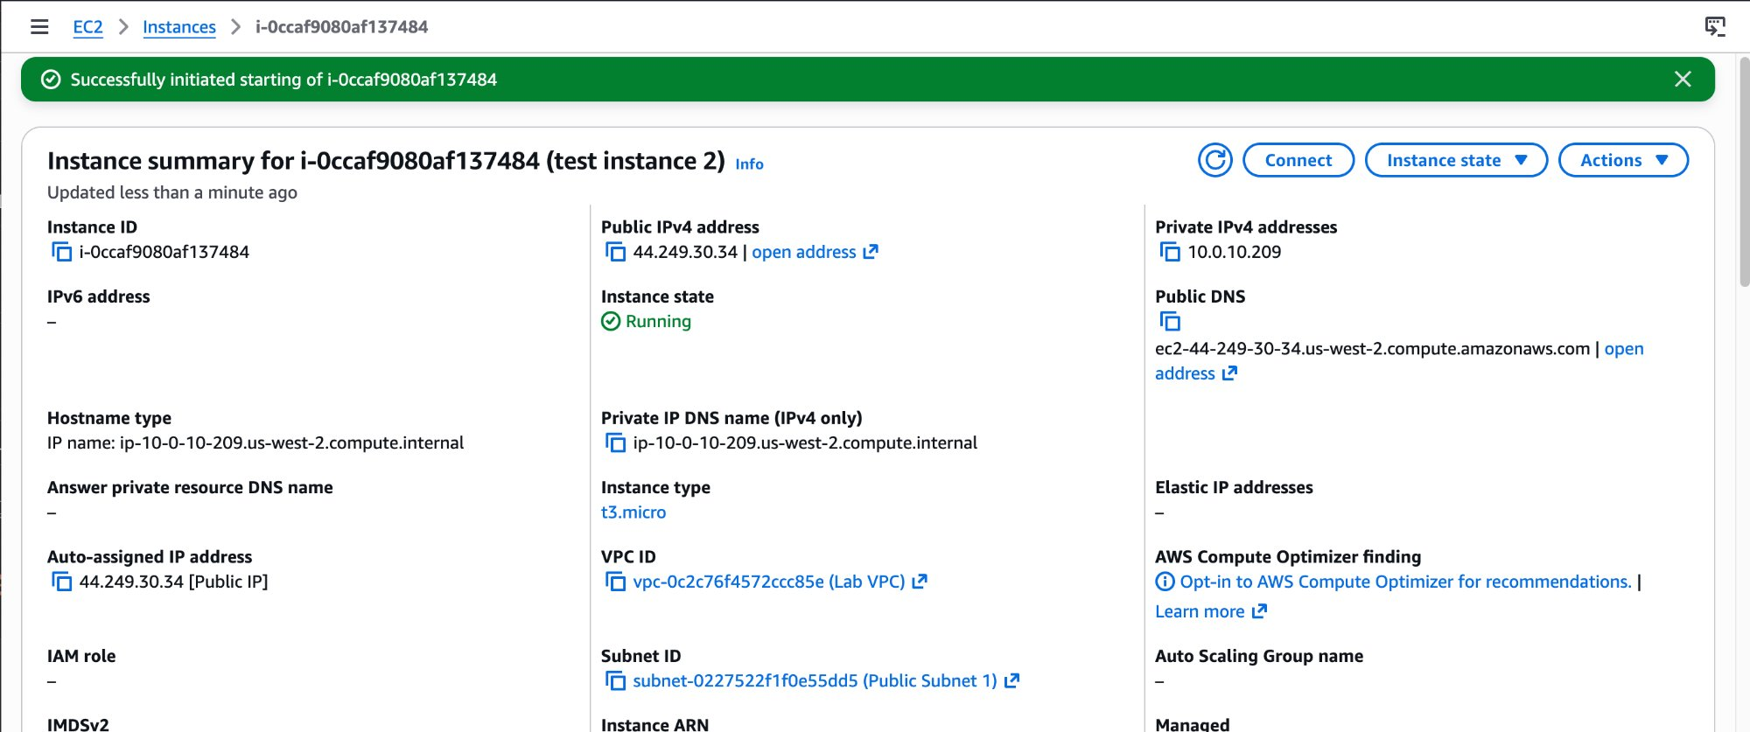

NOTE | This confirms the lab instructions are accurate. The first instance showed a cached value in the browser. With a fresh browser session, the console correctly shows the Public IPv4 field as empty when the instance is stopped — the IP is genuinely released.

Task 2: Send the Response to the Customer
Based on the investigation findings, I drafted the following response to Bob's support ticket:

Hi Bob,
I've investigated the issue with your Public Instance and identified the root cause.
Your instance is configured with an auto-assigned public IP address. This type of IP is dynamic — AWS releases it back to the shared pool whenever the instance is stopped, and assigns a new one when it starts again. That is why the address changes every time.
The fix is to allocate an Elastic IP (EIP) and associate it with your instance. An EIP is a static public IPv4 address tied to your AWS account — it persists through stop/start cycles and will never change unless you explicitly release it.
I have applied this fix to the test environment. The EIP 50.112.147.142 is now associated with the instance and verified to remain unchanged through a full stop/start cycle.
Note: AWS charges for EIPs that are allocated but not associated with a running instance. Keep it associated whenever the instance is running to avoid unnecessary charges.
Let me know if you have any questions.

Git — Commit and Push
NOTE | Run these commands from your Mac terminal from inside the repo root.

GIT | cd ~/Desktop/AWS-reStart-Journey

GIT | git pull origin main --no-rebase

GIT | git add Labs/Networking/lab-262-static-dynamic-addresses/

GIT | git commit -m "Add Lab 262: Static and Dynamic Addresses (Elastic IP)"

GIT | git push origin main

