LAB 275
Introduction to Amazon DynamoDB
AWS re/Start Programme
Estimated Duration: 35 minutes | Region: United States (Oregon)

Resource Names
Resource / Parameter | Value
DynamoDB Table Name | Music
Partition Key | Artist (String)
Sort Key | Song (String)
AWS Region | United States (Oregon)
Capacity Mode | On-demand
Delete confirmation | confirm (type this word in the deletion dialog)
Local repo root | Desktop/AWS-reStart-Journey/Labs/Databases/lab-275-introduction-to-dynamodb
Screenshots folder | Desktop/AWS-reStart-Journey/Labs/Databases/lab-275-introduction-to-dynamodb/screenshots/

Before You Begin
WARNING
Curly quotes: If you copy attribute values from a document, Word/PDF may silently replace straight quotes with curly/typographic quotes. Always type values directly in the DynamoDB console fields.

WARNING
Pasting extra text: When entering values into DynamoDB console fields, paste only the value. Any surrounding text will be stored as part of the attribute value and will cause incorrect query results.

WARNING
Table Active status: After choosing Create table, the table status starts as Pending. Do NOT proceed to Task 2 until the status shows Active (green tick). This typically takes under 60 seconds.

NOTE
Delete confirmation word: The DynamoDB console asks you to type 'confirm' (not 'delete') to confirm table deletion. The lab guide says 'delete' — the actual console prompt says 'confirm'. Type confirm.

Task 1: Create a new table
In this task, you create a DynamoDB table named Music. DynamoDB is a fully managed key-value and document NoSQL database. Every table requires a partition key, which DynamoDB uses to distribute data across physical partitions. An optional sort key combines with the partition key to form a composite primary key.

Step 1 — Open DynamoDB in the AWS Management Console
1. In the AWS Management Console (region: United States / Oregon), choose the Services menu.
2. Under Database, choose DynamoDB.

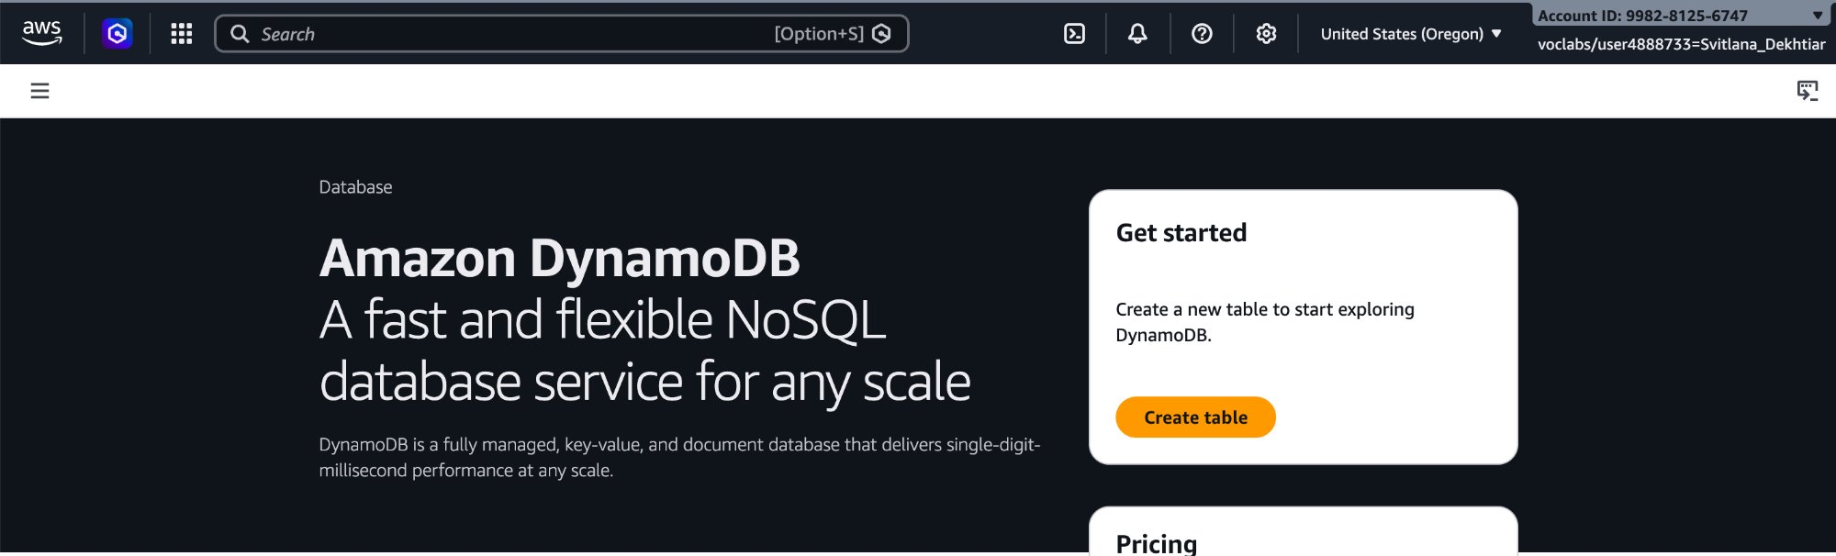

Step 2 — Create the Music table
3. Choose Create table.
4. For Table name, enter: Music
5. For Partition key, enter: Artist — leave String selected.
6. For Sort key - optional, enter: Song — leave String selected.
7. Scroll down and choose Create table.
8. Wait for Status: Active before continuing.

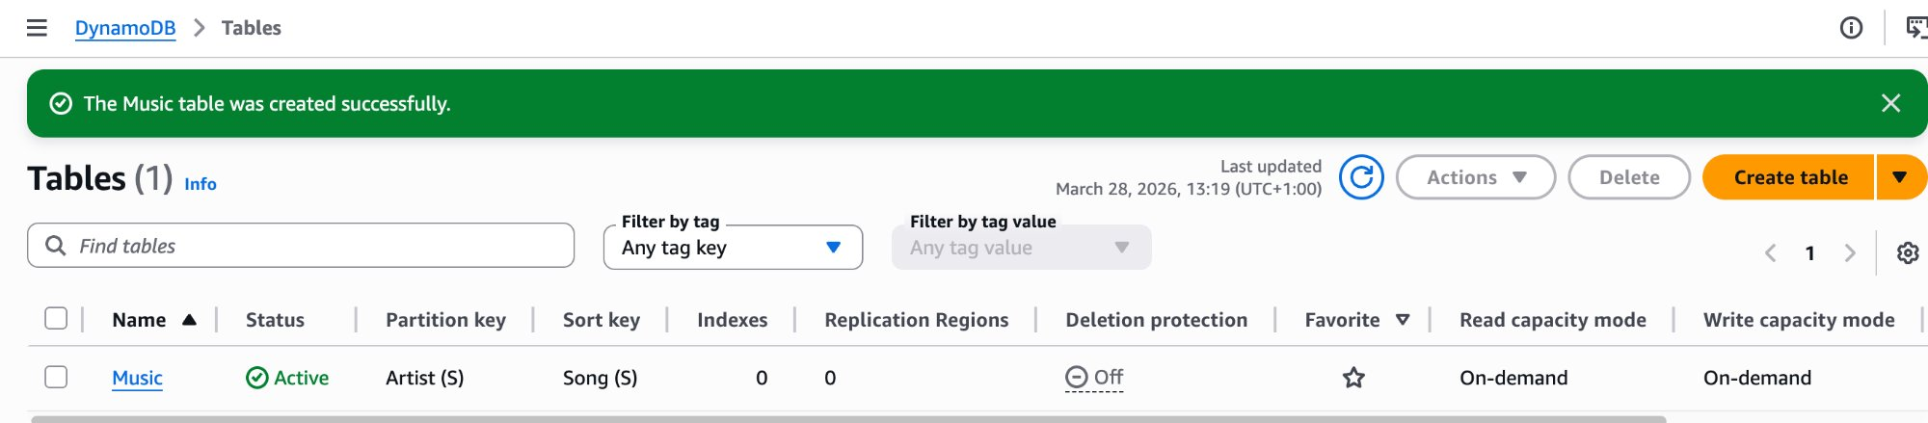

NOTE
The Music table was created successfully. Capacity mode is On-demand. Artist (S) is the Partition key, Song (S) is the Sort key. Deletion protection is Off by default.

Task 2: Add data
In this task, you add three items to the Music table. Only the partition key (Artist) and sort key (Song) are required for each item. All other attributes are optional and can differ between items — this is the schema flexibility that defines a NoSQL database.

Item 1 — Pink Floyd: Money
1. Choose the Music table.
2. Choose Actions > Create item.
3. Enter the following values:

Resource / Parameter | Value
Artist (Partition key, String) | Pink Floyd
Song (Sort key, String) | Money
Album (String) | The Dark Side of the Moon
Year (Number) | 1973

4. Choose Add new attribute > String. Enter Field: Album / Value: The Dark Side of the Moon.
5. Choose Add new attribute > Number. Enter Field: Year / Value: 1973.
6. Choose Create item.

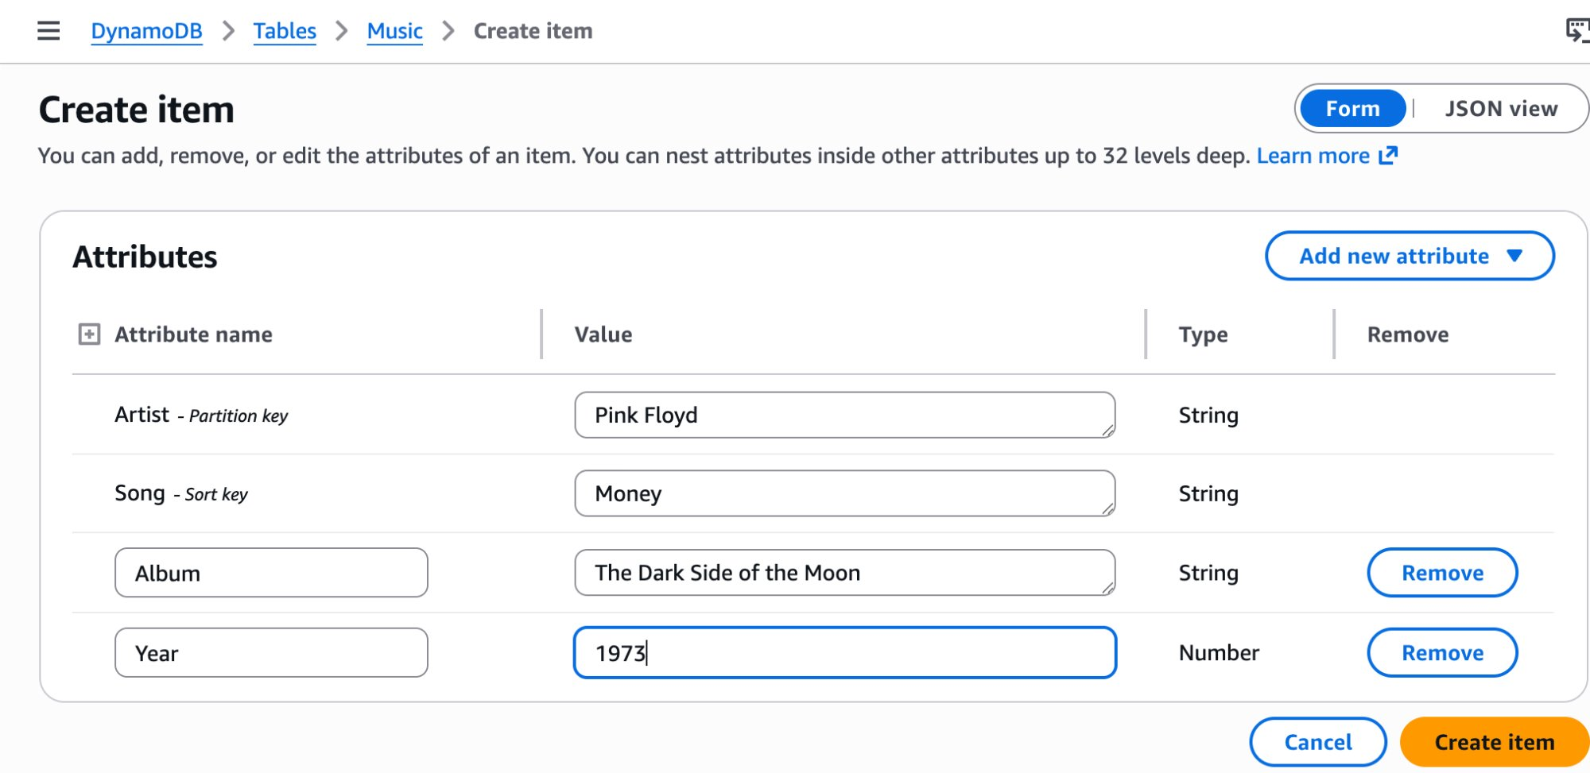

Item 2 — John Lennon: Imagine
7. Choose Actions > Create item and enter:

Resource / Parameter | Value
Artist (String) | John Lennon
Song (String) | Imagine
Album (String) | Imagine
Genre (String) | Soft rock
Year (Number) | 1971

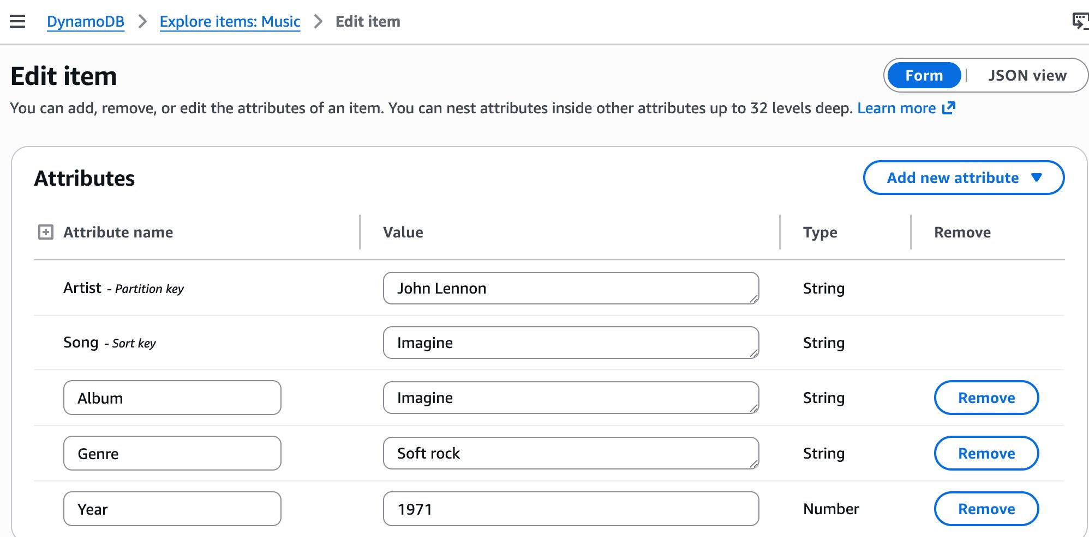

NOTE
The John Lennon item has a Genre attribute that Pink Floyd's item does not have. DynamoDB stored it without any schema change — each item is independent.

Item 3 — Psy: Gangnam Style
8. Choose Actions > Create item and enter:

Resource / Parameter | Value
Artist (String) | Psy
Song (String) | Gangnam Style
Album (String) | Psy 6 (Six Rules), Part 1
Year (Number) | 2011
LengthSeconds (Number) | 219

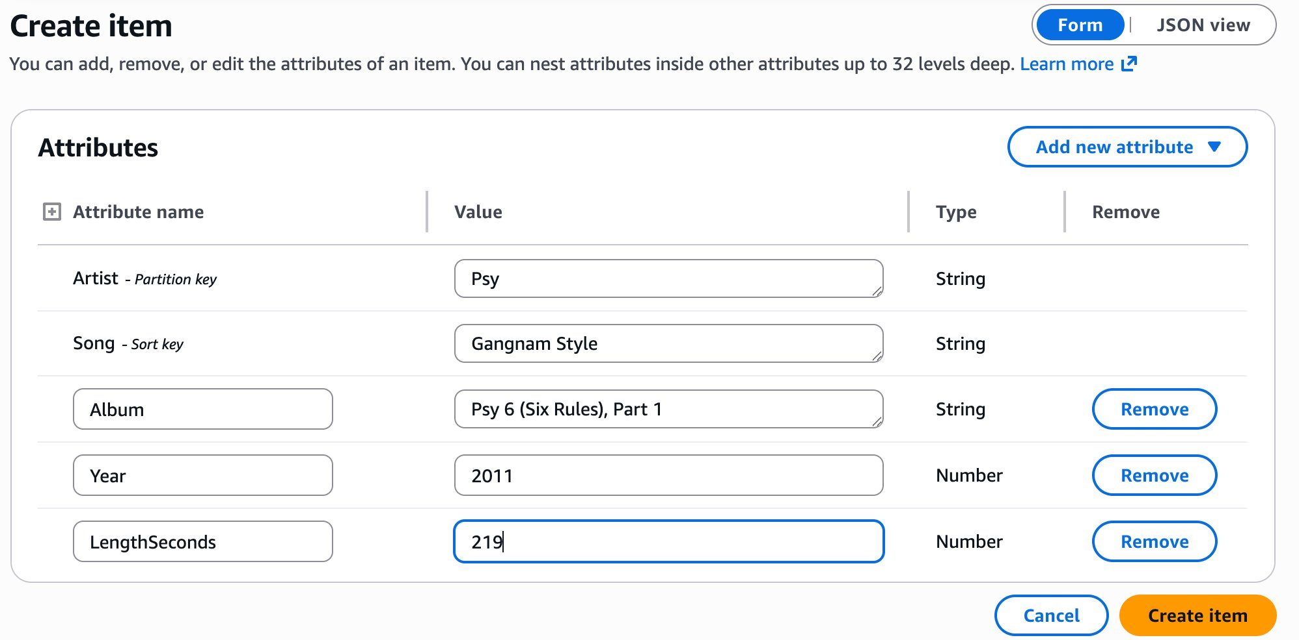

After adding all three items, the table scan shows all records:

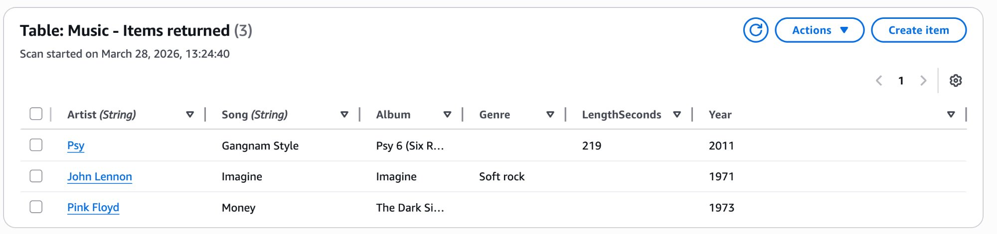

NOTE
At this point Psy's Year shows 2011 — this is intentional. The error will be corrected in Task 3.

Task 3: Modify an existing item
In this task, you correct an error in the Psy item. Gangnam Style was released in 2012, not 2011.

Steps
1. In the DynamoDB left nav, under Tables, choose Explore Items.
2. Choose the Music table.
3. In the items list, choose Psy to open the Edit item form.
4. Change the Year value from 2011 to 2012.
5. Choose Save and close.

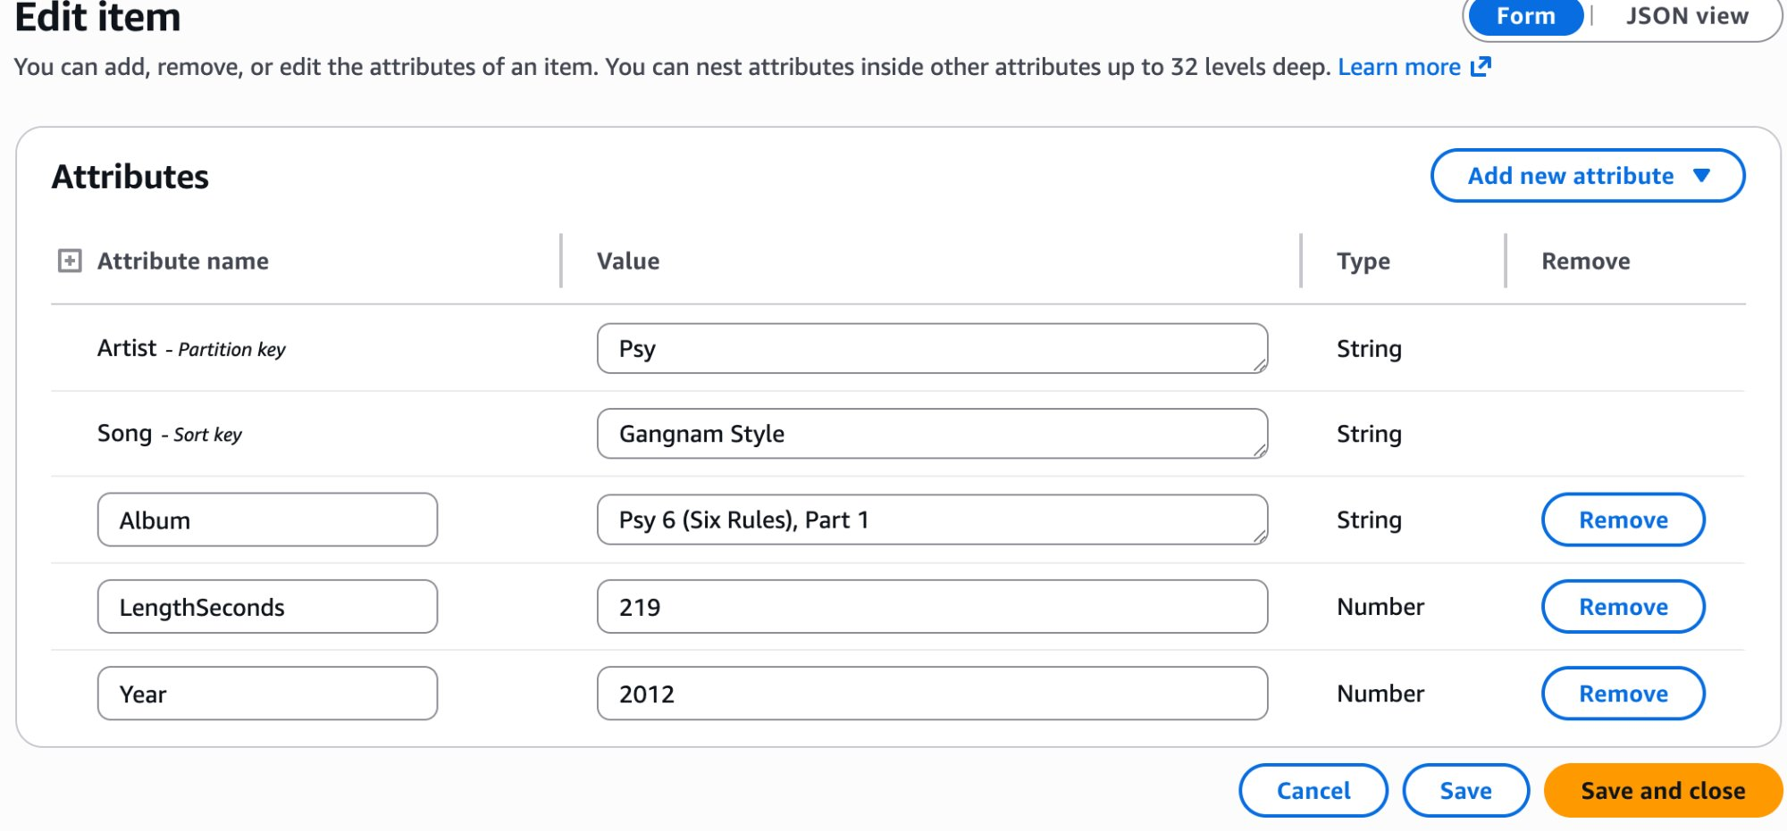

After saving, the items list confirms Year = 2012 for Psy:

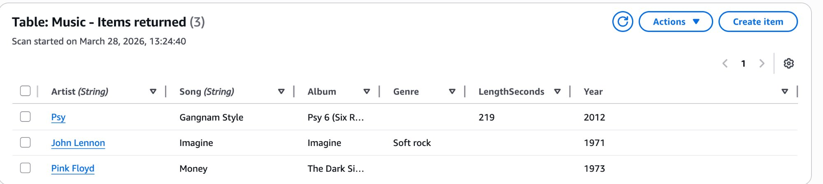

TIP
DynamoDB item edits are immediate — there is no pending state. Once you choose Save and close, the change is applied. Verify by scanning the table or running a query.

Task 4: Query the table
DynamoDB offers two retrieval methods:
Query: Uses the partition key (and optionally the sort key) directly via the table index. Only reads matching items. 100% efficient.
Scan: Reads every item in the table, then applies filters. Efficiency drops as table size grows — in this example: 1 match out of 3 items = 33.33% efficiency, consuming 2 RCUs.

Query — Psy / Gangnam Style
1. On the Explore Items page, expand Scan or query items.
2. Choose Query.
3. Enter: Artist = Psy | Song = Gangnam Style
4. Choose Run.

OUTPUT
Completed
Items returned: 1 | Items scanned: 1 | Efficiency: 100% | RCUs consumed: 0.5
Artist: Psy | Song: Gangnam Style

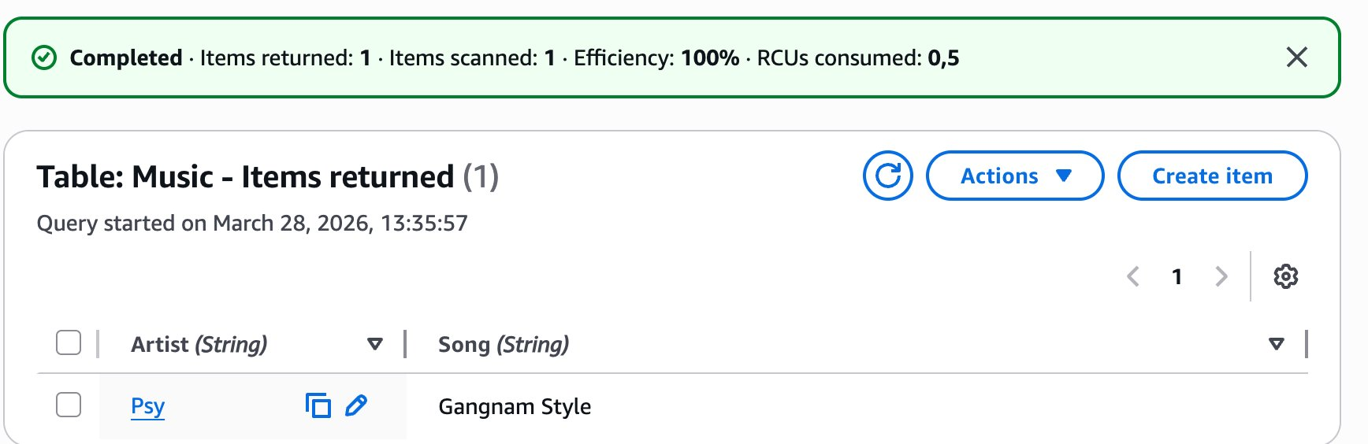

NOTE
100% efficiency means DynamoDB read only the items it returned — it used the index directly. RCUs consumed: 0.5 (one eventually-consistent read of one small item).

Scan with filter — Year = 1971
5. Choose Scan.
6. Expand Filters — optional and enter:

Resource / Parameter | Value
Attribute name | Year
Condition | Equal to
Type | Number
Value | 1971

7. Choose Run.

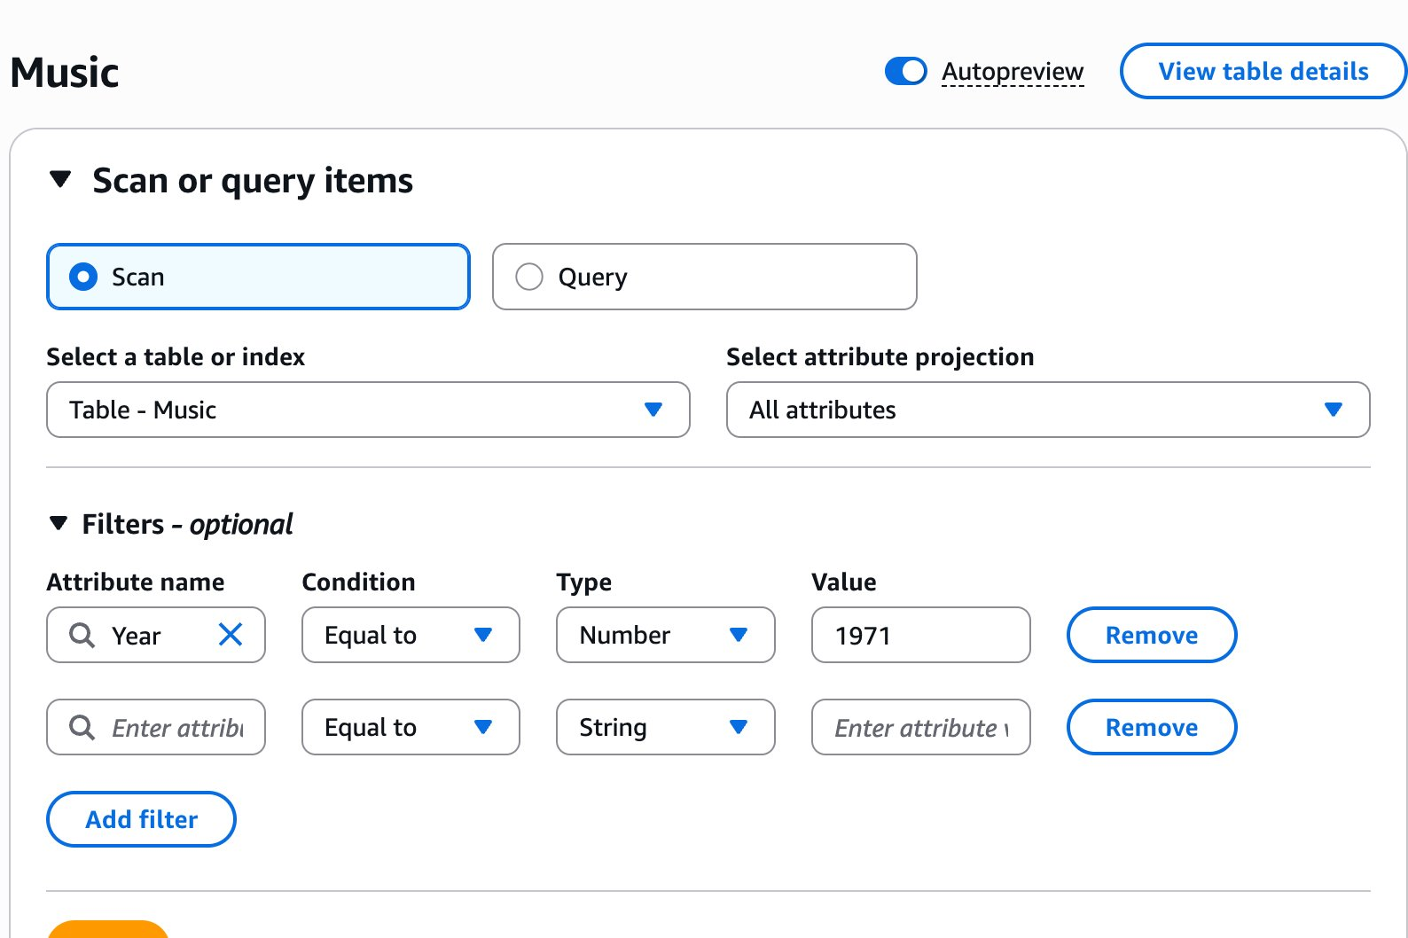

OUTPUT
Completed
Items returned: 1 | Items scanned: 3 | Efficiency: 33.33% | RCUs consumed: 2
Artist: John Lennon | Song: Imagine | Album: Imagine | Genre: Soft rock | Year: 1971

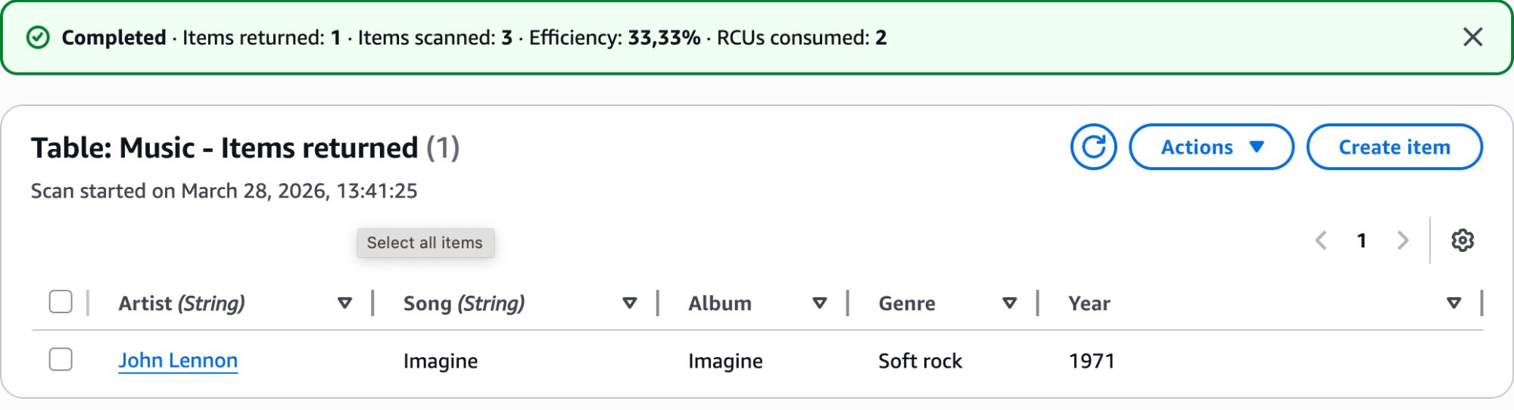

NOTE
Efficiency 33.33% = the scan read all 3 items but only 1 matched the filter. In production tables with millions of items, this gap becomes significant — a full-table scan consumes read capacity proportional to table size, not result size.

Task 5: Delete the table
In this task, you delete the Music table. Deleting a DynamoDB table immediately and permanently removes the table and all items it contains.

WARNING
Deleting a DynamoDB table is irreversible. The confirmation dialog will ask you to type 'confirm' (not 'delete' as the lab guide states). Type confirm exactly as shown.

Steps
1. Navigate to Tables.
2. Select the Music table.
3. Choose Actions > Delete table.
4. In the confirmation dialog, type: confirm
5. Choose Delete.

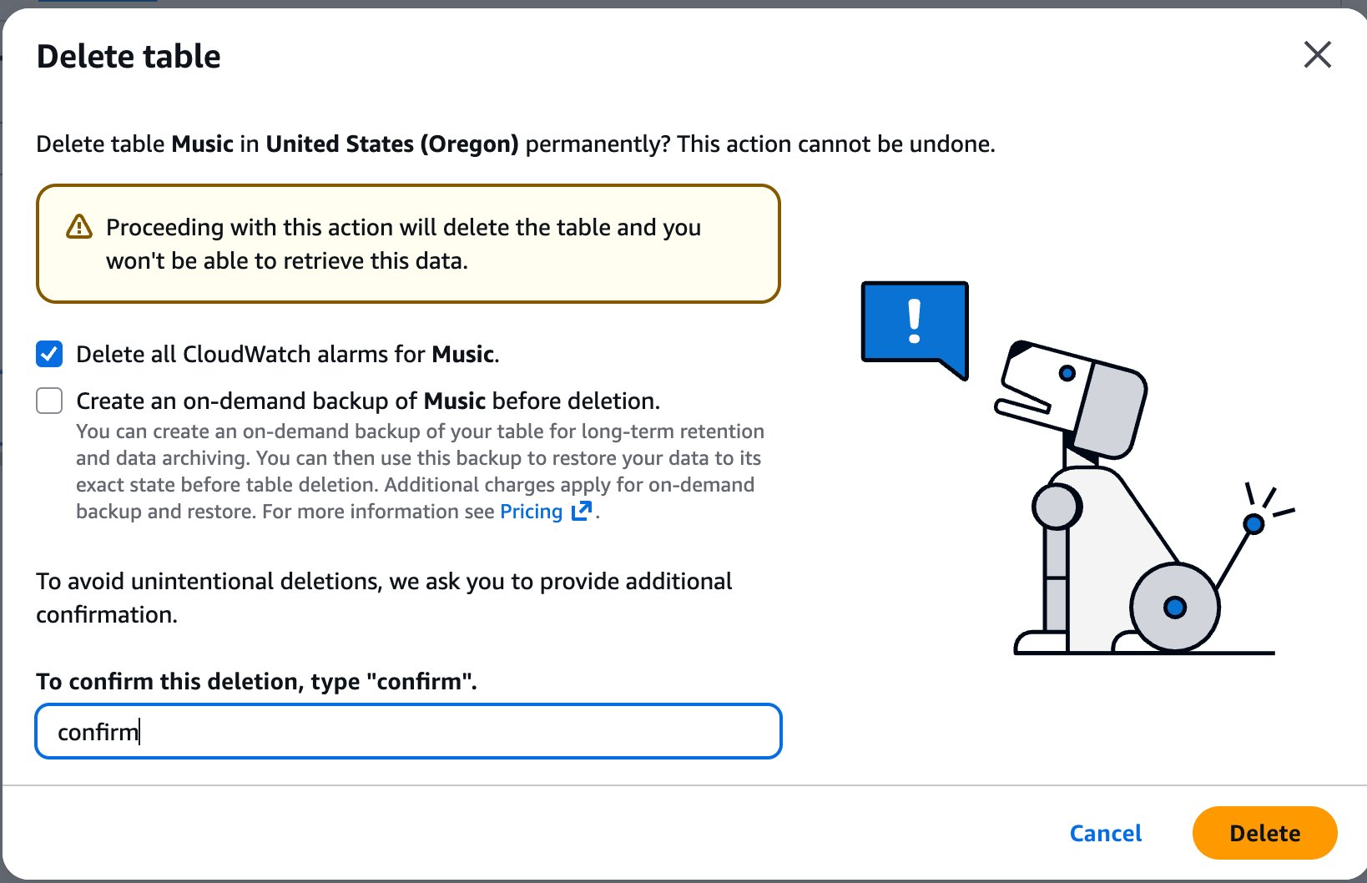

After deletion, the Tables list shows 0 tables:

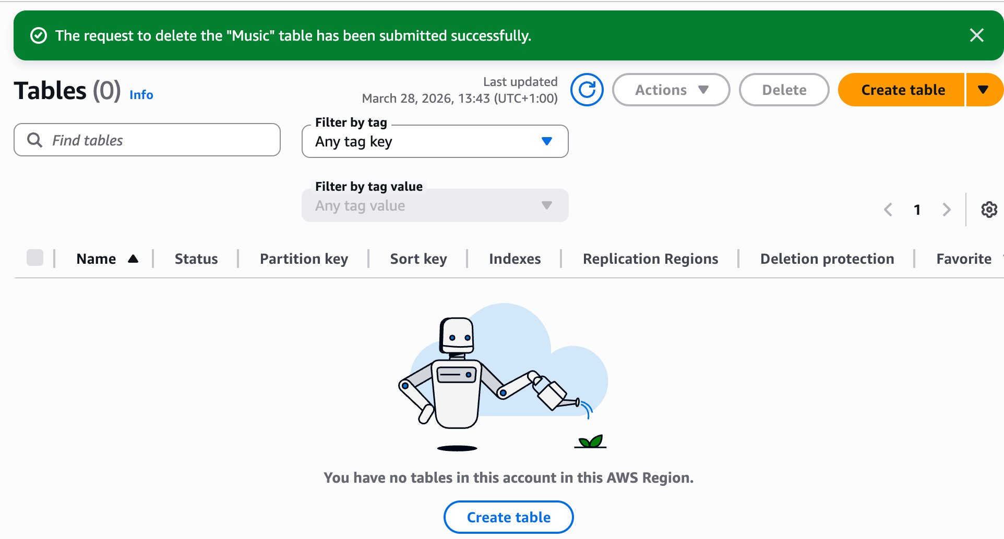

Pushing to GitHub

GIT | cd ~/Desktop/AWS-reStart-Journey/Labs/Databases/lab-275-introduction-to-dynamodb

GIT | git add .

GIT | git commit -m "Add Lab 275: Introduction to Amazon DynamoDB"

GIT | git push origin main

NOTE
GitHub does not accept your account password for CLI pushes. Use a Personal Access Token (PAT) as the password when prompted.

Screenshot Reference Summary
All screenshots saved to: Desktop/AWS-reStart-Journey/Labs/Databases/lab-275-introduction-to-dynamodb/screenshots/

# | Filename | Task | What to capture
01 | Desktop/AWS-reStart-Journey/Labs/Databases/lab-275-introduction-to-dynamodb/screenshots/01_dynamodb_console_home.png | Task 1 | DynamoDB console home (Amazon DynamoDB landing page)
02 | Desktop/AWS-reStart-Journey/Labs/Databases/lab-275-introduction-to-dynamodb/screenshots/02_table_active_status.png | Task 1 | Music table created — Status: Active in Tables list
03 | Desktop/AWS-reStart-Journey/Labs/Databases/lab-275-introduction-to-dynamodb/screenshots/03_create_item_pink_floyd.png | Task 2 | Create item — Pink Floyd / Money with Album and Year
04 | Desktop/AWS-reStart-Journey/Labs/Databases/lab-275-introduction-to-dynamodb/screenshots/04_create_item_john_lennon.png | Task 2 | Create item — John Lennon / Imagine with Genre
05 | Desktop/AWS-reStart-Journey/Labs/Databases/lab-275-introduction-to-dynamodb/screenshots/05_create_item_psy.png | Task 2 | Create item — Psy / Gangnam Style with LengthSeconds
06 | Desktop/AWS-reStart-Journey/Labs/Databases/lab-275-introduction-to-dynamodb/screenshots/06_items_list_three_items.png | Task 2 | Items list showing all 3 items (Year 2011 before edit)
07 | Desktop/AWS-reStart-Journey/Labs/Databases/lab-275-introduction-to-dynamodb/screenshots/07_edit_psy_year_2012.png | Task 3 | Edit item form — Psy Year changed to 2012
08 | Desktop/AWS-reStart-Journey/Labs/Databases/lab-275-introduction-to-dynamodb/screenshots/08_psy_item_saved_2012.png | Task 3 | Items list after save — Psy Year now 2012
09 | Desktop/AWS-reStart-Journey/Labs/Databases/lab-275-introduction-to-dynamodb/screenshots/09_query_psy_result.png | Task 4 | Query result — Psy / Gangnam Style (1 returned, 100% efficiency)
10 | Desktop/AWS-reStart-Journey/Labs/Databases/lab-275-introduction-to-dynamodb/screenshots/10_scan_year_1971_maintenance.png | Task 4 | Scan filter configuration — Year = 1971, Number, Equal to
11 | Desktop/AWS-reStart-Journey/Labs/Databases/lab-275-introduction-to-dynamodb/screenshots/11_scan_year_1971_result_.png | Task 4 | Scan result — 1 item returned (John Lennon), 3 scanned, 33.33% efficiency
12 | Desktop/AWS-reStart-Journey/Labs/Databases/lab-275-introduction-to-dynamodb/screenshots/12_delete_table_confirmation.png | Task 5 | Delete table confirmation dialog — 'confirm' typed
13 | Desktop/AWS-reStart-Journey/Labs/Databases/lab-275-introduction-to-dynamodb/screenshots/13_table_deleted_success.png | Task 5 | Tables (0) — Music table successfully deleted

