Lab 265 — Internet Protocol Troubleshooting Commands
AWS re/Start Programme | Duration: 30 min | Region: us-east-1
Resource Names
Resource / Setting | Value
EC2 Instance | Amazon Linux 2 (lab-provided)
Public IP | 44.246.128.202
Instance hostname | ip-10-0-10-96
Key file | labsuser.pem
Key location | ~/Downloads/labsuser.pem
Lab region | us-east-1
Local repo root | ~/Desktop/AWS-reStart-Journey/Labs/Networking/lab-265-ip-troubleshooting
Screenshots folder | ~/Desktop/AWS-reStart-Journey/Labs/Networking/lab-265-ip-troubleshooting/screenshots
GitHub repo | https://github.com/svitlana-dekhtiar/aws-restart-journey

Before You Begin
WARNING: Curly quotes: copying commands from Word or PDF may convert straight quotes to curly ones. Always retype quotes and apostrophes manually in the terminal.

WARNING: Pasting extra text: paste only the command itself — never paste surrounding explanatory text into the terminal.

WARNING: Silent wait commands: commands such as aws ec2 wait block silently. Do not close the terminal or assume the command failed.

WARNING: SSH key permissions: if chmod 400 was not run before connecting, SSH will reject the key with 'Permission denied (publickey)'. Always set permissions before the first connection.

Task 1: Use SSH to Connect to an Amazon Linux EC2 instance
Retrieve credentials
Choose Details → Show. Note the PublicIP value. Click Download PEM → save labsuser.pem to Downloads.
Set key permissions
CMD | chmod 400 ~/Downloads/labsuser.pem

Connect via SSH
CMD | ssh -i ~/Downloads/labsuser.pem ec2-user@44.246.128.202
NOTE: Type yes when prompted to accept the host fingerprint. No password prompt — authentication uses the key file.

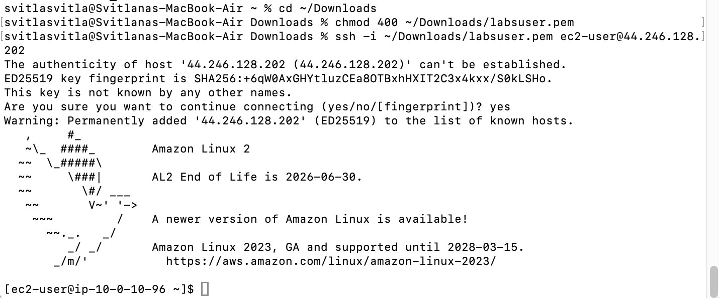

Task 2: Practice Troubleshooting Commands
Layer 3 (Network): ping
Scenario: customer launched an EC2 instance and needs to verify ICMP connectivity through security groups and NACLs.
CMD | ping 8.8.8.8 -c 5
NOTE: The -c flag sets packet count. ping sends ICMP echo requests and reports round-trip time and packet loss per packet. 0% loss confirms the security group allows outbound ICMP.

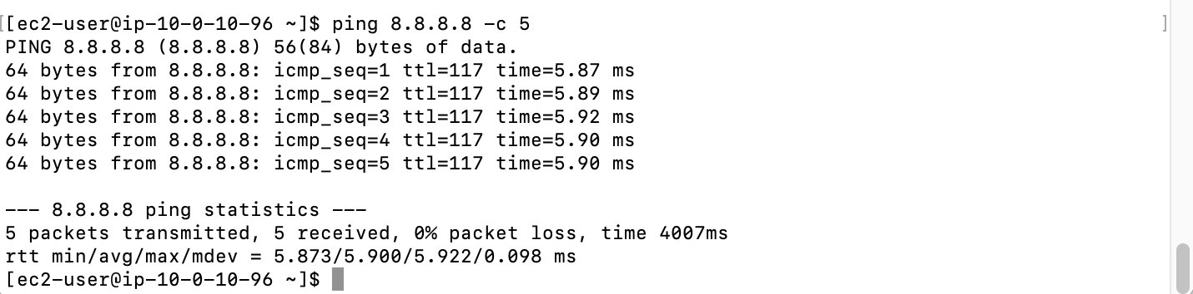

Layer 3 (Network): traceroute
Scenario: customer reports latency and packet loss — determine whether the issue is within AWS or the customer's ISP.
CMD | traceroute 8.8.8.8
NOTE: Each line = one hop. Three asterisks (***) indicate a filtered or failed hop. Packet loss appearing in the early hops suggests a LAN/ISP issue; loss at the final hops suggests a server or destination issue.

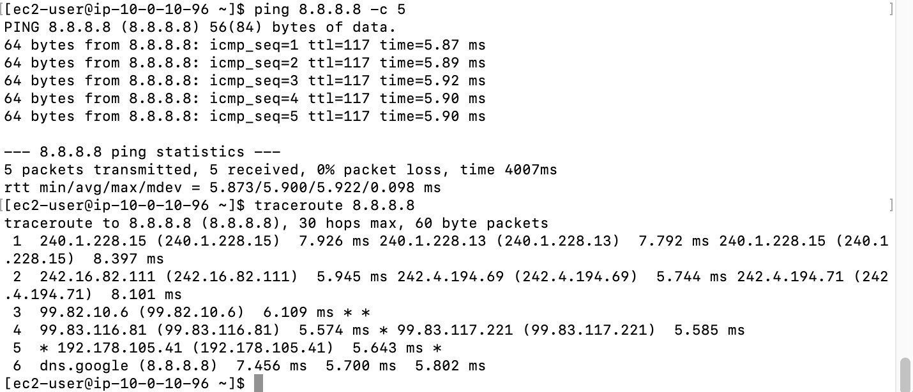

Layer 4 (Transport): netstat
Scenario: security scan flagged a port — confirm whether it is actively listening on this host.
CMD | netstat -tp
Other useful options: netstat -tlp (listening services) netstat -ntlp (no port name resolution)
NOTE: Running netstat -tp as ec2-user (not root) shows connections but suppresses process names — the warning 'No info could be read for -p' is expected behaviour. Use sudo netstat -tp to see process names.

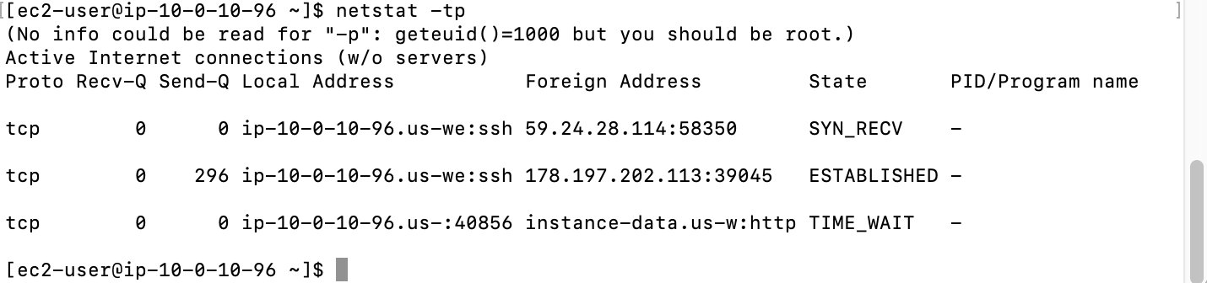

Layer 4 (Transport): telnet
Scenario: customer suspects port 80 is open despite a security group rule — verify TCP reachability with telnet.
CMD | sudo yum install telnet -y

CMD | telnet www.google.com 80
NOTE: Successful connection = nothing is blocking the path. 'Connection refused' = firewall/security group actively blocking. 'Connection timed out' = no route or silent drop.

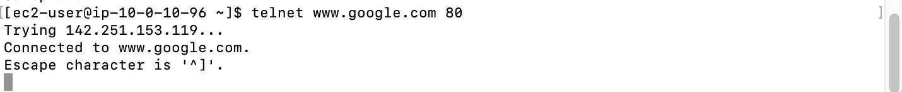

Layer 7 (Application): curl
Scenario: customer runs an Apache server and wants to verify they receive HTTP 200 OK.
CMD | curl -vLo /dev/null https://aws.com
Options: -v verbose -L follow redirects -o /dev/null discard body -I HEAD request -k ignore SSL errors
NOTE: curl shows the full TLS handshake, redirect chain, and response headers in verbose mode. A '200' status in the output confirms the application is reachable end-to-end.

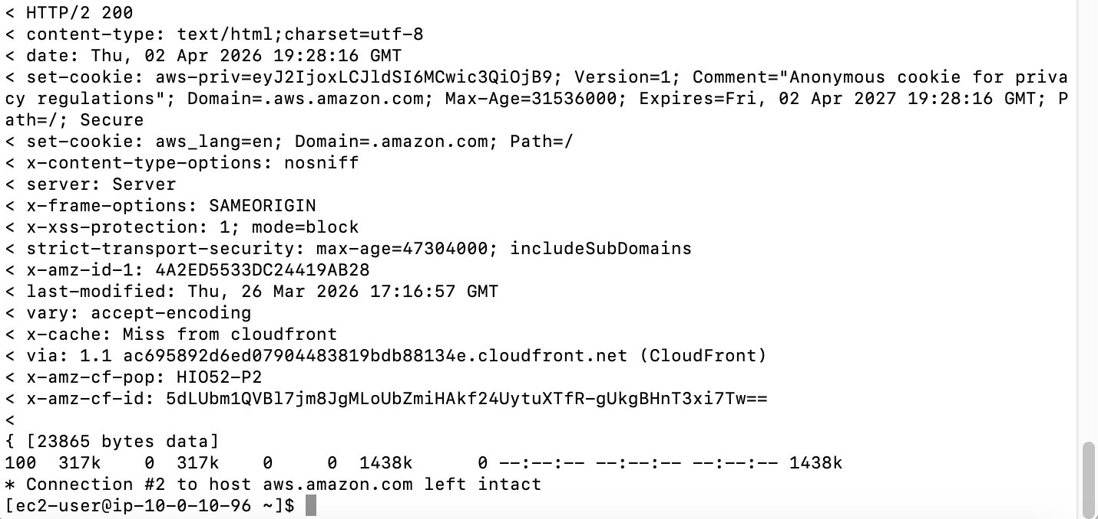

Git — Commit and Push
GIT | cd ~/Desktop/AWS-reStart-Journey  git pull origin main --no-rebase  git add Labs/Networking/lab-265-ip-troubleshooting/  git commit -m "Add Lab 265 — IP troubleshooting commands"  git push origin main

