LAB 274
Introduction to Amazon Aurora
AWS re/Start Programme | Estimated Duration: 40 minutes
Region: us-west-2 | Instance ID: i-0777648380193b330 | Engine: Aurora MySQL 8.0.42

Resource Names & Values
Resource | Value
DB Cluster Identifier | aurora
Master Username | admin
Master Password | admin123
Initial Database Name | world
Instance Class | db.t3.medium
Engine | Aurora MySQL 8.0.42 (740a7f82)
Region | us-west-2
Availability Zone | us-west-2a
Aurora Writer Endpoint | aurora.cluster-cnvedsxuwk0.us-west-2.rds.amazonaws.com
Port | 3306
VPC | LabVPC
Subnet Group | dbsubnetgroup
VPC Security Group | DBSecurityGroup
Public Access / Internet gateway | Disabled
EC2 Instance | Command Host (i-0777648380193b330)
Connection Method | AWS Systems Manager — Session Manager
MySQL Connection ID | 127
Table Created | country (in world database)
Records Inserted | 5 (GAB, IRL, THA, CRI, AUS)
Lab Folder | ~/Desktop/AWS-reStart-Journey/Labs/Databases/lab-274-intro-to-aurora
Screenshots Folder | ~/Desktop/AWS-reStart-Journey/Labs/Databases/lab-274-intro-to-aurora/screenshots/

Before You Begin — Important Warnings
WARNING | CURLY QUOTES: Copying commands from Word or PDF may silently replace straight quotes (' ") with typographic curly quotes. MySQL and the AWS CLI will reject these with authentication or syntax errors. Always type quotes manually in the terminal, or paste and immediately re-type the quote characters.

WARNING | PASTING EXTRA TEXT: Only paste the command itself — never paste surrounding explanatory text. Pasting extra text causes 'bash: command not found' or SQL syntax errors.

WARNING | SILENT WAIT COMMANDS: Some commands produce no output and block the terminal silently while waiting. This is normal. Do not close the terminal or press Ctrl+C.

WARNING | MYSQL CONTINUATION PROMPT: If you see '->' instead of 'MySQL [world]>' after entering a command, MySQL is waiting for a closing semicolon. Type ';' and press Enter to complete the statement, or type '\c' to cancel it.

Task 1: Create an Aurora Instance
In this task, you create an Aurora database (DB) instance using the RDS console.

Step 1 — Navigate to RDS
In the AWS Management Console search bar, search for and choose RDS. In the left navigation menu, choose Databases.

Step 2 — Create Database
Choose Create database and configure as follows:

Setting | Value
Creation method | Standard create
Engine type | Aurora (MySQL Compatible)
Engine version | Default for major version 8.0
Template | Dev/Test
DB cluster identifier | aurora
Master username | admin
Master password | admin123
Instance class | Burstable classes → db.t3.medium
Multi-AZ deployment | Don't create an Aurora Replica
VPC | LabVPC
Subnet group | dbsubnetgroup
Public access | No
VPC security group | Choose existing → DBSecurityGroup (remove default)
Enhanced monitoring | Disabled (uncheck)
Initial database name | world
Encryption | Disabled (uncheck)
Auto minor version upgrade | Disabled (uncheck)

Scroll to the bottom and choose Create database.

NOTE | Aurora takes up to 5 minutes to provision. You can continue to Task 2 while it launches. If a 'Suggested add-ons' popup appears, choose Close.

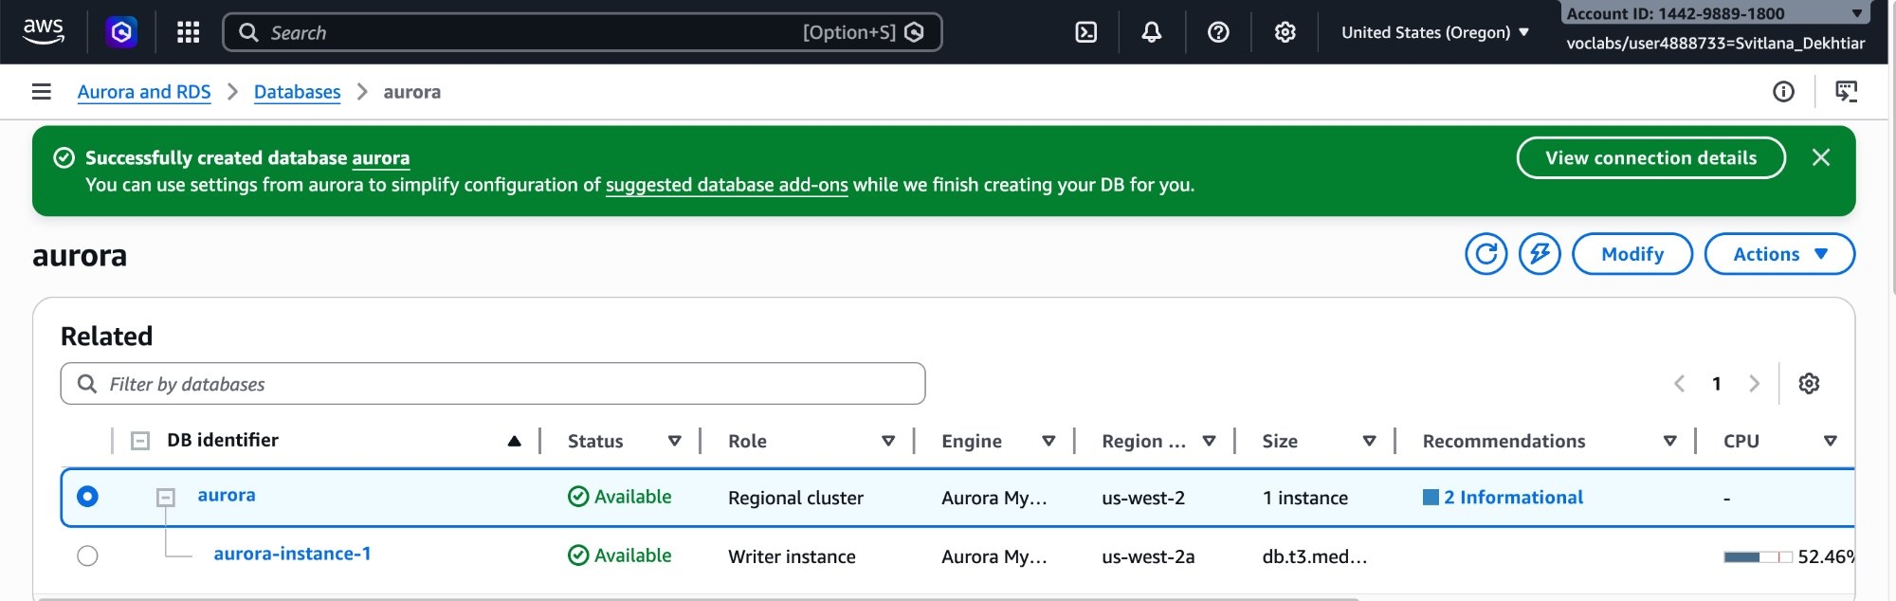
RDS console — aurora cluster Available with success banner

Task 2: Connect to an Amazon EC2 Linux Instance
In this task, you connect to the Command Host EC2 instance (i-0777648380193b330) using Session Manager.

Navigate to EC2 → Instances. Select the check box next to Command Host, choose Connect, select the Session Manager tab, and choose Connect to open a terminal window.

NOTE | If the Command Host instance is not visible, the lab may still be provisioning, or you may be in the wrong Region (this lab uses us-west-2).

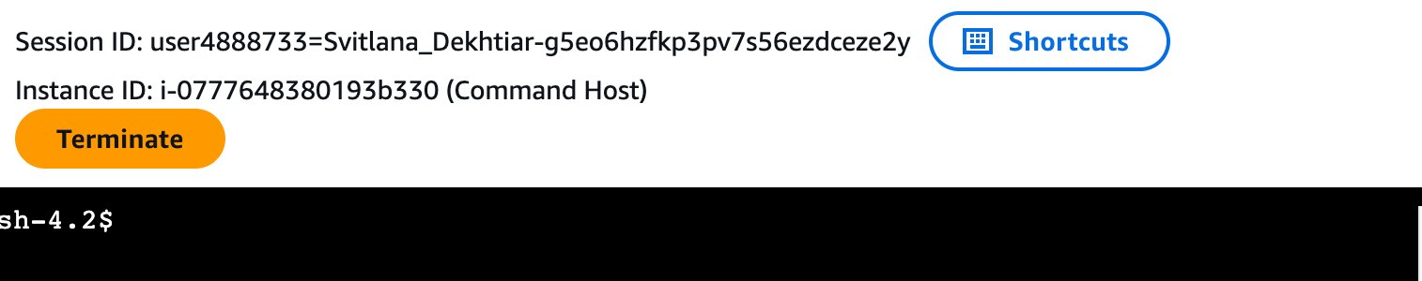
Session Manager terminal connected to Command Host (i-0777648380193b330)

Task 3: Configure the Amazon EC2 Linux Instance to Connect to Aurora
In this task, you install the MariaDB client and connect to the Aurora database using the writer endpoint.

Step 1 — Install MariaDB client
CMD | sudo yum install mariadb -y
OUTPUT | Dependencies Resolved  =================================================================  Package Arch Version Repository Size  =================================================================  Installing:  mariadb x86_64 1:5.5.68-1.amzn2.0.1 amzn2-core 8.8 M  Transaction Summary  Install 1 Package  Total download size: 8.8 M | Installed size: 49 M  mariadb-5.5.68-1.amzn2.0.1.x86_64.rpm | 8.8 MB 00:00:00  Running transaction check → Transaction test succeeded  Installing : 1:mariadb-5.5.68-1.amzn2.0.1.x86_64 1/1  Verifying : 1:mariadb-5.5.68-1.amzn2.0.1.x86_64 1/1  Installed: mariadb.x86_64 1:5.5.68-1.amzn2.0.1  Complete!

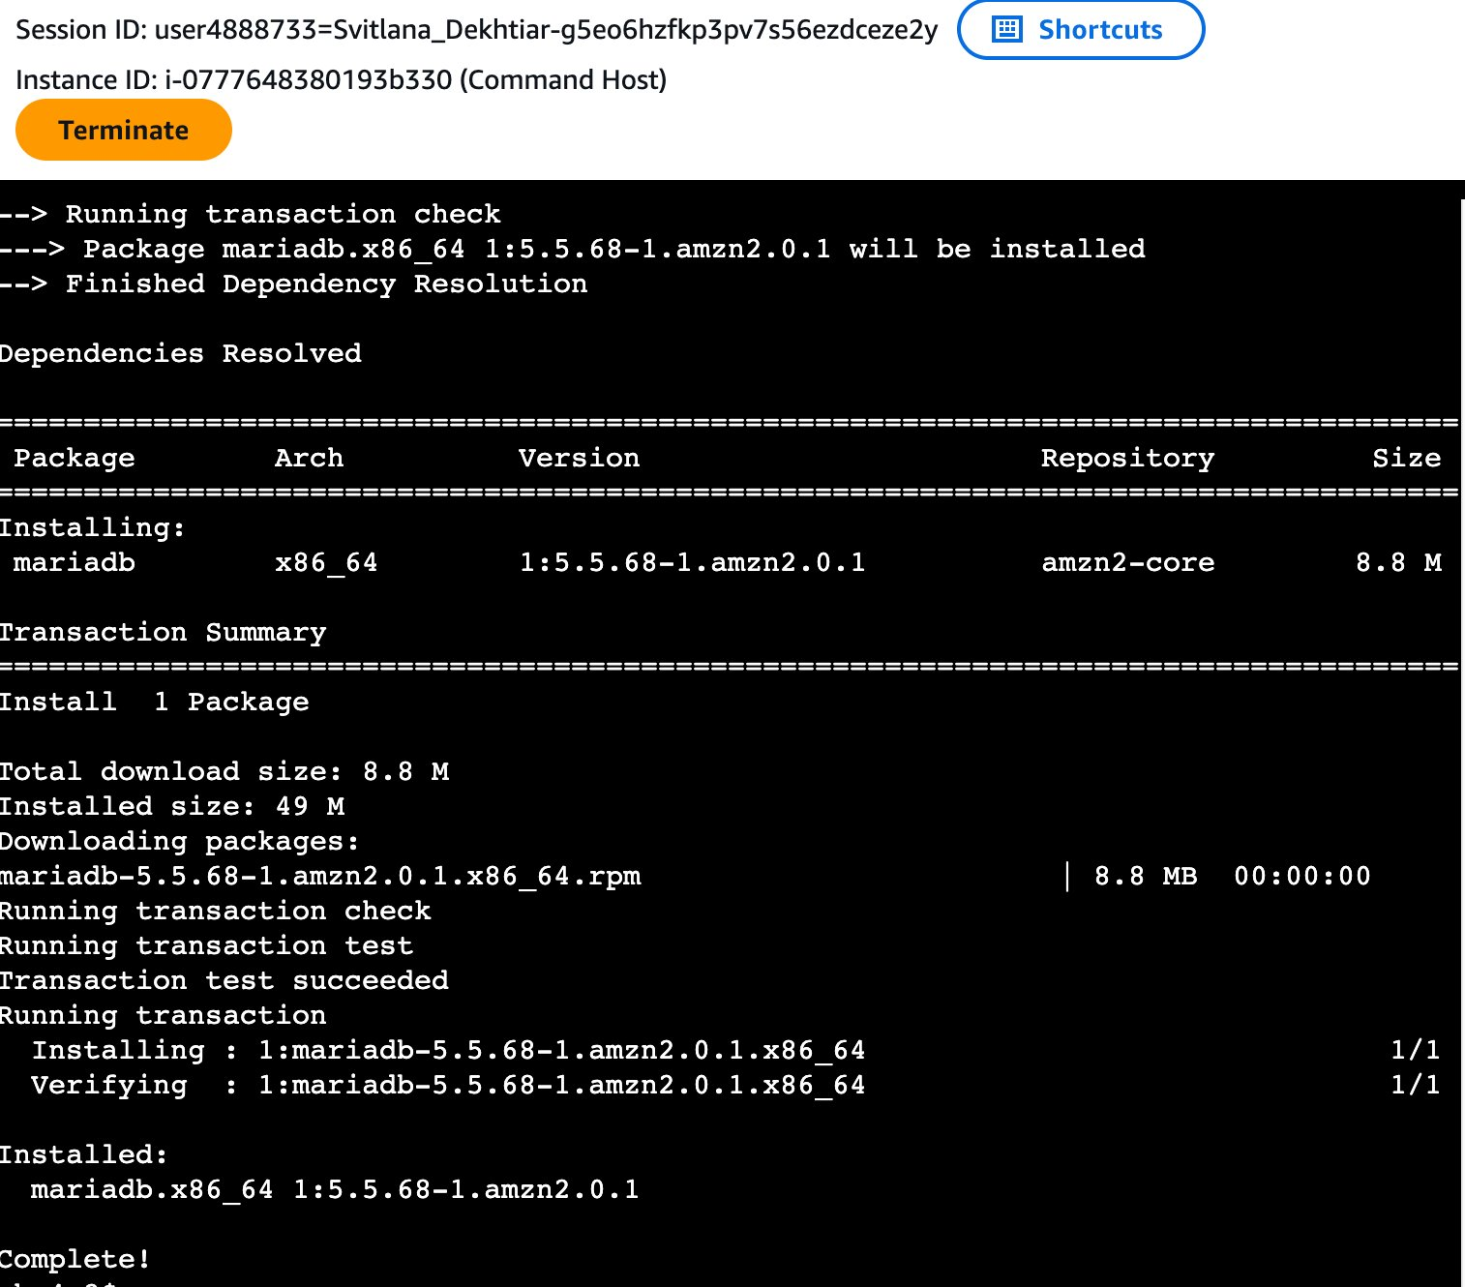
yum install output — mariadb 5.5.68 installed, Complete!
Step 2 — Copy the Aurora Writer Endpoint
In the RDS console, navigate to Databases → aurora → Connectivity & security tab. In the Endpoints section (filter by 'writ'), copy the Writer endpoint URL.

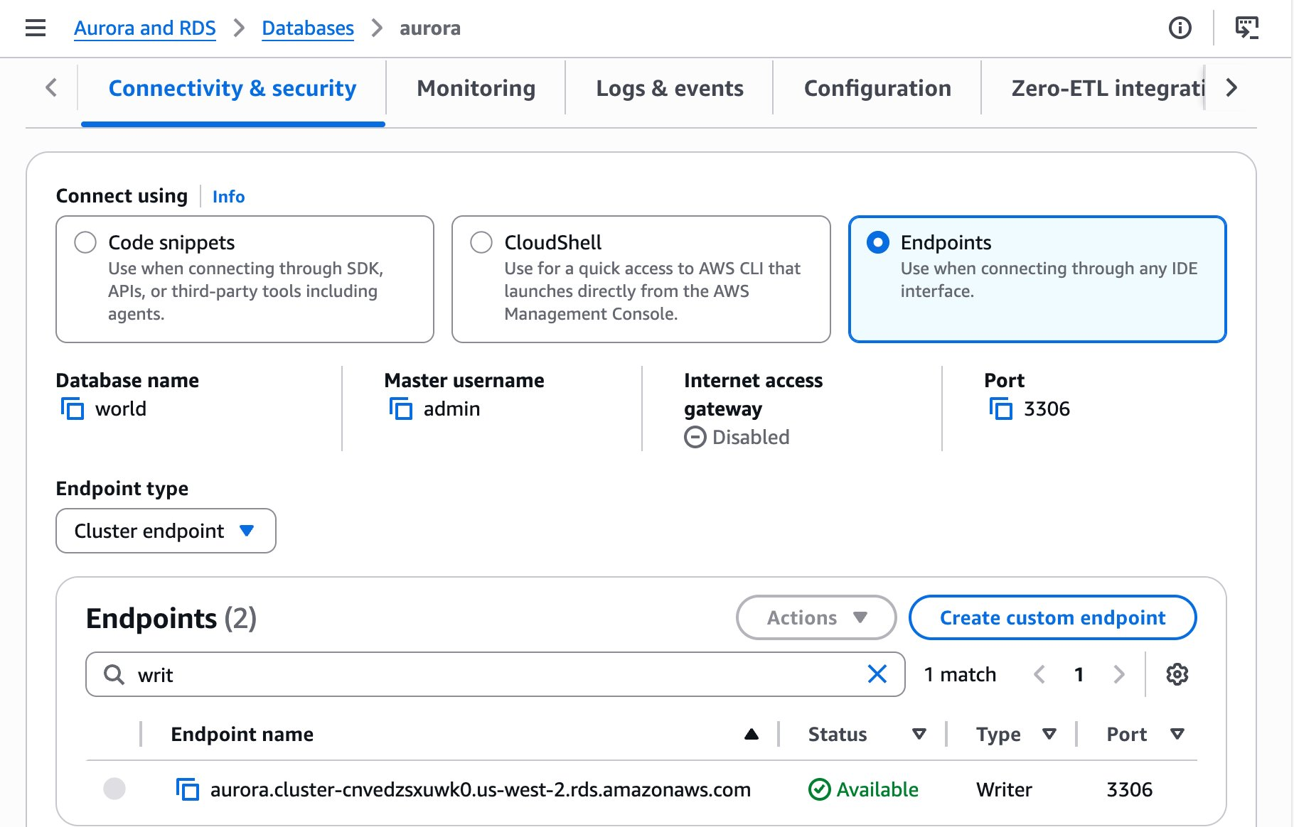
RDS Connectivity & security — Writer endpoint: aurora.cluster-cnvedsxuwk0.us-west-2.rds.amazonaws.com
Step 3 — Connect to Aurora
CMD | mysql -u admin --password='admin123' -h aurora.cluster-cnvedsxuwk0.us-west-2.rds.amazonaws.com
OUTPUT | Welcome to the MariaDB monitor. Commands end with ; or \g.  Your MySQL connection id is 127  Server version: 8.0.42 740a7f82  Copyright (c) 2000, 2018, Oracle, MariaDB Corporation Ab and others.  Type 'help;' or '\h' for help. Type '\c' to clear the current input statement.  MySQL [(none)]>

NOTE | The connection banner shows 'Welcome to the MariaDB monitor' because the installed client binary is MariaDB-branded. The server running Aurora is MySQL 8.0.42. Both speak the same wire protocol, so the connection succeeds.

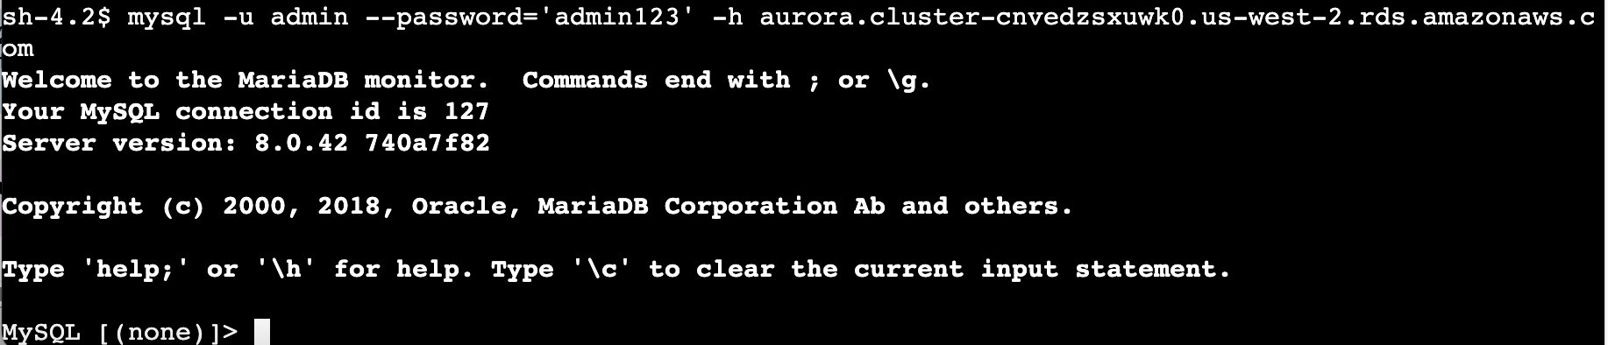
Successful Aurora connection — MySQL [(none)]> prompt, connection id 127, server 8.0.42

Task 4: Create a Table and Insert and Query Records
In this task, you create the country table in the world database, insert five records, and run a filtered query.

Step 1 — Show Databases
SQL | SHOW DATABASES;
OUTPUT | +--------------------+  | Database |  +--------------------+  | information_schema |  | mysql |  | performance_schema |  | sys |  | world |  +--------------------+  5 rows in set (0.01 sec)

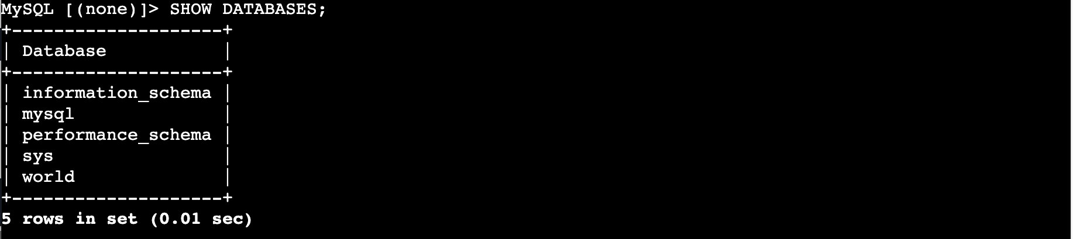
SHOW DATABASES — 5 databases including world (run from MySQL [(none)]>)
Step 2 — Switch to world database
SQL | USE world;
OUTPUT | Database changed  MySQL [world]>

Step 3 — Create the country table
SQL | CREATE TABLE `country` (  `Code` CHAR(3) NOT NULL DEFAULT '',  `Name` CHAR(52) NOT NULL DEFAULT '',  `Continent` enum('Asia','Europe','North America','Africa',  'Oceania','Antarctica','South America')  NOT NULL DEFAULT 'Asia',  `Region` CHAR(26) NOT NULL DEFAULT '',  `SurfaceArea` FLOAT(10,2) NOT NULL DEFAULT '0.00',  `IndepYear` SMALLINT(6) DEFAULT NULL,  `Population` INT(11) NOT NULL DEFAULT '0',  `LifeExpectancy` FLOAT(3,1) DEFAULT NULL,  `GNP` FLOAT(10,2) DEFAULT NULL,  `GNPOld` FLOAT(10,2) DEFAULT NULL,  `LocalName` CHAR(45) NOT NULL DEFAULT '',  `GovernmentForm` CHAR(45) NOT NULL DEFAULT '',  `Capital` INT(11) DEFAULT NULL,  `Code2` CHAR(2) NOT NULL DEFAULT '',  PRIMARY KEY (`Code`)  );
OUTPUT | Query OK, 0 rows affected, 7 warnings (0.03 sec)  MySQL [world]>
NOTE | The 7 warnings are expected — they relate to deprecated FLOAT(M,D) syntax in MySQL 8.0. The table is created successfully.

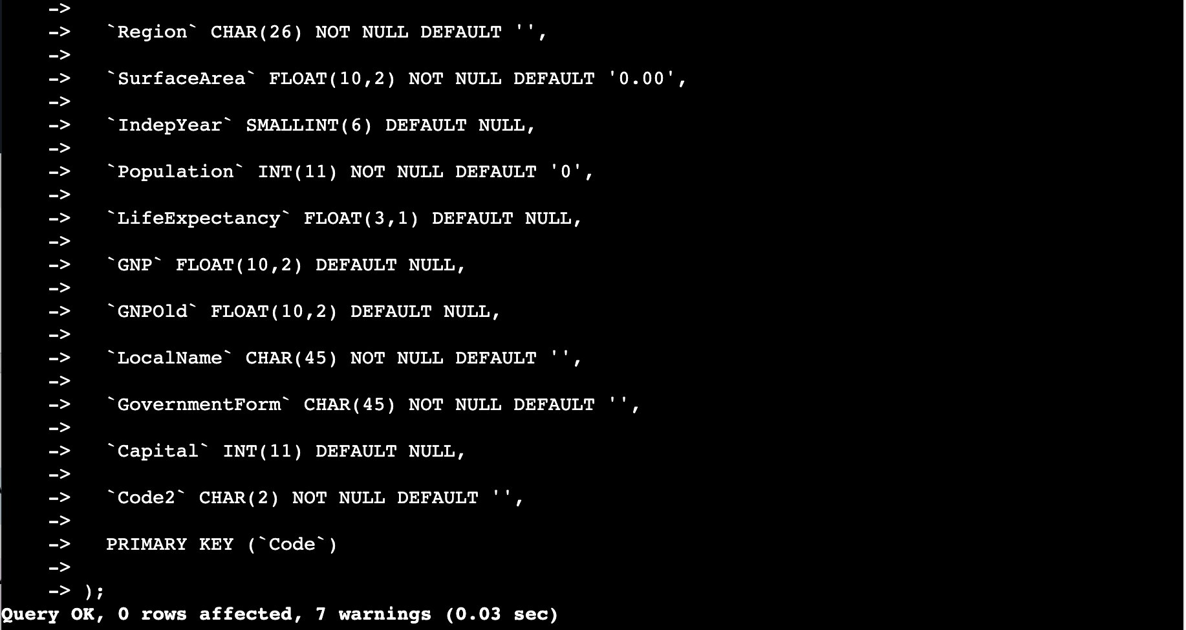
CREATE TABLE country — Query OK, 0 rows affected, 7 warnings (0.03 sec)
Step 4 — Insert Records
Run each INSERT statement individually. Each returns 'Query OK, 1 row affected'.
SQL | INSERT INTO `country` VALUES ('GAB','Gabon','Africa','Central Africa',267668.00,1960,1226000,50.1,5493.00,5279.00,'Le Gabon','Republic',902,'GA');  INSERT INTO `country` VALUES ('IRL','Ireland','Europe','British Islands',70273.00,1921,3775100,76.8,75921.00,73132.00,'Ireland/Éire','Republic',1447,'IE');  INSERT INTO `country` VALUES ('THA','Thailand','Asia','Southeast Asia',513115.00,1350,61399000,68.6,116416.00,153907.00,'Prathet Thai','Constitutional Monarchy',3320,'TH');  INSERT INTO `country` VALUES ('CRI','Costa Rica','North America','Central America',51100.00,1821,4023000,75.8,10226.00,9757.00,'Costa Rica','Republic',584,'CR');  INSERT INTO `country` VALUES ('AUS','Australia','Oceania','Australia and New Zealand',7741220.00,1901,18886000,79.8,351182.00,392911.00,'Australia','Constitutional Monarchy, Federation',135,'AU');
OUTPUT | Query OK, 1 row affected (0.00 sec) [×5]  MySQL [world]>

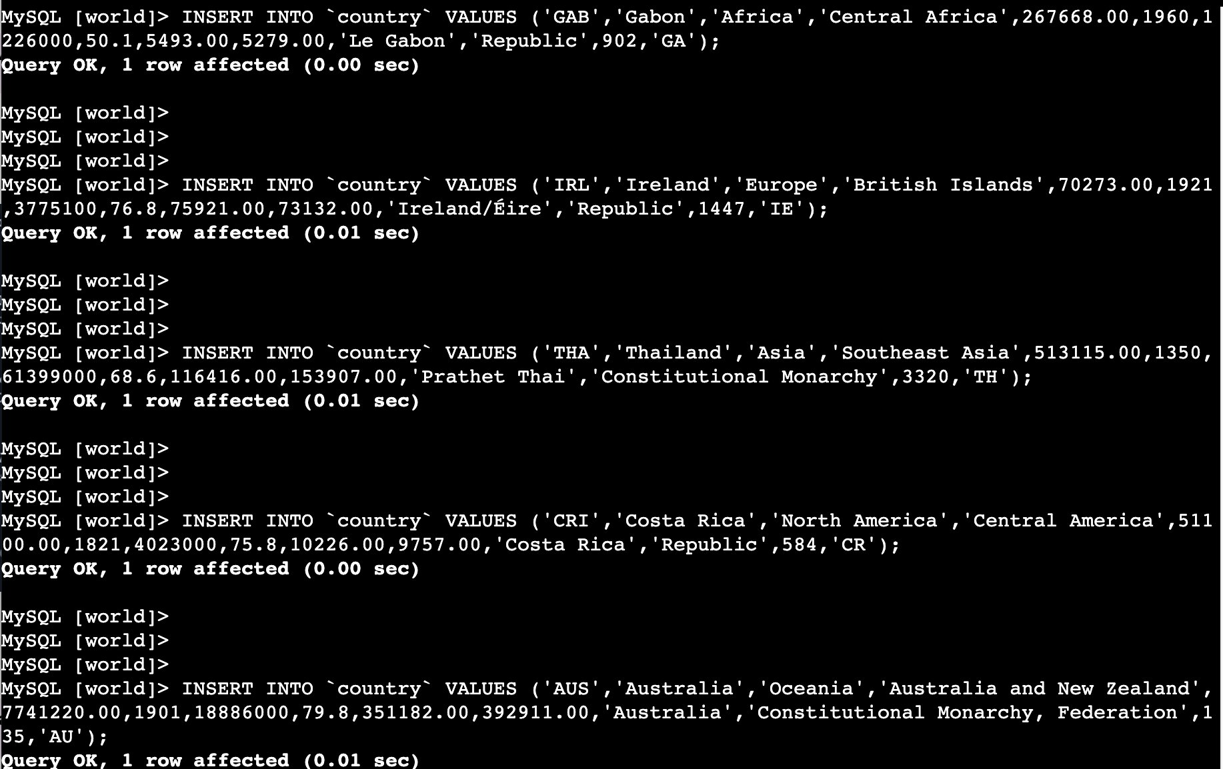
All 5 INSERT statements completed — each returned Query OK, 1 row affected
Step 5 — Query the table
SQL | SELECT * FROM country WHERE GNP > 35000 AND Population > 10000000;
OUTPUT | | AUS | Australia | Oceania | Australia and New Zealand |  | | 7741220.00 | 1901 | 18886000 | 79.8 | 351182.00 | 392911.00 |  | | Australia | Constitutional Monarchy, Federation | 135 | AU |  | THA | Thailand | Asia | Southeast Asia |  | | 513115.00 | 1350 | 61399000 | 68.6 | 116416.00 | 153907.00 |  | | Prathet Thai | Constitutional Monarchy | 3320 | TH |  2 rows in set (0.00 sec)
The query returns two records: Australia (GNP 351,182 / population 18,886,000) and Thailand (GNP 116,416 / population 61,399,000). Ireland's population falls below 10 million; Gabon and Costa Rica have GNP values well below the threshold.

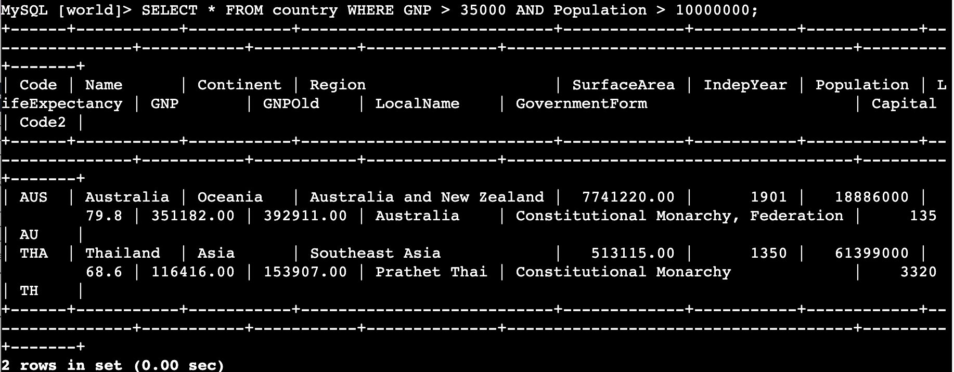
SELECT result — 2 rows: Australia (AUS) and Thailand (THA)

Screenshot Reference Summary
All screenshots saved in:
~/Desktop/AWS-reStart-Journey/Labs/Databases/lab-274-intro-to-aurora/screenshots/

# | Filename | Task | What to Capture
1 | 01_aurora_created.png | 1 | aurora cluster Available + success banner in RDS console
2 | 02_session_manager_connected.png | 2 | Session Manager terminal open, Instance ID i-0777648380193b330
3 | 03_mariadb_installed.png | 3 | yum install mariadb — Complete! at bottom
4 | 04_aurora_endpoint.png | 3 | RDS Connectivity & security — Writer endpoint URL
5 | 05_connected_to_aurora.png | 3 | MySQL [(none)]> prompt, connection id 127, server 8.0.42
6 | 06_show_databases.png | 4 | SHOW DATABASES — 5 rows including world
7 | 07_create_table.png | 4 | CREATE TABLE — Query OK, 0 rows affected, 7 warnings (0.03 sec)
8 | 08_insert_records.png | 4 | 5 INSERT statements — all Query OK, 1 row affected
9 | 09_select_query_results.png | 4 | SELECT result — 2 rows: AUS and THA

Git Commands — Push to GitHub
GIT | cd ~/Desktop/AWS-reStart-Journey/Labs/Databases/lab-274-intro-to-aurora  git add .  git commit -m "Add Lab 274 - Introduction to Amazon Aurora"  git push origin main

