LAB 271
Performing a Conditional Search
AWS re/Start Programme
Estimated Duration: 45 minutes

Resource Names & Values

Resource / Field | Value
EC2 Instance Name | Command Host
Instance ID | i-0b84399ee5e469c8b
Instance Hostname | ip-10-1-11-68
Server Version | 10.5.29-MariaDB MariaDB Server
Database Name | world
DB Tables | city, country, countrylanguage
DB Username | root
DB Password | re:St@rt!9
Connection Method | Session Manager (no SSH key required)
Lab Region | As assigned — do not change
Local Repo Path | Desktop\AWS-reStart-Journey\Labs\Databases\lab-271-conditional-search
Screenshots Folder | Desktop\AWS-reStart-Journey\Labs\Databases\lab-271-conditional-search\screenshots\

Before You Begin

WARNING: Copying commands from Word or PDF can silently convert straight quotes (" ') into typographic curly quotes. AWS CLI and MySQL/MariaDB will reject these with syntax or authentication errors. Always type quotes manually in the terminal, or paste and verify immediately.

WARNING: Never paste explanatory text along with a command. Only paste the command itself. Pasting surrounding text causes "bash: command not found" or SQL syntax errors.

WARNING: Any command that waits silently (e.g. aws ec2 wait, long-running queries) may produce no output and block the terminal. This is normal — do not close the terminal.

WARNING: The MariaDB/MySQL client uses a continuation prompt (->) when it expects more input — usually because a statement is missing a semicolon (;). If your terminal shows -> instead of MariaDB [(none)]>, your query is incomplete. Type a semicolon and press Enter to execute, or type \c and press Enter to cancel.

Task 1: Connect to the Command Host

In this task you connect to an Amazon EC2 instance containing a database client (the Command Host) using AWS Session Manager. No SSH key is required.

Step 1.1 — Open EC2 Instances
In the AWS Management Console choose Services → Compute → EC2. In the left navigation choose Instances.

Step 1.2 — Connect to Command Host
Select the check box next to the instance labelled Command Host (Instance ID: i-0b84399ee5e469c8b), then choose Connect.

NOTE: If you do not see the Command Host, the lab may still be provisioning, or you may be in the wrong Region. Wait a minute and refresh.

On the Connect to instance screen, choose the Session Manager tab, then choose Connect.

NOTE: If the Connect button is greyed out, wait one to two minutes and try again. Session Manager needs time to register the agent on the instance.

Screenshot 1 — Session Manager terminal — shows instance i-0b84399ee5e469c8b (Command Host)
File: 01_session_manager_connected.png
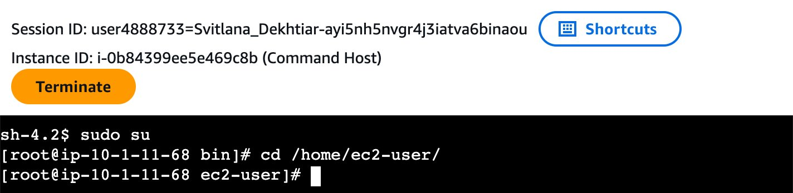

Step 1.3 — Switch to root and change directory

CMD | sudo su

CMD | cd /home/ec2-user/

Step 1.4 — Connect to the database server

CMD | mysql -u root --password='re:St@rt!9'

OUTPUT
Welcome to the MariaDB monitor. Commands end with ; or \g.
Your MariaDB connection id is 5
Server version: 10.5.29-MariaDB MariaDB Server

Copyright (c) 2000, 2018, Oracle, MariaDB Corporation Ab and others.

Type 'help;' or '\h' for help. Type '\c' to clear the current input statement.

MariaDB [(none)]>

TIP: Reconnection procedure: If Session Manager becomes unresponsive, close the window, reconnect via EC2 → Instances → Command Host → Connect → Session Manager, then re-run: sudo su, cd /home/ec2-user/, and the mysql command.

Screenshot 2 — MariaDB prompt — Server version: 10.5.29-MariaDB, connection id 5
File: 02_mysql_connected.png
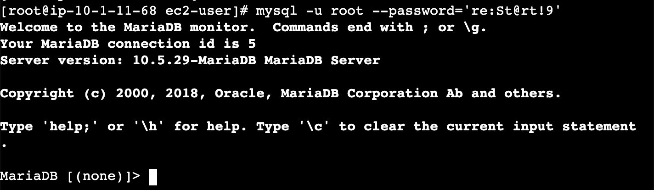

Task 2: Query the world Database

In this task you run a series of SQL queries against the world database, using WHERE, BETWEEN, LIKE, AS, and SQL functions to filter and aggregate data.

Step 2.1 — Show available databases

SQL | SHOW DATABASES;

OUTPUT
+--------------------+
| Database |
+--------------------+
| information_schema |
| mysql |
| performance_schema |
| world |
+--------------------+
4 rows in set (0.001 sec)

IMPORTANT: Verify that world appears in the list. If it is missing, contact your instructor — the lab environment has not been configured correctly.

Screenshot 3 — SHOW DATABASES — 4 rows including world
File: 03_show_databases.png
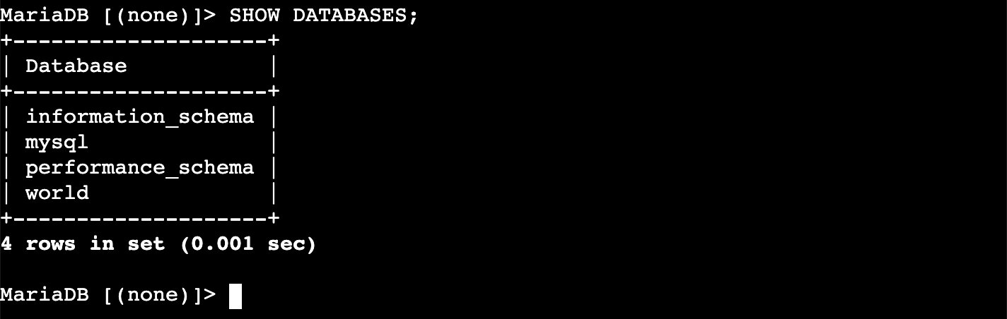

Step 2.2 — Review the full country table
Returns every row and column from the country table. The table is wide — output wraps across multiple lines in the terminal. This is normal.

SQL | SELECT * FROM world.country;

OUTPUT
| Code | Name | Continent | Region | SurfaceArea | ...
+------+-------------+---------------+---------------------+-------------+...
| ABW | Aruba | North America | Caribbean | 193.00 | ...
| AFG | Afghanistan | Asia | Southern and Central| 652090.00 | ...
| AGO | Angola | Africa | Central Africa | 1246700.00 | ...
...
239 rows in set

NOTE: The country table has 15 columns and wraps across the terminal. The column header also appears fragmented. This is expected — the data is intact.

Screenshot 4 — SELECT * FROM world.country — full table, starts with ABW (Aruba), AFG (Afghanistan)
File: 04_select_all_country.png
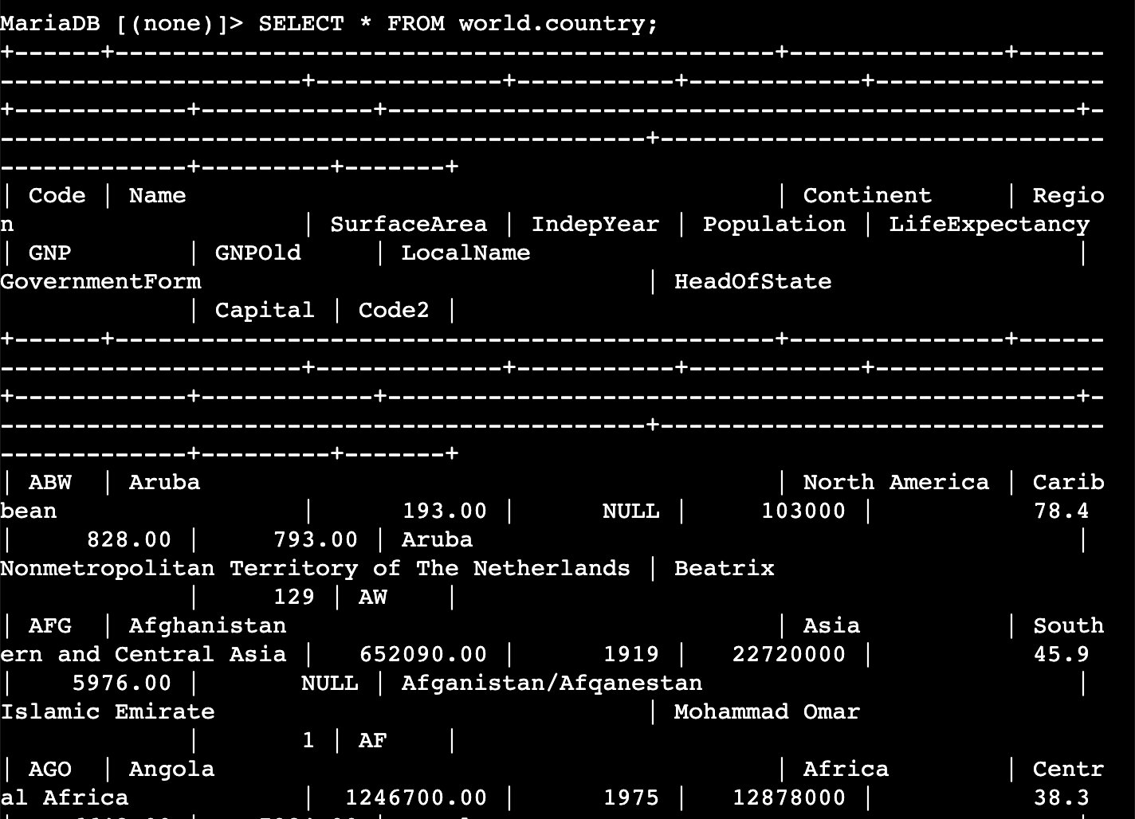

Step 2.3 — Filter with WHERE and AND
Returns countries with a population between 50 million and 100 million using >= and <= combined with AND.

SQL | SELECT Name, Capital, Region, SurfaceArea, Population FROM world.country WHERE Population >= 50000000 AND Population <= 100000000;

OUTPUT
| Name | Capital | Region | SurfaceArea | Population |
+---------------------------------------+---------+---------------------------+--------------+------------+
| Congo, The Democratic Republic of the | 2298 | Central Africa | 2344858.00 | 51654000 |
| Germany | 3068 | Western Europe | 357022.00 | 82164700 |
| Egypt | 608 | Northern Africa | 1001449.00 | 68470000 |
| Ethiopia | 756 | Eastern Africa | 1104300.00 | 62565000 |
| France | 2974 | Western Europe | 551500.00 | 59225700 |
| United Kingdom | 456 | British Islands | 242900.00 | 59623400 |
| Iran | 1380 | Southern and Central Asia | 1648195.00 | 67702000 |
| Italy | 1464 | Southern Europe | 301316.00 | 57680000 |
| Mexico | 2515 | Central America | ... | ... |
...

Screenshot 5 — WHERE Population >= 50000000 AND <= 100000000 — Congo DRC, Germany, Egypt, Ethiopia, France, UK, Iran, Italy, Mexico...
File: 05_where_and_population.png
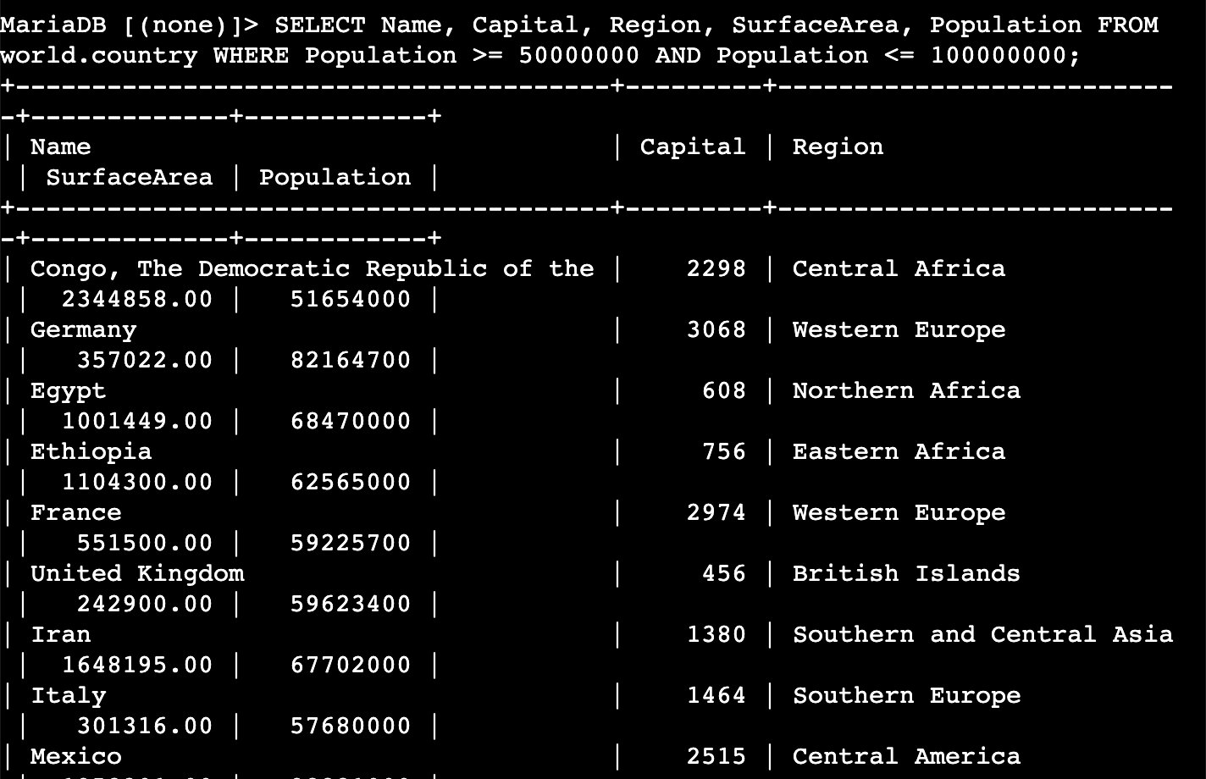

Step 2.4 — Use the BETWEEN operator
Produces the same result as step 2.3. BETWEEN is inclusive of both boundary values and is easier to read.

SQL | SELECT Name, Capital, Region, SurfaceArea, Population FROM world.country WHERE Population BETWEEN 50000000 AND 100000000;

OUTPUT
(identical result set to step 2.3 — same 14 rows)

NOTE: BETWEEN 50000000 AND 100000000 is inclusive — equivalent to Population >= 50000000 AND Population <= 100000000.

Screenshot 6 — BETWEEN operator — identical result to WHERE/AND query
File: 06_between_operator.png
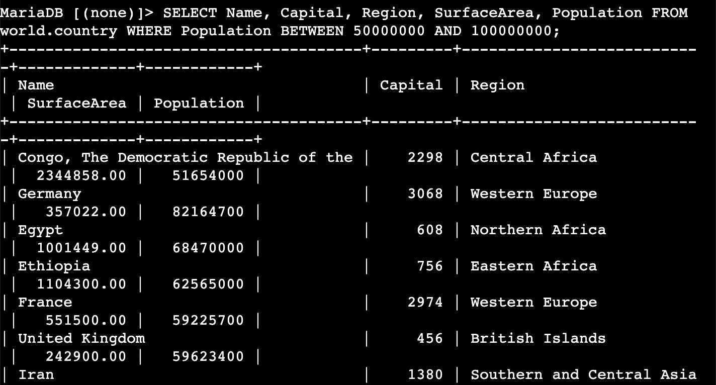

Step 2.5 — Use LIKE with SUM
The % wildcard matches any number of characters before or after Europe. SUM totals the population across all matching European regions.

SQL | SELECT sum(Population) from world.country WHERE Region LIKE "%Europe%";

OUTPUT
+------------------+
| sum(Population) |
+------------------+
| 634947800 |
+------------------+
1 row in set (0.000 sec)

NOTE: 634,947,800 is the total population across all European regions (Eastern Europe, Western Europe, Southern Europe, Northern Europe, British Islands).

Screenshot 7 — SUM + LIKE %Europe% — result: 634947800
File: 07_like_sum_europe.png
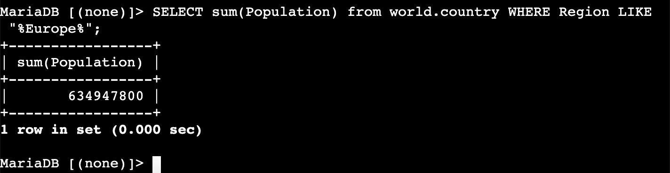

Step 2.6 — Add a column alias with AS
Identical logic to step 2.5. The AS keyword renames the output column from sum(population) to Europe Population Total.

SQL | SELECT sum(population) as "Europe Population Total" from world.country WHERE region LIKE "%Europe%";

OUTPUT
+-------------------------+
| Europe Population Total |
+-------------------------+
| 634947800 |
+-------------------------+
1 row in set (0.000 sec)

NOTE: SQL keywords are case-insensitive. SELECT and select are equivalent. However, it is best practice to match the capitalisation used in the database schema for column and table names.

Screenshot 8 — AS alias — column labelled Europe Population Total, value 634947800
File: 08_column_alias_as.png
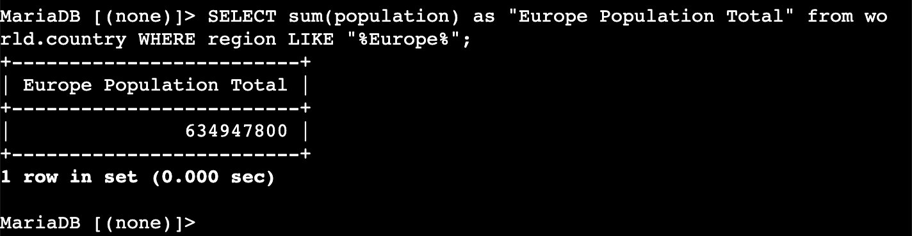

Step 2.7 — Case-insensitive search with LOWER
LOWER converts the Region column value to lowercase before comparing it to the search string, so the match works regardless of how data is capitalised.

SQL | SELECT Name, Capital, Region, SurfaceArea, Population from world.country WHERE LOWER(Region) LIKE "%central%";

OUTPUT
| Name | Capital | Region | SurfaceArea | Population |
+-------------+---------+---------------------------+-------------+------------+
| Afghanistan | 1 | Southern and Central Asia | 652090.00 | 22720000 |
| Angola | 56 | Central Africa | 1246700.00 | 12878000 |
| Bangladesh | 150 | Southern and Central Asia | 143998.00 | 129155000 |
| Belize | 185 | Central America | 22696.00 | 241000 |
| Bhutan | 192 | Southern and Central Asia | 47000.00 | 2124000 |
...

TIP: Use LOWER() in the WHERE clause any time you are unsure about the capitalisation of stored data. It converts the stored value to lowercase before the comparison runs.

Screenshot 9 — LOWER(Region) LIKE %central% — Afghanistan, Angola, Bangladesh, Belize, Bhutan...
File: 09_lower_function.png
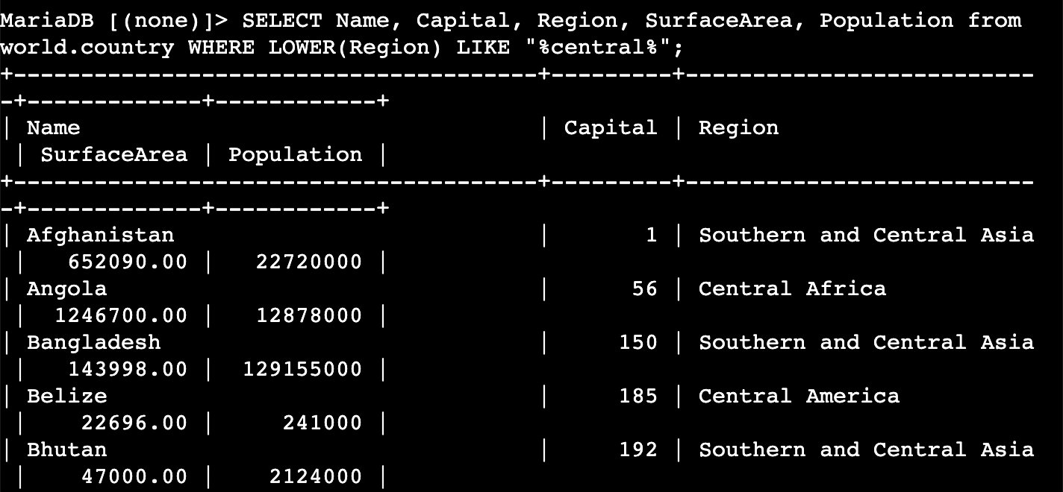

Challenge: North America Summary

Write a query to return the sum of the surface area and sum of the population of North America.

Solution

SQL | SELECT SUM(SurfaceArea) as "N. America Surface Area", SUM(Population) as "N. America Population" FROM world.country WHERE Region = "North America";

OUTPUT
+-------------------------+-----------------------+
| N. America Surface Area | N. America Population |
+-------------------------+-----------------------+
| 21500515.00 | 309632000 |
+-------------------------+-----------------------+
1 row in set (0.000 sec)

TIP: This query uses exact equality (=) rather than LIKE because 'North America' is a precise region name with no spelling variations. Using = is more precise and performs better than LIKE on large tables.

Screenshot 10 — Challenge result — N. America Surface Area: 21500515.00, Population: 309632000
File: 10_challenge_north_america.png
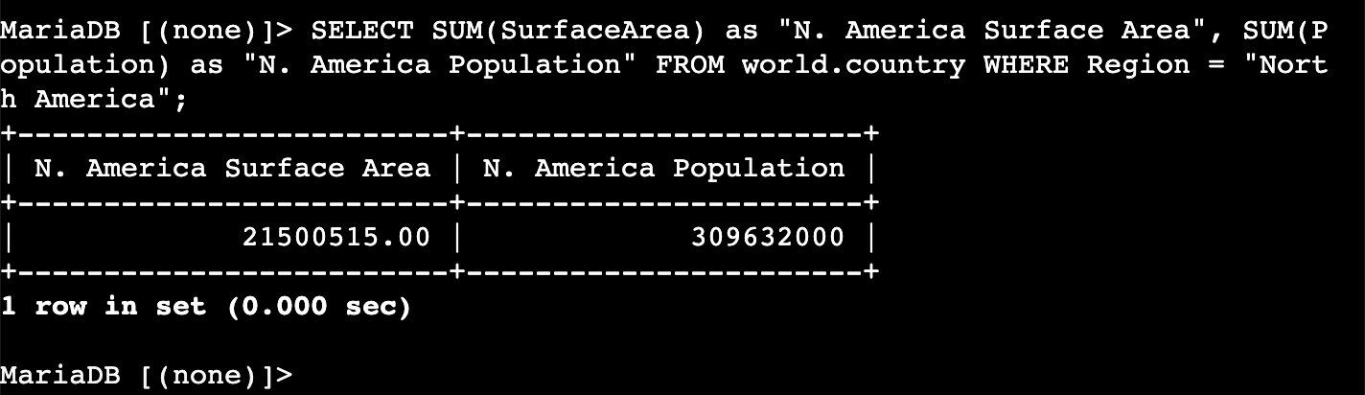

Screenshot Reference Summary

Screenshots folder: Desktop\AWS-reStart-Journey\Labs\Databases\lab-271-conditional-search\screenshots\

# | Filename | Task | What Was Captured
1 | 01_session_manager_connected.png | Task 1 | Session Manager terminal — instance i-0b84399ee5e469c8b
2 | 02_mysql_connected.png | Task 1 | MariaDB 10.5.29 prompt — connection id 5
3 | 03_show_databases.png | Task 2 | SHOW DATABASES — 4 rows, world confirmed
4 | 04_select_all_country.png | Task 2 | SELECT * FROM world.country — 239 rows
5 | 05_where_and_population.png | Task 2 | WHERE >= AND <= population filter
6 | 06_between_operator.png | Task 2 | BETWEEN operator — identical result
7 | 07_like_sum_europe.png | Task 2 | SUM + LIKE %Europe% = 634947800
8 | 08_column_alias_as.png | Task 2 | AS alias — Europe Population Total = 634947800
9 | 09_lower_function.png | Task 2 | LOWER(Region) LIKE %central% results
10 | 10_challenge_north_america.png | Challenge | N. America: 21500515.00 / 309632000

Git Commands — Push to GitHub

Run these commands from your repo root: Desktop\AWS-reStart-Journey\Labs\Databases\lab-271-conditional-search

Stage all files
GIT | git add .

Commit with message
GIT | git commit -m "Add Lab 271 - Performing a Conditional Search"

Push to GitHub
GIT | git push origin main

OUTPUT
Enumerating objects: ...
Counting objects: 100% (...)
Writing objects: 100% (...)
To https://github.com/<your-username>/<your-repo>.git
xxxxxxx..xxxxxxx main -> main

TIP: If you see 'error: failed to push some refs', run git pull origin main first to sync any remote changes, then push again.

