LAB 160
Build Your DB Server and Interact With Your DB Using an App
AWS re/Start Programme · Estimated Duration: 45 minutes

Resource Names & Values

Resource / Parameter | Value
Security Group Name | DB Security Group
Security Group Description | Permit access from Web Security Group
VPC | Lab VPC
Inbound Rule — Type | MySQL/Aurora (port 3306)
Inbound Rule — Source | Web Security Group
DB Subnet Group Name | DB Subnet Group
Private Subnet 1 | 10.0.1.0/24
Private Subnet 2 | 10.0.3.0/24
DB Engine | MySQL (latest version)
DB Template | Dev/Test
Availability Mode | Multi-AZ DB Instance
DB Instance Identifier | lab-db
Master Username | main
Master Password | lab-password
DB Instance Class | db.t3.medium (Burstable)
Storage Type | General Purpose SSD
Initial Database Name | lab
RDS Endpoint | lab-db.ckfyfe06umkc.us-west-2.rds.amazonaws.com
WebServer IP | [copy from AWS Details panel]
Local Repo Path | ~/Desktop/AWS-reStart-Journey/Labs/Databases/lab-160-build-db-server
Screenshots Folder | ~/Desktop/AWS-reStart-Journey/Labs/Databases/lab-160-build-db-server/screenshots/
GitHub Repository | https://github.com/svitlana-dekhtiar/aws-restart-journey

Before You Begin

WARNING | Curly quotes: Copying commands from Word can silently change straight quotes (", ') into curly quotes. MySQL will reject them. Always type quotes manually in the terminal.

WARNING | RDS takes 4–10 minutes to provision. Status will go Creating → Modifying → Available. Do not navigate away.

WARNING | The endpoint URL appears only after the instance reaches Available. Even one extra space in the endpoint will prevent the web app from connecting.

Accessing the AWS Management Console

1 | Click Start Lab at the top right. If you see an 'Access Denied' error, close it and click Start Lab again.

2 | Wait for the circle next to AWS (top left) to turn GREEN — this means the lab environment is ready.

3 | Click the green circle to open the AWS Management Console in a new tab.

4 | Arrange the Console and these instructions side by side so you can see both.

Task 1: Create a Security Group for the RDS DB Instance

You will create a security group that allows your web server to reach the RDS database on port 3306. This group will be attached to the database when you launch it.
1 | Services menu → VPC (under Networking & Content Delivery)

2 | Left navigation pane → Security Groups

3 | Click Create security group. Configure:

- Security group name: DB Security Group
- Description: Permit access from Web Security Group
- VPC: Lab VPC

4 | In the Inbound rules section → click Add rule. Configure:

- Type: MySQL/Aurora (3306)
- Source: Type sg in the search box → select Web Security Group

5 | Scroll to the bottom → click Create security group.

📷 SCREENSHOT | 01_security_group_created.png  DB Security Group created — inbound rule showing port 3306 from Web Security Group
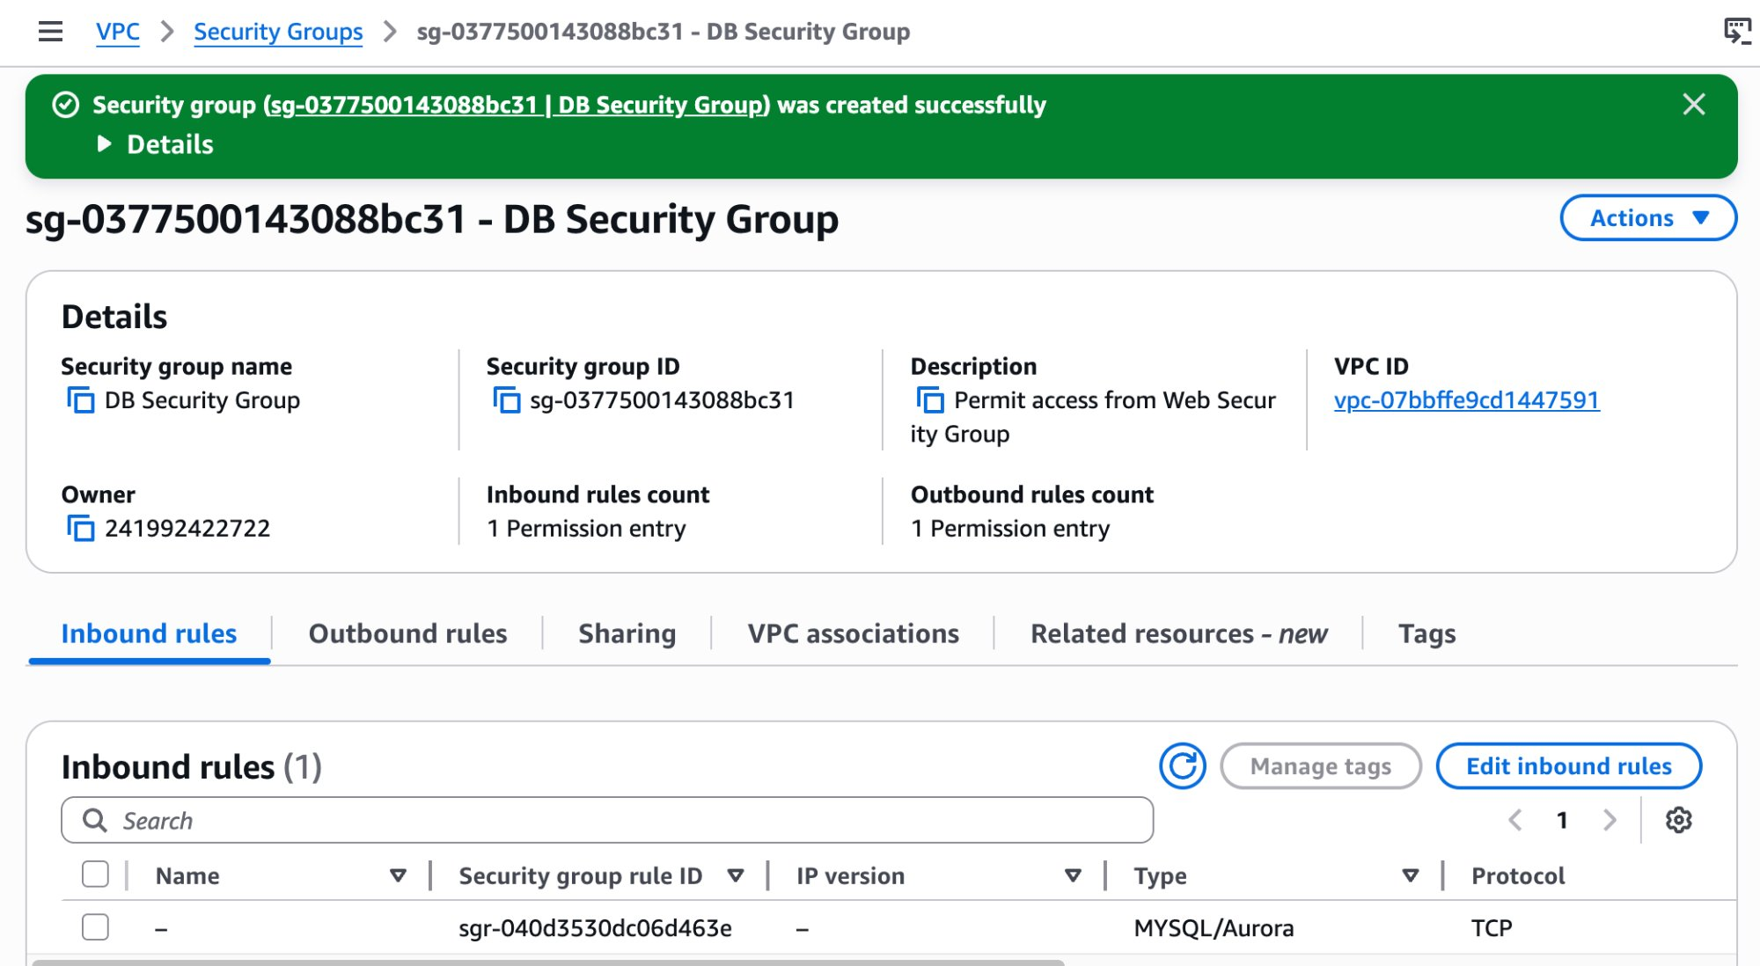

Task 2: Create a DB Subnet Group

A DB Subnet Group tells RDS which subnets it can use. RDS requires subnets in at least two Availability Zones for Multi-AZ deployments.
1 | Services menu → RDS (under Database)

2 | Left navigation pane → Subnet groups (if the pane is hidden, click the ≡ menu icon at top-left)

3 | Click Create DB Subnet Group. Configure:

- Name: DB Subnet Group
- Description: DB Subnet Group
- VPC ID: Lab VPC

4 | Under Add Subnets → Availability zones → select the first and second AZs.

5 | Under Subnets → select:

- First AZ subnet: 10.0.1.0/24
- Second AZ subnet: 10.0.3.0/24

6 | Click Create.

📷 SCREENSHOT | 02_db_subnet_group_created.png  DB Subnet Group created — both subnets (10.0.1.0/24 and 10.0.3.0/24) listed
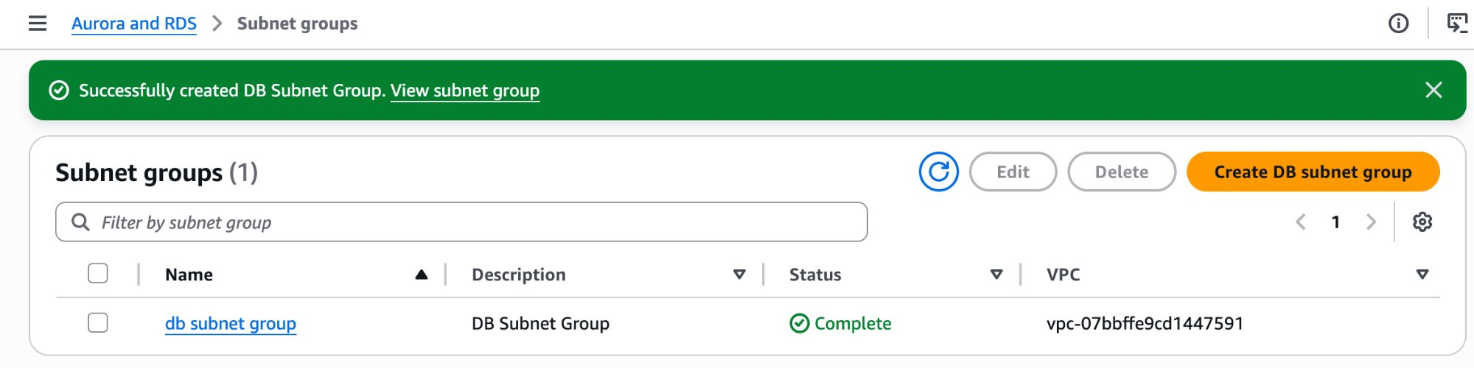
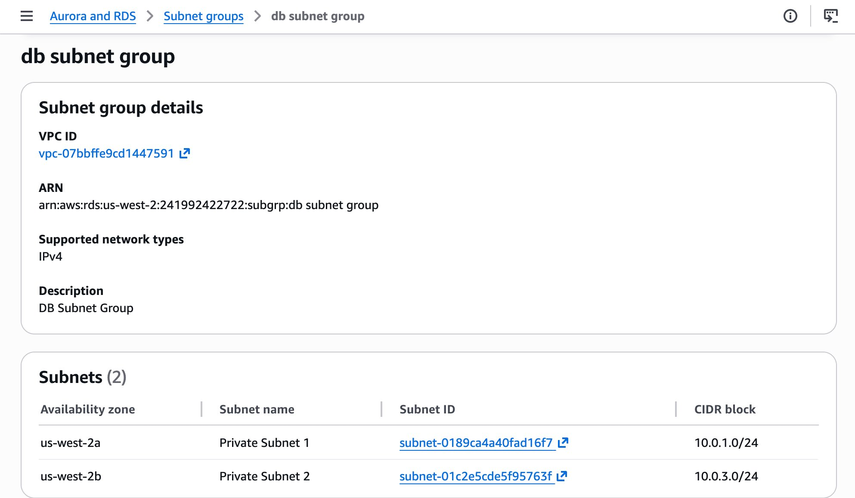

Task 3: Create an Amazon RDS DB Instance

You will configure and launch a Multi-AZ MySQL RDS instance. Multi-AZ automatically creates a primary database and a synchronous standby in a second Availability Zone.
1 | Left navigation pane → Databases

2 | Click Create database. If you see 'Switch to the new database creation flow' — click it.

3 | Select Standard create.

4 | Engine options → Engine type: MySQL

5 | Engine version: choose the latest version available.

6 | Templates: Dev/Test

7 | Availability and durability: Multi-AZ DB Instance

8 | Under Settings, configure:

- DB instance identifier: lab-db
- Master username: main
- Master password: lab-password
- Confirm password: lab-password

9 | Instance configuration → select Burstable classes (includes t classes) → db.t3.medium

10 | Storage → Storage type: General Purpose (SSD)

11 | Connectivity → VPC: Lab VPC

12 | VPC security group → Choose existing → remove default → select DB Security Group

13 | Monitoring → Additional configuration → uncheck Enable Enhanced monitoring

14 | Additional configuration (scroll down, expand it) → configure:

- Initial database name: lab
- Backup: uncheck Enable automated backups

15 | Scroll to the bottom → click Create database.

📷 SCREENSHOT | 03_rds_creating.png  RDS console showing lab-db with status: Creating
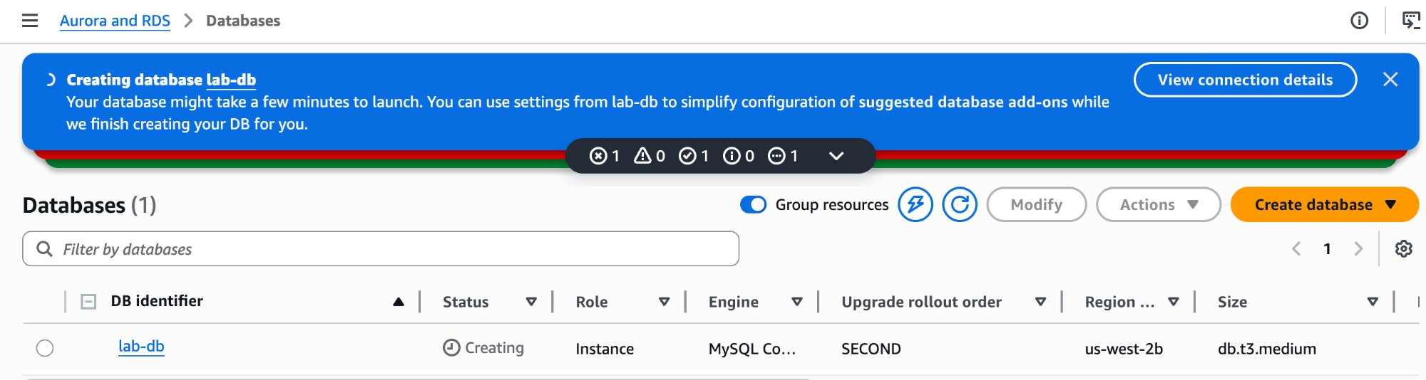

NOTE | Wait 4–10 minutes. Status will go: Creating → Modifying → Available. If a 'Suggested add-ons' popup appears, click Close.

16 | Click lab-db (the link) → wait until Status shows Available or Modifying.

📷 SCREENSHOT | 04_rds_available.png  lab-db showing Available (or Modifying) status
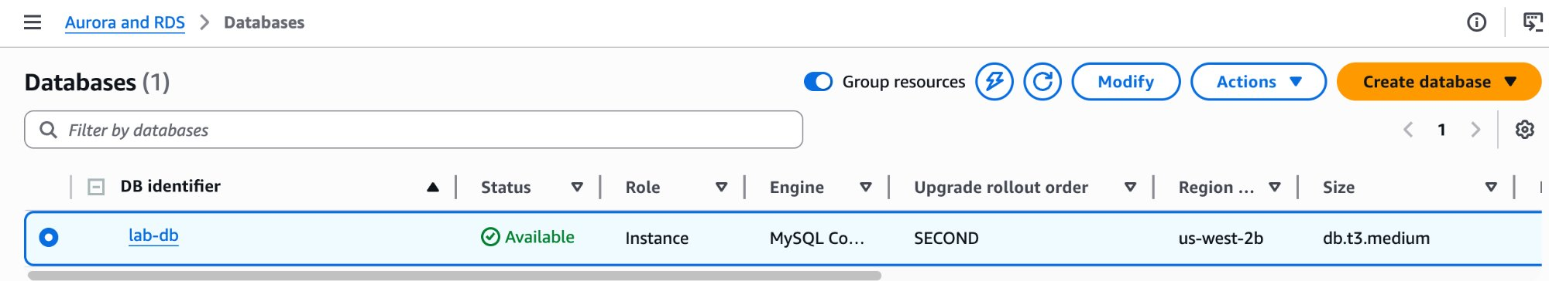

17 | Scroll down to Connectivity & Security → copy the Endpoint value and paste it into a text editor.

NOTE | The endpoint looks like: lab-db.ckfyfe06umkc.us-west-2.rds.amazonaws.com — you will paste this into the web app in Task 4.

📷 SCREENSHOT | 05_rds_endpoint.png  Connectivity & Security section showing the full RDS endpoint URL
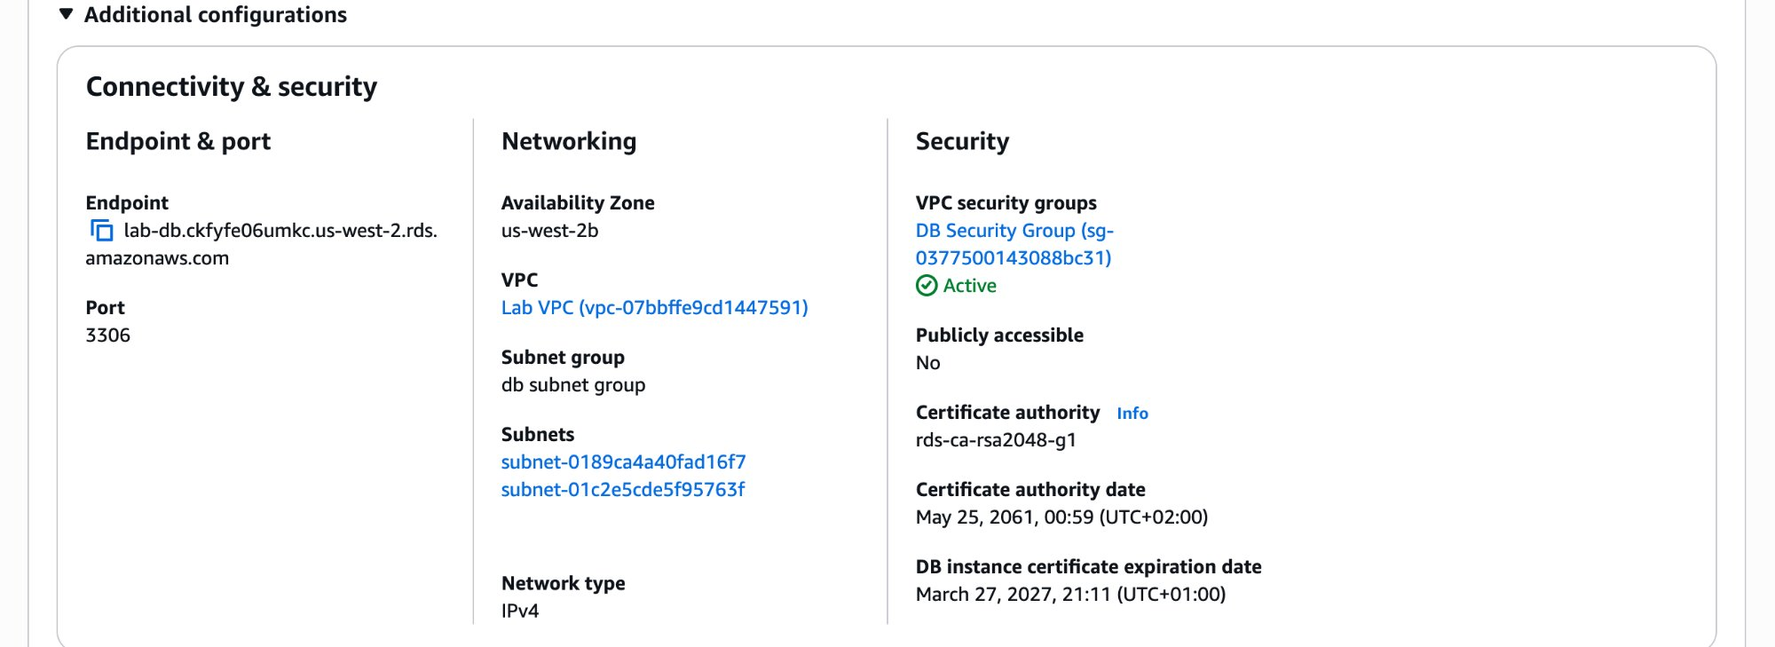

Task 4: Interact with Your Database

You will open a pre-built web application running on the lab EC2 web server and connect it to your RDS instance.
1 | Copy the WebServer IP address from the i AWS Details panel (above the lab instructions).

2 | Open a new browser tab → paste the WebServer IP → press Enter. The web application will load.

3 | At the top of the web application → click the RDS link.

4 | Fill in the connection form:

- Endpoint: lab-db.ckfyfe06umkc.us-west-2.rds.amazonaws.com
- Database: lab
- Username: main
- Password: lab-password

5 | Click Submit.

📷 SCREENSHOT | 06_web_app_rds_form.png  Web app RDS form filled in with all connection details before clicking Submit

6 | Wait a few seconds. The Address Book application will load — data is being written to the RDS database.

7 | Test the application: add, edit, and remove contacts. Data is stored in RDS and replicated to the standby AZ automatically.

📷 SCREENSHOT | 07_address_book_running.png  Address Book application running and connected to the RDS database

Screenshot Reference Summary

Folder: ~/Desktop/AWS-reStart-Journey/Labs/Databases/lab-160-build-db-server/screenshots/
# | Filename | Task | What to Capture
1 | 01_security_group_created.png | Task 1 | DB Security Group created — inbound rule showing port 3306 from Web Security Group
2 | 02_db_subnet_group_created.png | Task 2 | DB Subnet Group created with both private subnets listed
3 | 03_rds_creating.png | Task 3 | RDS console showing lab-db status: Creating
4 | 04_rds_available.png | Task 3 | RDS instance lab-db showing Available status
5 | 05_rds_endpoint.png | Task 3 | Connectivity & Security tab showing the full endpoint URL
6 | 06_web_app_rds_form.png | Task 4 | Web app RDS form filled in with endpoint, database, username, password
7 | 07_address_book_running.png | Task 4 | Address Book application running and showing contact records

Git — Push to GitHub

- Navigate to your lab folder:

GIT | cd ~/Desktop/AWS-reStart-Journey/Labs/Databases/lab-160-build-db-server

- Stage all files:

GIT | git add .

- Commit:

GIT | git commit -m "Add Lab 160: Build DB Server with Amazon RDS"

- Push to GitHub:

GIT | git push origin main

