LAB 162
Challenge Lab: Build Your DB Server and Interact With Your DB
AWS re/Start Programme • Estimated duration: 45 minutes • Region: us-west-2 • Server: 8.0.42

Before You Begin
WARNING | Curly quotes: Copying commands from Word or PDFs silently converts straight quotes (", ') into typographic curly quotes. MySQL will reject them with syntax or authentication errors. Always type quotes manually in the terminal.

WARNING | Pasting extra text: Paste the command only — never paste surrounding explanation. Extra text causes "bash: command not found" or SQL syntax errors.

WARNING | MySQL continuation prompt: If you forget a semicolon, MySQL shows "->" and waits. Type ; and press Enter — do not close the terminal.

NOTE | SSH key permissions: The PEM file must have permissions 0400. If you see UNPROTECTED PRIVATE KEY FILE, run: chmod 400 ~/Downloads/labsuser.pem before connecting.

Resource Names
Resource | Value
DB Engine | Amazon Aurora MySQL 3.10.3 (MySQL 8.0.42)
DB Cluster ID | lab162-cluster
DB Instance | lab162-cluster-instance-1
DB Instance Class | db.t3.medium (Burstable)
Region | us-west-2
VPC | Lab VPC (vpc-082dce302a25927e1)
VPC Security Group | lab-db-sg (created new)
Initial DB Name | restart_db
Master Username | admin
Master Password | Challenge123
Instance Endpoint | lab162-cluster-instance-1.cc4wsbuoc2jx.us-west-2.rds.amazonaws.com
LinuxServer IP | 44.246.227.45 (internal: ip-10-0-2-254)
SSH Key | ~/Downloads/labsuser.pem
Table 1 | RESTART
Table 2 | CLOUD_PRACTITIONER

Step 1 — Access the AWS Management Console
1. Click Start Lab and wait for Lab status: ready.
2. Click X to close the panel, then click AWS to open the console in a new tab.
TIP | If the new tab is blocked, click the browser banner and choose Allow pop-ups.

Step 2 — Launch the RDS DB Instance
Navigate to RDS → Create database. Work through every section in the table below. Green values = what to select or enter. Fields not listed can be left at default.

Field | Select / Enter | Notes
ENGINE & VERSION
Creation method | Full configuration | Not Easy create
Engine type | Aurora (MySQL Compatible) | Not PostgreSQL
Cluster scalability | Provisioned | Not Serverless v2
Template | Dev/Test | Not Production
Instance class type | Burstable classes (includes t classes) | Not Memory optimized
DB instance | db.t3.medium | 2 vCPUs, 4 GiB RAM
Engine version | Aurora MySQL 3.10.3 (MySQL 8.0.42) | Latest 3.x in lab
DB cluster identifier | lab162-cluster | Lowercase, hyphens only
CREDENTIALS
Master username | admin | Leave as default
Credential management | Self managed | Not Managed in AWS Secrets Manager
Auto generate password | Unchecked | Enter your own password
Master password | Challenge123 | Note it — cannot be retrieved later
STORAGE
Cluster storage config | Aurora Standard | Not Aurora I/O-Optimized
Database authentication | Password only | Leave IAM and Kerberos unchecked
AVAILABILITY & DURABILITY
Multi-AZ deployment | Don't create an Aurora Replica | Required — standby restricted in lab
CONNECTIVITY
Compute resource | Don't connect to an EC2 compute resource | Manual setup
Network type | IPv4 | Not Dual-stack
VPC | Lab VPC (vpc-082dce302a25927e1) | 4 Subnets, 2 AZs
DB subnet group | Create new DB Subnet Group | Auto-created for Lab VPC
Public access | No | RDS not publicly accessible
VPC security group | Create new → lab-db-sg | Add inbound rule port 3306 after creation
Availability Zone | No preference
RDS Proxy | Unchecked | Leave off
Certificate authority | Default | Leave as-is
Database port | 3306 | Default MySQL port
MONITORING
Database Insights | Database Insights - Standard | Advanced is grayed out in lab
Performance Insights | Unchecked (disabled) | Leave off
Enhanced Monitoring | Unchecked (disabled) | Leave off
Log exports | All unchecked | No CloudWatch log exports needed
ADDITIONAL CONFIGURATION
Initial database name | restart_db | Creates DB automatically on launch
DB cluster param group | default.aurora-mysql8.0 | Leave as default
DB parameter group | default.aurora-mysql8.0 | Leave as default
Failover priority | No preference
Read replica write forwarding | Unchecked | Leave off
Backup retention | 7 days | Default — leave as-is
Backup window | No preference
Copy tags to snapshots | Checked | Default — leave on
Encryption key | AWS owned KMS key (SSE-RDS) | Default — leave as-is
Backtrack | Unchecked | Leave off
Auto minor version upgrade | Checked (enabled) | Leave on
Maintenance window | No preference
Deletion protection | Unchecked (disabled) | Must be OFF — lab cleanup requires it

IMPORTANT | After clicking Create database, wait until the cluster status shows Available before proceeding. This takes 5–10 minutes.

RDS console — Engine options (Aurora MySQL Compatible selected):
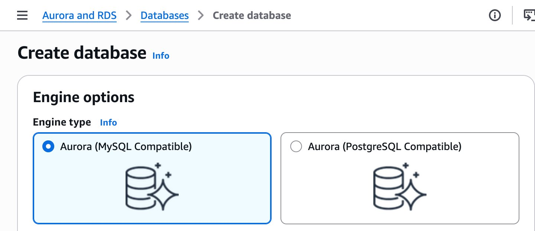
Creation method (Full configuration) and Templates (Dev/Test), Cluster scalability (Provisioned):
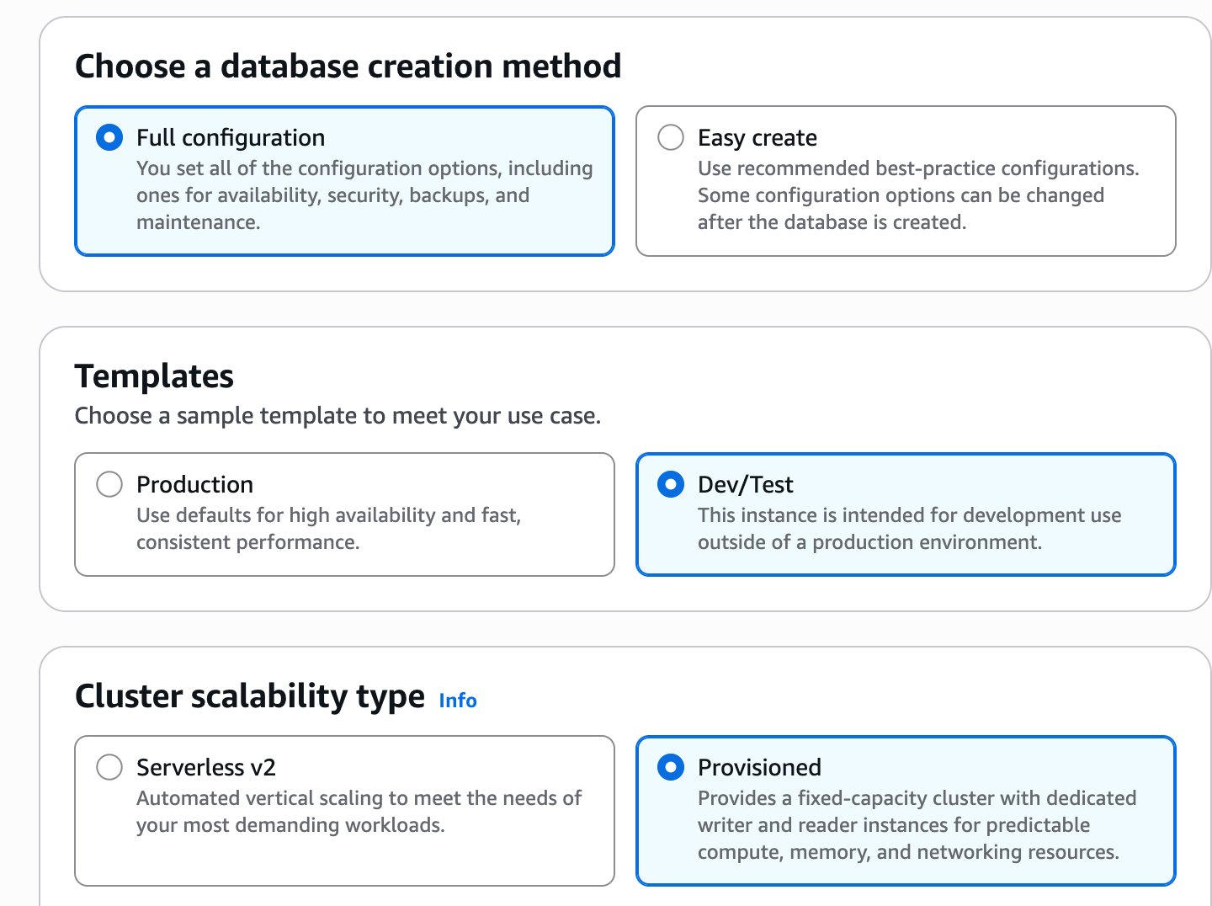
Instance class (Burstable, db.t3.medium), Engine version (Aurora MySQL 3.10.3), DB cluster identifier:
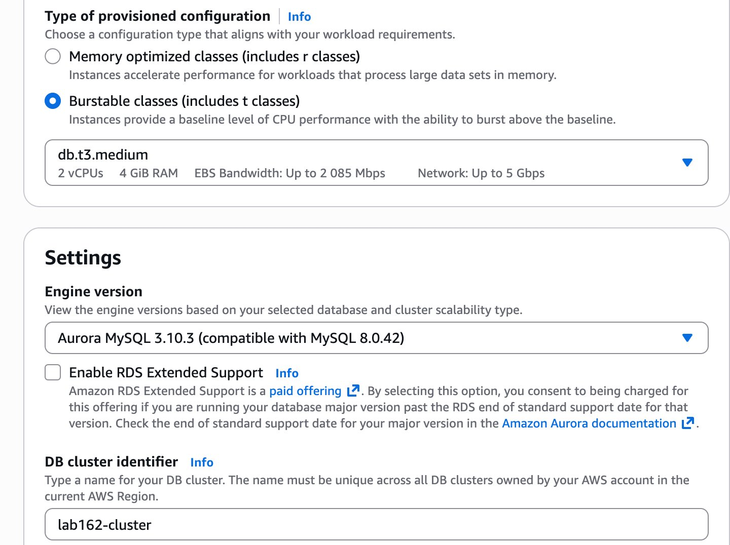
Credentials — Master username: admin, Self managed, password entered:
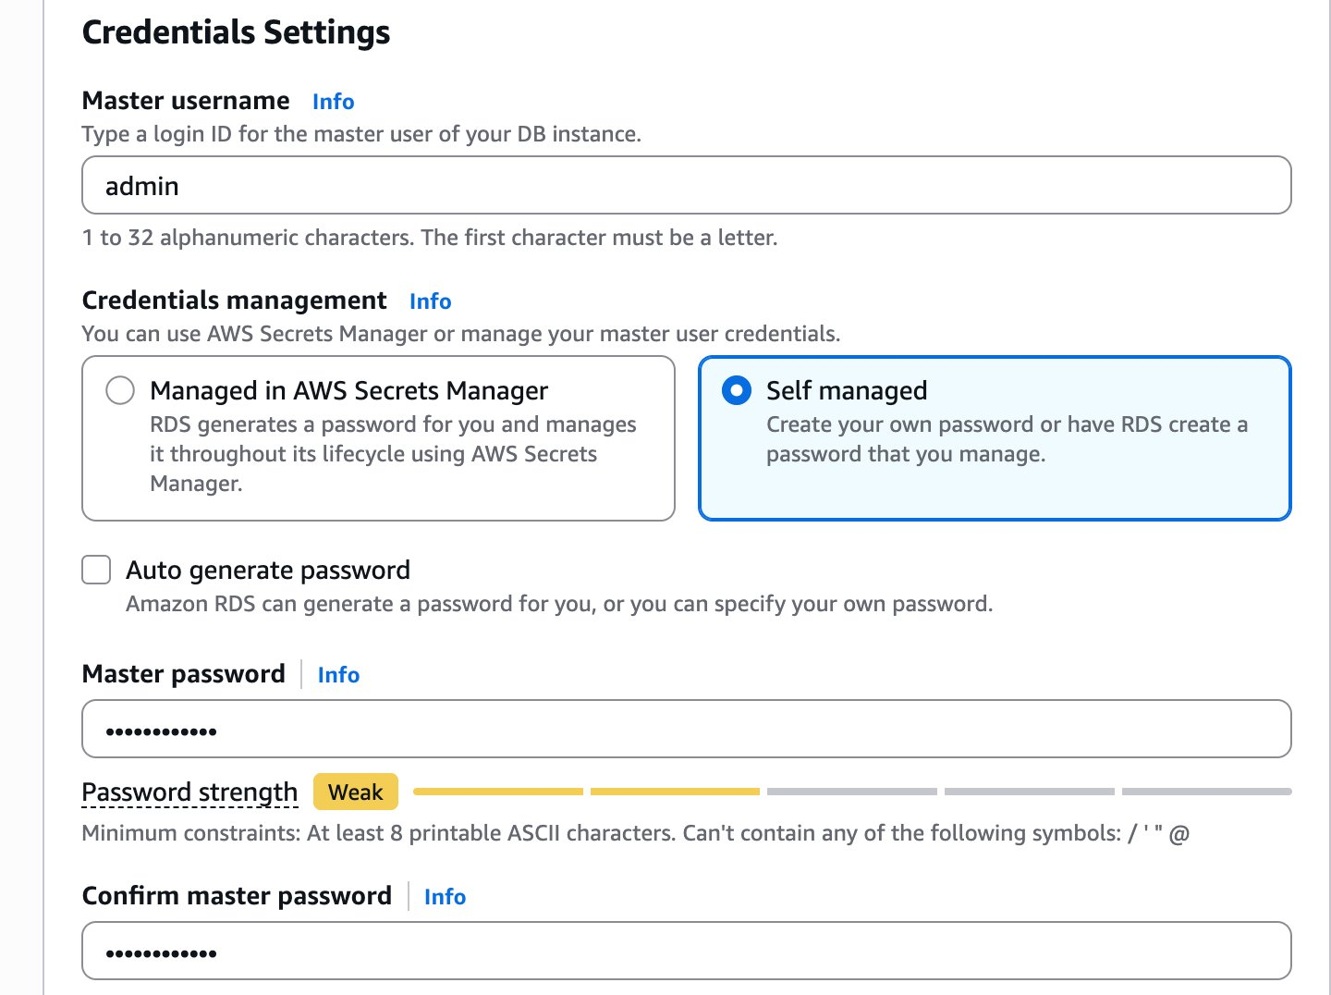
Additional credentials and Cluster storage configuration (Aurora Standard):
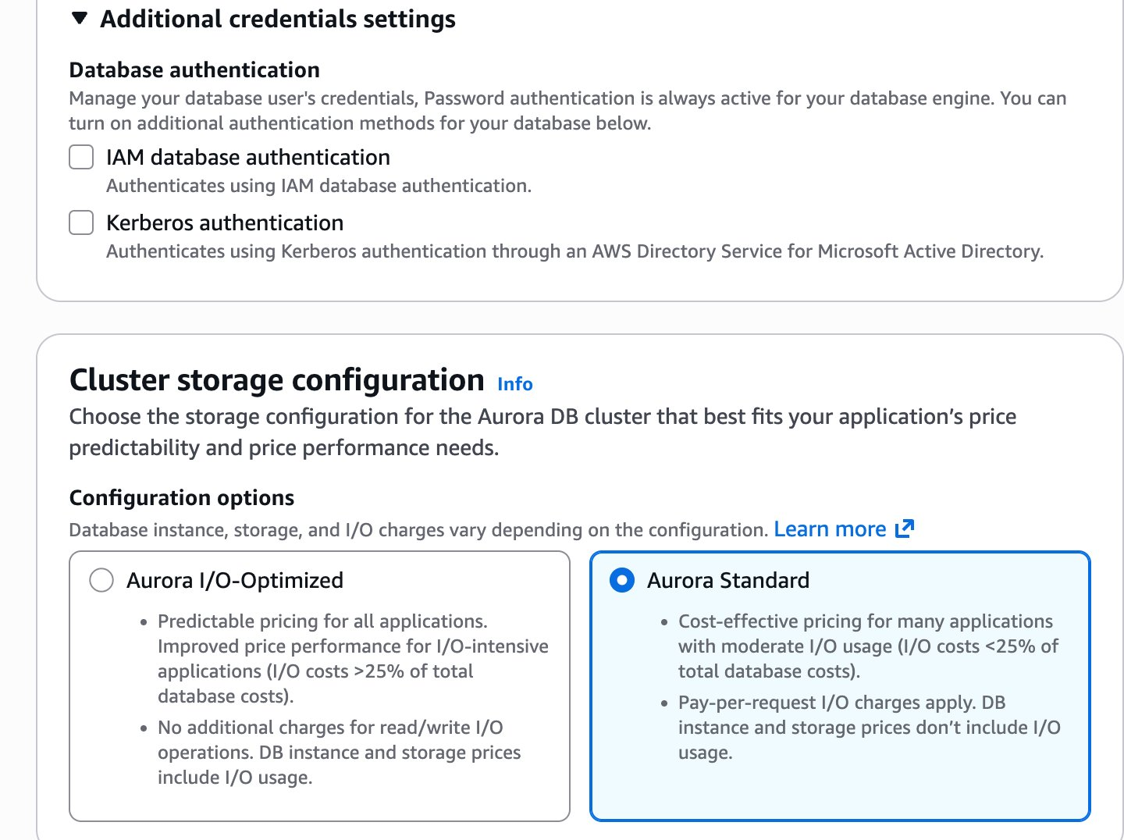
Availability & durability (Don't create Aurora Replica) and Connectivity (Don't connect to EC2, IPv4):
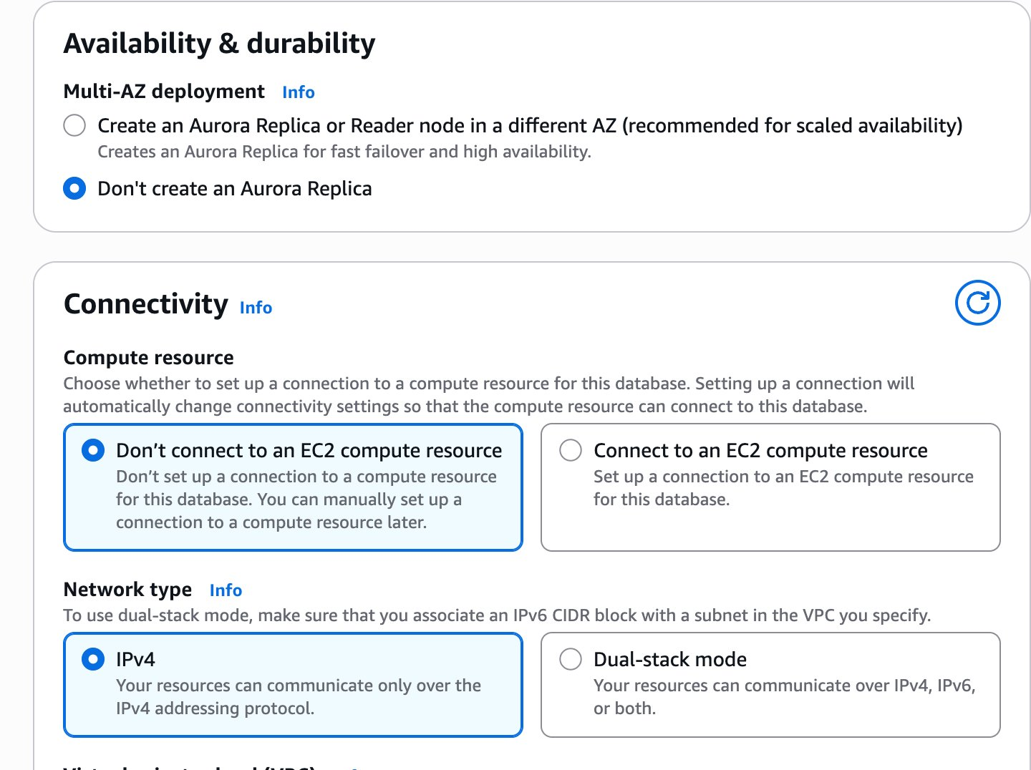
VPC (Lab VPC), DB subnet group (Create new), Public access (No):
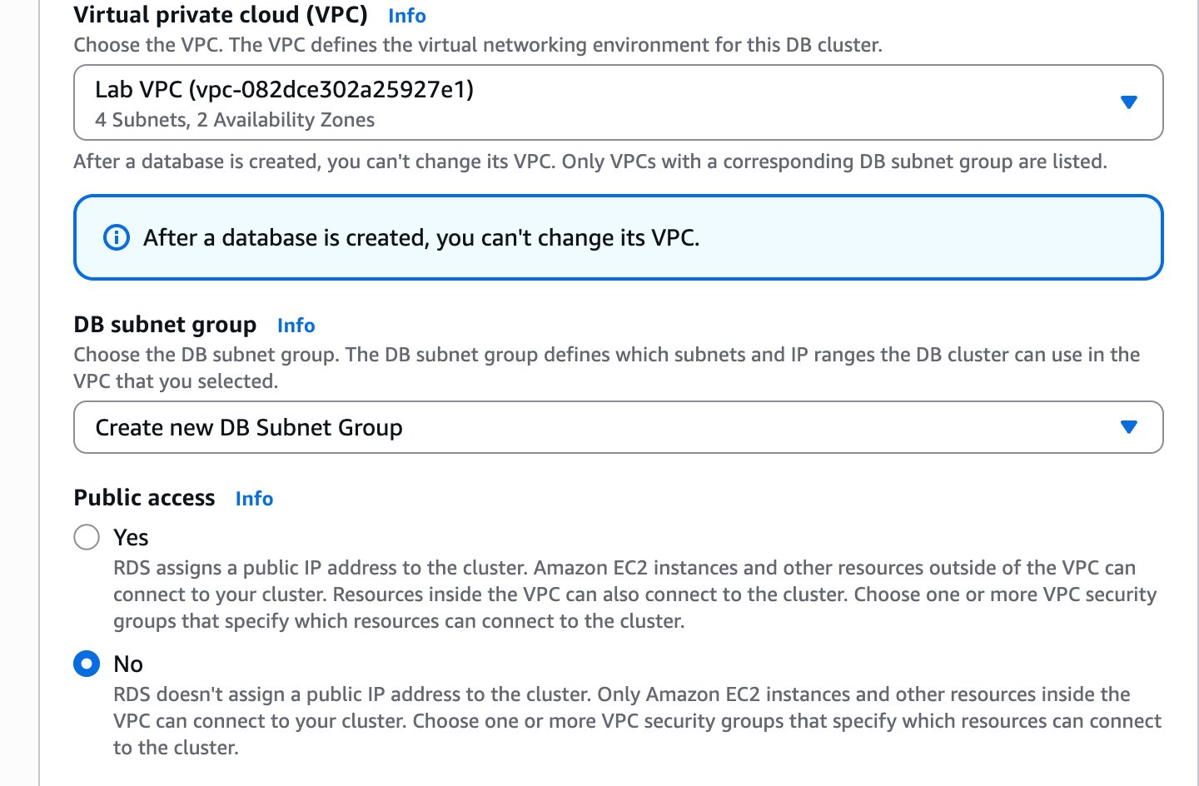
VPC security group (Create new → lab-db-sg), Availability Zone (No preference), Certificate authority:
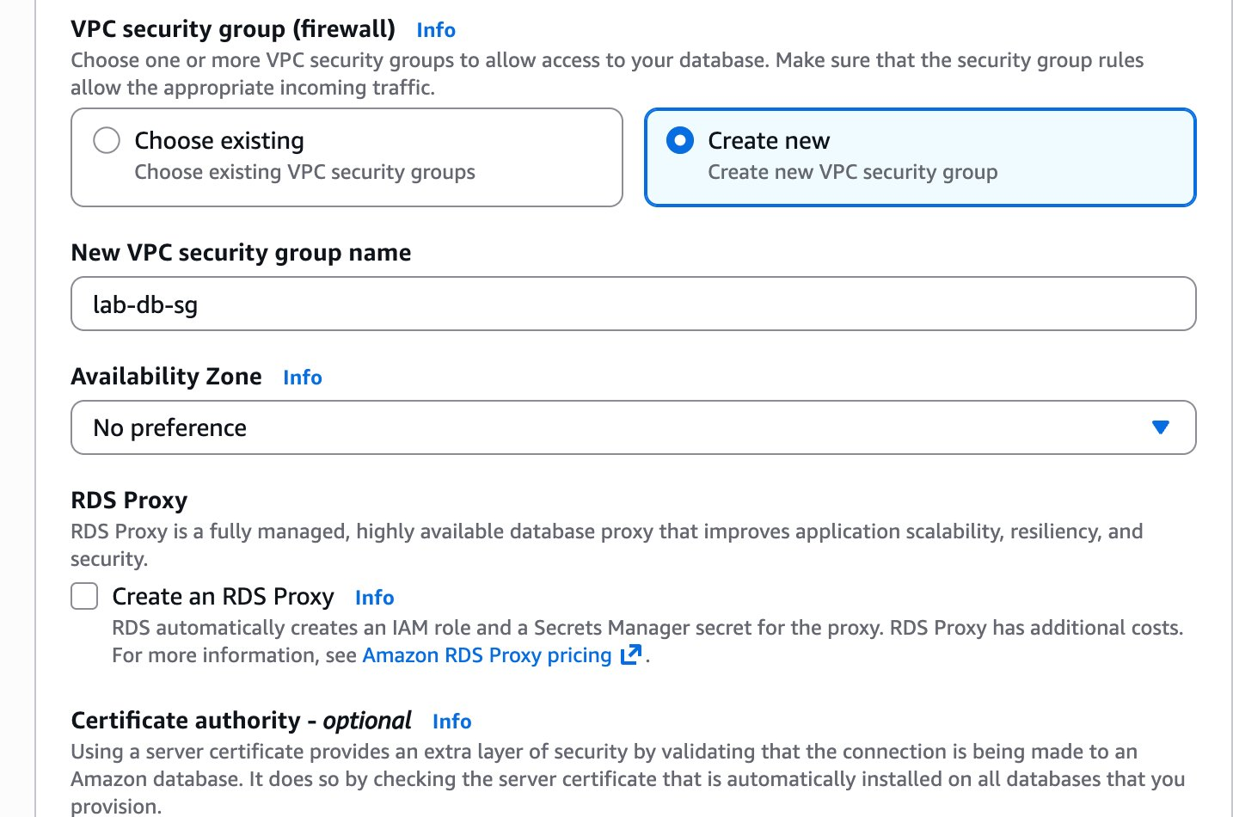
Additional connectivity — Database port 3306, Read replica write forwarding off, Tags:
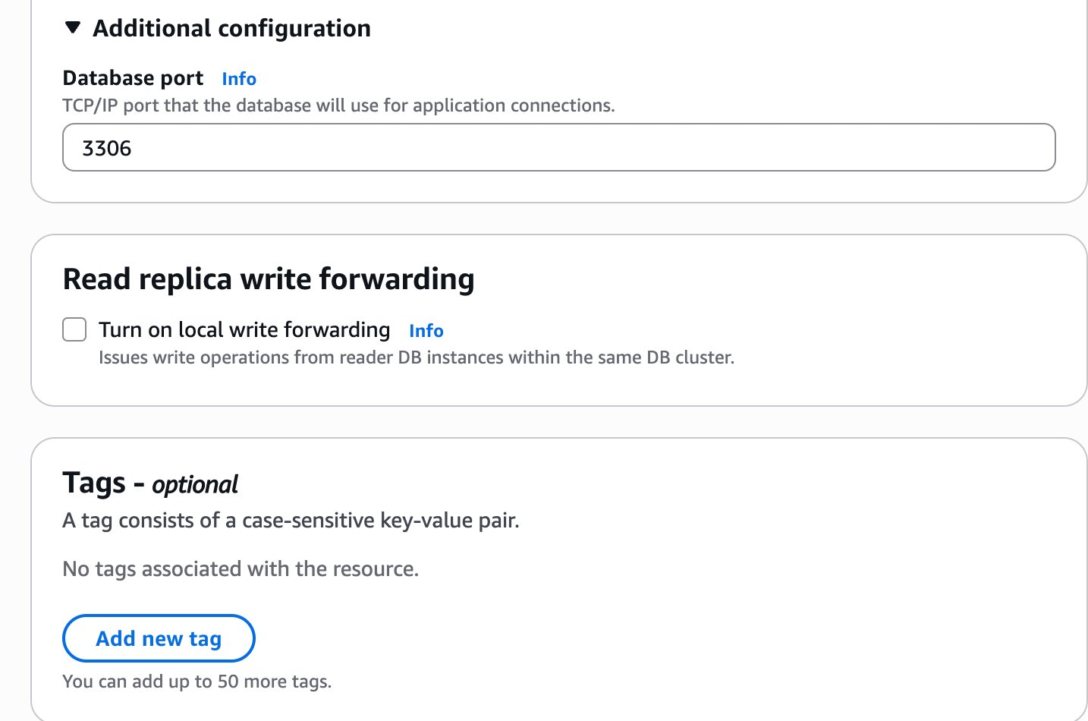
Monitoring — Database Insights Standard, Performance Insights unchecked:
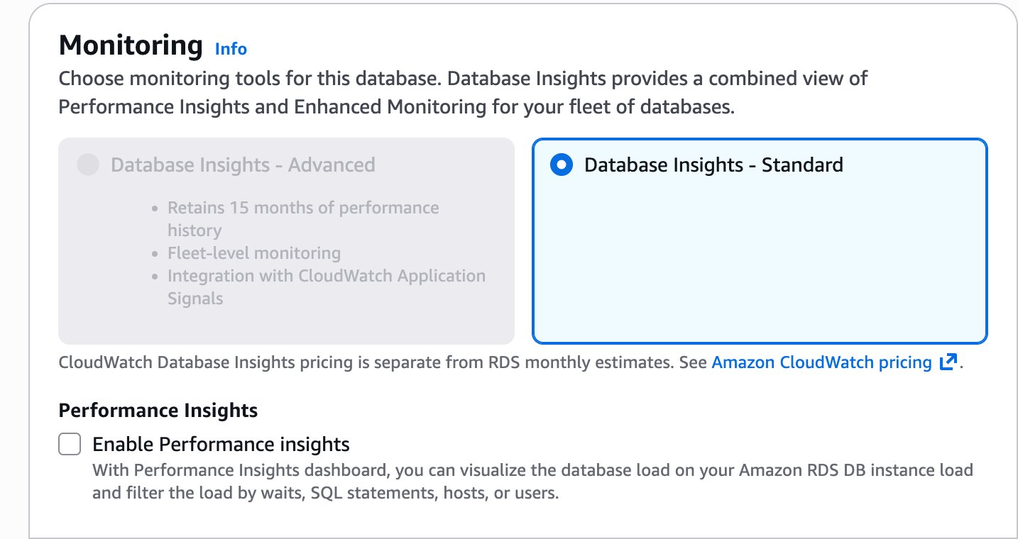
Additional monitoring settings — Enhanced Monitoring off, all log exports unchecked:
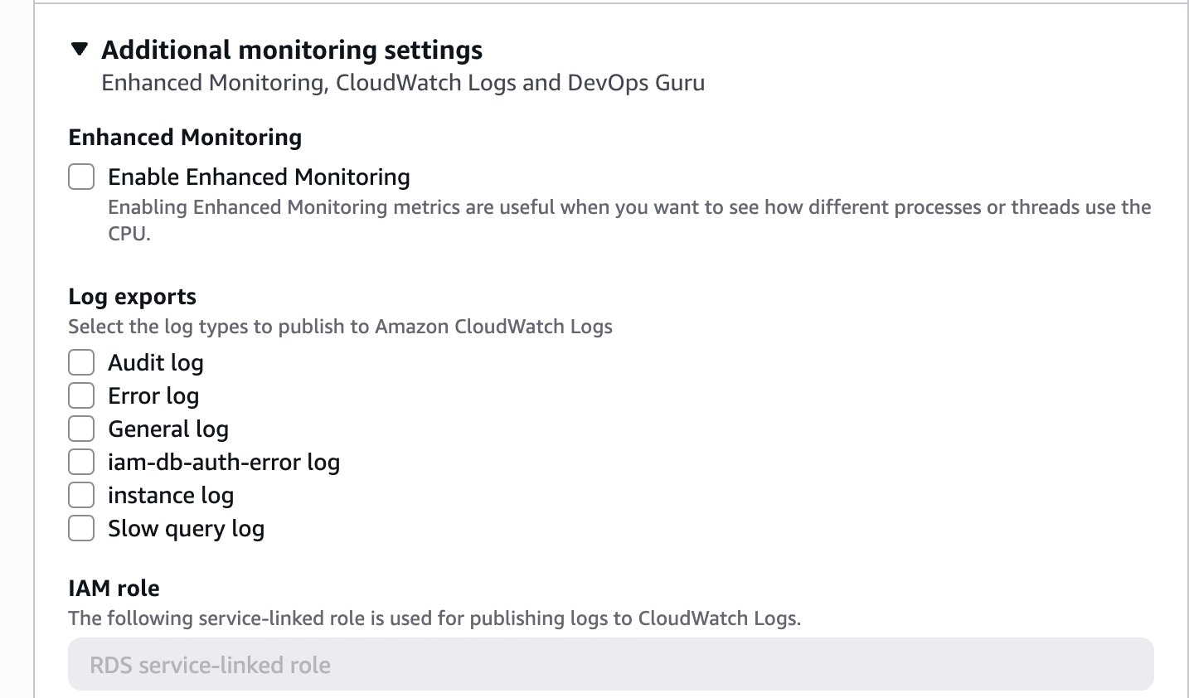
Additional configuration — Initial database name: restart_db, parameter groups, Failover priority:
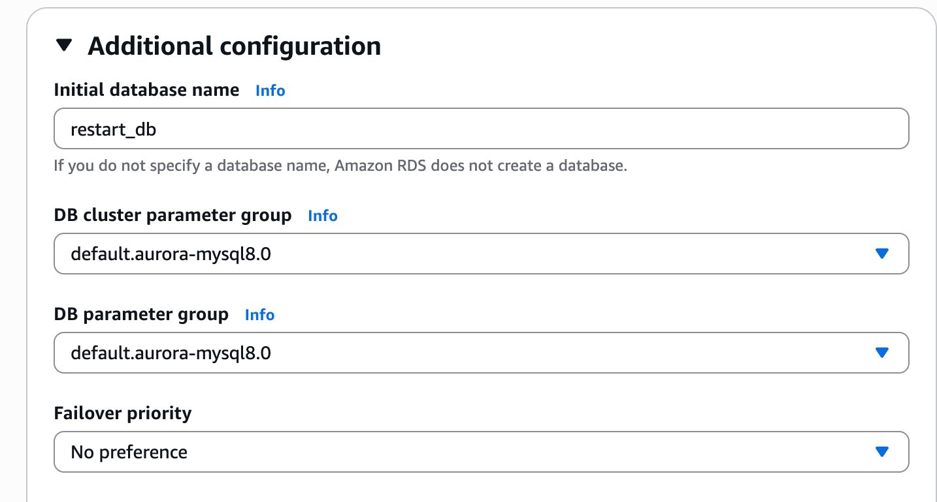
Backup — 7 days retention, No preference window, Copy tags to snapshots checked, Encryption key: AWS owned KMS key (SSE-RDS):
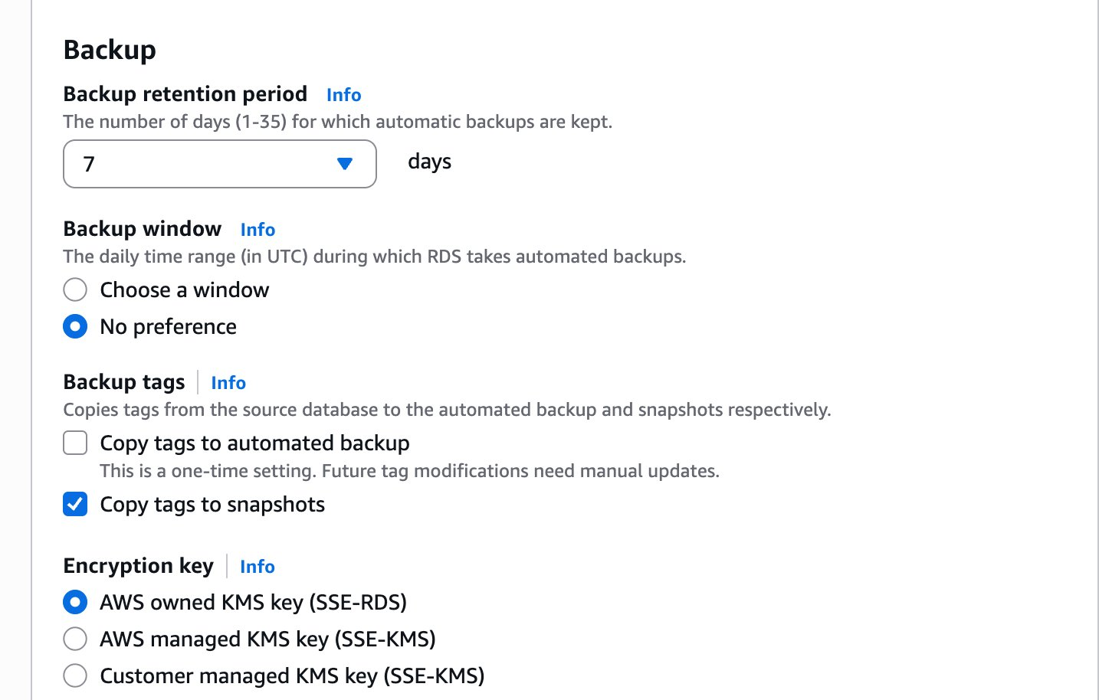
Maintenance — Auto minor version upgrade enabled, No preference window, Deletion protection unchecked:
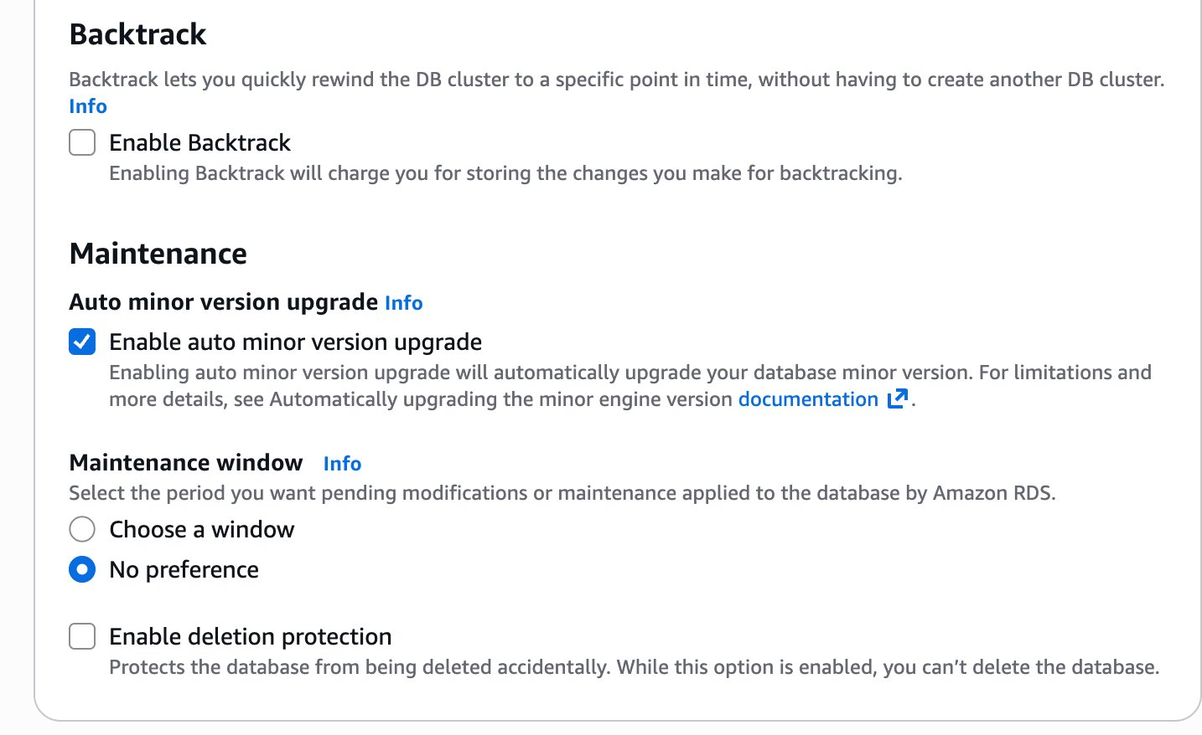

Step 3 — Get the SSH Key and LinuxServer Address
1. Click Details → Show.
2. Click Download PEM (macOS/Linux). Save it — cannot be re-downloaded after closing the panel.
3. Note the LinuxServer address: 44.246.227.45

Step 4 — Connect to the LinuxServer via SSH
CMD | chmod 400 ~/Downloads/labsuser.pem

CMD | ssh -i ~/Downloads/labsuser.pem ec2-user@44.246.227.45
OUTPUT | Last login: Sat Mar 28 14:35:19 2026 from 178.197.206.200  Amazon Linux 2  [ec2-user@ip-10-0-2-254 ~]$
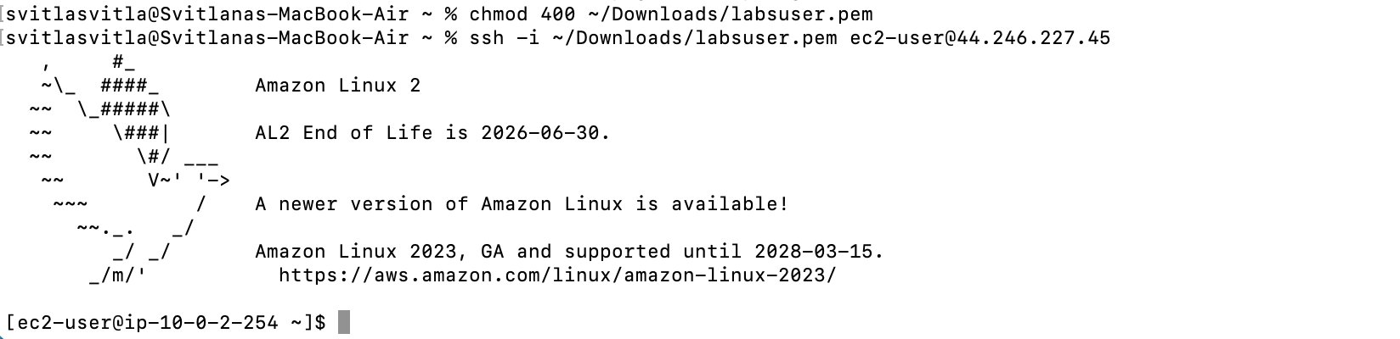

Step 5 — Install the MySQL Client and Connect to RDS
CMD | sudo yum install -y mysql

CMD | mysql -h lab162-cluster-instance-1.cc4wsbuoc2jx.us-west-2.rds.amazonaws.com -u admin -p
OUTPUT | Enter password:  Welcome to the MariaDB monitor. Commands end with ; or \g.  Your MySQL connection id is 183  Server version: 8.0.42 6252a59a  MySQL [(none)]>
NOTE | The prompt shows MySQL [(none)]> — this is correct. The server version is 8.0.42 as expected for Aurora MySQL 3.10.3.
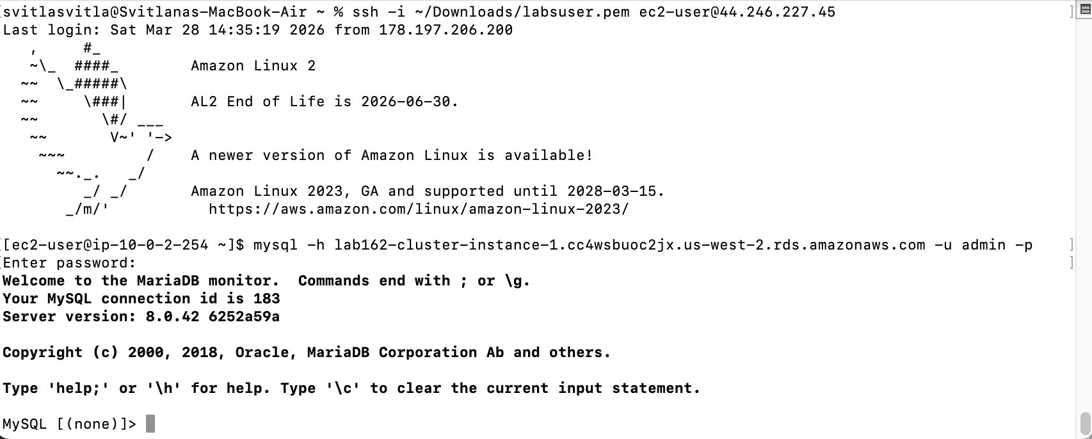

Step 6 — Create the RESTART Table
NOTE | restart_db was set as Initial database name during RDS creation, so it already exists. Run USE restart_db; to select it — no CREATE DATABASE needed.
SQL | USE restart_db;

SQL | CREATE TABLE RESTART (  StudentID INT PRIMARY KEY,  StudentName VARCHAR(100),  RestartCity VARCHAR(100),  GraduationDate DATETIME  );
OUTPUT | Database changed  Query OK, 0 rows affected (0.03 sec)
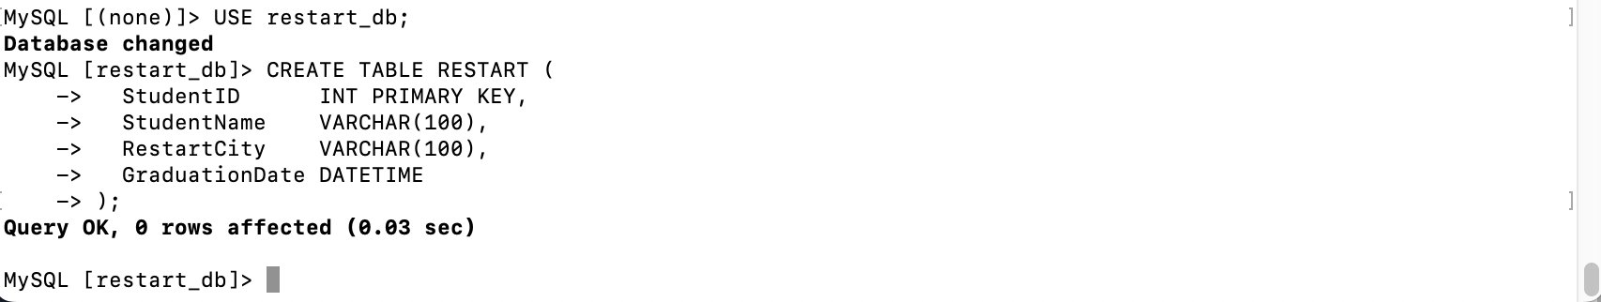

Step 7 — Insert 10 Rows into RESTART
SQL | INSERT INTO RESTART VALUES  (1, 'Alice Brown', 'London', '2024-06-15 09:00:00'),  (2, 'Bob Smith', 'Dublin', '2024-06-15 09:00:00'),  (3, 'Clara Jones', 'Berlin', '2024-07-20 09:00:00'),  (4, 'David Lee', 'Paris', '2024-07-20 09:00:00'),  (5, 'Emma Wilson', 'Amsterdam', '2024-08-10 09:00:00'),  (6, 'Frank Taylor', 'Warsaw', '2024-08-10 09:00:00'),  (7, 'Grace Martin', 'Madrid', '2024-09-01 09:00:00'),  (8, 'Henry Clark', 'Rome', '2024-09-01 09:00:00'),  (9, 'Isla Anderson', 'Vienna', '2024-10-05 09:00:00'),  (10, 'Jack Thompson', 'Zurich', '2024-10-05 09:00:00');
OUTPUT | Query OK, 10 rows affected (0.00 sec)  Records: 10 Duplicates: 0 Warnings: 0
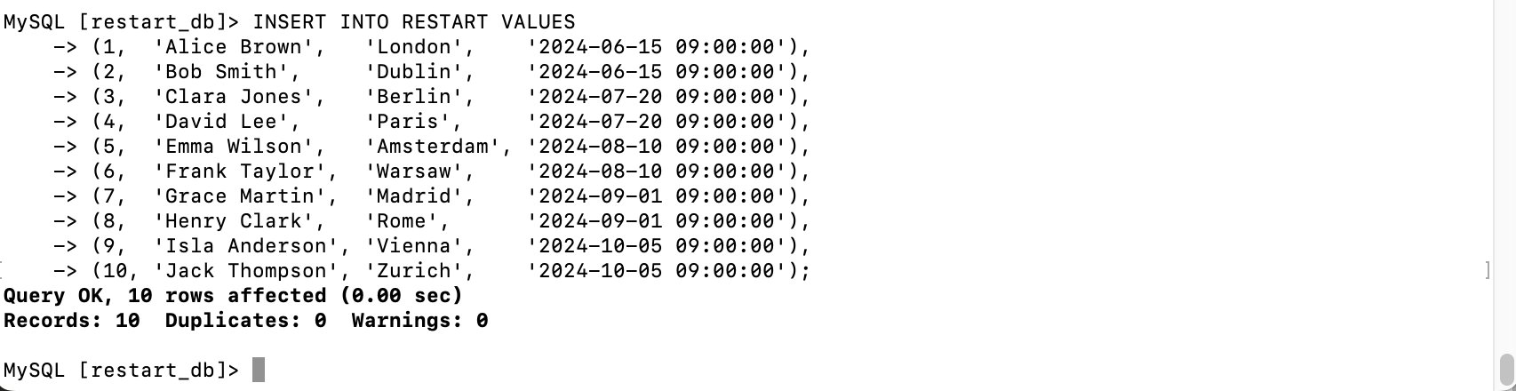

Step 8 — Select All Rows from RESTART
SQL | SELECT * FROM RESTART;
OUTPUT | 10 rows in set (0.00 sec)
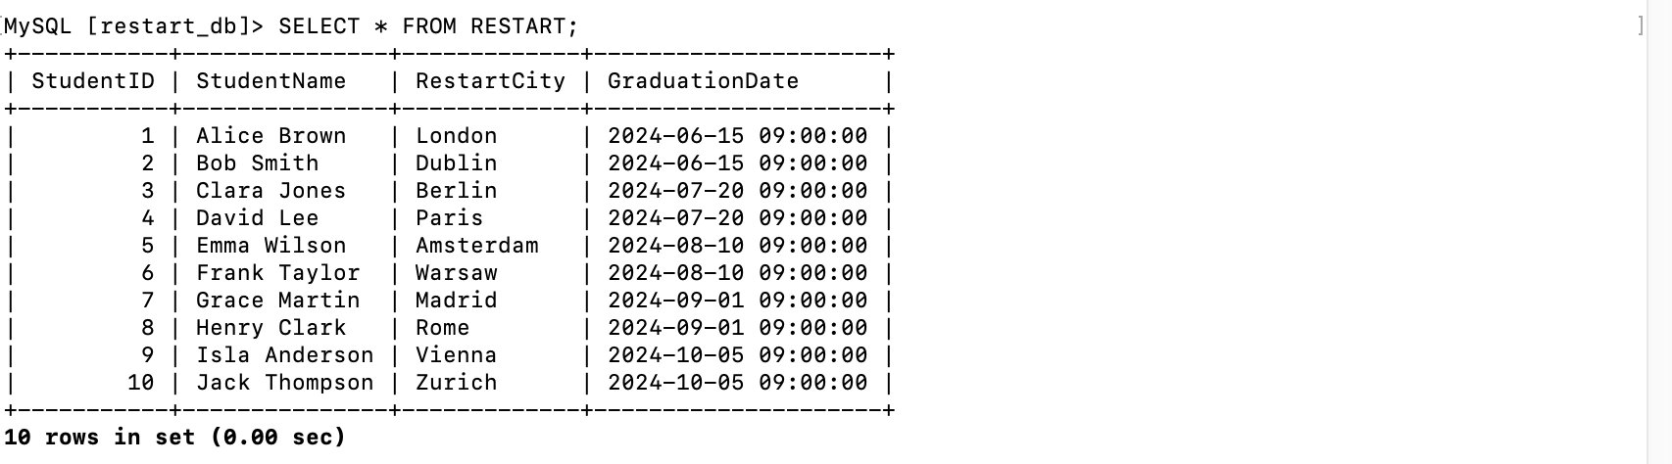

Step 9 — Create the CLOUD_PRACTITIONER Table
SQL | CREATE TABLE CLOUD_PRACTITIONER (  StudentID INT PRIMARY KEY,  CertificationDate DATETIME  );
OUTPUT | Query OK, 0 rows affected (0.02 sec)

Step 10 — Insert 5 Rows into CLOUD_PRACTITIONER
SQL | INSERT INTO CLOUD_PRACTITIONER VALUES  (1, '2024-09-10 10:00:00'),  (3, '2024-10-01 10:00:00'),  (5, '2024-10-15 10:00:00'),  (7, '2024-11-05 10:00:00'),  (9, '2024-11-20 10:00:00');
OUTPUT | Query OK, 5 rows affected (0.01 sec)  Records: 5 Duplicates: 0 Warnings: 0
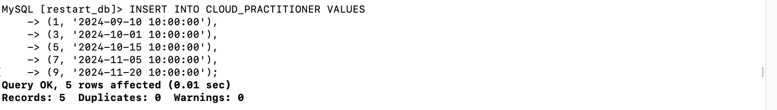

Step 11 — Select All Rows from CLOUD_PRACTITIONER
SQL | SELECT * FROM CLOUD_PRACTITIONER;
OUTPUT | 5 rows in set (0.00 sec)
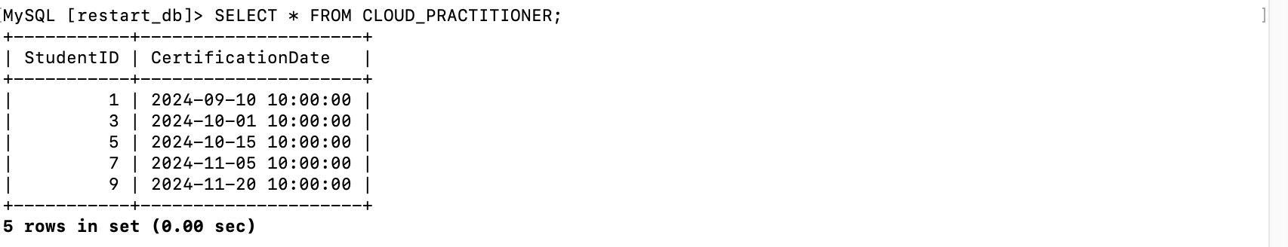

Step 12 — Inner Join: Student ID, Name, and Certification Date
SQL | SELECT r.StudentID, r.StudentName, cp.CertificationDate  FROM RESTART r  INNER JOIN CLOUD_PRACTITIONER cp  ON r.StudentID = cp.StudentID;
OUTPUT | 5 rows in set (0.00 sec)
NOTE | Returns 5 rows — only StudentIDs that exist in both tables (1, 3, 5, 7, 9). Students 2, 4, 6, 8, 10 have no certification record and are excluded.
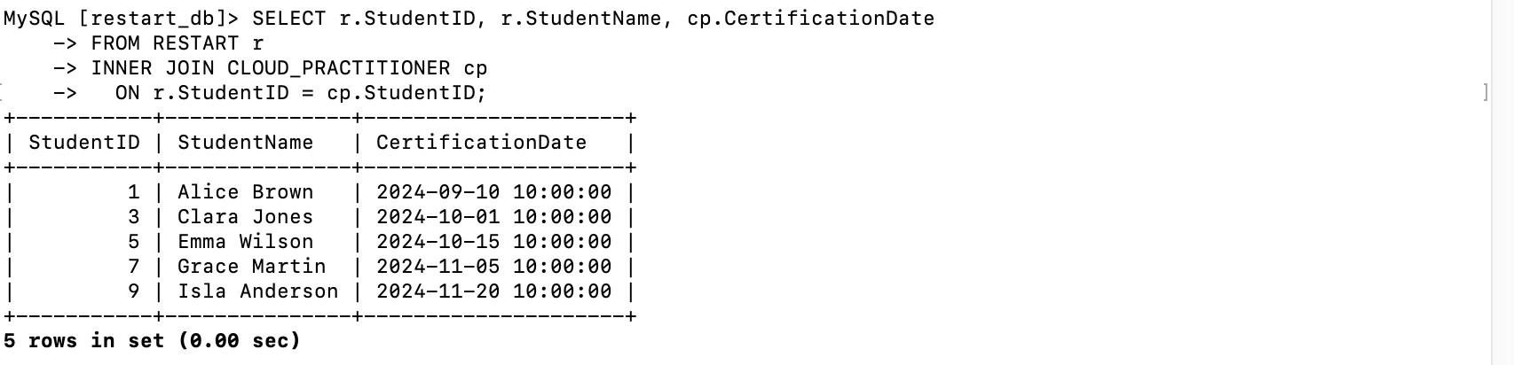

Step 13 — End the Lab
1. Exit MySQL:
SQL | EXIT;

2. Return to the lab page, click End Lab, then click Yes to confirm.
WARNING | All resources are destroyed after clicking End Lab. Make sure every screenshot is saved before confirming.

Git Push
GIT | cd ~/Desktop/AWS-reStart-Journey/Labs/Databases/lab-162-challenge-db-server

GIT | git add .

GIT | git commit -m "Add Lab 162: Challenge DB Server — Aurora MySQL, RDS, SSH, joins"

GIT | git push origin main

