LAB270 – Selecting Data from a Database
AWS re/Start Programme · Step-by-Step Lab Guide
Estimated duration: 45 minutes · MariaDB 10.5.29 · Instance: i-09b877e1c871c9fed

Resource Names Reference
Every command in this guide uses the real values below. Do not substitute placeholders.

Resource | Name / Value | Notes
Database name | world | Pre-installed on Command Host
Database tables | city, country, countrylanguage | Three tables in the world DB
DB user | root | Pre-configured
DB password | re:St@rt!9 | Set during installation
EC2 instance label | Command Host | EC2 > Instances
Instance ID | i-09b877e1c871c9fed | Visible in Session Manager header
DB server version | MariaDB 10.5.29 | Shown on login banner
Connection method | Session Manager | No SSH key or open port required
Repo path | Desktop\AWS-reStart-Journey\Labs\Databases\lab-270-selecting-data-from-database | Local repo root

Before You Begin — Important Warnings

WARNING | Copying commands from Word or PDF can silently convert straight quotes (") and apostrophes (')  into curly/typographic versions. MySQL will reject these with syntax errors.  Always type quotes manually in the terminal, or paste into Notepad first to strip formatting.

WARNING | Never paste explanatory text together with a command. Only paste the command line itself.  Pasting surrounding text causes: bash: command not found or MySQL syntax errors.

NOTE | SQL keywords (SELECT, FROM, WHERE, etc.) are case-insensitive in MariaDB/MySQL.  String values inside quotes ARE case-sensitive — 'Southern Europe' != 'southern europe'.  The MariaDB prompt shows -> when a statement spans multiple lines — this is normal.

Task 1: Connect to the Command Host
Connect to an EC2 instance called the Command Host using AWS Session Manager. This gives you a browser-based terminal — no SSH key or open security group port required.

Step 1.1 — Navigate to EC2 Instances
1. In the AWS Management Console, open the Services menu.
2. Under Compute, choose EC2.
3. In the left navigation menu, choose Instances.
4. Find the instance labelled Command Host, select its checkbox, then choose Connect.

NOTE | If Command Host is not visible, the lab environment may still be provisioning. Wait one to two minutes and refresh.

Step 1.2 — Open Session Manager Terminal
5. On the Connect to instance page, choose the Session Manager tab.
6. Choose Connect. A browser-based terminal opens in a new tab.

Step 1.3 — Configure the Terminal Environment
Run the following two commands to switch to root and move to the working directory:

CMD | sudo su

CMD | cd /home/ec2-user/

NOTE | These commands produce no output. Your prompt will change to [root@ip-10-1-11-13 ec2-user]# confirming you are root in the correct directory.

SCREENSHOT 01_session_manager_connected.png
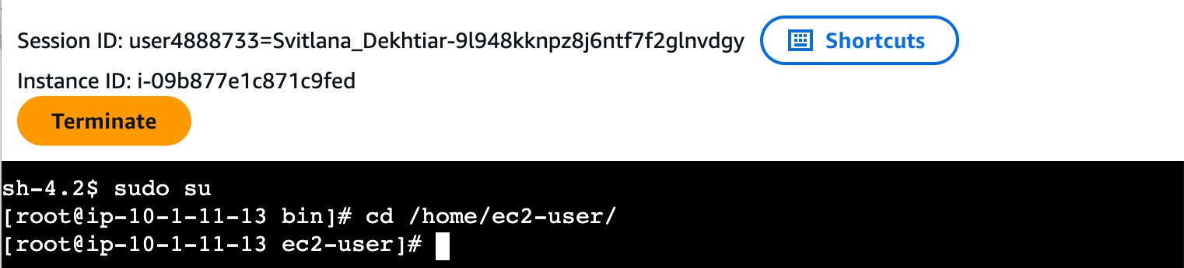
Session Manager terminal open — Instance ID i-09b877e1c871c9fed visible, root prompt confirmed after sudo su and cd

Step 1.4 — Connect to the MariaDB Database Server
Run the following command to connect. The password was set when the database was installed:

CMD | mysql -u root --password='re:St@rt!9'

OUTPUT | Welcome to the MariaDB monitor. Commands end with ; or \g.  Your MariaDB connection id is 5  Server version: 10.5.29-MariaDB MariaDB Server  ...  MariaDB [(none)]>

TIP | The MariaDB [(none)]> prompt confirms you are connected and ready to run SQL commands.  All SQL statements must end with a semicolon (;).  To exit the database at any time, type: exit

WARNING | If Session Manager disconnects at any point, close the window, reconnect from EC2 Instances,  then run all three commands again:  sudo su  cd /home/ec2-user/  mysql -u root --password='re:St@rt!9'

SCREENSHOT 02_mysql_connected.png
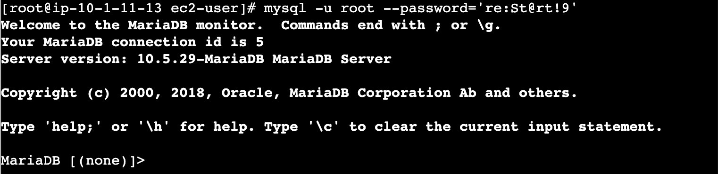
MariaDB 10.5.29 welcome banner and MariaDB [(none)]> prompt — database connection confirmed

Task 2: Query the world Database
Run a series of SELECT queries using progressively more operators to filter, sort, count, and alias the results from the world database.

Step 2.1 — Verify the world Database Exists
SQL | SHOW DATABASES;

OUTPUT | +-----------+----------+--------------------+  | Database |  +--------------------+  | information_schema |  | mysql |  | performance_schema |  | world |  +--------------------+  4 rows in set (0.001 sec)

IMPORTANT | Confirm world is in the list before continuing. If it is missing, contact your instructor — the lab environment did not provision correctly.

SCREENSHOT 03_show_databases.png
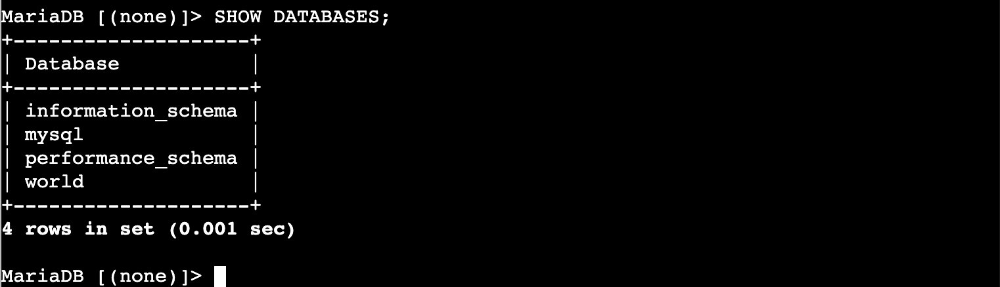
SHOW DATABASES output — world database confirmed present alongside information_schema, mysql, and performance_schema

Step 2.2 — View All Rows in the country Table
SELECT * returns every row and every column. This is useful to see what data is available, though the output is very wide — the terminal wraps columns across multiple lines.

SQL | SELECT * FROM world.country;

OUTPUT | (239 rows — all columns including Code, Name, Continent, Region, SurfaceArea,  IndepYear, Population, LifeExpectancy, GNP, GNPOld, LocalName, GovernmentForm, Capital, Code2)  239 rows in set (...)

SCREENSHOT 04_select_all_country.png
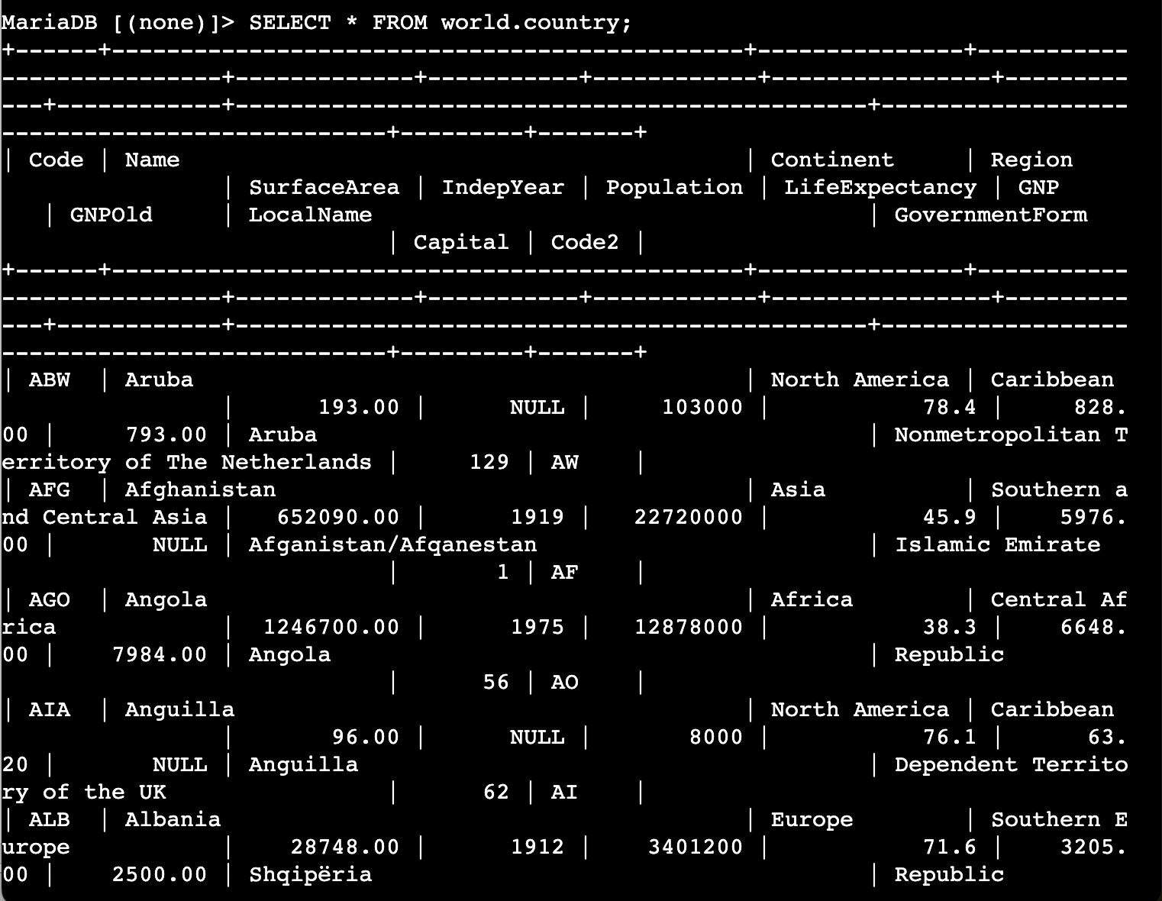
SELECT * FROM world.country — all 239 rows returned, columns wrap due to terminal width, showing Code, Name, Continent, Region, SurfaceArea etc.

Step 2.3 — Count Rows with COUNT(*)
COUNT(*) returns the total number of rows in the table without retrieving all the data.

SQL | SELECT COUNT(*) FROM world.country;

OUTPUT | +----------+  | COUNT(*) |  +----------+  | 239 |  +----------+  1 row in set (0.002 sec)

NOTE | COUNT(*) counts every row regardless of NULL values. COUNT(column_name) only counts rows where that specific column is not NULL — both can return different numbers for the same table.

SCREENSHOT 05_count_country.png
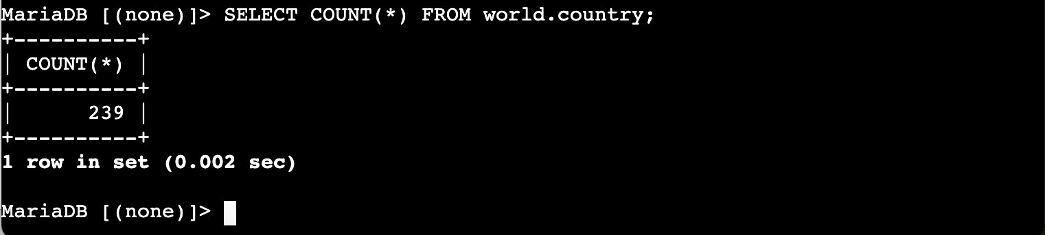
SELECT COUNT(*) result — 239 rows confirmed in world.country

Step 2.4 — Inspect the Table Schema with SHOW COLUMNS
Before writing targeted queries it helps to see all column names and their data types.

SQL | SHOW COLUMNS FROM world.country;

OUTPUT | Field | Type | Null | Key | Default  ----------------+-------------------+------+-----+--------  Code | char(3) | NO | PRI |  Name | char(52) | NO | |  Continent | enum(...) | NO | | Asia  Region | char(26) | NO | |  SurfaceArea | decimal(10,2) | NO | | 0.00  IndepYear | smallint(6) | YES | | NULL  Population | int(11) | NO | | 0  LifeExpectancy | decimal(3,1) | YES | | NULL  GNP | decimal(10,2) | YES | | NULL  ...

TIP | Note the exact column names — SurfaceArea is camel-cased with no space. Using the wrong casing in ORDER BY or WHERE can cause unexpected results.

SCREENSHOT 06_show_columns_country.png
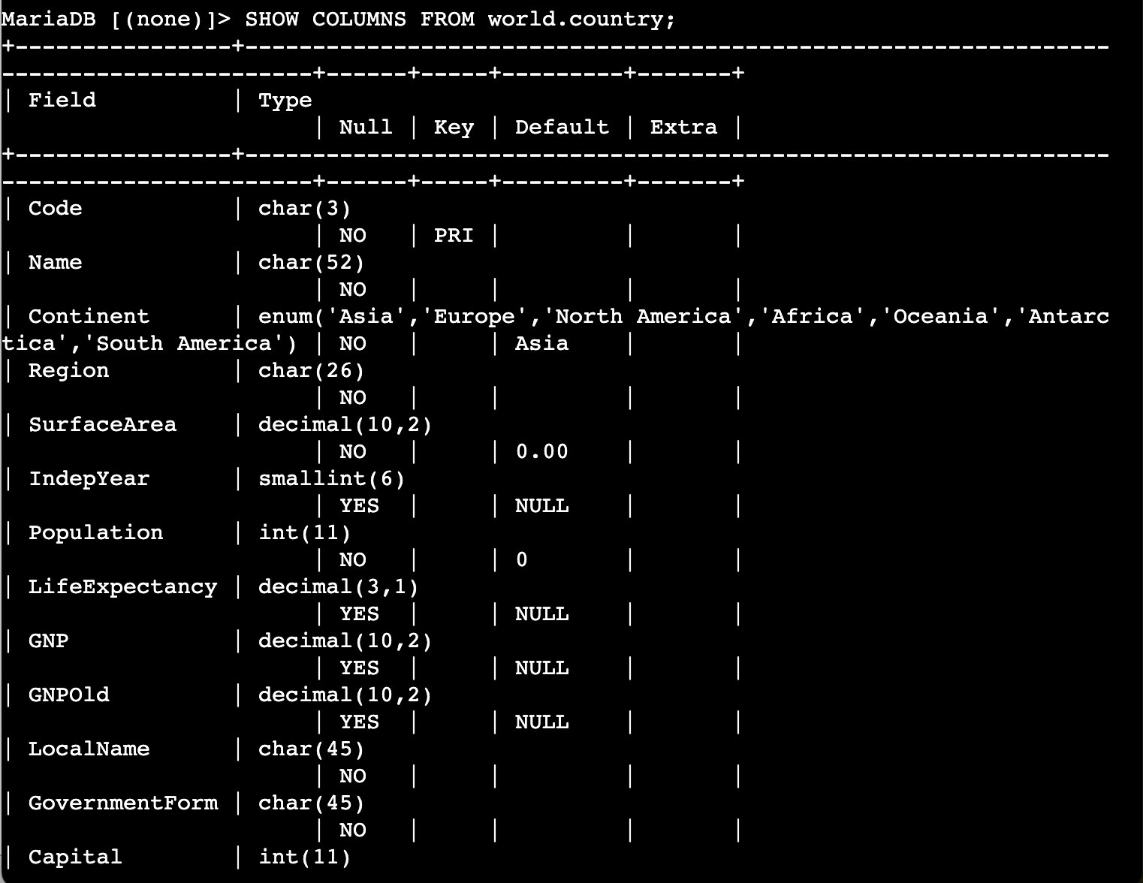
SHOW COLUMNS output — all 15 field names and data types visible, including Code (PRI key), SurfaceArea (decimal), Population (int)

Step 2.5 — Select Specific Columns
Listing only the columns you need makes results far more readable than SELECT *.

SQL | SELECT Name, Capital, Region, SurfaceArea, Population FROM world.country;

OUTPUT | (239 rows — 5 columns only: Name, Capital (as numeric ID), Region, SurfaceArea, Population)

SCREENSHOT 07_select_specific_columns.png
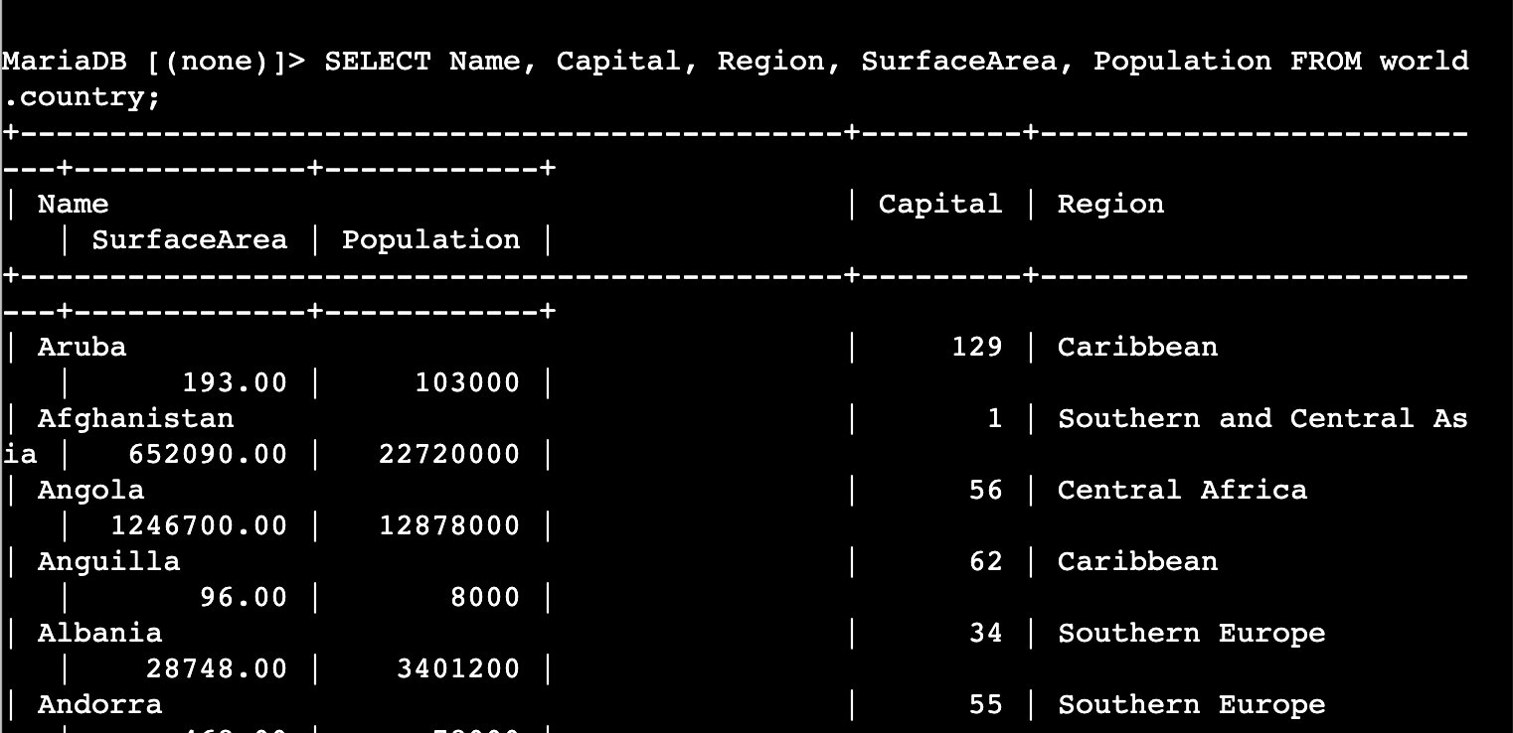
Five-column SELECT result — Name, Capital (numeric ID), Region, SurfaceArea, Population shown for all 239 countries

Step 2.6 — Rename a Column with AS
The AS keyword gives a column a display alias in the result. The table itself is not changed — AS is display-only.

SQL | SELECT Name, Capital, Region, SurfaceArea AS "Surface Area", Population FROM world.country;

OUTPUT | (239 rows — same as above, but the column header now reads 'Surface Area' with a space)

WARNING | The double quotes around Surface Area must be straight quotes ("). Curly/typographic quotes pasted from a document will cause a syntax error. Type them directly in the terminal.

SCREENSHOT 08_column_alias.png
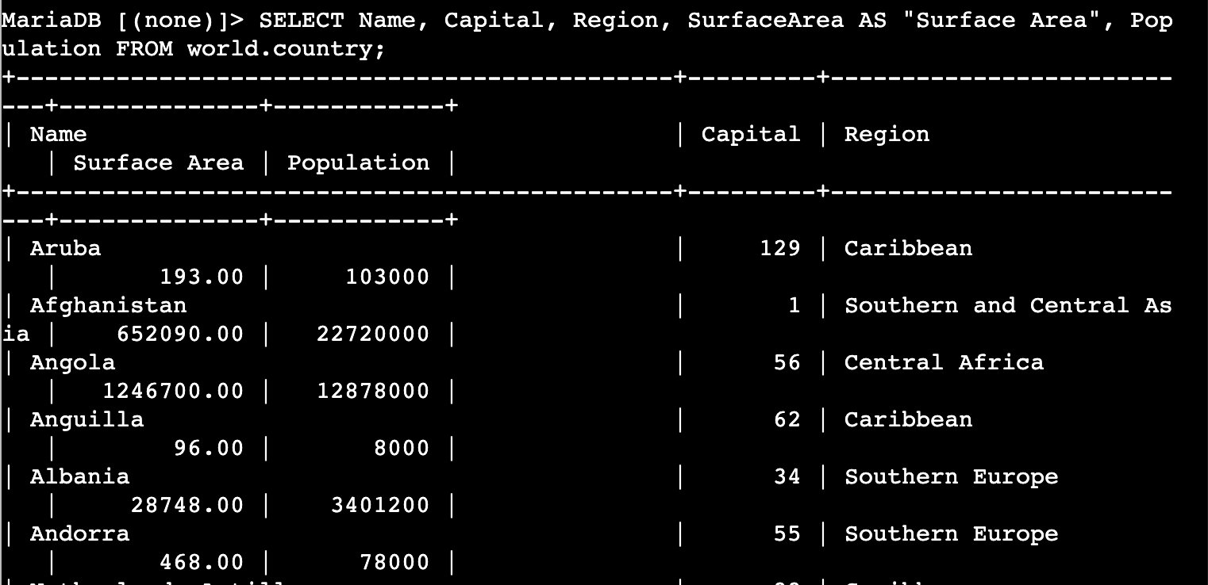
AS alias applied — column header displays as 'Surface Area' (with space) instead of SurfaceArea

Step 2.7 — Sort Results with ORDER BY (Ascending)
ORDER BY sorts the result set. Without DESC, sort order is ascending — smallest values first.

SQL | SELECT Name, Capital, Region, SurfaceArea AS "Surface Area", Population FROM world.country ORDER BY Population;

OUTPUT | (239 rows — least populated entries first: Antarctica (0), French Southern territories (0),  Heard Island and McDonald Islands (0), ..., Pitcairn (50), ...)

SCREENSHOT 09_order_by_population_asc.png
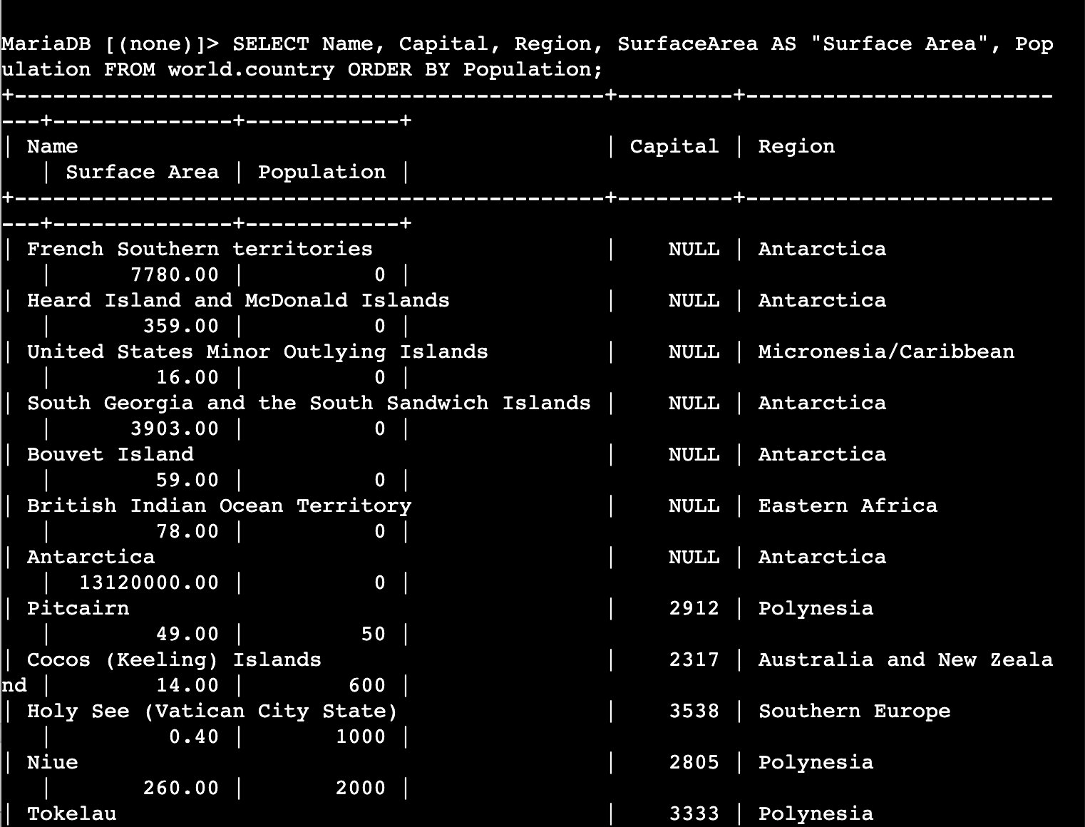
ORDER BY Population ascending — zero-population territories (Antarctica, French Southern territories) appear first

Step 2.8 — Sort Descending with ORDER BY ... DESC
Adding DESC reverses the sort — largest values appear first.

SQL | SELECT Name, Capital, Region, SurfaceArea AS "Surface Area", Population FROM world.country ORDER BY Population DESC;

OUTPUT | (239 rows — China (1,277,558,000) first, India (1,013,662,000) second, United States third)

SCREENSHOT 10_order_by_population_desc.png
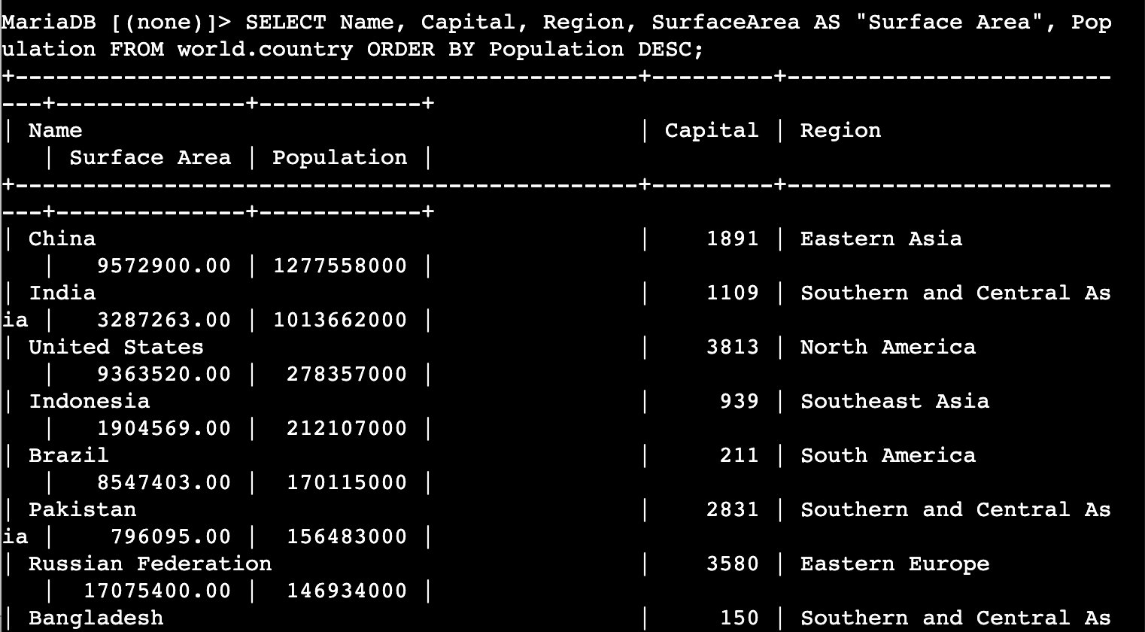
ORDER BY Population DESC — China (1.27B), India (1.01B), United States (278M) at the top

Step 2.9 — Filter with WHERE and > (Greater Than)
The WHERE clause restricts which rows are returned. The > operator filters for values above a threshold.

SQL | SELECT Name, Capital, Region, SurfaceArea AS "Surface Area", Population  FROM world.country  WHERE Population > 50000000  ORDER BY Population DESC;

OUTPUT | (~25 rows — countries with population above 50 million, sorted largest first:  China, India, United States, Indonesia, Brazil, Pakistan, Russian Federation,  Bangladesh, Japan, ...)

NOTE | When you press Enter mid-query, MariaDB shows -> to indicate it is waiting for the rest of the statement. It only executes when it receives a semicolon. This is normal — not an error.

SCREENSHOT 11_where_population_gt50m.png
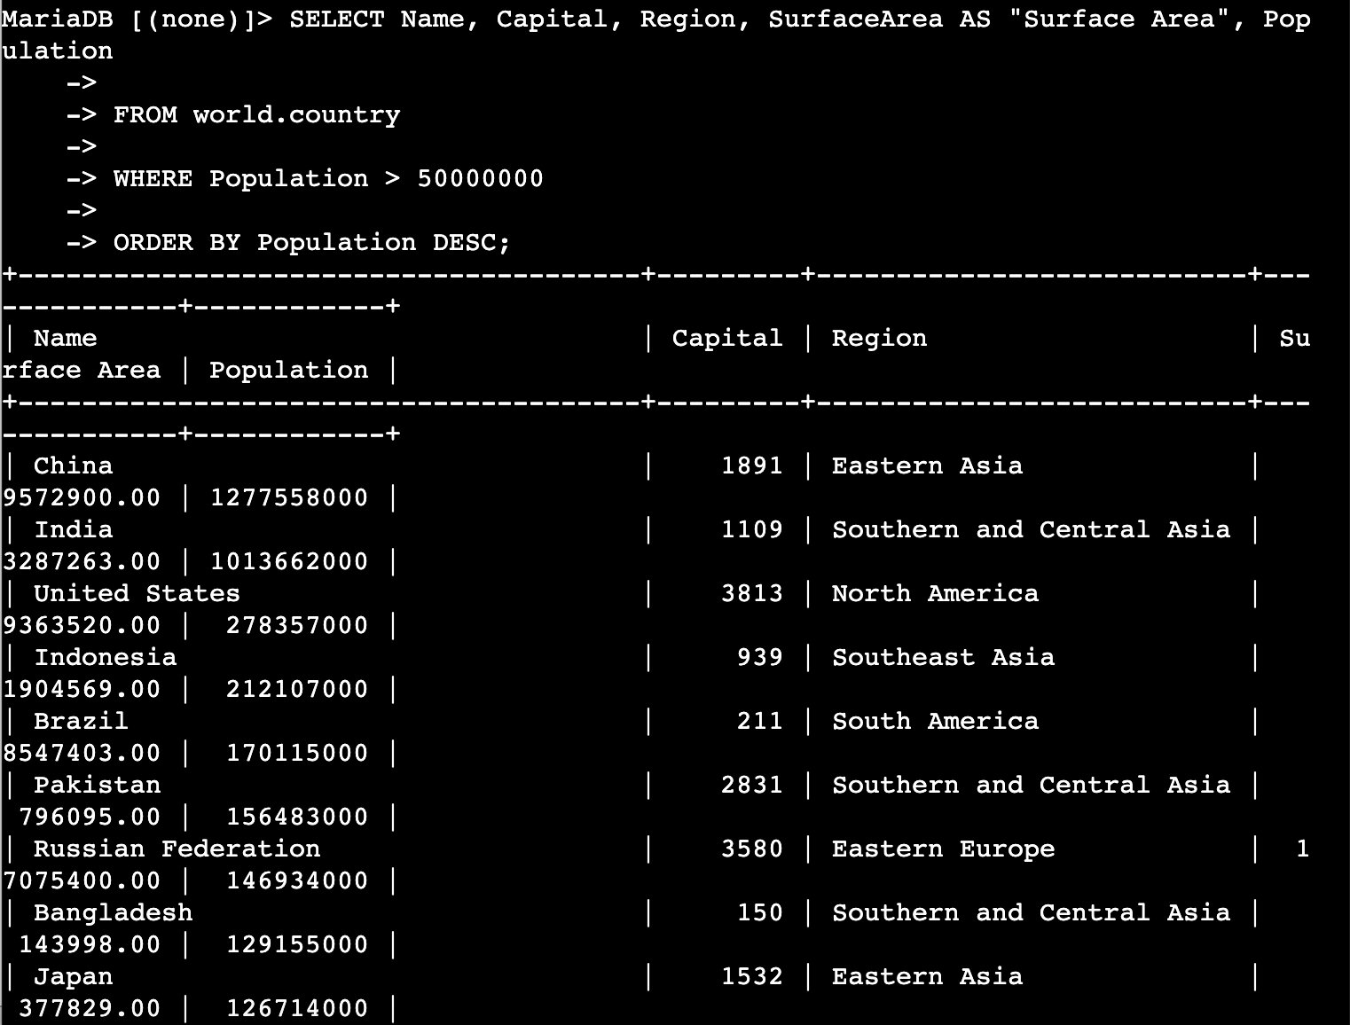
WHERE Population > 50000000 — filtered to ~25 countries, multi-line -> prompt visible, China at top

Step 2.10 — Combine Conditions with AND
The AND operator requires all conditions to be true simultaneously. This query returns countries in the 50–100 million population range.

SQL | SELECT Name, Capital, Region, SurfaceArea AS "Surface Area", Population  FROM world.country  WHERE Population > 50000000  AND Population < 100000000  ORDER BY Population DESC;

OUTPUT | (~12 rows — Mexico (98.8M), Germany (82.1M), Vietnam (79.8M), Philippines (75.9M),  Egypt (68.4M), Iran (67.7M), Turkey (66.5M), Ethiopia (62.5M), ...)

SCREENSHOT 12_where_population_range.png
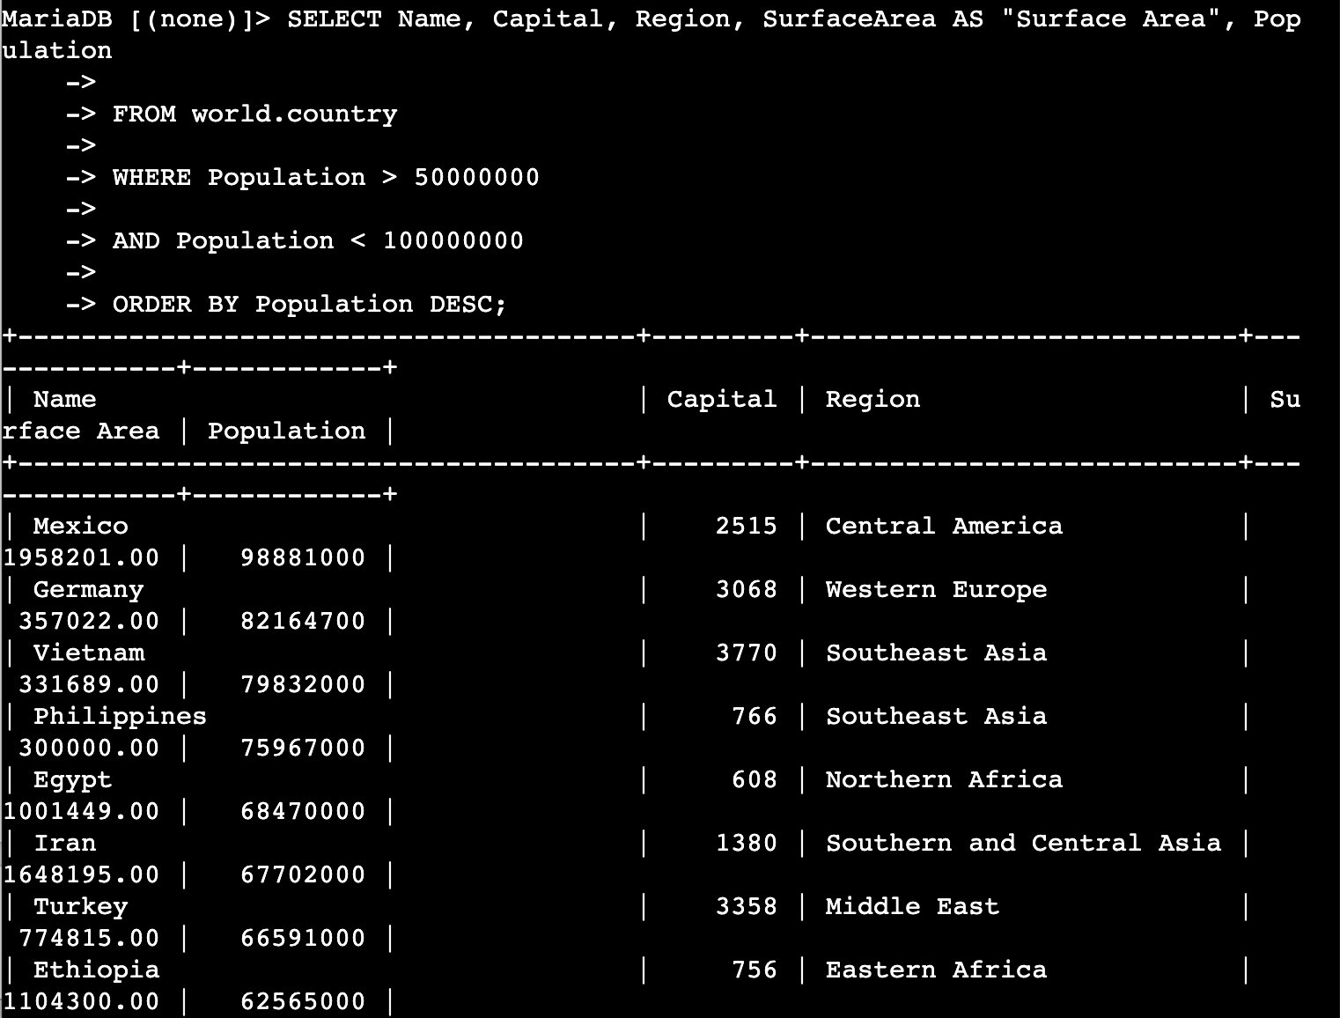
AND operator — population between 50M and 100M, Mexico at top (98.8M), multi-line -> prompt visible

Challenge: Which Country in Southern Europe Has Population > 50M?
Combine a numeric comparison with an exact string match on the Region column to answer the question.

TIP | The Region value must match exactly: "Southern Europe" — the string comparison is case-sensitive for values in MariaDB.

SQL | SELECT Name, Capital, Region, SurfaceArea AS "Surface Area", Population  FROM world.country  WHERE Population > 50000000  AND Region = "Southern Europe";

OUTPUT | +-------+---------+----------------+--------------+------------+  | Name | Capital | Region | Surface Area | Population |  +-------+---------+----------------+--------------+------------+  | Italy | 1464 | Southern Europe| 301316.00 | 57680000 |  +-------+---------+----------------+--------------+------------+  1 row in set (0.000 sec)

NOTE | Only Italy qualifies — population 57,680,000. Spain's population in this dataset (circa year 2000 data) falls below 50 million.

SCREENSHOT 13_challenge_southern_europe.png
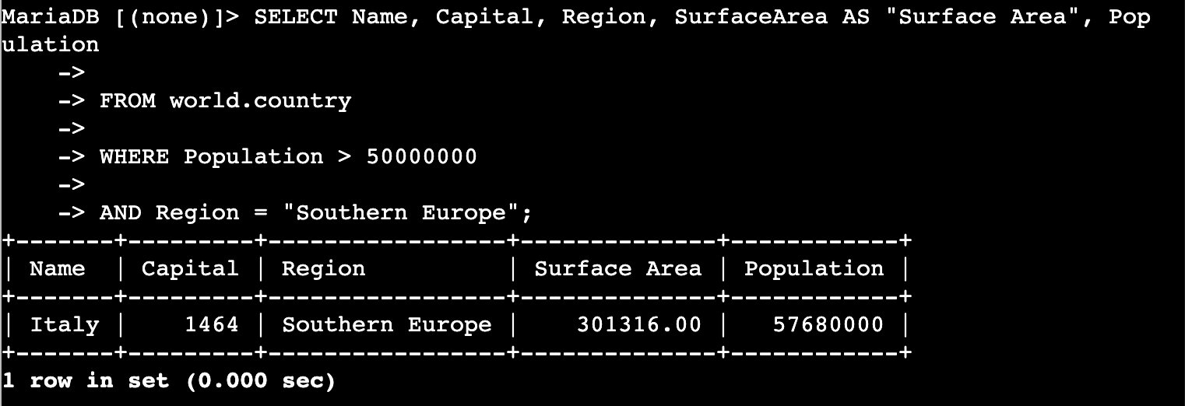
Challenge result — Italy (57,680,000) is the only Southern European country with population > 50 million in this dataset

Screenshot Reference Summary
Save all screenshots in: Desktop\AWS-reStart-Journey\Labs\Databases\lab-270-selecting-data-from-database\screenshots\

# | Filename | Task | What to Capture
01 | 01_session_manager_connected.png | Task 1.2–1.3 | Session Manager terminal, Instance ID visible, root prompt confirmed
02 | 02_mysql_connected.png | Task 1.4 | MariaDB 10.5.29 banner and MariaDB [(none)]> prompt
03 | 03_show_databases.png | Task 2.1 | SHOW DATABASES output with world visible
04 | 04_select_all_country.png | Task 2.2 | SELECT * FROM world.country result, top of output
05 | 05_count_country.png | Task 2.3 | COUNT(*) result showing 239
06 | 06_show_columns_country.png | Task 2.4 | SHOW COLUMNS listing all 15 field names
07 | 07_select_specific_columns.png | Task 2.5 | Five-column SELECT result
08 | 08_column_alias.png | Task 2.6 | Surface Area alias visible in column header
09 | 09_order_by_population_asc.png | Task 2.7 | Ascending sort — zero-population territories at top
10 | 10_order_by_population_desc.png | Task 2.8 | Descending sort — China (1.27B) at top
11 | 11_where_population_gt50m.png | Task 2.9 | WHERE Population > 50000000, ~25 rows
12 | 12_where_population_range.png | Task 2.10 | AND — population between 50M and 100M
13 | 13_challenge_southern_europe.png | Challenge | Italy as sole result for Southern Europe > 50M

Pushing to GitHub
Run these commands from your repo root. Make sure all screenshots are in the screenshots\ folder first.

GIT | git add .

GIT | git commit -m "Complete Lab270: SELECT queries and DB operators"

GIT | git push origin main

OUTPUT | Enumerating objects: ...  Counting objects: 100%  Writing objects: 100%  To https://github.com/<your-username>/<your-repo>.git  abc1234..def5678 main -> main

TIP | Verify screenshots are staged: git status  All files in screenshots\ should appear under 'Changes to be committed' after git add .  If your branch is called master: git push origin master

