AWS re/Start Programme
Lab 273 — Organizing Data
SQL GROUP BY and Window Functions (MariaDB 10.5.29)
Instance: i-0035167e4da9dfed8 (Command Host) | Connection ID: 5
Estimated Duration: 45 minutes

Before You Begin
WARNING | Curly quotes: Copying commands from Word or PDF can silently convert straight quotes (", ') into typographic/curly quotes. MariaDB will reject these with syntax or authentication errors. Always type quotes manually — especially the password 're:St@rt!9'.

WARNING | Pasting extra text: Never paste explanatory text along with a command. Only paste the command itself.

WARNING | Silent wait commands: Any command that blocks the terminal silently is normal — do not close the terminal.

NOTE | MariaDB continuation prompt: If you press Enter before closing a SQL statement with a semicolon (;), the prompt changes to '->'. MariaDB is waiting for more input. Type ; and press Enter to execute, or type '\c' and press Enter to cancel.

Resource Names Reference
Resource / Setting | Value
Database Engine | MariaDB 10.5.29-MariaDB
EC2 Instance | Command Host (i-0035167e4da9dfed8)
Connection ID | 5
Database Name | world
Tables | city, country, countrylanguage
DB User | root
DB Password | re:St@rt!9
Connection Method | AWS Systems Manager — Session Manager
Region Total (ANZ) | 22,753,100
Country Rows | 239
Local Repo Root | [USER WILL PROVIDE — e.g. ~/Desktop/AWS-reStart-Journey/Labs/Databases/lab-273-organizing-data]
Screenshots Folder | [USER WILL PROVIDE]/screenshots/
GitHub Repo | https://github.com/svitlana-dekhtiar/aws-restart-journey

Task 1: Connect to the Command Host
Navigate to EC2, select the Command Host instance, and open a Session Manager terminal. Switch to root and navigate to the ec2-user home directory, then connect to MariaDB.

Steps 5–9 — EC2 Console and Session Manager
In the AWS Management Console, choose Services → Compute → EC2. In the navigation pane choose Instances. Tick the Command Host checkbox, choose Connect, select the Session Manager tab, then choose Connect.

Steps 10–11 — Switch to Root
CMD | sudo su  cd /home/ec2-user/

Steps 12–14 — Connect to MariaDB
SQL | mysql -u root --password='re:St@rt!9'

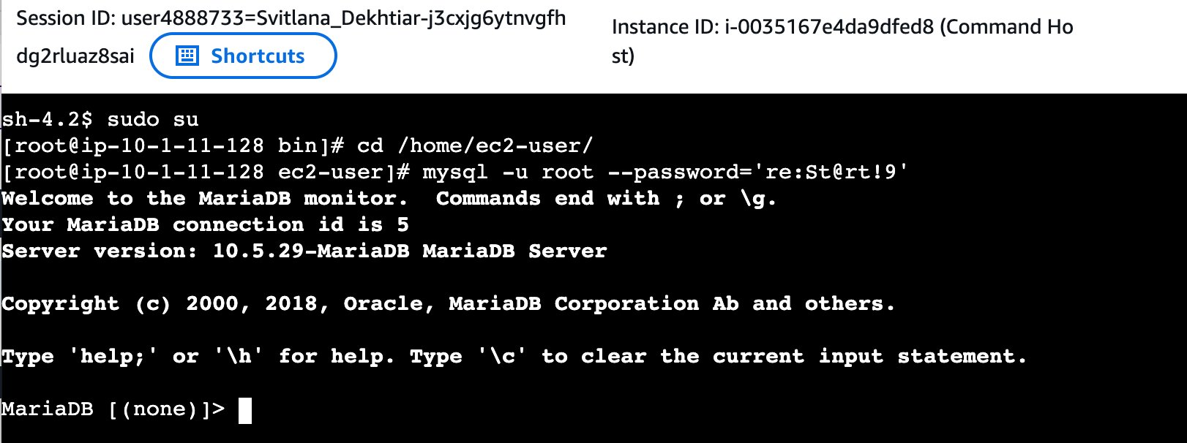

NOTE | Server version confirmed as 10.5.29-MariaDB. Instance ID i-0035167e4da9dfed8 is visible in the Session Manager header. Connection ID is 5.

Task 2: Query the world Database
Run a sequence of SELECT statements against world.country, progressing from basic filtering through GROUP BY aggregation to window functions with OVER(), SUM(), and RANK().

Step 12 — Show Available Databases
SQL | SHOW DATABASES;
OUTPUT | 4 rows in set (0.001 sec)  information_schema | mysql | performance_schema | world

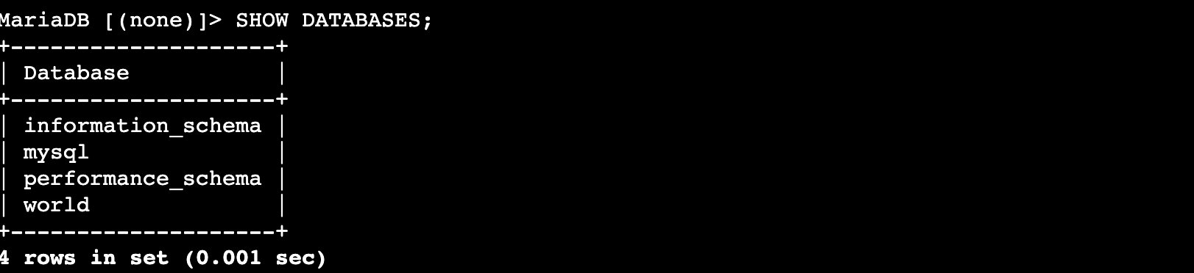

Steps 13–14 — Review the country Table
SQL | SELECT * FROM world.country;
OUTPUT | 239 rows in set (0.002 sec)

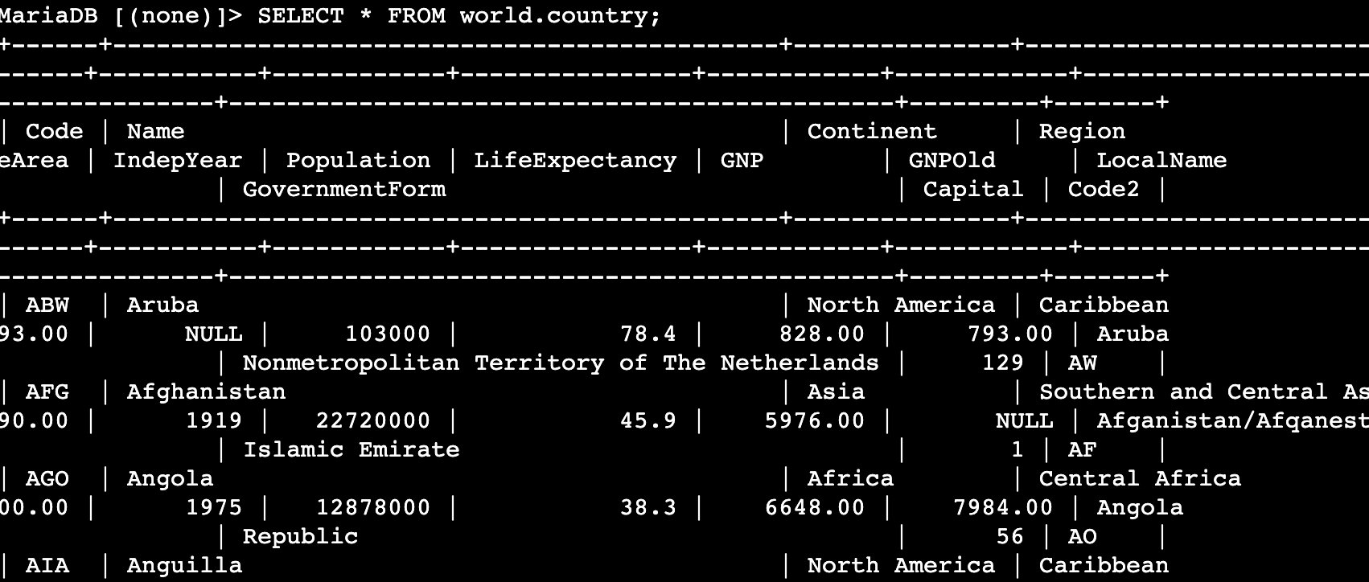

NOTE | The country table contains 15+ columns including Code, Name, Continent, Region, SurfaceArea, IndepYear, Population, LifeExpectancy, GNP, GNPOld, LocalName, GovernmentForm, HeadOfState, Capital, and Code2. The columns used in this lab are Name, Region, and Population.

Steps 15–16 — Filter and Order by Region
SQL | SELECT Region, Name, Population FROM world.country  WHERE Region = 'Australia and New Zealand'  ORDER By Population desc;
OUTPUT | 5 rows in set (0.000 sec)  Australia: 18,886,000 | New Zealand: 3,862,000  Christmas Island: 2,500 | Norfolk Island: 2,000 | Cocos (Keeling) Islands: 600

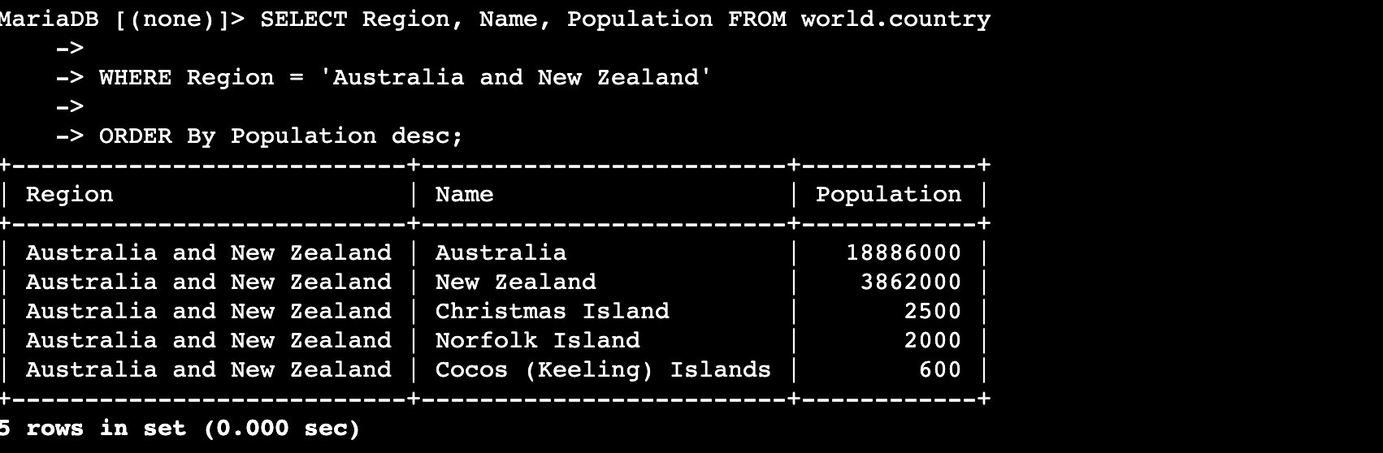

TIP | ORDER BY Population desc sorts from largest to smallest. This region contains 5 countries/territories, not 6 as some older dataset versions show. Australia's population is 18,886,000 in this dataset.

Steps 17–20 — GROUP BY with SUM()
GROUP BY collapses all rows sharing the same Region value into a single result row. SUM() aggregates the Population values across those rows.

SQL | SELECT Region, SUM(Population)  FROM world.country  WHERE Region = 'Australia and New Zealand'  GROUP By Region  ORDER By SUM(Population) desc;
OUTPUT | Australia and New Zealand | 22,753,100  1 row in set (0.002 sec)

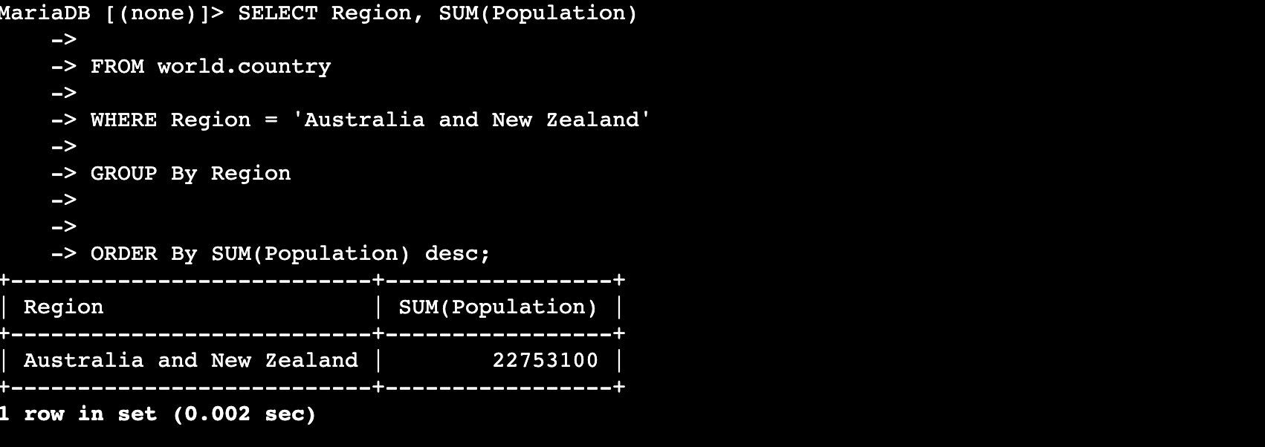

NOTE | The total population for the Australia and New Zealand region is 22,753,100 — the sum of all 5 countries/territories in the filtered result set.

Steps 21–23 — OVER() Clause with SUM() — Running Total
A window function keeps every row and computes an aggregate across a sliding window. PARTITION BY Region resets the running total per region. ORDER BY Population inside OVER() controls the accumulation sequence.

SQL | SELECT Region, Name, Population,  SUM(Population) OVER(partition by Region ORDER BY Population) as 'Running Total'  FROM world.country  WHERE Region = 'Australia and New Zealand';
OUTPUT | Cocos (Keeling) Islands: 600 | Running Total: 600  Norfolk Island: 2000 | Running Total: 2600  Christmas Island: 2500 | Running Total: 5100  New Zealand: 3862000 | Running Total: 3867100  Australia: 18886000 | Running Total: 22753100  5 rows in set (0.001 sec)

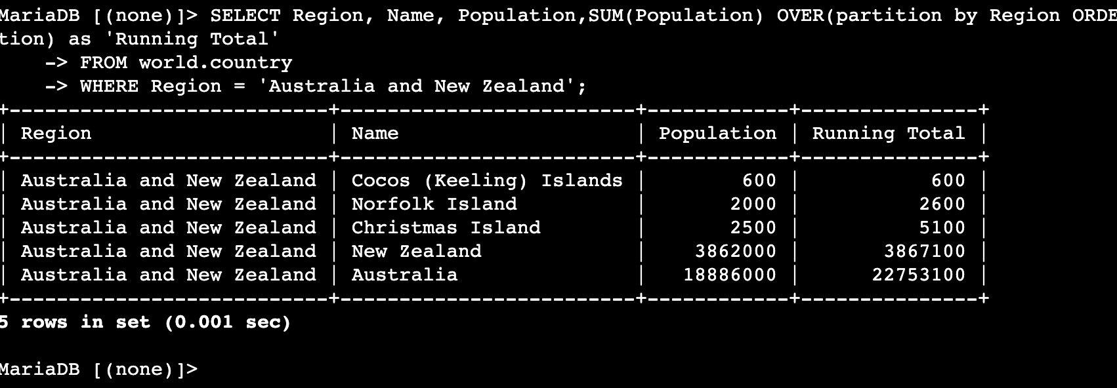

NOTE | Unlike GROUP BY, OVER() preserves all individual rows. The final running total (22,753,100) matches the GROUP BY + SUM() result — both are summing the same data, just presented differently.

Steps 24–25 — OVER() with SUM() and RANK()
RANK() assigns a position number to each row within a partition based on the ORDER BY expression. Combined with SUM() OVER(), both the running total and rank appear as columns alongside each row.

SQL | SELECT Region, Name, Population,  SUM(Population) OVER(partition by Region ORDER BY Population) as 'Running Total',  RANK() over(partition by region ORDER BY population) as 'Ranked'  FROM world.country  WHERE region = 'Australia and New Zealand';
OUTPUT | Cocos (Keeling) Islands: 600 | Running Total: 600 | Ranked: 1  Norfolk Island: 2000 | Running Total: 2600 | Ranked: 2  Christmas Island: 2500 | Running Total: 5100 | Ranked: 3  New Zealand: 3862000 | Running Total: 3867100 | Ranked: 4  Australia: 18886000 | Running Total:22753100 | Ranked: 5  5 rows in set (0.001 sec)

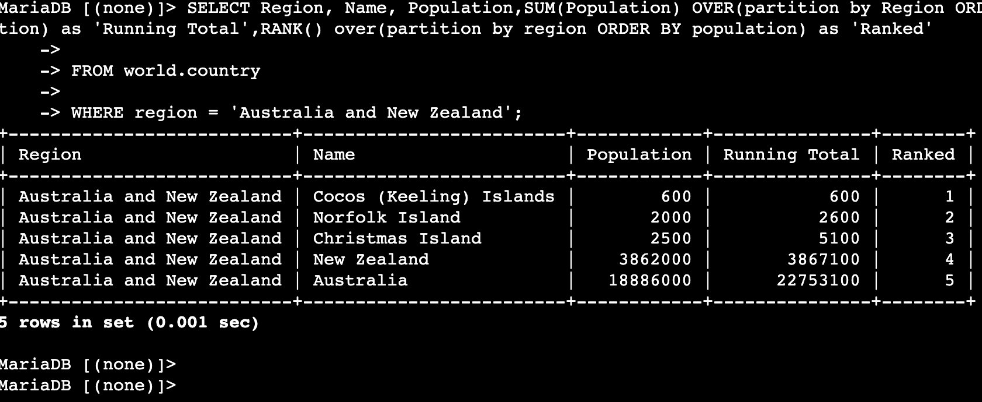

Challenge: Rank Countries by Population in Every Region
Write a query that ranks every country in the world database by population within each region, from largest to smallest.

TIP | Use RANK() OVER(partition by Region ORDER BY Population desc) to rank within each region in descending order. Cover all rows in world.country — no WHERE clause.

SQL | SELECT Region, Name, Population,  RANK() OVER(partition by Region ORDER BY Population desc) as 'Ranked'  FROM world.country  ORDER BY Region, Ranked;
OUTPUT | Antarctica: French Southern territories, Bouvet Island, South Georgia... all Population 0, all Ranked 1  Australia and New Zealand: Australia 18886000 Ranked 1, New Zealand 3862000 Ranked 2...  (239 rows total)

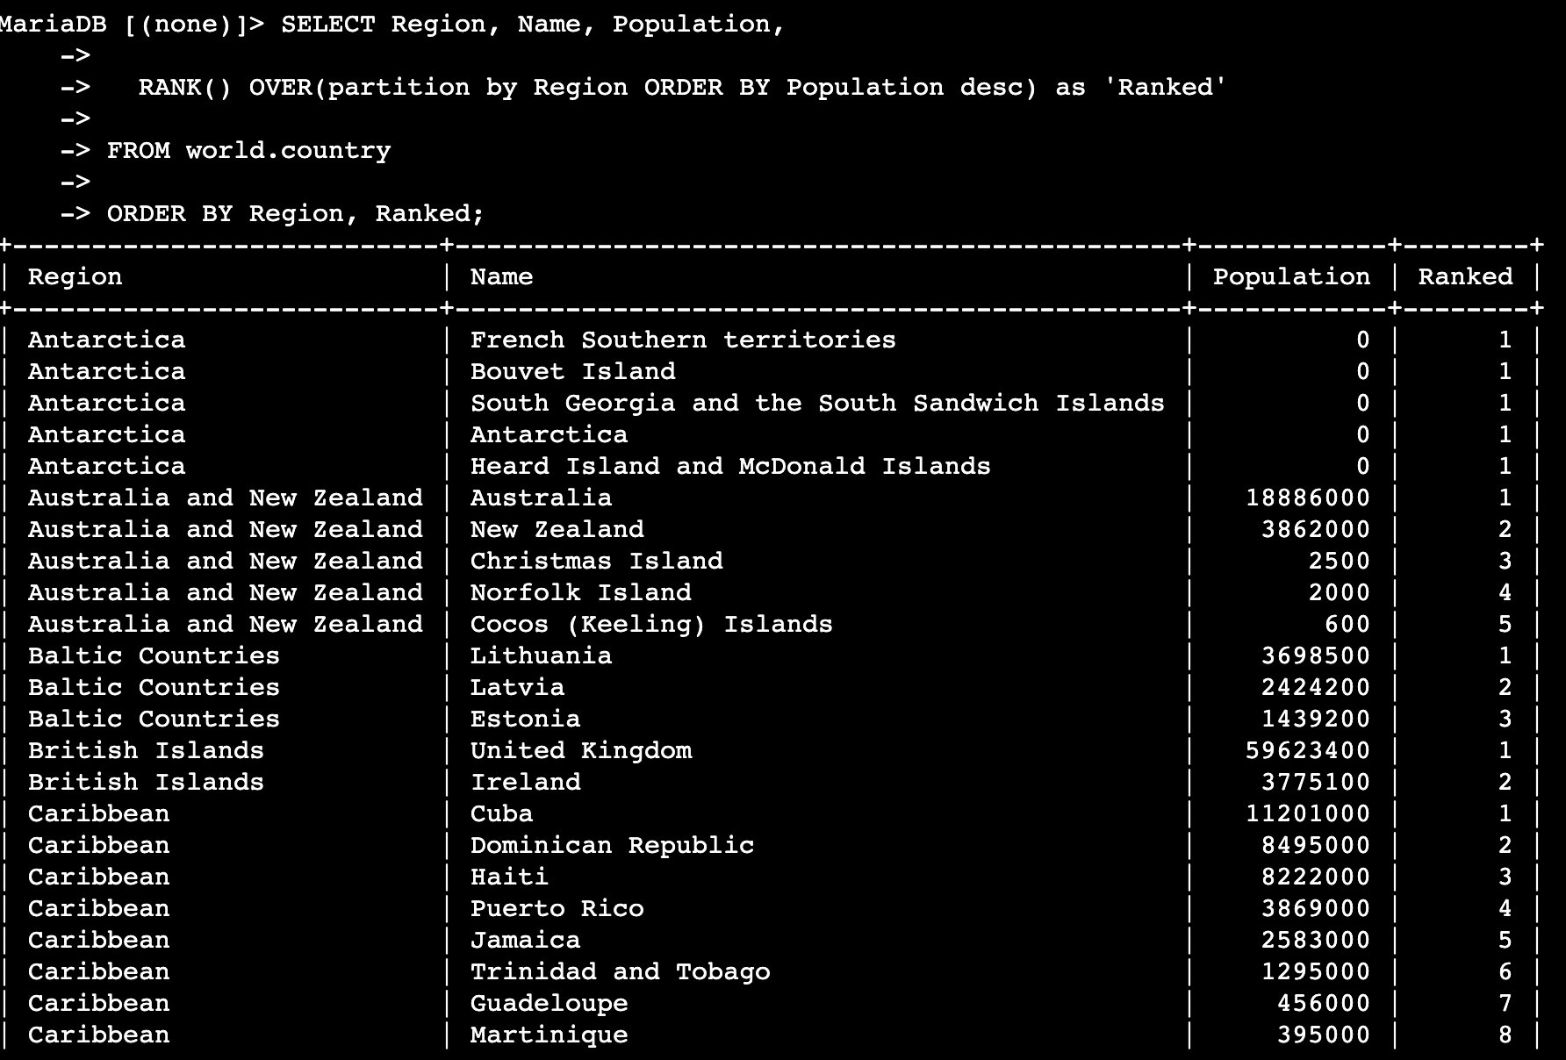

NOTE | Antarctica territories all have Population 0, so they all tie at Ranked 1. This demonstrates how RANK() handles ties — equal values receive the same rank. The 'Australia and New Zealand' block shows Australia at Rank 1 with 18,886,000.

Git — Stage, Commit, and Push
Run from your local repo root in Mac Terminal (not Session Manager).

GIT | git add README.md commands.sh lab-273-organizing-data.docx screenshots/

GIT | git commit -m "Add Lab 273 — Organizing Data (GROUP BY, OVER, RANK)"

GIT | git push origin main

Screenshot Reference Summary
Screenshots folder: [USER WILL PROVIDE]/screenshots/

# | Filename | Task | What Was Captured
1 | 01_mariadb_connected.png | Task 1 | MariaDB 10.5.29 banner, connection ID 5, prompt
2 | 02_show_databases_.png | Task 2 | SHOW DATABASES — world database confirmed
3 | 03_select_all_country.png | Task 2 | SELECT * FROM world.country — 239 rows
4 | 04_filter_order_region.png | Task 2 | WHERE Region filter + ORDER BY Population desc — 5 rows
5 | 05_group_by_sum.png | Task 2 | GROUP BY Region — SUM = 22,753,100
6 | 06_over_running_total.png | Task 2 | SUM() OVER() running total — 5 rows
7 | 07_rank_running_total.png | Task 2 | RANK() + SUM() OVER() — Ranked column added
8 | 08_challenge_rank_all_regions.png | Challenge | All 239 countries ranked within each region

