Lab 266 — Troubleshooting a Network Issue
AWS re/Start Programme
Duration: 1 hour | Region: us-west-2 | SSH via PEM key + public IP

Before You Begin
WARNING: Curly quotes: copying commands from Word or PDF may convert straight quotes to curly variants. Always retype quotes manually in the terminal.

WARNING: Pasting extra text: paste only the command itself — never include surrounding text, labels, or line numbers.

WARNING: Silent wait commands: aws ec2 wait and similar commands block silently without output. Do not close the terminal until the prompt returns.

WARNING: SSH key permissions: if you receive a 'WARNING: UNPROTECTED PRIVATE KEY FILE' error, run chmod 400 labsuser.pem before retrying the SSH command.

Resource Names
EC2 Public IP | 44.255.199.108
EC2 Private IP | 10.0.10.67 (ip-10-0-10-67)
PEM key file | labsuser.pem
Key location | ~/Downloads/labsuser.pem
VPC ID | vpc-0f65dbf6f3032d666 (Lab VPC)
VPC CIDR | 10.0.0.0/16
Subnet | subnet-0d976ded0592600c5 (Public Subnet 1, 10.0.10.0/24)
Route Table | rtb-0c2b3f92bddbc2122 (Public Route Table)
Internet GW | igw-00c6a8b0e8c379dfa
Security Group | sg-0d09265853b002a60
Region | us-west-2
Local Repo | ~/Desktop/AWS-reStart-Journey/Labs/Networking/lab-266-troubleshooting-network
Screenshots | ~/Desktop/AWS-reStart-Journey/Labs/Networking/lab-266-troubleshooting-network/screenshots/
GitHub Repo | https://github.com/svitlana-dekhtiar/aws-restart-journey

Task 1: Use SSH to Connect to an Amazon Linux EC2 Instance
From the Vocareum Details panel → Show, download the PEM key and note the PublicIP address.

Change to the downloads directory:
CMD | cd ~/Downloads

Set read-only permissions on the key:
CMD | chmod 400 labsuser.pem

Connect via SSH:
CMD | ssh -i labsuser.pem ec2-user@44.255.199.108
NOTE: Type yes when prompted about host authenticity. No password is required — authentication uses the key pair.

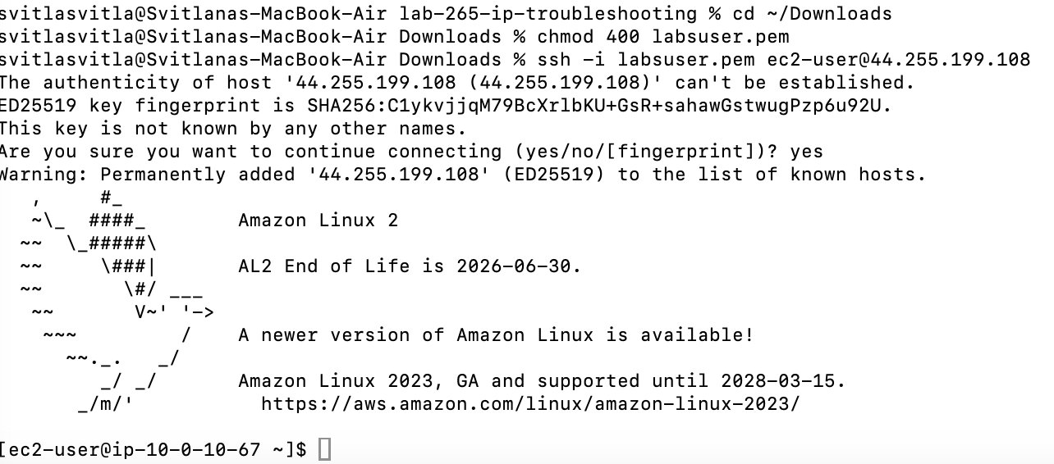
01_task1_ssh_connected.png — Successful SSH connection to EC2 instance (Amazon Linux 2, ip-10-0-10-67)

Task 2: Install httpd
Check the current status of the httpd service:
CMD | sudo systemctl status httpd.service
NOTE: Expected output shows Active: inactive (dead) — the service has not yet been started.

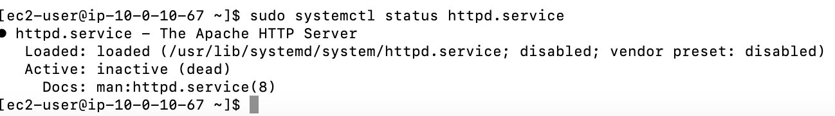
02_task2_httpd_inactive.png — httpd service inactive (dead) before start

Start the httpd service:
CMD | sudo systemctl start httpd.service

Verify the service is now active:
CMD | sudo systemctl status httpd.service

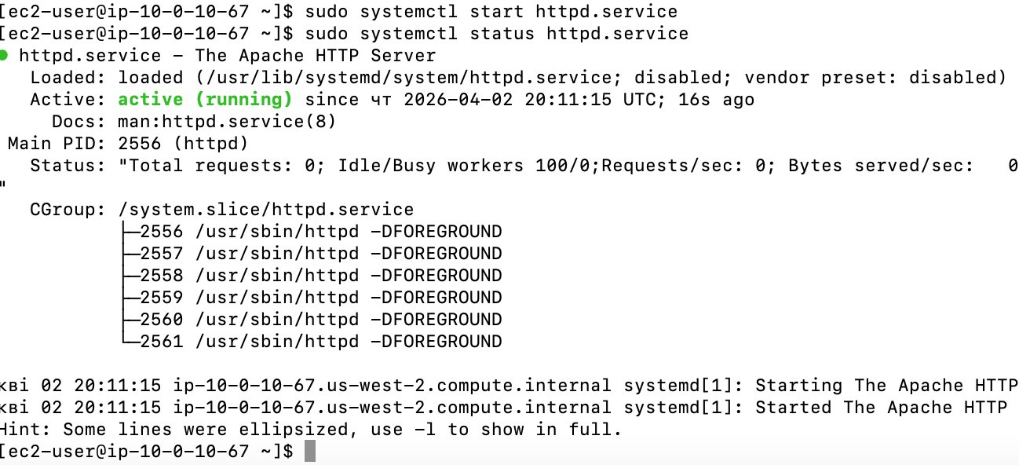
03_task2_httpd_active.png — httpd service active (running) after start

Attempt to load Apache in a browser tab:
CMD | http://44.255.199.108
NOTE: The page will not load at this stage — ERR_CONNECTION_TIMED_OUT is expected. This confirms the customer's reported issue before VPC investigation begins.

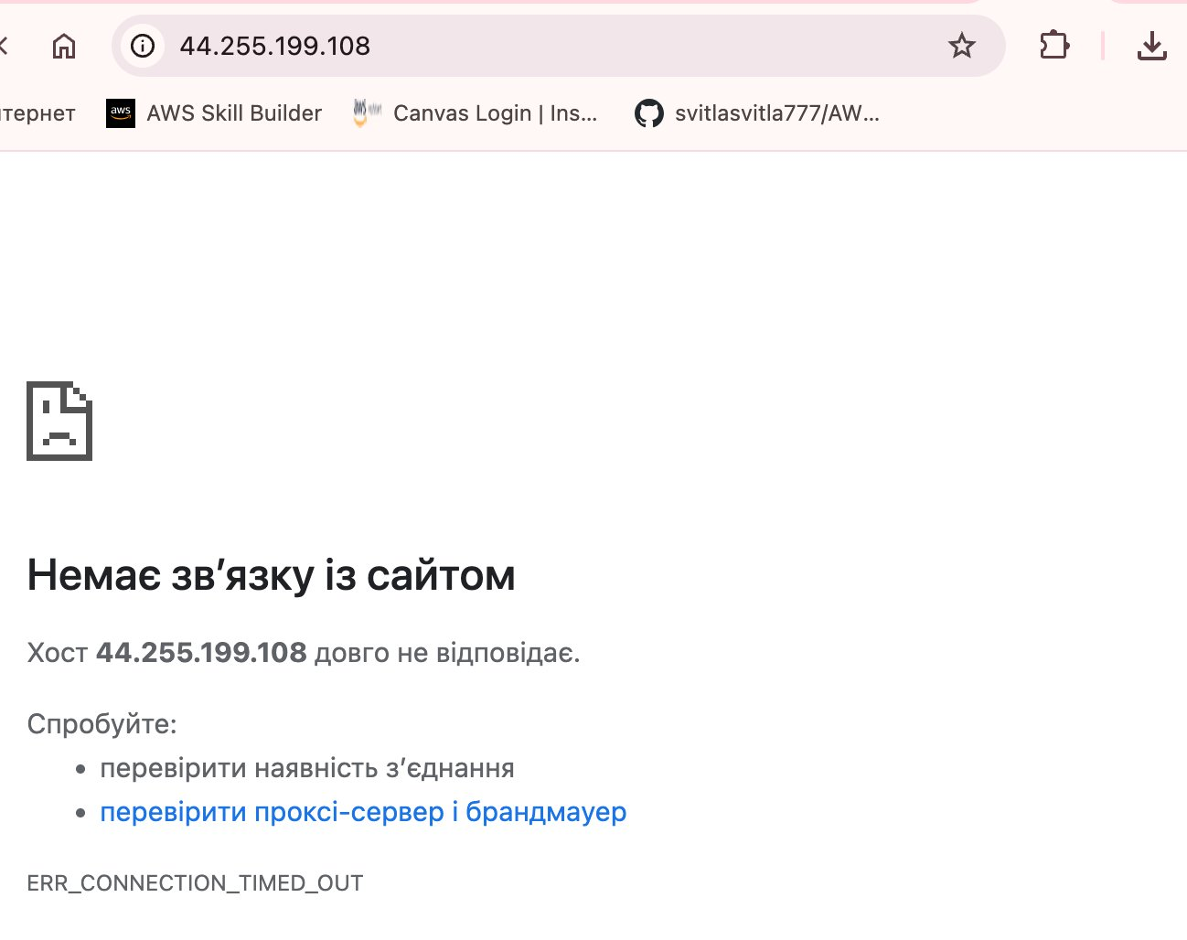
04_task2_browser_timeout.png — Browser shows ERR_CONNECTION_TIMED_OUT for 44.255.199.108

Task 3: Investigate the Customer's VPC Configuration
Navigate to Services → Networking & Content Delivery → VPC.

Step 1 — VPC details: confirm VPC vpc-0f65dbf6f3032d666 (Lab VPC) is Available.
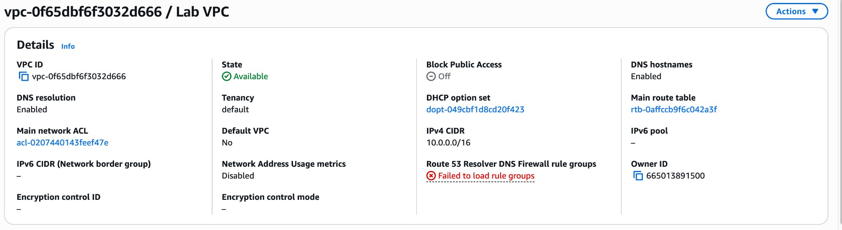
05_task3_lab_vpc.png — Lab VPC details: vpc-0f65dbf6f3032d666, CIDR 10.0.0.0/16, state Available

Step 2 — Resource map: review the full topology. VPC → Public Subnet 1 → Public Route Table → igw-00c6a8b0e8c379dfa.
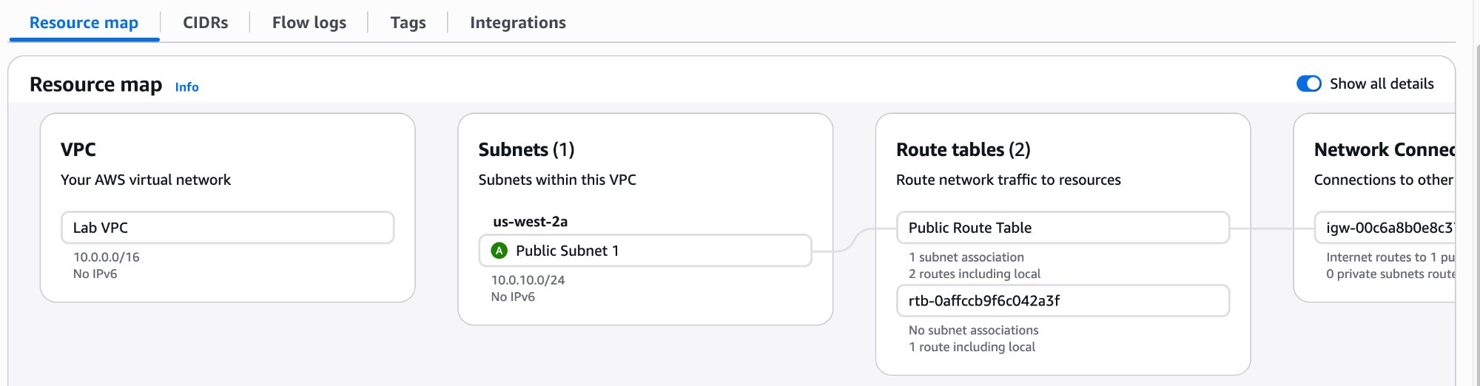
06_task3_lab_vpc_resource_map.png — VPC resource map showing subnet, route tables, and IGW

Step 3 — Subnet: confirm subnet-0d976ded0592600c5 (Public Subnet 1) is associated to the Public Route Table.
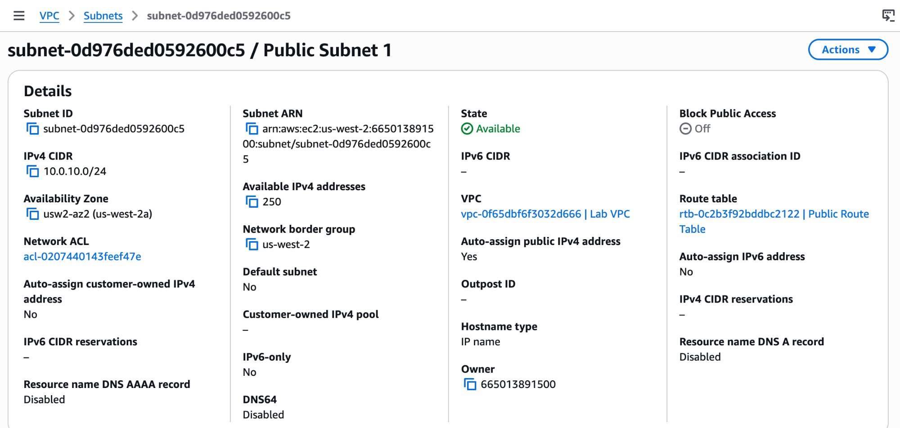
07_task3_public_subnet.png — Public Subnet 1 details: 10.0.10.0/24, us-west-2a, route table rtb-0c2b3f92bddbc2122

Step 4 — Route Table: confirm rtb-0c2b3f92bddbc2122 has a route 0.0.0.0/0 → igw-00c6a8b0e8c379dfa.
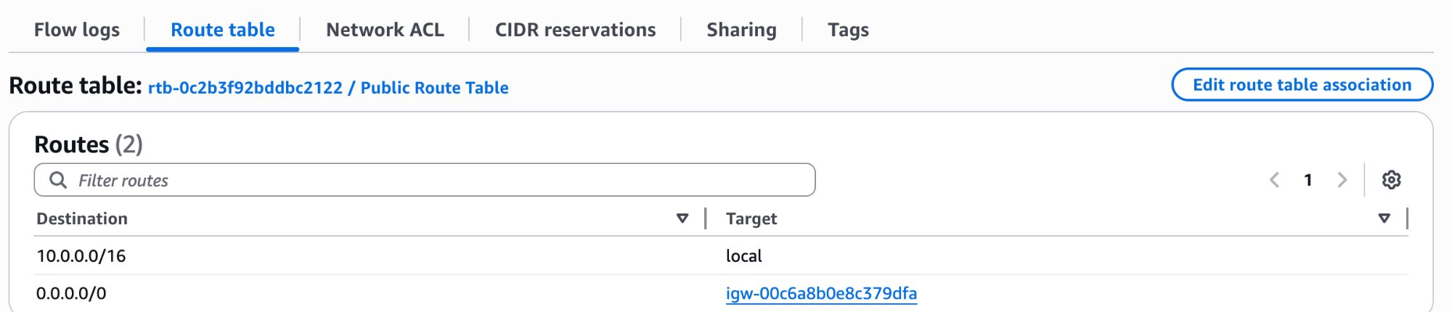
08_task3_route_table.png — Public Route Table: 0.0.0.0/0 → igw-00c6a8b0e8c379dfa confirmed

Step 5 — Internet Gateway: confirm igw-00c6a8b0e8c379dfa state is Attached to vpc-0f65dbf6f3032d666.
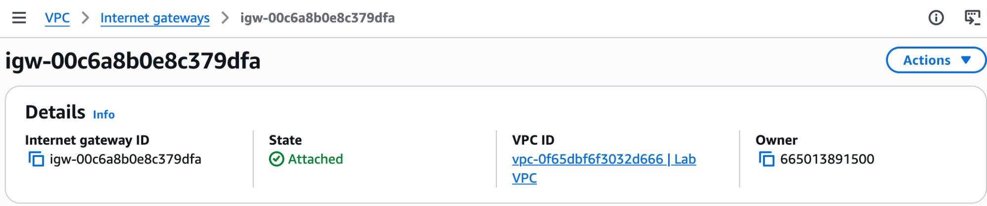
09_task3_igw_attached_to_vpc.png — Internet Gateway igw-00c6a8b0e8c379dfa, state: Attached to Lab VPC

Step 6 — Security Group details: open sg-0d09265853b002a60. Inbound rules count shows 1 Permission entry (SSH only — HTTP is missing).
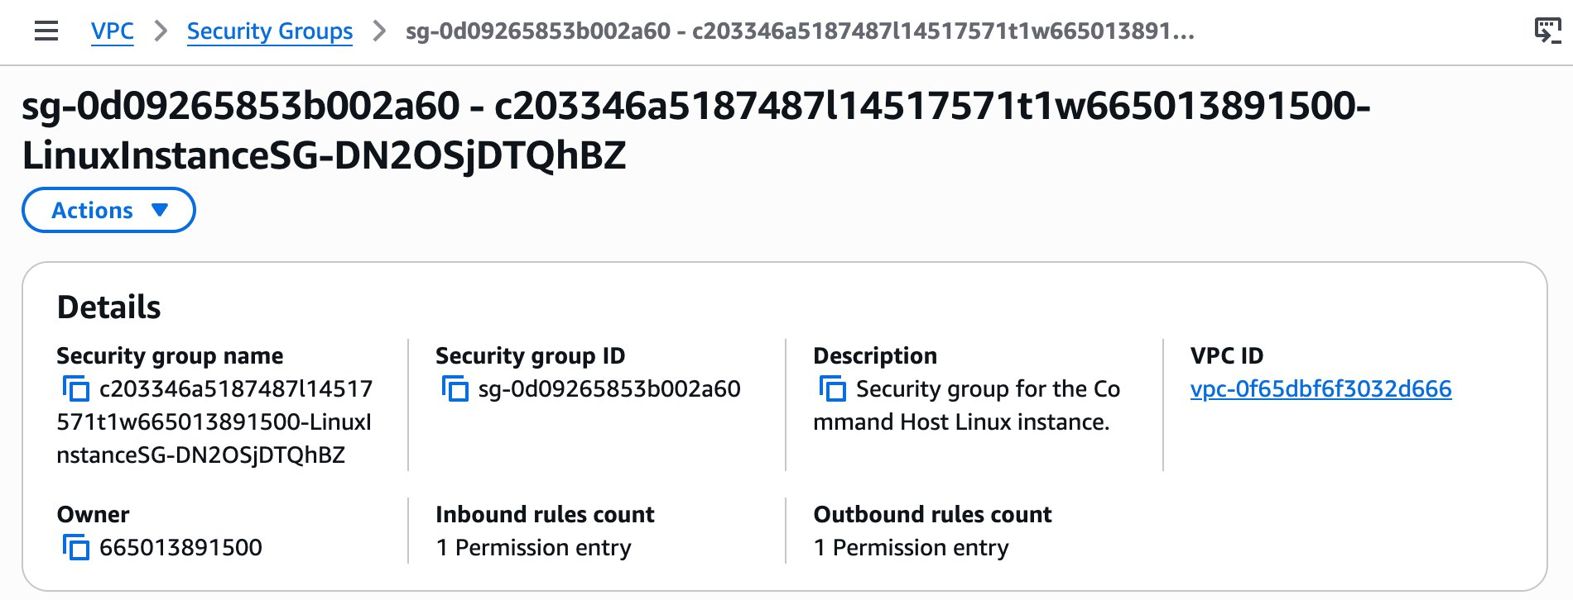
10_task3_security_group.png — Security group sg-0d09265853b002a60: only 1 inbound rule (SSH), HTTP rule absent

Step 7 — Inbound rules — root cause identified: only SSH (port 22) is present. No rule for HTTP (port 80).
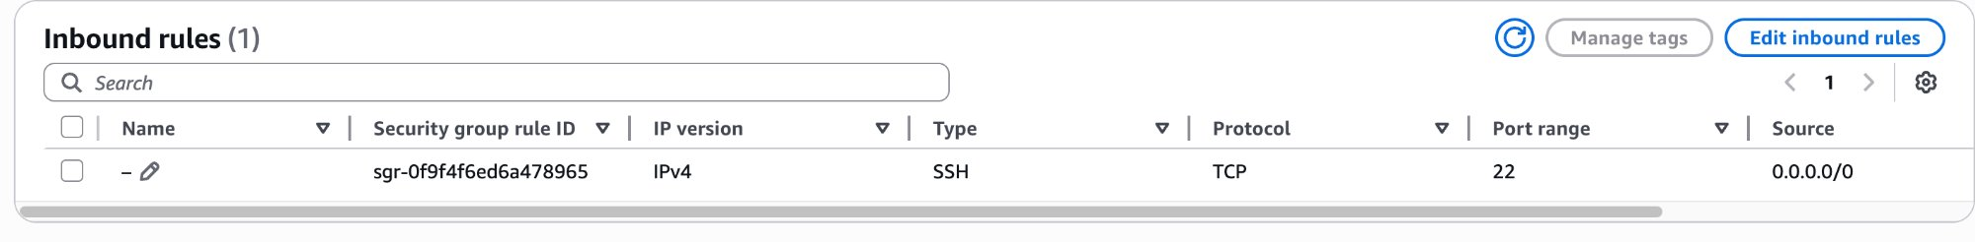
11_task3_security_group_inbound.png — Inbound rules: SSH port 22 only — no HTTP rule on port 80

IMPORTANT: Root cause confirmed: the security group has no inbound rule permitting HTTP traffic on port 80. Routing and IGW are correct — only the security group blocks the connection.

Click Edit inbound rules → Add rule:
Type: HTTP | Protocol: TCP | Port range: 80 | Source: 0.0.0.0/0
Click Save rules.

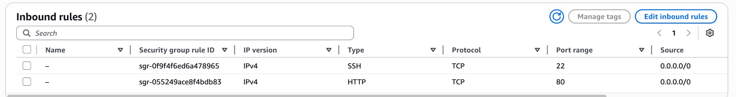
12_task3_sg_inbound_fixed.png — Inbound rules after fix: SSH (22) + HTTP (80) from 0.0.0.0/0

Reload http://44.255.199.108 in the browser — Apache test page loads.
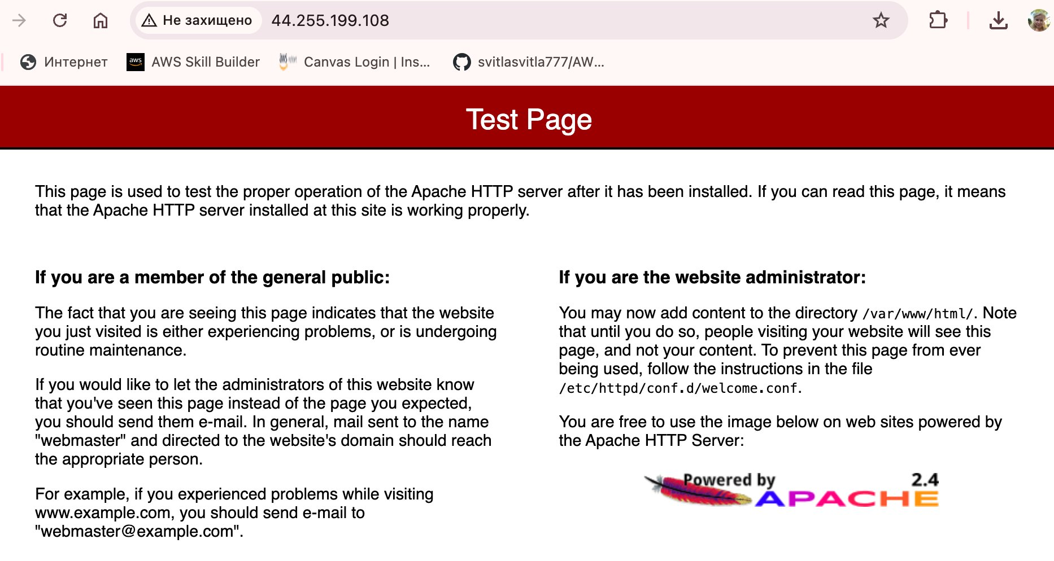
13_task3_apache_working.png — Apache HTTP Server Test Page loading successfully at 44.255.199.108

Git Commands
GIT | cd ~/Desktop/AWS-reStart-Journey

GIT | git pull origin main --no-rebase

GIT | git add Labs/Networking/lab-266-troubleshooting-network/

GIT | git commit -m "Add Lab 266 – Troubleshooting a Network Issue"

GIT | git push origin main

