**Stock Price Prediction using lasso regression algorithm**

**TABLE OF CONTENTS**

|  |  |  |
| --- | --- | --- |
| **CHAPTER** | **TITLE** | **PAGE NO** |
|  | **ABSTRACT** |  |
|  | **INTRODUCTION** |  |
|  | * 1. General Introduction |  |
|  | * 1. Project Objectives |  |
|  | * 1. Problem Statement |  |
|  | **SYSTEM** **PROPOSAL** |  |
|  | * 1. Existing System |  |
|  | * + 1. Disadvantages |  |
|  | * 1. Proposed System |  |
|  | 2.2.1 Advantages |  |
|  | * 1. Literature Survey |  |
|  | **SYSTEM DIAGRAMS** |  |
|  | * 1. Architecture Diagram |  |
|  | * 1. Flow Diagram |  |
|  | * 1. UML Diagrams |  |
|  | **IMPLEMENTATION** |  |
|  | * 1. Modules |  |
|  | * 1. Modules Description |  |
|  | **SYSTEM** **REQUIREMENTS** |  |
|  | * 1. Hardware Requirements |  |
|  | * 1. Software Requirements |  |
|  | * 1. Software Description |  |
|  | * 1. Testing of Products |  |
|  | **CONCLUSION** |  |
| **7.** | **FUTURE** **ENHANCEMENT** |  |
| **8.** | **SAMPLE** **CODING** |  |
| **9.** | **SAMPLE** **SCREENSHOT** |  |
| **10.** | **REFERENCES** |  |

**ABSTRACT**

Accurate prediction of stock market returns is a very challenging task due to volatile and non-linear nature of the financial stock markets. With the introduction of artificial intelligence and increased computational capabilities, programmed methods of prediction have proved to be more efficient in predicting stock prices. The financial data: Open, High, Low and Close prices of stock are used for creating new variables which are used as inputs to the model. The models are evaluated using standard strategic indicators: RMSE and MAPE. The low values of these two indicators show that the models are efficient in predicting stock closing price. The Stock Market prediction task is interesting as well as divides researchers and academics into two groups those who believe that we can devise mechanisms to predict the market and those who believe that the market is efficient and whenever new information comes up the market absorbs it by correcting itself, thus there is no space for prediction. The artificial intelligence and increased computational capabilities, programmed methods of prediction have proved to be more efficient in predicting stock prices. In existing system, Artificial Neural Network and Random Forest techniques have been utilized for predicting the next day closing price.in this system, it doesn’t efficient for large number of dataset. The predictive result is low. In our process, we have to take the input from the input dataset. The input dataset is time series dataset. It contains the open, high, low and close price. After that we have to implement the regression algorithms. The regression such as Support Vector regression and lasso regression. The final result, we have to find the error values. In time series dataset, we should find error values. Next, we have to visualize the data.

**CHAPTER 1**

**INTRODUCTION**

* 1. **General Introduction:**

The macroeconomic environment and the financial market are complex, evolutionary, and non-linear dynamical systems. The field of financial forecasting is characterized by data intensity, noise, non-stationary, unstructured nature, and hidden relationships. Predicting financial indicators is therefore a difficult task. However, forecasting is important in the sense that it provides concrete data for investment decisions. How can we predict whether the price of a particular stock will go up or down in the upcoming year? In the modern techniques, one way is to develop a predictor based on the information in the historical data.

First of all, we should selected some major factors that may influence the performance of the stocks, we can further discover an interesting model from our dataset to predict the future performance of any stocks. That is to say, we need to learn a model that can map those factors into the class attribute which indicates the whole performance of stocks.

Support vector machine (SVM) is a machine learning technique that can be used for this purpose of classification. Established on the unique theory of the structural risk minimization principle to estimate a function by minimizing an upper bound of the generalization error, SVM is shown to be very resistant to the over-fitting problem, eventually achieving a high generalization performance.

Another key property of SVM is that training SVM is equivalent to solving a linearly constrained quadratic programming problem so that the solution of SVM is always unique and globally optimal, unlike neural networks training, which requires nonlinear optimization with the danger of getting stuck at local minima.

Stock market is characterized as dynamic, unpredictable and non-linear in nature. Predicting stock prices is a challenging task as it depends on various factors including but not limited to political conditions, global economy, company’s financial reports and performance etc. Thus, to maximize the profit and minimize the losses, techniques to predict values of the stock in advance by analysing the trend over the last few years, could prove to be highly useful for making stock market movements.

Traditionally, two main approaches have been proposed for predicting the stock price of an organization. Technical analysis method uses historical price of stocks like closing and opening price, volume traded, adjacent close values etc. of the stock for predicting the future price of the stock. The second type of analysis is qualitative, which is performed on the basis of external factors like company profile, market situation, political and economic factors, and textual information in the form of financial new articles, social media and even blogs by economic analyst

Now a days, advanced intelligent techniques based on either technical or fundamental analysis are used for predicting stock prices. Particularly, for stock market analysis, the data size is huge and also non-linear. To deal with this variety of data efficient model is needed that can identify the hidden patterns and complex relations in this large data set. Machine learning techniques in this area have proved to improve efficiencies by 60-86 percent as compared to the past methods.

* 1. **Objectives:**

The main objective of our project is,

* To predict or to forecast the stock price effectively.
* To implement the different machine learning algorithms for better performance.
* To enhance the overall performance for classification algorithms.

**CHAPTER 2**

**SYSTEM PROPOSAL**

* 1. **EXISTING SYSTEM:**

In existing system, accurate prediction of a stock price is a challenging task due to the complexity, chaos, and non-linearity nature of financial systems. In this brief, we proposed a multi-indicator feature selection method for stock price prediction based on Pearson Correlation coefficient (PCC) and Broad Learning System (BLS), Named the PCC-BLS framework. Firstly, PCC was used to select the input features from 35 features, including original stock price, technical indicators, and financial indicators. Secondly, these screened input features were used for rapid information feature extraction and training a BLS. The financial data: Open, High, Low and Close prices of stock are used for creating new variables which are used as inputs to the model. The models are evaluated using standard strategic indicators: RMSE and MAPE. The low values of these two indicators show that the models are efficient in predicting stock closing price.

**2.1.1 DISADVANTAGES:**

* The results is low when compared with proposed
* It doesn’t efficient for large volume of data’s
* Theoretical limits.
  1. **PROPOSED SYSTEM:**

In this system, the stock price dataset was taken as input from the dataset repository. Then, we have to implement the data pre-processing step. In this step, we have to handle the missing values for avoid wrong prediction. After that, we have to implement the feature selection for selecting the best features from our dataset by using Pearson coefficient. Then, we have to split the data into test and train. In this step, test is used for predict the model and train is used for evaluate the model.we have to implement the machine learning regression algorithms such as support vector regression and linear regression .Finally, the experimental results shows that the performance metrics such as MAE, MSE, RMSE and predict or forecast the stock price based on input attributes.

**2.2.1 ADVANTAGES:**

* It is efficient for large number of datasets.
* The experimental result is high when compared with existing system.
* The prediction is efficient
* The process is implemented with removing unwanted data.

**2.3 LITERATURE SURVEY:**

# **2.3.1Stock Closing Price Prediction using Machine Learning Techniques, 2020**

# **Author*:*** Mehar Vijha , Deeksha Chandolab, Vinay Anand Tikkiwalb, Arun Kumarc**Methodology:**

Accurate prediction of stock market returns is a very challenging task due to volatile and non-linear nature of the financial stock markets. With the introduction of artificial intelligence and increased computational capabilities, programmed methods of prediction have proved to be more efficient in predicting stock prices. In this work, Artificial Neural Network and Random Forest techniques have been utilized for predicting the next day closing price for five companies belonging to different sectors of operation. The financial data: Open, High, Low and Close prices of stock are used for creating new variables which are used as inputs to the model. The models are evaluated using standard strategic indicators: RMSE and MAPE. The low values of these two indicators show that the models are efficient in predicting stock closing price

**Advantage*:***

* It prove to be highly useful for making stock market movements
* To obtain higher accuracy in the predicted price value.

**Disadvantages:**

* The noise in stock market data is usually quite high
* Complexity is high

# **2.3.2Computational Intelligence Techniques Used for Stock Market Prediction: A Systematic Review, 2020**

# **Author:** S. Zavadzki; M. Kleina; F. Drozda; M. Marques

# **Methodology:**

With the advancement of various computational techniques and the growing search for assertive predictive models, computational intelligence methods have attracted much attention. They are data-based methodologies and mainly include fuzzy logic, artificial neural networks and evolutionary computation. In the economic environment, more specifically, in the stock market forecast, where there is the challenge of the time series volatility, these methods have stood out. In this context, the objective of this paper is to present a systematic review of the literature on recent research involving forecasting techniques in the stock market, and the computational intelligence were the ones that stood out.

**Advantage**:

* Hybrid articles were collected from four large databases.
* It remove duplicated articles

**Disadvantages:**

* Prediction of stock is improper
* It occurred low accuracy

# **2.3.3 Predicting Stock Market Trends Using Machine Learning and Deep Learning Algorithms Via Continuous and Binary Data; a Comparative Analysis, 2020**

# **Author:** MOJTABA NABIPOUR1, POOYAN NAYYERI, HAMED JABANI3 ,SHAHAB S

**Methodology:**

The nature of stock market movement has always been ambiguous for investors because of various influential factors. This study aims to significantly reduce the risk of trend prediction with machine learning and deep learning algorithms. Four stock market groups, namely diversified financials, petroleum, non-metallic minerals and basic metals from Tehran stock exchange, are chosen for experimental evaluations. This study compares nine machine learning models (Decision Tree, Random Forest, Adaptive Boosting (Adaboost), eXtreme Gradient Boosting (XGBoost), Support Vector Classifier (SVC), Naïve Bayes, K-Nearest Neighbors (KNN), Logistic Regression and Artificial Neural Network (ANN))

**Advantage*:***

* On the contrary, constructing over-complex trees that cause over fitting.

**Disadvantage:**

* Over-complex trees that cause over fitting is a typical disadvantage.

# **2.3.4 An innovative neural network approach for stock market prediction, 2018**

# **Author**: Xiongwen Pang1 · Yanqiang Zhou1 · Pan Wang1 · Weiwei Lin2 · Victor Chang

# **Methodology:**

This paper aims to develop an innovative neural network approach to achieve better stock market predictions. Data were obtained from the live stock market for real-time and off-line analysis and results of visualizations and analytics to demonstrate Internet of Multimedia of Things for stock analysis. To study the influence of market characteristics on stock prices, traditional neural network algorithms may incorrectly predict the stock market, since the initial weight of the random selection problem can be easily prone to incorrect predictions. Based on the development of word vector in deep learning, we demonstrate the concept of “stock vector.” The input is no longer a single index or single stock index, but multi-stock high-dimensional historical data.

**Advantage**:

* The accuracy of two models is high.

**Disadvantage:**

* Encoder to predict the stock market is low.

# **2.3.5 Applications of deep learning in stock market prediction, 2020**

**Author:** WeiweiJiang

**Methodology**:

Stock market prediction has been a classical yet challenging problem, with the attention from both economists and computer scientists. With the purpose of building an effective prediction model, both linear and machine learning tools have been explored for the past couple of decades. Lately, deep learning models have been introduced as new frontiers for this topic and the rapid development is too fast to catch up. Hence, our motivation for this survey is to give a latest review of recent works on deep learning models for stock market prediction.

**Advantage**:

* Can achieve high classification rates.
* Different sparse algorithm is analysed.

**Disadvantages:**

* To easily reproduce the previous studies as baselines.
* It didn’t implement the more than one algorithm.

**CHAPTER 3**

**SYSTEM DIAGRAMS**

**3.1 SYSTEM ARCHITECTURE:**

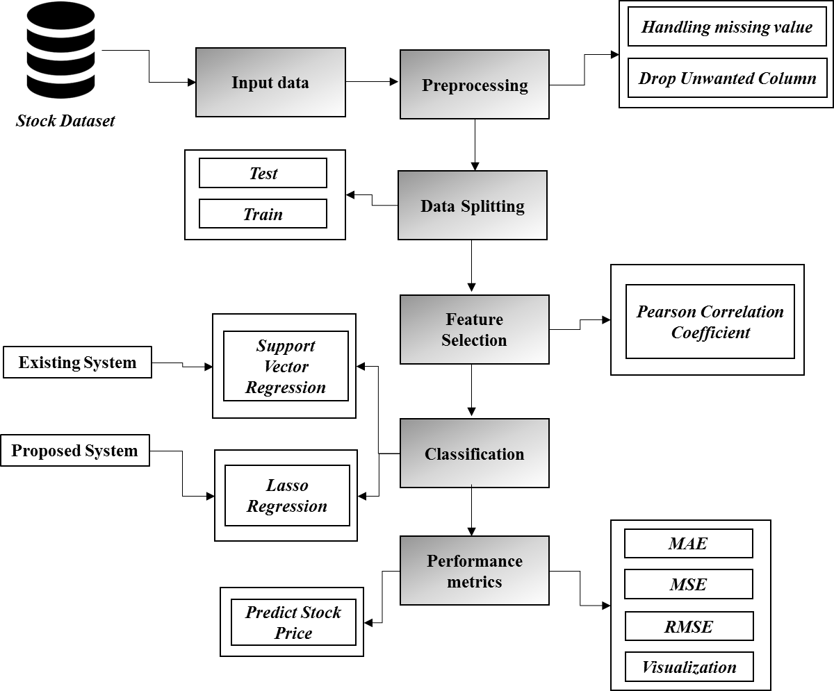

***FIGURE 3.1: SYSTEM ARCHITECTURE***

**3.2 FLOW DIAGRAM**

Input Data

Preprocessing

Data splitting

Classification

Performance analysis

***FIGURE 3.2: FLOW DIAGRAM***

**3.3 UML DIAGRAMS:**

**3.3.1 USE CASE DIAGRAM:**

System

User

***FIGURE 3.3.1: USE CASE DIAGRAM***

**3.3.2 USE CASE DIAGRAM:**

Input Data

Preprocessing

Data Splitting

Performance Analysis

Classification

***FIGURE 3.3.2: ACTIVITY CASE DIAGRAM***

**3.3.3 SEQUENCE DIAGRAM:**

Input Data

Preprocessing

Classification

Performance Analysis

Select data

Missing value

SVR

Load data

Data splitting

Lasso regression

***FIGURE 3.3.3: SEQUENCE DIAGRAM***

**3.3.4 ER DIAGRAM:**

Data selection

Preprocessing

Data Splitting

Classification

***FIGURE 3.3.4: ER DIAGRAM***

**3.3.6 CLASS DIAGRAM:**

Select data ()

Load data ()

View data ()

INPUT

Test ()

SVR ()

Train ()

Classification

Prediction ()

Lasso ()

Performance analysis

Preprocessing

Missing values ()

Drop columns ()

Data Splitting

MAE ()

***FIGURE 3.3.5: CLASS DIAGRAM***

**CHAPTER 4**

**IMPLEMENTATION**

**4.1 MODULES:**

* Data selection
* Data preprocessing
* Feature Selection
* Data splitting
* Classification
* Result Generation

**4.2 MODULES DESCRIPTION:**

**4.2.1: DATA SELECTION:**

* The data selection is the process of selecting the data for predicting the stock.
* The dataset was collected from dataset repository like UCI.
* The dataset is in the format like ‘.csv’
* In this system, the time series dataset is used for predicting the stock.
* The dataset which contains the information about the high, low, open and close price.
* With the help of panda’s package, we can read or load our input dataset.

**4.2.2: DATA PREPROCESSING:**

* Data pre-processing is the process of removing the unwanted data from the dataset.
* Pre-processing data transformation operations are used to transform the dataset into a structure suitable for machine learning.
* This step also includes cleaning the dataset by removing irrelevant or corrupted data that can affect the accuracy of the dataset, which makes it more efficient.
* Missing data removal
* Missing data removal: In this process, the null values such as missing values and Nan values are replaced by 0.
* Missing and duplicate values were removed and data was cleaned of any abnormalities.
* If you want to drop unwanted or unnecessary columns from our dataset, we can drop it in priorly.

**4.2.3: FEATURE SELECTION:**

* In this step, we can select the features from preprocessed data by using Pearson’s correlation.
* One of the measures used for feature selection is dependency measures. Many dependency based methods have been proposed.
* The main measure is Correlation based method. Pearson's Correlation method is used for finding the association between the continuous features and the class feature.
* Features with high correlation are more linearly dependent and hence have almost the same effect on the dependent variable.
* So, when two features have high correlation, we can drop one of the two features.

**4.2.4: DATA SPLITTING:**

* During the machine learning process, data are needed so that learning can take place.
* In addition to the data required for training, test data are needed to evaluate the performance of the algorithm in order to see how well it works.
* In our process, we considered 70% of our input dataset to be the training data and the remaining 30% to be the testing data.
* Data splitting is the act of partitioning available data into two portions, usually for cross-validator purposes.
* One Portion of the data is used to develop a predictive model and the other to evaluate the model's performance.
* Separating data into training and testing sets is an important part of evaluating data mining models.
* Typically, when you separate a data set into a training set and testing set, most of the data is used for training, and a smaller portion of the data is used for testing.

**4.2.5: CLASSIFICATION:**

* In our process, we have to implement the two machine learning algorithm such as lasso regression and support vector regression.
* **Support Vector Regression** is a supervised learning algorithm that is used to predict discrete values. Support Vector Regression uses the same principle as the SVMs.
* The basic idea behind SVR is to find the best fit line. In SVR, the best fit line is the hyper plane that has the maximum number of points.
* **Lasso regression** is a type of linear regression that uses shrinkage. Shrinkage is where data values are shrunk towards a central point, like the mean.
* The lasso procedure encourages simple, sparse models (i.e. models with fewer parameters).

**4.2.5: RESULT GENERATION:**

The Final Result will get generated based on the overall classification and prediction. The performance of this proposed approach is evaluated using some measures like,

* **MAE:** In statistics, the **mean absolute error** (MAE) is a way to measure the accuracy of a given model. It is calculated as:

**MAE = (1/n) * Σ|yi – xi|**

Where:

* **Σ:** A Greek symbol that means “sum”
* **yi:** The observed value for the ith observation
* **xi:** The predicted value for the ith observation
* **n:** The total number of observations
* **MSE:** The mean squared error (MSE) is a common way to measure the prediction accuracy of a model. It is calculated as:

**MSE**= (1/n) * Σ (actual – prediction) 2

Where:

* **Σ** – a fancy symbol that means “sum”
* **n** – sample size
* **actual** – the actual data value
* **forecast** – the predicted data value

**CHAPTER 5**

**SYSTEM REQUIREMENTS**

**5.1 HARDWARE REQUIREMENTS:**

* System : Pentium IV 2.4 GHz
* Hard Disk : 200 GB
* Mouse : Logitech.
* Keyboard : 110 keys enhanced
* Ram : 4GB

**5.2 SOFTWARE REQUIREMENTS:**

* O/S : Windows 7.
* Language : Python
* Front End : Anaconda Navigator – Spyder

**5.3 SOFTWARE DESCRIPTION:**

**5.3.1 Python**

Python is one of those rare languages which can claim to be both *simple* and powerful. You will find yourself pleasantly surprised to see how easy it is to concentrate on the solution to the problem rather than the syntax and structure of the language you are programming in. The official introduction to Python is Python is an easy to learn, powerful programming language. It has efficient high-level data structures and a simple but effective approach to object-oriented programming. Python's elegant syntax and dynamic typing, together with its interpreted nature, make it an ideal language for scripting and rapid application development in many areas on most platforms. I will discuss most of these features in more detail in the next section.

## **5.3.2 Features of Python**

### **Simple**

Python is a simple and minimalistic language. Reading a good Python program feels almost like reading English, although very strict English! This pseudo-code nature of Python is one of its greatest strengths. It allows you to concentrate on the solution to the problem rather than the language itself.

### **Easy to Learn**

As you will see, Python is extremely easy to get started with. Python has an extraordinarily simple syntax, as already mentioned.

### **Free and Open Source**

Python is an example of a FLOSS (Free/Libré and Open Source Software). In simple terms, you can freely distribute copies of this software, read its source code, make changes to it, and use pieces of it in new free programs. FLOSS is based on the concept of a community which shares knowledge. This is one of the reasons why Python is so good - it has been created and is constantly improved by a community who just want to see a better Python.

### **High-level Language**

When you write programs in Python, you never need to bother about the low-level details such as managing the memory used by your program, etc.

### **Portable**

Due to its open-source nature, Python has been ported to (i.e. changed to make it work on) many platforms. All your Python programs can work on any of these platforms without requiring any changes at all if you are careful enough to avoid any system-dependent features.

You can use Python on GNU/Linux, Windows, FreeBSD, Macintosh, Solaris, OS/2, Amiga, AROS, AS/400, BeOS, OS/390, z/OS, Palm OS, QNX, VMS, Psion, Acorn RISC OS, VxWorks, PlayStation, Sharp Zaurus, Windows CE and PocketPC!

You can even use a platform like [Kivy](http://kivy.org) to create games for your computer and for iPhone, iPad, and Android.

### **Interpreted**

This requires a bit of explanation.

A program written in a compiled language like C or C++ is converted from the source language i.e. C or C++ into a language that is spoken by your computer (binary code i.e. 0s and 1s) using a compiler with various flags and options. When you run the program, the linker/loader software copies the program from hard disk to memory and starts running it.

Python, on the other hand, does not need compilation to binary. You just run the program directly from the source code. Internally, Python converts the source code into an intermediate form called bytecodes and then translates this into the native language of your computer and then runs it. All this, actually, makes using Python much easier since you don't have to worry about compiling the program, making sure that the proper libraries are linked and loaded, etc. This also makes your Python programs much more portable, since you can just copy your Python program onto another computer and it just works!

### **Object Oriented**

Python supports procedure-oriented programming as well as object-oriented programming. In procedure-oriented languages, the program is built around procedures or functions which are nothing but reusable pieces of programs. In object-oriented languages, the program is built around objects which combine data and functionality. Python has a very powerful but simplistic way of doing OOP, especially when compared to big languages like C++ or Java.

### **Extensible**

If you need a critical piece of code to run very fast or want to have some piece of algorithm not to be open, you can code that part of your program in C or C++ and then use it from your Python program.

### **Embeddable**

You can embed Python within your C/C++ programs to give scripting capabilities for your program's users.

### **Extensive Libraries**

The Python Standard Library is huge indeed. It can help you do various things involving regular expressions, documentation generation, unit testing, threading, databases, web browsers, CGI, FTP, email, XML, XML-RPC, HTML, WAV files, cryptography, GUI (graphical user interfaces), and other system-dependent stuff. Remember, all this is always available wherever Python is installed. This is called the Batteries Included philosophy of Python.

Besides the standard library, there are various other high-quality libraries which you can find at the Python Package Index.

**5.4 TESTING PRODUCTS:**

System testing is the stage of implementation, which aimed at ensuring that system works accurately and efficiently before the live operation commence. Testing is the process of executing a program with the intent of finding an error. A good test case is one that has a high probability of finding an error. A successful test is one that answers a yet undiscovered error.

Testing is vital to the success of the system. System testing makes a logical assumption that if all parts of the system are correct, the goal will be successfully achieved. . A series of tests are performed before the system is ready for the user acceptance testing. Any engineered product can be tested in one of the following ways. Knowing the specified function that a product has been designed to from, test can be conducted to demonstrate each function is fully operational. Knowing the internal working of a product, tests can be conducted to ensure that “al gears mesh”, that is the internal operation of the product performs according to the specification and all internal components have been adequately exercised.

**5.4.1 UNIT TESTING:**

Unit testing is the testing of each module and the integration of the overall system is done. Unit testing becomes verification efforts on the smallest unit of software design in the module. This is also known as ‘module testing’.

The modules of the system are tested separately. This testing is carried out during the programming itself. In this testing step, each model is found to be working satisfactorily as regard to the expected output from the module. There are some validation checks for the fields. For example, the validation check is done for verifying the data given by the user where both format and validity of the data entered is included. It is very easy to find error and debug the system.

**5.4.2 INTEGRATION TESTING:**

Data can be lost across an interface, one module can have an adverse effect on the other sub function, when combined, may not produce the desired major function. Integrated testing is systematic testing that can be done with sample data. The need for the integrated test is to find the overall system performance. There are two types of integration testing. They are:

i) Top-down integration testing. ii) Bottom-up integration testing.

**5.4.3 TESTING TECHNIQUES/STRATEGIES:**

* **WHITE BOX TESTING:**

White Box testing is a test case design method that uses the control structure of the procedural design to drive cases. Using the white box testing methods, we

Derived test cases that guarantee that all independent paths within a module have been exercised at least once.

* **BLACK BOX TESTING:**

1. Black box testing is done to find incorrect or missing function
2. Interface error
3. Errors in external database access
4. Performance errors.
5. Initialization and termination errors

In ‘functional testing’, is performed to validate an application conforms to its specifications of correctly performs all its required functions. So this testing is also called ‘black box testing’. It tests the external behaviour of the system. Here the engineered product can be tested knowing the specified function that a product has been designed to perform, tests can be conducted to demonstrate that each function is fully operational.

**5.4.4 SOFTWARE TESTING STRATEGIES**

**VALIDATION TESTING:**

After the culmination of black box testing, software is completed assembly as a package, interfacing errors have been uncovered and corrected and final series of software validation tests begin validation testing can be defined as many,

But a single definition is that validation succeeds when the software functions in a manner that can be reasonably expected by the customer

**USER ACCEPTANCE TESTING:**

User acceptance of the system is the key factor for the success of the system. The system under consideration is tested for user acceptance by constantly keeping in touch with prospective system at the time of developing changes whenever required.

**OUTPUT TESTING**:

After performing the validation testing, the next step is output asking the user about the format required testing of the proposed system, since no system could be useful if it does not produce the required output in the specific format. The output displayed or generated by the system under consideration. Here the output format is considered in two ways. One is screen and the other is printed format. The output format on the screen is found to be correct as the format was designed in the system phase according to the user needs. For the hard copy also output comes out as the specified requirements by the user. Hence the output testing does not result in any connection in the system.

**CHAPTER 6**

**CONCLUSION**

We conclude that, the stock price dataset was taken as input. The input dataset was mentioned in our research paper. We are implemented the different machine algorithm such as support vector regression and lasso regression. Then, we are predicted the house price and performance metrics such as MAE, MSE and RMSE.

**CHAPTER 7**

**FUTURE ENHANCEMENT**

In the future, we should like to hybrid the two different machine learning. In future, it is possible to provide extensions or modifications to the proposed clustering and classification algorithms to achieve further increased performance. Apart from the experimented combination of data mining techniques, further combinations and other clustering algorithms can be used to improve the detection accuracy.

**CHAPTER 8**

**SAMPLE CODING**

#====================== IMPORT PACKAGES ==================================

import warnings

warnings.filterwarnings("ignore")

import numpy as np

import pandas as pd

from sklearn.model_selection import train_test_split

import matplotlib.pyplot as plt

from sklearn.svm import SVR

from sklearn import metrics

from sklearn import linear_model

from scipy.stats import pearsonr

#====================== READ INPUT DATA ==================================

print("--------------------------------------")

print(" Input data ")

print("--------------------------------------")

print()

dataframe=pd.read_csv('Stock Dataset.csv')

print(dataframe.head(20))

#======================== PREPROCESSING ==================================

#==== checking missing values =====

print("----------------------------------------------")

print(" Data Preprocessing ")

print("----------------------------------------------")

print()

print (dataframe.isnull().sum())

#==== cdrop unwanted columns =====

columns = ['Date']

dataframe.drop(columns, inplace=True, axis=1)

#========================== FEATURE SELECTION =============================

# === Correlation ===

print("-------------------------------------------------------")

print("Correlation")

print("-------------------------------------------------------")

print()

val1 = dataframe['Close']

val2 = dataframe['High']

corr, _ = pearsonr(val1, val2)

print('Pearsons correlation :' % corr)

print()

**CHAPTER 9**

**SAMPLE SCREENSHOTS**

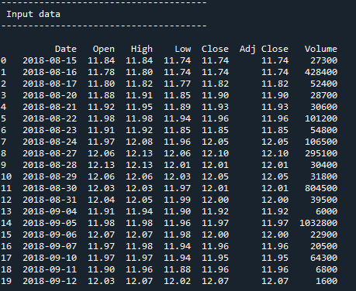

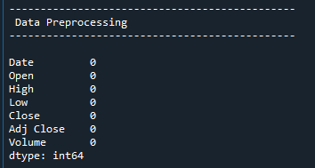

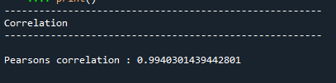

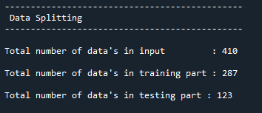

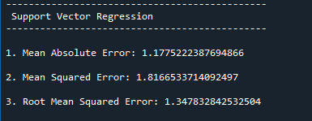

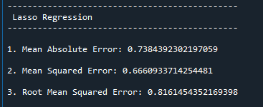

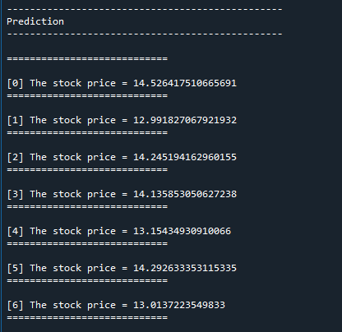

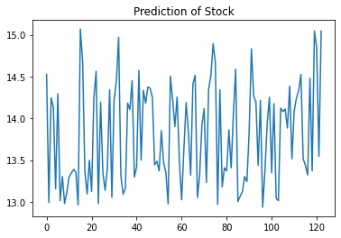

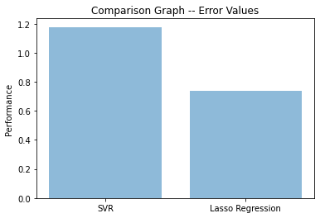

**CHAPTER 10**

**REFERENCES**

* Wei Huang, Yoshiteru Nakamori, Shou-Yang Wang, “Forecasting stock market movement direction with support vector machine”, Computers & Operations Research, Volume 32, Issue 10, October 2005, Pages 2513–2522.
* C.J.C. Burges, “A Tutorial on Support Vector Machines for Pattern Recognition”, Data Mining and Knowledge Discovery, Volume 2, pp. 1-43, Kluwer Academic Publishers, Boston, 1998.
* C. Cortes and V. Vapnik, “Support Vector Networks”, Machine Learning, 20, 273-297, 1995.
* M.Pontil and A. Verri, “Properties of Support Vector Machines”, Technical Report, Massachusetts Institute of Technology, 2016
* E.E. Osuna, R. Freund and F. Girosi, “Support Vector Machines: Training and Applications”, Technical Report, Massachusetts Institute of Technology, Artificial Intelligence Laboratory, AI Memo No. 1602, , 2014.
* Masoud, Najeb MH. (2017) “The impact of stock market performance upon economic growth.” International Journal of Economics and Financial Issues 3 (4) : 788–798.
* Murkute, Amod, and Tanuja Sarode. (2015) “Forecasting market price of stock using artificial neural network.” International Journal of Computer Applications 124 (12) : 11-15.
* Hur, Jung, Manoj Raj, and Yohanes E. Riyanto. (2006) “Finance and trade: A cross-country empirical analysis on the impact of financial development and asset tangibility on international trade.” World Development 34 (10) : 1728-1741.
* Li, Lei, Yabin Wu, Yihang Ou, Qi Li, Yanquan Zhou, and Daoxin Chen. (2017) “Research on machine learning algorithms and feature extraction for time series.” IEEE 28th Annual International Symposium on Personal, Indoor, and Mobile Radio Communications (PIMRC): 1-5.
* Seber, George AF and Lee, Alan J. (2012) “Linear regression analysis.” John Wiley & Sons 329
* Zhanpeng Zhang, Ping Luo, Chen Change Loy (May 2016), "Learning deep representation for face alignment with auxiliary attribute", IEEE Transaction on Pattern Analysis and Machine Intelligence, vol. 38, No. 3, pp. 67-73.
* Reichek, Nathaniel, and Richard B. Devereux. (1982) “Reliable estimation of peak left ventricular systolic pressure by M-mode echographicdetermined end-diastolic relative wall thickness: identification of severe valvular aortic stenosis in adult patients.” American heart journal 103 (2) : 202-209.