Contact Experiment Data Analysis

data$Part <- factor(data$Part,levels = c("TRUE","FALSE"),  
 labels = c("Part 1","Part 2"))  
  
nrTrialsPerBlockToRemove <- 1  
#trialsToRemove <- seq(from = 1, to = nrTrialsPerBlockToRemove)  
  
 data <- data %>%  
 group_by(ID, Part, InterpenetrationFeedback, FullyShaded) %>% # I have added here the fully shaded   
 slice(nrTrialsPerBlockToRemove+1:n())  
 # to double check we are discarding the right rows  
 #print(data[[i]]$Trial)  
  
 # This df will be used to create the subsets for 1st part and 2nd part of the experiment.   
   
data$InterpenetrationFeedback <- as.factor(data$InterpenetrationFeedback)  
data$FullyShaded <- as.factor(data$FullyShaded)

ParsiDF <- data  
  
  
# Exclude the IDs which produced the extreme values (i.e., = or > 3 coefficients from the mean)  
ParsiDF$ID[ParsiDF$ID == 9] <- NA   
ParsiDF$ID[ParsiDF$ID == 17] <- NA  
ParsiDF$ID[ParsiDF$ID == 20] <- NA  
  
ParsiDF <- na.omit(ParsiDF)  
  
ParsiDF <- aggregate(. ~ ID + Age + Gender + InterpenetrationFeedback + Part, ParsiDF, mean)  
  
#Before Conversion to logarithms (showing the abnormal distribution)  
shapiro_test(ParsiDF$MaxInterpenetration)

## # A tibble: 1 x 3  
## variable statistic p.value  
## <chr> <dbl> <dbl>  
## 1 ParsiDF$MaxInterpenetration 0.937 0.000000946

shapiro_test(ParsiDF$AverageInterpenetration)

## # A tibble: 1 x 3  
## variable statistic p.value  
## <chr> <dbl> <dbl>  
## 1 ParsiDF$AverageInterpenetration 0.936 0.000000844

ggqqplot(ParsiDF$MaxInterpenetration)

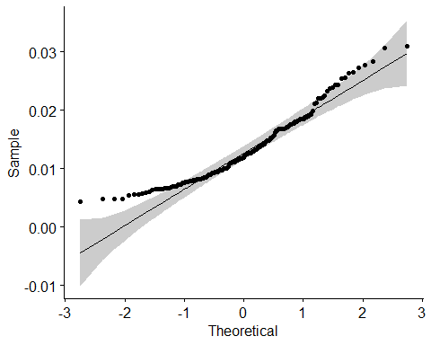

ggqqplot(ParsiDF$AverageInterpenetration)

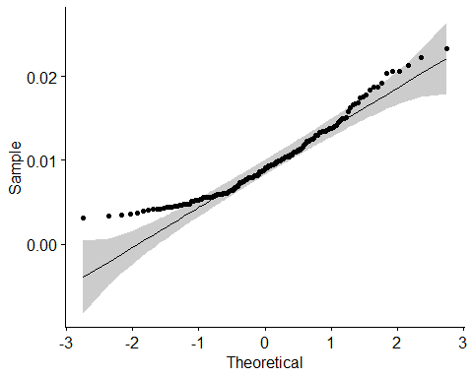

ParsiDF %>%  
 group_by(InterpenetrationFeedback, Part) %>%  
 shapiro_test(MaxInterpenetration)

## # A tibble: 8 x 5  
## InterpenetrationFeedback Part variable statistic p  
## <fct> <fct> <chr> <dbl> <dbl>  
## 1 Both Part 1 MaxInterpenetration 0.946 0.290   
## 2 Both Part 2 MaxInterpenetration 0.834 0.00225  
## 3 Electrotactile Part 1 MaxInterpenetration 0.967 0.677   
## 4 Electrotactile Part 2 MaxInterpenetration 0.859 0.00611  
## 5 NoFeedback Part 1 MaxInterpenetration 0.969 0.720   
## 6 NoFeedback Part 2 MaxInterpenetration 0.977 0.872   
## 7 Visual Part 1 MaxInterpenetration 0.860 0.00622  
## 8 Visual Part 2 MaxInterpenetration 0.898 0.0327

ParsiDF %>%  
 group_by(InterpenetrationFeedback, Part) %>%  
 shapiro_test(AverageInterpenetration)

## # A tibble: 8 x 5  
## InterpenetrationFeedback Part variable statistic p  
## <fct> <fct> <chr> <dbl> <dbl>  
## 1 Both Part 1 AverageInterpenetration 0.947 0.301   
## 2 Both Part 2 AverageInterpenetration 0.827 0.00175  
## 3 Electrotactile Part 1 AverageInterpenetration 0.964 0.592   
## 4 Electrotactile Part 2 AverageInterpenetration 0.877 0.0128   
## 5 NoFeedback Part 1 AverageInterpenetration 0.964 0.598   
## 6 NoFeedback Part 2 AverageInterpenetration 0.955 0.420   
## 7 Visual Part 1 AverageInterpenetration 0.851 0.00445  
## 8 Visual Part 2 AverageInterpenetration 0.914 0.0655

#After Conversion of the performance variables into logs (Normal Distribution)  
ParsiDF$MaxInterpenetration <- log(ParsiDF$MaxInterpenetration)  
  
ParsiDF$AverageInterpenetration <- log(ParsiDF$AverageInterpenetration)  
  
shapiro_test(ParsiDF$MaxInterpenetration)

## # A tibble: 1 x 3  
## variable statistic p.value  
## <chr> <dbl> <dbl>  
## 1 ParsiDF$MaxInterpenetration 0.988 0.149

shapiro_test(ParsiDF$AverageInterpenetration)

## # A tibble: 1 x 3  
## variable statistic p.value  
## <chr> <dbl> <dbl>  
## 1 ParsiDF$AverageInterpenetration 0.986 0.0873

ggqqplot(ParsiDF$MaxInterpenetration)

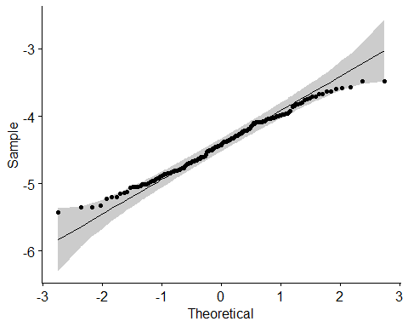

ggqqplot(ParsiDF$AverageInterpenetration)

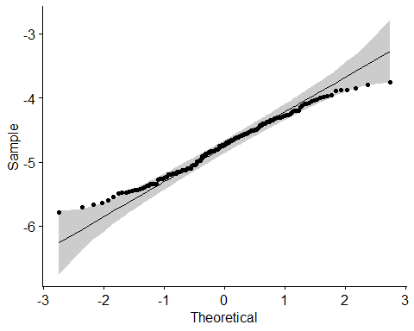

#Let's check the assumption for each interpenetration feedback and shade condition  
ParsiDF %>%  
 group_by(InterpenetrationFeedback, Part) %>%  
 shapiro_test(MaxInterpenetration)

## # A tibble: 8 x 5  
## InterpenetrationFeedback Part variable statistic p  
## <fct> <fct> <chr> <dbl> <dbl>  
## 1 Both Part 1 MaxInterpenetration 0.987 0.989  
## 2 Both Part 2 MaxInterpenetration 0.966 0.646  
## 3 Electrotactile Part 1 MaxInterpenetration 0.931 0.143  
## 4 Electrotactile Part 2 MaxInterpenetration 0.975 0.831  
## 5 NoFeedback Part 1 MaxInterpenetration 0.958 0.468  
## 6 NoFeedback Part 2 MaxInterpenetration 0.951 0.352  
## 7 Visual Part 1 MaxInterpenetration 0.963 0.582  
## 8 Visual Part 2 MaxInterpenetration 0.976 0.851

ParsiDF %>%  
 group_by(InterpenetrationFeedback, Part) %>%  
 shapiro_test(AverageInterpenetration)

## # A tibble: 8 x 5  
## InterpenetrationFeedback Part variable statistic p  
## <fct> <fct> <chr> <dbl> <dbl>  
## 1 Both Part 1 AverageInterpenetration 0.976 0.854  
## 2 Both Part 2 AverageInterpenetration 0.970 0.740  
## 3 Electrotactile Part 1 AverageInterpenetration 0.954 0.396  
## 4 Electrotactile Part 2 AverageInterpenetration 0.979 0.906  
## 5 NoFeedback Part 1 AverageInterpenetration 0.956 0.434  
## 6 NoFeedback Part 2 AverageInterpenetration 0.977 0.873  
## 7 Visual Part 1 AverageInterpenetration 0.955 0.428  
## 8 Visual Part 2 AverageInterpenetration 0.964 0.600

hist(ParsiDF$MaxInterpenetration,main = paste("Histogram of Maximum Interpenetration") , xlab = "Maximum Interpenetration")

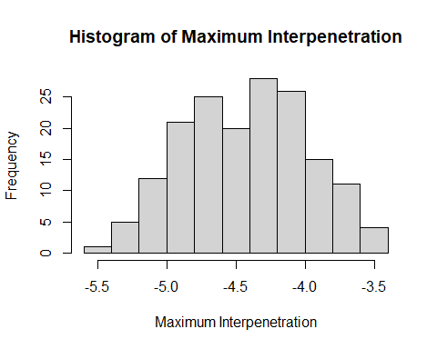

hist(ParsiDF$AverageInterpenetration, main = paste("Histogram of Average Interpenetration") , xlab = "Average Interpenetration")

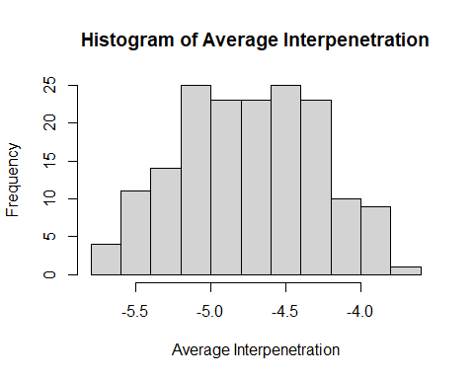

#Let’s visualize the data per interpenetration feedback and/or part of the experiment (part 1 & part 2).

ParsiDFplots <- data # A dataframe just for the plots, so we show everything in real numbers and in centimeters!  
ParsiDFplots$ID[ParsiDFplots$ID == 9] <- NA  
ParsiDFplots$ID[ParsiDFplots$ID == 17] <- NA  
ParsiDFplots$ID[ParsiDFplots$ID == 20] <- NA  
ParsiDFplots <- na.omit(ParsiDFplots)  
ParsiDFplots <- aggregate(. ~ ID + Age + Gender + InterpenetrationFeedback + Part, ParsiDFplots, mean)  
  
ParsiDFplots$AverageInterpenetration <-100 * ParsiDFplots$AverageInterpenetration #Converting meters to centimeters  
ParsiDFplots$MaxInterpenetration <- 100 * ParsiDFplots$MaxInterpenetration #Converting meters to centimeters  
  
p1

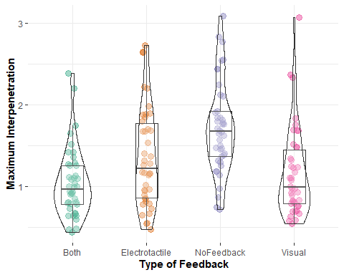

p2

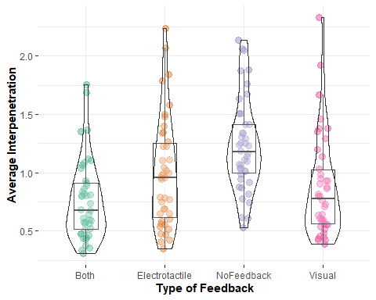

p3

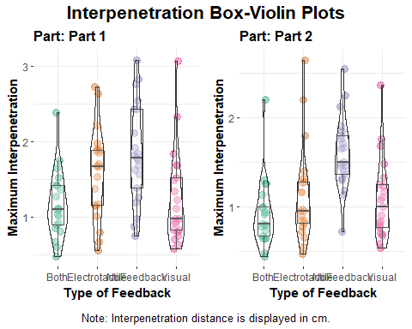

p4

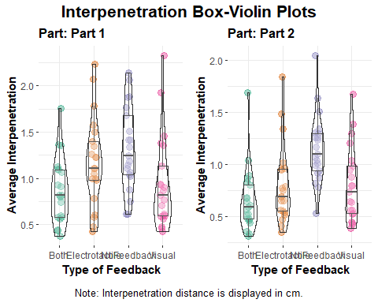

p5

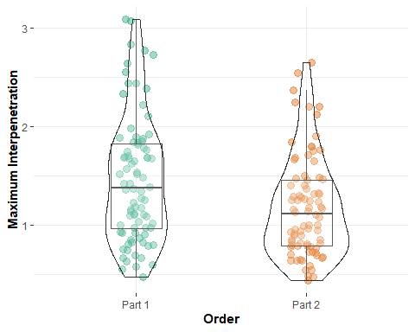

p6

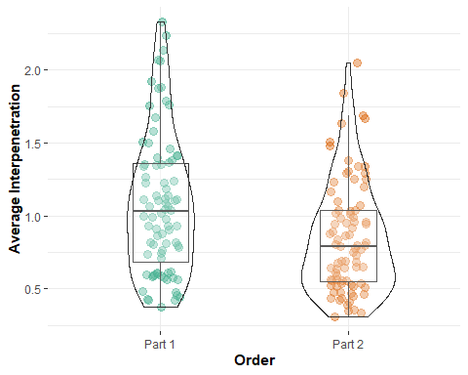

p7

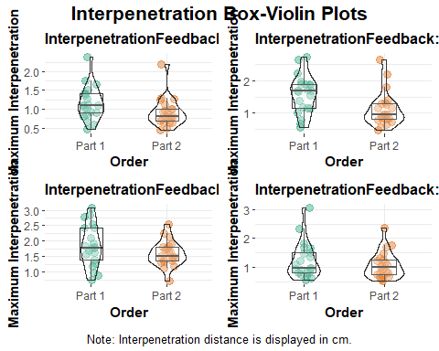

p8

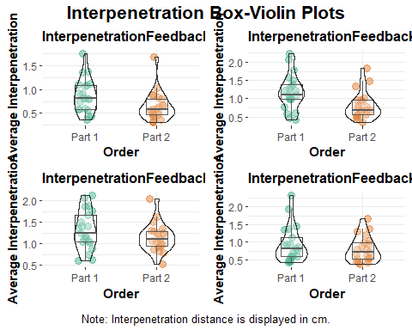

Let’s check the Two Way Repeated Measures ANOVA

aMax <- aov_ez("ID", "MaxInterpenetration", ParsiDF,  
 within = c("Part", "InterpenetrationFeedback"),  
 anova_table = list(es = "pes"))  
  
knitr::kable(nice(aMax$anova_table))

|  |  |  |  |  |  |
| --- | --- | --- | --- | --- | --- |
| Effect | df | MSE | F | pes | p.value |
| Part | 1, 20 | 0.06 | 29.43 *** | .595 | <.001 |
| InterpenetrationFeedback | 1.88, 37.52 | 0.12 | 28.36 *** | .586 | <.001 |
| Part:InterpenetrationFeedback | 2.06, 41.24 | 0.04 | 5.16 ** | .205 | .009 |

aAv <- aov_ez("ID", "AverageInterpenetration", ParsiDF,  
 within = c("Part", "InterpenetrationFeedback"),  
 anova_table = list(es = "pes"))  
  
knitr::kable(nice(aAv$anova_table))

|  |  |  |  |  |  |
| --- | --- | --- | --- | --- | --- |
| Effect | df | MSE | F | pes | p.value |
| Part | 1, 20 | 0.07 | 31.74 *** | .613 | <.001 |
| InterpenetrationFeedback | 1.97, 39.31 | 0.12 | 25.89 *** | .564 | <.001 |
| Part:InterpenetrationFeedback | 2.11, 42.21 | 0.04 | 5.72 ** | .222 | .006 |

#The Effect Sizes of the above ANOVAs: 1) Max Interpenetration 2) Average Interpenetration

effectsize::omega_squared(aMax, partial = TRUE, ci = 0.95)

## Parameter | Omega2 (partial) | 95% CI  
## ----------------------------------------------------------------  
## Part | 0.56 | [ 0.24, 0.74]  
## InterpenetrationFeedback | 0.56 | [ 0.38, 0.68]  
## Part:InterpenetrationFeedback | 0.16 | [-0.02, 0.32]

effectsize::omega_squared(aAv, partial = TRUE, ci = 0.95)

## Parameter | Omega2 (partial) | 95% CI  
## ----------------------------------------------------------------  
## Part | 0.58 | [ 0.26, 0.75]  
## InterpenetrationFeedback | 0.54 | [ 0.35, 0.66]  
## Part:InterpenetrationFeedback | 0.18 | [-0.01, 0.34]

#We can see that every type of feedback as well as the interrelationship with the part of the experiment have a large effect on DVs!!!!!!

#Reference for interpreting Omega Squared

#Small effect: ω2 = 0.01;

#Medium effect: ω2 = 0.06;

#Large effect: ω2 = 0.14.

Let’s plot the main effects (Interpenetration Feedback OR Part of the experiment).

# ANOVAs just for the plots  
aMaxPlots <- aov_ez("ID", "MaxInterpenetration", ParsiDFplots,  
 within = c("Part", "InterpenetrationFeedback"),  
 anova_table = list(es = "pes"))  
  
aAvPlots <- aov_ez("ID", "AverageInterpenetration", ParsiDFplots,  
 within = c("Part", "InterpenetrationFeedback"),  
 anova_table = list(es = "pes"))  
  
#plots  
afex_plot(aMaxPlots, x = "InterpenetrationFeedback", error = "within",   
 mapping = c("linetype", "shape", "fill"),  
 data_geom = ggpol::geom_boxjitter,   
 data_arg = list(width = 0.5)) +  
 ylim(0, 3)

## NOTE: Results may be misleading due to involvement in interactions

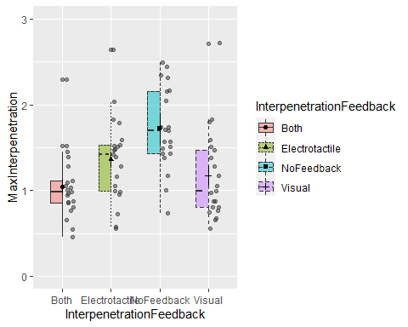

afex_plot(aMaxPlots, x = "Part", error = "within",   
 mapping = c("linetype", "shape", "fill"),  
 data_geom = ggpol::geom_boxjitter,   
 data_arg = list(width = 0.5)) +  
 ylim(0, 3)

## NOTE: Results may be misleading due to involvement in interactions

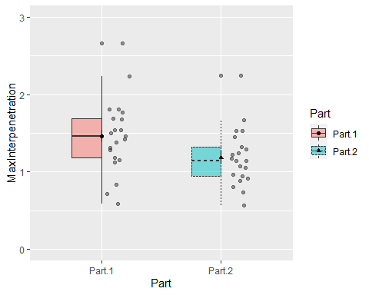

afex_plot(aAvPlots, x = "InterpenetrationFeedback", error = "within",   
 mapping = c("linetype", "shape", "fill"),  
 data_geom = ggpol::geom_boxjitter,   
 data_arg = list(width = 0.5)) +  
 ylim(0, 2.25)

## NOTE: Results may be misleading due to involvement in interactions

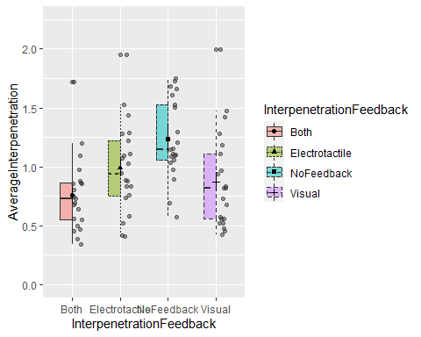

afex_plot(aAvPlots, x = "Part", error = "within",   
 mapping = c("linetype", "shape", "fill"),  
 data_geom = ggpol::geom_boxjitter,   
 data_arg = list(width = 0.5)) +  
 ylim(0, 2.25)

## NOTE: Results may be misleading due to involvement in interactions

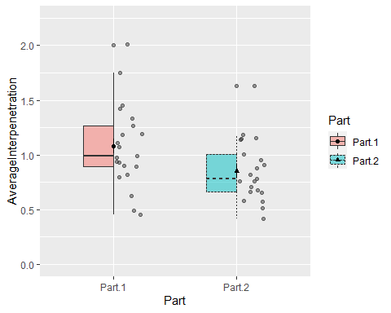

Let’s plot the main interaction effects (Interpenetration Feedback AND Part of the experiment).

afex_plot(aMaxPlots, x = "InterpenetrationFeedback", trace = "Part", error = "within",   
 mapping = c("linetype", "shape", "fill"),  
 data_geom = ggpol::geom_boxjitter,   
 data_arg = list(width = 0.5)) +  
 ylim(0, 3)

## Warning: Removed 2 rows containing non-finite values (stat_box_jitter).

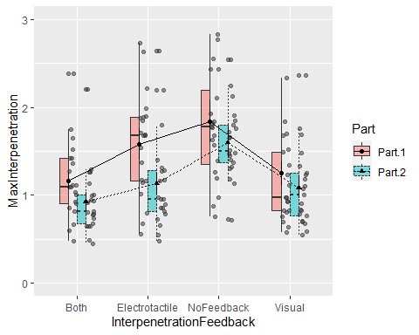

afex_plot(aMaxPlots, x = "Part", trace = "InterpenetrationFeedback", error = "within",   
 mapping = c("linetype", "shape", "fill"),  
 data_geom = ggpol::geom_boxjitter,   
 data_arg = list(width = 0.5)) +  
 ylim(0, 3)

## Warning: Removed 2 rows containing non-finite values (stat_box_jitter).

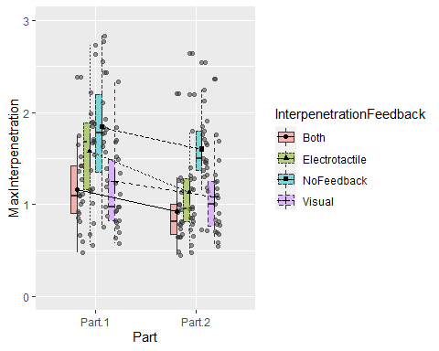

afex_plot(aAvPlots, x = "InterpenetrationFeedback", trace = "Part", error = "within",   
 mapping = c("linetype", "shape", "fill"),  
 data_geom = ggpol::geom_boxjitter,   
 data_arg = list(width = 0.5)) +  
 ylim(0, 2.25)

## Warning: Removed 1 rows containing non-finite values (stat_box_jitter).

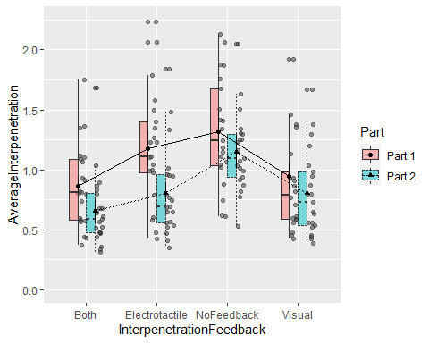

afex_plot(aAvPlots, x = "Part", trace = "InterpenetrationFeedback", error = "within",   
 mapping = c("linetype", "shape", "fill"),  
 data_geom = ggpol:: geom_boxjitter,   
 data_arg = list(width = 0.5)) +  
 ylim(0, 2.25)

## Warning: Removed 1 rows containing non-finite values (stat_box_jitter).

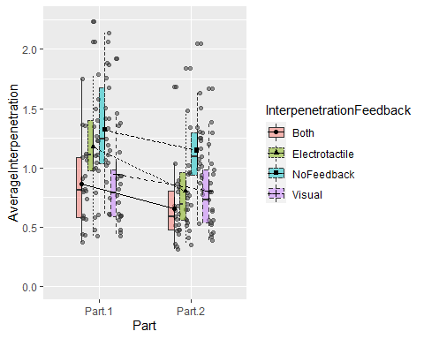

Post-hoc Tests

############################ Maximum Interpenetration #######################  
aMaxemm <- emmeans(aMax,~ Part:InterpenetrationFeedback,  
 method="pairwise", interaction=TRUE, adjust = "bonf")  
  
pairs(aMaxemm, adjust = "bonf")

require(esvis)

## Loading required package: esvis

EffectSizeMax <- hedg_g(ParsiDF,MaxInterpenetration ~ InterpenetrationFeedback + Part, keep_d = FALSE) #Calculates the hedge's g per pair!

######################## Average Interpenetration #######################  
aAvemm <- emmeans(aAv,~ Part:InterpenetrationFeedback,  
 method="pairwise", interaction= TRUE, adjust = "bonf")  
pairs(aAvemm, adjust = "bonf")

EffectSizeAv <- hedg_g(ParsiDF,AverageInterpenetration ~ InterpenetrationFeedback + Part, keep_d = FALSE)  
EffectSizeAv

# Change in the Performance (Part 1 vs Part2) per Interpenetration Feedback #  
  
contrast(emmeans(aMax,~ Part:InterpenetrationFeedback),   
 method="pairwise", interaction=TRUE, adjust = "bonf")

contrast(emmeans(aAv,~ Part:InterpenetrationFeedback),   
 method="pairwise", interaction=TRUE, adjust = "bonf")

#### For Maximum Interpenetration

#### Significant Comparisons:

#Part.1 Both - Part.2 Both p = 0.0039 Hedge’s g = 0.61676553

#Part.1 Both - Part.1 Electrotactile p = 0.0014 Hedge’s g = -0.72831779

#Part.1 Both - Part.1 NoFeedback p <.0001 Hedge’s g = -1.16801037

#Part.2 Both - Part.2 NoFeedback p <.0001 Hedge’s g = -1.79394003

#Part.1 Electrotactile - Part.2 Electrotactile p <.0001 Hedge’s g = 0.81636215

#Part.1 Electrotactile - Part.1 Visual p = 0.0100 Hedge’s g = 0.58901263

#Part.2 Electrotactile - Part.2 NoFeedback p <.0001 Hedge’s g = -1.11877925

#Part.1 NoFeedback - Part.1 Visual p <.0001 Hedge’s g = 0.98702238

#Part.2 NoFeedback - Part.2 Visual p <.0001 Hedge’s g = 1.26405828

#Hedge’s G Interpretation (Note: + or - just shows the direction!):

#Small effect (cannot be discerned by the naked eye) = 0.2

#Medium Effect = 0.5

#Large Effect (can be seen by the naked eye) = 0.8

#### For Average Interpenetration

#### Significant Comparisons:

#Part.1 Both - Part.2 Both p = 0.0004 Hedge’s g = 0.688559174

#Part.1 Both - Part.1 Electrotactile p = 0.0024 Hedge’s g = -0.673535198

#Part.1 Both - Part.1 NoFeedback p < .0001 Hedge’s g = -1.102751598

#Part.2 Both - Part.2 NoFeedback p < .0001 Hedge’s g = -1.688918621

#Part.1 Electrotactile - Part.2 Electrotactile p < .0001 Hedge’s g = 0.855157215

#Part.1 Electrotactile - Part.1 Visual p = 0.0258 Hedge’s g = 0.524527360

#Part.2 Electrotactile - Part.2 NoFeedback p < .0001 Hedge’s g = -1.095756543

#Part.1 NoFeedback - Part.1 Visual p < .0001 Hedge’s g = 0.901187692

#Part.2 NoFeedback - Part.2 Visual p < .0001 Hedge’s g = 1.096379269

#Key Findings:

#Electrotactile in Part 1 has significant differences against Visual and combined feedback (moderate effects), while is not significant different from No Feedback.

#However, in part 2, Electrotactile is significant different from No Feedback, while it does not show significant differences against Visual and Combined feedback.

#Both (i.e., combined) and Visual feedback are significantly different against No Feedback in part 1 and part 2.

#Notably, ONLY Both (combined) and Electrotactile feedback show a significant improvement from part 1 to part 2.

#This explains why the comparison between combined feedback against No Feedback has far greater effect size in part 2.

#Importantly, this explains why the Electrotactile feedback becomes significantly different against No Feedback in part 2, as well as the absence of differences against Visual and Combined.

#Since the Visual and No feedback do not improve in part 2 (i.e, no differences between part 1 and part 2), we may infer that the practice/order effect does not affect significantly the performance.

#Also, since the Visual feedback do not improve in part 2, then we may infer that the significant improvement that we observe for combined feedback in part 2 (i.e., part 1 vs part 2) is predominantly attributed to the improvement of the electrotactile feedback.

#Hence, either the calibration of, or the familiarization with, or both, concerning the electrotactile feedback, is the reason that we observe these effects of electrotactile and combined feedback in part 2.

##### Regarding the change of the performance for each type of interpenetration feedback between part 1 and part 2 of the experiment!

#### we can see that for MAX INTERPENETRATION the significant comparisons are:

#1) Part.1 - Part.2 Electrotactile - NoFeedback p = 0.0066 Hedge’s g = 0.623131

#2) Part.1 - Part.2 Electrotactile - Visual p = 0.0105 Hedge’s g = 0.595509

#This means that the improvement of the performance from part 1 to part 2 regarding the maximum interpenetration was significantly greater for the “Electrotactile Feedback” compared to the “No Feedback” and “Visual Feedback” respectively! (Medium to Large effects)

#The rest of the comparisons were insignificant!

#Hedge’s G Interpretation (Note: + or - just shows the direction!):

#Small effect (cannot be discerned by the naked eye) = 0.2

#Medium Effect = 0.5

#Large Effect (can be seen by the naked eye) = 0.8

#For the AVERAGE INTERPENETRATION the significant comparisons are:

#1) Part.1 - Part.2 Electrotactile - NoFeedback p = 0.0049 Hedge’s g = 0.6409399

#2) Part.1 - Part.2 Electrotactile - Visual p = 0.0097 Hedge’s g = 0.6004155

#This means that the improvement of the performance from part 1 to part 2 regarding the average interpenetration was significantly greater for the “Electrotactile Feedback” compared to the “No Feedback” and “Visual Feedback” respectively! (Medium to Large effects)

#The rest of the comparisons were insignificant!

Intensities of the Electrotactile Feedback

pairwise_t_test(data = intensities, Pain ~ Calibration, p.adjust.method = "bonferroni", paired = TRUE, alternative = "two.sided", detailed = TRUE)

pairwise_t_test(data = intensities, ActualValue ~ Calibration, p.adjust.method = "bonferroni", paired = TRUE, alternative = "two.sided", detailed = TRUE)

#OK, for every DV (i.e., Sensation, Pain , and Actual Value) we have the same results

#Significant differences between

#Final and Initial !!!!!!

#Middle and Initial !!!!!!

#Non-Significant differences between

#Middle and Final calibration

#I interpret them as follows: During the 1st part (i.e., until the middle calibration ) the individuals get familiarized with the electrotactile feedback. Then, the variation drops significantly! So, the most reliable calibration appears the middle one (considering that the final doesnt differ, so it seems redundant). Importantly, these results utterly support the familiarization hypothesis regarding the results of the ANOVAs and Comparisons between the feedback types, as well as it explains why the electrotactile and both have greater effect size on the 2nd part!!!

#Let’s check the effect sizes of the significant comparisons (i.e, Final vs Initial, Midlle vs Initial) now.

MidVSInitial <- filter(intensities, Calibration != "final")  
  
FinalVSInitial <- filter(intensities, Calibration != "middle")  
  
effectsize::hedges_g("Sensation", "Calibration", data = MidVSInitial, correction = TRUE, paired = TRUE,)

## Hedge's g | 95% CI  
## --------------------------  
## -1.55 | [-2.15, -0.99]

effectsize::hedges_g("Pain", "Calibration", data = MidVSInitial, correction = TRUE, paired = TRUE,)

## Hedge's g | 95% CI  
## --------------------------  
## -0.88 | [-1.34, -0.45]

effectsize::hedges_g("ActualValue", "Calibration", data = MidVSInitial, correction = TRUE, paired = TRUE,)

## Hedge's g | 95% CI  
## --------------------------  
## -1.08 | [-1.57, -0.61]

effectsize::hedges_g("Sensation", "Calibration", data = FinalVSInitial, correction = TRUE, paired = TRUE,)

## Hedge's g | 95% CI  
## ------------------------  
## 0.82 | [0.39, 1.27]

effectsize::hedges_g("Pain", "Calibration", data = FinalVSInitial, correction = TRUE, paired = TRUE,)

## Hedge's g | 95% CI  
## ------------------------  
## 0.85 | [0.42, 1.30]

effectsize::hedges_g("ActualValue", "Calibration", data = FinalVSInitial, correction = TRUE, paired = TRUE,)

## Hedge's g | 95% CI  
## ------------------------  
## 0.95 | [0.50, 1.42]

#The + or - is just the direction of the SDs change proportionally to how the comparison is called (e..g, Final vs Initial or Initial vs Final) so just ignore it.

#The important is the value of hedges g.

#We have a Large (or a Very large in some) Effect in every significant comparison.

#Hedge’s G Interpretation:

#Small effect (cannot be discerned by the naked eye) = 0.2

#Medium Effect = 0.5

#Large Effect (can be seen by the naked eye) = 0.8

Let’s visualize the comparisons

intensities$Calibration <- as.ordered(intensities$Calibration)  
levels(intensities$Calibration)

## [1] "final" "initial" "middle"

intensities$Calibration <- factor(intensities$Calibration,levels = c("initial","middle", "final"),  
 labels = c("initial","middle", "final"))  
ordered(intensities$Calibration)

p9

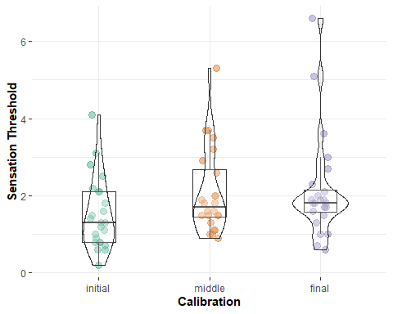

p10

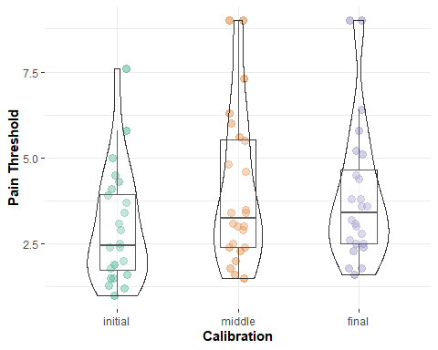

p11

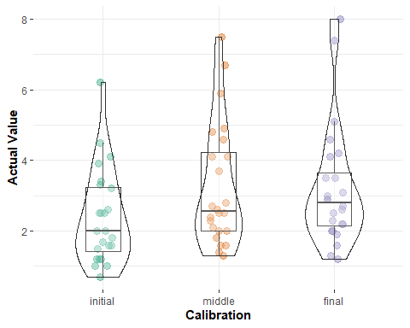

Checking if the results on the performance may be due to ineffective initial calibration and not due to familiriazation with electrotactile feedback.

require(data.table)  
setDT(intensities)  
  
intensities_wide <- dcast(intensities,ParticipantID ~ Calibration, value.var=c("Sensation", "Pain","ActualValue"))  
  
intensities_wide$DiffSensation <- intensities_wide$Sensation_middle - intensities_wide$Sensation_initial  
  
intensities_wide$DiffPain <- intensities_wide$Pain_middle - intensities_wide$Pain_initial  
  
intensities_wide$DiffActual <- intensities_wide$ActualValue_middle - intensities_wide$ActualValue_initial  
  
  
identify_outliers(intensities_wide, variable = "DiffSensation", coef = 1.5)

## ParticipantID Sensation_initial Sensation_middle Sensation_final  
## 1: 14 2.2 3.5 1.7

## identify_outliers(intensities_wide, variable = "DiffPain", coef = 1.5)

## ParticipantID Sensation_initial Sensation_middle Sensation_final  
## 1: 12 3.1 3.7 5.1  
## 2: 19 2.1 3.2 2.7  
identify_outliers(intensities_wide, variable = "DiffActual", coef = 1.5)

## ParticipantID Sensation_initial Sensation_middle Sensation_final  
## 1: 12 3.1 3.7 5.1  
## 2: 19 2.1 3.2 2.7  
describe.by(intensities_wide$DiffSensation)

## vars n mean sd median trimmed mad min max range skew kurtosis se  
## X1 1 24 0.56 0.33 0.5 0.54 0.3 -0.1 1.3 1.4 0.55 -0.05 0.07

describe.by(intensities_wide$DiffPain)

## vars n mean sd median trimmed mad min max range skew kurtosis se  
## X1 1 24 1.07 1.08 0.9 0.92 0.59 -0.2 4.7 4.9 1.61 2.92 0.22

describe.by(intensities_wide$DiffActual)

## vars n mean sd median trimmed mad min max range skew kurtosis se  
## X1 1 24 0.86 0.72 0.8 0.78 0.59 -0.2 3.3 3.5 1.55 3.26 0.15

#IDs 12 and 19 seem suspicious, however the rest are seem ok  
#lets exclude them and rerun the analyses  
  
intensities$ParticipantID[intensities$ParticipantID == 19] <- NA  
intensities$ParticipantID[intensities$ParticipantID == 12] <- NA  
  
intensities <- na.omit(intensities)  
  
pairwise_t_test(data = intensities, Sensation ~ Calibration, p.adjust.method = "bonferroni", paired = TRUE, alternative = "two.sided", detailed = TRUE)

## # A tibble: 3 x 15  
## estimate .y. group1 group2 n1 n2 statistic p df conf.low  
## * <dbl> <chr> <chr> <chr> <int> <int> <dbl> <dbl> <dbl> <dbl>  
## 1 -0.536 Sens~ initi~ middle 22 22 -7.90 1.01e-7 21 -0.678  
## 2 -0.555 Sens~ initi~ final 22 22 -4.12 4.89e-4 21 -0.835  
## 3 -0.0182 Sens~ middle final 22 22 -0.145 8.86e-1 21 -0.280  
## # ... with 5 more variables: conf.high <dbl>, method <chr>, alternative <chr>,  
## # p.adj <dbl>, p.adj.signif <chr>

pairwise_t_test(data = intensities, Pain ~ Calibration, p.adjust.method = "bonferroni", paired = TRUE, alternative = "two.sided", detailed = TRUE)

## # A tibble: 3 x 15  
## estimate .y. group1 group2 n1 n2 statistic p df conf.low  
## * <dbl> <chr> <chr> <chr> <int> <int> <dbl> <dbl> <dbl> <dbl>  
## 1 -0.823 Pain initi~ middle 22 22 -5.77 1.00e-5 21 -1.12   
## 2 -0.782 Pain initi~ final 22 22 -5.49 1.91e-5 21 -1.08   
## 3 0.0409 Pain middle final 22 22 0.424 6.76e-1 21 -0.160  
## # ... with 5 more variables: conf.high <dbl>, method <chr>, alternative <chr>,  
## # p.adj <dbl>, p.adj.signif <chr>

pairwise_t_test(data = intensities, ActualValue ~ Calibration, p.adjust.method = "bonferroni", paired = TRUE, alternative = "two.sided", detailed = TRUE)

## # A tibble: 3 x 15  
## estimate .y. group1 group2 n1 n2 statistic p df conf.low  
## * <dbl> <chr> <chr> <chr> <int> <int> <dbl> <dbl> <dbl> <dbl>  
## 1 -7.00e- 1 Actu~ initi~ middle 22 22 -7.52e+ 0 2.18e-7 21 -0.894  
## 2 -7.00e- 1 Actu~ initi~ final 22 22 -6.08e+ 0 4.91e-6 21 -0.939  
## 3 -2.02e-17 Actu~ middle final 22 22 -2.19e-16 1.00e+0 21 -0.192  
## # ... with 5 more variables: conf.high <dbl>, method <chr>, alternative <chr>,  
## # p.adj <dbl>, p.adj.signif <chr>

#OK, we have similar results, lets go a wee bit farther  
# I will also exclude the IDs which were not included in the performance analyses.   
  
intensities$ParticipantID[intensities$ParticipantID == 9] <- NA  
intensities$ParticipantID[intensities$ParticipantID == 17] <- NA  
intensities$ParticipantID[intensities$ParticipantID == 20] <- NA  
intensities <- na.omit(intensities)  
  
pairwise_t_test(data = intensities, Sensation ~ Calibration, p.adjust.method = "bonferroni", paired = TRUE, alternative = "two.sided", detailed = TRUE)

## # A tibble: 3 x 15  
## estimate .y. group1 group2 n1 n2 statistic p df conf.low  
## * <dbl> <chr> <chr> <chr> <int> <int> <dbl> <dbl> <dbl> <dbl>  
## 1 -0.532 Sens~ initi~ middle 19 19 -6.95 1.71e-6 18 -0.692  
## 2 -0.484 Sens~ initi~ final 19 19 -3.23 5.00e-3 18 -0.799  
## 3 0.0474 Sens~ middle final 19 19 0.339 7.38e-1 18 -0.246  
## # ... with 5 more variables: conf.high <dbl>, method <chr>, alternative <chr>,  
## # p.adj <dbl>, p.adj.signif <chr>

pairwise_t_test(data = intensities, Pain ~ Calibration, p.adjust.method = "bonferroni", paired = TRUE, alternative = "two.sided", detailed = TRUE)

## # A tibble: 3 x 15  
## estimate .y. group1 group2 n1 n2 statistic p df conf.low  
## * <dbl> <chr> <chr> <chr> <int> <int> <dbl> <dbl> <dbl> <dbl>  
## 1 -0.884 Pain initi~ middle 19 19 -5.70 2.09e-5 18 -1.21   
## 2 -0.811 Pain initi~ final 19 19 -5.03 8.69e-5 18 -1.15   
## 3 0.0737 Pain middle final 19 19 0.673 5.09e-1 18 -0.156  
## # ... with 5 more variables: conf.high <dbl>, method <chr>, alternative <chr>,  
## # p.adj <dbl>, p.adj.signif <chr>

pairwise_t_test(data = intensities, ActualValue ~ Calibration, p.adjust.method = "bonferroni", paired = TRUE, alternative = "two.sided", detailed = TRUE)

## # A tibble: 3 x 15  
## estimate .y. group1 group2 n1 n2 statistic p df conf.low  
## * <dbl> <chr> <chr> <chr> <int> <int> <dbl> <dbl> <dbl> <dbl>  
## 1 -0.732 Actu~ initi~ middle 19 19 -7.25 9.64e-7 18 -0.944  
## 2 -0.689 Actu~ initi~ final 19 19 -5.25 5.42e-5 18 -0.965  
## 3 0.0421 Actu~ middle final 19 19 0.408 6.88e-1 18 -0.175  
## # ... with 5 more variables: conf.high <dbl>, method <chr>, alternative <chr>,  
## # p.adj <dbl>, p.adj.signif <chr>

#OK, we have similar results again. So, it doesn’t seem that for the lower performance in the 1st part the reason was an inappropriate calibration. On the other hand, a familiarization with the electrotactile feedback seems to explain better the difference in the performance between part 1 and part 2. To clarify, by familiarization I mean the acceptance of the electrotactile feedback (e.g., it doesnt startle or frighten the user) as well as the cognitive association (in psychological terms: conditioning, or in game terms: game mechanics) between an X event (e.g., when I feel that) and Y action (e.g., then I stop or I adjust the position of my hand).

Questionnaires

#Now let’s check the questionnaires’ results

#For Questionnaires is better to compare the medians (i.e., non-parametric tests) because the responses are not real numbers, the responses are ordinal data which may be better interpreted as ranks.

quest <- read_csv("C:/repos/contactExperimentRNotebook/Questionnaires.csv")

#Lets check the median and the mode of the responses (These should be reported in a table)  
#TableQuestionnaire <-   
  
median(quest$VisualUseful)

## [1] 5.5

Mode(quest$VisualUseful)

## [1] 5  
## attr(,"freq")  
## [1] 9

median(quest$ElectrotactileUseful)

## [1] 6

Mode(quest$ElectrotactileUseful)

## [1] 5  
## attr(,"freq")  
## [1] 8

median(quest$VisualCoherent)

## [1] 5

Mode(quest$VisualCoherent)

## [1] 5  
## attr(,"freq")  
## [1] 10

median(quest$RelyingMoreOn)

## [1] 4.5

Mode(quest$RelyingMoreOn)

## [1] 3  
## attr(,"freq")  
## [1] 9

median(quest$ElectricalCoherent)

## [1] 5

Mode(quest$ElectricalCoherent)

## [1] 5  
## attr(,"freq")  
## [1] 12

median(quest$VisualResembling)

## [1] 3

Mode(quest$VisualResembling)

## [1] 3  
## attr(,"freq")  
## [1] 7

median(quest$ModalitiesSynchronized)

## [1] 6

Mode(quest$ModalitiesSynchronized)

## [1] 7  
## attr(,"freq")  
## [1] 8

median(quest$ElectrotactileResembling)

## [1] 2.5

Mode(quest$ElectrotactileResembling)

## [1] 1  
## attr(,"freq")  
## [1] 8

median(quest$CombinedResembling)

## [1] 4

Mode(quest$CombinedResembling)

## [1] 5  
## attr(,"freq")  
## [1] 7

#Usefulness  
wilcox.test(quest$VisualUseful, quest$ElectrotactileUseful,   
 alternative = "two.sided",   
 paired = TRUE,  
 exact = FALSE,   
 correct = FALSE,   
 conf.int = TRUE,   
 data = quest)

##   
## Wilcoxon signed rank test  
##   
## data: quest$VisualUseful and quest$ElectrotactileUseful  
## V = 57, p-value = 0.5436  
## alternative hypothesis: true location shift is not equal to 0  
## 95 percent confidence interval:  
## -1.0000388 0.5000392  
## sample estimates:  
## (pseudo)median   
## -4.04176e-05

#Coherence   
wilcox.test(quest$VisualCoherent, quest$ElectricalCoherent,   
 alternative = "two.sided",   
 paired = TRUE,  
 exact = FALSE,   
 correct = FALSE,   
 conf.int = TRUE,   
 data = quest)

##   
## Wilcoxon signed rank test  
##   
## data: quest$VisualCoherent and quest$ElectricalCoherent  
## V = 18, p-value = 1  
## alternative hypothesis: true location shift is not equal to 0  
## 95 percent confidence interval:  
## -1.000049 1.000049  
## sample estimates:  
## (pseudo)median   
## 0

#Resemblance  
wilcox.test(quest$VisualResembling, quest$ElectrotactileResembling,   
 alternative = "two.sided",   
 paired = TRUE,  
 exact = FALSE,   
 correct = FALSE,   
 conf.int = TRUE,   
 data = quest)

##   
## Wilcoxon signed rank test  
##   
## data: quest$VisualResembling and quest$ElectrotactileResembling  
## V = 130, p-value = 0.1472  
## alternative hypothesis: true location shift is not equal to 0  
## 95 percent confidence interval:  
## -2.426288e-05 1.500011e+00  
## sample estimates:  
## (pseudo)median   
## 0.5000355

#No differences!  
###### Let's check on which type of feedback the users relied upon more  
  
#Includes Visual, Both, Electrotactile. Values: 0 or 1  
Reliance <- read_csv("C:/repos/contactExperimentRNotebook/reliance.csv")

Reliance$Type <- factor(Reliance$Type, levels = c("Both", "Visual", "Electrotactile"))  
pairwise.wilcox.test(Reliance$Reliance, Reliance$Type, alternative = "greater",p.adjust.method = "bonferroni")

## data: Reliance$Reliance and Reliance$Type   
##   
## Both Visual  
## Visual 0.288 -   
## Electrotactile 0.024 0.377   
##   
## P value adjustment method: bonferroni

#Includes Visual and Electrotactile. Values: 0,1,2,3  
RelianceMore <- read_csv("C:/repos/contactExperimentRNotebook/relianceMore.csv")

RelianceMore<- dcast(RelianceMore,ID ~ TypeMore, value.var= "RelianceMore")

wilcox.test(RelianceMore$Electrotactile, RelianceMore$Visual,  
 alternative = "greater",   
 paired = TRUE,  
 exact = FALSE,   
 correct = FALSE,   
 conf.int = TRUE,   
 data = RelianceMore)   
## Wilcoxon signed rank test  
##   
## data: RelianceMore$Electrotactile and RelianceMore$Visual  
## V = 142, p-value = 0.07042  
## alternative hypothesis: true location shift is greater than 0  
## 95 percent confidence interval:  
## -1.206806e-05 Inf  
## sample estimates:  
## (pseudo)median   
## 0.4999568

###### Let's check which resembled better touching a surface  
Resemble <- read_csv("C:/repos/contactExperimentRNotebook/resemblance3factors.csv")

pairwise.wilcox.test(Resemble$Resemblance, Resemble$Type, p.adjust.method = "bonferroni")

## Pairwise comparisons using Wilcoxon rank sum test with continuity correction   
##   
## data: Resemble$Resemblance and Resemble$Type   
##   
## Combined Electrotactile  
## Electrotactile 0.074 -   
## Visual 0.596 0.655   
##   
## P value adjustment method: bonferroni

#Note for the interpertation:

#Median: The median value is the number that is in the middle, with the same amount of numbers below and above.

#Mode: The mode is the most commonly/frequently observed value in a set of data (i.e., the most frequent response)

Visual

#Usefulness

#Median:5.5

#Mode: 5

#Interpertation: Useful

#Coherence

#Median:5

#Mode: 5

#Interpertation: Coherent

#Resemblance

#Median:3

#Mode: 3

#Interpertation: Different

Electrotactile

#Usefulness

#Median:6

#Mode: 5 (8 Response)

#Interpertation: Useful to Very Useful

#Coherence

#Median:5

#Mode: 5

#Interpertation: Coherent

#Resemblance

#Median: 2.5

#Mode: 1 (8 responses)

#Interpertation: Different to Extremely Different

Combined

#Usefulness (Rely more on visual or electrotactile)

#Median:4.5 (i.e., half of the responses indicated > 4 which means 12 preferred the electrotactile since 5-7 corresponds to electrotactile. Note that < 4.5, means that the other 12 responses were for both visual and combined feedback. combined = 4, while visual = 1 - 3)

#Mode: 3 (9 Responses)

#Interpertation: Ballanced, however it leans towards Electrotactile

#Modalities synchronized

#Median:6

#Mode: 7

#Interpertation: Very Coherent to Completely Coherent

#Resemblance

#Median:4

#Mode: 5

#Interpertation: Moderately Similar to Similar

Comparisons

#1) In Terms of Usefulness, Coherence, and resemblance

#There are not significant differences between Combined, Visual, and Electrotatcile feedback, which replicates our findings on the users’ performance in part 2, where we did not find any significant differences as well. In combination with the medians and modes for each question (see above), we may infer that electrotactile feedback was equivalent to visual feedback, as well as it received positive evaluations by the users especially in terms of usefulness and coherence.

#2) Reliance

#Again there were no significant differences amongst Combined, Visual, and Electrotatcile feedback. The only significant difference that was detected was between Electrotactile and Combined feedback (in favor of electrotactile). In general, considering also the medians and modes of the responses on this question (see also the bar chart below), we may infer that the users relied more on a single type of feedback in the combined feedback condition, and this single type of feedback was most of the times the electrotactile feedback (12 users), followed by visual feedback (8 users) and both (4 users). These findings again align with the the results on the performance in part 2.

# Resemblance Part2

#Regarding the electrotactile feedback, our findings replicate the findings of previous studies which found that the sensation of touching provided by electrotactile feedback substantially deviates from the sensation of touching in real world.

#Now, Let’s visualize the data

#Visualization of the responses in terms of Usefulness, Coherence, and Resemblance  
  
visualVSelectro <- read_csv("C:/repos/contactExperimentRNotebook/visualVSelectro.csv")

p12

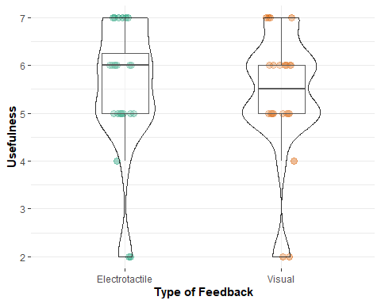

p13

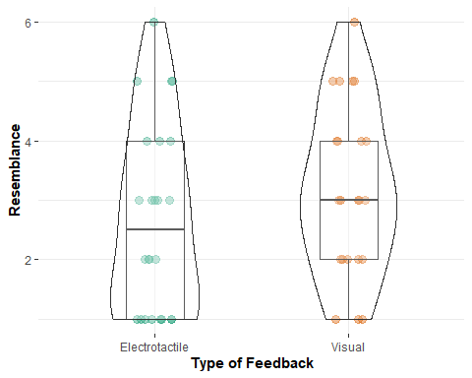

p14

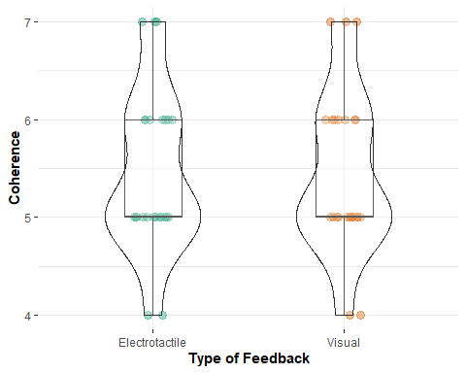

Preferences <- read_csv("C:/repos/contactExperimentRNotebook/prefFeed.csv")

#This will show on which type of feedback the users relied upon more  
ggplot(Preferences) + geom_bar(aes(x = Preferences$Type))

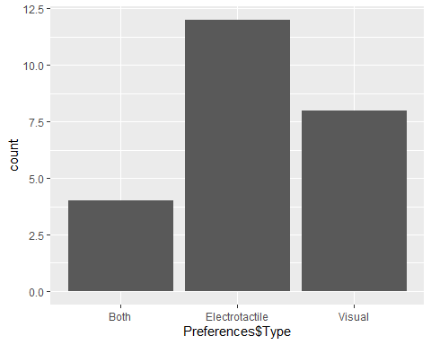

#This will show on which type of feedback the users relied upon more  
hist(quest$RelyingMoreOn)

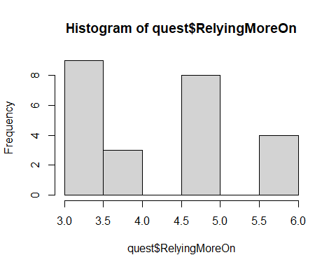

p15

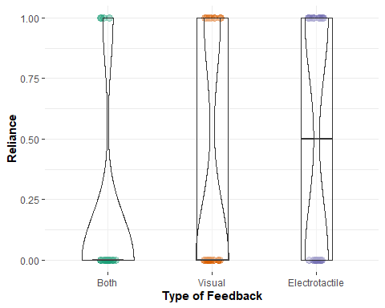

#This will show which type of feedback resemble better touching a surface  
p16

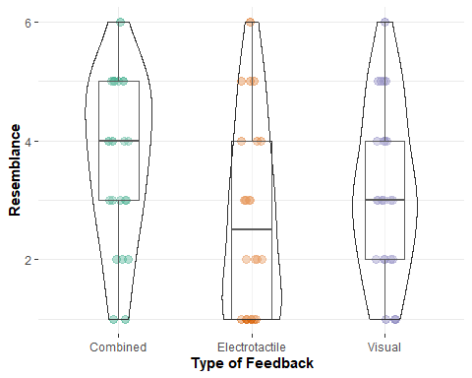

#The rest of info on the electrotactile feedback from the questionnaires

median(quest$ElectricalSensation)

## [1] 4

Mode(quest$ElectricalSensation)

## [1] 4  
## attr(,"freq")  
## [1] 10

#Moderate i.e., neither pleasant nor annoying  
hist(quest$ElectricalSensation)

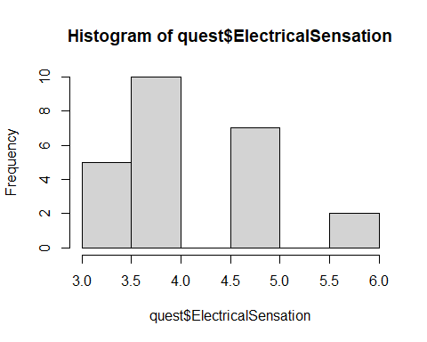

median(quest$ElectricalUpdatePerception)

## [1] 5.5

Mode(quest$ElectricalUpdatePerception)

## [1] 5 6 7  
## attr(,"freq")  
## [1] 6

# Often, Very often, All the time!   
hist(quest$ElectricalUpdatePerception)

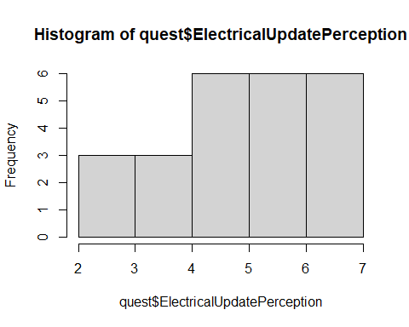

#OK so we have a neutral feedback regarding the pleasantness or discomfort of the sensation provided by the electrotactile feedback. which I interpreted as a positive result since we did not recei, especially considering the previous literature.

#Regarding the perceptual update that the user presses harder the surface, the results are really positive, and postulate that the electrotactile feedback may contribute with strengthening the plausibility illusion (i.e., the illusion that the virtual environment responds to your action). However, this should be meticuously investigated in a future study.