1. Register with Buggy cars Rating form, When LastName field is empty- error displayed should be “Last Name is required’ , but showed “First Name is required”.

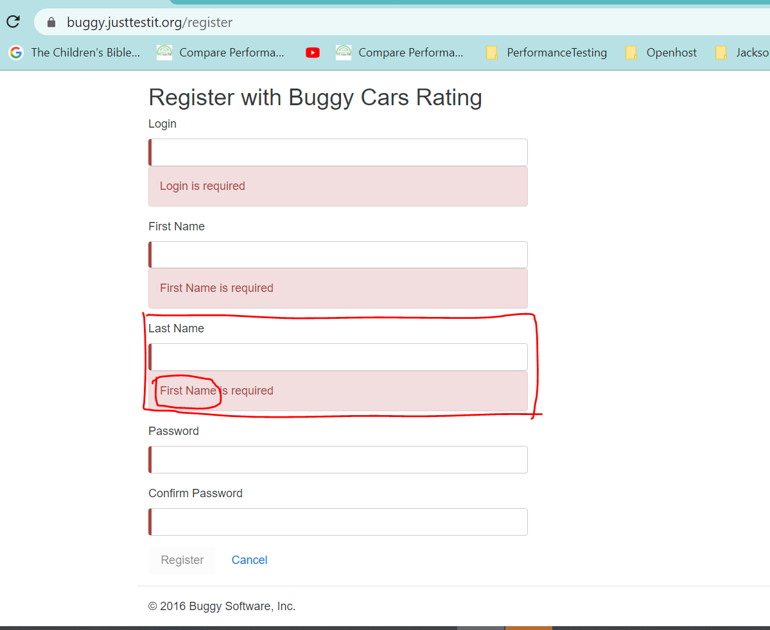

1. Reister With Buggy Cars Rating – Password validation error message – Left Trim and Right Trim is not done properly . As a result. Error message is throwing error when validating the message

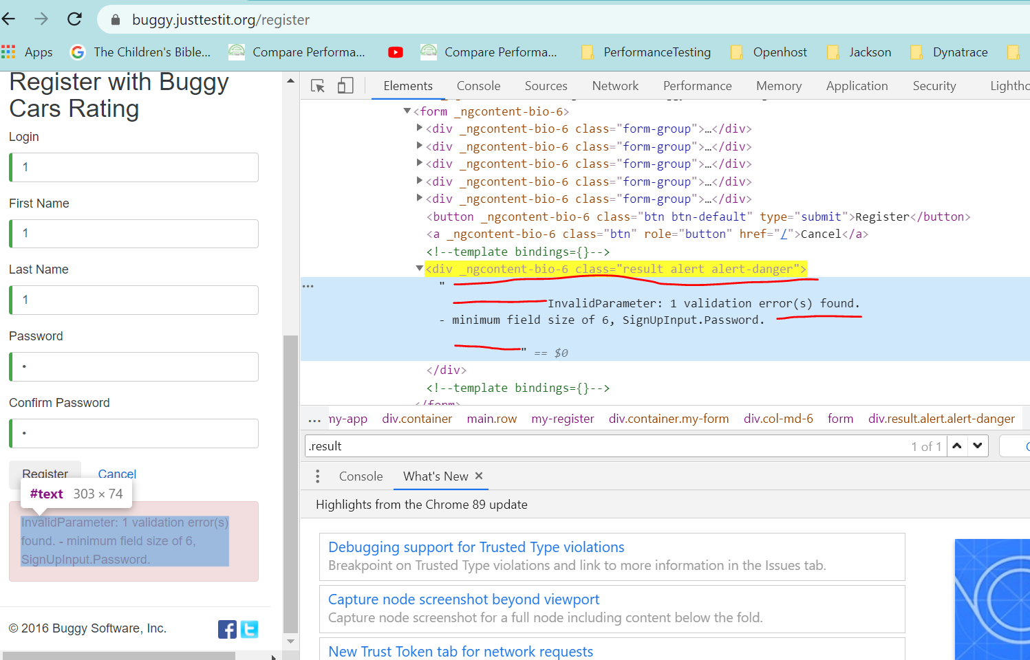

1. Password minimum field size is 6 as for validation error. But when all 6 character password is provided, instead of showing password combination error message, displayed password strength message again

InvalidParameter: 1 validation error(s) found. - minimum field size of 6, SignUpInput.Password.

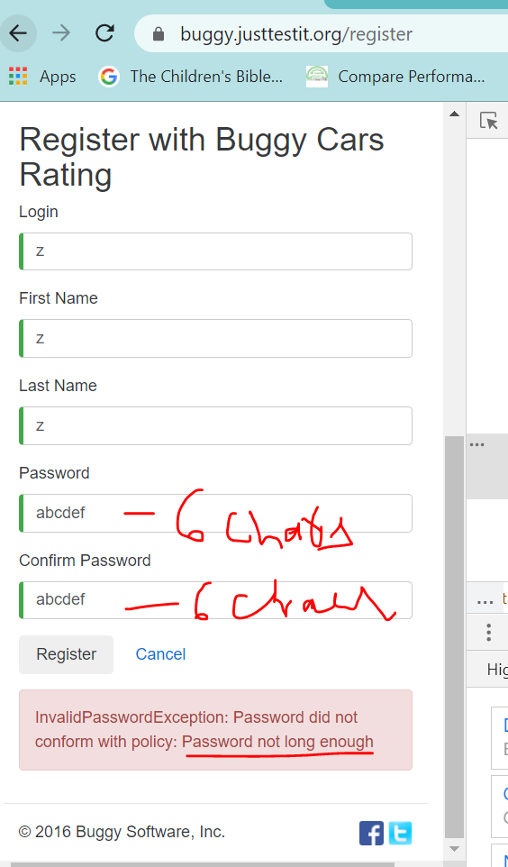

Password length error message was wrong. 8 characters is the valid password length

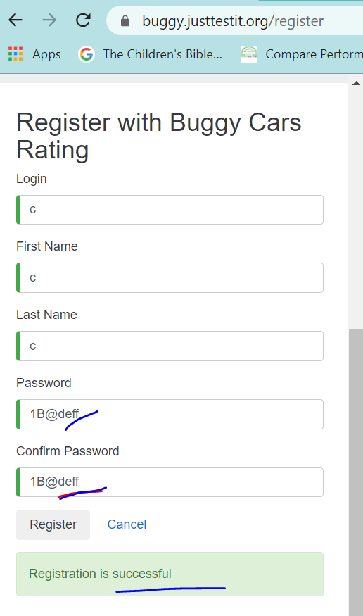

1. Copy right year should have been updated to the latest Year -2021. Instead showing 2016

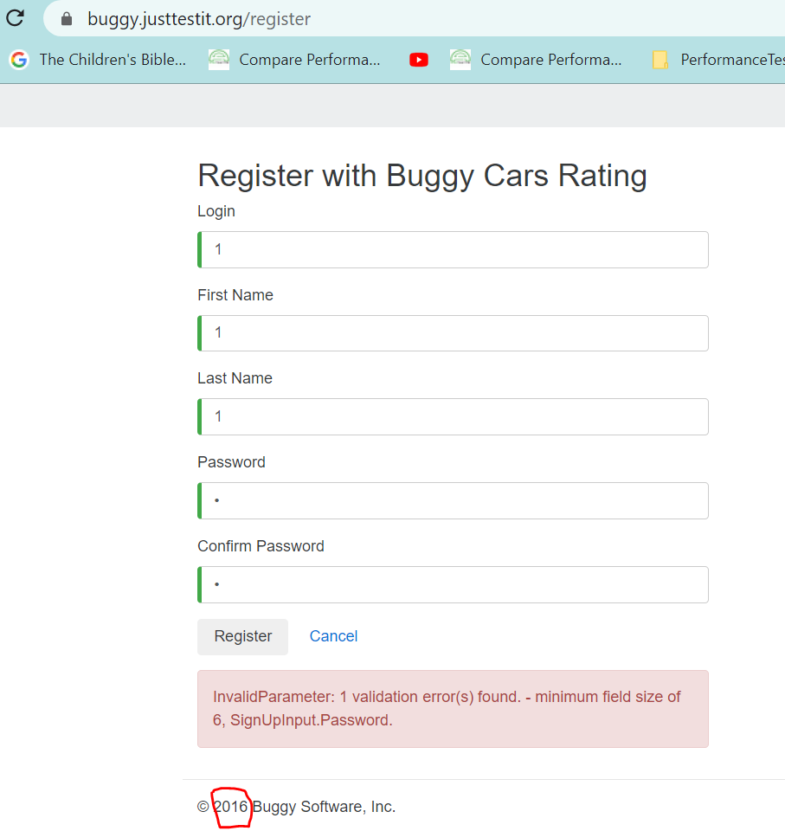

1. Vote information is not showing Author details