This App support companion powered by RAG (Retrieval-Augmented Generation) and LLM tool calling, providing empathetic, evidence-based mental health support.

- It classifies the keyword first , if it’s Under High Risk category it’ll direct to crisis Resource.
2. If it’s Low Priority then it’ll invoke original flow

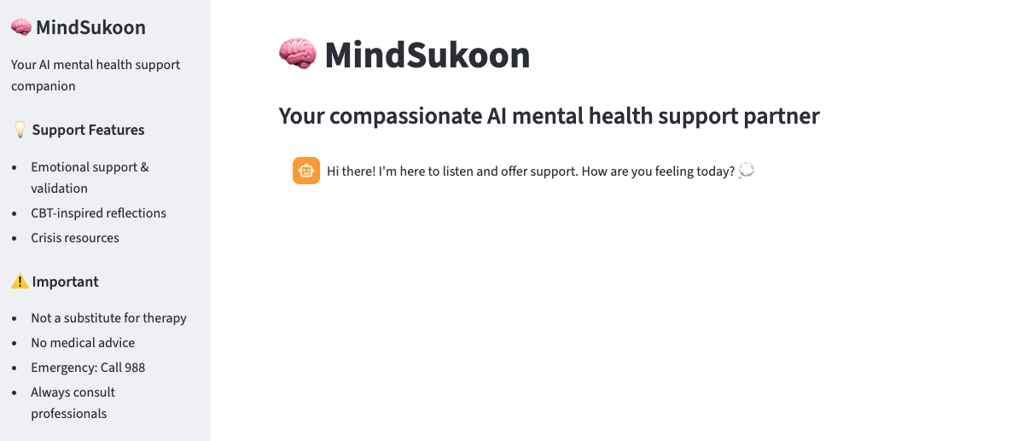
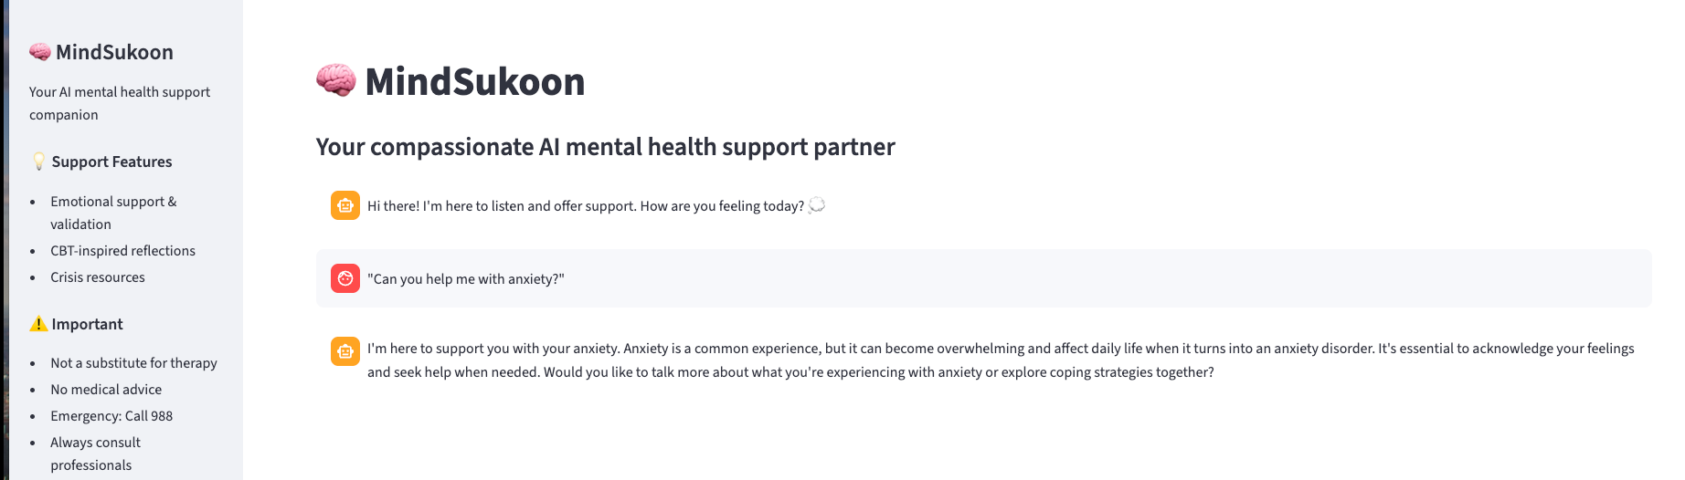
RAG Questions:

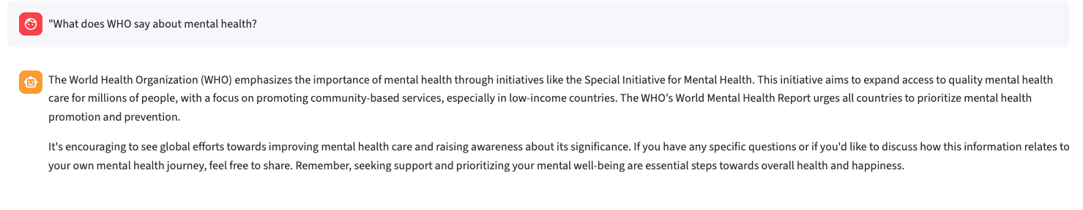
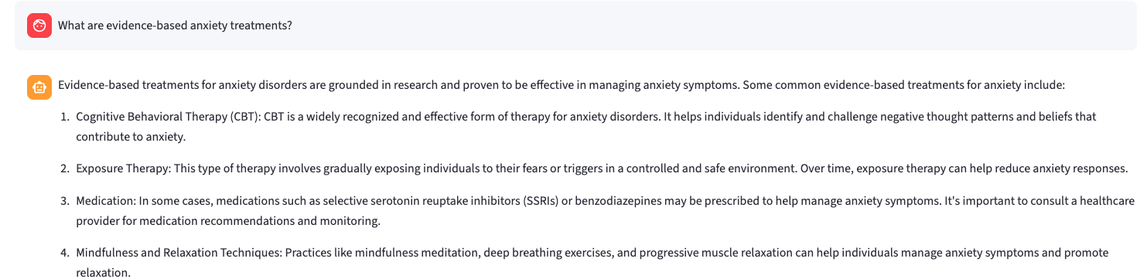

Web Search Tool Call:

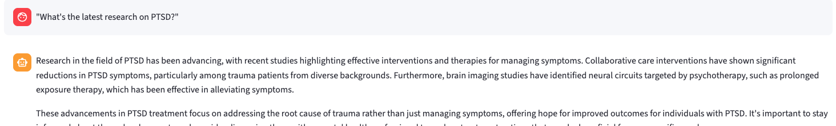

ConsoleLogs:
🔍 Executing web search: latest research on PTSD...
✅ Tavily search returned 4 results for: latest research on PTSD...
🤖 LLM processing search results and generating final response...

LLM Respond without Tools:

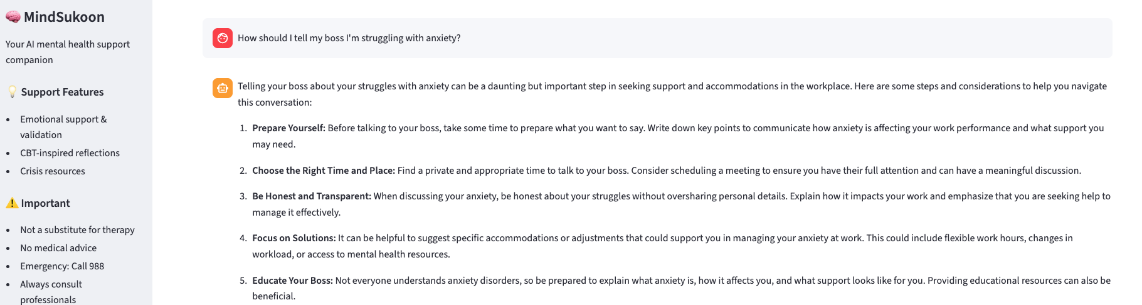
Console Logs:

High RISK Keywords

igh_risk_keywords = [
"suicide", "kill myself", "end my life",
"want to die", "better off dead"
]
medium_risk_keywords = [
"hopeless", "can't go on", "no point",
"self-harm", "hurt myself"
]

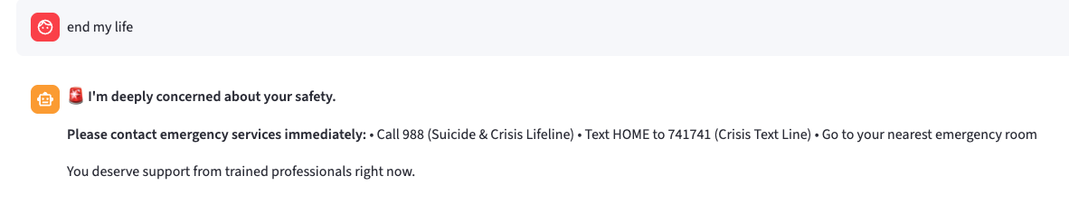

GIT HUB Link:
https://github.com/svk8888/MENTAL_HEALTH_APP/blob/main/README.md

