**Skin texture change detection for clinical trials**

DISSERTATION

Submitted in partial fulfillment of the requirements of the

MTech, Data Science and Engineering

By

(NAGA KALYAN C S SARMA V)

(2018AH04042)

Under the supervision of

VENKATA KRISHNA TEJASVI SARRAJU

SENIOR ASSOCIATE,

COGNIZANT TECHNOLOGY SOLUTIONS

Dissertation work carried out at

COGNIZANT TECHNOLOGY SOLUTIONS,

HYDERABAD

BIRLA INSTITUTE OF TECHNOLOGY AND SCIENCE

Pilani (Rajasthan) INDIA

(January, 2021)

**BIRLA INSTITUTE OF TECHNOLOGY AND SCIENCE, PILANI**

**CERTIFICATE**

This is to certify that the Dissertation entitled “**Skin texture change detection for clinical trials”** and submitted by Mr. **NAGA KALYAN C S SARMA V** ID No: **2018AH04042** in partial fulfillment of the requirements of DSE CL ZG628T Dissertation embodies the work done by him under my supervision.

(Signature of the Supervisor)

**Place:** Hyderabad VENKATA KRISHNA TEJASVI SARRAJU

**Date:** 10th January, 2021 SENIOR ASSOCIATE

**ACKNOWLEGDEMENTS**

**“**Being with the wise is the first sign of wisdom”

I would like to take this opportunity to express my gratitude to my supervisor **Tejasvi Venkata Krishna Sarraju**, who gave me an opportunity to work on this wonderful project, lending me his experience and counsel. He was a tremendous help in the research and development of this project.

Many thanks to Internal Supervisors **Professor Sankara Nayaki K** for guiding

me throughout this project. Her continuous feedback and direction has helped

this project reach its best form.

I would also like to thank my friends and family who helped me a lot in finalizing this project

and supporting me in my endeavors in ways both big and small, but always significant.

**BIRLA INSTITUTE OF TECHNOLOGY AND SCIENCE, PILANI**

**FOURTH SEMESTER 2019-2020**

**DSECLZG628T DISSERTATION**

**Dissertation Outline**

**BITS ID No.**:2018AH04042

**Name of Student**: NAGA KALYAN C S SARMA V

**E-mail ID of the student**: 2018AH04042@wilp.bits-pilani.ac.in

**Name of Supervisor**: Venkata Krishna Tejasvi Sarraju

**Designation of Supervisor**: Senior Associate

**Qualification**: B.Tech **Experience**: 11 years

**E-mail ID of Supervisor**: TejasviVenkataKrishna.Sarraju@cognizant.com

**Title of Dissertation**: Skin texture change detection for clinical trials

**Name of First Examiner**: Prof. Sankara Nayaki K

**Designation of First Examiner**:

**Qualification and Examiner**:

**E-mail ID of First Examiner:**

**Name of Second Examiner**:

**Designation of Second Examiner**:

**Qualification and Examiner**:

**E-mail ID of Second Examiner:**

(Signature of Student) (Signature of Supervisor)

Date: 10th January, 2021 Date: 10th January, 2021

**BIRLA INSTITUTE OF TECHNOLOGY & SCIENCE, PILANI**

**FOURTH SEMESTER 2019-20**

DSE CL ZG628T **DISSERTATION**

Dissertation Title : SKIN TEXTURE CHANGE DETECTION FOR CLINICAL TRIALS

Name of Supervisor : TEJASVI VENKATA KRISHNA SARRAJU

Name of Student : NAGA KALYAN C S SARMA V

ID No. of Student : 2018AH04042

**Abstract**

In most of the clinical trials, specifically in cosmetic industry, a substantial amount of images are generated such that, the research scientists have an opportunity to analyze and document the efficacy of a chemical/product that is going to be introduced into the consumer market.

This poses 2 major problems:

1. The industries are bound by confidentiality agreements with the participants, hence each of these images are to be masked in order to protect PII from the internal and external technicians/approvers/stakeholders who view these images.
2. The research scientists are needed to analyze huge number of images that are generated over a period of time to understand good and bad effects of the product used in the trial, which is a cumbersome task and prone to human error

By leveraging Computer Vision algorithms in this solution, the facial parts of the participants which are not helpful for research (such as eyes) are automatically masked and also the skin texture changes can be compared from one image to another.

(Signature of Student) (Signature of Supervisor)

Date: 10th January, 2021 Date: 10th January, 2021

## Contents

1. Problem Statement: 7

2. Existing system: 7

3. Solution 7

4. Scope of work 7

5. Methodology 7

6. Uniqueness of the project 7

7. Benefit to the organization 8

8. Key challenges 8

9. Source 8

10. Input/Output Dimensions 8

11. Feasibility study 8

12. Resources needed 8

13. Project plan & Deliverables 9

14. Solution architecture**:** 9

15. Work accomplished so far 9

15.1 Gather images with diversified demographics 10

15.2 Mask eyes in the facial images 10

15.3 Deploy to AWS 10

15.4 Choose a library for LBP implementation……………………………………………………………………………………10

15.5 Read and pre-process masked image…………………………………………………………………………………………10

15.6 LBP implementation……………………………………………………………..……………………………………………………10

15.7 Reporting……………………………………………………………………………………………………………………………………10

16. Screenshot of the results…………………………………………………………………………………………………………………11

16.1 Masked Image 1 (Figure 2.1) ………………………………………………………………………………………………….….11

16.2 Masked Image 2 (different ethnicity/age) (Figure 2.2)……………………….………………………………………11

16.3 Before using a facial cream (P1): (Figure 3.1) ………….…………………………………………………………………12

16.4 After using a facial cream (P1): (Figure 3.2)………..………………………………………………………………………12

16.5 Before using a facial cream (P2): (Figure 4.1)……..………………………………………………………………………13

16.6 After using a facial cream (P2): (Figure 4.1)..………………………………………………………………………………13

17. Conclusion…………………………………………………………………………………………………………………………………….…14

18. Recommendations/Directions for future……………………………………………………………………………………….…14

18. Appendices………………………………………………………………………………………………………………………………………14

19. Bibliography / References……………………………………………………………………………………………………………..…15

20. List of Publications / Conference Presentations……………………………………….………………………………………15

21. Check list of items for final report (with Yes or No marked, as applicable) ………………………………………15

**Chapters**

**1. Problem Statement**:

The global skin care products market size was valued at 134.8 billion in 2018 and is projected to expand at a CAGR of 4.4% from 2019 to 2025 on account of the rapidly expanding global cosmetics industry. The growing e-commerce sector is anticipated to boost the market growth further. Moreover, technological and product innovations have led to an increased demand for skincare products.

This escalating demand for face creams, sunscreens and body lotions across the globe is pushing manufacturers to spend more time, money and resources on research and development. To target global markets, clinical trial participants are chosen from various demographics including age, location, ethnicity and skin types. Huge amounts of images get generated during the course of each trial, which are analyzed by the clinicians to note the efficacy of each chemical/product.

These industries are also bound by confidentiality agreements with the participants which demands protection of PII data.

**2. Existing system**:

To protect PII data, image masking softwares are used to cover some facial parts of the participants however, the licensing costs become a burden very soon. Moreover, manual observation of skin changes such as wrinkles, blemish etc by a clinician over such a large volume of images is time consuming and error prone.

**3. Solution**:

Build automated solution to mask facial parts (which need not be analyzed) for protecting identity of the participants. Use computer vision algorithms to detect changes in skin texture and provide insights to the clinicians to better understand the efficacy of the products.

**4. Scope of work:**

The scope of work will involve understanding the design and other requirements

* Explore the machine learning and deep learning techniques for image masking
* Experiment with various Computer Vision algorithms for texture analysis
* Design the solution in cloud to meet the algorithm and visualization requirements

**5. Methodology**:

1. Clinicians to upload the raw images to cloud storage
2. Mask the images instantly and delete the original images
3. Apply computer vision algorithm to perform texture analysis on facial images
4. Build visualizations for the clinicians to better understand the efficacy of the products

**6. Uniqueness of the project:**

This is an end-to-end solution of what is expected by the industry rather than just a portion. The following modules form the entire solution:

* Data engineering: Gathering, storing and masking of data
* Data Science: Applying Deep Learning and Computer Vision algorithms to generate insights from image which are helpful for research
* Operationalization: Leveraging cloud services to host the entire solution in order to generate repeated value

**7. Benefit to the organization:**

The following are the primary benefits:

* Ability to automatically infer the changes in the skin texture, thereby identifying efficacy of each chemical/product being used in the lab
* Compliance with confidentiality agreements with the participants of the clinical trials
* Since no human involvement is needed, scalability in terms of speed, volume and accuracy is a huge benefit.

**8. Key challenges:**

* Gathering huge volumes of images to train the model
* The masking process has to be 100% accurate to stay compliant
* Good amount of testing is needed in skin texture identification as key decisions are taken around the chemicals used in a product
* Understanding LBP algorithm and its implementation in various libraries

**9. Source:**

Since we are not allowed to use the actual images taken in the lab, in order to train/test the algorithm and for user acceptance testing purposes, we will be downloading free image datasets available on ImageNet, Kaggle, Google Images, celebfaces etc to gather a collection of facial images suitable for our use case.

**10. Input/Output Dimensions :**

Inputs will be the participant_id and the image taken in a controlled lab environment in the form of a high quality image ideally in JPEG format. Output 1 will be Masked images and Output 2 will be histogram for each "region" of an input facial image (no. of regions can be controlled by the user to get higher or lower granular details) to help analyze skin texture (such as wrinkles). Other visualizations according to Ethnicity, age group are being planned.

**11. Feasibility study:**

Although lot of aspects of this project are experimental in nature, the planned outcome is certainly possible to achieve as long as we take a controlled and step-by-step approach for the completion of the project.

**12. Resources needed**:

Cloud platform, Python, Computer Vision, Machine Learning and Deep Learning packages and good number of images for training/testing

**13. Project Plan & Deliverables: (Table 1.1)**

|  |  |  |  |
| --- | --- | --- | --- |
| **S.No.** | **Task** | **Planned duration (in weeks)** | **Name of Deliverables** |
| 1 | Research and feasibility check | 1 | Research |
| 2 | Gathering the raw images | 1 | Data Gathering |
| 3 | Setup a cloud platform with storage, compute and software | 1 | Cloud setup |
| 4 | Implement PII data masking | 5 | Application |
| 5 | Implement texture analysis using a computer vision algorithm | 5 | Application |
| 6 | Build visualization showing efficacy of products | 3 | Reporting |

**14. Solution architecture: (Figure 1.1)**

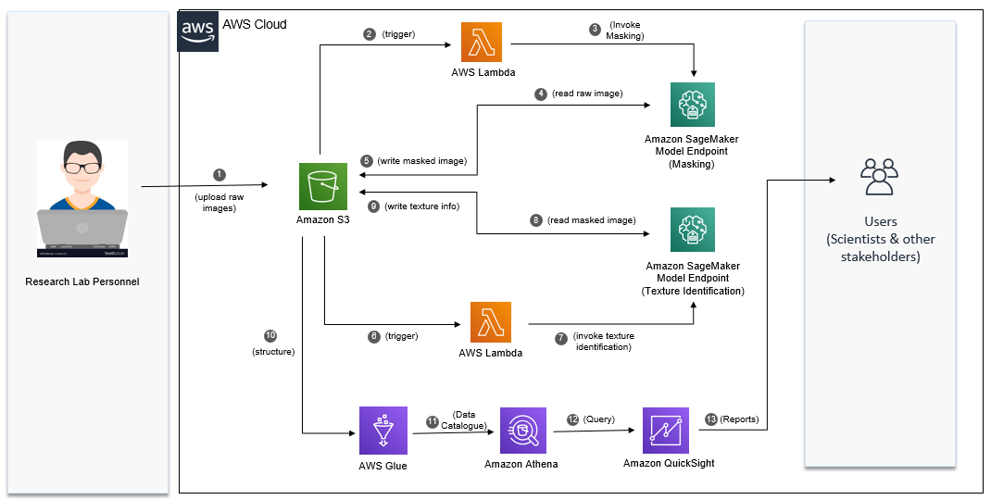

**15. Work accomplished:**

15.1 Gather images with diversified demographics

Gathered images that concur to the following criteria:

* Clear image with high pixel density and light background
* Subject (the participant) in the image should be looking into the camera
* Face of the subject should be entirely present in the picture
* Subjects should belong to diversified demographics such as Age, Ethnicity, Gender

15.2 Mask eyes and mouth in the facial images

Trained a multi-layer Convolutional Neural Network from scratch by leveraging a training dataset available on public domain

Masked specific coordinates of facial parts such that there is no data loss (for eg: dark circles below the eyes), which should enable better data (skin texture) analysis

Masked mouth along with eyes

15.3 Deploy to AWS

The images have been uploaded to a S3 bucket. A lambda function would be polling for incoming images. As soon as an image arrives, trained CNN model is loaded and masked image is stored as an output.

15.4 Choose a library for LBP implementation

Have gone through pros and cons of multiple implementations of LBP algorithm in libraries such as Mahotas, OpenCV and scikit-image.

OpenCV implementation of LBP is strictly in the context of face recognition — the underlying LBP extractor is not exposed for raw LBP histogram computation.

Narrowed down to scikit-image implementation as it offers more control of the types of LBP histograms we want to generate.

15.5 Read and pre-process masked image

Preprocessed the image to extract just the face, convert to gray scale and modify dimensions to fit into LBP algorithm.

15.6 LBP implementation

Experimented with hyper parameters (eg: number of points, radius) to generate best possible results for texture analysis

Based on the feature vectors generated by LBP algorithm, generated overlay images to show rough, smooth and medium areas of the skin texture

15.7 Reporting

Generated Histograms in alignment with the images

Saved the reports in PDF format in S3 to seamlessly distribute the output to the end users

**16. Screenshot of the results:**

**Masked Image 1 (Figure 2.1)**

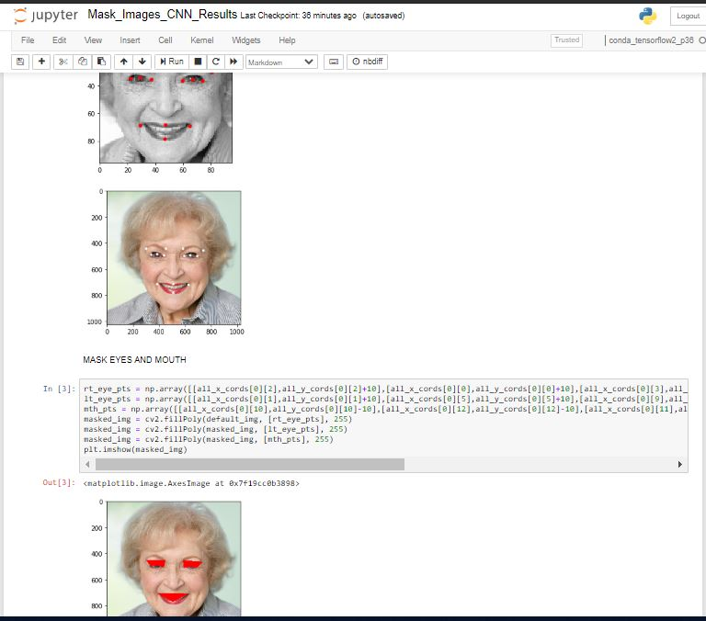

**Masked Image 2 (different ethnicity/age) (Figure 2.2)**

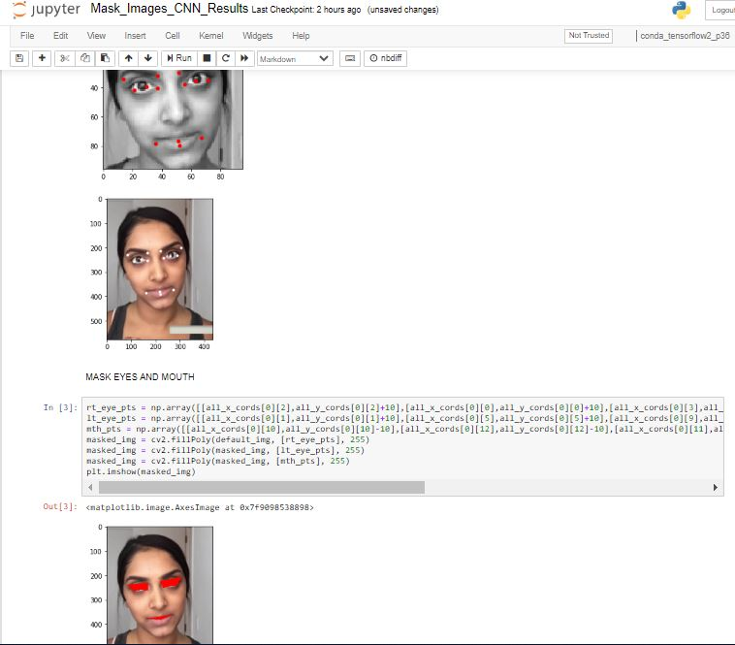

**LBP Output for 2 participants:**

**Before using a facial cream: (Figure 3.1)**

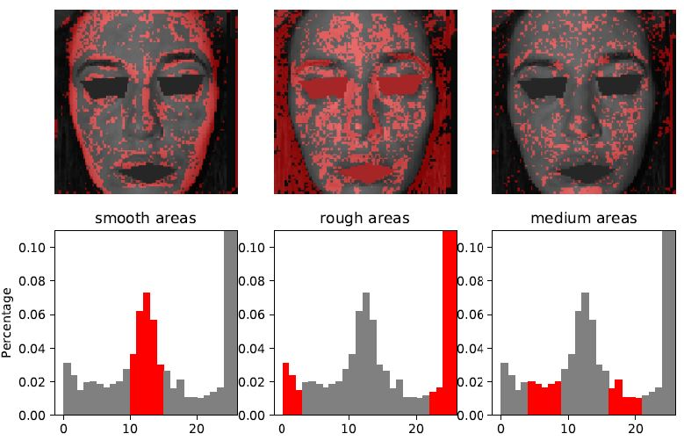

**After using a facial cream: (Figure 3.2)**

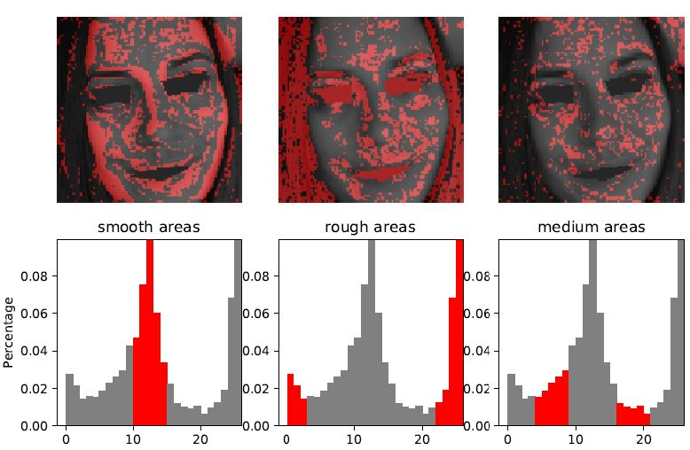

**Before using a facial cream: (Figure 4.1)**

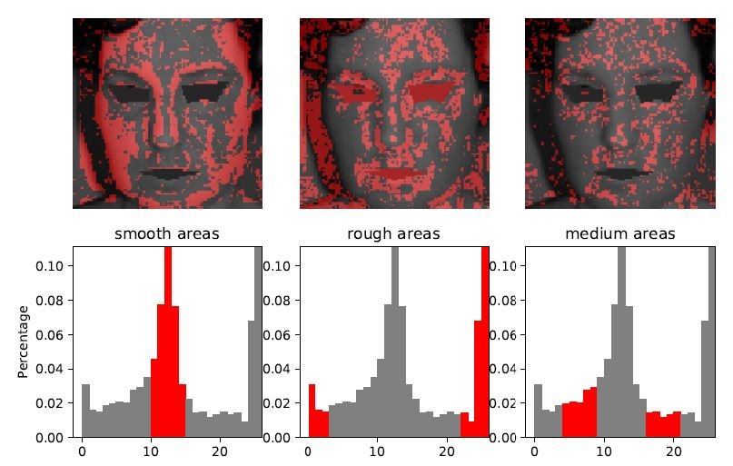

**After using a facial cream: (Figure 4.2)**

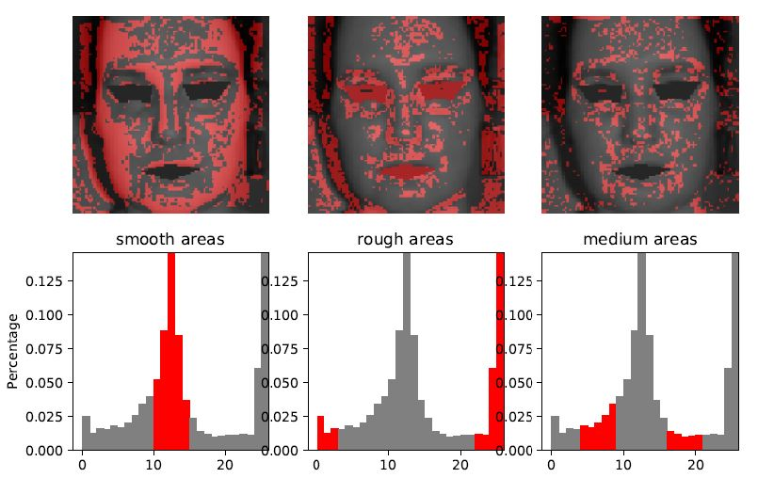

**17. Conclusion**

After trying the OpenCV and CNN (Convolutional Neural Network) methodologies for masking eyes and mouth, it can be concluded that the Neural Network approach is generating way more precise results, also ensuring there is no loss of essential information such as dark circles under the eyes. However, CNN approach is more complicate, needs good amount of training data and experimentation to arrive at an optimal solution.

LBP (Local Binary Patterns) algorithm proved to be highly effective methodology to perform texture analysis of any surface, especially skin. Reason being, its ability to capture fine grain details about the texture of the subject in the image.

**18. Recommendations/Directions for future**

* To improve accuracy of CNN model, improve the training data set by introducing more labelled image data
* Extend the solution to compare the efficacy of single product/chemical over multiple ethnicity/age/gender groups of participants.
* Extend the solution to compare the efficacy of multiple products/chemicals
* Improve the visualization with interactive features

**19. Appendices**

**List of Tables**

Table 1: Project plan & Deliverables…………………………………………………….…………………………… 9

**List of Figures**

Figure 1.1: Solution Architecture ...........................................................................................9

**List of Output Screens**

Figure 2.1: Masked Image for Participant 1………………………………………………………..………...…11

Figure 2.2: Masked Image for Participant 2 (different ethnicity/age)……………..……………….11

Figure 3.1: Before using a facial cream (Participant 3) ……………………………………………..…….12

Figure 3.2: After using a facial cream (Participant 3)…………………………………………………...….12

Figure 4.1: Before using a facial cream (Participant 4) ………………………………………………..….13

Figure 4.2: After using a facial cream (Participant 4) ………………………………………………..…….13

**20. Bibliography / References**

* MIT lecture on CNN**:** <https://www.youtube.com/watch?v=H-HVZJ7kGI0&t=10s>
* A Comprehensive Guide to Convolutional Neural Networks — the ELI5 way <https://towardsdatascience.com/a-comprehensive-guide-to-convolutional-neural-networks-the-eli5-way-3bd2b1164a53>
* Wikipedia CNN: <https://en.wikipedia.org/wiki/Convolutional_neural_network>
* Wikipedia LBP: <https://en.wikipedia.org/wiki/Local_binary_patterns>
* Local Binary Patterns with Python & OpenCV: <https://www.pyimagesearch.com/2015/12/07/local-binary-patterns-with-python-opencv/>
* LBP examples (scikit-image): <https://scikit-image.org/docs/dev/auto_examples/>

**21. List of Publications / Conference Presentations**

* Presented masked images and LBP solutions to a team
* Demonstrated progress on regular basis to the management
* Got the solution peer reviewed on multiple occassions

**22. Check list of items for final report (with Yes or No marked, as applicable)**

a) Is the Cover page in proper format? **Y** / N

b) Is the Title page in proper format? **Y** / N

c) Is the Certificate from the Supervisor in proper format? Has it been signed? **Y** / N

d) Is Abstract included in the Report? Is it properly written? **Y** / N

e) Does the Table of Contents’ page include chapter page numbers? **Y** / N

f) Is Introduction included in the report? Is it properly written? **Y** / N

g) Are the Pages numbered properly? **Y** / N

h) Are the Figures numbered properly? **Y** / N

i) Are the Tables numbered properly? **Y** / N

j) Are the Captions for the Figures and Tables proper? **Y** / N

k) Are the Appendices numbered? **Y** / N

l) Does the Report have Conclusions/ Recommendations of the work? **Y** / N

m) Are References/ Bibliography given in the Report? **Y** / N

n) Have the References been cited in the Report? **Y** / N

o) Is the citation of References/ Bibliography in proper format? **Y** / N