Q) Different programming paradigms
Ans:
-Monolithic Programmin
-Modular/Procedural Programming
-OOP (Object-Oriented)
-Aspect-Oriented/component Assembly

Monolithic – entire program code is a single file- single block
Modular – dividing the program into different blocks – multiple programmers can work together to complete a program, each programmer taking care of different blocks
OOP- Object-oriented programming (OOP) refers to a type of computer programming (software design) in which programmers define the data type of a data structure, and also the types of operations (functions) that can be applied to the data structure.
Object-oriented programming (OOP) is a programming paradigm based on the concept of "objects", which can contain data, in the form of fields (often known as attributes or properties), and code, in the form of procedures (often known as methods).

Q) What is Algorithm?
Ans:
a finite sequence of well-defined, computer-implementable instructions, typically to solve a class of problems or to perform a computation.
The word Algorithm means “a process or set of rules to be followed in calculations or other problem-solving operations”. Therefore Algorithm refers to a set of rules/instructions that step-by-step define how a work is to be executed upon in order to get the expected results.
Algorithms are written using pseudo-code.

Q) What is a namespace? How to use it?
Ans:
Namespaces allow us to group named entities that otherwise would have global scope into narrower scopes, giving them namespace scope. This allows organizing the elements of programs into different logical scopes referred to by names.
- Namespace is a feature added in C++ and not present in C.
- A namespace is a declarative region that provides a scope to the identifiers (names of the types, function, variables etc) inside it.
- Multiple namespace blocks with the same name are allowed. All declarations within those blocks are declared in the named scope.
A namespace definition begins with the keyword namespace followed by the namespace name as follows:
namespace namespace_name
{
int x, y; // code declarations where
// x and y are declared in
// namespace_name's scope
}
- Namespace declarations appear only at global scope.
- Namespace declarations can be nested within another namespace.
- Namespace declarations don’t have access specifiers. (Public or private)
- No need to give semicolon after the closing brace of definition of namespace.
- We can split the definition of namespace over several units.

In each scope, a name can only represent one entity. So, there cannot be two variables with the same name in the same scope. Using namespaces, we can create two variables or member functions having the same name.

Using namespace:-
#include <iostream>
using namespace std;
namespace ns1
{
int value() { return 5; }
}
namespace ns2
{
const double x = 100;
double value() { return 2*x; }
}

int main()
{
// Access value function within ns1
cout << ns1::value() << '\n';

// Access value function within ns2
cout << ns2::value() << '\n';

// Access variable x directly
cout << ns2::x << '\n';

return 0;
}

Classes in namespace

Method1 – inside namespace

namespace ns
{
// A Class in a namespace
class geek
{
public:
void display()
{
cout << "ns::geek::display()\n";
}
};
}

Method2 – outside namespace

namespace ns
{
// Only declaring class here
class geek;
}

// Defining class outside
class ns::geek
{
public:
void display()
{
cout << "ns::geek::display()\n";
}
};

Defining methods
// Creating a namespace
namespace ns
{
void display();
class geek
{
public:
void display();
};
}

// Defining methods of namespace
void ns::geek::display()
{
cout << "ns::geek::display()\n";
}
void ns::display()
{
cout << "ns::display()\n";
}

Namespaces can be defined in parts.It is also possible to create two namespace blocks having the same name. The second namespace block is nothing but actually the continuation of the first namespace. In simpler words, we can say that both the namespaces are not different but actually the same, which are being defined in parts.
Eg:
// first name space
namespace first
{
int val1 = 500;
}

// rest part of the first namespace
namespace first
{
int val2 = 501;
}

int main()
{
cout << first::val1 <<"\n";
cout << first::val2 <<"\n";
return 0;
}

Namespaces need not be named.
They are directly usable in the same program and are used for declaring unique identifiers.
- In unnamed namespaces, name of the namespace in not mentioned in the declaration of namespace.
- The name of the namespace is uniquely generated by the compiler.
- The unnamed namespaces you have created will only be accessible within the file you created it in.
- Unnamed namespaces are the replacement for the static declaration of variables.

“using” directive

namespace geek
{
int rel = 300;
}

// use of ‘using’ directive
using namespace geek;

int main()
{
// variable ‘rel’ accessed
// without using scope resolution variable
cout << rel << "\n"; //prints 300

return 0;
}

Q) How is Heap memory allocated/deallocated in C++?
Ans:
int *p;
p = new int[5];

p will be in stack but the memory for 5 integers will be allocated in heap.

To deallocate the memory, use
delete []p;
p=NULL;

Q) Pointer arithmetic
Ans:

int A[4]={2,4,6,8};
int *p=A; //say p=2000

3 operations allowed using pointers:

1) ++/--
p++; //new value of p=2004

p--; //new value of p=1996

2) Addition/Subtraction
p=p+2; //new value of p=2008

p=p-3; //new value of p=1988

3) Pointer subtraction
Say q=&A[3]; //q=2012

d = p-q; //d=3 =(2012-2000)/4

Section II – Object Oriented Programming (OOPS)

Definition of OOP

Object-oriented programming (OOP) is a programming language model that organizes software design around data, or objects, rather than functions and logic. An object can be defined as a data field that has unique attributes and behavior.

OOP focuses on the objects that developers want to manipulate rather than the logic required to manipulate them. This approach to programming is well-suited for programs that are large, complex and actively updated or maintained. Due to the organization of an object-oriented program, this method is also conducive to collaborative development where projects can be divided into groups. Additional benefits of OOP include code reusability, scalability efficiency.

Principles of OOP

Object-oriented programming is based on the following principles:
- Encapsulation- The implementation and state of each object are privately held inside a defined or class. Other objects do not have access to this class or the authority to make changes but are only able to call a list of public or methods. This characteristic of data hiding provides greater program security and avoids unintended data corruption.
- Abstraction- Objects only reveal internal mechanisms that are relevant for the use of other objects, hiding any unnecessary implementation code. This concept helps developers make changes and additions over time more easily.
- Inheritance- Relationships and subclasses between objects can be assigned, allowing developers to reuse a common logic while still maintaining a unique hierarchy. This property of OOP forces a more thorough data analysis, reduces development time and ensures a higher level of accuracy.
- Polymorphism- Objects are allowed to take on more than one form depending on the context. The program will determine which meaning or usage is necessary for each execution of that object, cutting down on the need to duplicate code.

Q) What is a class?
Ans:
A class is an entity that determines how an object will behave and what the object will contain. In other words, it is a blueprint or a set of instruction to build a specific type of object.

class <class_name>{
field;
method;
}
A class in C++ is the building block, that leads to Object-Oriented programming. It is a user-defined data type, which holds its own data members and member functions, which can be accessed and used by creating an instance of that class.

Q) What is an object?
Ans:
Object is an entity that has state and behavior. Here, state means data and behavior means functionality.
Object is a runtime entity, it is created at runtime.
Object is an instance of a class. All the members of the class can be accessed through object.

Q) Accessors and Mutators?
Ans:
Accessing data members of a class depends upon the access specifiers of these members. Sometimes there is a necessity to provide access even to private data members. In this case technique of Accessors (getters) and Mutators (setters) are used.

The access to public data members can be done by using dot operator (arrow operator in the case of pointers).
The access to private data members outside of class is allowed only to friend classes or functions. But you can specify a special function Accessor to get the value of private data member. In this case a good style is to start name of this function with get, followed by the data member identifier. The return type must be the same as type of the data member.
Accessors are often used to perform some additional checks before returning a value
Mutators (setters) are used to set values of private data members. One of the main goals of a mutator is to check correctness of the value to be set to data member. A setter’s name starts with set, followed by name of data member. Setter must have one parameter of the same type as the data member to bet set by the setter.
Protected data members can be accessed in the same way as public data members from friend functions or classes and from derived classes. If you need to provide access to protected data members from any other functions, you will have to use the same technique as for accessing private data members.

Q) What are constructors?
Ans:
A constructor is a member function of a class which initializes objects of a class. In C++, Constructor is automatically called when object(instance of class) create. It is special member function of the class.
- Constructor has same name as the class itself
- Constructors don’t have return type
- A constructor is automatically called when an object is created.
- If we do not specify a constructor, C++ compiler generates a default constructor for us (expects no parameters and has an empty body).

Types of constructors
===============
1) Default Constructors: Default constructor is the constructor which doesn’t take any argument. It has no parameters. Even if we do not define any constructor explicitly, the compiler will automatically provide a default constructor implicitly.
2) Parameterized Constructors: It is possible to pass arguments to constructors. Typically, these arguments help initialize an object when it is created. To create a parameterized constructor, simply add parameters to it the way you would to any other function. When you define the constructor’s body, use the parameters to initialize the object. When an object is declared in a parameterized constructor, the initial values have to be passed as arguments to the constructor function. The normal way of object declaration may not work. The constructors can be called explicitly or implicitly.
Uses of Parameterized constructor:
- It is used to initialize the various data elements of different objects with different values when they are created.
- It is used to overload constructors.
Whenever we define one or more non-default constructors( with parameters ) for a class, a default constructor( without parameters ) should also be explicitly defined as the compiler will not provide a default constructor in this case. However, it is not necessary but it’s considered to be the best practice to always define a default constructor.

3) Copy Constructor: A copy constructor is a member function which initializes an object using another object of the same class.
A copy constructor has the following general function prototype:
ClassName (const ClassName &old_obj);
// Copy constructor
Point(const Point &p2) {x = p2.x; y = p2.y; }

Point p2 = p1; // Copy constructor is called here

In C++, a Copy Constructor may be called in following cases:
1. When an object of the class is returned by value.
2. When an object of the class is passed (to a function) by value as an argument.
3. When an object is constructed based on another object of the same class.
4. When the compiler generates a temporary object.

Q) Difference between shallow copy and deep copy?
Ans:
A shallow copy of an object copies all of the member field values. This works well if the fields are values, but may not be what you want for fields that point to dynamically allocated memory. The pointer will be copied. but the memory it points to will not be copied -- the field in both the original object and the copy will then point to the same dynamically allocated memory, which is not usually what you want. The default copy constructor and assignment operator make shallow copies.

A deep copy copies all fields, and makes copies of dynamically allocated memory pointed to by the fields. To make a deep copy, you must write a copy constructor and overload the assignment operator, otherwise the copy will point to the original, with disasterous consequences.
If an object has pointers to dynamically allocated memory, and the dynamically allocated memory needs to be copied when the original object is copied, then a deep copy is required.
A class that requires deep copies generally needs:
- A constructor to either make an initial allocation or set the pointer to NULL.
- A destructor to delete the dynamically allocated memory.
- A copy constructor to make a copy of the dynamically allocated memory.
- An overloaded assignment operator to make a copy of the dynamically allocated memory.

If we don’t define our own copy constructor, the C++ compiler creates a default copy constructor for each class which does a member-wise copy between objects. The compiler created copy constructor works fine in general. We need to define our own copy constructor only if an object has pointers or any runtime allocation of the resource like file handle, a network connection..etc.
Default constructor does only shallow copy.
Deep copy is possible only with user defined copy constructor. In user defined copy constructor, we make sure that pointers (or references) of copied object point to new memory locations.

Copy constructor is called when a new object is created from an existing object, as a copy of the existing object. Assignment operator is called when an already initialized object is assigned a new value from another existing object.

Q) Can we make copy constructor private?
Ans:
Yes, a copy constructor can be made private. When we make a copy constructor private in a class, objects of that class become non-copyable. This is particularly useful when our class has pointers or dynamically allocated resources. In such situations, we can either write our own copy constructor or make a private copy constructor so that users get compiler errors rather than surprises at runtime.

Q) Why argument to a copy constructor must be passed as a reference?
Ans:
A copy constructor is called when an object is passed by value. Copy constructor itself is a function. So if we pass an argument by value in a copy constructor, a call to copy constructor would be made to call copy constructor which becomes a non-terminating chain of calls. Therefore compiler doesn’t allow parameters to be passed by value.

Q) Why argument to a copy constructor should be const?
Ans:
We should use const in C++ wherever possible so that objects are not accidentally modified.
When a function returns an object, the compiler creates a temporary object which is copied using copy constructor.
Compiler created temporary objects cannot be bound to non-const references and the original program tries to do that. It doesn’t make sense to modify compiler created temporary objects as they can die any moment.

Q) Types of functions in a class?
Ans:
-Default constructors
-Parameterized constructors
-Copy constructors
-Accessors
-Mutators
-Facilitators
-Enquiry
-Destructors

Q) Scope resolution operator?
Ans:
It is used for following purposes.
1) To access a global variable when there is a local variable with same name:
2) To define a function outside a class.
3) To access a class’s static variables.
4) In case of multiple Inheritance:
If same variable name exists in two ancestor classes, we can use scope resolution operator to distinguish.
5) For namespace
If a class having the same name exists inside two namespace we can use the namespace name with the scope resolution operator to refer that class without any conflicts
6) Refer to a class inside another class:
If a class exists inside another class we can use the nesting class to refer the nested class using the scope resolution operator

Q) Difference in defining member function outside the class and inside the class?
Ans:
If a function is defined inside the class, wherever the function is called, the machine code of the function is expanded there. These are inline functions.

If the function is defined outside the class, the function call results in program jumping to the machine code of the function and returning back to the next instruction after function execution.

Q) How to make a function inline?
Ans:
-If we define the function inside a class, it is by default inline.
-using “inline” keyword

Q) What is this pointer?
Ans:
The ‘this’ pointer is passed as a hidden argument to all nonstatic member function calls and is available as a local variable within the body of all nonstatic functions. ‘this’ pointer is not available in static member functions as static member functions can be called without any object (with class name).
For a class X, the type of this pointer is ‘X* ‘. Also, if a member function of X is declared as const, then the type of this pointer is ‘const X *’.
Following are the situations where ‘this’ pointer is used:
1) When local variable’s name is same as member’s name
For constructors, initializer list can also be used when parameter name is same as member’s name.
2) To return reference to the calling object

Q) What is operator overloading?
Ans:
In C++, we can make operators to work for user defined classes. This means C++ has the ability to provide the operators with a special meaning for a data type, this ability is known as operator overloading.
For example, we can overload an operator ‘+’ in a class like String so that we can concatenate two strings by just using +.

Q) What is the difference between operator functions and normal functions?
Operator functions are same as normal functions. The only differences are, name of an operator function is always operator keyword followed by symbol of operator and operator functions are called when the corresponding operator is used.
Q) Can we overload all operators?
Almost all operators can be overloaded except few. Following is the list of operators that cannot be overloaded.
. (dot)
::
?:
sizeof

Q) Why can't I overload dot, ::, sizeof, etc.?
Ans:
Most operators can be overloaded by a programmer. The exceptions are
. (dot) :: ?: sizeof
There is no fundamental reason to disallow overloading of ?:. I just didn't see the need to introduce the special case of overloading a ternary operator. Note that a function overloading expr1?expr2:expr3 would not be able to guarantee that only one of expr2 and expr3 was executed.
Sizeof cannot be overloaded because built-in operations, such as incrementing a pointer into an array implicitly depends on it. Consider:
X a[10];
X* p = &a[3];
X* q = &a[3];
p++; // p points to a[4]
// thus the integer value of p must be
// sizeof(X) larger than the integer value of q
Thus, sizeof(X) could not be given a new and different meaning by the programmer without violating basic language rules.
In N::m neither N nor m are expressions with values; N and m are names known to the compiler and :: performs a (compile time) scope resolution rather than an expression evaluation. One could imagine allowing overloading of x::y where x is an object rather than a namespace or a class, but that would - contrary to first appearances - involve introducing new syntax (to allow expr::expr). It is not obvious what benefits such a complication would bring.
Operator . (dot) could in principle be overloaded using the same technique as used for ->. However, doing so can lead to questions about whether an operation is meant for the object overloading . or an object referred to by . For example:
class Y {
public:
void f();
// ...
};

class X { // assume that you can overload .
Y* p;
Y& operator.() { return *p; }
void f();
// ...
};

void g(X& x)
{
x.f(); // X::f or Y::f or error?
}
This problem can be solved in several ways. At the time of standardization, it was not obvious which way would be best.

Q) What is friend oeprator overloading?
Ans:
Friend function using operator overloading offers better flexibility to the class.
These functions are not a members of the class and they do not have 'this' pointer.
When you overload a unary operator you have to pass one argument.
When you overload a binary operator you have to pass two arguments.
Friend function can access private members of a class directly.

Syntax:
friend return-type operator operator-symbol (Variable 1, Varibale2)
{
//Statements;
}

Q) What is inheritance?
Ans:
The capability of a class to derive properties and characteristics from another class is called Inheritance. Inheritance is one of the most important feature of Object Oriented Programming.
Sub Class: The class that inherits properties from another class is called Sub class or Derived Class.
Super Class:The class whose properties are inherited by sub class is called Base Class or Super class.

Implementing inheritance in C++: For creating a sub-class which is inherited from the base class we have to follow the below syntax.
Syntax:
class subclass_name : access_mode base_class_name
{
//body of subclass
};
Here, subclass_name is the name of the sub class, access_mode is the mode in which you want to inherit this sub class for example: public, private etc. and base_class_name is the name of the base class from which you want to inherit the sub class.
Note: A derived class doesn’t inherit access to private data members. However, it does inherit a full parent object, which contains any private members which that class declares.

Q) What are the different modes of inheritance?
Ans:
Public mode: If we derive a sub class from a public base class. Then the public member of the base class will become public in the derived class and protected members of the base class will become protected in derived class.
Protected mode: If we derive a sub class from a Protected base class. Then both public member and protected members of the base class will become protected in derived class.
Private mode: If we derive a sub class from a Private base class. Then both public member and protected members of the base class will become Private in derived class.
Note : The private members in the base class cannot be directly accessed in the derived class, while protected members can be directly accessed.
The below table summarizes the above three modes and shows the access specifier of the members of base class in the sub class when derived in public, protected and private modes:
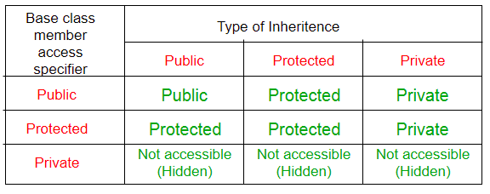

Q) Which class constructor will be executed first, derived or base?
Ans:
Base class constructor.

Q) How to call base class constructor from derived class constructor?
Ans:

Derived(int x, int y) : Base(x)
{
//statements
}

Q) What is isA and hasA?
Ans:
In object-oriented programming, the concept of IS-A is a totally based on Inheritance, which can be of two types Class Inheritance or Interface Inheritance. It is just like saying "A is a B type of thing". For example, Apple is a Fruit, Car is a Vehicle etc. Inheritance is uni-directional. For example, House is a Building. But Building is not a House.

Composition(HAS-A) simply mean the use of instance variables that are references to other objects.
A HAS-A relationship is dynamic (run time ) binding while inheritance is a static (compile time ) binding.

Q) What are the types of inheritance?
Ans:
Single Inheritance: In single inheritance, a class is allowed to inherit from only one class. i.e. one sub class is inherited by one base class only.
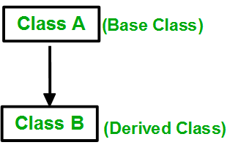

Multiple Inheritance: Multiple Inheritance is a feature of C++ where a class can inherit from more than one classes. i.e one sub class is inherited from more than one base classes.
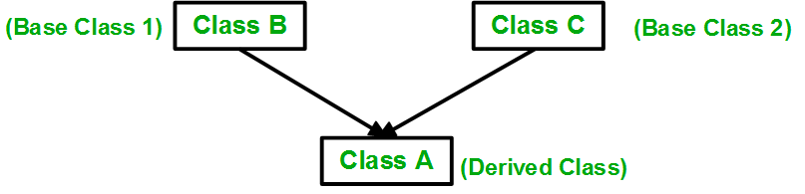

Multilevel Inheritance: In this type of inheritance, a derived class is created from another derived class.

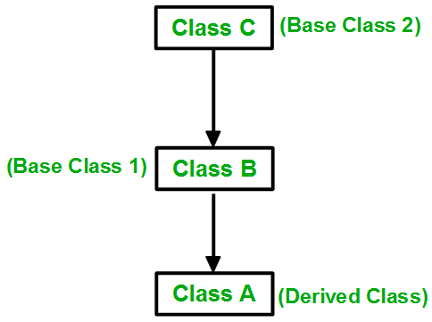

Hierarchical Inheritance: In this type of inheritance, more than one sub class is inherited from a single base class. i.e. more than one derived class is created from a single base class.

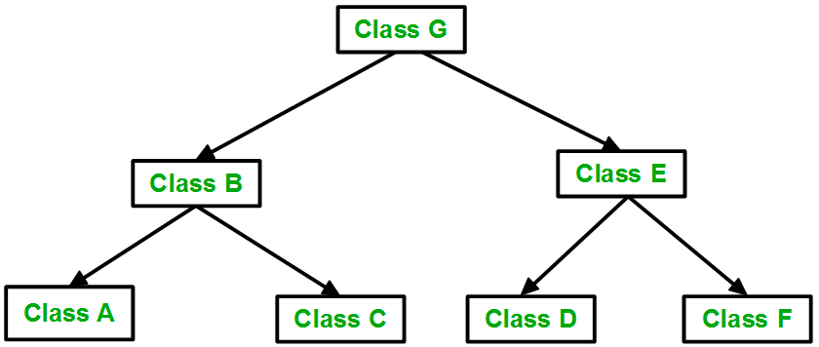

Hybrid (Virtual) Inheritance: Hybrid Inheritance is implemented by combining more than one type of inheritance. For example: Combining Hierarchical inheritance and Multiple Inheritance.
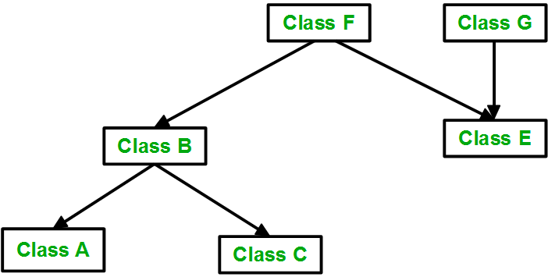

Q) What is virtual base class?
Ans:
Virtual base classes are used in virtual inheritance in a way of preventing multiple “instances” of a given class appearing in an inheritance hierarchy when using multiple inheritances.

Syntax 1:
class B : virtual public A
{
};

Syntax 2:
class C : public virtual A
{
};
To resolve this ambiguity when class A is inherited in both class B and class C, it is declared as virtual base class by placing a keyword virtual.
Note: virtual can be written before or after the public. Now only one copy of data/function member will be copied to class C and class B and class A becomes the virtual base class.
Virtual base classes offer a way to save space and avoid ambiguities in class hierarchies that use multiple inheritances. When a base class is specified as a virtual base, it can act as an indirect base more than once without duplication of its data members. A single copy of its data members is shared by all the base classes that use virtual base.

Q) Difference between private and protected members?
Ans:
Private members are only accessible within the class defining them. Protected members are accessible in the class that defines them and in classes that inherit from that class. Edit: Both are also accessible by friends of their class, and in the case of protected members, by friends of their derived classes.

The class members declared as private can be accessed only by the functions inside the class. They are not allowed to be accessed directly by any object or function outside the class. Only the member functions or the friend functions are allowed to access the private data members of a class.

Q) Generalization vs Specialization
Ans:
Generalization is the process of extracting shared characteristics from two or more classes, and combining them into a generalized superclass. Shared characteristics can be attributes, associations, or methods. Purpose of generalization – polymorphism.

Specialization means creating new subclasses from an existing class. If it turns out that certain attributes, associations, or methods only apply to some of the objects of the class, a subclass can be created. The most inclusive class in a generalization/specialization is called the superclass and is generally located at the top of the diagram. The more specific classes are called subclasses and are generally placed below the superclass.

All statements that are made about a superclass also apply to all subclasses. We say that subclasses “inherit” attributes, associations, and operations from the superclass.
Anything that can be done with an object of the superclass can also be done with an object of the subclass.

Q) If the pointer is a base class object, can it call derived class functions?
Ans:
No.
Base *p;
p=new Derived;
p->funBase1; //this is fine
p->funDerived1; //not fine

Q) Can a derived class pointer point to a object of base class?
Ans:
No.
Q) Can a base class pointer point to a derived class object?
Ans:
Yes. But it cannot call derived class functions.

Q) What is function overriding?
Ans:
When the base class and derived class have member functions with exactly the same name, same return-type, and same arguments list, then it is said to be function overriding.

The following example shows how function overriding is done in C++, which is an objectoriented programming language −
#include <iostream>
using namespace std;

class A {
public:
void display() {
cout<<"Base class";
}
};

class B:public A {
public:
void display() {
cout<<"Derived Class";
}
};

int main() {
B obj;
obj.display();
return 0;
}

It will produce the following output
Derived Class
Function overriding is a feature that allows us to have a same function in child class which is already present in the parent class. A child class inherits the data members and member functions of parent class, but when you want to override a functionality in the child class then you can use function overriding. It is like creating a new version of an old function, in the child class.

Note: In function overriding, the function in parent class is called the overridden function and function in child class is called overriding function.

If you want to call the overridden function by using the object of child class, you can do that by creating the child class object in such a way that the reference of parent class points to it.

If you want to call the Overridden function from overriding function then you can do it like this:
parent_class_name::function_name

Q) What are virtual functions?
Ans:
A virtual function a member function which is declared within a base class and is re-defined(Overriden) by a derived class. When you refer to a derived class object using a pointer or a reference to the base class, you can call a virtual function for that object and execute the derived class’s version of the function.
- Virtual functions ensure that the correct function is called for an object, regardless of the type of reference (or pointer) used for function call.
- They are mainly used to achieve Runtime polymorphism
- Functions are declared with a virtual keyword in base class.
- The resolving of function call is done at Run-time.
Rules for Virtual Functions
- Virtual functions cannot be static and also cannot be a friend function of another class.
- Virtual functions should be accessed using pointer or reference of base class type to achieve run time polymorphism.
- The prototype of virtual functions should be same in base as well as derived class.
- They are always defined in base class and overridden in derived class. It is not mandatory for derived class to override (or re-define the virtual function), in that case base class version of function is used.
- A class may have virtual destructor but it cannot have a virtual constructor.

Runtime polymorphism is achieved only through a pointer (or reference) of base class type. Also, a base class pointer can point to the objects of base class as well as to the objects of derived class.
Late binding(Runtime) is done in accordance with the content of pointer (i.e. location pointed to by pointer) and Early binding(Compile time) is done according to the type of pointer, since print() function is declared with virtual keyword so it will be bound at run-time (output is print derived class as pointer is pointing to object of derived class ) and show() is non-virtual so it will be bound during compile time(output is show base class as pointer is of base type ).
NOTE: If we have created a virtual function in the base class and it is being overridden in the derived class then we don’t need virtual keyword in the derived class, functions are automatically considered as virtual functions in the derived class.

Q) Explain how the virtual functions work?
Ans:
If a class contains a virtual function then compiler itself does two things:
- If object of a class is created then a virtual pointer(VPTR) is inserted as a data member of the class to point to VTABLE of that class. For each new object created, a new virtual pointer is inserted as a data member of that class.
- Irrespective of object is created or not, a static array of function pointer called VTABLE where each cell contains the address of each virtual function contained in that class.

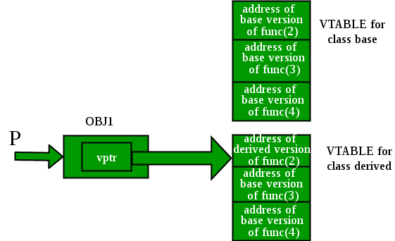

Initially, we create a pointer of type base class and initialize it with the address of the derived class object. When we create an object of the derived class, the compiler creates a pointer as a data member of the class, containing the address of VTABLE of the derived class.

Q) What is an abstract class?
Ans:
Implementation of all functions cannot be provided in a base class because we don’t know the implementation. Such a class is called abstract class. You cannot create objects of the abstract class but you can have pointers. Child classes must override the functions. Achieves run-time polymorphism.
A class is abstract if it has at least one pure virtual function.
We can have pointers and references of abstract class type.
If we do not override the pure virtual function in derived class, then derived class also becomes abstract class.
An abstract class can have constructors.

Q) What is an interface?
Ans:
An interface does not have implementation of any of its methods, it can be considered as a collection of method declarations. In C++, an interface can be simulated by making all methods as pure virtual.

Q) Types of base classes and use?
Ans:
All concrete functions -----> Reusability
All virtual functions -----> Polymorphism
Some concrete+some virtual -----> Reusability+Polymorphism

Q) What is a pure virtual function?
Ans:
A pure virtual function (or abstract function) in C++ is a virtual function for which we don’t have implementation, we only declare it. A pure virtual function is declared by assigning 0 in declaration.

// An abstract class
class Test
{
// Data members of class
public:
// Pure Virtual Function
virtual void show() = 0;

/* Other members */
};

A pure virtual function is implemented by classes which are derived from a Abstract class.

Q) What is a friend function?
Ans:
A friend function can be given special grant to access private and protected members. A friend function can be:
a) A method of another class
b) A global function

Q) What is a friend class?
Ans:
A friend class can access private and protected members of other class in which it is declared as friend. It is sometimes useful to allow a particular class to access private members of other class.

Following are some important points about friend functions and classes:
1) Friends should be used only for limited purpose. Too many functions or external classes are declared as friends of a class with protected or private data, it lessens the value of encapsulation of separate classes in object-oriented programming.
2) Friendship is not mutual. If class A is a friend of B, then B doesn’t become a friend of A automatically.
3) Friendship is not inherited

Q) What are static members?
Ans:
When we declare a member of a class as static it means no matter how many objects of the class are created, there is only one copy of the static member.
A static member is shared by all objects of the class. All static data is initialized to zero when the first object is created, if no other initialization is present.
We can't put it in the class definition but it can be initialized outside the class
Redeclare the static variable, using the scope resolution operator :: to identify which class it belongs to.
Usually used as counters.

Static member functions:-
By declaring a function member as static, you make it independent of any particular object of the class. A static member function can be called even if no objects of the class exist and the static functions are accessed using only the class name and the scope resolution operator ::.
A static member function can only access static data member, other static member functions and any other functions from outside the class.
Static member functions have a class scope and they do not have access to the this pointer of the class. You could use a static member function to determine whether some objects of the class have been created or not.

Q) What are nested classes?
Ans:
A nested class is a class which is declared in another enclosing class. A nested class is a member and as such has the same access rights as any other member. The members of an enclosing class have no special access to members of a nested class; the usual access rules shall be obeyed.

Nested class can access the private members of the enclosing class. Enclosing class cannot access the private members of the nested class.

Enclosing class can use the objects of the inner class.
Exception Handling

Q) What are exceptions?
Ans:
Exceptions are run-time anomalies or abnormal conditions that a program encounters during its execution. There are two types of exceptions: a)Synchronous, b)Asynchronous(Ex:which are beyond the program’s control, Disc failure etc).

An exception is a problem that arises during the execution of a program. A C++ exception is a response to an exceptional circumstance that arises while a program is running, such as an attempt to divide by zero.

Q) How does C++ handle exceptions?
Ans:
C++ provides following specialized keywords for this purpose.
try: represents a block of code that can throw an exception.
catch: represents a block of code that is executed when a particular exception is thrown.
throw: Used to throw an exception. Also used to list the exceptions that a function throws, but doesn’t handle itself.
Assuming a block will raise an exception, a method catches an exception using a combination of the try and catch keywords. A try/catch block is placed around the code that might generate an exception. Code within a try/catch block is referred to as protected code, and the syntax for using try/catch as follows −
try {
// protected code
} catch( ExceptionName e1 ) {
// catch block
} catch( ExceptionName e2 ) {
// catch block
} catch( ExceptionName eN ) {
// catch block
}

Eg:
#include <iostream>
using namespace std;

int main()
{
int x = -1;

// Some code
cout << "Before try \n";
try {
cout << "Inside try \n";
if (x < 0)
{
throw x;
cout << "After throw (Never executed) \n";
}
}
catch (int x ) {
cout << "Exception Caught \n";
}

cout << "After catch (Will be executed) \n";
return 0;
}

Exceptions can be thrown anywhere within a code block using throw statement. The operand of the throw statement determines a type for the exception and can be any expression and the type of the result of the expression determines the type of exception thrown.
Following is an example of throwing an exception when dividing by zero condition occurs −
double division(int a, int b) {
if( b == 0 ) {
throw "Division by zero condition!";
}
return (a/b);
}

The catch block following the try block catches any exception. You can specify what type of exception you want to catch and this is determined by the exception declaration that appears in parentheses following the keyword catch.
try {
// protected code
} catch( ExceptionName e ) {
// code to handle ExceptionName exception
}
Above code will catch an exception of ExceptionName type. There is a special catch block called ‘catch all’ catch(…) that can be used to catch all types of exceptions.
If you want to specify that a catch block should handle any type of exception that is thrown in a try block, you must put an ellipsis, ..., between the parentheses enclosing the exception declaration as follows −
try {
// protected code
} catch(...) {
// code to handle any exception
}
Catch all block must be the last block if there are multiple catch blocks.
Implicit type conversion doesn’t happen for primitive types.
If an exception is thrown and not caught anywhere, the program terminates abnormally.
Throw and catch can be in different function blocks.

Q) How to indicate that a function may throw an exceptions?
Ans:
Functions can declare that they may throw an exception like below:
int division(int x,int y) throw(MyException)
{
//statements
}

If the function is declared such that it doesn’t throw any exception, and then if it throws, it is an error.

Q) Can a try statement have multiple catch blocks?
Ans:
A single try statement can have multiple catch statements. Execution of particular catch block depends on the type of exception thrown by the throw keyword. If throw keyword send exception of integer type, catch block with integer parameter will get execute.
Eg:
try
{
...
if x condition
throw 10;
if y condition
throw 12.4;
...
}
catch(int a)
{
...
}
catch(float b)
{
...
}

Q) IS nesting of tr...catch blocks possible?
Ans:
Yes.

Q) Which exception should be caught first, child class or base class?
Ans:
A derived class exception should be caught before a base class exception.
Template Class

Q) What are templates?
Ans:
Templates are used to pass data type as a parameter so that we don’t need to write the same code for different data types.
Templates are expanded at compiler time. This is like macros. The difference is, compiler does type checking before template expansion.
Source code contains only function/class, but compiled code may contain multiple copies of same function/class.

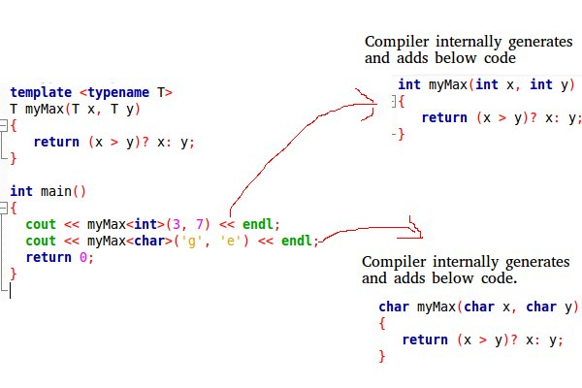

Function Templates We write a generic function that can be used for different data types.

T myMax(T x, T y)
{
return (x > y)? x: y;
}

cout << myMax<int>(3, 7) << endl;
cout << myMax<double>(3.0, 7.0) << endl;
cout << myMax<char>('g', 'e') << endl;

Class Templates Like function templates, class templates are useful when a class defines something that is independent of the data type. Can be useful for classes like LinkedList, BinaryTree, Stack, Queue, Array, etc.

template <typename T>
class Array {
private:
T *ptr;
int size;
public:
Array(T arr[], int s);
void print();
};

template <typename T>
Array<T>::Array(T arr[], int s) {
ptr = new T[s];
size = s;
for(int i = 0; i < size; i++)
ptr[i] = arr[i];
}

template <typename T>
void Array<T>::print() {
for (int i = 0; i < size; i++)
cout<<" "<<*(ptr + i);
cout<<endl;
}

int main() {
int arr[5] = {1, 2, 3, 4, 5};
Array<int> a(arr, 5);
a.print();
return 0;
}

Like normal parameters, we can pass more than one data types as arguments to templates.
template<class T, class U>
class A {
T x;
U y;
public:
A() { cout<<"Constructor Called"<<endl; }
};

Q) Can we pass nontype parameters to templates?
Ans:
We can pass non-type arguments to templates. Non-type parameters are mainly used for specifying max or min values or any other constant value for a particular instance of a template. The important thing to note about non-type parameters is, they must be const. The compiler must know the value of non-type parameters at compile time. Because compiler needs to create functions/classes for a specified non-type value at compile time.

Q) What is the difference between function overloading and templates?
Ans:
Both function overloading and templates are examples of polymorphism feature of OOP. Function overloading is used when multiple functions do similar operations, templates are used when multiple functions do identical operations.

Q) What is the use of const qualifier in C++?
Ans:
We use the const qualifier to declare a variable as constant. That means that we cannot change the value once the variable has been initialized. Using const has a very big benefit. For example, if you have a constant value of the value of PI, you wouldn't like any part of the program to modify that value. So you should declare that as a const.
Objects declared with const-qualified types may be placed in read-only memory by the compiler, and if the address of a const object is never taken in a program, it may not be stored at all.

Q) Difference between int const *ptr and int *const ptr?
Ans:
int const *ptr = &x; //pointer to a constant int variable. It cannot modify the variable x. But it can point to other variables.

int *const ptr = &x; //constant pointer to an int variable. It can modify x. But it cannot point to another variable.

Q) When to use constant functions?
Ans:
A function becomes const when the const keyword is used in the function’s declaration. The idea of const functions is not to allow them to modify the object on which they are called. It is recommended the practice to make as many functions const as possible so that accidental changes to objects are avoided.

When a function is declared as const, it can be called on any type of object. Non-const functions can only be called by non-const objects.

Q) What is the behavior of constant object?
Ans:
An object declared as const cannot be modified and hence, can invoke only const member functions as these functions ensure not to modify the object.
A const object can be created by prefixing the const keyword to the object declaration. Any attempt to change the data member of const objects results in a compile-time error.
Syntax:
const Class_Name Object_name;
Whenever an object is declared as const, it needs to be initialized at the time of declaration. however, the object initialization while declaring is possible only with the help of constructors.

Destructors

Q) What is destructor?
Destructor is a member function which destructs or deletes an object.
Destructors have same name as the class preceded by a tilde (~)
Destructors don’t take any argument and don’t return anything

Q) When is destructor called?
A destructor function is called automatically when the object goes out of scope:
(1) the function ends
(2) the program ends
(3) a block containing local variables ends
(4) a delete operator is called.

Q) Can there be more than one destructor in a class?
No, there can only one destructor in a class with classname preceded by ~, no parameters and no return type.

Q) When do we need to write a user-defined destructor?
If we do not write our own destructor in class, compiler creates a default destructor for us. The default destructor works fine unless we have dynamically allocated memory or pointer in class. When a class contains a pointer to memory allocated in class, we should write a destructor to release memory before the class instance is destroyed. This must be done to avoid memory leak.

Q) Can a destructor be virtual?
Yes, In fact, it is always a good idea to make destructors virtual in base class when we have a virtual function.
Deleting a derived class object using a pointer to a base class that has a non-virtual destructor results in undefined behavior. To correct this situation, the base class should be defined with a virtual destructor.
Making base class destructor virtual guarantees that the object of derived class is destructed properly, i.e., both base class and derived class destructors are called.
As a guideline, any time you have a virtual function in a class, you should immediately add a virtual destructor (even if it does nothing). This way, you ensure against any surprises later.

I/O stream

C++ comes with libraries which provides us with many ways for performing input and output. In C++ input and output is performed in the form of a sequence of bytes or more commonly known as streams.
- Input Stream: If the direction of flow of bytes is from the device(for example, Keyboard) to the main memory then this process is called input.
- Output Stream: If the direction of flow of bytes is opposite, i.e. from main memory to device( display screen ) then this process is called output.

Header files available in C++ for Input/Output operations are:
- iostream: iostream stands for standard input-output stream. This header file contains definitions to objects like cin, cout, cerr etc.
- iomanip: iomanip stands for input output manipulators. The methods declared in this files are used for manipulating streams. This file contains definitions of setw, setprecision etc.
- fstream: This header file mainly describes the file stream. This header file is used to handle the data being read from a file as input or data being written into the file as output.
The two keywords cout in C++ and cin in C++ are used very often for printing outputs and taking inputs respectively. These two are the most basic methods of taking input and printing output in C++. To use cin and cout in C++ one must include the header file iostream in the program.

Standard output stream (cout): Usually the standard output device is the display screen. The C++ cout statement is the instance of the ostream class. It is used to produce output on the standard output device which is usually the display screen. The data needed to be displayed on the screen is inserted in the standard output stream (cout) using the insertion operator(<<).

standard input stream (cin): Usually the input device in a computer is the keyboard. C++ cin statement is the instance of the class istream and is used to read input from the standard input device which is usually a keyboard.
The extraction operator(>>) is used along with the object cin for reading inputs. The extraction operator extracts the data from the object cin which is entered using the keboard.

Un-buffered standard error stream (cerr): The C++ cerr is the standard error stream which is used to output the errors. This is also an instance of the ostream class. As cerr in C++ is un-buffered so it is used when one needs to display the error message immediately. It does not have any buffer to store the error message and display later.

buffered standard error stream (clog): This is also an instance of iostream class and used to display errors but unlike cerr the error is first inserted into a buffer and is stored in the buffer until it is not fully filled. The error message will be displayed on the screen too.

File Handling through C++ Classes

In C++, files are mainly dealt by using three classes fstream, ifstream, ofstream available in fstream headerfile.
ofstream: Stream class to write on files
ifstream: Stream class to read from files
fstream: Stream class to both read and write from/to files.

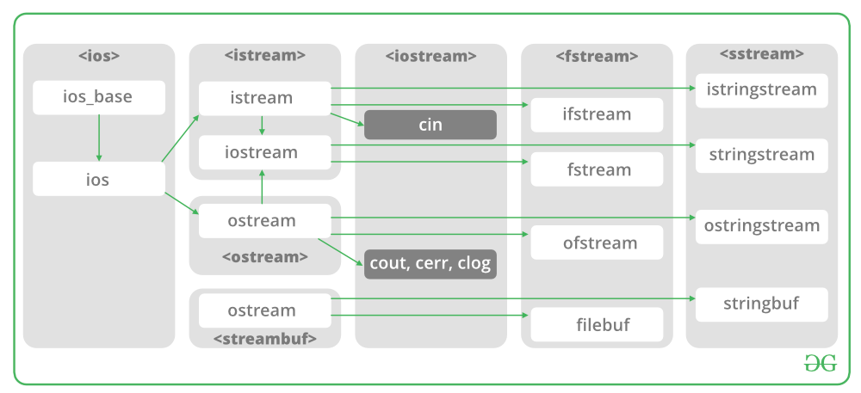

Now the first step to open the particular file for read or write operation. We can open file by
1. passing file name in constructor at the time of object creation
2. using the open method

Open File by using constructor
ifstream (const char* filename, ios_base::openmode mode = ios_base::in);
ifstream fin(filename, openmode) by default openmode = ios::in
ifstream fin(“filename”);
Open File by using open method
Calling of default constructor
ifstream fin;

fin.open(filename, openmode)
fin.open(“filename”);

Modes :
Member Constant | Stands For | Access
in * | input | File open for reading: the internal stream buffer supports input operations.
out | output | File open for writing: the internal stream buffer supports output operations.
binary | binary | Operations are performed in binary mode rather than text.
ate | at end | The output position starts at the end of the file.
app | append | All output operations happen at the end of the file, appending to its existing contents.
trunc | truncate | Any contents that existed in the file before it is open are discarded.

Q) Usage of is_open()?
Ans:

bool is_open() const;

Check if a file is open.
Streams can be associated to files by a successful call to member open or directly on construction, and disassociated by calling close or on destruction.

Q) Usage of is_eof()?
Ans:
The eof() method of ios class in C++ is used to check if the stream is has raised any EOF (End Of File) error. It means that this function will check if this stream has its eofbit set.
Syntax:
bool eof() const;
Parameters: This method does not accept any parameter.
Return Value: This method returns true if the stream has eofbit set, else false.

Q) What is serialization?
Ans:
Serialization consists of writing data and objects on a support (a file, a buffer, a socket), so that they can be reconstructed later in the memory of the same or another computing host. The reconstruction process is also known as deserialization.

Serializing a primitive type like a bool, int, or float, is trivial: just write the data as it is (assuming that no compression is used). Serializing a pointer is different: the object it points to must be serialized first. That way deserializing the pointer simply consists of setting its value to the memory address at which the object has been reconstructed.

Q) What are the manipulators in C++?
Ans:
Manipulators are helping functions that can modify the input/output stream. It does not mean that we change the value of a variable, it only modifies the I/O stream using insertion (<<) and extraction (>>) operators.
For example, if we want to print the hexadecimal value of 100 then we can print it as:
cout<<setbase(16)<<100
There are various types of manipulators:
- Manipulators without arguments: The most important manipulators defined by the IOStream library are provided below.
  - endl: It is defined in ostream. It is used to enter a new line and after entering a new line it flushes (i.e. it forces all the output written on the screen or in the file) the output stream.
  - ws: It is defined in istream and is used to ignore the whitespaces in the string sequence.
  - ends: It is also defined in ostream and it inserts a null character into the output stream. It typically works with std::ostrstream, when the associated output buffer needs to be null-terminated to be processed as a C string.
  - flush: It is also defined in ostream and it flushes the output stream i.e. it forces all the output written on the screen or in the file. Without flush, the output would be the same but may not appear in real-time.
Manipulators with Arguments: Some of the manipulators are used with the argument like setw (20), setfill (‘*’) and many more. These all are defined in the header file. If we want to use these manipulators then we must include this header file in our program.
For Example, you can use following manipulators to set minimum width and fill the empty space with any character you want: std::cout << std::setw (6) << std::setfill (’*’);
- Some important manipulators in <iomanip> are:
  - setw (val): It is used to sets the field width in output operations.
  - setfill (c): It is used to fill the character ‘c’ on output stream.
  - setprecision (val): It sets val as the new value for the precision of floating-point values.
  - setbase(val): It is used to set the numeric base value for numeric values.
  - setiosflags(flag): It is used to sets the format flags specified by parameter mask.
  - resetiosflags(m): It is used to resets the format flags specified by parameter mask.
- Some important manipulators in <ios> are:
  - showpos: It forces to show a positive sign on positive numbers.
  - noshowpos: It forces not to write a positive sign on positive numbers.
  - showbase: It indicates numeric base of numeric values.
  - uppercase: It forces uppercase letters for numeric values.
  - nouppercase: It forces lowercase letters for numeric values.
  - fixed: It uses decimal notation for ?oating-point values.
  - scientific: It use scientific floating-point notation.
  - hex: Read and write hexadecimal values for integers and it works same as the setbase(16).
  - dec: Read and write decimal values for integers i.e. setbase(10).
  - oct: Read and write octal values for integers i.e. setbase(10).
  - left: It adjust output to the left.
  - right: It adjust output to the right.

STL

Q) What is STL?
Ans:
The Standard Template Library (STL) is a set of C++ template classes to provide common programming data structures and functions such as lists, stacks, arrays, etc. It is a library of container classes, algorithms, and iterators. It is a generalized library and so, its components are parameterized. A working knowledge of template classes is a prerequisite for working with STL.
STL has four components
- Algorithms
- Containers
- Functions
- Iterators
Algorithms

The header algorithm defines a collection of functions especially designed to be used on ranges of elements.They act on containers and provide means for various operations for the contents of the containers.
- Algorithm
  - Sorting
  - Searching
  - Important STL Algorithms
  - Useful Array algorithms
  - Partition Operations
- Numeric
  - valarray class
Containers
Containers or container classes store objects and data. There are in total seven standard “first-class” container classes and three container adaptor classes and only seven header files that provide access to these containers or container adaptors.
- Sequence Containers: implement data structures which can be accessed in a sequential manner.
  - vector
  - list
  - deque
  - arrays
  - forward_list( Introduced in C++11)
- Container Adaptors : provide a different interface for sequential containers.
  - queue
  - priority_queue
  - stack
- Associative Containers : implement sorted data structures that can be quickly searched (O(log n) complexity).
  - set
  - multiset
  - map
  - multimap
- Unordered Associative Containers : implement unordered data structures that can be quickly searched
  - unordered_set (Introduced in C++11)
  - unordered_multiset (Introduced in C++11)
  - unordered_map (Introduced in C++11)
  - unordered_multimap (Introduced in C++11)
Functions
The STL includes classes that overload the function call operator. Instances of such classes are called function objects or functors. Functors allow the working of the associated function to be customized with the help of parameters to be passed.
- Functors
Iterators
As the name suggests, iterators are used for working upon a sequence of values. They are the major feature that allow generality in STL.
- Iterators
Utility Library
Defined under <utility header>
- pair

Q) What are vectors? Usage?
Ans:
Vectors are same as dynamic arrays with the ability to resize itself automatically when an element is inserted or deleted, with their storage being handled automatically by the container. Vector elements are placed in contiguous storage so that they can be accessed and traversed using iterators. In vectors, data is inserted at the end. Inserting at the end takes differential time, as sometimes there may be a need of extending the array. Removing the last element takes only constant time because no resizing happens. Inserting and erasing at the beginning or in the middle is linear in time.

Iterators
begin() – Returns an iterator pointing to the first element in the vector
- end() – Returns an iterator pointing to the theoretical element that follows the last element in the vector
- rbegin() – Returns a reverse iterator pointing to the last element in the vector (reverse beginning). It moves from last to first element
- rend() – Returns a reverse iterator pointing to the theoretical element preceding the first element in the vector (considered as reverse end)
- cbegin() – Returns a constant iterator pointing to the first element in the vector.
- cend() – Returns a constant iterator pointing to the theoretical element that follows the last element in the vector.
- crbegin() – Returns a constant reverse iterator pointing to the last element in the vector (reverse beginning). It moves from last to first element
- crend() – Returns a constant reverse iterator pointing to the theoretical element preceding the first element in the vector (considered as reverse end)
Capacity
- size() – Returns the number of elements in the vector.
- max_size() – Returns the maximum number of elements that the vector can hold.
- capacity() – Returns the size of the storage space currently allocated to the vector expressed as number of elements.
- resize(n) – Resizes the container so that it contains ‘n’ elements.
- empty() – Returns whether the container is empty.
- shrink_to_fit() – Reduces the capacity of the container to fit its size and destroys all elements beyond the capacity.
- reserve() – Requests that the vector capacity be at least enough to contain n elements.

Element access:
- reference operator [g] – Returns a reference to the element at position ‘g’ in the vector
- at(g) – Returns a reference to the element at position ‘g’ in the vector
- front() – Returns a reference to the first element in the vector
- back() – Returns a reference to the last element in the vector
- data() – Returns a direct pointer to the memory array used internally by the vector to store its owned elements.

Modifiers:
- assign() – It assigns new value to the vector elements by replacing old ones
- push_back() – It push the elements into a vector from the back
- pop_back() – It is used to pop or remove elements from a vector from the back.
- insert() – It inserts new elements before the element at the specified position
- erase() – It is used to remove elements from a container from the specified position or range.
- swap() – It is used to swap the contents of one vector with another vector of same type. Sizes may differ.
- clear() – It is used to remove all the elements of the vector container
- emplace() – It extends the container by inserting new element at position
- emplace_back() – It is used to insert a new element into the vector container, the new element is added to the end of the vector

