PROTOCOLS
A protocol is a standard set of rules that allow electronic devices to communicate with each other. These rules include what type of data may be transmitted, what commands are used to send and receive data, and how data transfers are confirmed.

RS-232
RS232 is a Serial Communication Standard developed by the Electronic Industry Association (EIA) and Telecommunications Industry Association (TIA).

RS232 defines the signals connecting between DTE and DCE. Here, DTE stands for Data Terminal Equipment and an example for DTE is a computer. DCE stands for Data Communication Equipment or Data Circuit Terminating Equipment and an example for DCE is a modem.
RS232 is one of the oldest serial communication standards with ensured simple connectivity and compatibility across different manufacturers.
RS232 uses serial communication, where one bit of data is sent at a time along a single data line.
The advantage of using serial communication over parallel communication is the number of wires required to make a full duplex data transmission will be very less (two wires are sufficient without considering electrical lines).
But the main drawback of RS232 standard is data rate and length of cable. RS232 supports a maximum baud rate of 19200 bps and the maximum length of the cable is 20 meters.
RS232 ensures that there is no conflict between the DTE and DCE devices by specifying:
- Electrical Specifications
- Mechanical Specifications
- Functional Specifications and
- Procedural Specifications
All these specifications provide us different parameters like common voltage levels, signal levels, pin wiring specifications, control data between the host device and its peripheral etc.

Electrical Characteristics
The electrical characteristics of RS232 defines the specifications related to voltage levels, line impedance and rate of change of signal levels.

Voltage Levels
The logic ‘1’ in RS232 is described as being in the voltage range of -15V to -3V and logic ‘0’ is described as the voltage range of +3V to +15V i.e. low level voltage is logic ‘1’ and high level voltage is logic ‘0’.
Typically, the logic ‘1’ in RS232 will be -12V and logic ‘0’ will be +12V. All the above mentioned voltages are with respect to a common ground ‘GND’ pin. Any voltage between -3V and +3V is considered to be an undefined logic state.
Historically, logic ’1’ (-15V to -3V) is referred to as Marking and logic ‘0’ (+3V to +15V) is referred to as Spacing.

Slew Rate
The other important electrical characteristic is the rate of change of signal levels i.e. the Slew Rate. The maximum slew rate in RS232 is limited to 30V/µs. Also, a maximum bit rate of 20 Kbps is also defined.
These limitations of the standard help in reducing the cross – talk with adjacent signals.

Line Impedance
The line impedance i.e. impedance of the wire between the DTE and DCE devices is specified to be around 3Ω to 7Ω.
Also, the original RS232 standard specifies the maximum length of the cable as 15 meters but the revised standards specify the maximum length in terms of capacitance per unit length.

Mechanical Specifications
The Mechanical Specifications of RS232 covers the mechanical interface of the standard. The RS232 standard specifies a 25 – pin D – Type connector to support the full functionality of RS232.
The DTE device uses a female outer casing with male pins and the DCE device uses a male outer casing with female pins.

There are three types of signals in RS232. They are data, control and ground. The following table shows the list of pins, their direction in communication along with their signal type.
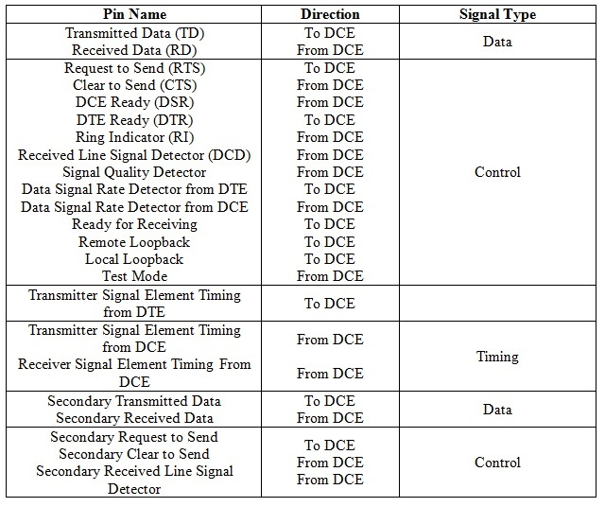

Most common applications do not require all the 25 pins in the connector. Hence, a reduced function 9 – pin connector is used commonly.
The 9 – pin connector is called as DE-9 (often wrongly called as DB-9) and it is a D – Type subminiature (D- Sub) connector.
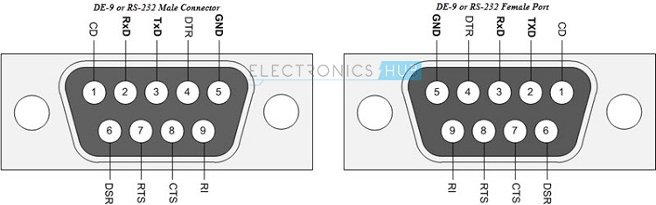
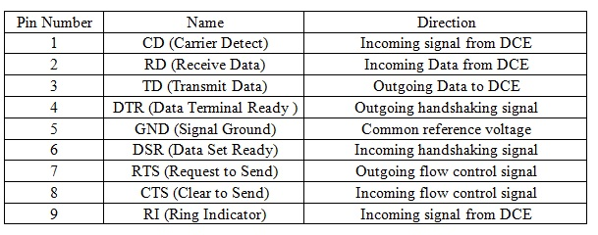
RS232 standard also defines the functions of different signals used in the interface.
The signals are classified as: Common, Data, Timing and Control Signals.

Procedural Specifications
The Procedural Specifications of RS232 specify the sequence of operations that must be carried out when a DTE and DCE are connected.
Assume a computer (DTE) is connected to a Modem (DCE) through RS232 interface. In order to send data from computer to Modem, the following procedure must be followed.
- When Modem (DCE) is ready to receive, it will send a DCE ready signal.
- When the computer (DTE) is ready to send the data, it sends a Ready to Send (RTS) signal.
- The Modem (DCE) then sends a Clear to Send (CTS) signal to indicate that data can be sent by computer (DTE).
- Finally, the Computer (DTE) sends data on Transmit Data (TD) line to the Modem (DCE).
Ics like MAX232 by Maxim Integrated take in the RS232 signals and generate a TTL level voltages. These ICs also invert the signals as low voltage levels in RS232 are logic ‘1’ and high voltage levels in RS232 are logic ‘0’.
RS232 follows asynchronous communication protocol i.e. there is no clock signal to synchronize transmitter and receiver. Hence, it uses start and stop bits to inform the receiver when to check for data.
There is a delay of certain time between the transmissions of each bit. This delay is nothing but an inactive state i.e. the signal is set to logic ‘1’ i.e. -12V (if you remember, logic ‘1’ in RS232 is -12V and logic ‘0’ is +12V).
First, the transmitter i.e. the DTE sends a Start bit to the receiver i.e. the DCE to inform it that data transmission starts from next bit. The Start bit is always ‘0’ i.e. +12V. The next 5 to 9 characters are data bits.
If parity bit is used, a maximum of 8 bits can be transmitted. If parity isn’t used, then 9 data bits can be transmitted. After the data is transmitted, the transmitter sends the stop bits. It can be either 1 bit or 1.5 bits or 2 bits long. The following image shows the frame format of the RS232 protocol.
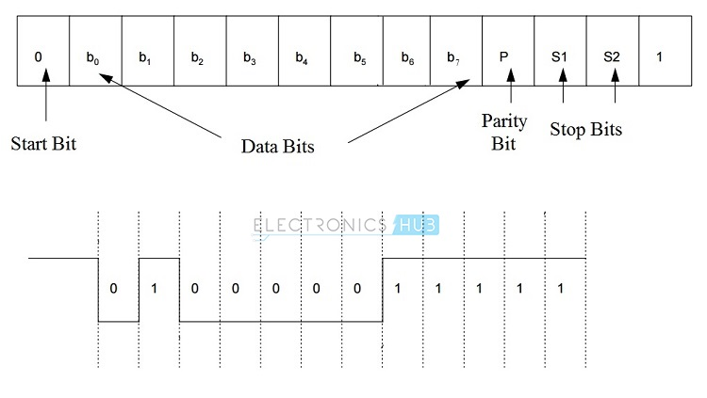

how does the Transmitter and Receiver, which might use different set of specifications, successfully transmit or receive the data? A process called Handshaking is used for this purpose.

Handshaking
Handshaking is a process of dynamically setting the parameters of a communication between the transmitter and receiver before the communication begins.
The need for handshaking is dictated by the speed at with the transmitter (DTE) transmits the data, the speed at which the receiver (DCE) receives the data and the rate at which the data is transmitted.
In an asynchronous data transmission system, there can be no handshaking, hardware handshaking and software handshaking.

No Handshaking
If handshaking is not used, then the receiver (DCE) must read the data that is already received by it before the transmitter (DTE) sends the next data. For this, the receiver uses a special memory location called Buffer and since it is used at receiver end, it is called Receiver Buffer.
The received data is stored in the buffer before it is read by the receiver. The Receiver Buffer can typically store a single bit of data and this data must be cleared (read) before the next data arrives and if it is not cleared, the existing data will be overwritten with the new data. To avoid situations like this, we need some sort of Handshaking mechanism (either Software or Hardware Handshaking).

Hardware Handshaking
In Hardware Handshaking, the transmitter first asks the receiver whether it is ready to receive the data. The receiver then checks its buffer and if the buffer is empty, it will then tell the transmitter that it is ready to receive.
The transmitter will transmit the data and it is loaded into the receiver buffer. During this time, the receiver tells the transmitter not to send any further data until the data in the buffer has been read by the receiver.
The RS232 Protocol defines four signals for the purpose of Handshaking:
- Ready to Send (RTS)
- Clear to Send (CTS)
- Data Terminal Ready (DTR) and
- Data Set Ready (DSR)
The following image shows the connection between a 9 – pin Transmitter (DTE) and 25 – pin Receiver (DCE) and a 9 – pin Transmitter and a 9 – pin Receiver in hardware handshaking mode.
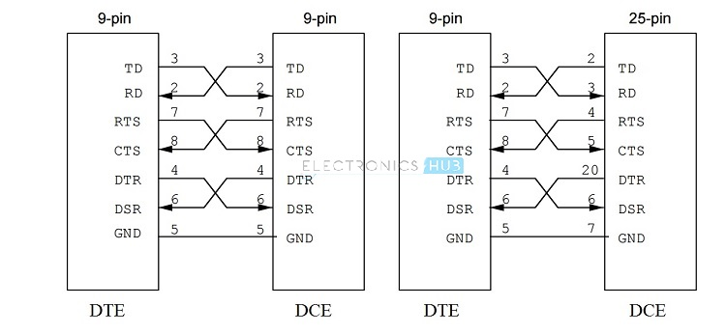

TD ----> RD
RTS ----> CTS
DTR ----> DSR
With the help of Hardware Handshaking, the data from the transmitter is never lost or overwritten in the receiver buffer. When the transmitter (DTE) wants to send data, it pulls the RTS (Ready to Send) line to high.
Then the transmitter waits for CTS (Clear to Send) to go high and hence it keeps on monitoring it. If the CTS line is low, it means that the receiver (DCE) is busy and not yet ready to receive data.
When the receiver is ready, it pulls the CTS line to high. The transmitter then transmits the data. This method is also called as RTS/CTS Handshaking.
Additionally, there are two other wires used in Handshaking. They are DTR (Data Terminal Ready) and DSR (Data Set Ready). These two signals are used by the DTE and DCE to indicate their individual status. Often, these two signals are used in modem communication.

Software Handshaking
Software Handshaking in RS232 involves two special characters for starting and stopping the communication. These characters are X-ON and X-OFF (Transmitter On and Transmitter OFF).
When the receiver sends an X-OFF signal, the transmitter stops sending the data. The transmitter starts sending data only after it receives the X-ON signal.
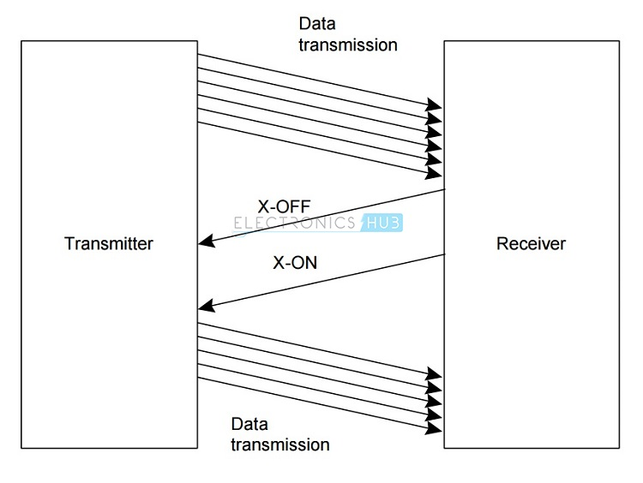

Limitations of RS232
- RS232 Protocol requires a common ground between the transmitter (DTE) and receiver (DCE). Hence, the reason for shorter cables between DTE and DCE in RS232 Protocol.
- The signal in the line is highly susceptible to noise. The noise can be either internal or external.
- If there is an increase in baud rate and length of the cable, there is a chance of cross talk introduced by the capacitance between the cables.
- The voltage levels in RS232 are not compatible with modern TTL or CMOS logics. We need an external level converter.

Applications
- Though RS232 is a very famous serial communication protocol, it is now has been replaced with advanced protocols like USB.
- Previously they we used for serial terminals like Mouse, Modem etc.
- But, RS232 is still being used in some Servo Controllers, CNC Machines, PLC machines and some microcontroller boards use RS232 Protocol.
RS-232 transmissions seldom exceed 100 feet for two reasons. Firstly, the difference between transmitted levels (±5V) and receive levels (±3V) allows only 2V of common-mode rejection. Secondly, the distributed capacitance of a longer cable can degrade slew rates by exceeding the maximum specified load (2500pF). Because the RS-232 was designed as a point-to-point rather than multidrop interface, its drivers are specified for single loads from 3kΩ to 7kΩ.

RS-485
RS485 was developed to provide high speed data. The standard is defined by industry telecommunications bodies and may be referred to most commonly as RS485, but references to EIA485 or TIA-485 may also be seen.
RS485 is able to provide a headline data rate of 10 Mbps at distances up to 50 feet, but distances can be extended to 4000 feet with a lower speed of 100 kbps.
RS-485 allows multiple devices (up to 32) to communicate at half-duplex on a single pair of wires, plus a ground wire (more on that later), at distances up to 1200 meters (4000 feet). Both the length of the network and the number of nodes can easily be extended using a variety of repeater products on the market.

How does the hardware work? Data is transmitted differentially on two wires twisted together, referred to as a "twisted pair." The properties of differential signals provide high noise immunity and long distance capabilities.
A 485 network can be configured two ways, "two-wire" or "four-wire." In a "two-wire" network the transmitter and receiver of each device are connected to a twisted pair. "Four-wire" networks have one master port with the transmitter connected to each of the "slave" receivers on one twisted pair. The "slave" transmitters are all connected to the "master" receiver on a second twisted pair. In either configuration, devices are addressable, allowing each node to be communicated to independently. Only one device can drive the line at a time, so drivers must be put into a high-impedance mode (tri-state) when they are not in use. Some RS-485 hardware handles this automatically. In other cases, the 485 device software must use a control line to handle the driver.

A consequence of tri-stating the drivers is a delay between the end of a transmission and when the driver is tri-stated. This turn-around delay is an important part of a two-wire network because during that time no other transmissions can occur.
Two-wire or four-wire? Two-wire 485 networks have the advantage of lower wiring costs and the ability for nodes to talk amongst themselves. On the downside, two-wire mode is limited to half-duplex and requires attention to turn-around delay. Four-wire networks allow full-duplex operation, but are limited to master-slave situations (i.e. a "master" node requests information from individual "slave" nodes). "Slave" nodes cannot communicate with each other. Remember when ordering your cable, "two-wire" is really two wires + ground, and "four-wire" is really four wires + ground.

With RS485 on the contrary there is no such thing as a common zero as a signal reference. Several volts difference in the ground level of the RS485 transmitter and receiver does not cause any problems. The RS485 signals are floating and each signal is transmitted over a Sig+ line and a Sig- line. The RS485 receiver compares the voltage difference between both lines, instead of the absolute voltage level on a signal line. This works well and prevents the existence of ground loops, a common source of communication problems. The best results are achieved if the Sig+ and Sig- lines are twisted.
RS485 Highlight Specifications
Attribute | Specification
Cabling | Multi-drop
Number of devices | 32 transmitters  32 receivers
Communications modes | half duplex
Maximum distance | 4000 feet @ 100 kbps
Maximum data rate | 10 Mbps @ 50 feet
Signalling | Balanced
Mark (data = 1)  condition | 1.5 V to 5 V (B greater than A)
Space (data = 0)  condition | 1.5 V to 5 V (A greater than B>
Driver output current capability | 250 mA

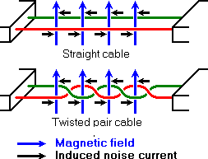

noise is generated by magnetic fields from the environment. The picture shows the magnetic field lines and the noise current in the RS485 data lines that is the result of that magnetic field. In the straight cable, all noise current is flowing in the same direction, practically generating a looping current just like in an ordinary transformer. When the cable is twisted, we see that in some parts of the signal lines the direction of the noise current is the oposite from the current in other parts of the cable. Because of this, the resulting noise current is many factors lower than with an ordinary straight cable. Shielding—which is a common method to prevent noise in RS232 lines—tries to keep hostile magnetic fields away from the signal lines. Twisted pairs in RS485 communication however adds immunity which is a much better way to fight noise. The magnetic fields are allowed to pass, but do no harm. If high noise immunity is needed, often a combination of twisting and shielding is used as for example in STP, shielded twisted pair and FTP, foiled twisted pair networking cables.
Differential signals and twisting allows RS485 to communicate over much longer communication distances than achievable with RS232. With RS485 communication distances of 1200 m are possible.
Differential signal lines also allow higher bit rates than possible with non-differential connections. Therefore RS485 can overcome the practical communication speed limit of RS232. Currently RS485 drivers are produced that can achieve a bit rate of 35 mbps.
Table 3. RS-485 Summary of Key Specifications
Parameter | Conditions | Min | Max | Units
Driver Output Voltage, Open Circuit |  | 1.5  -1.5 | 6  -6 | V  V
Driver Output Voltage, Loaded | RL = 100Ω | 1.5  -1.5 | 5  -5 | V  V
Driver Output Short-Circuit Current | Per output to common |  | ±250 | mA
Driver Output Rise Time | RL = 54Ω  CL = 50pF |  | 30 | % of bit width
Driver Common-Mode Voltage | RL = 54Ω |  | ±3 | V
Receiver Sensitivity | -7V < VCM < 12V |  | ±200 | mV
Receiver Common-Mode Voltage Range |  | -7 | 12 | V
Receiver Input Resistance |  | 12 |  | kΩ

The wider common-mode range of RS-485 also enables longer line lengths and a higher input resistance per node, allowing more nodes to be connected to the bus.

RS-485. Every node on the network can generally listen at the same time. However, only one node can talk at any given time. If more than one node attempts to talk at once, the message will be garbled. So, a higher level protocol is necessary to ensure that every node will get a chance to talk and that its message will get through ungarbled.
RS485 is the only of the interfaces capable of internetworking multiple transmitters and receivers in the same network. When using the default RS485 receivers with an input resistance of 12 kΩ it is possible to connect 32 devices to the network. Currently available high-resistance RS485 inputs allow this number to be expanded to 256. RS485 repeaters are also available which make it possible to increase the number of nodes to several thousands, spanning multiple kilometers.
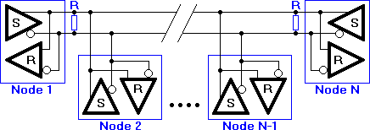

N nodes are connected in a multipoint RS485 network. For higher speeds and longer lines, the termination resistances are necessary on both ends of the line to eliminate reflections. Use 100 Ω resistors on both ends. The RS485 network must be designed as one line with multiple drops, not as a star.

how does RS485 function in practice? Default, all the senders on the RS485 bus are in tri-state with high impedance. In most higher level protocols, one of the nodes is defined as a master which sends queries or commands over the RS485 bus. All other nodes receive these data. Depending of the information in the sent data, zero or more nodes on the line respond to the master. In this situation, bandwidth can be used for almost 100%. There are other implementations of RS485 networks where every node can start a data session on its own. This is comparable with the way ethernet networks function. Because there is a chance of data collosion with this implementation, theory tells us that in this case only 37% of the bandwidth will be effectively used. With such an implementation of a RS485 network it is necessary that there is error detection implemented in the higher level protocol to detect the data corruption and resend the information at a later time.
There is no need for the senders to explicity turn the RS485 driver on or off. RS485 drivers automatically return to their high impedance tri-state within a few microseconds after the data has been sent. Therefore it is not needed to have delays between the data packets on the RS485 bus.

RS485 Wiring Arrangements

Write Only System: Sending Data Only
In this arrangement the computer sends data out over a single RS485 pair of wires to many instruments. It never reads any data back. An example of this is the remote control of CCTV cameras. The operator can send out messages to move the camera. His feedback is the TV picture so no return data is needed. This requires only conversion of the RS232 TX signal to RS485.

Full Duplex System: Sending and Receiving Data over 4 Wires
Full Duplex means that data can pass simultaneously both to and from the instruments. This requires 4 wires - one pair to Transmit and one pair to Receive. The computer alone controls the TX transmit line. It sends out a message which includes an Address. The addressed instrument alone replies by driving the RX line.
This does mean that all the connected instruments must use the same software protocol - otherwise there will be confusion as to which instrument is being addressed.
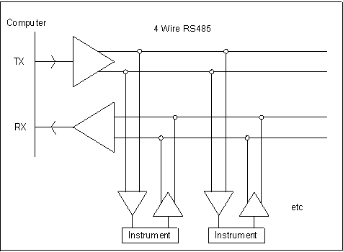

Half Duplex System: Sending and Receiving Data over 2 Wires
Half Duplex means that data can only pass in one direction at a time. In this arrangement both TX and RX signals share a single pair of wires. This can save in installation costs.
The computer drives the lines to send out its request message but must turn its driver off to allow the instrument to reply. This is the tricky bit. Many RS232-to-RS485 converters recruit the RTS line of the serial port to switch the RS485 driver On and Off. If the instrument starts its reply before the switch-off then the start of the reply will be missed. Instrument manufacturers are forced to find their own solutions to this problem. This may include special software, special hardware or both.
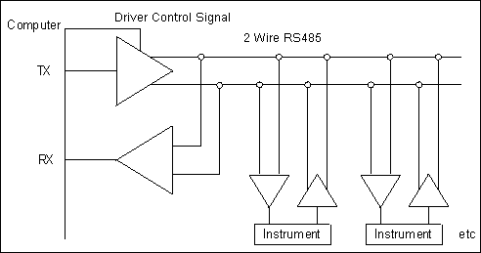

Ideal RS485 Wiring
Ideally an RS485 system consists of a single linear cable (no branches) with 120 ohm resistors connected across the 2 wires at each end of the cable.
RS485 can handle speeds of over 10 Mbits per second and line lengths of over 1 km. If you are operating anywhere near these values you must arrange your wiring close to the ideal.

RS-422

RS422 uses both differential transmitters and receivers which means that it is much more resilient to common mode interference, a key issue with long lines.
Lower voltage line levels are used for RS422: A space is represented by a line voltage level in the band between +2 and +6 volts while a mark is represented by a voltage in the range -2 to -6 volts. The range between +2 and -2 volts provides a good noise margin for the system. Additionally the RS422 standard allows for line impedances down to 50 ohms while supporting the high data rates.

RS422 is able to provide data rates of up to 10 Mbps at distances up to 50 feet (15.24 metres). However using reduced data rates, RS422 is able to transmit data over distances of 4000 feet (~1220 metres): the maximum is 100 kbps at this distance.
The key reason why RS422 is able to achieve these improvements results from the use of differential or balanced transmission techniques.

To enable the differential driver to be used, the RS-422 standard uses a four conductor cable. Additionally up to ten receivers can be placed on a single cable, providing a multi-point network or bus.

RS422 Standard Summary
Attribute | Specification
Cabling | Single ended  Multi-drop
Number of devices | 5 transmitters  10 receivers
Communications modes | half duplex  full duplex
Maximum distance | 4000 feet @ 100 kbps
Maximum data rate | 10 Mbps @ 50 feet
Signalling | Balanced
Mark (data = 1)  condition | 2V to 6V (B greater than A)
Space (data = 0)  condition | 2V to 6 V (A greater than B)
Driver output current capability | 150 mA

Serial, balanced and differential are the keywords for the RS422 interface standard. Serial means, that the information is sent bit by bit on a single transmission line
With RS422, each signal line consists of two wires, preferably twisted to reduce noise. The voltage-difference between the two lines is an indication of the signal value, rather than the voltage-level. Looking at voltage differences with RS422 rather than levels eliminates a lot of noise induced by external sources and allows for higher data rates and cable lengths compared to RS232.
RS422 allows the direct connection of intelligent devices, without the need of modems. Furthermore, where the RS232 line driver is only designed to serve one receiver, a RS422 line driver can serve up to ten receivers in parallel. This allows one central control unit to send commands in parallel to up to ten slave devices. Unfortunately, those slave devices cannot send information back over a shared interface line. RS422 allows a multi-drop network topology, rather than a multi-point network where all nodes are considered equal and every node has send and receive capabilities over the same line.

Q) Difference between multidrop, multipoint and point to point?
Ans:
*Multi-Drop Network:* In many cases this refers to one transceiver communicating with some number of receivers on a common bus. The EIA-422 interface [RS422] is an example of an interface network with one driver and some number of multiple receivers all connected on the same interface. A Multi-Drop Network is a specific type of Bus Network Topology.
*Multi-Point Network:* A Multi-Point interface, unlike a Multi-Drop Network is a topology that allows any node to be a transmitter or receiver. Any node may transmit on a Multi-Point Network [EIA/TIA-485]. A Multi-Point Network is a specific type of Bus Network Topology.
*Point-to-Point Network:* A single connection interface that connects one device to one other device. A Point-to-Point interface is normally found with IC buses or high speed interconnects with a tight jitter tolerance.

SSI
SSI (Serial Synchronous Interface) is a widely used serial interface between an absolute position sensor and a controller. SSI uses a clock pulse train from a controller to initiate a gated output from the sensor.

Position data is continually updated by the sensor and made available to the shift register. Between each clock pulse train there is a minimum dwell of 25 microseconds during which fresh data is moved into the register. Data is shifted out when the sensor receives a pulse train from the controller. When the least significant bit (LSB) goes HIGH and the minimum dwell time has elapsed, new data is available to read.

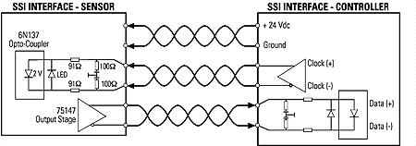

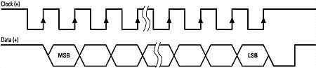

Despite the name, SSI has both Synchronous and Asynchronous modes:
- Synchronous Mode: A synchronous pulse from the control system starts the measuring time of the sensor, the measured result is available before the next synchronizing pulse is generated. The synchronizing pulse is the first high to low transition of the clock train after the dwell time.
- Asynchronous Mode: SSI takes measurements at its fastest internal interrogation rate (length dependent) and provides information upon request.
SSI also has different supported baud rates based on cable lengths:
Cable Length (ft.) | <100 | <200 | <400 | <400
Baud Rate* | <400 kHz | <300 kHz | <200 kHz | <100 kHz
*Maximum baud rate = 1.5 MBaud

Inputs can use an opto-coupler for galvanic isolation that can be driven by RS-422/485 levels. The DATA output of the sensor is driven by an RS-422/485 line driver. Differential signalling improves the resistance to electromagnetic interference (EMI), hence making it a reliable communication channel over long transmission lengths and harsh external environments.
When high data rates are used, the application is limited to a shorter cables. It is possible to use longer cables when low data rates are used. The DC resistance of the cable limits the length of the cable for low data rate applications by increasing the noise margin as the voltage drop in the cable increases. The AC effects of the cable limit the quality of the signal and limit the cable length to short distances when high data rates are used. Examples of data rate and cable length combinations vary from 90 kbit/s at 1.2 km to 10 Mbit/s at 5m for RS-422.

Benefits
- Serial data transfer has reduced the wiring. This, in addition to the simplicity of SSI design due to use of minimal number of components, has considerably reduced the cost and created more transmission bandwidth for message bits.
- High Electromagnetic interference immunity due to RS-422 standards and higher reliability of data transmission due to differential signalling.
- Optimal galvanic isolation
- Complete protocol flexibility for the number of bits transferred. Not limited to a certain number of words and has an arbitrary choice of message size.
- Slaves use master’s clock and hence don’t need precision oscillators.
- The SSI allows to connect up to three slaves to a common clock. Therefore, it is possible to attain values from multiple sensors.
Limitations
SSI can handle only short distance communication (up to 1.2 km) and supports only one master device.
When compared to advanced communication systems based on field buses or Ethernet, SSI is limited to a master slave architecture and a simple point to point communication between a master and a slave.
Another disadvantage is that there is no hardware slave acknowledgment i.e. detection of slave for communication.

I2C
Philips Semiconductors (now NXP Semiconductors) developed a simple bidirectional 2-wire bus for efficient inter-IC control. This bus is called the Inter-IC or I2C-bus. Only two bus lines are required: a serial data line (SDA) and a serial clock line (SCL). Serial, 8-bit oriented, bidirectional data transfers can be made at up to 100 kbit/s in the Standard-mode, up to 400 kbit/s in the Fast-mode, up to 1 Mbit/s in the Fast-mode Plus (Fm+), or up to 3.4 Mbit/s in the High-speed mode. The Ultra Fast-mode is a uni-directional mode with data transfers of up to 5 Mbit/s.
The versatile I2C-bus is used in various control architectures such as System Management Bus (SMBus), Power Management Bus (PMBus), Intelligent Platform Management Interface (IPMI), Display Data Channel (DDC) and Advanced Telecom Computing Architecture (ATCA).

Features of the I2C-bus:
• Only two bus lines are required; a serial data line (SDA) and a serial clock line (SCL).
• Each device connected to the bus is software addressable by a unique address and
simple master/slave relationships exist at all times; masters can operate as
master-transmitters or as master-receivers.
• It is a true multi-master bus including collision detection and arbitration to prevent data
corruption if two or more masters simultaneously initiate data transfer.
• Serial, 8-bit oriented, bidirectional data transfers can be made at up to 100 kbit/s in
the Standard-mode, up to 400 kbit/s in the Fast-mode, up to 1 Mbit/s in Fast-mode
Plus, or up to 3.4 Mbit/s in the High-speed mode.
• Serial, 8-bit oriented, unidirectional data transfers up to 5 Mbit/s in Ultra Fast-mode
• On-chip filtering rejects spikes on the bus data line to preserve data integrity.
• The number of ICs that can be connected to the same bus is limited only by a
maximum bus capacitance.

Benefits of I2C:
Here are some of the features of I 2 C-bus compatible ICs that are particularly attractive to
designers:
• Functional blocks on the block diagram correspond with the actual ICs; designs
proceed rapidly from block diagram to final schematic.
• No need to design bus interfaces because the I 2 C-bus interface is already integrated on-chip.
Integrated addressing and data-transfer protocol allow systems to be completely
software-defined.
• The same IC types can often be used in many different applications.
• Design-time reduces as designers quickly become familiar with the frequently used
functional blocks represented by I2C-bus compatible ICs.
• ICs can be added to or removed from a system without affecting any other circuits on
the bus.
• Fault diagnosis and debugging are simple; malfunctions can be immediately traced.
• Software development time can be reduced by assembling a library of reusable
software modules.

I 2 C-bus compatible ICs not only assist designers, they also give a wide range of benefits
to equipment manufacturers because:
• The simple 2-wire serial I 2 C-bus minimizes interconnections so ICs have fewer pins
and there are not so many PCB tracks; result — smaller and less expensive PCBs.
• The completely integrated I 2 C-bus protocol eliminates the need for address decoders
and other ‘glue logic’.
• The multi-master capability of the I 2 C-bus allows rapid testing and alignment of
end-user equipment via external connections to an assembly line.
• The availability of I 2 C-bus compatible ICs in various leadless packages reduces
space requirements even more.

I2C Protocol Details

The I 2 C-bus is a multi-master bus. This means that more than one device capable of
controlling the bus can be connected to it.

The possibility of connecting more than one microcontroller to the I 2 C-bus means that
more than one master could try to initiate a data transfer at the same time. To avoid the
chaos that might ensue from such an event, an arbitration procedure has been developed.
This procedure relies on the wired-AND connection of all I 2 C interfaces to the I 2 C-bus.

If two or more masters try to put information onto the bus, the first to produce a ‘one’ when
the other produces a ‘zero’ loses the arbitration. The clock signals during arbitration are a
synchronized combination of the clocks generated by the masters using the wired-AND
connection to the SCL line

Generation of clock signals on the I 2 C-bus is always the responsibility of master devices;
each master generates its own clock signals when transferring data on the bus. Bus clock
signals from a master can only be altered when they are stretched by a slow slave device
holding down the clock line or by another master when arbitration occurs.

SDA and SCL signals
Both SDA and SCL are bidirectional lines, connected to a positive supply voltage via a
current-source or pull-up resistor. When the bus is free, both lines are
HIGH. The output stages of devices connected to the bus must have an open-drain or
open-collector to perform the wired-AND function. The bus capacitance limits the number of interfaces connected to the bus.

SDA and SCL logic levels
Due to the variety of different technology devices (CMOS, NMOS, bipolar) that can be
connected to the I 2 C-bus, the levels of the logical ‘0’ (LOW) and ‘1’ (HIGH) are not fixed
and depend on the associated level of V DD . Input reference levels are set as 30 % and
70 % of V DD ; V IL is 0.3V DD and V IH is 0.7V DD. Some
legacy device input levels were fixed at V IL = 1.5 V and V IH = 3.0 V, but all new devices
require this 30 %/70 % specification.

Data validity
The data on the SDA line must be stable during the HIGH period of the clock. The HIGH
or LOW state of the data line can only change when the clock signal on the SCL line is
LOW.

START and STOP conditions
All transactions begin with a START (S) and are terminated by a STOP (P).
A HIGH to LOW transition on the SDA line while SCL is HIGH defines a START condition.
A LOW to HIGH transition on the SDA line while SCL is HIGH defines a STOP condition.

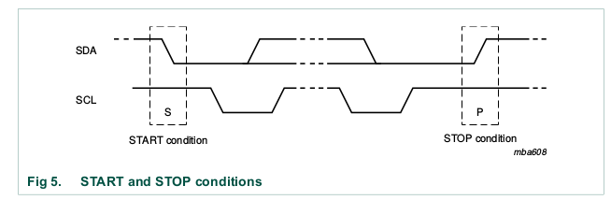
START and STOP conditions are always generated by the master. The bus is considered
to be busy after the START condition. The bus is considered to be free again a certain
time after the STOP condition.
The bus stays busy if a repeated START (Sr) is generated instead of a STOP condition. In
this respect, the START (S) and repeated START (Sr) conditions are functionally identical.

Byte format
Every byte put on the SDA line must be eight bits long. The number of bytes that can be
transmitted per transfer is unrestricted. Each byte must be followed by an Acknowledge
bit. Data is transferred with the Most Significant Bit (MSB) first. If a slave
cannot receive or transmit another complete byte of data until it has performed some other
function, for example servicing an internal interrupt, it can hold the clock line SCL LOW to
force the master into a wait state. Data transfer then continues when the slave is ready for
another byte of data and releases clock line SCL.

Acknowledge (ACK) and Not Acknowledge (NACK)
The acknowledge takes place after every byte. The acknowledge bit allows the receiver to
signal the transmitter that the byte was successfully received and another byte may be
sent. The master generates all clock pulses, including the acknowledge ninth clock pulse.

The Acknowledge signal is defined as follows: the transmitter releases the SDA line
during the acknowledge clock pulse so the receiver can pull the SDA line LOW and it
remains stable LOW during the HIGH period of this clock pulse.

When SDA remains HIGH during this ninth clock pulse, this is defined as the Not
Acknowledge signal. The master can then generate either a STOP condition to abort the
transfer, or a repeated START condition to start a new transfer. There are five conditions
that lead to the generation of a NACK:
1. No receiver is present on the bus with the transmitted address so there is no device to
respond with an acknowledge.
2. The receiver is unable to receive or transmit because it is performing some real-time
function and is not ready to start communication with the master.
3. During the transfer, the receiver gets data or commands that it does not understand.
4. During the transfer, the receiver cannot receive any more data bytes.
5. A master-receiver must signal the end of the transfer to the slave transmitter.

Clock synchronization
Two masters can begin transmitting on a free bus at the same time and there must be a
method for deciding which takes control of the bus and complete its transmission. This is
done by clock synchronization and arbitration. In single master systems, clock
synchronization and arbitration are not needed.

Clock synchronization is performed using the wired-AND connection of I 2 C interfaces to
the SCL line. This means that a HIGH to LOW transition on the SCL line causes the
masters concerned to start counting off their LOW period and, once a master clock has
gone LOW, it holds the SCL line in that state until the clock HIGH state is reached.

However, if another clock is still within its LOW period, the LOW to HIGH
transition of this clock may not change the state of the SCL line. The SCL line is therefore
held LOW by the master with the longest LOW period. Masters with shorter LOW periods
enter a HIGH wait-state during this time.

When all masters concerned have counted off their LOW period, the clock line is released
and goes HIGH. There is then no difference between the master clocks and the state of
the SCL line, and all the masters start counting their HIGH periods. The first master to
complete its HIGH period pulls the SCL line LOW again.

In this way, a synchronized SCL clock is generated with its LOW period determined by the
master with the longest clock LOW period, and its HIGH period determined by the one
with the shortest clock HIGH period.

Arbitration
Arbitration, like synchronization, refers to a portion of the protocol required only if more
than one master is used in the system. Slaves are not involved in the arbitration
procedure. A master may start a transfer only if the bus is free. Two masters may
generate a START condition within the minimum hold time (t HD;STA ) of the START
condition which results in a valid START condition on the bus. Arbitration is then required
to determine which master will complete its transmission.

Arbitration proceeds bit by bit. During every bit, while SCL is HIGH, each master checks to
see if the SDA level matches what it has sent. This process may take many bits. Two
masters can actually complete an entire transaction without error, as long as the transmissions are identical. The first time a master tries to send a HIGH, but detects that
the SDA level is LOW, the master knows that it has lost the arbitration and turns off its
SDA output driver. The other master goes on to complete its transaction.

No information is lost during the arbitration process. A master that loses the arbitration
can generate clock pulses until the end of the byte in which it loses the arbitration and
must restart its transaction when the bus is free.
Since control of the I 2 C-bus is decided solely on the address and data sent by competing
masters, there is no central master, nor any order of priority on the bus.

The following combinations result in an undefined condition:
• Master 1 sends a repeated START condition and master 2 sends a data bit.
• Master 1 sends a STOP condition and master 2 sends a data bit.
• Master 1 sends a repeated START condition and master 2 sends a STOP condition.

Clock stretching
Clock stretching pauses a transaction by holding the SCL line LOW. The transaction
cannot continue until the line is released HIGH again. Clock stretching is optional and in
fact, most slave devices do not include an SCL driver so they are unable to stretch the
clock.
On the byte level, a device may be able to receive bytes of data at a fast rate, but needs
more time to store a received byte or prepare another byte to be transmitted. Slaves can
then hold the SCL line LOW after reception and acknowledgment of a byte to force the
master into a wait state until the slave is ready for the next byte transfer in a type of
handshake procedure

On the bit level, a device such as a microcontroller with or without limited hardware for the
I 2 C-bus, can slow down the bus clock by extending each clock LOW period. The speed of
any master is adapted to the internal operating rate of this device.

The slave address and R/W bit
After the START condition (S), a slave address is sent. This address is seven bits long followed by an eighth bit which is a data direction bit (R/W) — a ‘zero’ indicates a transmission (WRITE), a ‘one’ indicates a request for data (READ). A data transfer is always terminated by a STOP condition (P) generated by the master. However, if a master still wishes to communicate on the bus, it can generate a repeated START condition (Sr) and address another slave without first generating a STOP condition. Various combinations of read/write formats are then possible within such a transfer.

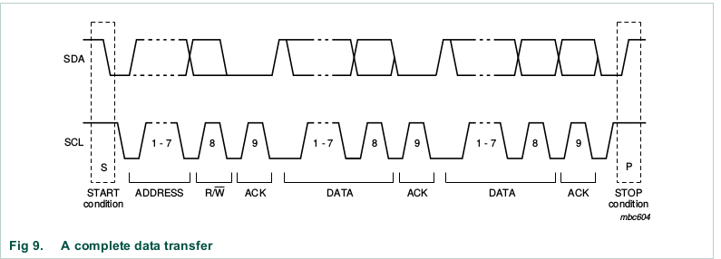
Possible data transfer formats are:
• Master-transmitter transmits to slave-receiver. The transfer direction is not changed.
The slave receiver acknowledges each byte.
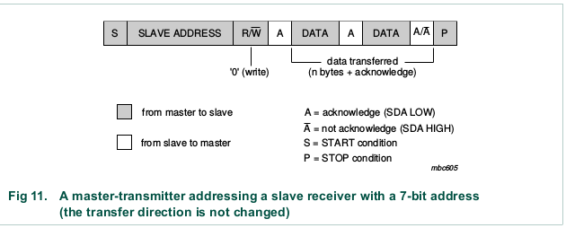

• Master reads slave immediately after first byte. At the moment of the
first acknowledge, the master-transmitter becomes a master-receiver and the
slave-receiver becomes a slave-transmitter. This first acknowledge is still generated
by the slave. The master generates subsequent acknowledges. The STOP condition
is generated by the master, which sends a not-acknowledge (~A) just before the STOP
condition.
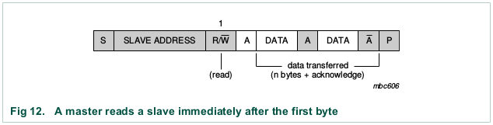
• Combined format (see Figure 13). During a change of direction within a transfer, the
START condition and the slave address are both repeated, but with the R/W bit
reversed. If a master-receiver sends a repeated START condition, it sends a
not-acknowledge (~A) just before the repeated START condition.
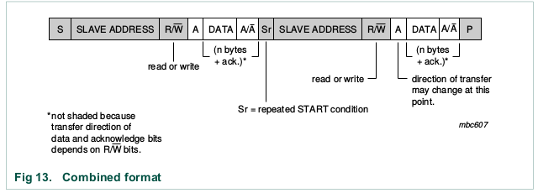
Combined formats can be used, for example, to control a serial memory. The internal
memory location must be written during the first data byte. After the START condition
and slave address is repeated, data can be transferred.

10-bit addressing
10-bit addressing expands the number of possible addresses. Devices with 7-bit and
10-bit addresses can be connected to the same I 2 C-bus, and both 7-bit and 10-bit
addressing can be used in all bus speed modes. Currently, 10-bit addressing is not being
widely used.
The 10-bit slave address is formed from the first two bytes following a START condition
(S) or a repeated START condition (Sr)

The first seven bits of the first byte are the combination 1111 0XX of which the last two bits
(XX) are the two Most-Significant Bits (MSB) of the 10-bit address; the eighth bit of the
first byte is the R/W bit that determines the direction of the message.

Although there are eight possible combinations of the reserved address bits 1111 XXX,
only the four combinations 1111 0XX are used for 10-bit addressing. The remaining four
combinations 1111 1XX are reserved for future I 2 C-bus enhancements.

Master-transmitter transmits to slave-receiver with a 10-bit slave address.
The transfer direction is not changed (see Figure 14). When a 10-bit address follows
a START condition, each slave compares the first seven bits of the first byte of the
slave address (1111 0XX) with its own address and tests if the eighth bit (R/W
direction bit) is 0. It is possible that more than one device finds a match and generate
an acknowledge (A1). All slaves that found a match compare the eight bits of the
second byte of the slave address (XXXX XXXX) with their own addresses, but only
one slave finds a match and generates an acknowledge (A2). The matching slave
remains addressed by the master until it receives a STOP condition (P) or a repeated
START condition (Sr) followed by a different slave address.
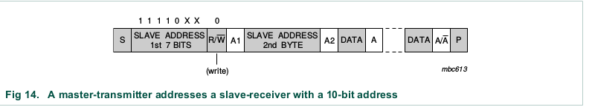
Master-receiver reads slave-transmitter with a 10-bit slave address.
The transfer direction is changed after the second R/W bit (Figure 15). Up to and
including acknowledge bit A2, the procedure is the same as that described for a
master-transmitter addressing a slave-receiver. After the repeated START condition
(Sr), a matching slave remembers that it was addressed before. This slave then
checks if the first seven bits of the first byte of the slave address following Sr are the
same as they were after the START condition (S), and tests if the eighth (R/W) bit is 1.
If there is a match, the slave considers that it has been addressed as a transmitter
and generates acknowledge A3. The slave-transmitter remains addressed until it
receives a STOP condition (P) or until it receives another repeated START condition
(Sr) followed by a different slave address. After a repeated START condition (Sr), all
the other slave devices will also compare the first seven bits of the first byte of the
slave address (1111 0XX) with their own addresses and test the eighth (R/W) bit.
However, none of them will be addressed because R/W = 1 (for 10-bit devices), or the
1111 0XX slave address (for 7-bit devices) does not match.

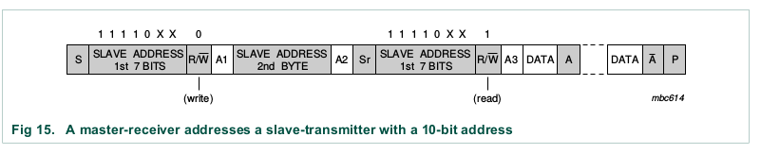
Slave devices with 10-bit addressing react to a ‘general call’ in the same way as slave
devices with 7-bit addressing. Hardware masters can transmit their 10-bit address after a
‘general call’. In this case, the ‘general call’ address byte is followed by two successive
bytes containing the 10-bit address of the master-transmitter.
The START byte 0000 0001 (01h) can precede the 10-bit addressing in the same way as
for 7-bit addressing.

Two groups of eight addresses (0000 XXX and 1111 XXX) are reserved for the purposes
shown.
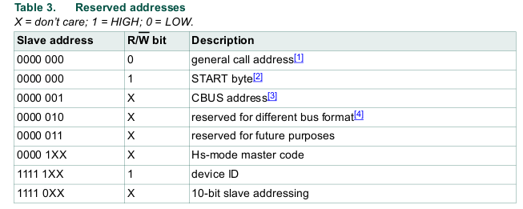
General call address
The general call address is for addressing every device connected to the I 2 C-bus at the
same time. However, if a device does not need any of the data supplied within the general
call structure, it can ignore this address by not issuing an acknowledgment. If a device
does require data from a general call address, it acknowledges this address and behave
as a slave-receiver. The master does not actually know how many devices acknowledged
if one or more devices respond. The second and following bytes are acknowledged by
every slave-receiver capable of handling this data. A slave who cannot process one of
these bytes must ignore it by not-acknowledging. Again, if one or more slaves
acknowledge, the not-acknowledge will not be seen by the master. The meaning of the
general call address is always specified in the second byte.

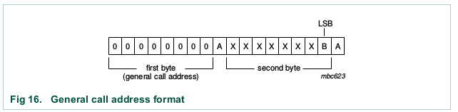
There are two cases to consider:
• When the least significant bit B is a ‘zero’.
• When the least significant bit B is a ‘one’.

When bit B is a ‘zero’, the second byte has the following definition:
• 0000 0110 (06h): Reset and write programmable part of slave address by hardware. On receiving this 2-byte sequence, all devices designed to respond to the general call address reset and take in the programmable part of their address.
• 0000 0100 (04h): Write programmable part of slave address by hardware. Behaves as above, but the device does not reset.
• 0000 0000 (00h): This code is not allowed to be used as the second byte.

When bit B is a ‘one’, the 2-byte sequence is a ‘hardware general call’. This means that
the sequence is transmitted by a hardware master device, such as a keyboard scanner,
which can be programmed to transmit a desired slave address. Since a hardware master
does not know in advance to which device the message has to be transferred, it can only
generate this hardware general call and its own address — identifying itself to the system.

The seven bits remaining in the second byte contain the address of the hardware master.
This address is recognized by an intelligent device (for example, a microcontroller)
connected to the bus which then accepts the information from the hardware master. If the
hardware master can also act as a slave, the slave address is identical to the master
address.

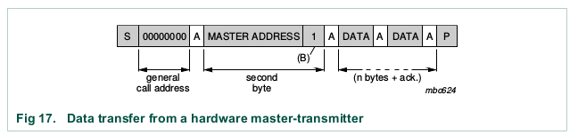

Software reset
Following a General Call, (0000 0000), sending 0000 0110 (06h) as the second byte
causes a software reset. This feature is optional and not all devices respond to this
command. On receiving this 2-byte sequence, all devices designed to respond to the
general call address reset and take in the programmable part of their address.

START byte
Microcontrollers can be connected to the I 2 C-bus in two ways. A microcontroller with an
on-chip hardware I 2 C-bus interface can be programmed to be only interrupted by requests
from the bus. When the device does not have such an interface, it must constantly monitor
the bus via software.

There is therefore a speed difference between fast hardware devices and a relatively slow
microcontroller which relies on software polling.
In this case, data transfer can be preceded by a start procedure which is much longer than
normal (see Figure 19). The start procedure consists of:
•A START condition (S)
•A START byte (0000 0001)
•An acknowledge clock pulse (ACK)
•A repeated START condition (Sr).

After the START condition S has been transmitted by a master which requires bus access,
the START byte (0000 0001) is transmitted. Another microcontroller can therefore sample
the SDA line at a low sampling rate until one of the seven zeros in the START byte is
detected. After detection of this LOW level on the SDA line, the microcontroller can switch
to a higher sampling rate to find the repeated START condition Sr which is then used for
synchronization.

Bus clear
In the unlikely event where the clock (SCL) is stuck LOW, the preferential procedure is to
reset the bus using the HW reset signal if your I 2 C devices have HW reset inputs. If the
I 2 C devices do not have HW reset inputs, cycle power to the devices to activate the
mandatory internal Power-On Reset (POR) circuit.

If the data line (SDA) is stuck LOW, the master should send nine clock pulses. The device
that held the bus LOW should release it sometime within those nine clocks. If not, then
use the HW reset or cycle power to clear the bus.

Device ID
The Device ID field is an optional 3-byte read-only (24 bits) word giving
the following information:
• Twelve bits with the manufacturer name, unique per manufacturer (for example, NXP)
• Nine bits with the part identification, assigned by manufacturer (for example, PCA9698)
• Three bits with the die revision, assigned by manufacturer (for example, RevX)

The Device ID is read-only, hard-wired in the device and can be accessed as follows:
1. START condition
2. The master sends the Reserved Device ID I 2 C-bus address followed by the R/W bit
set to ‘0’ (write): ‘1111 1000’.
3. The master sends the I 2 C-bus slave address of the slave device it must identify. The
LSB is a ‘Don’t care’ value. Only one device must acknowledge this byte (the one that
has the I 2 C-bus slave address).
4. The master sends a Re-START condition.
5. The master sends the Reserved Device ID I 2 C-bus address followed by the R/W bit
set to ‘1’ (read): ‘1111 1001’.
6. The Device ID Read can be done, starting with the 12 manufacturer bits (first byte +
four MSBs of the second byte), followed by the nine part identification bits (four LSBs
of the second byte + five MSBs of the third byte), and then the three die revision bits
(three LSBs of the third byte).
7. The master ends the reading sequence by NACKing the last byte, thus resetting the
slave device state machine and allowing the master to send the STOP condition.

Remark: The reading of the Device ID can be stopped anytime by sending a NACK.
If the master continues to ACK the bytes after the third byte, the slave rolls back to the first
byte and keeps sending the Device ID sequence until a NACK has been detected.

SPI
Serial Peripheral Interface or SPI is a synchronous serial communication protocol that provides full – duplex communication at very high speeds. Serial Peripheral Interface (SPI) is a master – slave type protocol that provides a simple and low cost interface between a microcontroller and its peripherals.

SPI Interface bus is commonly used for interfacing microprocessor or microcontroller with memory like EEPROM, RTC (Real Time Clock), ADC (Analog – to – Digital Converters), DAC (Digital – to – Analog Converters), displays like LCDs, Audio ICs, sensors like temperature and pressure, memory cards like MMC or SD Cards or even other microcontrollers.

For short distance communication, Synchronous Serial Communication would be a better choice and in that Serial Peripheral Interface or SPI in particular is the best choice. When we say short distance communication, it often means communication with in a device or between the devices on the same board (PCB).

SPI is a Synchronous type serial communication i.e. it uses a dedicated clock signal to synchronise the transmitter and receiver or Master and Slave, speaking in SPI terms. The transmitter and receiver are connected with separate data and clock lines and the clock signal will help the receiver when to look for data on the bus.
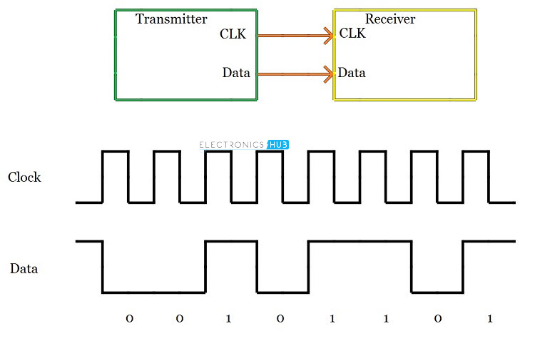

The clock signal must be supplied by the Master to the slave (or all the slaves in case of multiple slave setup). There are two types of triggering mechanisms on the clock signal that are used to intimate the receiver about the data: Edge Triggering and Level Triggering.

The most commonly used triggering is edge triggering and there are two types: rising edge (low to high transition on the clock) and falling edge (high to low transition). Depending on how the receiver is configured, up on detecting the edge, the receiver will look for data on the data bus from the next bit.

Since both the clock and data are sent by the Master (or transmitter), we need not worry about the speed of data transfer.

It provides a high speed secured data transfer with reasonably simple hardware like shift registers at relatively less cost.

SPI or Serial Peripheral Interface was developed by Motorola in the 1980’s as a standard, low – cost and reliable interface between the Microcontroller (microcontrollers by Motorola in the beginning) and its peripheral ICs.
Because of its simple interface, flexibility and ease of use, SPI has become a standard and soon other semiconductor manufacturers started implementing it in their chips.
In SPI protocol, the devices are connected in a Master – Slave relationship in a multi – point interface. In this type of interface, one device is considered the Master of the bus (usually a Microcontroller) and all the other devices (peripheral ICs or even other Microcontrollers) are considered as slaves.
In SPI protocol, there can be only one master but many slave devices.
The SPI bus consists of 4 signals or pins. They are
- Master – Out / Slave – In (MOSI)
- Master – In / Slave – Out (MISO)
- Serial Clock (SCLK) and
- Chip Select (CS) or Slave Select (SS)
The following image depicts a Master (Processor) connected to a Slave (Peripheral) using SPI bus.
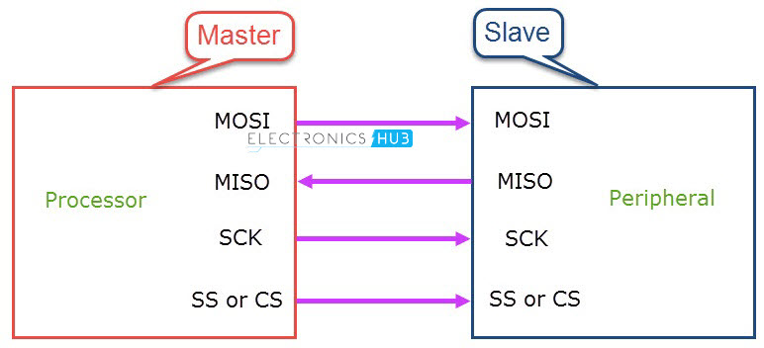

Master – Out / Slave – In or MOSI, as the name suggests, is the data generated by the Master and received by the Slave. Hence, MOSI pins on both the master and slave are connected together. Master – In / Slave – Out or MISO is the data generated by Slave and must be transmitted to Master.
MISO pins on both the master and slave are ties together. Even though the Signal in MISO is produced by the Slave, the line is controlled by the Master. The Master generates a clock signal at SCLK and is supplied to the clock input of the slave. Chip Select (CS) or Slave Select (SS) is used to select a particular slave by the master.
Since the clock is generated by the Master, the flow of data is controlled by the master. For every clock cycle, one bit of data is transmitted from master to slave and one bit of data is transmitted from slave to master.

This process happen simultaneously and after 8 clock cycles, a byte of data is transmitted in both directions and hence, SPI is a full – duplex communication.

If the data has to be transmitted by only one device, then the other device has to send something (even garbage or junk data) and it is up to the device whether the transmitted data is actual data or not.
This means that for every bit transmitted by one device, the other device has to send one bit data i.e. the Master simultaneously transmits data on MOSI line and receive data from slave on MISO line.
If the slave wants to transmit the data, the master has to generate the clock signal accordingly by knowing when the slave wants to send the data in advance. If more than one slave has to be connected to the master, then the setup will be something similar to the following image.
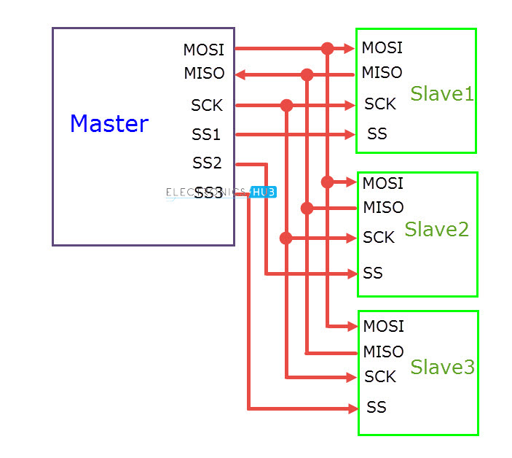

Even though multiple slaves are connected to the master in the SPI bus, only one slave will be active at any time. In order to select the slave, the master will pull down the SS (Slave Select) or CS (Chip Select) line of the corresponding slave.
Hence, there must by a separate CS pin on the Master corresponding to each of the slave device. We need to pull down the SS or CS line to select the slave because this line is active low.

SPI Hardware
The hardware requirement for implementing SPI is very simple when compared to UART and I2C. Consider a Master and a single Slave are connected using SPI bus. The following image shows the minimal system requirements for both the devices.
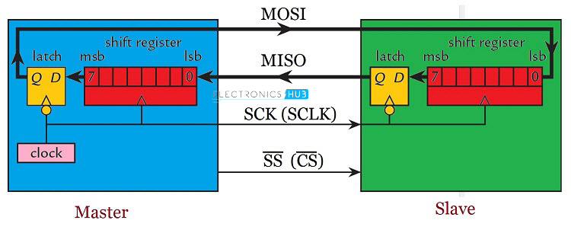

From the image, the Master device consists of a Shift Register, a data latch and a clock generator. The slave consists of similar hardware: a shift register and a data latch. Both the shift registers are connected to form a loop. Usually, the size of the register is 8 – bits but higher size registers of 16 – bits are also common.
During the positive edge of the clock signal, both the devices (master and slave) read input bit into LSB of the register. During the negative cycle of the clock signal, both the master and slave places a bit on its corresponding output from the MSB of the shift register.
Hence, for each clock cycle, a bit of data is transferred in each direction i.e. from master to slave and slave to master. So, for a byte of data to be transmitted from each device, it will take 8 clock cycles.

SPI Modes of Operation
the master and slave have to agree on certain synchronization protocols. For this, two features of the clock i.e. the Clock Polarity (CPOL or CKP) and Clock Phase (CPHA) come in to picture.
Clock Polarity determines the state of the clock. When CPOL is LOW, the clock generated by the Master i.e. SCK is LOW when idle and toggles to HIGH during active state (during a transfer). Similarly, when CPOL is HIGH, SCK is HIGH during idle and LOW during active state.
Clock Phase determines the clock transition i.e. rising (LOW to HIGH) or falling (HIGH to LOW), at which the data is transmitted. When CPHA is 0, the data is transmitted on the rising edge of the clock. Data is transmitted on the falling edge when CPHA is 1.

Depending on the values of Clock Polarity (CPOL) and Clock Phase (CPHA), there are 4 modes of operation of SPI: Modes 0 through 3.
With non-inverted clock polarity (i.e., the clock is at logic low when slave select transitions to logic low):
- Mode 0: Clock phase is configured such that data is sampled on the rising edge of the clock pulse and shifted out on the falling edge of the clock pulse. Data must be available before the first rising edge of the clock.
- Mode 1: Clock phase is configured such that data is sampled on the falling edge of the clock pulse and shifted out on the rising edge of the clock pulse.
With inverted clock polarity (i.e., the clock is at logic high when slave select transitions to logic low):
- Mode 2: Clock phase is configured such that data is sampled on the falling edge of the clock pulse and shifted out on the rising edge of the clock pulse. Data must be available before the first falling edge of the clock.
- Mode 3: Clock phase is configured such that data is sampled on the rising edge of the clock pulse and shifted out on the falling edge of the clock pulse.

SPI Configurations
There are two types of configurations in which the SPI devices can be connected in an SPI bus. They are Independent Slave Configuration and Daisy Chain Configuration.
In Independent Slave Configuration, the master has dedicated Slave Select Lines for all the slaves and each slave can be selected individually. All the clock signals of the slaves are connected to the master SCK.
Similarly, all the MOSI pins of all the slaves are connected to the MOSI pin of the master and all the MISO pins of all the slaves are connected to the MISO pin of the master.
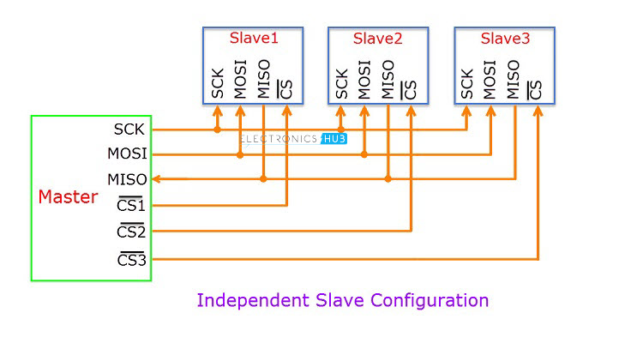

In Daisy Chain Configuration, only a single Slave Select line is connected to all the slaves. The MOSI of the master is connected to the MOSI of slave 1. MISO of slave 1 is connected to MOSI of slave 2 and so on. The MISO of the final slave is connected to the MISO of the master.
Consider the master transmits 3 bytes of data in to the SPI bus. First, the 1st byte of data is shifted to slave 1. When the 2nd byte of data reaches slave 1, the first byte is pushed in to slave 2.
Finally, when the 3rd byte of data arrives in to the first slave, the 1st byte of data is shifted to slave 3 and the second byte of data is shifted in to second slave.
If the master wants to retrieve information from the slaves, it has to send 3 bytes of junk data to the slaves so that the information in the slaves comes to the master.
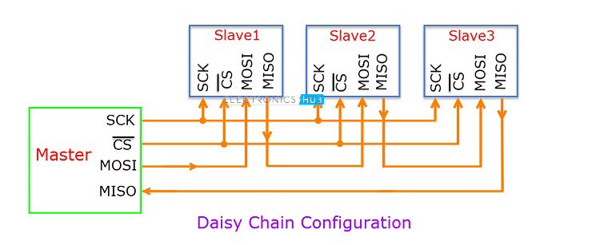

Applications of SPI
- Memory: SD Card , MMC , EEPROM , Flash
- Sensors: Temperature and Pressure
- Control Devices: ADC , DAC , digital POTS and Audio Codec.
- Others: Camera Lens Mount, touchscreen, LCD, RTC, video game controller, etc.

Advantages
- SPI is very simple to implement and the hardware requirements are not that complex.
- Supports full – duplex communication at all times.
- Very high speed of data transfer.
- No need for individual addresses for slaves as CS or SS is used.
- Only one master device is supported and hence there is no chance of conflicts.
- Clock from the master is configured based on speed of the slave and hence slave doesn’t have to worry about clock.

Disadvantages
- Each additional slave requires an additional dedicated pin on master for CS or SS.
- There is no acknowledgement mechanism and hence there is no confirmation of receipt of data.
- Slowest device determines the speed of transfer.
- There are no official standards and hence often used in application specific implementations.
- There is no flow control.

UART

UART or Universal Asynchronous Receiver Transmitter is a dedicated hardware associated with serial communication. The hardware for UART can be a circuit integrated on the microcontroller or a dedicated IC.

UART is one of the most simple and most commonly used Serial Communication techniques. Today, UART is being used in many applications like GPS Receivers, Bluetooth Modules, GSM and GPRS Modems, Wireless Communication Systems, RFID based applications.

The main reason for integrating the UART hardware in to microcontrollers is that it is a serial communication and requires only two wires for communication.

UART or Universal Asynchronous Receiver Transmitter is a serial communication device that performs parallel – to – serial data conversion at the transmitter side and serial – to – parallel data conversion at the receiver side. It is universal because the parameters like transfer speed, data speed, etc. are configurable.
As mentioned in the introduction section, UART is a piece of hardware that acts as a bridge between the processor and the serial communication protocol or port. The following image shows this interface briefly. The serial communication can be anything like USB, RS – 232, etc.
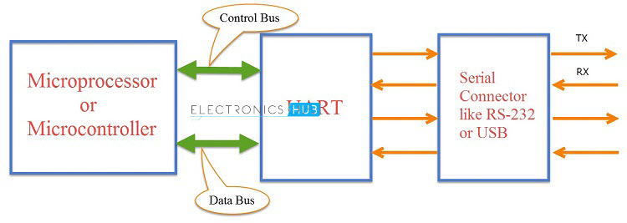

The letter ‘A’ in UART stands for Asynchronous i.e. there is no clock signal to synchronize or validate the data transmitted from transmitter and received by the receiver (Asynchronous Serial Communication).

In UART, the transmitter and receiver must agree on timing parameters beforehand. Also, UART uses special bits at the beginning and ending of each data word to synchronize the transmitter and receiver.

In UART based Serial Communication, the transmitter and receiver communicate in the following manner. The UART on the sender device i.e. the transmitting UART receives parallel data from the CPU (microprocessor or microcontroller) and converts it in to serial data.

This serial data is transmitted to the UART on the receiver device i.e. receiving UART. The receiving UART, upon receiving the serial data, converts it back to parallel data and gives it to the CPU.

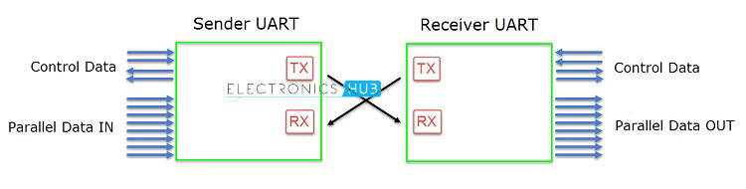
The pin on the transmitting UART, which transmits the serial data is called TX and the pin on the receiving UART, which receives the serial data is called RX.
Since the UART involves parallel – to – serial and serial – to – parallel data conversion, shift registers are an essential part of the UART hardware (two shift registers to be specific: Transmitter Shift Register and Receiver Shift Register).

How UART Works?
In UART Serial Communication, the data is transmitted asynchronously i.e. there is no clock or other timing signal involved between the sender and receiver. Instead of clock signal, UART uses some special bits called Start and Stop bits.
These bits are added to the actual data packet at the beginning and end respectively. These additional bits allows the receiving UART to identify the actual data.
The transmitting UART receives data from the controlling device through the data bus. The controlling device can be anything like a CPU of a microprocessor or a microcontroller, memory unit like a RAM or ROM, etc. The data received by the transmitting UART from the data bus is parallel data.
To this data, the UART adds Start, Parity and Stop bits in order to convert it into a data packet. The data packet is then converted from parallel to serial with the help of shift register and is transmitted bit – by – bit from the TX pin.
The receiving UART receives this serial data at the RX pin and detects the actual data by identifying the start and stop bits. Parity bit is used to check the integrity of the data.
Up on separating the start, parity and stop bits from the data packet, the data is converted to parallel data with the help of shift register. This parallel data is sent to the controller at the receiving end through a data bus.

Structure of Data Packet or Frame
The data in UART serial communication is organised in to blocks called Packets or Frames. The structure of a typical UART Data Packet or the standard framing of the data is shown in the following image.
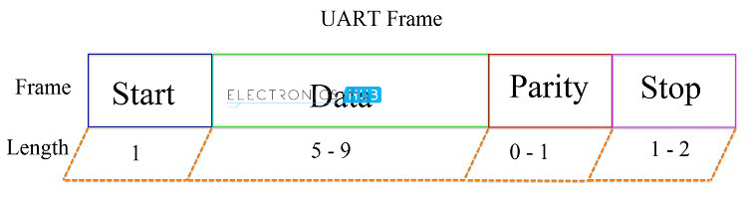

Start Bit: Start bit is a synchronisation bit that is added before the actual data. Start bit marks the beginning of the data packet. Usually, an idle data line i.e. when the data transmission line is not transmitting any data, it is held at a high voltage level (1).
In order to start the data transfer, the transmitting UART pulls the data line from high voltage level to low voltage level (from 1 to 0). The receiving UART detects this change from high to low on the data line and begins reading the actual data. Usually, there is only one start bit.
Stop Bit: The Stop Bit, as the name suggests, marks the end of the data packet. It is usually two bits long but often only on bit is used. In order to end the transmission, the UART maintains the data line at high voltage (1).
Parity Bit: Parity allows the receiver to check whether the received data is correct or not. Parity is a low – level error checking system and comes in two varieties: Even Parity and Odd Parity. Parity bit is optional and it is actually not that widely used.
Data Bits: Data bits are the actual data being transmitted from sender to receiver. The length of the data frame can be anywhere between 5 and 9 (9 bits if parity is not used and only 8 bits if parity is used). Usually, the LSB is the first bit of data to be transmitted (unless otherwise specified).

Rules of UART
As mentioned earlier, there is no clock signal in UART and the transmitter and receiver must agree on some rules of serial communication for error free transfer of data. The rules include:
- Synchronisation Bits (Start and Stop bits)
- Parity Bit
- Data Bits and
- Baud Rate
Baud Rate: The speed at which the data is transmitted is mentioned using Baud Rate. Both the transmitting UART and Receiving UART must agree on the Baud Rate for a successful data transmission.
Baud Rate is measured in bits per second. Some of the standard baud rates are 4800 bps, 9600 bps, 19200 bps, 115200 bps etc. Out of these 9600 bps baud rate is the most commonly used one.

Advantages of UART
- Requires only two wires for full duplex data transmission (apart from the power lines).
- No need for clock or any other timing signal.
- Parity bit ensures basic error checking is integrated in to the data packet frame.

Disadvantages of UART
- Size of the data in the frame is limited.
- Speed for data transfer is less compared to parallel communication.
- Transmitter and receiver must agree to the rules of transmission and appropriate baud rate must be selected.

CAN
The Controller Area Network (CAN) is a serial communications protocol which
efficiently supports distributed realtime control with a very high level of security.
Its domain of application ranges from high speed networks to low cost multiplex wiring.
In automotive electronics, engine control units, sensors, anti-skid-systems, etc. are
connected using CAN with bitrates up to 1 Mbit/s. At the same time it is cost effective to
build into vehicle body electronics.

To achieve design transparency and implementation flexibility CAN has been subdivided into different layers.
• the (CAN-) object layer
• the (CAN-) transfer layer
• the physical layer

The object layer and the transfer layer comprise all services and functions of the data link layer defined by the ISO/OSI model. The scope of the object layer includes
• finding which messages are to be transmitted
• deciding which messages received by the transfer layer are actually to be used,
• providing an interface to the application layer related hardware.

There is much freedom in defining object handling.

The scope of the transfer layer mainly is the transfer protocol, i.e. controlling the framing, performing arbitration, error checking, error signalling and fault confinement. Within the transfer layer it is decided whether the bus is free for starting a new transmission or whether a reception is just starting. Also some general features of the bit timing are regarded as part of the
transfer layer. It is in the nature of the transfer layer that there is no freedom for
modifications.

The scope of the physical layer is the actual transfer of the bits between the different nodes with respect to all electrical properties. Within one network the physical layer, of course, has to be the same for all nodes.

CAN has the following properties:
• prioritization of messages
• guarantee of latency times
• configuration flexibility
• multicast reception with time synchronization
• system wide data consistency
• multimaster
• error detection and signalling
• automatic retransmission of corrupted messages as soon as the bus is idle again
• distinction between temporary errors and permanent failures of nodes and autonomous switching off of defect nodes

Layered Structure of a CAN node
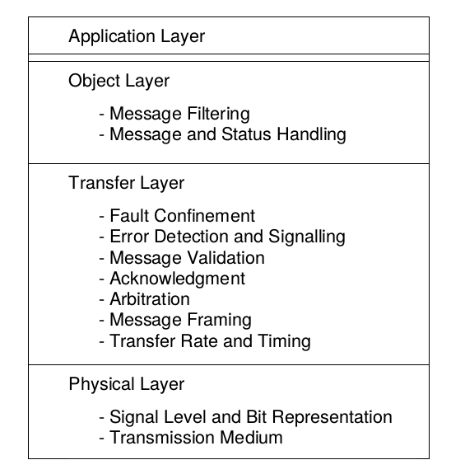

The Physical Layer defines how signals are actually transmitted. Within this specification the physical layer is not defined so as to allow transmission medium and signal level implementations to be optimized for their application.

The Transfer Layer represents the kernel of the CAN protocol. It presents messages received to the object layer and accepts messages to be transmitted from the object layer. The transfer layer is responsible for bit timing and synchronization, message framing, arbitration, acknowledgment, error detection and signalling, and fault confinement.

The Object Layer is concerned with message filtering as well as status and message handling.

Messages
Information on the bus is sent in fixed format messages of different but limited length. When the bus is free any connected unit may start to transmit a new message.

Information Routing
In CAN systems a CAN node does not make use of any information about the system configuration (e.g. station addresses). This has several important consequences.

System Flexibility: Nodes can be added to the CAN network without requiring any change in the software or hardware of any node and application layer.

Message Routing: The content of a message is named by an IDENTIFIER. The IDENTIFIER does not indicate the destination of the message, but describes the meaning of the data, so that all nodes in the network are able to decide by MESSAGE FILTERING whether the data is to be acted upon by them or not.

Multicast: As a consequence of the concept of MESSAGE FILTERING any number of nodes can receive and simultaneously act upon the same message.

Data Consistency: Within a CAN network it is guaranteed that a message is simultaneously accepted either by all nodes or by no node. Thus data consistency of a system is achieved by the concepts of multicast and by error handling.

Bit rate
The speed of CAN may be different in different systems. However, in a given system
the bitrate is uniform and fixed.

Priorities
The IDENTIFIER defines a static message priority during bus access.

Remote Data Request
By sending a REMOTE FRAME a node requiring data may request another node to send the corresponding DATA FRAME. The DATA FRAME and the corresponding REMOTE FRAME are named by the same IDENTIFIER.

Multimaster
When the bus is free any unit may start to transmit a message. The unit with the
message of higher priority to be transmitted gains bus access.

Arbitration
Whenever the bus is free, any unit may start to transmit a message. If 2 or more units
start transmitting messages at the same time, the bus access conflict is resolved by
bitwise arbitration using the IDENTIFIER. The mechanism of arbitration guarantees that
neither information nor time is lost.
- If a DATA FRAME and a REMOTE FRAME with the same IDENTIFIER are initiated at the same time, the DATA FRAME prevails over the REMOTE FRAME.
- During arbitration every transmitter compares the level of the bit transmitted with the level that is monitored on the bus. If these levels are equal the unit may continue to send. When a ’recessive’ level is sent and a ’dominant’ level is monitored , the unit has lost arbitration and must withdraw without sending one more bit.

Safety
In order to achieve the utmost safety of data transfer, powerful measures for error detection, signalling and self-checking are implemented in every CAN node.

Error Detection
For detecting errors the following measures have been taken:
- Monitoring (transmitters compare the bit levels to be transmitted with the bit
levels detected on the bus)
- Cyclic Redundancy Check
- Bit Stuffing
- Message Frame Check

Performance of Error Detection
The error detection mechanisms have the following properties:
-all global errors are detected.
-all local errors at transmitters are detected.
-up to 5 randomly distributed errors in a message are detected.
-burst errors of length less than 15 in a message are detected.
-errors of any odd number in a message are detected.

Error Signalling and Recovery Time
Corrupted messages are flagged by any node detecting an error. Such messages are aborted and will be retransmitted automatically. The recovery time from detecting an error until the start of the next message is at most 29 bit times, if there is no further error.
Fault Confinement
CAN nodes are able to distinguish short disturbances from permanent failures.
Defective nodes are switched off.

Connections
The CAN serial communication link is a bus to which a number of units may be connected. This number has no theoretical limit. Practically the total number of units will be limited by delay times and/or electrical loads on the bus line.

Single Channel
The bus consists of a single channel that carries bits. From this data resynchronization information can be derived. The way in which this channel is implemented is not fixed in this specification. E.g. single wire (plus ground), two differential wires, optical fibres,etc.

Bus values
The bus can have one of two complementary logical values: ’dominant’ or ’recessive’.
During simultaneous transmission of ’dominant’ and ’recessive’ bits, the resulting bus
value will be ’dominant’. For example, in case of a wired-AND implementation of the
bus, the ’dominant’ level would be represented by a logical ’0’ and the ’recessive’ level
by a logical ’1’.

Acknowledgment
All receivers check the consistency of the message being received and will acknowledge a consistent message and flag an inconsistent message.

Sleep Mode / Wake-up
To reduce the system’s power consumption, a CAN-device may be set into sleep mode without any internal activity and with disconnected bus drivers. The sleep mode is finished with a wake-up by any bus activity or by internal conditions of the system. On wake-up, the internal activity is restarted, although the transfer layer will be waiting for the system’s oscillator to stabilize and it will then wait until it has synchronized itself to the bus activity (by checking for eleven consecutive ’recessive’ bits), before the bus drivers are set to "on-bus" again.
In order to wake up other nodes of the system, which are in sleep-mode, a special wake-up message with the dedicated, lowest possible IDENTIFIER (rrr rrrd rrrr; r = ’recessive’ d = ’dominant’) may be used.

Message Transfer

Frame Types
Message transfer is manifested and controlled by four different frame types:
-A DATA FRAME carries data from a transmitter to the receivers.
-A REMOTE FRAME is transmitted by a bus unit to request the transmission of the
DATA FRAME with the same IDENTIFIER.
-An ERROR FRAME is transmitted by any unit on detecting a bus error.
-An OVERLOAD FRAME is used to provide for an extra delay between the preceding
and the succeeding DATA or REMOTE FRAMEs.

DATA FRAMEs and REMOTE FRAMEs are separated from preceding frames by an
INTERFRAME SPACE.

DATA FRAME
A DATA FRAME is composed of seven different bit fields:
START OF FRAME, ARBITRATION FIELD, CONTROL FIELD, DATA FIELD, CRC
FIELD, ACK FIELD, END OF FRAME. The DATA FIELD can be of length zero.

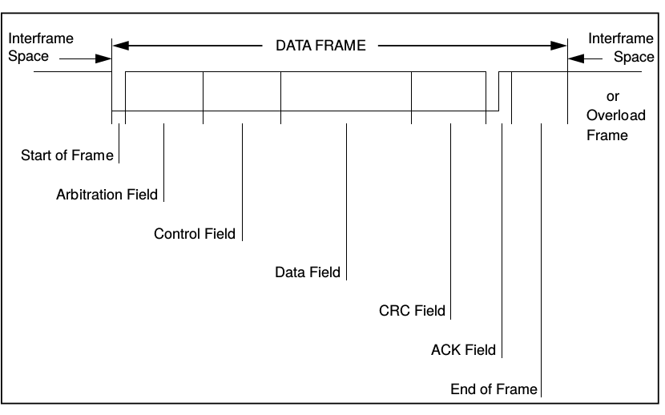

START OF FRAME
marks the beginning of DATA FRAMES and REMOTE FRAMEs. It consists of a single
’dominant’ bit.
A station is only allowed to start transmission when the bus is idle (see BUS IDLE). All stations have to synchronize to the leading edge caused by START OF FRAME (see ’HARD SYNCHRONIZATION’) of the station starting transmission first.

ARBITRATION FIELD
The ARBITRATION FIELD consists of the IDENTIFIER and the RTR-BIT.

IDENTIFIER
The IDENTIFIER’s length is 11 bits. These bits are transmitted in the order from ID-10
to ID-0. The least significant bit is ID-0. The 7 most significant bits (ID-10 - ID-4) must
not be all ’recessive’.

RTR BIT
Remote Transmission Request BIT
In DATA FRAMEs the RTR BIT has to be ’dominant’. Within a REMOTE FRAME the
RTR BIT has to be ’recessive’.

CONTROL FIELD
The CONTROL FIELD consists of six bits. It includes the DATA LENGTH CODE and
two bits reserved for future expansion. The reserved bits have to be sent ’dominant’.
Receivers accept ’dominant’ and ’recessive’ bits in all combinations.

DATA LENGTH CODE
The number of bytes in the DATA FIELD is indicated by the DATA LENGTH CODE.
This DATA LENGTH CODE is 4 bits wide and is transmitted within the CONTROL
FIELD.

DATA FIELD
The DATA FIELD consists of the data to be transferred within a DATA FRAME. It can
contain from 0 to 8 bytes, which each contain 8 bits which are transferred MSB first.
CRC FIELD
contains the CRC SEQUENCE followed by a CRC DELIMITER.

CRC SEQUENCE
The frame check sequence is derived from a cyclic redundancy code best suited for
frames with bit counts less than 127 bits (BCH Code).
In order to carry out the CRC calculation the polynomial to be divided is defined as the
polynomial, the coefficients of which are given by the destuffed bit stream consisting of
START OF FRAME, ARBITRATION FIELD, CONTROL FIELD, DATA FIELD (if
present) and, for the 15 lowest coefficients, by 0. This polynomial is divided (the
coefficients are calculated modulo-2) by the generator-polynomial:
X 15 + X 14 + X 10 + X 8 + X 7 + X 4 + X 3 + 1.

CRC DELIMITER
The CRC SEQUENCE is followed by the CRC DELIMITER which consists of a single
’recessive’ bit.

ACK FIELD
The ACK FIELD is two bits long and contains the ACK SLOT and the ACK DELIMITER.
In the ACK FIELD the transmitting station sends two ’recessive’ bits.
A RECEIVER which has received a valid message correctly, reports this to the
TRANSMITTER by sending a ’dominant’ bit during the ACK SLOT (it sends ’ACK’).

ACK SLOT
All stations having received the matching CRC SEQUENCE report this within the ACK
SLOT by superscribing the ’recessive’ bit of the TRANSMITTER by a ’dominant’ bit.

ACK DELIMITER
The ACK DELIMITER is the second bit of the ACK FIELD and has to be a ’recessive’
bit. As a consequence, the ACK SLOT is surrounded by two ’recessive’ bits (CRC
DELIMITER, ACK DELIMITER).

END OF FRAME
Each DATA FRAME and REMOTE FRAME is delimited by a flag sequence consisting
of seven ’recessive’ bits.

REMOTE FRAME
A station acting as a RECEIVER for certain data can initiate the transmission of the
respective data by its source node by sending a REMOTE FRAME.
A REMOTE FRAME is composed of six different bit fields:
START OF FRAME, ARBITRATION FIELD, CONTROL FIELD, CRC FIELD, ACK
FIELD, END OF FRAME.
Contrary to DATA FRAMEs, the RTR bit of REMOTE FRAMEs is ’recessive’. There is
no DATA FIELD, independent of the values of the DATA LENGTH CODE which may
be signed any value within the admissible range 0...8. The value is the DATA LENGTH
CODE of the corresponding DATA FRAME.
The polarity of the RTR bit indicates whether a transmitted frame is a DATA FRAME
(RTR bit ’dominant’) or a REMOTE FRAME (RTR bit ’recessive’).
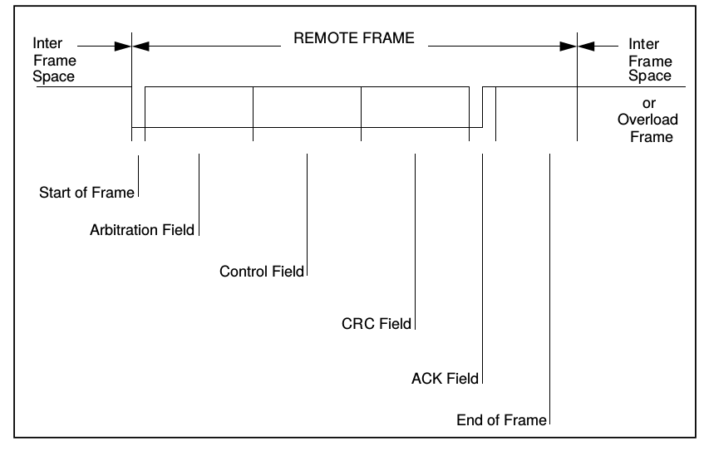

ERROR FRAME
The ERROR FRAME consists of two different fields. The first field is given by the
superposition of ERROR FLAGs contributed from different stations. The following
second field is the ERROR DELIMITER.

In order to terminate an ERROR FRAME correctly, an ’error passive’ node may need
the bus to be ’bus idle’ for at least 3 bit times (if there is a local error at an ’error
passive’ receiver). Therefore the bus should not be loaded to 100%.

ERROR FLAG
There are 2 forms of an ERROR FLAG: an ACTIVE ERROR FLAG and a PASSIVE
ERROR FLAG.
1. The ACTIVE ERROR FLAG consists of six consecutive ’dominant’ bits.
2. The PASSIVE ERROR FLAG consists of six consecutive ’recessive’ bits unless it
is overwritten by ’dominant’ bits from other nodes.

ERROR DELIMITER
The ERROR DELIMITER consists of eight ’recessive’ bits.
After transmission of an ERROR FLAG each station sends ’recessive’ bits and
monitors the bus until it detects a ’recessive’ bit. Afterwards it starts transmitting seven
more ’recessive’ bits.

OVERLOAD FRAME
The OVERLOAD FRAME contains the two bit fields OVERLOAD FLAG and
OVERLOAD DELIMITER.
There are two kinds of OVERLOAD conditions, which both lead to the transmission of
an OVERLOAD FLAG:
1. The internal conditions of a receiver, which requires a delay of the next DATA
FRAME or REMOTE FRAME.
2. Detection of a ’dominant’ bit during INTERMISSION.

The start of an OVERLOAD FRAME due to OVERLOAD condition 1 is only allowed to
be started at the first bit time of an expected INTERMISSION, whereas OVERLOAD
FRAMEs due to OVERLOAD condition 2 start one bit after detecting the ’dominant’ bit.

At most two OVERLOAD FRAMEs may be generated to delay the next DATA or REMOTE FRAME.

OVERLOAD FLAG
consists of six ’dominant’ bits. The overall form corresponds to that of the ACTIVE
ERROR FLAG.

OVERLOAD DELIMITER
consists of eight ’recessive’ bits.

Stuffing Bits
The term “bit stuffing” broadly refers to a technique whereby extra bits are added to a data stream, which do not themselves carry any information, but either assist in management of the communications or deal with other issues. Bit stuffing is all about protocol management.

INTERFRAME SPACING
DATA FRAMEs and REMOTE FRAMEs are separated from preceding frames whatever type they are (DATA FRAME, REMOTE FRAME, ERROR FRAME, OVERLOAD FRAME) by a bit field called INTERFRAME SPACE.

In contrast, OVERLOAD FRAMEs and ERROR FRAMEs are not preceded by an INTERFRAME
SPACE and multiple OVERLOAD FRAMEs are not separated by an INTERFRAME
SPACE.

INTERFRAME SPACE
contains the bit fields INTERMISSION and BUS IDLE and, for ’error passive’ stations,
which have been TRANSMITTER of the previous message, SUSPEND TRANSMISSION.

INTERMISSION
consists of three ’recessive’ bits.

During INTERMISSION no station is allowed to start transmission of a DATA FRAME
or REMOTE FRAME. The only action to be taken is signalling an OVERLOAD
condition.

BUS IDLE
The period of BUS IDLE may be of arbitrary length. The bus is recognized to be free
and any station having something to transmit can access the bus. A message, which is
pending for transmission during the transmission of another message, is started in the
first bit following INTERMISSION.
The detection of a ’dominant’ bit on the bus is interpreted as a START OF FRAME.

SUSPEND TRANSMISSION
After an ’error passive’ station has transmitted a message, it sends eight ’recessive’
bits following INTERMISSION, before starting to transmit a further message or
recognizing the bus to be idle. If meanwhile a transmission (caused by another station)
starts, the station will become receiver of this message.

MESSAGE VALIDATION
The point of time at which a message is taken to be valid, is different for the transmitter
and the receivers of the message.

Transmitter:
The message is valid for the transmitter, if there is no error until the end of END OF
FRAME. If a message is corrupted, retransmission will follow automatically and
according to prioritization. In order to be able to compete for bus access with other
messages, retransmission has to start as soon as the bus is idle.

Receivers:
The message is valid for the receivers, if there is no error until the last but one bit of
END OF FRAME.

BIT STREAM CODING
The frame segments START OF FRAME, ARBITRATION FIELD, CONTROL FIELD,
DATA FIELD and CRC SEQUENCE are coded by the method of bit stuffing. Whenever
a transmitter detects five consecutive bits of identical value in the bit stream to be
transmitted it automatically inserts a complementary bit in the actual transmitted bit
stream.

The remaining bit fields of the DATA FRAME or REMOTE FRAME (CRC DELIMITER,
ACK FIELD, and END OF FRAME) are of fixed form and not stuffed. The ERROR
FRAME and the OVERLOAD FRAME are of fixed form as well and not coded by the
method of bit stuffing.
The bit stream in a message is coded according to the Non-Return-to-Zero (NRZ) method. This means that during the total bit time the generated bit level is either ’dominant’ or ’recessive’.

Error Detection
There are 5 different error types (which are not mutually exclusive):

• BIT ERROR
A unit that is sending a bit on the bus also monitors the bus. A BIT ERROR has to
be detected at that bit time, when the bit value that is monitored is different from the
bit value that is sent. An exception is the sending of a ’recessive’ bit during the
stuffed bit stream of the ARBITRATION FIELD or during the ACK SLOT. Then no
BIT ERROR occurs when a ’dominant’ bit is monitored. A TRANSMITTER sending
a PASSIVE ERROR FLAG and detecting a ’dominant’ bit does not interpret this as
a BIT ERROR.

• STUFF ERROR
A STUFF ERROR has to be detected at the bit time of the 6th consecutive equal bit
level in a message field that should be coded by the method of bit stuffing.

• CRC ERROR
The CRC sequence consists of the result of the CRC calculation by the transmitter.
The receivers calculate the CRC in the same way as the transmitter. A CRC ERROR has to be detected, if the calculated result is not the same as that received in the CRC sequence.
• FORM ERROR
A FORM ERROR has to be detected when a fixed-form bit field contains one or
more illegal bits.

• ACKNOWLEDGMENT ERROR
An ACKNOWLEDGMENT ERROR has to be detected by a transmitter whenever it
does not monitor a ’dominant’ bit during the ACK SLOT.

Error Signalling
A station detecting an error condition signals this by transmitting an ERROR FLAG. For
an ’error active’ node it is an ACTIVE ERROR FLAG, for an ’error passive’ node it is a
PASSIVE ERROR FLAG. Whenever a BIT ERROR, a STUFF ERROR, a FORM
ERROR or an ACKNOWLEDGMENT ERROR is detected by any station, transmission
of an ERROR FLAG is started at the respective station at the next bit.

MODBUS

MODBUS ASCII/RTU is a master-slave communication protocol, able to support up to 247 slaves connected in a bus or a star network.
The protocol uses a simplex connection on a single line. In this way, the communication messages move on a single line in two opposite directions.

MODBUS TCP is a variant of the MODBUS family. Specifically, it covers the use of MODBUS messaging in an “Intranet” or “Internet” environment using the TCP/IP protocol on a fixed port 502.

Master-slave messages can be:
• Reading (Function code $01 / $03 / $04) : the communication is between the master and a single slave. It allows to read information about the queried counter
• Writing (Function code $10) : the communication is between the master and a single slave. It allows to change the counter settings
• Broadcast (not available for MODBUS TCP) : the communication is between the master and all the connected slaves. It is always a write command (Function code $10) and required logical number $00

In a multi-point type connection (MODBUS ASCII/RTU), slave address (called also logical number) allows to identify each counter during the communication. Each communication module is preset with a default slave address (01) and the user can change it.

In case of MODBUS TCP, slave address is replaced by a single byte, the Unit identifier.

Communication frame structure
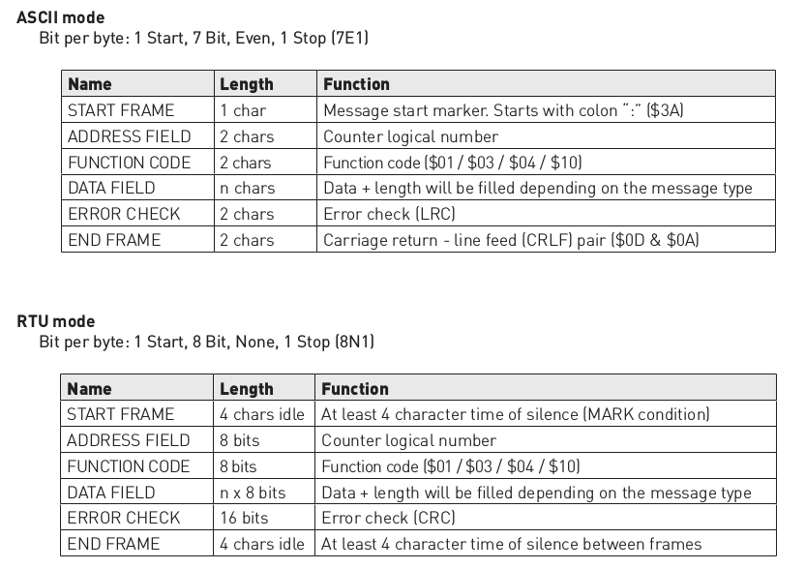

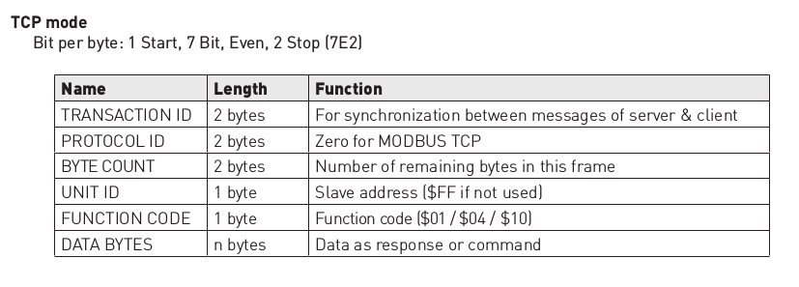

LRC generation
The Longitudinal Redundancy Check (LRC) field is one byte, containing an 8–bit binary value. The LRC value is calculated by the transmitting device, which appends the LRC to the message. The receiving device recalculates an LRC during receipt of the message, and compares the calculated value to the actual value it received in the LRC field. If the two values are not equal, an error results. The LRC is calculated by adding together successive 8–bit bytes in the message, discarding any carries, and then two’s complementing the result. The LRC is an 8–bit field, therefore each new addition of a character that would result in a value higher than 255 decimal simply ‘rolls over’ the field’s value through zero. Because there is no ninth bit, the carry is discarded automatically.

A procedure for generating an LRC is:
1. Add all bytes in the message, excluding the starting ‘colon’ and ending CR LF. Add them into an 8–bit field, so that carries will be discarded.
2. Subtract the final field value from 0xFF, to produce the ones–complement.
3. Add 1 to produce the twos–complement.

CRC generation
The Cyclical Redundancy Check (CRC) field is two bytes, containing a 16–bit value. The CRC value is calculated by the transmitting device, which appends the CRC to the message. The receiving device recalculates a CRC during receipt of the message, and compares the calculated value to the actual value it received in the CRC field. If the two values are not equal, an error results. The CRC is started by first preloading a 16–bit register to all 1’s. Then a process begins of applying successive 8–bit bytes of the message to the current contents of the register. Only the eight bits of data in each character are used for generating the CRC. Start and stop bits, and the parity bit, do not apply to the CRC.
During generation of the CRC, each 8–bit character is exclusive ORed with the register contents. Then the result is shifted in the direction of the least significant bit (LSB), with a zero filled into the most significant bit (MSB) position. The LSB is extracted and examined. If the LSB was a 1, the register is then exclusive ORed with a preset, fixed value. If the LSB was a 0, no exclusive OR takes place.
This process is repeated until eight shifts have been performed. After the last (eighth) shift, the next 8–bit character is exclusive ORed with the register’s current value, and the process repeats for eight more shifts as described above. The final contents of the register, after all the characters of the message have been applied, is the CRC value.
A calculated procedure for generating a CRC is:
1. Load a 16–bit register with 0xFFFF. Call this the CRC register.
2. Exclusive OR the first 8–bit byte of the message with the low–order byte of the 16–bit CRC register, putting the result in the CRC register.
3. Shift the CRC register one bit to the right (toward the LSB), zero–filling the MSB. Extract and examine the LSB.
4. (If the LSB was 0): Repeat Step 3 (another shift).
(If the LSB was 1): Exclusive OR the CRC register with the polynomial value $A001 (1010 0000 0000 0001).
5. Repeat Steps 3 and 4 until 8 shifts have been performed. When this is done, a complete 8–bit byte will have been processed.
6. Repeat Steps 2 through 5 for the next 8–bit byte of the message. Continue doing this until all bytes have been processed.
7. The final contents of the CRC register is the CRC value.
8. When the CRC is placed into the message, its upper and lower bytes must be swapped as described below.

Placing the CRC into the Message
When the 16–bit CRC (two 8–bit bytes) is transmitted in the message, the low-order byte will be transmitted first, followed by the high-order byte.
For example, if the CRC value is $35F7 (0011 0101 1111 0111):
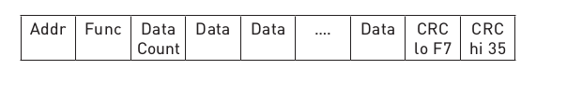

Since Modbus protocol is just a messaging structure, it is independent of the underlying physical layer. It is traditionally implemented using RS232, RS422, or RS485

The Request
The function code in the request tells the addressed slave device what kind of action to perform. The data bytes contains any additional information that the slave will need to perform the function. For example, function code 03 will request the slave to read holding registers and respond with their contents. The data field must contain the information telling the slave which register to start at and how many registers to read. The error check field provides a method for the slave to validate the integrity of the message contents.

The Response
If the slave makes a normal response, the function code in the response is an echo of the function code in the request. The data bytes contain the data collected by the slave, such as register values or status. If an error occurs, the function code is modified to indicate that the response is an error response, and the data bytes contain a code that describes the error. The error check field allows the master to confirm that the message contents are valid.
Controllers can be setup to communicate on standard Modbus networks using either of two transmission modes: ASCII or RTU.

ASCII Mode
When controllers are setup to communicate on a Modbus network using ASCII (American Standard Code for Information Interchange) mode, each eight-bit byte in a message is sent as ASCII characters. The main advantage of this mode is that it allows time intervals of up to one second to occur between characters without causing an error.
Coding System
Hexadecimal ASCII printable characters 0 ... 9, A ... F
Bits per Byte
1 start bit
7 data bits, least significant bit sent first
1 bit for even / odd parity-no bit for no parity
1 stop bit if parity is used-2 bits if no parity
Error Checking
Longitudinal Redundancy Check (LRC)

RTU Mode
When controllers are setup to communicate on a Modbus network using RTU (Remote Terminal Unit) mode, each eight-bit byte in a message contains two four-bit hexadecimal characters. The main advantage of this mode is that its greater character density allows better data throughput than ASCII for the same baud rate. Each message must be transmitted in a continuous stream.
Coding System
Eight-bit binary, hexadecimal 0 ... 9, A ... F
Two hexadecimal characters contained in each eight-bit field of the message
Bits per Byte
1 start bit
8 data bits, least significant bit sent first
1 bit for even / odd parity-no bit for no parity
1 stop bit if parity is used-2 bits if no parity
Error Check Field
Cyclical Redundancy Check (CRC)
In ASCII mode, messages start with a colon ( : ) character (ASCII 3A hex), and end with a carriage return-line feed (CRLF) pair (ASCII 0D and 0A hex).
The allowable characters transmitted for all other fields are hexadecimal 0 ... 9, A ... F. Networked devices monitor the network bus continuously for the colon character. When one is received, each device decodes the next field (the address field) to find out if it is the addressed device.
Intervals of up to one second can elapse between characters within the message. If a greater interval occurs, the receiving device assumes an error has occurred. A typical message frame is shown below.
Start | Address | Function | Data | LRC | End
: | 2 Chars | 2 Chars | N Chars | 2 Chars | CR LF
RTU Framing
In RTU mode, messages start with a silent interval of at least 3.5 character times. This is most easily implemented as a multiple of character times at the baud rate that is being used on the network . The first field then transmitted is the device address.
The allowable characters transmitted for all fields are hexadecimal 0 ... 9, A ... F. Networked devices monitor the network bus continuously, including during the silent intervals. When the first field (the address field) is received, each device decodes it to find out if it is the addressed device.
Following the last transmitted character, a similar interval of at least 3.5 character times marks the end of the message. A new message can begin after this interval.
The entire message frame must be transmitted as a continuous stream. If a silent interval of more than 1.5 character times occurs before completion of the frame, the receiving device flushes the incomplete message and assumes that the next byte will be the address field of a new message.
Similarly, if a new message begins earlier than 3.5 character times following a previous message, the receiving device will consider it a continuation of the previous message. This will set an error, as the value in the final CRC field will not be valid for the combined messages. A typical message frame is shown below.
Start | Address | Function | Data | CRC | End
3.5 Char time | 8 Bit | 8 Bit | N * 8Bit | 16 Bit | 3.5 Char time
Address Field
The address field of a message frame contains two characters (ASCII) or eight bits (RTU). The individual slave devices are assigned addresses in the range of 1 ... 247.
Function Field
The Function Code field tells the addressed slave what function to perform.
The following functions are supported by Modbus poll
01 READ COIL STATUS
02 READ INPUT STATUS
03 READ HOLDING REGISTERS
04 READ INPUT REGISTERS
05 WRITE SINGLE COIL
06 WRITE SINGLE REGISTER
15 WRITE MULTIPLE COILS
16 WRITE MULTIPLE REGISTERS
The data field contains the requested or send data.
Contents of the Error Checking Field
Two kinds of error-checking methods are used for standard Modbus networks. The error checking field contents depend upon the method that is being used.
ASCII
When ASCII mode is used for character framing, the error-checking field contains two ASCII characters. The error check characters are the result of a Longitudinal Redundancy Check (LRC) calculation that is performed on the message contents, exclusive of the beginning colon and terminating CRLF characters.
The LRC characters are appended to the message as the last field preceding the CRLF characters.
RTU
When RTU mode is used for character framing, the error-checking field contains a 16-bit value implemented as two eight-bit bytes. The error check value is the result of a Cyclical Redundancy Check calculation performed on the message contents.
The CRC field is appended to the message as the last field in the message. When this is done, the low-order byte of the field is appended first, followed by the high-order byte. The CRC high-order byte is the last byte to be sent in the message.

