**Introduction:**

* The city of Charlotte, NC is medium sized city with an amazing uptown and the city is packed with restaurants, night life and amazing people. Charlotte is the Financial capital of NC and is the largest city in NC. For people that used to live in Charlotte or people visiting Charlotte, how do you know what the best places are to get something to eat?

**Business Problem:**

* In this project I would create a simple guide on where to eat based on Foursquare ratings, price, category and geographic location data for restaurants in Charlotte. I will then cluster these restaurants based on their similarities so that a user can easily determine what type cuisine they are looking for and in what price range.

**Required Data**

For this assignment, I will be utilizing the Foursquare API to pull the following location data on restaurants in Charlotte, NC:

* Venue Name
* Venue ID
* Venue Location
* Venue Category
* Count of Likes

**Approach**

I would be using the below to get the data:

* Get geolocator lat and long coordinates for Charlotte, NC

Get a list of all venues in Charlotte For this assignment, I will be utilizing the Foursquare API to pull the following location data on restaurants in Charlotte, NC:

* Venue Name
* Venue ID
* Venue Location
* Venue Category
* Count of Likes
* Get venue IDs for each venue in Charlotte
* Pull venue name, location, category, rating, price, count of likes and phrases for each venue

**Methodology**

The more likes the better the restaurant is. This is one of the common practice which we follow in our daily routines. Bin the data into a quality categorical variables so clustering can be appropriately done.

I am also going to create new categorical variables for the restaurants to better group them based on type of cuisine. This way you can look for food, Bars and Other things in this area.

K-Means clustering algorithm is used to cluster the data gathered. I have used 3 clusters.

Cluster 3:

Poor Quality

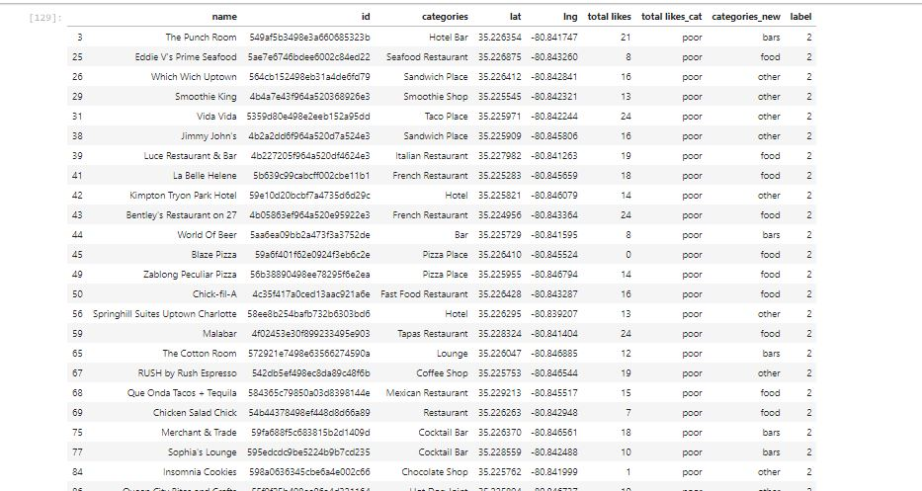

Cluster 2:

Great Quality

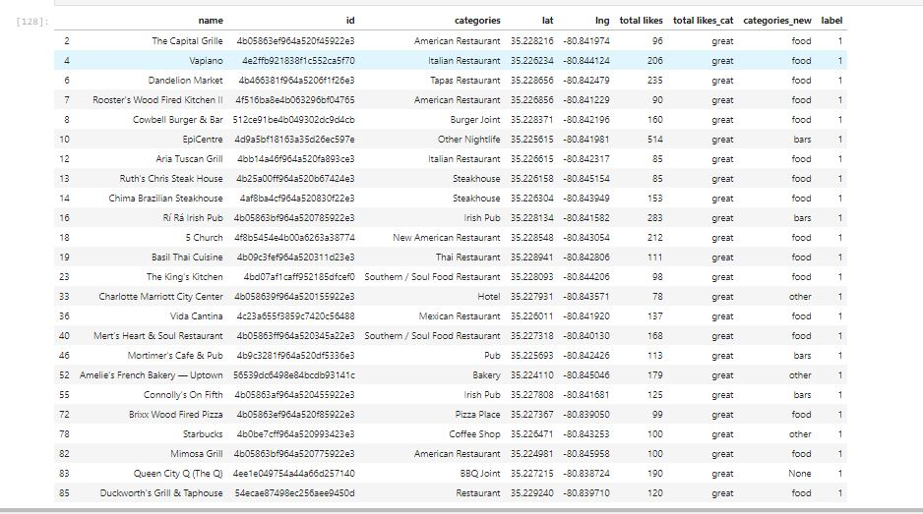

Cluster 1:

Average

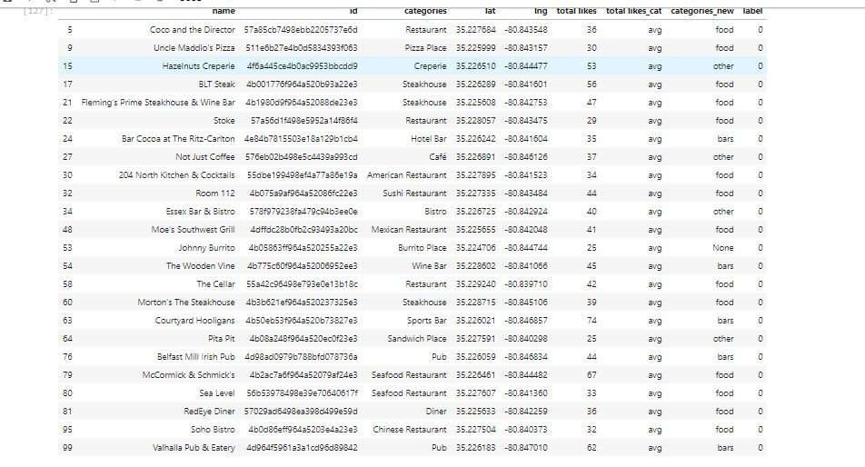

Map of Clusters for users

