- 1 0Pod is stuck in Pending state. What will you check? Check node resources (CPU/Memory), taints & tolerations, node affinity rules, PVC binding issues, and scheduler events using kubectl describe pod.

Pod stuck in Pending – What to check?
When a Pod is in Pending state, it means Kubernetes has accepted the Pod but cannot schedule it on any node yet.

🔍 Step-by-step debugging approach
1️⃣ Check Pod details (MOST IMPORTANT)
kubectl describe pod <pod-name>
👉 This is your first and strongest step
Look at:
- Events section
- Scheduler messages like:
  - 0/3 nodes are available
  - Insufficient CPU
  - node(s) had taint
  - PVC not bound
2️⃣ Check Node Resources (CPU / Memory)
👉 If cluster doesn’t have enough resources:
kubectl describe nodes
Look for:
- Allocated vs Available CPU/Memory
- Conditions like MemoryPressure

3️⃣ Check Taints & Tolerations
👉 If nodes have taints and Pod doesn’t tolerate them → scheduling fails
kubectl describe node <node-name>
Example issue:
node(s) had taint {key=value:NoSchedule}
4️⃣ Check Node Affinity / Node Selector
👉 Pod may have strict rules:
nodeSelector:
disktype: ssd
If no node matches → Pod stays Pending

5️⃣ Check PVC (Persistent Volume Claim)
👉 Very common issue in real projects
kubectl get pvc
If status:
Pending
Then Pod cannot start because storage is not available

6️⃣ Check Scheduler Issues
👉 Sometimes scheduler itself has issues
kubectl get events
Look for:
- FailedScheduling
- Preemption issues

7️⃣ Check Image Pull Secrets (rare case for Pending)
If Pod cannot resolve image registry (private repo issue)

💡 Pro Tip (Real DevOps Insight)
In real projects, 90% cases are due to:
- ❌ Insufficient CPU/Memory
- ❌ PVC not bound
- ❌ Taints mismatch
- ------------------------------------------------------------------------------------------------

✅ Pods running but Service not routing traffic — Why?
If Pods are Running but traffic isn’t reaching them, it usually means the Service can’t correctly discover or route to those Pods.

🔍 Step-by-step debugging
1️⃣ Check Service → Pod label matching (MOST COMMON)
kubectl get svc <service-name> -o yaml
kubectl get pods --show-labels
👉 Ensure: Service selector = Pod labels
❌ Example issue:
# Service
selector:
app: backend
# Pod
labels:
app: api ❌ mismatch

2️⃣ Check Endpoints (CRITICAL)
kubectl get endpoints <service-name>

👉 If you see:
<none>
➡️ Service is not linked to any Pod
✔️ Fix = correct labels

3️⃣ Check Readiness Probe
👉 Even if Pod is Running, it won’t receive traffic unless Ready
kubectl describe pod <pod-name>
Look for:
- Readiness probe failed
➡️ Pod will NOT be added to Service endpoints

4️⃣ Check Service Type & Port Mapping
kubectl get svc <service-name> -o yaml
Verify:
- targetPort matches container port
- port is correct
❌ Example:
port: 80
targetPort: 8080 ❌ but app runs on 3000

5️⃣ Check kube-proxy / Networking
👉 Internal routing depends on kube-proxy (iptables/IPVS)
kubectl get pods -n kube-system | grep kube-proxy
Check:
- kube-proxy is running
- No networking plugin issue (CNI)

6️⃣ Test Connectivity inside cluster
kubectl exec -it <pod> -- curl <service-name>
👉 Helps confirm:
- DNS working
- Service reachable internally

7️⃣ Check Network Policies (ADVANCED)
👉 Traffic may be blocked
kubectl get networkpolicy

💡 Real-world Most Common Causes
- ❌ Label mismatch (VERY COMMON)
- ❌ No endpoints
- ❌ Readiness probe failing
- ❌ Wrong targetPort

3) Application latency suddenly increased after scaling. Why?
Possible causes: resource throttling, HPA misconfiguration, network bottleneck, uneven , traffic distribution, or cold start delays.

What to check (with reasoning + commands)
1️⃣ CPU throttling / resource limits
👉 New Pods may have low CPU limits, causing throttling under load
kubectl top pod
kubectl describe pod <pod-name>
Look for:
- High CPU usage near limits
- CPU throttling in metrics (Prometheus/Grafana)
- ⚠️ CPU Throttling — What it actually means
- CPU throttling happens when a container tries to use more CPU than its defined limit, and Kubernetes (via Linux cgroups) restricts it.
- 👉 Result: your application slows down, even if the node has free CPU

2️⃣ HPA misconfiguration
👉 Autoscaler may scale too late or incorrectly
kubectl get hpa
kubectl describe hpa <hpa-name>
Common issues:
- High CPU target (e.g., 80–90%)
- Slow scale-up behavior
- Wrong metric (CPU vs real bottleneck like memory or RPS)

3️⃣ Uneven traffic distribution
👉 Load balancer may not distribute traffic evenly
Check:
- Some Pods overloaded, others idle
- Sticky sessions causing imbalance
kubectl get endpoints <service-name>

4️⃣ Cold start latency
👉 New Pods take time to:
- Start JVM / app
- Load cache / DB connections
Result → initial requests are slow
Check:
kubectl get pods -w
kubectl logs <new-pod>

5️⃣ Database / downstream bottleneck
👉 Scaling app ≠ scaling DB
Symptoms:
- DB connection pool exhausted
- Increased query latency
Check:
- DB metrics (connections, slow queries)
- App logs

6️⃣ Network bottleneck / CNI issues
👉 More Pods = more network traffic
Check:
- CNI plugin health
- kube-proxy performance
- 7️⃣ Readiness probe misconfiguration
- 👉 Pods receive traffic before they are fully ready
- kubectl describe pod <pod-name>

💡 Real-world insight (VERY IMPORTANT)
In production, most common causes are:
- ❌ HPA reacts too slowly
- ❌ DB becomes bottleneck after scaling
- ❌ Cold start (especially Java/Spring Boot apps)

✅ Node in NotReady state — What it means
A node becomes NotReady when Kubernetes can’t reliably communicate with it or it reports unhealthy conditions (via kubelet).

🔍 Step-by-step troubleshooting
1️⃣ Check node status & conditions (START HERE)
kubectl get nodes
kubectl describe node <node-name>
👉 Look for:
- Ready: False
- Conditions:
  - MemoryPressure
  - DiskPressure
  - PIDPressure
  - NetworkUnavailable

2️⃣ Check kubelet service (MOST COMMON ISSUE)
👉 kubelet is the heart of the node
systemctl status kubelet
journalctl -u kubelet -f
Common problems:
- kubelet stopped/crashed
- certificate issues
- API server unreachable

✅ What is Kubelet?
Kubelet is an agent that runs on every Kubernetes node and ensures containers are running as expected.
👉 In simple words:
Kubelet = “Node manager” of Kubernetes

3️⃣ Check container runtime (Docker / containerd)
systemctl status containerd
# or
systemctl status docker
👉 If runtime is down → node becomes NotReady

4️⃣ Check resource pressure
🔹 Memory pressure
free -h
🔹 Disk pressure
df -h
👉 If disk is full or memory exhausted → node marked unhealthy

5️⃣ Check network connectivity
👉 Node must talk to control plane
ping <api-server>
curl -k https://<api-server>:6443
Issues:
- Security group / firewall
- VPC routing (in AWS)

6️⃣ Check node logs (deep debugging)
journalctl -xe
Look for:
- kubelet errors
- runtime failures
- disk mount issues

7️⃣ Check certificate expiry (advanced)
👉 kubelet uses certs to talk to API server
kubeadm certs check-expiration

Real-world Most Common Causes
- ❌ kubelet stopped/crashed
- ❌ Disk full (very common in logs-heavy systems)
- ❌ Network issue with control plane
- ❌ Container runtime failure

Q- 5) How would you design multi-tenant Kubernetes architecture?
Use namespaces, RBAC isolation, network policies, resource quotas, and separate node
pools if required.

✅ What is Multi-Tenant Kubernetes?
A multi-tenant cluster allows multiple teams, apps, or customers (tenants) to share the same Kubernetes cluster securely and efficiently.

🚀 Multi-Tenant Kubernetes Architecture (Full Design)
Multi-tenancy means multiple teams / applications / customers share the same cluster while staying secure and isolated.

  - Namespace Isolation (First Layer)-
Each tenant gets its own Namespace.

Benefits:
- Logical isolation
- Separate resources (Pods, Services, ConfigMaps)
- Easy management.

🔹 2. RBAC (Role-Based Access Control)
- Restrict access per tenant using:
  - Roles
  - RoleBindings
Example:
Team A → can only access namespace team-a
Team B → can only access namespace team-b
👉 Key idea:
- No cross-namespace access
- Principle of least privilege.

  - Network Policies (Security Layer)- Control pod-to-pod communication.
- Allow traffic only within same namespace
- Deny all cross-tenant communication.
Without this → pods can talk to each other (security risk ⚠️).

🔹 4. Resource Quotas & Limits (Fair Usage)
- Prevent one tenant from consuming all resources
Example:
CPU: 4 cores
Memory: 8GB
Pods: 10
👉 Use:
- ResourceQuota
- LimitRange .
5. Node Isolation (Advanced / High Security)- Use:
- Node pools
- Taints & Tolerations
- Node affinity
Sensitive workloads → dedicated nodes
General workloads → shared nodes
👉 Used in:
- Banking 🏦
- Healthcare 🏥
- Production-critical apps.
🔹 7. Storage Isolation
- Use:
  - Separate Persistent Volumes (PV)
  - StorageClasses per tenant
👉 Prevents:
- Data leakage across tenants.
8. Monitoring & Logging Per Tenant
- Use:
  - Prometheus (labels per namespace)
  - Grafana dashboards per tenant
  - Central logging (ELK)
🔹 9. Multi-Tenant Models (Interview Gold ⭐)
🟢 Soft Multi-Tenancy
- Shared cluster
- Namespace-based isolation
- Cost-effective
🔴 Hard Multi-Tenancy
- Separate clusters per tenant
- Maximum isolation
- Expensive
Q-6) How to implement zero-downtime deployment?
ANSWER- Use Rolling Updates with proper readiness probes, maxUnavailable=0, and maxSurge configuration.

  - Zero-downtime means:
👉 Users should never see errors or downtime during deployment.
- 🔹 1. Rolling Updates (Core Strategy)- Kubernetes gradually replaces old pods with new ones
Example-
strategy:
type: RollingUpdate
rollingUpdate:
maxUnavailable: 0
maxSurge: 1
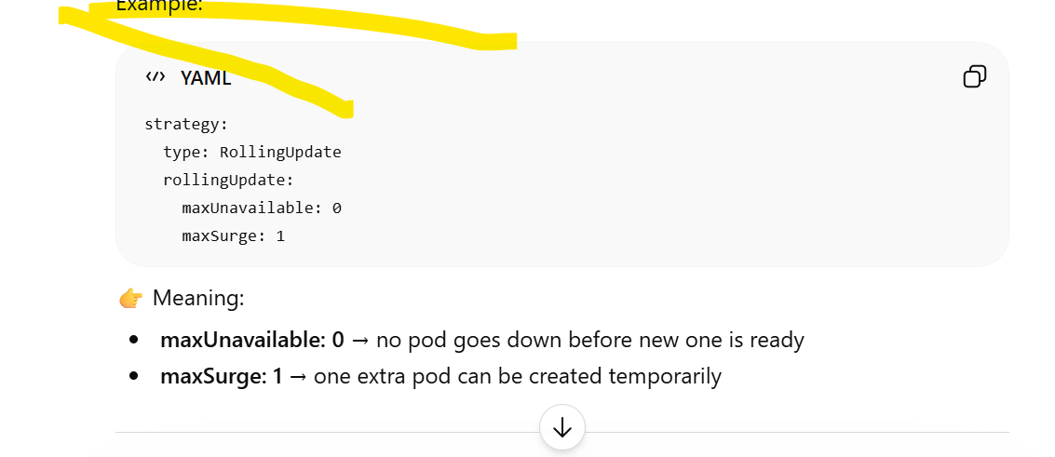
🔹 2. Readiness Probes (Critical 🔥)- Ensures traffic goes only to healthy pods.

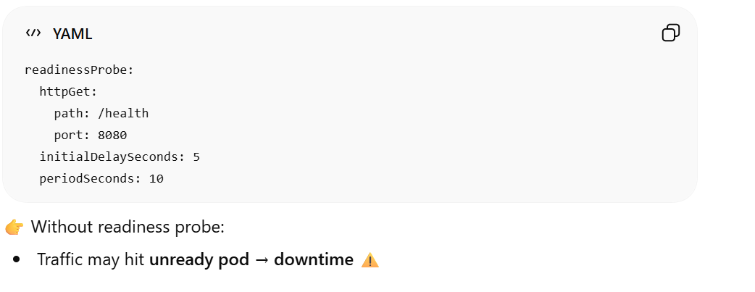
6. Advanced Strategies (Interview Bonus ⭐)
🟢 Blue-Green Deployment
Two environments:
  - Blue (current)
  - Green (new)
- Switch traffic instantly.
🟡 Canary Deployment
- Release to small % of users first
- Monitor → then increase traffic
- 🧠 Perfect Interview Answer
- 👉 Say this:
- “To achieve zero-downtime deployment in Kubernetes, I use Rolling Updates with maxUnavailable set to 0 and maxSurge configured appropriately. I configure readiness probes so traffic is only routed to healthy pods, and ensure proper resource allocation to avoid scheduling failures. I also implement graceful shutdown using preStop hooks and termination grace periods. For advanced scenarios, I use blue-green or canary deployments to further minimize risk and ensure seamless releases.”
Q-7) How to secure Kubernetes cluster?
Enable RBAC, use Network Policies, enable mTLS (Istio), restrict API access, rotate secrets,
and use OPA/Gatekeeper policies.
✅ How to Secure a Kubernetes Cluster (Structured Answer)
Kubernetes security should be implemented in multiple layers:
🔐 1. Authentication & Authorization
- Enable RBAC (Role-Based Access Control) to restrict user permissions
- Integrate with identity providers (Azure AD / IAM)
- Follow least privilege principle
👉 Example:
- Developers → read-only access
- Admins → full cluster access
2. Network Security
- Use Network Policies to control pod-to-pod communication
- Restrict traffic between namespaces
- Use private clusters or VPC isolation
👉 Tools:
- Calico / Cilium for network enforcement
🔑 3. Secrets Management
- Avoid storing secrets in plain YAML
- Use:
  - Kubernetes Secrets (base level)
  - External tools like HashiCorp Vault / Azure Key Vault
- Enable encryption at rest (etcd encryption)
4. API Server Security
- Restrict API server access:
  - Use private endpoints
  - Enable IP whitelisting
- Disable anonymous access
- Enable audit logging
5. Pod & Container Security
- Use Pod Security Standards (PSS) or policies
- Prevent:
  - Privileged containers
  - Root users
- Scan images for vulnerabilities
👉 Tools:
- Trivy, Aqua Security, Prisma Cloud
🔄 6. Service Mesh (mTLS)
- Use Istio for:
  - Mutual TLS (mTLS)
  - Secure service-to-service communication
- Encrypt traffic inside cluster.
7. Policy Enforcement
- Use OPA Gatekeeper
- Enforce rules like:
  - No privileged pods
  - Only approved container images
🔁 8. Secrets Rotation & Updates
- Regularly rotate:
  - API keys
  - Tokens
  - Certificates
- Use automation tools for rotation
📊 9. Monitoring & Auditing
- Enable:
  - Audit logs
  - Security monitoring
- Use tools like:
  - Prometheus + Grafana
  - Falco (runtime security)
- Final Interview Answer (Short Version)
- 👉 If interviewer asks for quick answer:
- “Securing Kubernetes requires a layered approach: I implement RBAC for access control, Network Policies for traffic isolation, encrypt secrets using etcd or external vaults, secure the API server with private access, enforce policies using OPA/Gatekeeper, enable mTLS via Istio for service communication, and continuously monitor with audit logs and security tools.”
-------------------------------------------------------------------------------------
Q-8) How do you debug CrashLoopBackOff?
Check container logs, describe pod events, verify environment variables, resource limits,
and startup probe settings.

CrashLoopBackOff means:
👉 Container starts → crashes → Kubernetes keeps restarting it → enters backoff state
1. Check Pod Status
kubectl get pods
kubectl describe pod <pod-name>
👉 Look for:
- Exit codes
- Events (OOMKilled, ImagePull errors, etc.)
2. Check Container Logs
kubectl logs <pod-name>
If restarting frequently:
kubectl logs <pod-name> --previous
👉 This is MOST IMPORTANT step
You’ll usually find:
- Application crash
- Config error
- Missing dependency
⚙️ 3. Check Configuration Issues
Verify:
- Environment variables
- ConfigMaps / Secrets
- Wrong ports or endpoint
👉 Common issue
DB_HOST wrong → app fails → CrashLoopBackOff.

💾 4. Check Resource Limits
kubectl describe pod <pod-name>
👉 Look for:
- OOMKilled → memory issue
- CPU throttling.
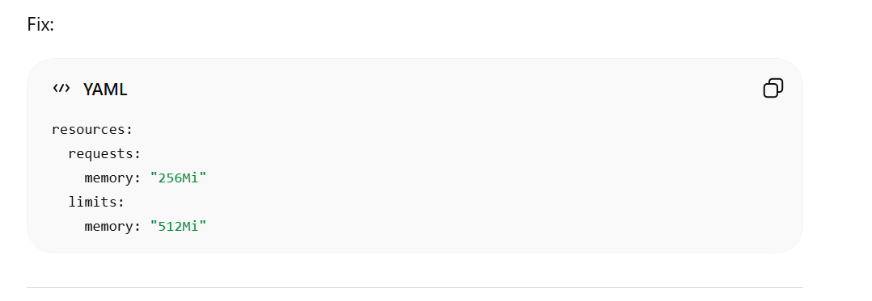
🧪 5. Check Probes (Startup / Liveness)
Wrong probes can kill healthy containers.
👉 Example issue:
- App needs 30 sec to start
- Liveness probe fails in 5 sec → restart loop
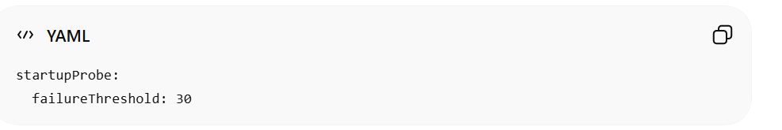

Final Short Answer (Perfect for Interview)
“CrashLoopBackOff happens when a container repeatedly crashes. I debug it by checking kubectl logs --previous, inspecting pod events using kubectl describe, verifying configs like env variables and secrets, checking resource limits for OOMKilled, and reviewing liveness/startup probes. I also validate image, command, and external dependencie

Q-9) How would you migrate a monolith to microservices in Kubernetes?
Break services gradually, containerize, define APIs, implement CI/CD, use Ingress or servicemesh for routing.
✅ How to Migrate a Monolith to Microservices in Kubernetes
The key is gradual, low-risk migration (Strangler Pattern)—not breaking everything at once.

🧭 1. Analyze the Monolith
- Identify modules (billing, auth, orders, etc.)
- Find tight vs loose coupling
- Understand database dependencies
👉 Goal: Decide service boundaries.

✂️ 2. Apply Strangler Pattern
- Don’t rewrite everything
- Gradually extract features into microservices
- Route specific requests to new services
👉 Old system + new services run together

📦 3. Containerize the Application
- Create Docker images for:
  - Monolith (initially)
  - New microservices
Deploy on Kubernetes using:
- Deployments
- Services

4. Define APIs & Communication
- Expose services via REST / gRPC APIs
- Use API Gateway or Ingress for routing
👉 For advanced routing:
- Use Istio (traffic splitting, retries, observability)
5. Traffic Routing & Ingress
- Use Kubernetes Ingress to:
Route traffic between monolith & microservices
  - Gradually shift traffic (canary release)

6. Database Decomposition (Critical Step ⚠️)
- Avoid shared database
- Split DB per microservice
- Use:
  - Event-driven architecture (Kafka)
  - Data sync strategies
👉 This is the hardest part in real projects

🔄 7. CI/CD Pipeline
- Build pipelines for:
  - Each microservice
- Use:
  - GitHub Actions / Azure DevOps
- Automate:
  - Build → Test → Deploy to Kubernetes

📊 8. Observability & Monitoring
- Add:
  - Logging (ELK stack)
  - Metrics (Prometheus, Grafana)
  - Tracing (Jaeger)
9. Security & Governance
- Implement:
  - RBAC
  - mTLS (via service mesh)
  - API security

🚀 10. Gradual Rollout Strategy
- Canary deployments
- Blue-Green deployments
- Rollback capability

🎯 Final Interview Answer (Perfect Version)
“To migrate a monolith to microservices in Kubernetes, I follow a gradual approach using the Strangler pattern. I first analyze the monolith to identify service boundaries, then containerize and deploy it on Kubernetes. I incrementally extract services, expose them via APIs, and route traffic using Ingress or a service mesh like Istio. I implement CI/CD pipelines, handle database decomposition carefully, and use canary or blue-green deployments to ensure zero downtime. Monitoring and security are integrated throughout the process.”

Q-10) What happens if etcd goes down?
Cluster state becomes unavailable. Control plane stops functioning. Restore using etcd
snapshot backup.

✅ What Happens If etcd Goes Down in Kubernetes?
👉 etcd is the brain of Kubernetes—it stores all cluster state (pods, nodes, configs, secrets).

⚠️ Immediate Impact
🧠 1. Cluster State Becomes Unavailable
- Kubernetes cannot read/write state
- No updates to:
  - Pods
  - Deployments
  - ConfigMaps
  - 🛑 2. Control Plane Stops Functioning Properly
- API Server depends on etcd → becomes non-functional
- Scheduler & Controller Manager stop working
  - 👉 Result:
- No new pods scheduled
- No scaling / self-healing
🟡 3. Running Workloads Continue (Important Insight)
- Existing pods keep running on nodes
- Because kubelet works locally
👉 BUT:
- If a pod crashes → it won’t be recreated

❌ 4. Cluster Becomes “Read-Only” or Unresponsive
- kubectl get may fail or return stale data
- kubectl apply/delete won’t work

🔄 Recovery Strategy
💾 1. Restore from Snapshot

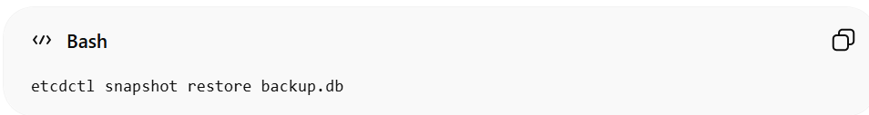

👉 Best practice:
- Take regular backups (cron job)

🧩 2. High Availability Setup (Prevention)
- Use multi-node etcd cluster (3 or 5 nodes)
- Quorum-based system:
  - Majority nodes must be up
👉 Example:
- 3 nodes → at least 2 must be healthy

🔁 3. Restart Control Plane Components
- After etcd restore:
  - API Server reconnects
  - Cluster becomes healthy

🎯 Final Interview Answer (Best Version)
“If etcd goes down, Kubernetes loses access to its cluster state, so the API server and control plane components stop functioning. No new pods can be scheduled or managed, although existing workloads may continue running temporarily. Since etcd relies on quorum, losing majority nodes makes it unavailable.

Recovery involves restoring etcd from a snapshot backup, and in production setups, we use a highly available multi-node etcd cluster to prevent downtime.”

Q- 11) How to scale cluster automatically?
Use Cluster Autoscaler integrated with cloud provider to add/remove worker nodes.

Auto-scaling in Kubernetes happens at two levels:
1. Pod-Level Scaling (Horizontal Pod Autoscaler)
👉 Horizontal Pod Autoscaler (HPA) automatically scales number of pods-
- Based on:
  - CPU / Memory
  - Custom metrics (e.g., requests/sec)
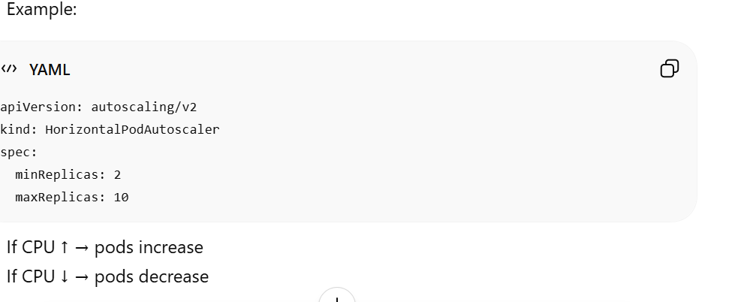
🖥️ 2. Node-Level Scaling (Cluster Autoscaler)
👉 Cluster Autoscaler scales worker nodes
- Trigger:
  - Pods are Pending due to lack of resources
- Action:
- Adds new nodes (via cloud provider like AWS, Azure, GCP)
✔ Removes nodes when underutilized

🔁 3. How They Work Together (Important 🔥)
- Traffic increases
- HPA creates more pods
- Cluster runs out of capacity
- Cluster Autoscaler adds nodes
👉 This combination ensures:
- No downtime
- Cost optimization
- ----------------------------------------------------------
12) Difference between HPA, VPA, and Cluster Autoscaler?
HPA scales Pods horizontally, VPA adjusts Pod resource limits, Cluster Autoscaler scales nodes.

HPA- What it scales: Number of Pods
- How it works: Based on metrics like CPU, memory, or custom metrics
- Example:
  - CPU > 70% → Pods increase from 2 → 5
- Use case: Handle traffic spikes
👉 Think: “More load? Add more copies of the app.”

- VPA (Vertical Pod Autoscaler)- What it scales: CPU & Memory of a Pod .
- How it works: Adjusts resource requests/limits
- Important: Often restarts Pods to apply changes
- Example:
  - Pod CPU request: 200m → updated to 500m
- Use case: Optimize resource usage
👉 Think: “Same Pod, but give it more/less power.”
- Cluster Autoscaler- What it scales: Nodes (VMs / EC2 instances)
- How it works:
  - Adds nodes when Pods can’t be scheduled
  - Removes underutilized nodes
- Example:
  - Pods pending → new node added
- Use case: Handle infrastructure scaling
👉 Think: “No space for Pods? Add more machines.”

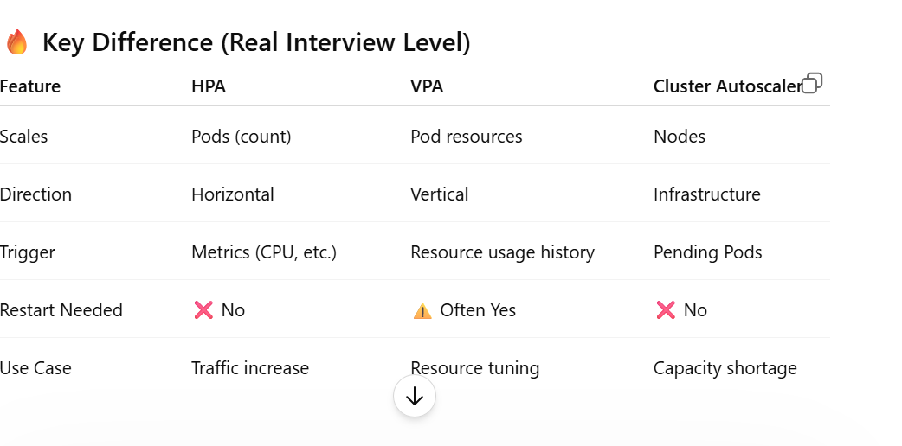

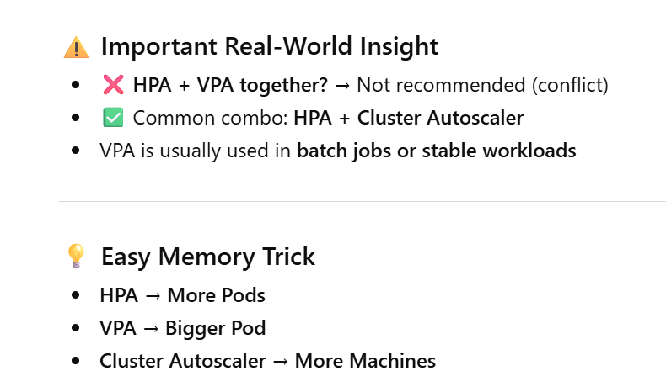
==============================================================

13) How to troubleshoot networking issues between Pods?

Check CNI plugin status, network policies, DNS resolution, service endpoints, and pod-to-pod connectivity.

How to Troubleshoot Networking Issues Between Pods-

  - Start with Pod-to-Pod Connectivity.

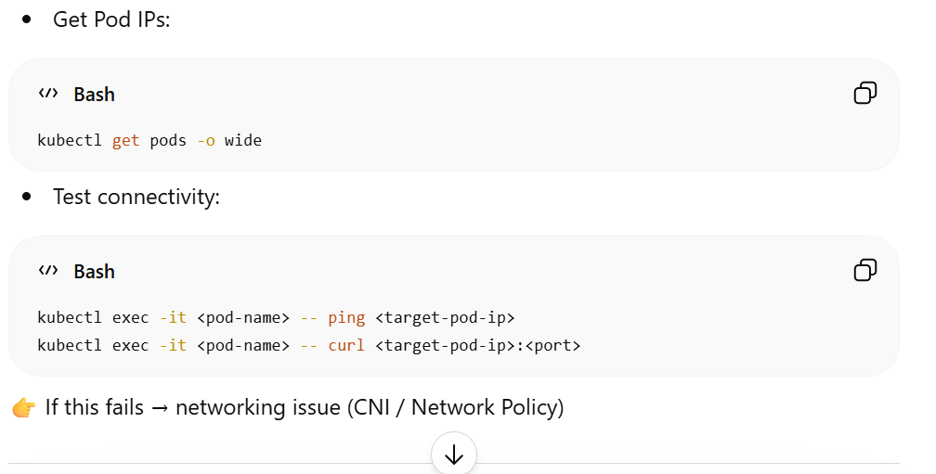

  - Check DNS Resolution (Service Discovery)
- 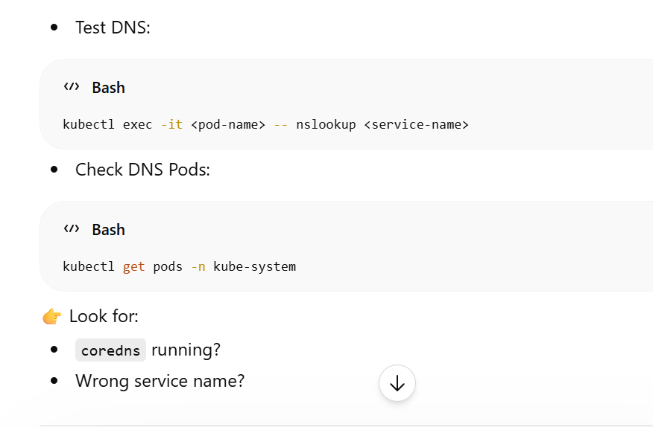
3. Verify Network Policies
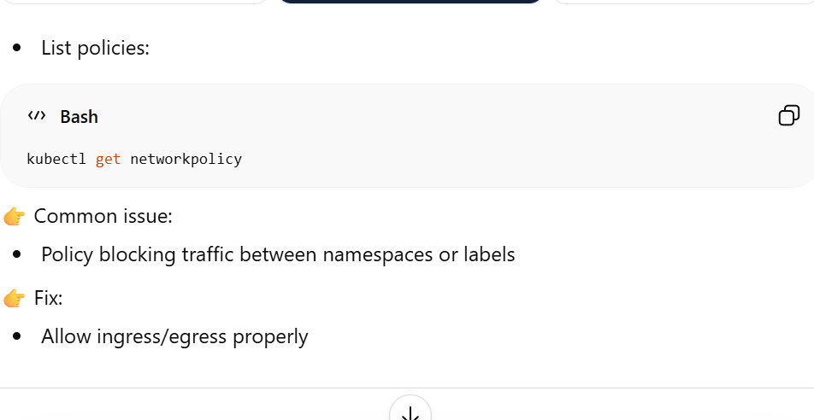

- Check CNI Plugin (Core Networking Layer)-
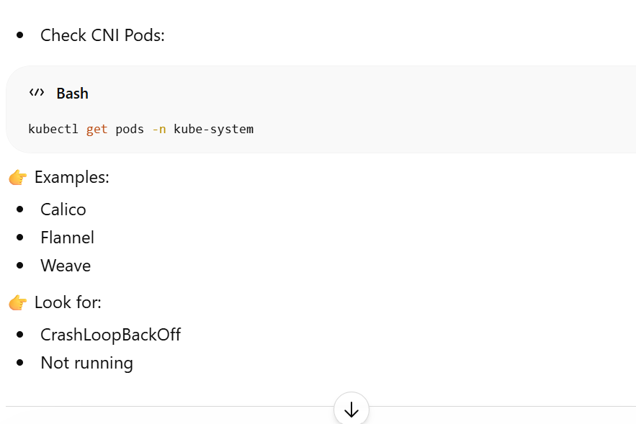

- Check Services & Endpoints-
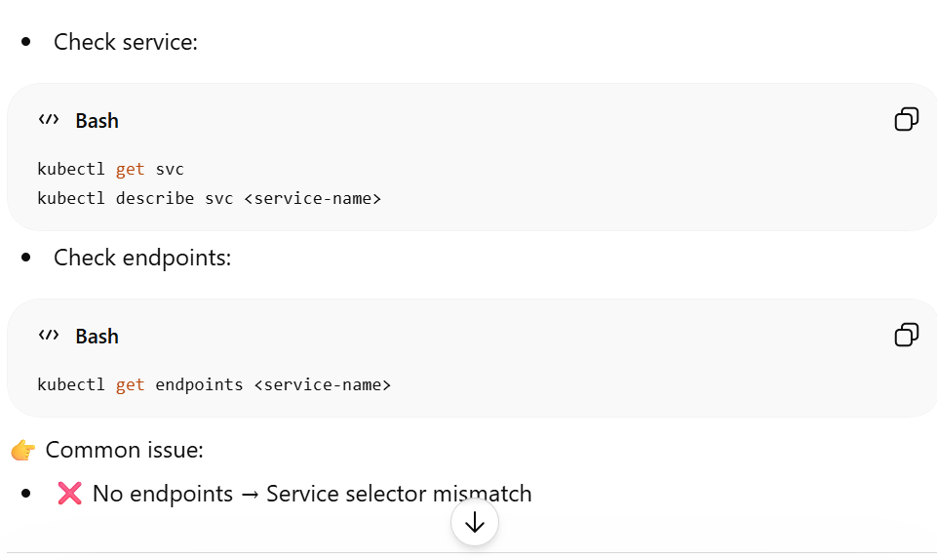

🔥 Real Interview Answer (Short Version)
If interviewer asks, say this confidently:
👉
“I troubleshoot pod networking by first testing pod-to-pod connectivity using ping/curl. Then I verify DNS resolution via CoreDNS, check network policies for traffic restrictions, validate service endpoints and selectors, inspect CNI plugin health like Calico/Flannel, and finally check application ports and node-level networking if needed.”

💡 Pro Tip (Very Important)
Most real issues come from:
- ❌ NetworkPolicy blocking traffic
- ❌ Service selector mismatch
- ❌ DNS issue
What is CNI?
CNI (Container Network Interface) is the component that:
- Assigns IPs to Pods
- Enables Pod-to-Pod communication
- Sets up routing between nodes
👉 Examples: Calico, Flannel, Weave
14) How to implement canary deployment in Kubernetes?
Use separate deployments and adjust traffic weights via Ingress or Istio VirtualService.

Canary Deployment in Kubernetes-

- Deploy new version (v2) alongside old version (v1)
- Send small % of traffic → test → gradually increase
- If issue → rollback instantly
👉 Example:
- 90% → v1 (stable)
- 10% → v2 (canary)
mplementation Approaches
🔹 1. Using Kubernetes Service (Basic Way)
- Create 2 Deployments:
  - app-v1
  - app-v2
- Use same labels so Service routes traffic
👉 Trick:
- Control traffic by replica count
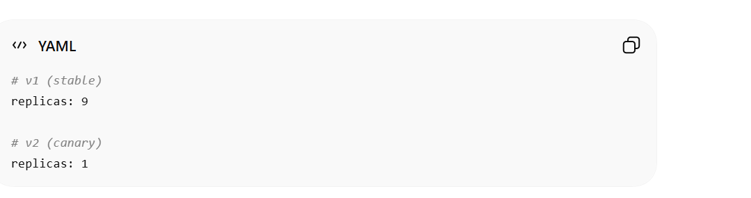

👉 Traffic ≈ proportional to replicas (90/10)
⚠️ Limitation:
- Not precise
- No header-based routing

2. Using Ingress (NGINX Canary)-

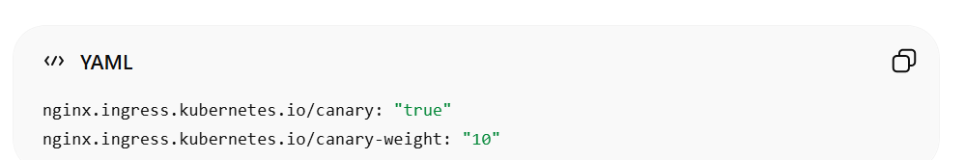
👉 Supports:
- % traffic split
- Header-based routing
- Cookie-based routing
3. Using Service Mesh (Istio - Best Practice)-

Use:
- VirtualService
- DestinationRule
Example:
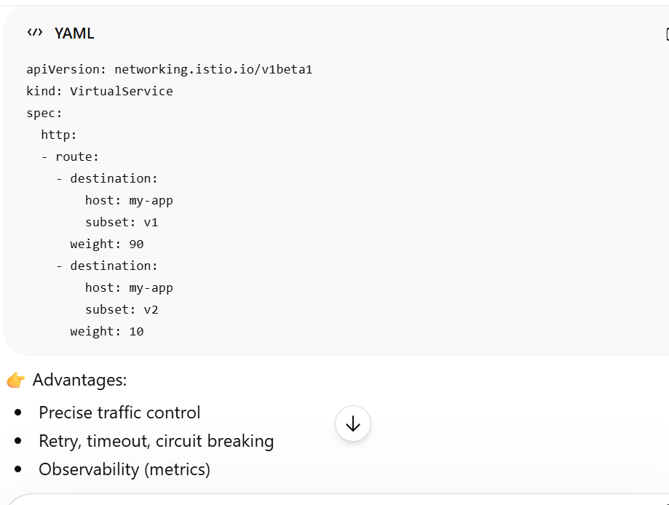
👉
“Canary deployment in Kubernetes is implemented by deploying a new version alongside the stable version and gradually shifting traffic using tools like Ingress or service mesh such as Istio. Traffic splitting can be controlled via replica ratios, Ingress annotations, or Istio VirtualService weights. The rollout is monitored, and traffic is increased progressively, with rollback capability if issues occur.”

15) How to monitor Kubernetes in production?
Use Prometheus, Grafana, ELK stack, distributed tracing (Jaeger), and alerting systems.

“In production, Kubernetes monitoring includes metrics, logging, tracing, and alerting. Prometheus collects cluster and application metrics, visualized through Grafana dashboards. Logs are centralized using the ELK stack for debugging. Distributed tracing tools like Jaeger help track request flows across microservices. Alerting systems notify teams based on thresholds like high CPU usage or pod failures, ensuring proactive issue resolution.”

16) How to handle secret management in enterprise?
Use external secret managers like AWS Secrets Manager or HashiCorp.

🔐 Secret Management in Enterprise (Kubernetes / Cloud)-

1. Use External Secret Managers (Best Practice)
Instead of relying only on Kubernetes Secrets:
- AWS Secrets Manager
- HashiCorp Vault
👉 Why?
- Encryption at rest
- Fine-grained access (IAM/RBAC)
- Audit logs
- Automatic rotation

2. Secure Injection into Applications
Secrets should not be hardcoded.
👉 Methods:
- External Secrets Operator (ESO)
- Vault Agent Sidecar
👉 Flow:
Secret Manager → Inject into Pod → App uses it

3. Secret Rotation (Very Important)
- Rotate:
  - DB passwords
  - API keys
- Use dynamic secrets (short-lived credentials)
👉 Example:
- Vault generates temporary DB user/password
4. Access Control
- Use:
  - IAM roles
  - Kubernetes RBAC
👉 Follow:
Least privilege principle

📜 5. Auditing & Monitoring
- Track:
  - Who accessed secrets
  - When
👉 Helps in compliance & security

🚫 6. What to Avoid
- ❌ Hardcoding secrets in code
- ❌ Storing secrets in Git
- ❌ Using plain text configs
👉
“In enterprise environments, secret management is handled using external tools like AWS Secrets Manager or HashiCorp Vault. These provide encryption, access control, auditing, and automatic rotation. Secrets are securely injected into applications using mechanisms like External Secrets Operator or Vault sidecars, and access is controlled using IAM and RBAC following the principle of least privilege.”.

17) How to ensure high availability of control plane?
Run multiple control plane nodes with etcd cluster and load balancer in front of API server.
🔹 Goal
Ensure the control plane (brain of cluster) stays available even if one node fails.

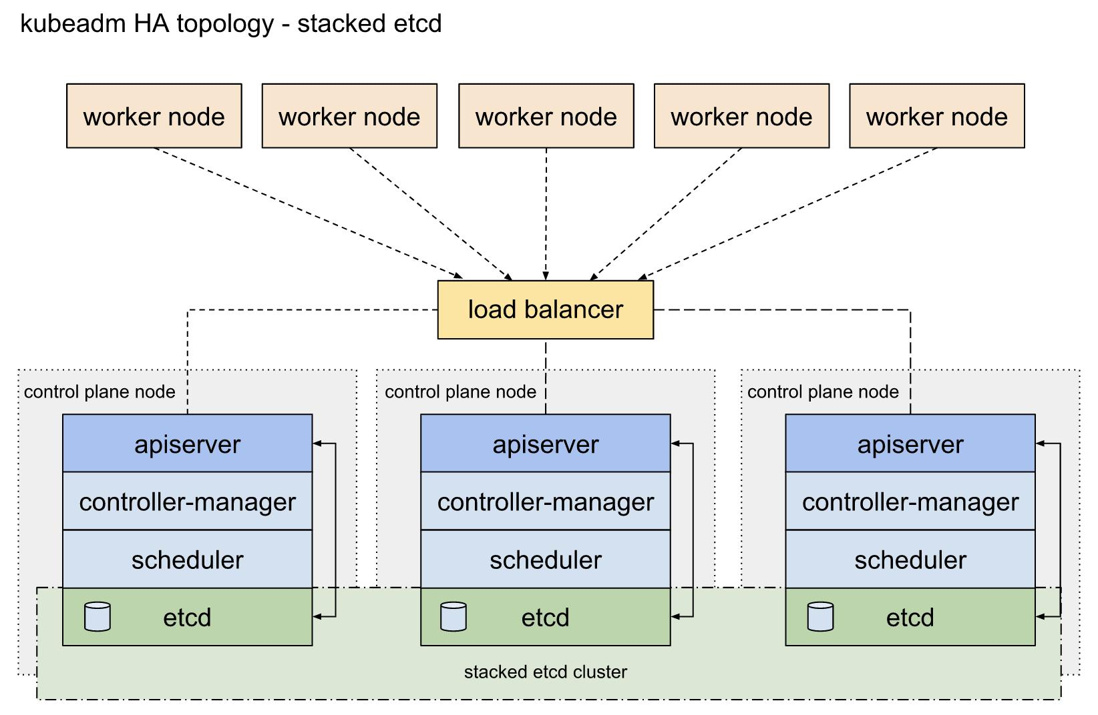

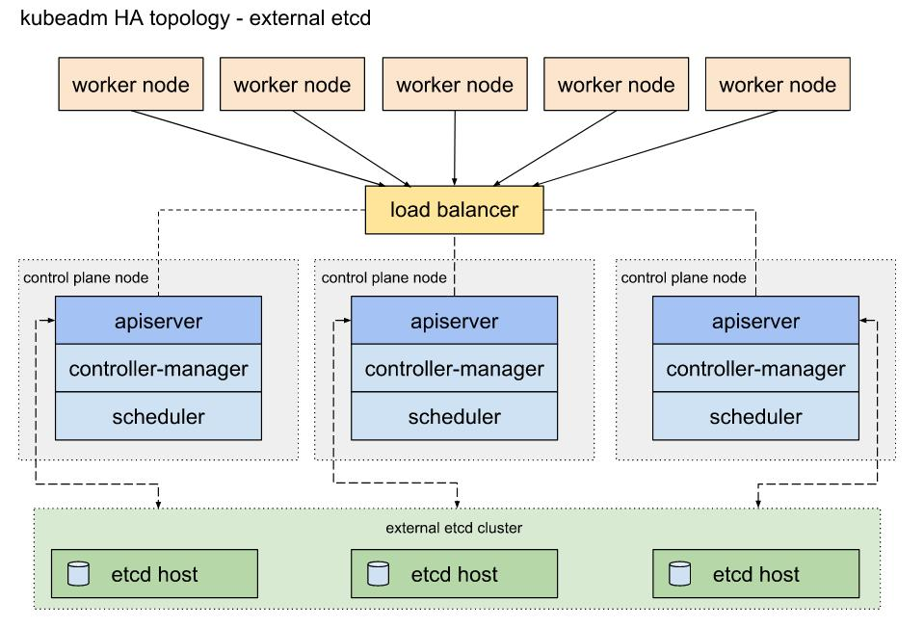

Key Components for HA
🧠 1. Multiple Control Plane Nodes
- Run at least 3 master nodes
- Each runs:
  - API Server
  - Controller Manager
  - Scheduler
👉 If one fails → others continue

2. Highly Available etcd Cluster
- etcd stores cluster state
- Use:
  - 3 or 5 nodes (odd number)
👉 Why?
- Maintains quorum (majority)

3. Load Balancer in Front of API Server
- Use:
  - Cloud LB or HAProxy
👉 Flow:
- User / kubectl → Load Balancer → Available API Server

🔁 4. Leader Election
- Controller Manager & Scheduler use leader election
👉 Only one active leader at a time
👉 Automatic failover

Interview-Ready Answer
👉
“To ensure high availability of the Kubernetes control plane, multiple control plane nodes are deployed with a distributed etcd cluster for state management. A load balancer is placed in front of API servers to distribute traffic, and leader election ensures failover for controller components. Deploying nodes across multiple availability zones further improves resilience

💡 Pro Tips (Important)
- Minimum:
  - 3 control plane nodes
  - 3 etcd nodes
- Always:
  - Backup etcd regularly
- Monitor:
  - API server health

18) How to reduce container image pull time?
Use smaller base images, multi-stage builds, image caching, and private registry near
cluster.

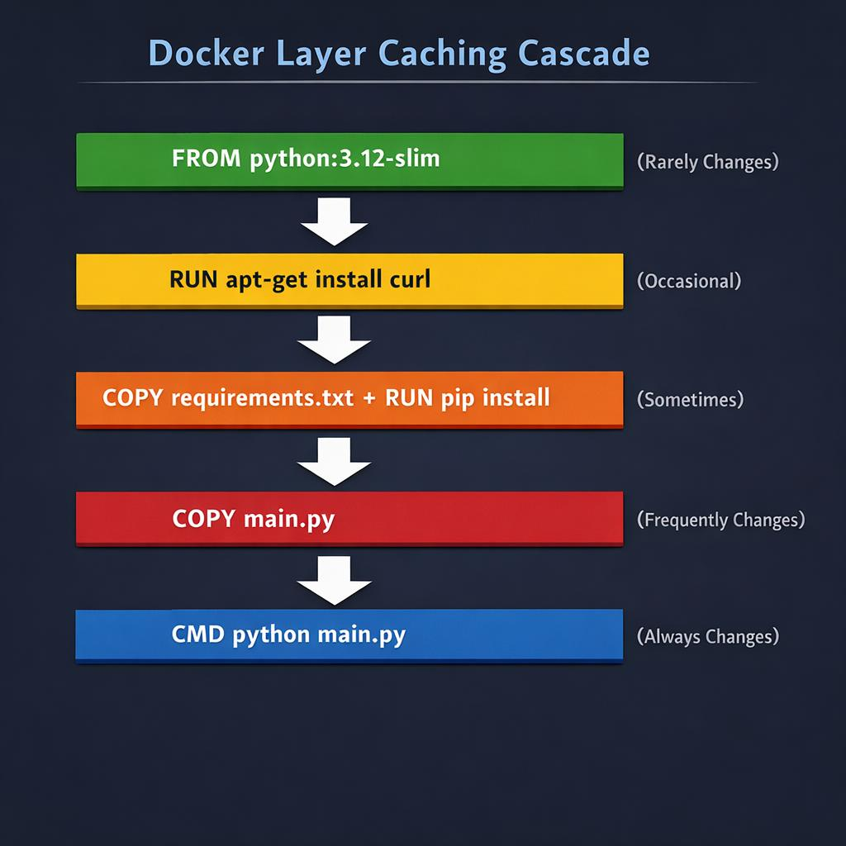

1. Use Smaller Base Images
- Use lightweight images like:
  - Alpine
  - Distroless
👉 Example:
- ❌ ubuntu (large)
- ✅ alpine (small)
👉 Benefit:
- Less data to download → faster pull

2. Multi-Stage Builds
- Build app in one stage
- Copy only required files to final image
👉 Result:
- Removes unnecessary dependencies
- Reduces image size

🔹 3. Image Layer Caching
- Docker images use layers
- If layers already exist on node → reused
👉 Tip:
- Don’t change base layers frequently
- Order Dockerfile properly

4. Use Nearby / Private Registry
- Use:
  - Amazon Elastic Container Registry (ECR)
  - Local/private registry
👉 Benefit:
- Lower network latency
- Faster image download

5. Pre-Pull Images (Kubernetes Trick)
- Use DaemonSet to pull images on all nodes
👉 When Pod starts:
- Image already available → no delay

🧠 Interview-Ready Answer
👉
“To reduce container image pull time, we use smaller base images, multi-stage builds to reduce size, leverage Docker layer cachi
ng, and store images in a nearby registry like ECR. Additionally, pre-pulling images and optimizing image layers further improves startup performance.”
19) What is Pod Disruption Budget (PDB)?
Ensures minimum number of Pods remain available during voluntary disruptions.

“Don’t allow too many pods to go down at once”

🚀 What are Voluntary Disruptions?
- Node maintenance (kubectl drain)
- Cluster upgrades
- Deployment rolling updates
👉 PDB controls these, not unexpected crashes

⚙️ How It Works
You define either:
🔹 minAvailable
- Minimum Pods that must stay running
minAvailable: 2
👉 At least 2 pods must always be available

🔹 maxUnavailable
- Maximum Pods allowed to be down
maxUnavailable: 1
👉 Only 1 pod can be unavailable at a time

🔥 Example Scenario
👉 You have 5 Pods
- minAvailable: 3
👉 Only 2 pods can be disrupted
If someone tries to drain node:
- Kubernetes blocks eviction if it violates PDB

🧠 Real Use Case
- Prevent downtime during:
  - Rolling deployments
  - Node upgrades
👉 Ensures app stays available

🧠 Interview-Ready Answer
👉
“A Pod Disruption Budget is a Kubernetes object that ensures a minimum number of pods remain available during voluntary disruptions like node maintenance or rolling updates. It is defined using minAvailable or maxUnavailable to control how many pods can be taken down at a time.”

💡 Pro Tips (Important)
- Works only for:
  - Voluntary disruptions
- Use with:
  - Deployments / StatefulSets

⚠️ Common Mistakes
- ❌ Thinking PDB prevents crashes
- ❌ Setting very strict PDB → blocks upgrades
- ❌ Not matching label selector correctly

🔥 Easy Memory Trick
- PDB = “Protect running Pods” 🛡️

20) How to design disaster recovery strategy for Kubernetes?
Regular etcd backups, PV snapshots, multi-region setup, GitOps configuration backup, and
tested restore procedures.

1) Define DR Goals First (RPO / RTO)
- RPO (Recovery Point Objective): how much data you can lose
- RTO (Recovery Time Objective): how fast you must recover
👉 These drive how often you back up and how you design failover.

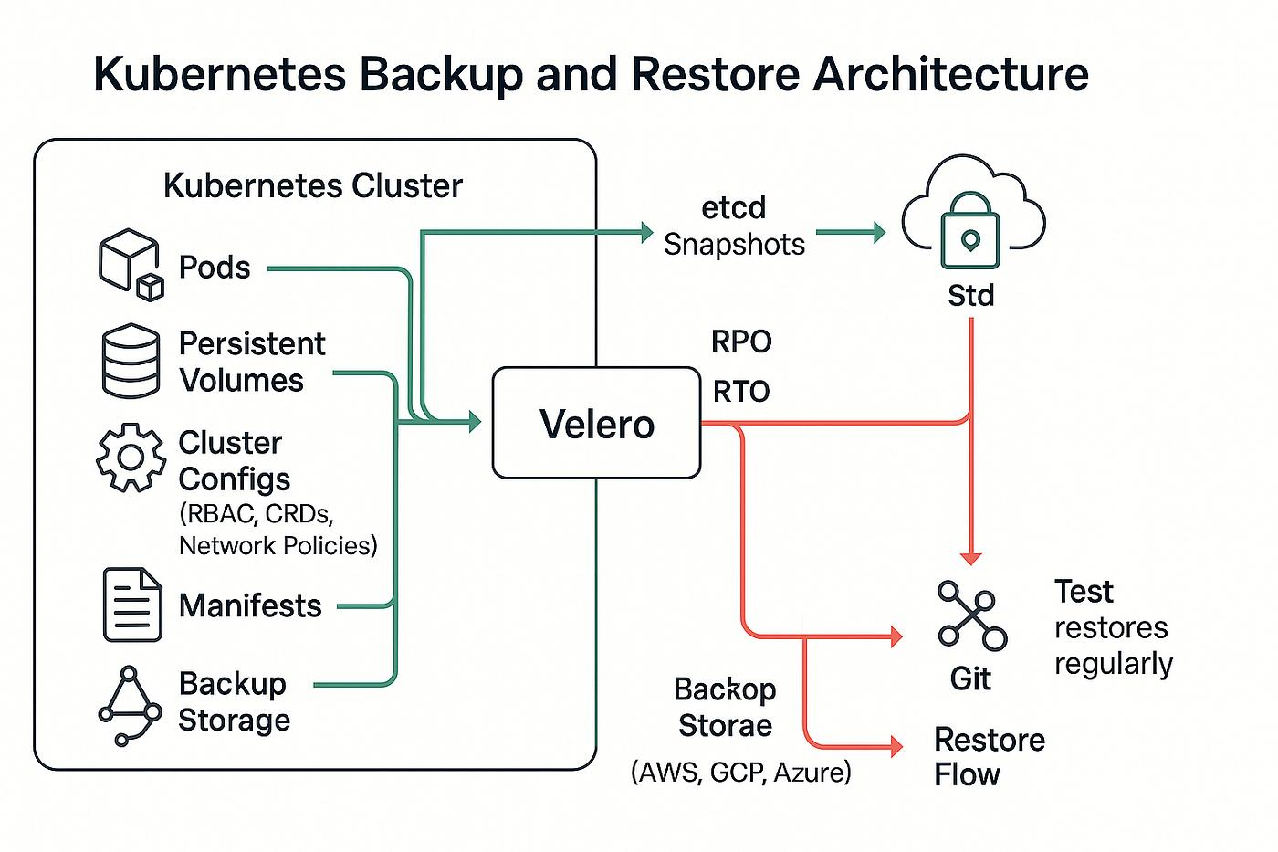

🧠 2) Back Up the Control Plane (Critical)
- etcd backups (snapshots) → cluster state (pods, configs, secrets refs)
etcdctl snapshot save backup.db
- Store backups in durable storage (e.g., object storage)
👉 Without etcd → cluster cannot be reconstructed

📦 3) Back Up Application Data (Stateful)
- Persistent Volume (PV) snapshots
- Use tools like Velero (with cloud snapshots)
👉 Covers:
- Databases
- Uploaded files
- Stateful apps
- ==================================================
Enterprise-Level & Real Production

Scenario Discussions

Production Incident Case Study 1 – High API Latency After Deployment
Imagine you deployed a new version of an application and suddenly latency increased across all services.
As a senior engineer, you would first validate whether the issue is application-related or
infrastructure-related. You would check resource utilization (CPU throttling, memory
pressure), HPA events, node health, and network latency. You would inspect Prometheus
metrics, compare old vs new container images, verify readiness/liveness probes, and
confirm no misconfiguration in ConfigMaps or Secrets. Rollback strategy and traffic shifting
(canary) should also be discussed in such a scenario.

Production Incident Case Study
High API Latency After Deployment
🧠 Step 1: Confirm the Problem Scope
First, I would validate the impact and scope:
- Is latency affecting all APIs or specific endpoints?
- Is it impacting all users or specific regions?
- Check dashboards (Grafana / APM tools)
👉 Goal: Understand whether it’s system-wide or localized

🔍 Step 2: Compare Before vs After Deployment
Since issue started after deployment, I would:
- Compare previous vs current version
- Check:
  - Image changes
  - Dependency updates
  - Config changes
👉 This helps identify if it's a code regression

⚙️ Step 3: Check Infrastructure Health
Now verify if infra is the root cause:
✅ Kubernetes / Node Level
- Node CPU / Memory pressure
- Pod restarts
- Node status (kubectl get nodes)
- Events (kubectl describe pod)
✅ Resource Issues
- CPU throttling
- Memory limits exceeded
- Disk I/O issues
👉 Many latency issues come from resource starvation

📊 Step 4: Analyze Metrics (Prometheus / Grafana)
Check key metrics:
- Request latency (P95 / P99)
- Error rate
- Throughput
- Pod CPU / Memory usage
👉 If latency ↑ but CPU normal → likely application issue
👉 If CPU ↑ → likely scaling or resource issue

🔁 Step 5: Check HPA & Scaling Behavior
- Is HPA scaling properly?
- Any delays in scaling?
- Are new pods getting traffic?
👉 Misconfigured HPA can cause under-scaling → high latency

🌐 Step 6: Network & Dependency Check
- External APIs slow?
- Database latency increased?
- DNS or service mesh issues?
👉 Sometimes latency is due to downstream services

🧪 Step 7: Validate Application Health
- Logs (kubectl logs)
- Thread blocking / slow queries
- DB connection pool exhaustion
- GC issues (for Java apps)
👉 Example:
- Slow SQL query → high API latency

🧾 Step 8: Check Configurations
- ConfigMaps / Secrets changes
- Environment variables
- Feature flags
👉 Small config change = big impact

🩺 Step 9: Readiness & Liveness Probes
- Are probes failing?
- Are pods marked ready too early?
👉 Incorrect probes → traffic to unhealthy pods

🔄 Step 10: Immediate Mitigation
As a senior engineer, you don’t just debug—you reduce impact quickly:
🚑 Options:
- Rollback to previous stable version
- Scale up replicas manually
- Disable problematic feature
- Route traffic away (canary / blue-green)

🧪 Step 11: Root Cause Analysis (RCA)
After stabilization:
- Identify exact root cause
- Document:
  - What happened
  - Why it happened
  - How to prevent

🛡️ Step 12: Prevention Strategy
- Add better monitoring & alerts
- Implement canary deployments
- Load testing before release
- Improve observability (tracing)

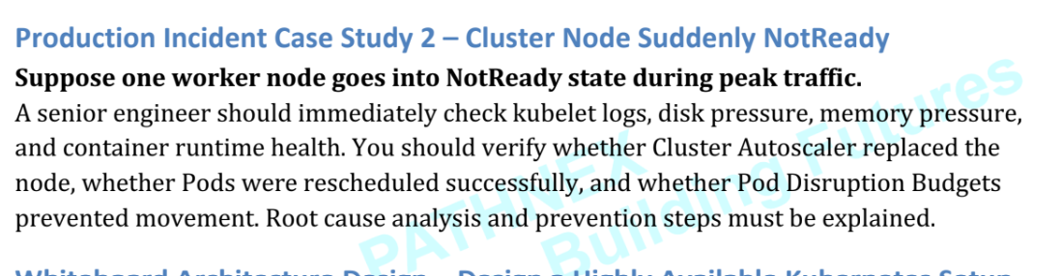

Worker Node Goes into NotReady State During Peak Traffic
When a Kubernetes worker node becomes NotReady, it means the control plane cannot communicate properly with that node.
This is a critical production issue because:
- Pods may become unavailable
- Traffic can fail
- Applications may slow down
- Customer impact may occur.

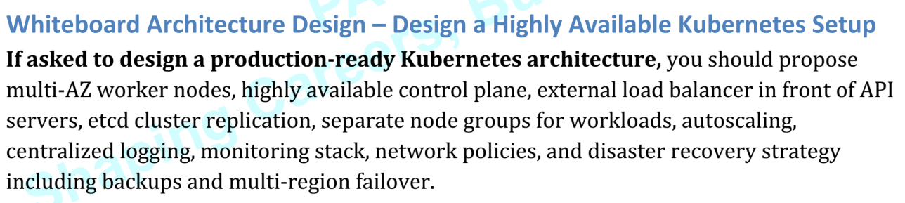

Users
│
External Load Balancer
│
┌─────────────┴─────────────┐
│ │
API Server 1 API Server 2
│ │
└─────────────┬─────────────┘
│
HA Control Plane
│
┌───────────┼───────────┐
│ │ │
etcd-1 etcd-2 etcd-3

┌────────────┴────────────┐
│ │
Worker Nodes AZ-1 Worker Nodes AZ-2
│ │
App Pods / Services App Pods / Services

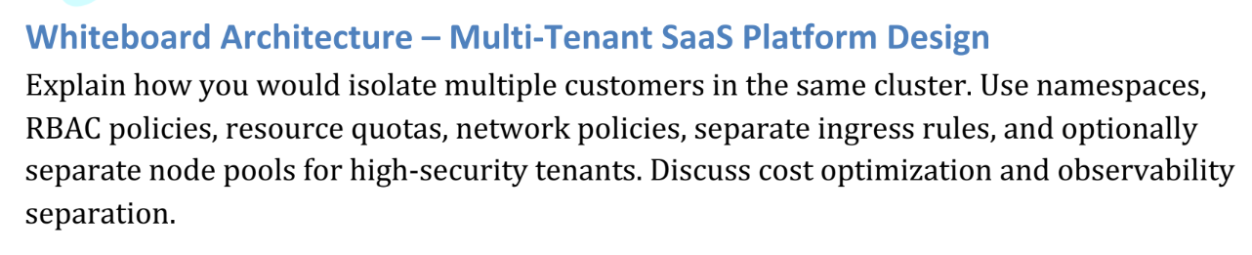
customerexperience@hclcare.in

Multi-Tenant SaaS Platform Design on Kubernetes
Goal
A multi-tenant SaaS platform allows:
- Multiple customers (tenants)
- To use the same Kubernetes cluster
- While keeping their:
  - Data isolated
  - Traffic isolated
  - Resources controlled
  - Security enforced
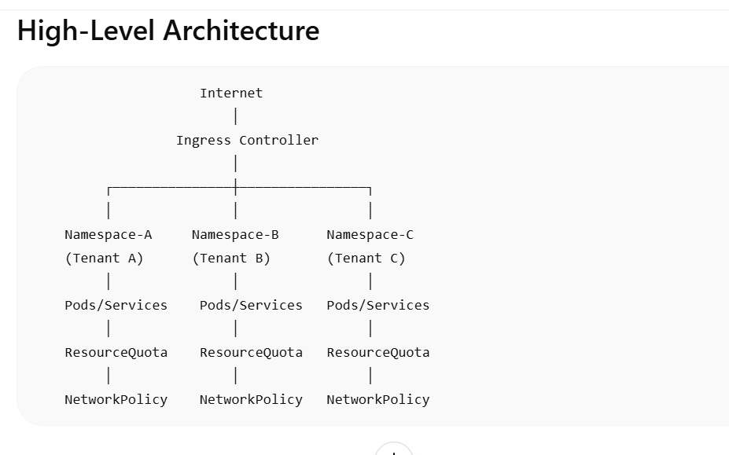

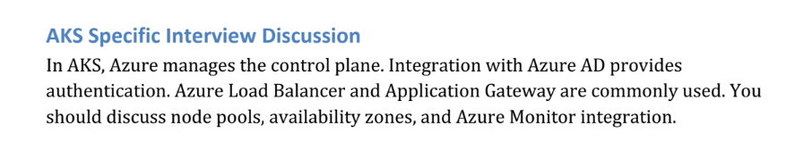
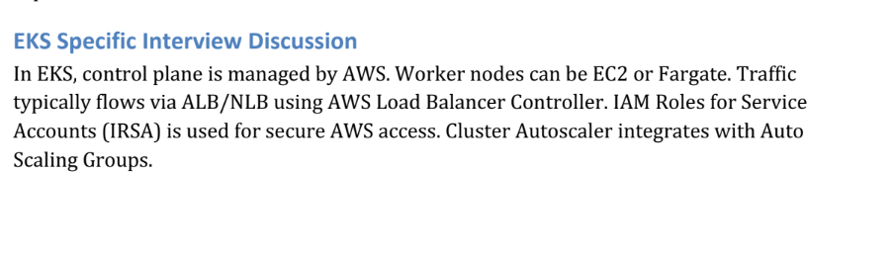

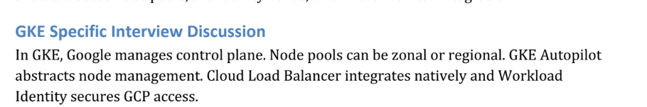

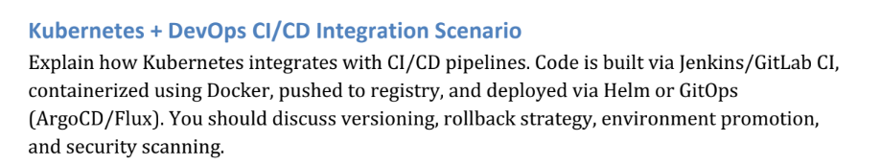

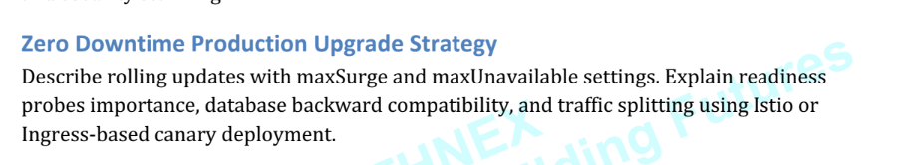

Zero Downtime Production Upgrade Strategy
A zero downtime deployment means:
Users should not experience service interruption during application upgrades.
The application remains available while new versions are deployed gradually.
This is critical for:
- Banking systems
- E-commerce platforms
- SaaS applications
- High-traffic APIs
