Lesson 01 Demo 02 –
Configuring Prometheus to Scrape and Visualize the Metrics
For above lesson and demo – first
- Prometheus Installation & Extraction-

wget https://github.com/prometheus/prometheus/releases/download/v2.52.0/prometheus-2.52.0.linux-amd64.tar.gz

tar -xvf prometheus-2.52.0.linux-amd64.tar.gz

cd prometheus-2.52.0.linux-amd64

- Starting the Prometheus Server-
./prometheus --config.file=prometheus.yml

3. AWS Security Group Port Opening
Since you are using an EC2 instance on Amazon Web Services, port 9090 was blocked externally.
You needed to add inbound rule:
Type | Port | Source
Custom TCP | 9090 | 0.0.0.0/0
Without this:
- browser cannot access Prometheus U

4. Using Public IP Instead of localhost
This was another missing concept.
You originally tried:
http://localhost:9090
But because Prometheus runs inside EC2, you must use:
http://44.244.59.221:9090
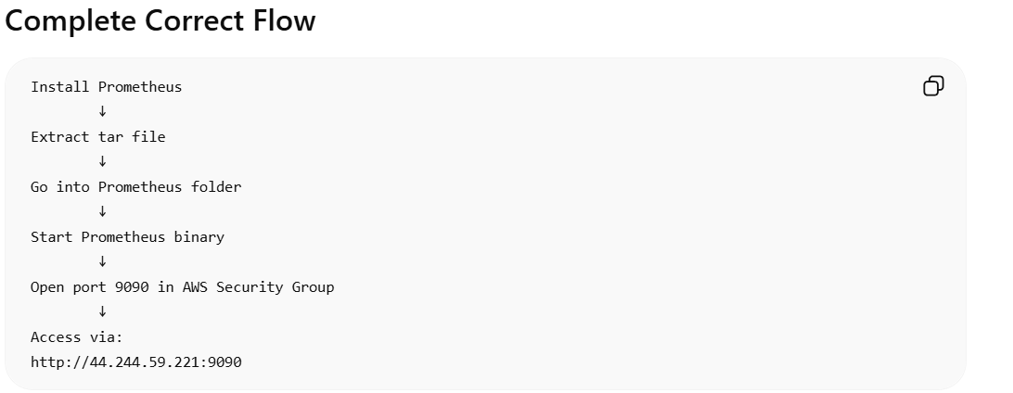
-------------------------------------------------------------------------------------------------------
Configuring Prometheus to Scrape and Visualize the Metrics-
This lesson explains how to start Prometheus, access its web UI, check metrics, and visualize them using graphs.

In Prometheus, scrape means:
Prometheus periodically collects/pulls metrics data from an application or server.

What Happens During Scraping?
Prometheus:
- Sends request to target (Target = Anything Prometheus monitors.)
- Reads metric values
- Stores them in TSDB (time-series database)
- Uses them for:
  - graphs
  - dashboards
  - alert

Lesson 02 Demo 01
Setting up and Monitoring with Node Exporter-

What Node Exporter Does
Node Exporter exposes Linux server metrics like:
- CPU
- RAM
- disk
- network
- filesystem.
- Node Exporter collects server health data.
- Prometheus monitors and visualizes that data.

Lesson 03 Demo 01 -
Adding Instrumentation to a Java Application-
To make a Java application expose internal metrics (health/performance data), then collect and visualize those metrics using Prometheus.

What is Instrumentation?
Instrumentation means:
Adding monitoring code inside the application so it can expose metrics.
Metrics are numbers like:
- Total requests
- JVM memory used
- CPU usage
- Thread count
- Garbage collection stats
Prometheus can then read these metrics.
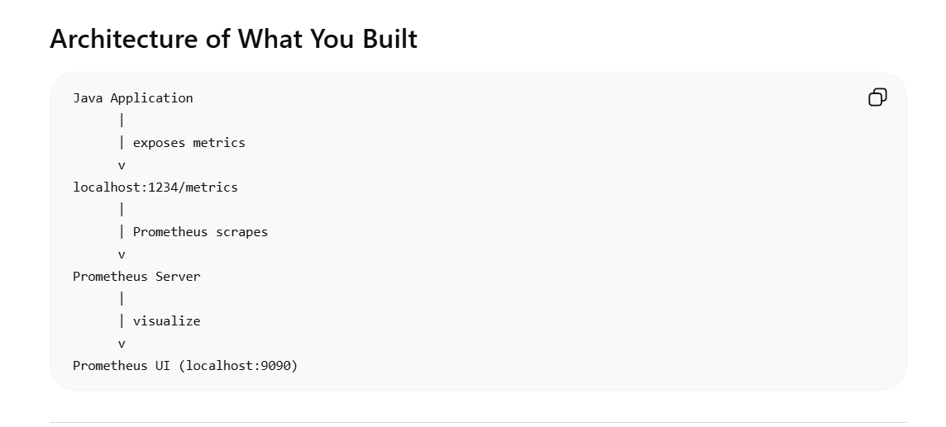
-----------------------------

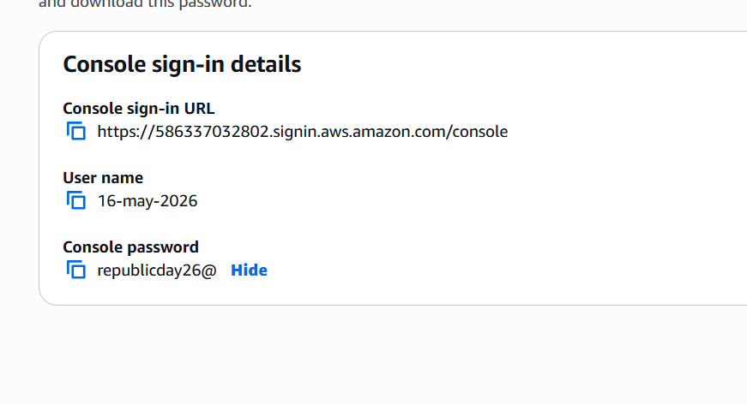
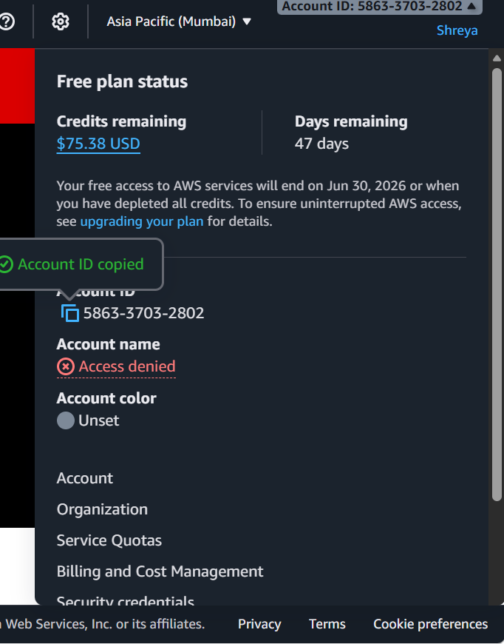

Lesson 03 Demo 02
Configuring Alertmanager for Email Notifications-
This document explains how to configure Prometheus with Alertmanager so that when a server or service goes down, an email alert is automatically sent.
Overall Flow
Node Exporter → Prometheus → Alertmanager → Email Notification
- Node Exporter collects server metrics (CPU, memory, etc.)
- Prometheus monitors those metrics
- Alertmanager handles alerts from Prometheus
- Email is sent when a problem happens
- ----------------------------------------------------------------------------------------------------------------

Lesson 04 Demo 04

Creating a Grafana Dashboard Using PromQL Queries to Visualize Specific Application Metrics-

This demo shows how to create a dashboard in Grafana using data from Prometheus and visualize important system metrics with PromQL queries.

