How to create a new skin for FDM
Step-by-step tutorial

- Open Free Download Manager's installation folder. Usually it's C:\Program files\Free Download Manager. There you'll see Skins folder. This folder contains folders, one folder for the each skin. By default here is the only one skin — old style.
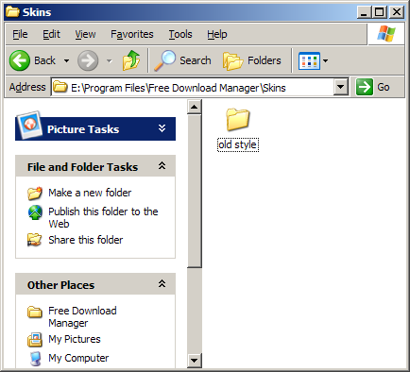
- Create a new folder for your skin here. Lets call it My new skin.
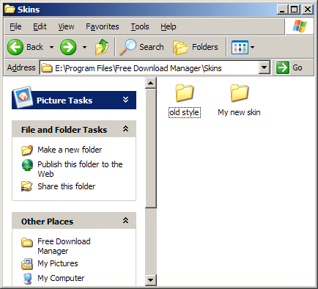
- Copy contents of old style folder to My new skin folder.
- Here the result you'll get:
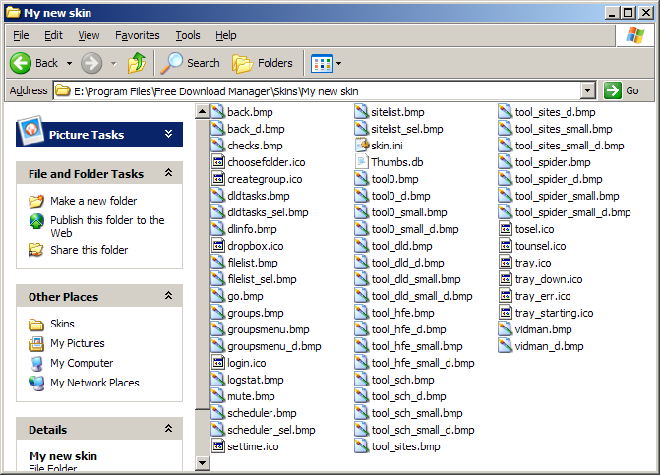
- Skin.ini file contains some information about your skin. Change it.
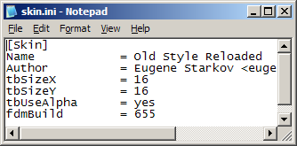
Name — name of your skin.
tbSizeX, tbSizeY — dimensions of FDM toolbar's buttons. Default skin uses 32x32 buttons.
tbUseAlpha — may be set to 2 values: yes or no. Yes — bitmaps of toolbar (not all bitmaps, but of main toolbar and context menus only) contains alpha channel. No — they are usual bitmaps.
fdmBuild — keep as is.
- Set the current skin to Old Style Reloaded. This will help you to understand what each bitmap is for. Here the example.
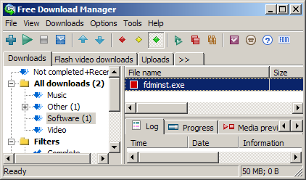
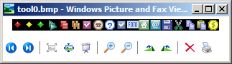
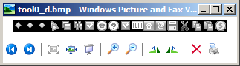
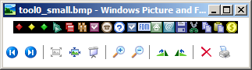
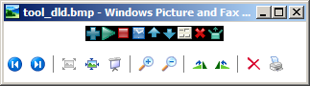
tool0.bmp is used for the main toolbar. tool0_d.bmp contains the same bitmaps in their disabled state, for the buttons that are grayed out.
tool_dld.bmp is used for the main toolbar too. But it contains additional buttons that will be shown for the Downloads tab only. tool_sch.bmp contains bitmaps for Scheduler tab and so on.
_d in the name of a file means that this bitmap contains images for grayed out state. _small means that this bitmap contains appropriate images that will be used in menus (their size should be 16x16 always).
.ico files contains images for tray icon, for some buttons in FDM's windows.
- Bitmaps for which alpha channel is not used has (R=255, G=0, B = 255) color reserved as the background color. Example: dldtasks.bmp.
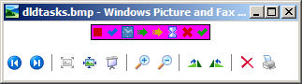
- Now just replace all images you would like to change in your skin's folder. Keep dimensions as is (excluding bitmaps for the main toolbar — these are customizable (in skin.ini)). Bitmaps without the alpha channel should be 24-bit.
- By setting current skin to your one and restarting FDM you can apply and see the changes.
- If you have some questions or problems, write to support@freedownloadmanager.org.

