AutoCAD Dockable ActiveX Control Container v1.1
Jorge Lopez
ObjectDBX Development
ADF / Engineering
Autodesk, Inc.
E-mail: jorge.lopez@autodesk.com

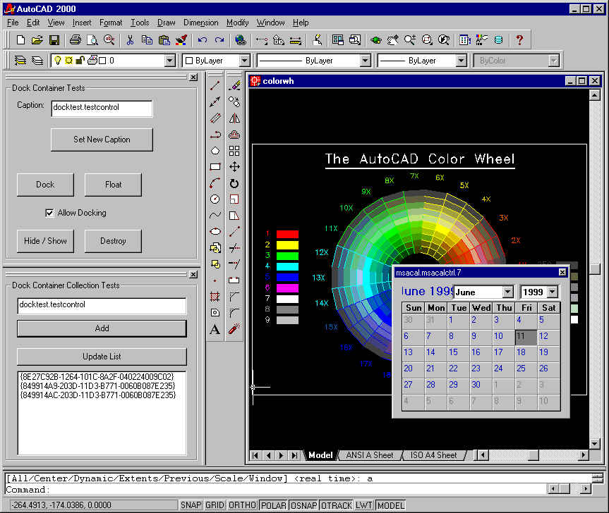

Introduction
This application is a tool for 3rd party developers who are interested in developing UI applications for AutoCAD 2000 without the need for C++ and ObjectARX. It provides a docking window that serves as a generic and programmable container of ActiveX controls. ActiveX controls can be created with a variety of tools such Visual Basic and Delphi. This enables easy creation of modeless UI applications using the language of your choice. AutoCAD can then be customized from your ActiveX control via the AutoCAD Automation Object Model.

Features
- Dock or float your custom UI application (ActiveX control) seamlessly within AutoCAD 2000 ala Properties window and AutoCAD Design Center.
- Host multiple ActiveX controls simultaneously.
- Persistent docking state, position, and size within the current session and between AutoCAD sessions.
- Automation interface to the docking window for additional control of the docking window from the ActiveX control.
- Automation interface to manage the collection of docking windows.

Installation
Two files need to be installed on the computer:

File Name Description
ACCONT.ARX ObjectARX application which implements the docking ActiveX control container window along with its Automation API. Once this application is loaded, it registers itself for demand loading and registers its Automation API.
ACCONT.TLB Contains all the type information for the application’s Automation API. You need to ship this file (in the same directory as ACCONT.ARX) if you late bind (use Idispatch) when using the application’s Automation API; otherwise, it’s only needed on the development machine.

Using the Dockable ActiveX Control Container

Using the Command Line
ACCONT.ARX provides the “DC” (short for “DOCKABLE_CONTAINER”) command to create the docking ActiveX control container window. This command requires the ProgID or CLSID string of the ActiveX control to proceed. The ProgID is a string that uniquely identifies the ActiveX control.

For example, using the Microsoft Calendar control registered on your system:

Command: DC
ProgID of control: mscal.calendar

NOTE: The ActiveX control needs to be installed and registered with the system.

Using the Automation API
Docking Container Window

Implements IAcadDockableContainer2

ActiveX Control

Implements IRetrieveDockableContainer2

IRetrieveDockableContainer2

IAcadDockableContainer2

The figure above shows the relationship between the container window and the ActiveX control. The container window sizes the ActiveX control to fit its client area minus the grip bar if docked. The container window then makes available an Automation interface (IAcadDockableContainer2) for the ActiveX control to have programmatic access to its properties and methods. If an ActiveX control wants access to this Automation interface, then it must implement the IRetrieveDockableContainer2 interface.

The container window will ask the ActiveX control for its IRetrieveDockableContainer2 interface immediately after it creates the control but before displaying it. If the control accepts the request, then the container calls the SetDockContainer() method of the interface and passes in an IAcadDockableContainter2 interface. The control can then keep this interface around if it wants to access the containers properties / methods at a later time or use it for initialization and discard it.

Below is an example of a VB implemented IRetrieveDockableContainer2:

‘ Global variable so the interface can be used at a later time if needed.
Dim dockContainer As AcadDockableContainer2

Implements IRetrieveDockableContainer2
Private Sub IRetrieveDockableContainer2_SetDockContainer(ByVal newVal As IacadDockableContainer2)
‘ Keep this interface around by assigning it to a global variable.
Set dockContainer = newVal

‘ Allow docking only on the left and right sides of AutoCAD 2000
dockContainer.EnableDockPositions = acDockLeft + acDockRight

‘ We want the window to appear as a floating window the very first time.
‘ The size of the floating window is specified below.
Dim rect(0 To 3) As Integer
rect(0) = 50 ' left
rect(1) = 50 ' top
rect(2) = 300 ' right
rect(3) = 300 ' bottom

dockContainer.SetPreferredDockPosition acFloating, rect
End Sub

As the code sample shows, the implementation of SetDockContainer() is a great place to call EnableDockPositions and SetPreferredDockPosition(). This is because it is called only once after the ActiveX control is created and before it is displayed for the first time.

Included with this application are two sample ActiveX controls (DOCKTEST.OCX) which were created using Visual Basic 5.0. The entire source code for these controls are also included for reference. Use REGSVR32.EXE if you want to sample the controls without rebuilding the OCX. The two ProgIDs serviced by DOCKTEST.OCX are “Docktest.TestControl” and “Docktest.Dockbars”.

Automation API Reference

IAcadDockableContainer (Legacy)
Used by the ActiveX control to set / get property values or call methods on the ActiveX control container window.

Methods Description
Float Undocks the container window.
Dock Docks the container window.
SetPreferredDockPosition Specifies the preferred docking mode and position. Use one of the following constants as the first argument: acFloating, acDockLeft, acDockTop, acDockRight, or acDockBottom. The second argument is optional and only used if acFloating is specified as the first argument. This optional argument is of type VARIANT and contains a safe array of four integers containing the floating window’s rectangle. The array is read as: left, top, right bottom. The preferred docking mode is ONLY used when the last known docking mode, position, and size are unavailable. This is equivalent to a default mode for the ActiveX control the first time it is used with ACCONT.ARX on a computer.

Properties Description
Caption Sets / retrieves a string value which is used as the caption for the container window when it is floating.
AllowDocking Sets / retrieves a boolean value which indicates whether the container window can be docked or not.
IsFloating Retrieves a boolean value of VARIANT_TRUE if the container window is currently floating.
EnableDockPositions Sets / retrieves which sides of the container window can be docked to. A value of zero means docking is disabled. The constants acDockLeft, acDockTop, acDockRight, and acDockBottom can be added together to specify the desired docking locations. Also, constant acDockAny is available to conveniently specify all sides. Do NOT use the acFloating constant with this property.

IAcadDockableContainer2
Used by the ActiveX control to set / get property values or call methods on the ActiveX control container window.

Methods Description
Float Undocks the container window.
Dock Docks the container window.
SetPreferredDockPosition Specifies the preferred docking mode and position. Use one of the following constants as the first argument: acFloating, acDockLeft, acDockTop, acDockRight, or acDockBottom. The second argument is optional and only used if acFloating is specified as the first argument. This optional argument is of type VARIANT and contains a safe array of four integers containing the floating window’s rectangle. The array is read as: left, top, right bottom. The preferred docking mode is ONLY used when the last known docking mode, position, and size are unavailable. This is equivalent to a default mode for the ActiveX control the first time it is used with ACCONT.ARX on a computer.
Hide Hides the container window.
Show Shows the container window.
Destroy Destroys the container window. (Use sparingly as AutoCAD will not save this container window’s state.)

Properties Description
Caption Sets / retrieves a string value which is used as the caption for the container window when it is floating.
AllowDocking Sets / retrieves a boolean value which indicates whether the container window can be docked or not.
IsFloating Retrieves a boolean value of VARIANT_TRUE if the container window is currently floating.
EnableDockPositions Sets / retrieves which sides of the container window can be docked to. A value of zero means docking is disabled. The constants acDockLeft, acDockTop, acDockRight, and acDockBottom can be added together to specify the desired docking locations. Also, constant acDockAny is available to conveniently specify all sides. Do NOT use the acFloating constant with this property.
Application Retrieves the IAcadApplication interface to the AutoCAD application object.
Name Retrieves a string value which represents the ActiveX control’s CLSID.

IRetrieveDockableContainer (Legacy)
Used to retrieve the Automation interface for the dockable container window. Implemented by the ActiveX Control author.

Methods Description
SetDockContainer Receives one argument of type IAcadDockableContainer.

IRetrieveDockableContainer2
Used to retrieve the Automation interface for the dockable container window. Implemented by the ActiveX Control author.

Methods Description
SetDockContainer Receives one argument of type IAcadDockableContainer2.

IAcadDockableContainers
Used by the ActiveX control to set / get property values or call methods on the ActiveX control container window.

Methods Description
Item Gets a specific container window from the collection. The specific container window can be specified by using an index number (zero based) or a string containing the CLSID or ProgID of the ActiveX control. The return value is of type IAcadDockableContainer2.
Add Creates and adds a container window to the collection. Receives one argument which is a string containing the CLSID or ProgID of the ActiveX control. The return value is of type IAcadDockableContainer2.

Properties Description
Count Retrieves the number of container windows in the collection.
Application Retrieves the IAcadApplication interface to the AutoCAD application object.

Constants

Name Value Description
acFloating 0xFFFFFFFF Creates a floating window. Only for use with the SetPreferredDockPosition method.
acDockAny 0x0000F000 Allow docking to all sides.
acDockLeft 0x00001000 Allow docking to the left side.
acDockTop 0x00002000 Allow docking along the top.
acDockRight 0x00004000 Allow docking to the right side.
acDockBottom 0x00008000 Allow docking along the bottom.

Disclaimer
Permission to use, copy, modify, and distribute this software in object code form for any purpose and without fee is hereby granted, provided that the above copyright notice appears in all copies and that both that copyright notice and the limited warranty and restricted rights notice below appear in all supporting documentation.

AUTODESK PROVIDES THIS PROGRAM "AS IS" AND WITH ALL FAULTS. AUTODESK SPECIFICALLY DISCLAIMS ANY IMPLIED WARRANTY OF MERCHANTABILITY OR FITNESS FOR A PARTICULAR USE. AUTODESK, INC. DOES NOT WARRANT THAT THE OPERATION OF THE PROGRAM WILL BE UNINTERRUPTED OR ERROR FREE.

Use, duplication, or disclosure by the U.S. Government is subject to restrictions set forth in FAR 52.227-19 (Commercial Computer Software - Restricted Rights) and DFAR 252.227-7013(c)(1)(ii) (Rights in Technical Data and Computer Software), as applicable.

