Resource Allocation
Abstract
This is a small toy example which is well-suited as a first introduction to CP-nets. The CPN model is described in great detail, explaining the basic concepts of CP-nets. Hence, it can be read by people with no/little Petri net background.

The CPN model describes how two different kinds of processes are sharing three different kinds of resources. It is simple to understand and easy to simulate/modify.

The example is taken from Sect. 1.2 of Vol. 1 of the CPN book.

Developed and Maintained by:
Kurt Jensen, Aarhus University, Denmark (kjensen@daimi.au.dk).

CPN Model

Assume that we have a set of processes, which share a common pool of resources. There are two different kinds of processes (called p-processes and q-processes) and three different kinds of resources (called r-resources, s-resources, and t-resources). The processes could be different computer programs (e.g., text editors and drawing programs) while the resources could be different facilities shared by the programs (e.g., tape drives, laser printers and plotters). Each process is cyclic and during the individual parts of its cycle, the process needs to have exclusive access to a varying amount of the resources. The resource allocation system is modelled by the CP-net shown below.
Initial Marking M0
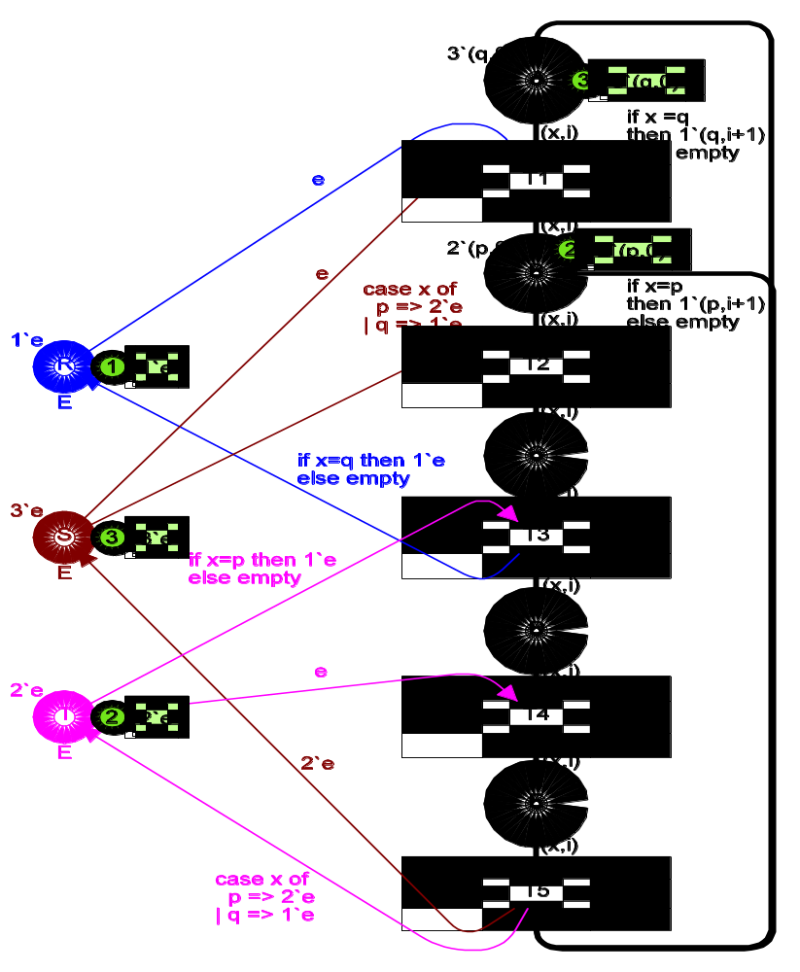
color U = with p|q;
color I = int;
color P = product U*I;
color E = with e;
var x: U;
var i: I;
The processes can be in five different states, represented by the places A–E. Each place may contain one or more markers, called tokens. Each token carries a data value – called the token colour. The data value may be of arbitrarily complex type (e.g., a record where the first field is a real, the second a text string, while the third is a list of integer pairs). For a given place all tokens must have token colours that belong to a specified type. This type is called the colour set of the place.
The use of colour sets in CP-nets is totally analogous to the use of types in programming languages. Colour sets determine the possible values of tokens (analogously to the way in which types determine the possible values of variables and expressions). For historical reasons we talk about “coloured tokens” which can be distinguished from each other – in contrast to the “plain tokens” of an ordinary Petri net.
By convention we write colour sets in italics. From the above figure, it can be seen that the places A–E have the type P as colour set, while the places R–T have the type E as colour set. The declarations of the colour sets (in the upper left corner of the figure) tell us that each token on A–E has a token colour which is a pair (because the colour set P is declared to be the Cartesian product of two other colour sets U and I). The first element of the pair is an element of U and thus it is either p or q (because the colour set U is declared to be an enumeration type with these two elements). The second element is an integer (because the colour set I is declared by means of the CPN ML standard type int, which contains all integers in an implementation-dependent interval). Intuitively, the first element of a token tells whether the token represents a p-process or a q-process, while the second element tells how many full cycles the process has completed. It can also be seen that all the tokens on R–T have the same token colour (e is the only element of E). Intuitively, this means that these tokens carry no information – apart from their presence/absence at a place.
The initial marking is determined by evaluating the initialization expressions, i.e., the underlined expressions next to the places. In the initial marking there are three (q,0)-tokens on A and two (p,0)-tokens on B, while C, D and E have no tokens (by convention we omit initialization expressions which evaluate to the empty multi-set). Moreover, R has one e-token, S has three e-tokens and T has two e-tokens. The marking of each place is a multi-set over the colour set attached to the place. We need multi-sets to allow two or more tokens to have identical token colours. If we only worked with sets it would be impossible, for example, to have three (q,0)-tokens in the initial marking of A.
The current marking of a given place is represented by means of a small circle (with an integer saying how many tokens there are) and a text string next to the circle (with a multi-set saying what the individual token colours are, and which coefficients they have). By convention we omit the circle and the text string for places which have no tokens. In the figure above, the current marking is identical to the initial marking, and this means that the small circles and their text strings contain the same information as the initialization expressions.
Each of the five transitions T1–T5 represents a shift from one state to the next. The surrounding arc inscriptions tell us how resources are reserved and released. To see how this works, let us consider transition T2 which has three surrounding arcs. The arc expression “(x,i)” appears twice (on the input arc from B and on the output arc to C) while “case x of p=>2`e | q=>1`e” appears once (on the input arc from S). Together these three arc expressions have two variables, x and i, and from the declarations it can be seen that x has type U while i has type I. At a first glance one might also think that e, p and q are variables, but from the declarations it can be seen that this is not the case: e is an element of the colour set E, while p and q are elements of U. This means that they are constants. Intuitively, the three arc expressions tell us that an occurrence of T2 moves a token from B to C – without changing the colour (because the two arc expressions are identical). Moreover, the occurrence removes a multi-set of tokens from S. This multi-set is determined by evaluating the corresponding arc expression. As it can be seen, the multi-set depends upon the kind of process involved. A p-process needs two s-resources to go from B to C (and thus it removes two e-tokens from S), while a q-process only needs one s-resource to go from B to C (and thus it removes only one e-token from S).
Marking M1
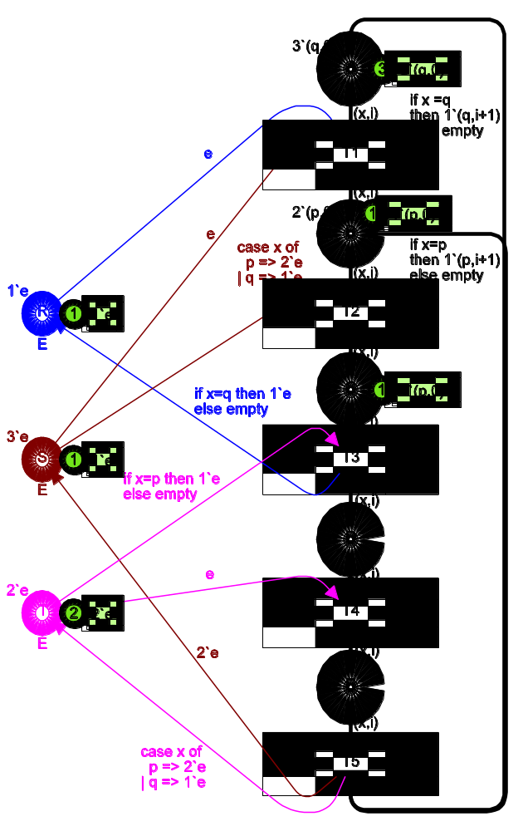
color U = with p|q;
color I = int;
color P = product U*I;
color E = with e;
var x: U;
var i: I;
Now let us be a little more precise, and explain in detail how the enabling and occurrence of CP-net transitions are determined. The transition T2 has two variables (x and i), and before we can consider an occurrence of the transition these variables have to be bound to colours of the corresponding types (i.e., elements of the colour sets U and I). This can be done in many different ways. One possibility is to bind x to p and i to zero: then we get the binding b1 = <x=p,i=0>. Another possibility is to bind x to q and i to 37: then we get the binding b2 = <x=q,i=37>.
For each binding we can check whether the transition, with that binding, is enabled (in the current marking). For the binding b1 the two input arc expressions evaluate to (p,0) and 2`e, respectively. Thus we conclude that b1 is enabled in the initial marking – because each of the input places contains at least the tokens to which the corresponding arc expression evaluates (one (p,0)-token on B and two e-tokens on S). For the binding b2 the two arc expressions evaluate to (q,37) and e. Thus we conclude that b2 is not enabled (there is no (q,37)-token on B). A transition can occur in as many ways as we can bind the variables that appear in the surrounding arc expressions (and in the guard – introduced below). However, for a given marking, it is usually only a few of these bindings that are enabled.
When a transition is enabled (for a certain binding) it may occur, and it then removes tokens from its input places and adds tokens to its output places. The number of removed/added tokens and the colours of these tokens are determined by the value of the corresponding arc expressions (evaluated with respect to the binding in question). A pair (t,b) where t is a transition and b a binding for t is called a binding element. The binding element (T2,b1) is enabled in the initial marking M0 and it transforms M0 into the marking M1 (shown below). Analogously, we conclude that the binding element (T1,<x=q,i=0>) is enabled in M0 and that it transforms M0 into the marking M2 (shown below). We say that each of the markings M1 and M2 is directly reachable from M0. The binding element (T2,b2) is not enabled in M0 and thus it cannot occur.
Next, let us take a closer look at transition T5. This transition moves a token from place E to either A or B (p-processes go to B, while q-processes go to A). Simultaneously the transition updates the cycle counter i. Notice that different bindings for a transition may not only result in different token colours but also in different numbers of tokens. In particular this may mean that the multi-set of tokens which are added/removed, for a given binding, may be empty, as illustrated by the two thick output arcs of T5. We have positioned the first segments of the two arcs on top of each other to illustrate the close relationship between them. However, it should be stressed that this has no formal meaning. The only purpose is to make the drawing more readable for human beings.
Next let us look at transition T1, which in addition to the arc expressions has a guard: “[x=q]”. A guard is a boolean expression (i.e., an expression that evaluates to either true or false). It may have variables in exactly the same way that the arc expressions have. The purpose of a guard is to define an additional constraint which must be fulfilled for a transition to be enabled. In this case the guard tells us that it is only tokens representing q-processes which can move from A to B (because the guard for all bindings <x=p, …> evaluates to false and thus prevents enabling). It is easy to see that we in this case could have omitted the guard, because we never will have p-tokens on place A. However, adding the guard makes our description more robust towards errors.
Marking M2
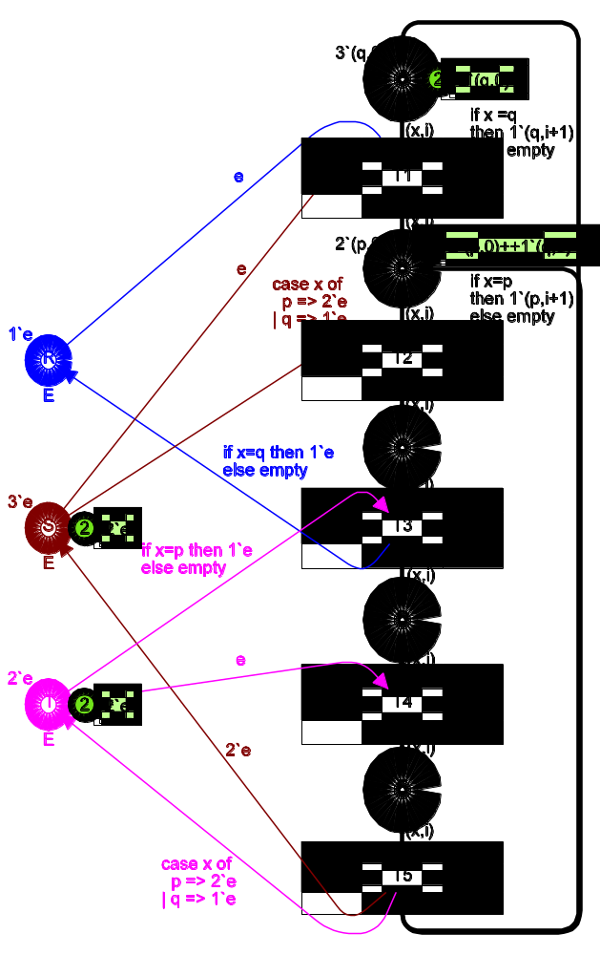
color U = with p|q;
color I = int;
color P = product U*I;
color E = with e;
var x: U;
var i: I;
When the same variable name appears more than once, in the guard/arc expressions of a single transition, we only have one variable (with multiple appearances). Each binding of the transition specifies a colour for the variable – and this colour is used for all the appearances. However, it should be noted that the appearances of x around T1 are totally independent of the appearances of x around T2 – in the sense that the two sets of appearances in the same step can be bound to different colour values.
It can be shown that the resource allocation system presented above has no deadlock (i.e., no reachable marking in which no binding element is enabled). However what happens if we change the number of processes or the number of resources? As an example, let us assume that the initial marking has an extra s-resource (i.e., an extra e-token on S). One should expect that this small modification cannot lead to a deadlock – because deadlocks appear when we have too few resource tokens, and thus an extra resource token cannot cause a deadlock.
Is the argument above convincing? At a first glance: yes! However, this argument is wrong. Adding the extra s-resource actually means that we can reach a deadlock. This can be seen by letting the two p-processes advance from state B to state D, while the q-processes remain in state A.
Hopefully, this small example demonstrates that informal arguments about behavioural properties are dangerous – and this is one of our motivations for the development of the more formal analysis methods, such as occurrence graphs and place invariants.

Timed Resource Allocation
Abstract
This is a small toy example which is well-suited as a first introduction to timed CP-nets. It shows how the CP-net from “Resource Allocation” can be turned into a timed CP-net. The time constructs are described in great detail, explaining the basic concepts of timed CP-nets.

The example is taken from Sect. 5.1 of Vol. 2 of the CPN book and Sect. 6.2 of Vol. 1 of the CPN book.

Developed and Maintained by:
Kurt Jensen, Aarhus University, Denmark (kjensen@daimi.au.dk).
CPN Model

To investigate the performance of systems, i.e., the speed at which they operate, it is convenient to extend CP-nets with a time concept. To do this, we introduce a global clock. The clock values represent the model time, and they may either be discrete (e.g., integers) or continuous (e.g., reals). In addition to the token colour, we allow each token to carry a time value, also called a time stamp. Intuitively, the time stamp describes the earliest model time at which the token can be used, i.e., removed by a binding element.
In a timed CP-net a binding element is said to be colour enabled when it satisfies the requirements of the usual enabling rule (for untimed CP-nets). However, to be enabled, the binding element must also be ready. This means all the time stamps of the removed tokens must be less than or equal to the current model time.
To model that an activity/operation takes ∆r time units, we let the corresponding transition t create time stamps for its output tokens that are ∆r time units larger than the clock value at which t occurs. This implies that the tokens produced by t are unavailable for ∆r time units. It can be argued that it would be more natural to delay the creation of the output tokens, so that they did not come into existence until ∆r time units after the occurrence of t had begun. However, such an approach would mean that a timed CP-net would get “intermediate” markings which do not correspond to markings in the corresponding untimed CP-net, because there would be markings in which input tokens have been removed but output tokens not yet generated. Hence we would get a more complex relationship between the behaviour of timed and untimed nets.
The execution of a timed CP-net is time driven, and it works in a similar way to that of the event queues found in many programming languages for discrete event simulation. The system remains at a given model time as long as there are colour enabled binding elements that are ready for execution. When no more binding elements can be executed, at the current model time, the system advances the clock to the next model time at which binding elements can be executed. Each marking exists in a closed interval of model time (which may be a point, i.e., a single moment). The occurrence of a binding element is instantaneous.
Now let us consider the timed CP-net for the resource allocation system (shown below). For this system, we use a discrete clock, starting at 0. From the third and fourth lines of the declarations, we see that P-tokens are timed (i.e., carry time stamps), while the E-tokens are not. This means E-tokens are always ready to be used. The small rectangle below the declarations indicates that the current model time is 641 (in CPN Tools this information is displayed in the index).
The @ signs in the current markings should be read “at”. Each @ sign is followed by a time stamp. The marking of place A contains two tokens, one with colour (q,4) and time stamp 627, and one with colour (q,5) and time stamp 598. Analogously, place B has two tokens, one with colour (p,6) and time stamp 567, and one with colour (q,1) and time stamp 602. Place D has a single token with colour (p,4) and time stamp 641. Finally, place T has one token with colour e and no time stamp. The initial marking of place A is displayed as 3`(q,0)@0 to indicate that all three tokens with colour (q,0) have timestamp 0.
Marking at time 641
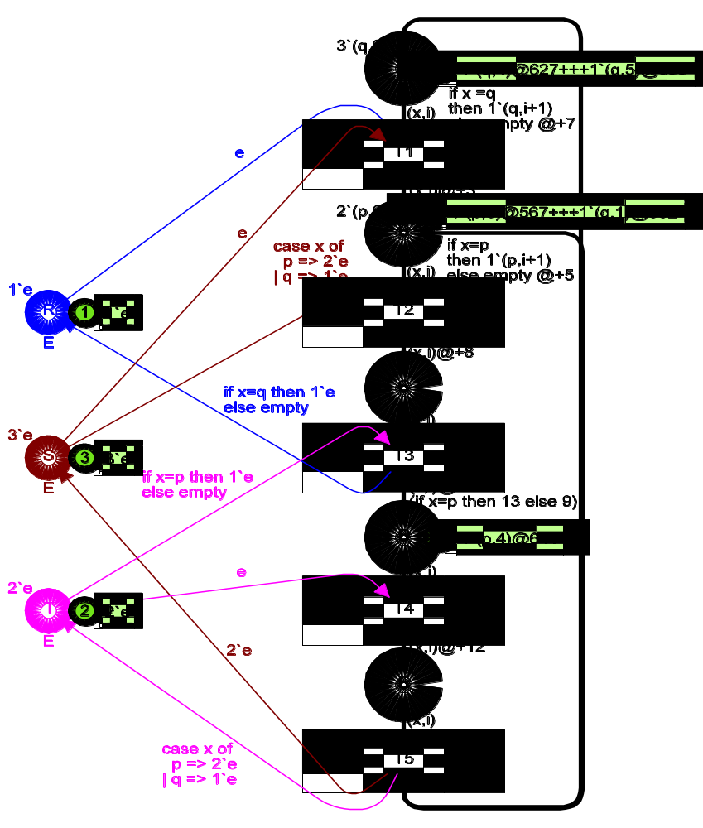
color U = with p | q;
color I = int;
color P = product U*I timed;
color E = with e;
var x: U;
var i: I;
Time: 641
Now let us consider the steps which may occur in the shown marking. The binding element b1 = (T4,<x=p, i=4>) is colour enabled, because the two input places have the necessary tokens. The binding element is also ready, because all the time stamps of the removed tokens are smaller than or equal to the current model time (in this case there is only one such time stamp and it is equal to the current model time). Hence b1 is enabled and it may occur. The occurrence of b1 removes the token from D and the token from T. The occurrence of b1 will also add a token to E. The colour of the new token is calculated in the usual way, i.e., as specified by the occurrence rule for untimed CP-nets. The time stamp of the new token is calculated as the current model time plus a time delay, which is specified in the corresponding output arc expression – after the @+ operator. In this case the delay is 12 time units, and hence we get 653 as the new time stamp. Intuitively, this means the p-token must stay at least 12 time units at place E. We can interpret this to mean that the state E has a minimal duration of 12 time units. We can also interpret it to mean that the activity T4 takes 12 time units.
When b1 has occurred, we reach a marking in which b2 = (T5,<x=p, i=4>) is the only colour enabled binding element. However, b2 is not ready at model time 641 because it involves a token with a too-high time stamp. Hence we increase the model time until b2 becomes ready, i.e., to 653. If there had been several colour enabled binding elements we would have increased the model time until one of them became ready. When b2 has occurred, at model time 653, we get the marking shown below. Now we have three colour enabled binding elements b3 = (T2,<x=p, i=5>), b4 = (T2,<x=p, i=6>), and b5 = (T2,<x=q, i=1>). The binding elements b4 and b5 are ready at 653, while b3 uses a token with time stamp 658. Hence either b4 or b5 will occur. They are in conflict with each other, because they both need e-tokens from S. This means only one of them will be executed. However, had there been an additional e-token on S, b4 and b5 would have been concurrently enabled and both of them would have occurred at time 653 (either in the same step, or in two subsequent steps).
Marking at time 653
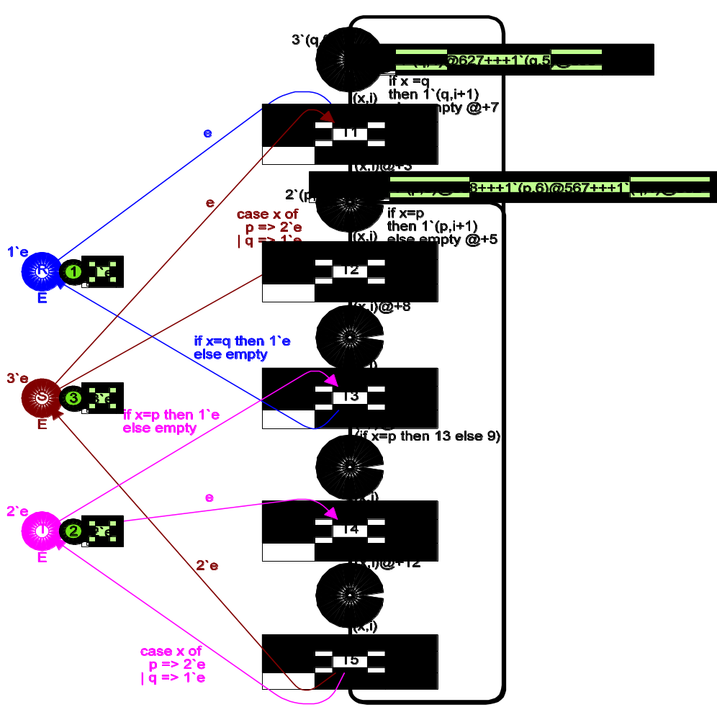
color U = with p | q;
color I = int;
color P = product U*I timed;
color E = with e;
var x: U;
var i: I;
Time: 653
The time delays may depend upon the binding, i.e., upon the colours of the input and output tokens. This is illustrated by the output arc of T3, where the delay depends upon the value of the variable x. For p-processes the delay is 13, while for q-processes it is 9. The delays are specified by means of expressions, and this means, for example, they can use functions which implement complex statistical distributions.
For a timed CP-net we require that each step consists of binding elements which are both colour enabled and ready. Hence the possible occurrence sequences of a timed CP-net always form a subset of the possible occurrence sequences of the corresponding untimed CP-net. This means we have a well defined and easy-to-understand relationship between the behaviour of a timed CP-net and the behaviour of the corresponding untimed CP-net.
In the resource allocation system, we have only illustrated one of the simplest ways in which time stamps can be used. All removed tokens for a binding element (t,b) were required either to be without time stamps or to have time stamps which were less than or equal to the time value r* at which (t,b) occurs. At a given place p, all added tokens for (t,b) either got no time stamps or got identical time stamps which were equal to r* plus a delay ∆r. In general, the situation can be considerably more complex.

Distributed Data Base
Abstract
This is a small toy example which describes the communication between a set of data base managers in a distributed system. The managers are supposed to keep their data bases identical. Hence, each update must be followed by a broadcast to all the other managers, asking them to perform a similar update.

The CPN ML declarations are described in great deal. Moreover, the example is used to illustrate three of the very basic concepts of net theory: concurrency, conflict and causal dependency.

The example is taken from Sect. 1.3 of Vol. 1 of the CPN book.

Developed and Maintained by:
Kurt Jensen, Aarhus University, Denmark (kjensen@daimi.au.dk).
CPN Model

This example describes a very simple distributed data base with n different sites (n is a positive integer, which is assumed to be greater than or equal to 3). Each site contains a copy of all data and this copy is handled by a local data base manager. Thus we have a set of data base managers:
DBM = {d1, d2, …, dn}.
Each manager is allowed to make an update to its own copy of the data base – but then it must send a message to all the other managers (so that they can perform the same update on their copy of the data base). In this example we are not interested in the content of the message – but only in the header information, which describes the sender and the receiver. Thus we have the following set of messages:
MES = {(s,r) | s,r ∈DBM ∧ s ≠ r}
where the sender s and the receiver r are two different data base managers. When a data base manager s makes an update, it must send a message to all other managers, i.e., the following messages:
Mes(s) =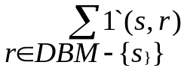
where the summation indicates that we form a multi-set, with n–1 elements, by adding the multi-sets {1`(s,r) | r∈DBM–{s}}, each of which contains a single element. The resulting multi-set contains one appearance of each message which has s as sender.
Together these definitions give us the following declarations:
constants: n : integer (* n ≥ 3 *);
colour sets: DBM = {d1, d2, …, dn};
MES = {(s,r) | s,r ∈DBM ∧ s ≠ r};
E = {e};
functions: Mes(s) =;
variables: s,r : DBM;
Now let us look at the CP-net (shown at the next page). Each data base manager has three different states: Inactive, Waiting (for acknowledgments) and Performing (an update requested by another manager). Each message can be in four different states: Unused, Sent, Received and Acknowledged. Finally, the system can be either Active or Passive.
Initially all managers are Inactive and all messages are Unused. This is indicated by the initialization expressions. DBM.all() generates the multi-set which contains exactly one appearance of each colour in the colour set DBM. Analogously, MES.all() generates the multi-set which contains exactly one appearance of each colour in the colour set MES.
When a manager, s, decides to make an Update and Send Messages, its state changes from Inactive to Waiting, while the state of its messages Mes(s) changes from Unused to Sent. Now the manager has to wait until all other managers have acknowledged the update. When one of these other managers, r, Receives a Message, its state changes from Inactive to Performing (the update), while the state of the corresponding message (s,r) changes from Sent to Received. Next the data base manager r may Send an Acknowledgment (saying that it has finished the update) and its state changes from Performing back to Inactive, while the state of the message (s,r) changes from Received to Acknowledged. When all the messages Mes(s), which were sent by the manager s, have been Acknowledged, the manager s may Receive all Acknowledgments and its state changes from Waiting back to Inactive, while the state of its messages Mes(s) changes from Acknowledged back to Unused.
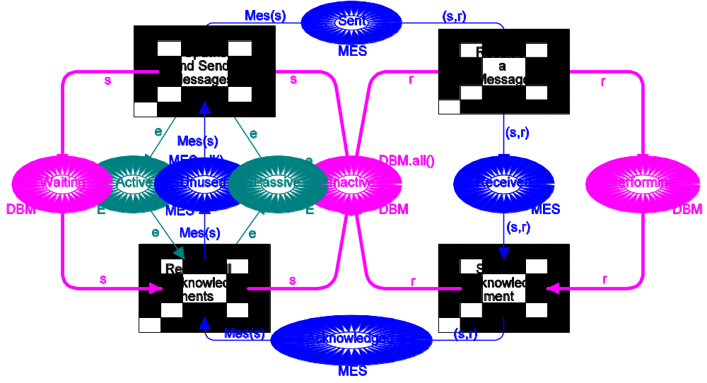
val n = 4;
color DBM = index d with 1..n;
volor PR = product DBM * DBM;
fun diff(x,y) = (x<>y);
color MES = subset PR by diff;
color E = with e;
fun Mes(s) = PR.mult(1`s, DBM.all()--1`s);
var s,r: DBM;
To ensure consistency between the different copies of the data base this simple synchronisation scheme only allows one update at a time. In other words, when a manager has initiated an update, this has to be performed by all the managers before another update can be initiated. This mutual exclusion is guaranteed by the place Passive (which is marked when the system is passive). Initially Passive contains a single e-token (as for the resource allocation system, we use e to denote “uncoloured tokens”, i.e., tokens with no information attached).
It should be remarked that our description of the data base system is very high-level (and unrealistic) – in the sense that the mutual exclusion is described by means of a global mechanism (the place Passive). To implement the data base system on distributed hardware, the mutual exclusion must be handled by means of a “distributed mechanism”. Such an implementation could be described by a more detailed CP-net – which also could model how to handle “loss of messages” and “disabled sites”.
It should also be noted that the CP-net description of the data base system has several redundant places – which could be omitted without changing the behaviour (i.e., the possible sequences of steps). As an example, we can omit Unused. Then there will only be an explicit representation of those messages which currently are in use (i.e., in one of the states Sent, Received or Acknowledged). We can also omit Active and Performing. It is very common to have redundant places in a CP-net, and this often makes the description easier to understand – because it gives a more detailed and more comprehensive description of the different states of the system.
The data base system can be used to illustrate three of the very basic concepts of Petri nets: concurrency, conflict and causal dependency. In the initial marking of the data base system, the transition Update and Send Messages is enabled for all managers, but it can only occur for one manager at a time (due to the single e-token on Passive). This situation is called a conflict (because the binding elements are individually enabled, but not concurrently enabled) – and we say that the transition Update and Send Messages is in conflict with itself.
When the transition Update and Send Messages has occurred for some manager s, the transition Receive a Message is concurrently enabled for all managers different from s. This situation is called concurrency – and we say that the transition Receive a Message is concurrent to itself.
The transition Receive all Acknowledgments is only enabled when the transition Update and Send Messages has occurred for some manager s, and the transitions Receive a Message and Send an Acknowledgment have occurred for all managers different from s. This situation is called causal dependency (because we have a binding element which can only be enabled after the occurrence of certain other binding elements).
We have drawn the places and arcs in three different ways. This has no formal meaning, but it makes the net more readable to humans – because it makes it easier to distinguish between: state changes of the data base managers (thick lines), state changes of the messages (thin lines), and the mechanism to ensure the mutual exclusion (shaded lines). The distinction may also help to make the model more consistent (because it helps the modeller to see whether he has covered all parts of the system).
Now let us explain why the CPN ML declarations (in the box at the bottom of the CP-net) are equivalent to the declarations outlined, at the beginning of this section.
Line 1 declares n to be a constant, and gives it the value 4. Constants in CP-nets are used in a way which is similar to that of programming languages. This means that we can change the number of data base managers by changing the declaration of n (instead of having to change a large number of declarations and net inscriptions).
Line 2 declares the colour set DBM. This is done by means of a built-in colour set constructor which makes it is easy to declare indexed colour sets, i.e., sets of the form {xi, xi+1, …, xk–1, xk} where x is an identifier (i.e., a text string), while i and k are two integers (specified by means of two integer expressions). CPN ML does not recognise different font styles and thus xr is written as x(r) or as x r (where the space after x is significant). In the initialization expression of Inactive the function DBM.all() is used to generate the multi-set containing a single appearance of each element in DBM. The function DBM.all() is a colour set function that is automatically defined for the colour set DBM. We could also have declared DBM by means of an enumeration colour set, but then it would have been impossible to make the declaration independent of the actual value of n.
Lines 3–5 declare the colour set MES. First we declare a colour set PR which is the cartesian product of DBM with itself. The CPN ML compiler automatically declares a function PR.mult with which we can multiply two DBM multi-sets with each other in order to get a PR multi-set. As an example, we have PR.mult(2`d3 + 1`d4, 1`d2 + 3`d3) = 2`(d3,d2) + 6`(d3,d3) + 1`(d4,d2) + 3`(d4,d3). The function PR.mult is used in line 7 of the declarations (see below). Next we declare a function diff. The function takes two arguments and tests whether these are different from each other (<> means ≠). Finally we declare MES to be the subset of PR which contains exactly those elements for which diff(s,r) is true. The function MES.all() is also automatically generated by the CPN ML compiler, and it calculates a constant multi-set. This function is used in the initialization expression of Unused.
Line 6 declares the colour set E, which is used in a similar way as in the resource allocation system.
Line 7 declares the function Mes mapping data base managers into multi-sets of messages. This is done by means of the predefined multiplication function PR.mult that was generated when PR was declared in line 3. The minus signs denotes multi-set subtraction.
Finally, line 8 declares the two variables s and r of type DBM.

Ring Protocol
Abstract
This is a small toy example which is well-suited as a first introduction to hierarchical CP-nets. The use of substitution transitions and fusion sets are described in great detail.

The CPN model describes how a number of different sites communicate via a ring network.

The example is taken from Sect. 3.1 of Vol. 1 of the CPN book.

Developed and Maintained by:
Kurt Jensen, Aarhus University, Denmark (kjensen@daimi.au.dk).
CPN Model

The basic idea behind hierarchical CP-nets is to allow the modeller to construct a large model by combining a number of small CP-nets into a larger net. This is similar to the situation in which a programmer constructs a large program from a set of modules and subroutines.

Substitution of transitions
The intuitive idea behind substitution transitions is to allow the user to relate a transition (and its surrounding arcs) to a more complex CP-net – which usually gives a more precise and detailed description of the activity represented by the substitution transition. The idea is analogous to the hierarchy constructs found in many graphical description languages (e.g., data flow diagrams) and it is also, in some respects, analogous to the module concepts found in many modern programming languages. At one level, we want to give a simple description of the modelled activity without having to consider internal details about how it is carried out. At another level, we want to specify the more detailed behaviour. Moreover, we want to be able to integrate the detailed specification with the more crude description – and this integration must be done in such a way that it becomes meaningful to speak about the behaviour of the combined system. Now let us consider a small example, consisting of a simple ring network with four different sites. The main purpose of the example is to explain the semantics of substitution transitions, and thus the described network is far too simple to be realistic.
As mentioned above, we want to relate individual CP-nets to nodes, which are members of other CP-nets, and this means that our description will contain a set of non-hierarchical CP-nets – which we shall call pages. Below you see a page from the network system. The page has a page name Network (which is a text string).
The page Network contains ring consisting of four places and four transitions. The four transitions are substitution transitions. This can be seen because each of them has a small tag adjacent which contains the identity of the subpage. The subpage is the page which contains the detailed description of the activity modelled by the corresponding substitution transition. Each substitution transition is said to be a supernode (of the corresponding subpage) while the page of a substitution transition is a superpage (of the corresponding subpage). In our example, we can see that all four substitution transitions of Network share the same subpage Site which is shown below. This means that the hierarchical net will have four instances of Site. Each of these page instances will have its own private marking, which is independent of the markings of the other instances (in a similar way that each procedure call has its own private copies of the local variables in the procedure).
When a CP-net is simulated by means of the CPN simulator within CPN Tools, we have a sheet for each page. The sheet shows the marking of one page instance at a time, and it is possible for the user to switch from one instance to another. We will return to the remaining lines of the hierarchy inscriptions in a moment, but let us first take a look at Site which describes an individual site in the ring network.
The declarations (at the bottom of the page) declares a constant NoOfSites = 4, which tells us how many sites the ring network has. Moreover, three colour sets are declared: INT contains all integers. SITES contains the elements {S(1), S(2), …, S(NoOfSites)}, which are used to identify the individual sites of the network. Finally, PACK describes the individual packages which are sent in the network. The format is a record, containing an se-field for the identity of the sender, an re-field for the identity of the receiver and a no-field for a package number. The actual data content of the packages is ignored, but if desired it could of course easily be added as an additional field of the record.
Site has three different transitions. Each occurrence of NewPack creates a new package. The no-field of the new package is determined by the token on the place PackNo (and the colour of this token is increased by one so that the next package will get a package number which is one higher). The se-field of the new package is determined by the tokens at place SiteNo. Finally, the re-field is determined by the variable r – which does not appear in the guard and input arc expressions. This means that the binding of r does not influence the enabling, and thus r can take an arbitrary value (from SITES). This means that a site can send a package to itself, but if desired this could of course easily be prevented by adding a guard specifying that r ≠ s.
Network
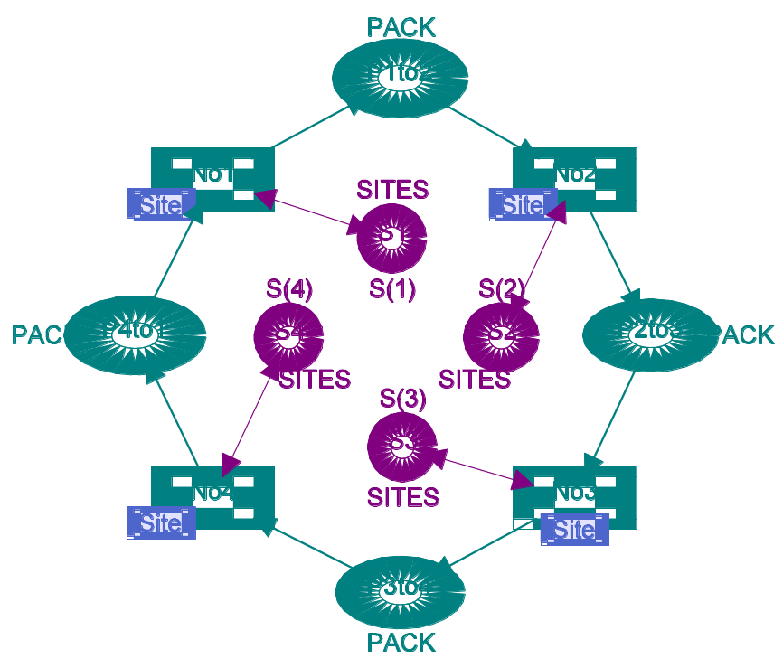
The created packages are handled by the transition Send, which inspects the re-field of the package. This is done by means of the expression #re p which denotes the re-field of the record p. When the re-field indicates that the receiver is different from the present site, the package is transferred to the place Outgoing (which is the “output gate” to the rest of the network) and a copy of the package is put on the place SentExt (indicating that the package is sent to an external receiver). Otherwise the package is sent directly to the place RecInt (indicating that the package is received from an internal sender).
Site
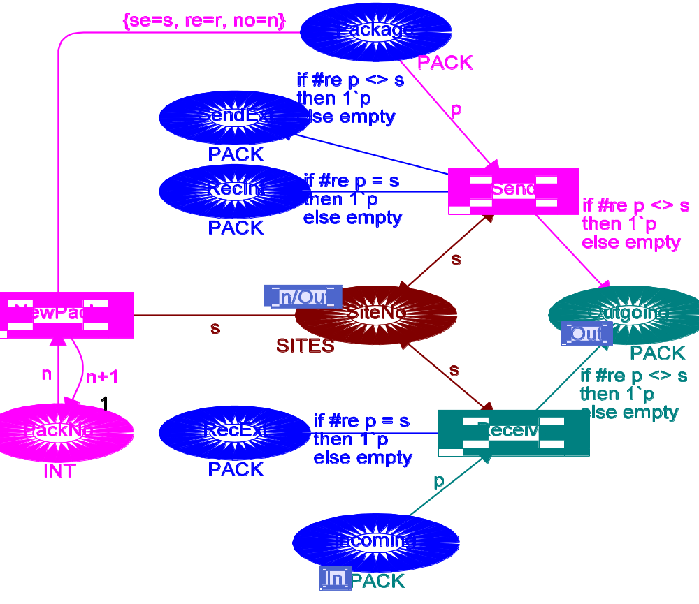
val NoOfSites = 4;
color INT = int;
color SITES = index S with 1..NoOfSites;
color PACK = record se: SITES * re:SITES * no:INT;
var s,r: SITES;
var p: PACK;
var n: INT;

Finally, the transition Receive inspects all the packages which arrive at the place Incoming (which is the “input gate” from the rest of the network). Again the re-field is inspected, and based on this inspection the package is routed, either to Outgoing or to RecExt (indicating that the package is received from an external sender).
The basic idea behind substitution transitions is that it should be possible to translate a hierarchical CP-net into a behaviourally equivalent non-hierarchical net by replacing each substitution node (and its surrounding arcs) with a copy of its subpage. However, to do this we need to know how the subpage should be “glued together” with the surroundings of the supernode (i.e., the rest of the superpage). This information is provided by the port assignment, which describes the interface between the superpage (Network) and the subpage (Site). A port assignment relates a socket node on the superpage (i.e., one of the places that surrounds the substitution transition) with a port node on the subpage (i.e., one of the places which have an In-tag, Out-tag or I/O-tag next to it). An In-tag indicates that the port node must be related to a socket node which is an input node of the substitution transition (and it is not allowed also to be an output node). Analogously, an Out-tag indicates that the port must be related to a socket which is an output node (and not an input node), while an I/O-tag indicates that the socket must be both an input and output node.
In our example, let us consider substitution transition No1 (which represents site number one). The socket node P1to2 is assigned to (i.e., “glued” together with) the port node Outgoing. Intuitively, this means that the two places represent a single conceptual place – and thus they will always have identical markings. If the occurrence of a step adds or removes one or more tokens at one of the two places, an identical set of tokens will be added/removed at the other. Analogously, the socket nodes S1 and P1to1 are assigned to the port nodes SiteNo and Incoming, respectively..

Fusion of places
The intuitive idea behind fusion of places is to allow the user to specify that a set of places are considered to be identical, i.e., they all represent a single conceptual place even though they are drawn as individual places. This means that when a token is added/removed at one of the places, an identical token will be added/removed at all the others. The relationship between the members of a fusion set is, in many respects, similar to the relationship between two places which are assigned to each other by a port assignment.
The places that participate in such a fusion set may belong to a single page or to several different pages. When all members of a fusion set belong to a single page and that page only has one page instance, place fusion is nothing other than a drawing convenience that allows the user to avoid too many crossing arcs. However, things become much more interesting when the members of a fusion set belong to several different pages or to a page that has several page instances. In that case fusion sets allow the user to specify a behaviour which it may be cumbersome to describe without fusion.To allow modular analysis of hierarchical CP-nets, fusion sets should be used with care.
To investigate fusion sets you may use CPN Tools to modify the “Ring Network” by defining two fusion sets on Site: an instance fusion set containing the two places RecExt and RecInt, and a page fusion set containing a single place SentExt. The first fusion set combines RecExt and RecInt into a single place – and since we deal with an instance fusion set, we get a “resulting place” for each of the four page instances of Site. The second fusion set combines SentExt with itself – but now we deal with a page fusion set, and thus there is only one “resulting place” shared by all four page instances.

Telephones
Abstract
This is a small toy example which describes how the public telephone system – as it is conceived by a user (and not by a telephone technician). We ignore time-outs and special services such as conference calls etc.

The example is taken from Sect. 3.2 of Vol. 1 of the CPN book.

Developed and Maintained by:
Kurt Jensen, Aarhus University, Denmark (kjensen@daimi.au.dk).
CPN Model

The telephone system has a single page Phone. This page has three transitions which all are substitution transitions. The substitution transitions are drawn with additional line thickness. However, we have hidden the hierarchy inscriptions because, in this particular system, they would only show that each substitution transition has a subpage with the same name, and that each socket node is assigned to a port node with the same name. From Phone we can see that the activities of the phone system are divided into three parts: the Establishment of a Connection, the Breaking of a connection by the Sender, and the Breaking of a connection by the Recipient.
The telephones are represented by U-tokens which at Phone only can be in two different states, Inactive and Connected. The telephone exchange (i.e., the electronics of the telephone switch) is represented by a single place, Connection. This place has a number of U × U–tokens, and each of them represents an established connection. The first element in a U × U–token identifies the sender (i.e., the phone from which the call was made), while the second element identifies the recipient (i.e., the phone which was called). It is important not to confuse the recipient with the receiver, which is the part of the telephone which you put to your ear. The receiver can be lifted and replaced, and we shall be a bit sloppy and say that the receiver is lifted or replaced by the sender/recipient – where we actually mean that a person at the sender/recipient performs the lifting/replacement operation. Analogously, we shall, e.g., say that the sender dials a number.
Phone
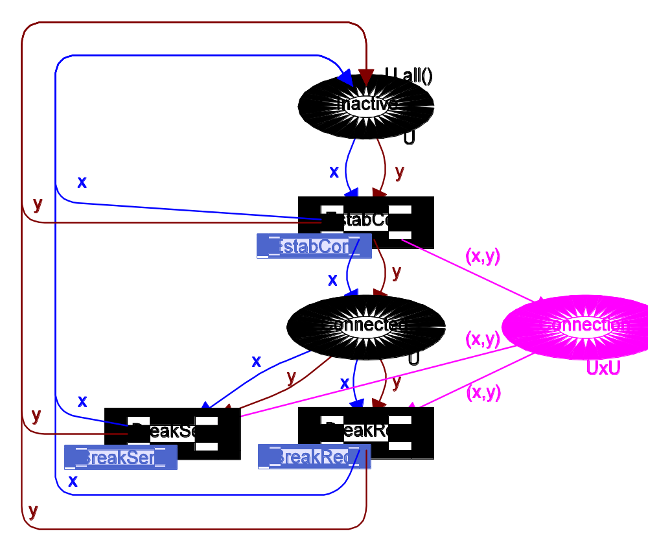
color U = index u with 1..10;
color UxU = product U * U;
var x,y: U;
Next, let us take a closer look at the Establishment of a Connection, i.e., the page EstabCon. This page has two substitution transitions, describing how the Dialing of a number and the Breaking of a connection due to Engaged recipient are performed. The telephones can now be in four additional states:
• Engaged, which intuitively is the opposite of Inactive. Notice that each transition which adds (removes) a token at Inactive, removes (adds) an identical token at Engaged. This property is not true for the substitution transitions, but this does not matter, because the arc expressions of the substitution transitions do not influence the behaviour of the hierarchical CP-net. We shall return to the arc expressions of the substitution transitions later in this section.
The property above, and the initialization expressions of Inactive and Engaged, tell us that each telephone always has a token either at Inactive or at Engaged. Notice that Engaged is a member of a fusion set. This fusion set is called FG:Engaged, and it has five different places as members, which all are called Engaged and belong to five different pages.
• NoTone, which represents the state where no tone is heard at the sender in the few seconds where the system checks whether the recipient is Inactive or Engaged.
EstabCon
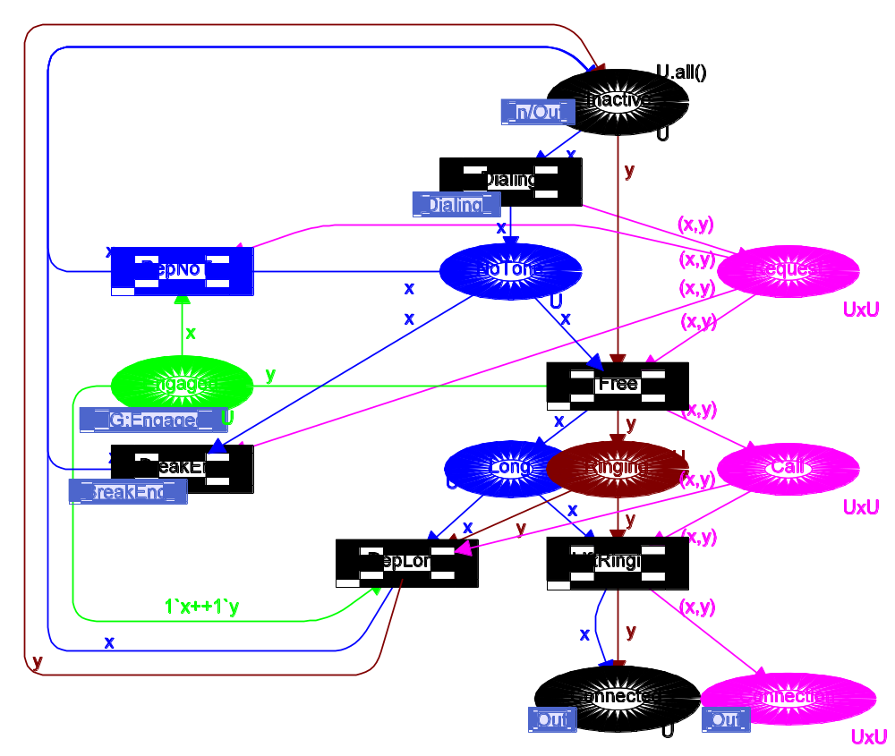
• Long, which represents the state where a beep tone with long intervals is heard at the sender – indicating that the recipient is Inactive.
• Ringing, which represents the state where the recipient is ringing, while the sender is in state Long.
EstabCon has two additional places for the telephone exchange:
• Request, which represents demands for connections which have just been made, but not yet been established.
• Call, which represents demands for connections – where it has been checked that the recipient is Inactive but where the connection has not yet been established, because the recipient has yet to lift the receiver.
EstabCon has four transitions in addition to the two substitution transitions:
• Free, which models that the telephone exchange observes the recipient being Inactive. The transition brings the sender from NoTone to Long and the recipient from Inactive to Ringing.
• LiftRinging, which models that a Call is answered by lifting the receiver at the recipient.

Dialing
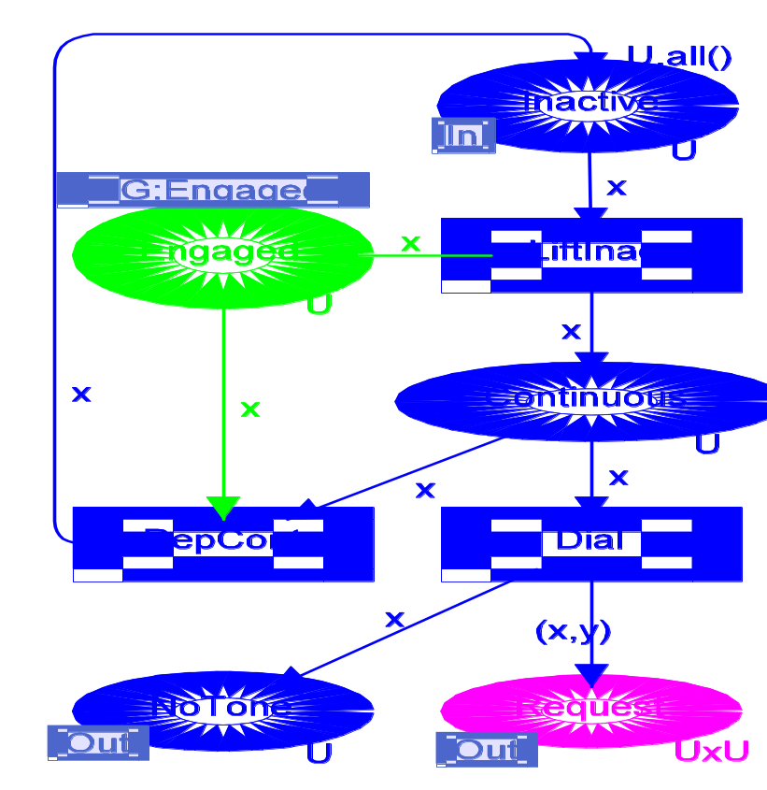

• RepNoTone, which models the sender giving up and replacing the receiver, while in state NoTone.
• RepLong, which is analogous to RepNoTone, except that the sender is in state Long.
Next, let us consider how the Dialing of a number is performed, i.e., the page Dialing. This page has only one additional state for the telephones:
• Continuous, which represents the state where a continuous tone is heard – indicating that the sender now may dial a number.
Dialing has no additional places for the telephone exchange, and it has three transitions:
• LiftInac, which models that a sender lifts the receiver, while the corresponding phone is Inactive.
• Dial, which models that a number is dialled at the sender. Notice that the variable y only appears at the output arc expressions of Dial, and this means that it does not influence the enabling. Intuitively, this means that the sender can dial any number he wants – including his own.
• RepCont, which is analogous to the other replacement transitions, except that the sender is in state Continuous.
Next, let us consider how the Breaking of a connection due to Engaged recipient is performed, i.e., the page BreakEng. This page has only one additional state for the telephones:
• Short, which represents the state where a beep tone with short intervals is heard at the sender – indicating that the recipient is Engaged.
BreakEng has no additional places for the telephone exchange, and it has two transitions:
• Engaged, which models that the telephone exchange observes the recipient being Engaged. The transition brings the sender from NoTone to Short while the state of the recipient is unaltered.
• RepShort, which is analogous to the other replacement transitions, except that the sender is in state Short.
Next, let us consider how the Breaking of a connection by the Sender is performed, i.e., the page BreakSen. This page has only one additional state for the telephones:

BreakEng
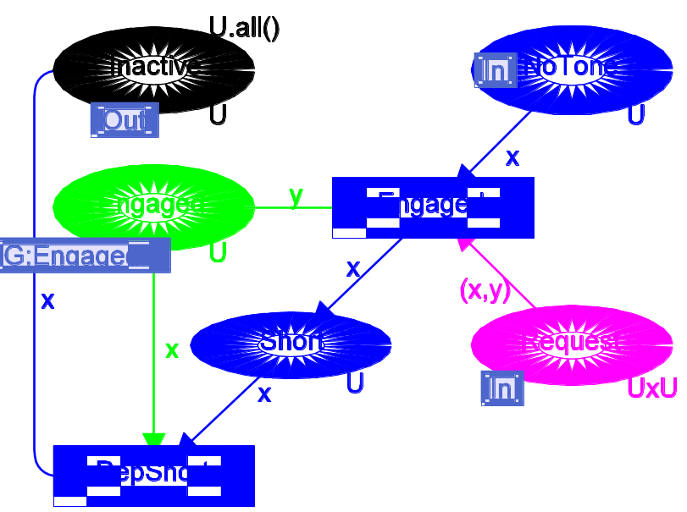

• Disconnected, which represents the state where the recipient has become disconnected because the sender has broken the connection by replacing the receiver.
BreakSen has no additional places for the telephone exchange, and it has two transitions:
• RepConSen, which models that the sender breaks the connection by replacing the receiver. Notice that the effect of this transition is not totally analogous to the other replacement transitions, because it is only the sender that returns to Inactive, while the recipient becomes Disconnected.
• RepDisc, which is analogous to the other replacement transitions, except that the recipient is in state Disconnected.
Finally, let us consider how the Breaking of a connection by the Recipient is performed, i.e., the page BreakRec. This page has only one additional state for the telephones:
• Replaced, which represents the state where the recipient has replaced the receiver. Notice that this action – at least in the Danish telephone system – does not terminate the connection, and this means that the conversation can be continued, if the recipient again lifts the receiver (for more information, see the description of RepConRec and LiftRepl below).
BreakRec has no additional places for the telephone exchange, and it has three transitions:

BreakSen
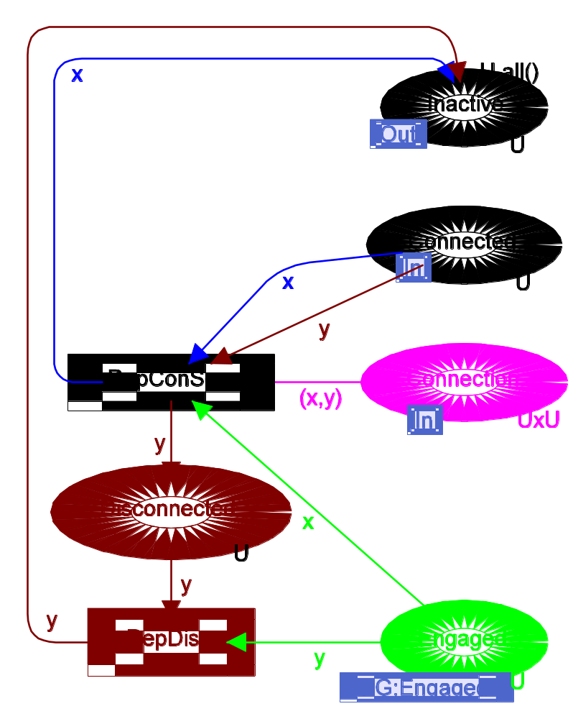
• RepConRec, which models that the recipient replaces the receiver. Notice that the effect of this transition is not analogous to the other replacement transitions, because neither the sender nor the recipient returns to Inactive. Instead the sender remains Connected, while the recipient becomes Replaced.
• LiftRepl, which represents the fact that the recipient lifts the receiver, while the recipient is in state Replaced.
• RepRepl, which is analogous to the other replacement transitions, except that the sender is in state Connected while the recipient is in state Replaced.
Now let us take a closer look at the arc expressions which surround the substitution transitions. These arc expressions do not influence the behaviour of the hierarchical CP-net, because the substitution transitions and their surrounding arcs are replaced by the subpages, and this means that it does not make sense to talk about an enabled or an occurring substitution transition. Thus we can omit the arc expressions surrounding the substitution transitions.
BreakRec
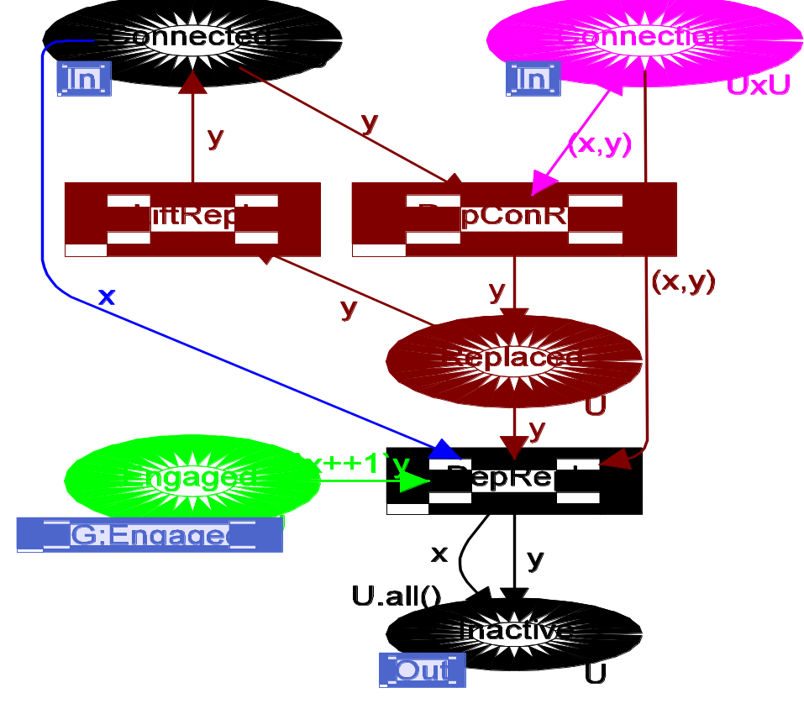
However, it is also possible to specify these arc expressions in a less trivial way – and they then act rather like comments, giving the reader of the hierarchical CP-net an idea about the behaviour of the subpages.
In the telephone example the arc expressions of the substitution transitions are used in two slightly different ways. The arc expressions of BreakSen give a rather precise description of the behaviour of the subpage BreakSen. The only differences are that the arc expressions (of course) do not show that the activity is executed in two subsequent steps, and that the arc expressions do not show the updating of Engaged (which does not exist at the abstraction level of Phone). The arc expressions of EstabCon are used in a different way. These arc expressions only describe the standard case, i.e., the case in which a Connection is established, and they ignore the possibilities where the recipient is Engaged or the sender replaces the receiver. It would not have been particularly difficult to include these additional possibilities into the arc expressions. However, the modeller has chosen, at the abstraction level of Phone, to concentrate on the standard case.
It may be argued that it is necessary to force the modeller to have a one-to-one correspondence between the arc expressions of a substitution transition and the behaviour of the corresponding subpage – because this will make it easier to develop methods allowing modular analysis. We think it is very important to develop such incremental analysis methods, built upon strict behavioural equivalence between the different levels of description. However, as indicated above, we do not think that strict behavioural equivalence is the only interesting relationship between the different abstraction levels. As an example, we may also want (for the hierarchical telephone system) to model the possibility of time-outs and the existence of special services such as conference calls, etc. This can be done by adding a number of transitions to the existing pages, but it can also be done by turning the existing transitions into substitution transitions. Then each subpage will model the effects of the time-outs and special services – as well as the standard behaviour of the corresponding action. This will mean that the pages shown above describe the standard behaviour of the telephone system, while the additional complexity introduced by time-outs and the special services are confined to the new pages. There will be a consistent relationship between the two levels of description – but this relationship will not be a strict behavioural equivalence.
The telephone system was presented in a top-down manner, but this does not necessarily mean that it was constructed in this way. It could just as well have been constructed bottom-up or (more likely) by mixing the two strategies.

