Resource Allocation
Abstract
This is a small toy example which is well-suited as a first introduction to occurrence graphs. The analysis of the occurrence graph is described in great detail, explaining the basic concepts of occurrence graphs. Hence, it can be read by people with no prior knowledge of occurrence graphs.

The CPN model describes how two different kinds of processes are sharing three different kinds of resources. The model is identical to the “Resource Allocation” system presented in “Introductory Examples” (which we recommend to study before this example).

The example is taken from Sect. 1.1 of Vol. 2 of the CPN book.

Developed and Maintained by:
Kurt Jensen, Aarhus University, Denmark (kjensen@daimi.au.dk).
CPN Model

The basic idea behind occurrence graphs is to construct a graph which has a node for each reachable marking and an arc for each occurring binding element. Obviously, such a graph may become very large, even for small CP-nets. As an example, let us consider again the “Resource Allocation” system from the “Introductory Examples”. Due to the cycle counters this net has an infinite number of reachable markings and thus an infinite occurrence graph. However, we can simplify the CP-net by omitting the cycle counters. Then we get the CP-net shown below.
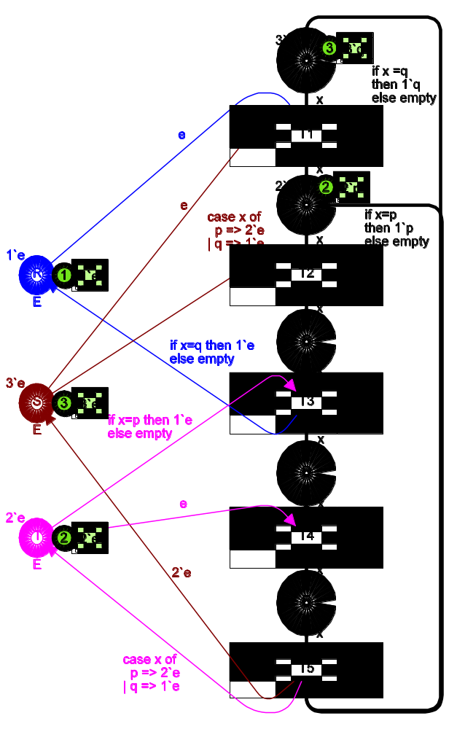
It is easy to check that the cycle counters form an isolated part of the original CP-net – in the sense that they influence neither the enabling nor the effect of an occurrence (except that they determine the values of new cycle counters). This means the simplified net has a behaviour similar to that of the original net. For each occurrence sequence in one of the CP-nets there is a corresponding occurrence sequence in the other. Hence we can get information about the dynamic properties of the original net by constructing an occurrence graph for the simplified net.
color U = with p | q;
color E = with e;
var x: U;

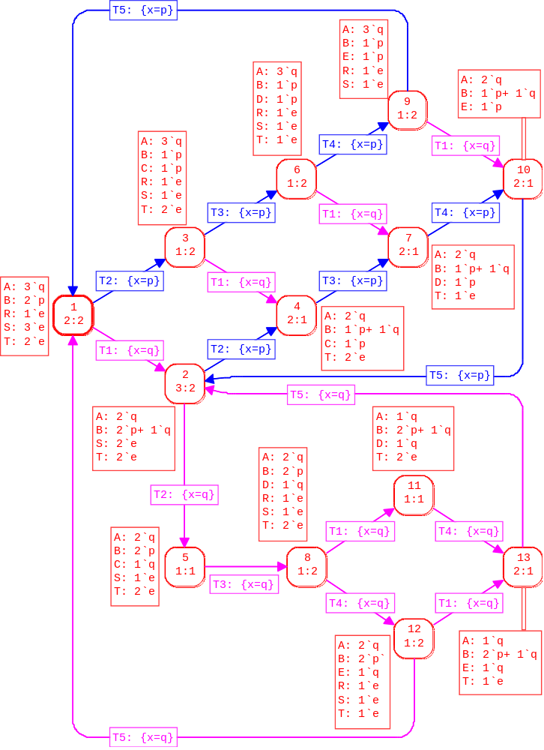
Such a graph is shown below – it is called a full occurrence graph or an O-graph. The current version of CPN Tools does not include facilities for drawing O-graphs. The rounded boxes are nodes. Each of them represents a reachable marking, and the content of this marking is described in the dashed region next to the node – places with an empty marking are omitted. To the left we have a node with a thicker borderline. This node represents the initial marking. The text inside the node tells us that this is node number 1 and that it has 2 predecessors and 2 successors (the latter information may be useful when we have drawn only a small part of a large occurrence graph). Analogously, we see that node #2 has 3 predecessors and 2 successors. By convention we use Mn to denote the marking of node number n.
Each arc represents the occurrence of the binding element in the dashed region on top of the arc. In M1 there are two enabled binding elements. If transition T1 occurs, with x bound to q, we reach M2, and if transition T2 occurs, with x bound to p, we reach M3.
Notice that we omit arcs that correspond to steps containing more than one binding element. Otherwise, we would have had, e.g., an arc from node #1 to node #4, representing the step 1`(T1,<x=q>) + 1`(T2,<x=p>). Such arcs would give us information about the concurrency between binding elements, but they are not necessary for the verification of boundedness, home, live and fairness properties.
When the occurrence graph and the strongly connected component (SCC) graph have been generated, we can ask the state space tool to generate a standard report, i.e., a text file with key information about the occurrence graph and the dynamic properties which can be deduced from it. The standard report has five parts. The first part looks as shown below. It contains statistical information about the size of the occurrence graph and the size of the SCC-graph (which has a node for each strongly connected component of the occurrence graph). We see that the occurrence graph has 13 nodes and 20 arcs. We have calculated the entire graph and this took less than 1 second. Finally, we see that there is only one strongly connected component.
Statistics
-----------------------------
Occurrence Graph
Nodes: 13
Arcs: 20
Secs: 0
Status: Full

Scc Graph
Nodes: 1
Arcs: 0
Secs: 0
The second part of the standard report contains information about the integer and multi-set bounds. First we get the upper and lower integer bounds, i.e., the maximal and minimal number of tokens on the individual places. As, an example, we see that place A always has 1-3 tokens. We also see that each of the places C, D and E has at most one token. Next we get the upper and lower multi-set bounds. From the upper multi-set bounds, we see that place A only can have q–tokens. We also see that each of the places B–E can have both p-tokens and q-tokens. From the lower multi-set bounds, we learn that place A always contains at least one q-token while place B always contains at least one p-token. We also see that we cannot omit any of the resources without changing the behaviour of the system.
Boundedness Properties
-----------------------------
Best Integers Bounds
Upper Lower
A 3 1
B 3 1
C 1 0
D 1 0
E 1 0
R 1 0
S 3 0
T 2 0

Best Upper Multi-set Bounds
A 3`q
B 2`p+ 1`q
C 1`p+ 1`q
D 1`p+ 1`q
E 1`p+ 1`q
R 1`e
S 3`e
T 2`e
Best Lower Multi-set Bounds
A 1`q
B 1`p
C empty
D empty
E empty
R empty
S empty
T empty
The third part contains information about the home properties. Here we see that all reachable markings are home markings. This means that they all can be reached from each other.
Home Properties
-----------------------------
Home Markings: All
The fourth part contains information about liveness properties. We see that there are no dead markings and that all transitions are live, which means that they always have the possibility of occurring once more.
Liveness Properties
--------------------------------
Dead Markings: None
Dead Transitions Instances:None
Live Transitions Instances: All
The fifth and final part of the standard report contains information about the fairness properties. Here we see that each of the transitions T2-T5 is impartial, which means that each infinite occurrence sequence contains an infinite number of the transition. Transition T1 is neither impartial, fair, or just. From the drawing of the occurrence graph we can see why this is the case. By repeating the cycle through the nodes #1, #3, #6 and #9, we get an infinite occurrence sequence. T1 is enabled in every marking of this occurrence sequence, but T1 never occurs in the sequence.
Fairness Properties
-----------------------------
T1 No Fairness
T2 Impartial
T3 Impartial
T4 Impartial
T5 Impartial
The standard report is produced in a few seconds – totally automatic. The standard report contains a lot of highly useful information about the behaviour of CPN model. However, we may also want to verify some properties which are more particular for the model at hand.
As an example, we may want to see how many tokens the places C–E has together. This is done by formulating the simple 4-lines query shown in left-hand box below. The function Mark.Top'C 1 allows us to determine the marking M(C) of the first instance of place C on page Top. Analogously, the next lines determine the markings M(D) and M(E), which are added to M(C). The function UpperInteger calculates the maximal number of tokens in M(C) + M(D) + M(E) when M traverses the set of markings in the occurrence graph (i.e., all reachable markings). The result is shown in the speech bubble to the right. It is 1, and this tells us that the places C, D and E form a critical region. There is never more than one process in this area – at a time.
Critical Region
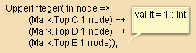
From the standard report we know that all five transitions are live. However, we may also want to know whether they are strictly live, i.e., whether each individual binding element is live. To check this, for transitions T1 and T2, we make the following queries, which tell us that both transitions are strictly live. It should be noted that transition T1 only has one possible binding – due to the guard.
Strict Liveness
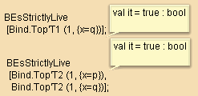
From the standard report we know that transition T1 possesses no fairness property while the only four transitions are impartial. However, we may also want to investigate the fairness properties for the sets of those binding elements that correspond to q-processes and p-processes, respectively. To do this, we make the following queries, which tell us that the set of binding elements of p-processes is just while the set of binding elements of q-processes possesses no fairness property.
Fairness
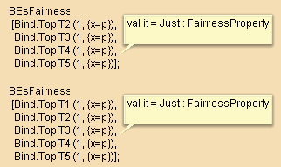
Even for a small O-graph, like the one in this example, the construction and investigation are tedious and error-prone. In practice, it is not unusual to handle CP-nets that have O-graphs containing more than 100,000 nodes (and many CP-nets have millions of markings). Thus it is obvious that we could not work with occurrence graphs without tool support.

Distributed Data Base
Abstract
This is a small toy example which is well-suited as an introduction to occurrence graphs. The analysis of the occurrence graph is described in great detail.

The CPN model describes the communication between a set of data base managers in a distributed system. The model is identical to the “Distributed Data Base” presented in “Introductory Examples”(which we recommend to study before this example).

The example is taken from Sect. 1.5 of Vol. 2 of the CPN book.

Developed and Maintained by:
Kurt Jensen, Aarhus University, Denmark (kjensen@daimi.au.dk).
CPN Model

In this example we study the O-graph for the data base system, i.e., the O-graph for the following CP-net:

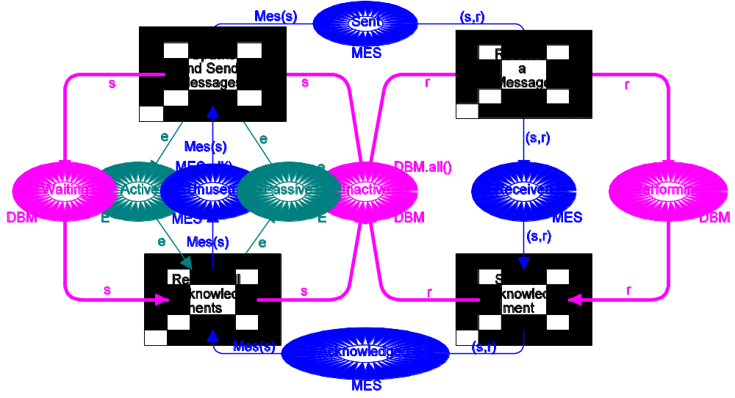
val n = 3;
color DBM = index d with 1..n;
volor PR = product DBM * DBM;
fun diff(x,y) = (x<>y);
color MES = subset PR by diff ;
color E = with e;
fun Mes(s) = PR.mult(1`s, DBM.all()--1`s);
var s,r: DBM;
For three data base managers the O-graph looks as shown below. The current version of CPN Tools does not include facilities for drawing O-graphs. Node number one is the initial marking. To save space the transition names are abbreviated to SM, RM, SA, and RA. Moreover, we write SM i and RM i, k instead of (SM,<s = di>) and (RM,<s = di, r = dk>), and analogously for SA and RA.

The standard report looks as shown below.
From the statistics we see that there only is one strongly connected component. This means that all reachable states are reachable from each other.
Statistics
-----------------------------
Occurrence Graph
Nodes: 28
Arcs: 42
Secs: 0
Status: Full

Scc Graph
Nodes: 1
Arcs: 0
Secs: 0
All the integer bounds are as expected (see below). In particular, we see that at most one process can be Waiting. This tells us that a new update cannot start until all data base managers have finished the processing of the previous one. Also the multi-set bounds are as expected. To improve the readability, we have substituted DBM for the multi-set 1`d(1) + 1`d(2) + 1`d(3) and MES for 1`(d(1),d(2)) + 1`(d(1),d(3)) + 1`(d(2),d(1)) + 1`(d(2),d(3)) + 1`(d(3),d(1)) + 1`(d(3),d(2)).
Boundedness Properties
-------------------------------
Best Integers Bounds
Upper Lower
Acknowledged 2 0
Active 1 0
Inactive 3 0
Passive 1 0
Performing 2 0
Received 2 0
Sent 2 0
Unused 6 4
Waiting 1 0

Best Upper Multi-set Bounds
Acknowledged MES
Active 1`e
Inactive DBM
Passive 1`e
Performing DBM
Received MES
Sent MES
Unused MES
Waiting DBM

Best Lower Multi-set Bounds
Acknowledged empty
Active empty
Inactive empty
Passive empty
Performing empty
Received empty
Sent empty
Unused empty
Waiting empty
The home properties tell us that all reachable markings are home markings. From the drawing of the occurrence graph, we can actually deduce that the system has a much stronger property. It is not only possible to return to the initial marking. This will always happen – whenever 2 * n transitions have occurred.
Home Properties
-----------------------------------
Home Markings: All
Also the liveness properties are as expected. There are no dead markings and all transitions are live.
Liveness Properties
-----------------------------------
Dead Markings: None
Dead Transitions Instances: None
Live Transitions Instances: All
Finally, the fairness properties tells us that all transitions are impartial. This is also easy to see from the drawing of the occurrence graph. Whenever 2 * n transitions have occurred SendMes and RecAck have occurred exactly one time each, while RecMes and SendAck have occurred exactly n – 1 times each.
Fairness Properties
-----------------------------------
SendMes Impartial
RecMes Impartial
SendAck Impartial
RecAck Impartial
Now let us look at some model dependent properties. First we investigate whether the transitions are strictly live. For SendMes and RecMes the queries look as shown below. They show us that SendMes is strictly live, while RecAck is not – because binding elements such as (RecAck,<s=d(2),r=d(2)>) are dead. If we add a guard, [s<>r], to RecAck, the transition becomes strictly live.
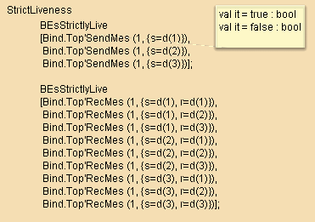
Next we investigate the fairness properties of some typical binding elements. We see that the binding element of SendMes is just, while those of the other three transitions are fair.
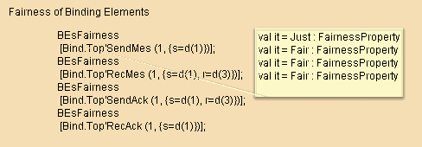
Finally, let us demonstrate that occurrence graphs also can be used to check whether place invariants are fulfilled. It should, however, be stressed that the best way to check place invariants (for complex systems) is by checking the place flow property, which is a static and local property that can be checked without generating all possible system states. We want to check the following two place invariants:
M(Performing) = Rec(M(Received))
Mes(Waiting) = M(Sent) + M(Received) + M(Acknowledged).
We first define a function Rec that maps a message into its receiver.
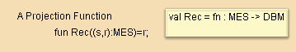
Then we extend Rec and Mes to two new functions Rec' and Mes' which can be applied to multi-sets of data base managers. This is done by means of two predeclared functions ext_col and ext_ms. The first of these extends a function [A ∅ B] to a function [AMS ∅ BMS], while the second extends a function [A ∅ BMS] to a function [AMS ∅ BMS].
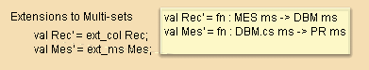
By definition the result of using an extended function to a multi-set is obtained by using the original function to each element in the multi-set – adding the results. This is illustrated by the following examples. The two mkstr_ms functions map the ML representation of a DBM/MES multi-set into a much more readable string representation.
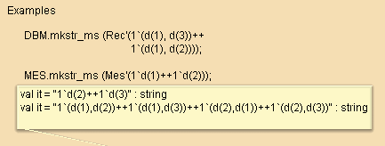
Finally, we use a predeclared search function called PredAllNodes to list all nodes violating the two invariants. There are no such nodes, and hence we have proved that the invariants are fulfilled in all reachable markings. Please note that the <><> operator checks whether two multi-sets differ from each other (if you replace <><> by <> you only check whether the representations of the two multi-sets differ from each other).
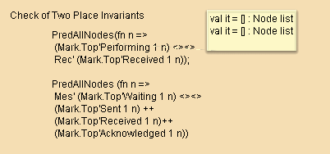
For the data base system it is rather easy to calculate how fast the O-graph grows – when we increase the number of data base managers. The results are as shown below. They illustrate the space complexity of the O-graph algorithm:
ΩDBMΩ | Nodes | Arcs
O(n) | O(n * 3n) | O(n2 * 3n)
2 | 7 | 8
3 | 28 | 42
4 | 109 | 224
5 | 406 | 1,090
6 | 1,459 | 4,872
7 | 5,104 | 20,426
8 | 17,497 | 81,664
9 | 59,050 | 314,946
10 | 196,831 | 1,181,000
15 | 71,744,536 | 669,615,690
20 | 23,245,229,341 | 294,439,571,680
As illustrated above, it is often the case that the O-graph of a CP-net grows very fast when the sizes of the involved colour sets increase. However, in practice, it is fortunately often sufficient to consider rather small colour sets in order to verify the logical correctness of a given CP-net. Having convinced ourselves that the data base system has the correct behaviour for 4 or 5 managers, we can feel pretty sure that the design also works correctly for any larger number of managers. Sadly, a similar statement is not true when we try to evaluate the performance of a given system.

Dining Philosophers
Abstract
This is a small toy example which is well-suited as an introduction to occurrence graphs. The analysis of the occurrence graph is described in great detail and a large number of different queries are illustrated.

The CPN model describes how a number of processes (philosophers) share common resources (chopsticks). The Dining Philosophers is one of the traditional examples used by computer scientists to illustrate new concepts in the area of synchronisation and concurrency.

The example is taken from Sect. 1.6 of Vol. 2 of the CPN book. Most of the detailed explanation is taken from the Occurrence Graph Manual, which uses the Dining Philosophers as its main example.

Developed and Maintained by:
Kurt Jensen, Aarhus University, Denmark (kjensen@daimi.au.dk).
CPN Model

Five Chinese philosophers are sitting around a circular table. In the middle of the table there is a delicious dish of rice, and between each pair of philosophers there is a single chopstick. Each philosopher alternates between thinking and eating. To eat, the philosopher needs two chopsticks, and he is only allowed to use the two which are situated next to him (on his left and right side). The sharing of chopsticks prevents two neighbours from eating at the same time.
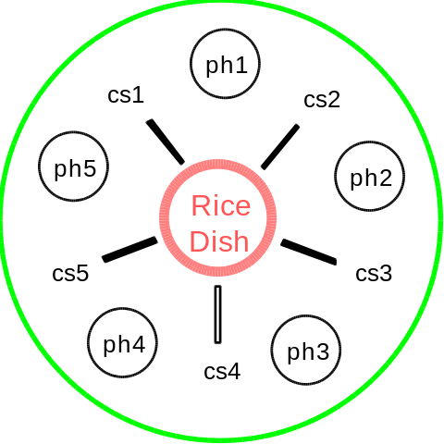
The philosopher system is modelled by the CP-net shown below. The PH colour set represents the philosophers, while the CS colour set represents the chopsticks. The function Chopsticks maps each philosopher into the two chopsticks next to him.

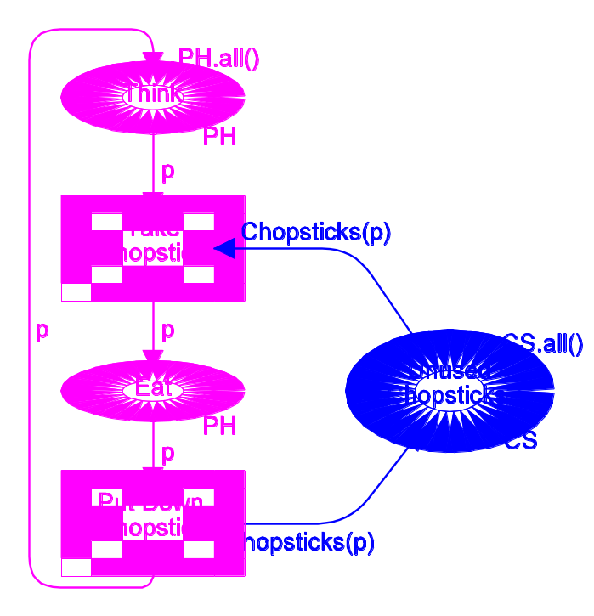
val n = 5;
color PH = index ph with 1..n;
color CS = index cs with 1..n;
var p: PH;
fun Chopsticks(ph(i)) =
1`cs(i)++1`cs(if i=n then 1 else i+1);

An occurrence graph for the dining philosophers is shown below. The current version of CPN Tools does not include facilities for drawing O-graphs. Each node represents a reachable marking, while each arc represents the occurrence of a binding element – leading from the marking of the source node to the marking of the destination node. To improve readability, we have only shown the contents of some of the markings and some of the binding elements. It should be noted that all arcs are double arcs (i.e., represents two individual arcs).

The standard report looks as shown below. To improve the readability of the multi-set bounds we have substituted PH for 1`ph(1) + 1`ph(2) + 1`ph(3) + 1`ph(4) + 1`ph(5) and CS for 1`cs(1) + 1`cs(2) + 1`cs(3) + 1`cs(4) + 1`cs(5).
Statistics
---------------------------------
Occurrence Graph
Nodes: 11
Arcs: 30
Secs: 1
Status: Full

Scc Graph
Nodes: 1
Arcs: 0
Secs: 0

Boundedness Properties
---------------------------------
Best Integer Bounds
Upper Lower
Eat 2 0
Think 5 3
Unused 5 1

Best Upper Multi-set Bounds
Eat PH
Think PH
Unused CS

Best Lower Multi-set Bounds
Eat empty
Think empty
Unused empty

Home Properties
---------------------------------
Home Markings: All

Liveness Properties
---------------------------------
Dead Markings: None
Dead Transitions Instances: None
Live Transitions Instances: All
Fairness Properties
---------------------------------
Put Impartial
Take Impartial
Below we show a large number of standard queries. They are all taken from the Occurrence Graph Manual:
Reachable determines whether there exists an occurrence sequence from the marking of the first node to the marking of the second.
Reachable (5,3)
returns true. This tells us that there exists an occurrence sequence from the marking M5 (of node 5) to the marking M3 (of node 3). The function also has a chatty version:
Reachable' (5,3)
which returns the same result together with the explanation:
"A path from node 5 to node 3 is: [5, 9, 3]"
This tells us that there exists an occurrence sequence containing the markings M5, M9 and M3 (in that order). The path is of minimal length.
SccReachable returns the same result as Reachable, but it uses the Scc-graph, i.e., the strongly connected components. This means that it is faster than Reachable (at least for occurrence graphs which contain cycles). The function also has a chatty version:
SccReachable' (5,3)
which returns the same result together with the explanation:
"A path from the SCC of node 5 to the SCC of node 3 is: [~1]"
This tells us that both M5 and M3 belong to the strongly connected component ~1 (i.e. the strongly connected component of the initial marking).
AllReachable determines whether all the reachable markings are reachable from each other. This is the case iff there is exactly one strongly connected component.
AllReachable ()
returns true.
UpperInteger uses a specified function F of type:
Node -> 'a ms
to calculate an integer |F(n)|. This is done for each node n in the occurrence graph, and the maximum of the calculated integers is returned. The query:
UpperInteger (Mark.System'Eat 1)
calculates the maximal number of tokens on place Eat on the first instance of page System. The result is 2, and this tells us that at most two philosophers can eat at the same time.
LowerInteger is analogous to UpperInteger, but returns the minimal value of the integers |F(n)|.
LowerInteger (Mark.System'Think 1)
calculates the minimal number of tokens on place Think on the first instance of page System. The result is 3, and this tells us that there always are at least three thinking philosophers.
UpperMultiSet is analogous to UpperInteger, but it calculates F(n) instead of ΩF(n)Ω. The result is the smallest multi-set which is larger than or equal to all the calculated multi-sets.
UpperMultiSet (Mark.System'Eat 1)
returns:
[ph 1, ph 2, ph 3, ph 4, ph 5]: PH ms
which is the ML representation of the multi-set:
1`ph(1)+1`ph(2)+1`ph(3)+1`ph(4)+1`ph(5)
This tells us that each of the five philosophers is able to eat. To obtain the second, more readable format of the result, evaluate the following ML code:
mkst_ms'PH (UpperMultiSet (Mark.System'Eat 1))
LowerMultiSet is analogous to UpperInteger, but returns the largest multi-set which is smaller than or equal to all the calculated multi-sets.
LowerMultiSet (Mark.System'Eat 1)
returns the empty multi-set, represented as an empty list. This tells us that each of the five philosophers is able to think (because there is a marking in which the philosopher is not eating).
HomeSpace determines whether the set of markings (specified in the list of nodes) is a home space, i.e., whether, from each reachable marking, it is possible to reach at least one of the markings.
HomeSpace [2,6]
returns true. The function also has a chatty version.
MinimalHomeSpace returns the minimal number of markings which is needed to form a home space. This is identical to the number of terminal strongly connected components.
MinimalHomeSpace ()
returns 1.
HomeMarking determines whether the marking of the specified node is a home marking, i.e., whether it can be reached from all reachable markings. This is the case iff there is exactly one terminal strongly connected component and the specified marking belongs to that component.
HomeMarking (6)
returns true. The function also has a chatty version.
ListHomeMarkings returns a list with all those nodes that are home markings.
ListHomeMarkings ()
returns a list which contains all 11 nodes of the occurrence graph.
ListHomeScc is similar to ListHomeMarkings, but the result is given in a more compact way. The result is either a single Scc (and then the home markings are exactly those markings that belong to the Scc) or the result is zero (and then there are no home markings). For the dining philosophers:
ListHomeScc ()
returns ~1 (i.e. the Scc to which the initial marking belongs). This tells us that all reachable markings are home markings.
HomeMarkingExists determines whether the CP-net has any home markings. This is the case iff there is exactly one terminal strongly connected component.
HomeMarkingExists ()
returns true.
Initial HomeMarking determines whether the initial marking of the occurrence graph is a home marking, i.e., whether it can be reached from all reachable markings. This is the case iff there is exactly one strongly connected component. The result of this function is identical to the result of AllReachable.
InitialHomeMarking ()
returns true.
DeadMarking determines whether the marking of the specified node is dead, i.e., has no enabled binding elements.
DeadMarking (8)
returns false. This tells us that M8 has some enabled binding elements.
ListDeadMarkings returns a list with all those nodes that are dead, i.e., have no enabled binding elements.
ListDeadMarkings ()
returns the empty list.
SccListDeadMarkings returns the same result as ListDeadMarkings, but it uses the Scc-graph, i.e., the strongly connected components. This means that it is faster than ListDeadMarkings (at least for occurrence graphs which contain cycles).
TIsDead determines whether the set of transition instances (specified in the list) is dead in the marking of the specified node, i.e., whether it is impossible to find an occurrence sequence which starts in the marking and contains one of the transition instances.
TIsDead ([TI.System'Take 1],4)
returns false. This tells us that there exists an occurrence sequence which starts in M4 and contains an occurrence of transition Take on the first instance of the page System. The function also has a chatty version:
TIsDead’ ([TI.System'Take 1],4)
which returns the same result together with the explanation:
"A transition instance from the given list is contained in the SCC: ~1 (which is reachable from the SCC of the given node)"
BEsDead is analogous to TIsDead except that the argument is a list of binding elements (instead of transition instances).
BEsDead ([Bind.System'Take (1,{p=ph(3)})],4)
returns false. This tells us that there exists an occurrence sequence which starts in M4 and contains an occurrence of transition Take on the first instance of page System, with the variable p bound to ph(3). The function also has a chatty version.
ListDeadTIs returns a list with all those transition instances that are dead, i.e., do not appear in any occurrence sequence starting from the initial marking of the occurrence graph.
ListDeadTIs ()
returns the empty list.
TIsLive determines whether the set of transition instances (specified in the list) is live, i.e., whether, from each reachable marking, it is possible to find an occurrence sequence which contains one of the transition instances.
TIsLive [TI.System'Take 1]
returns true. This tells us that it is impossible to reach a marking such that transition Take on the first instance of page System never can occur. The function also has a chatty version.
BEsLive is analogous to TIsLive except that the argument is a list of binding elements (instead of transition instances).
BEsLive [Bind.System'Take (1,{p=ph(3)})]
returns true. This tells us that philosopher ph(3) always has a chance to Take his chopsticks. He cannot do that in all the reachable markings – but it is always possible to choose a sequence of steps so that this may happen. The function also has a chatty version.
BEsStrictlyLive determines whether the set of binding elements (specified in the list) is strictly live, i.e., whether each individual element in the list is live.
BEsStrictlyLive [
Bind.System'Take (1,{p=ph(1)}),
Bind.System'Take (1,{p=ph(2)}),
Bind.System'Take (1,{p=ph(3)}),
Bind.System'Take (1,{p=ph(4)}),
Bind.System'Take (1,{p=ph(5)})]
returns true. This tells us that each philosopher always has a chance to Take his chopsticks. He cannot do that in all the reachable markings – but it is always possible to choose a sequence of steps so that this may happen.
ListLiveTIs returns a list with all those transition instances that are live.
ListLiveTIs ()
returns:
[System'Put 1,System'Take 1]
This tells us that it is impossible to reach a marking such that one of the transition instances never can occur.
TIsFairness determines whether the set of transition instances (specified in the list) is impartial, fair or just.
TIsFairness [TI.System'Take 1]
returns Impartial. This tells us that we cannot have an infinite occurrence sequence unless transition Take on the first instance of page System continues to occur.
BEsFairness is analogous to TIsFairness except that the argument is a list of binding elements (instead of transition instances).
BEsFairness[Bind.System'Take (1,{p=ph(3)})]
returns No_Fairness. This tells us that it is possible to have an infinite occurrence sequence (starting from a reachable marking) in which philosopher three never takes his chopsticks.
ListImpartialTIs returns a list with all those transition instances that are impartial.
ListImpartialTIs ()
returns the list:
[System'Put 1,System'Take 1]
This tells us that all infinite occurrence sequences (starting from the initial marking) contains an infinite number of both transition instances.
ListFairTIs and ListJustTIs are analogous to ListImpartialTIs except that they return those transition instances that are fair and just, respectively. Impartiality implies fairness which in turn implies justice. Hence, it is obvious that :
ListFairTIs ()
ListJustTIs ()
both return the list:
[System'Put 1,System'Take 1]
Below we show some model dependent queries. They are all taken from the Occurrence Graph Manual:
All nodes in which a particular philosopher is eating can be found as follows (where cf returns the coefficient of the specified colour in the specified multi-set):
fun Eating (p:PH) : Node list
= PredAllNodes (fn n => cf(p,Mark.System'Eat 1 n) > 0)
The maximal number of simultaneously enabled transition instances can be found as follows (where remdupl removes duplicates from a list, while map uses the specified function on all the elements of the specified list):
fun MaxTIEnabled () : int
= SearchAllNodes(
fn _ => true,
fn n =>
List.length(remdupl(List.map
ArcToTI(OutArcs n))),
0,
Int.max)
Checking whether there are reachable markings in which two neighbouring philosophers simultaneously eat, can be done as follows (where next is a function mapping each philosopher in its successor, ext_col extends a function 'a -> 'b to a function 'a ms -> 'b ms, while <<= is the less-than-equal operation on multi-sets):

fun next (ph i: PH) : PH
= if i<n then ph(i+1) else ph 1;
fun EatingNeighbours () : Node list
= PredAllNodes(fn n =>
let
val Eating = Mark.System'Eat 1 n
in
not(Eating + ext_col next Eating <<== PH)
end)
Checking whether there are nodes that violate the linear invariant:
M(Unused) + Chopsticks(M(Eat)) = CS
can be done in the following way (where <><> is the operator which checks whether two multi-sets are different from each other):
fun InvariantViolations () : Node list
= PredAllNodes(fn n =>
Mark.System'Unused 1 n +
ext_ms Chopsticks (Mark.System'Eat 1 n) <><> CS)
The following function returns all the arcs where transition Take occurs on the first instance of page System with the variable p bound to a specified philosopher:
fun TakeChopsticks (p:PH) : Arc list
= PredAllArcs(fn a =>
case ArcToBE a
of Bind.System'Take (1,{p=p’}) => p=p'
| _ => false)
For the dining philosophers system the O-graph grows relatively slow – when we increase the number of philosophers:
|PH| | Nodes | Arcs
2 | 3 | 4
3 | 4 | 6
4 | 7 | 16
5 | 11 | 30
6 | 18 | 60
7 | 29 | 112
8 | 47 | 208
9 | 76 | 378
10 | 123 | 680
15 | 1,364 | 11,310

Simple Protocol
Abstract
This is a small toy example which is well-suited as an introduction to occurrence graphs. The analysis of the occurrence graph is described in great detail.

The CPN model describes a simple protocol by which a sender can transfer a number of packets to a receiver. The model is identical to the “Simple Protocol” presented in “Introductory Examples”(which we recommend to study before this example).

Developed and Maintained by:
Kurt Jensen, Aarhus University, Denmark (kjensen@daimi.au.dk).
CPN Model

In this example we study the O-graph for the simple protocol. To obtain a finite and reasonably small O-graph we make three modifications of the CP-net. First we reduce the number of packets from eight to four. Secondly, we introduce a new place to Limit the number of packets/acknowledgments which simultaneously can be at the network. Finally, we simplify the decision mechanism for transferring/loosing packets and acknowledgments. For O-graphs it does not make sense that packets are lost/transmitted with a certain probability. Hence, we replace the Ok function with a boolean variable Ok.
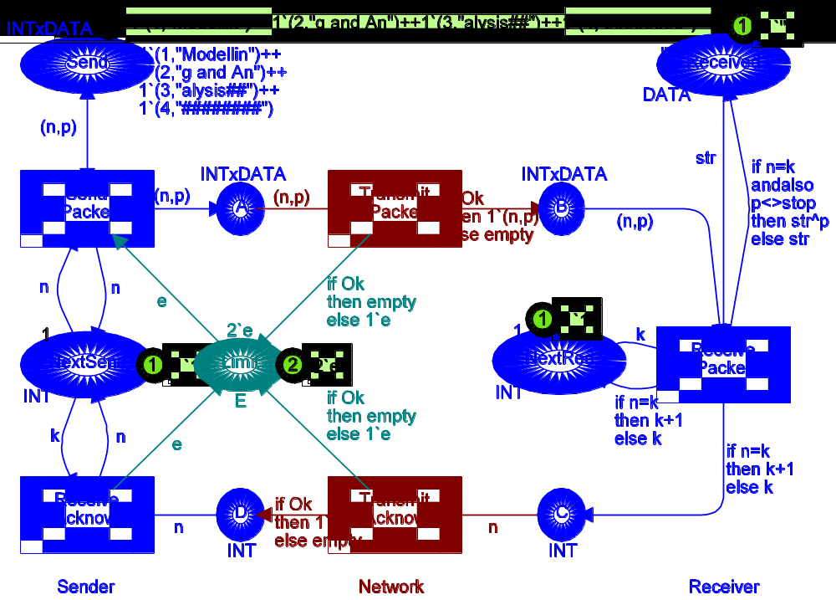

color INT = int;
color DATA = string;
color INTxDATA= product INT*DATA;
color E = with e;
var n,k: INT;
var p, str: DATA;
val stop = ”########”;

color BOOL = bool;
var Ok: BOOL;

Initial Part of O-graph

Having made the modifications described above, we are ready to construct O-graphs. Let us start with the situation where the initial marking of Limit is 1`e. This means that the network (i.e., the place A, B, C and D) contains at most one packet/acknowledgment at a time. Hence overtaking is impossible. The O–graph has 33 nodes and 44 arcs. The initial and final part of it is drawn below. The current version of CPN Tools does not include facilities for drawing O-graphs. From the O-graph we can see that the O-graph has a regular structure, in the sense that some patterns are repeated. The subgraph of nodes {4, 5, 7 and 9} has the same ”form” as the subgraph of nodes {28. 29. 31. 33}. The only difference is that the latter is “three packets ahead” of the former. If we construct the middle part of the occurrence graph, we will find two additional copies of the pattern.
Final Part of O-graph

Next let us investigate the more complex situation in which overtaking is possible. To do this, we construct an O-graph for the situation where the initial marking of Limit is 2`e. The new O-graph is considerably larger than the first one. The standard report looks as shown below.
From the statistics it can be seen that the O-graph has 428 nodes and 1130 arcs. It can also be seen that there are fewer strongly connected components than O-graph nodes. This means that the system has at least one non-trivial strongly connected component, and hence an infinite occurrence sequences exists. In other words, we cannot be sure that the simple protocol terminates – to achieve termination one usually limits the number of retransmissions.
Statistics
--------------------------------
Occurrence Graph
Nodes: 428
Arcs: 1130
Secs: 8
Status: Full

Scc Graph
Nodes: 182
Arcs: 673
Secs: 1
The integer bounds are as expected.
Boundedness Properties
--------------------------------
Best Integers Bounds
Upper Lower
A 2 0
B 2 0
C 2 0
D 2 0
Limit 2 0
NextRec 1 1
NextSend 1 1
Received 1 1
Send 4 4
Also the multi-set bounds are as expected. The places A and B may contain all four different packets, while places C and D may contain all four possible acknowledgments. Remember that an acknowledgment always specifies the number of the next packet to be sent (hence we never has an acknowledgment with value 1). The two counters Next Send and Next Rec can take all values between one and five. The place Received may contain four different values – corresponding to the situations where we have received the data from zero, one, two or three packets (packet number four contains "########" which we never copy to Received). Finally, the place Send has identical upper and lower multi-set bounds. This means that the marking never changes.
Best Upper Multi-set Bounds
A 2`(1,"Modellin")+
2`(2,"g and An")+
2`(3,"alysis##")+
2`(4,"########")
B 2`(1,"Modellin")+
2`(2,"g and An")+
2`(3,"alysis##")+
2`(4,"########")
C 2`2+ 2`3+ 2`4+ 2`5
D 2`2+ 2`3+ 2`4+ 2`5
Limit 2`e
NextRec 1`1+ 1`2+ 1`3+ 1`4+ 1`5
NextSend 1`1+ 1`2+ 1`3+ 1`4+ 1`5
Received 1`""+ 1`"Modellin"+
1`"Modelling and An"+
1`"Modelling and Analysis##"
Send 1`(1,"Modellin")+
1`(2,"g and An")+
1`(3,"alysis##")+
1`(4,"########")+
Best Lower Multi-set Bounds
A empty
B empty
C empty
D empty
Limit empty
NextRec empty
NextSend empty
Received empty
Send 1`(1,"Modellin")+
1`(2,"g and An")+
1`(3,"alysis##")+
1`(4,"########")+
The home and liveness properties are very interesting. They tell us that the system has exactly one dead marking M235 which also is a home marking:
Home Properties
----------------------------------
Home Markings: [235]

Liveness Properties
----------------------------------
Dead Markings: [235]
Dead Transitions Instances: None
Live Transitions Instances: None
Marking M235 looks as shown below. It corresponds to the situation where all four packets has been successfully transmitted. The fact that M235 is dead tells us that the protocol is partly correct – if it terminates it terminates with the correct result. The fact that M235 is a home marking tells us that the protocol has the nice property that it never can reach a state from which it is impossible to terminate with the correct result.
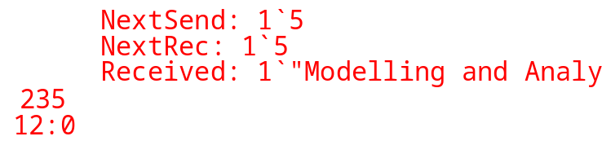
The fairness properties are as shown below.

Fairness Properties
----------------------------------
SendPack Impartial
TranPack Impartial
RecPack No Fairness
TranAck No Fairness
RecAck No Fairness
Above, we have seen that M235 is the desired final marking, and we have also seen that it can be reached from any reachable system state. Now let us investigate how fast it can be reached. To do this we ask the system to construct a path from the initial marking M1 to M235. By convention the system constructs a path with minimal length, and hence we see that at least 20 transitions must occur – in order to reach M235 from M1. This is not surprising. We have four packets and to process a packet (plus the corresponding acknowledgment) we need one occurrence of each of the five transitions.
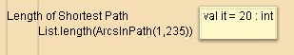
Next let us investigate the way in which we update the Next Send counter. One might expect that this counter always is increased (or left unchanged). However, the following query tells us that there are a number of occurrence graph arcs where Next Send actually is decreased. The result of the query is a list containing all those arcs where Next Send has a smaller value in the destination node than it has in the source node. The function ms_to_col maps a multi-set with one element into the element itself (e.g., 1`3 into 3).
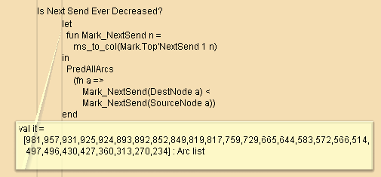

To investigate why Next Send is decreased, we examine the first arc in the result of the above query, i.e., arc number 981 (from node 368 to node 385). Recall that CPN Tools does not have facilities for drawing O-graphs, but standard queries can be used to examine all information associated with nodes and arcs in an O-graph. We also use standard queries to examine some of the nearest predecessors of node 368. After a few “backwards” steps we find marking M249, which is of interest. In this marking Next Send has the value 4 while Next Rec has the value 5. Moreover, there is an acknowledgment with value 5 positioned at place C. However, there is also an “old” acknowledgment with value 3 positioned at C. This acknowledgment must have been there quite a while. It was created when packet number 2 was successfully received, i.e., before receiving packets number 3 and 4. The old acknowledgment has been overtaken by several “younger” acknowledgments. However, it may still proceed and cause Next Send to be decreased to 3.
Another way to investigate the possible decrease of Next Send, is to ask how much Next Send can differ from the Next Rec. This is done by means of the following query, which tells us that the difference can be 3, 2, 1 and 0. This result is consistent with our analysis above. Next Rec can be at most 5, while Next Send is at least 1, but Next Send can never be reset to a value less than 2 – because we never have acknowledgments with value 1.
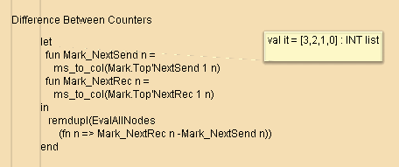
From our analysis above, it is quite obvious that an easy way to improve the simple protocol is to avoid decreasing Next Send. This can be done by modifying the arc expression of the arc from Rec Ack to Next Send – so that it becomes Int.max(n,k) instead of n. We encourage you to make this modification, construct a new O-graph and repeat the occurrence graph analysis – to convince yourself that the new protocol works as desired. You may also want to construct O-graphs where you allow the network to contain more than two packets/acknowledgments at a time. The size of the O-graphs are as follows:
Limit | Max | Nodes | Arcs
1 | no | 33 | 44
2 | no | 428 | 1130
3 | no | 3329 | 12825
4 | no | 19520 | 91220
1 | yes | 33 | 44
2 | yes | 293 | 764
3 | yes | 1829 | 6860
4 | yes | 9025 | 43124

