Simple Protocol
Abstract
This is a small toy example describing a simple protocol by which a sender can transfer a number of packets to a receiver. The communication medium may loose packets and packets may overtake each other. Hence, it may be necessary to retransmit packets and to ignore doublets and packets that are out of order.

The example illustrates how the results of a lengthy simulation can be recorded for later inspection and analysis. One way is to add “reporting places” and another is to use an output file.

The example is a modified version of a timed CP-net presented in Sect. 5.5 of Vol. 2 of the CPN book.

Developed and Maintained by:
Kurt Jensen, Aarhus University, Denmark (kjensen@daimi.au.dk).
CPN Model

This example describes a simple protocol where a sequence of packets is sent from one site to another via a network where packets may be delayed or lost. We do not claim that the described protocol is optimal (it is not). However, the protocol is interesting enough to deserve a closer investigation, and it is also complex enough for such an investigation to be valuable.
The CPN model of the protocol system is shown below. It consists of three parts. The Sender part has two transitions which can Send Packets and Receive Acknowledgments. The Network part has two transitions which can Transmit Packets and Transmit Acknowledgments. Finally, the Receiver part has a single transition which can Receive Packets (and send acknowledgments). The interface between the Sender and the Network consists of the places A and D, while the interface between the Network and the Receiver consists of the places B and C.
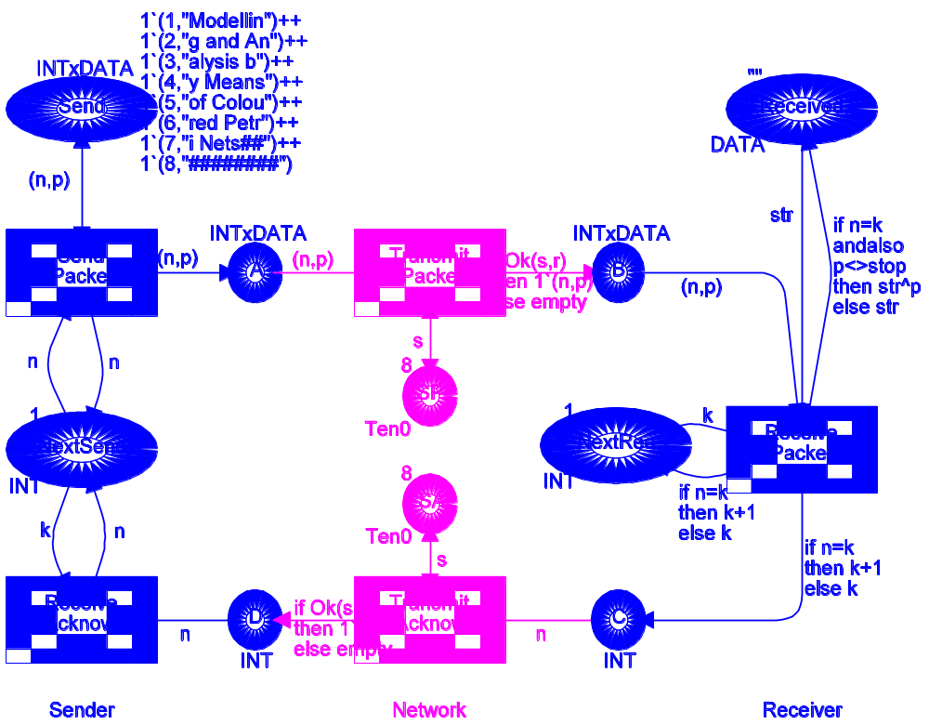
color INT = int;
color DATA = string;
color INTxDATA= product INT*DATA;
var n,k: INT;
var p, str: DATA;
val stop = ”########”;
color Ten0 = int with 0..10;
color Ten1 = int with 1..10;
var s: Ten0; var r: Ten1;
fun Ok(s:Ten0, r:Ten1) = (r<=s);

The packets to be sent are positioned at the place Send (in the upper left corner). Each token on this place contains a packet number and the data contents of the packet (represented as a text string). The place Next Send contains the number of the next packet to be sent. Initially this number is 1, and it is updated each time an acknowledgment is received.
The content of the received message is kept at the place Received (in the upper right corner). This place contains a single token with a text string which is the concatenation of the text strings contained in the received packets (ignoring the contents of duplicates and packets received out of order). Initially the text string at Received is empty, i.e., "". At the end of the transmission we expect Received to contain the text string "Modelling and Analysis by Means of Coloured Petri Nets". The place Next Rec contains the number of the next packet to be received. Initially this number is 1, and it is updated each time a packet is successfully received.
We do not model how the Sender splits a message into a sequence of packets or how the Receiver reassembles the packets into a message. Neither do we model how the tokens at Send and Received are removed at the end of the transmission or how the packet numbers in Next Send and Next Rec are reset to 1. Now let us take a closer look at the five different transitions in the protocol system.
Send Packet sends a packet to the Network by creating a copy of the packet on place A. The number in Next Send specifies which packet to send. It should be noted that the packet is not removed from Send. Neither is the counter at Next Send increased. The reason is that the packet may be lost and hence need to be retransmitted. Our protocol is pessimistic, in the sense that it continues to repeat the same packet – until it gets an acknowledgment telling that the packet has been successfully received. Transmit Packet transmits a packet from the Sender site of the Network to the Receiver site by moving the corresponding token from A to B. The boolean expression Ok(s,r) determines whether the packet is successfully transmitted or lost. The variable r will be bound to an arbitrary value in its colour set (i.e., to any integer between 1 and 10). CPN Tools makes a fair choice between the 10 values. The Ok function returns true if the value of r is less than or equal to the value of s. This means that the probability of successful transmission is determined by the token at place SP. We have given SP a token with value 8. Hence we have 80 % chance for successful transmission. However, it is easy to modify the success rate, simply by changing the token value at SP.
Receive Packet receives a packet and checks whether the packet number n is identical to the number k in Next Rec. When the two numbers match, the number in Next Rec is increased by 1 and the text string in the packet is concatenated to the text string in Received – unless it is stop = "########", which by convention indicates end-of-message. Otherwise, the packet is ignored and the number in Next Rec is left unchanged. In both cases an acknowledgment is sent containing the number of the next packet which the Sender should send.
Intermediate Marking
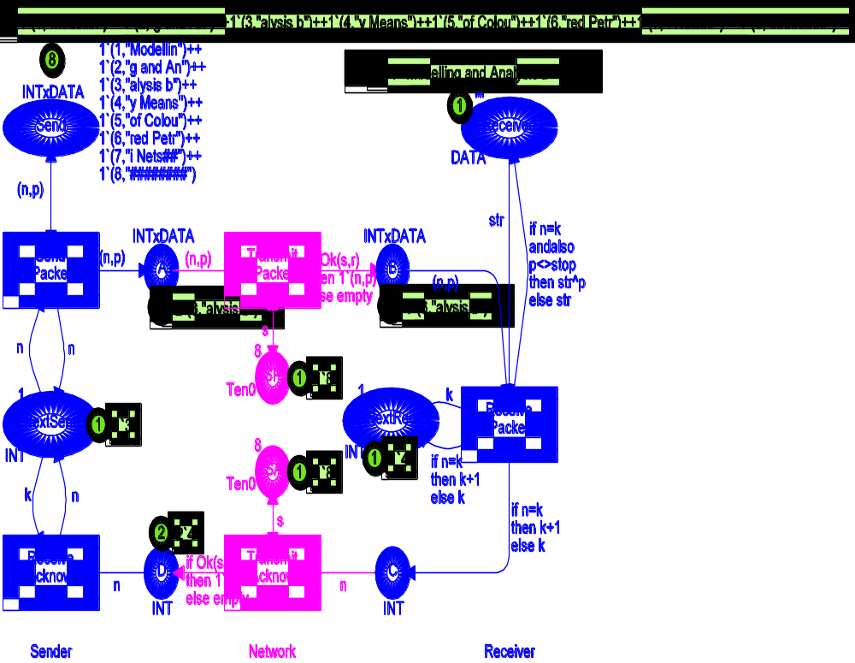
Transmit Acknowledgment transmits an acknowledgment from the Receiver site of the Network to the Sender site by moving the corresponding token from C to D. The transition works in a similar way as Transmit Packet. This means that the acknowledgment may be lost, with a probability determined by the token at place SA.
Receive Acknowledgment receives an acknowledgment and updates the number in Next Send by replacing the old value with the one contained in the acknowledgment.
After a number of steps the CP-net may have reached the intermediate marking shown below. From the left-hand part of the net, we see that the sender is sending packet number three. We also see that three copies of this packet are present at places A and B. From the right-hand part of the net we see that the string "Modelling and Analysis b" has been Received. This is the contents of the first three packets and the receiver is now waiting for packet number four. Hence the packets on A and B will be ignored when they reach the receiver. We can also see that two acknowledgments are present at place D. When Receive Acknowledgment occurs, Next Send will be updated to four, and then the sender will start sending packet number four.
When the last packet (with "########") is successfully received by the receiver, Next Rec gets the value nine (one larger than the number of packets). This value will (via an acknowledgment) be communicated to the sender, Next Send will be updated to nine, and the sending will stop – because no packet with this number exists. After a few more steps, where the places A, B, C and D are cleared for packets/acknowledgments, the CP-net will reach a dead final marking, which looks as shown below.
Even though this protocol is rather simple, it is not that easy to see that it actually works correctly. What happens, for instance, if the “last” acknowledgment gets lost? By making a number of simulations – interactive and automatic – the user can greatly increase his confidence in the protocol. He may also make a proof of correctness by using the occurrence graph tool. For more information about this, see the example: “Simple Protocol for Occurrence Graph”.
Final Marking
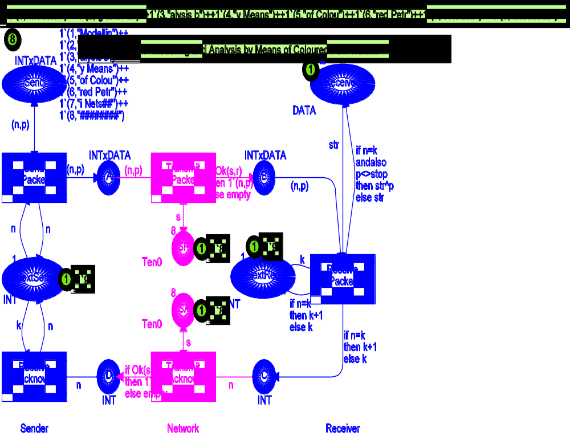
It is often convenient to be able to record the things that happen during a simulation. This is in particular the case when we perform a fast-forward simulation where we have no chance to observe the individual steps. This can be done by adding a number of “reporting places”, i.e., places that gather historical information about the simulation run – without influencing the simulation. The use of reporting places is illustrated below. To see the reporting places in CPN Tools, you have to use the CPN model called “SimpleProtocol_RP”. First we add a few extra declarations:
color BOOL = bool;
color INTxINT = product INT*INT;
color PackSeq = list INTxDATA;
var i: INT;
var plist: PackSeq;

Then we add one or two extra places for each of the five transitions. The place Sent Pack tells us how many times the individual packets have been sent. In our example, packet number one has been sent four times, packet number two six times and packet number three twice). The place Rec Ack tells us which acknowledgments the sender has received. Each acknowledgment is recorded as a pair, where the first element is a sequence number while the second is the contents of the acknowledgment. The sequence number is obtained from the place Count. In our example, we have first received four acknowledgments with value two and then three acknowledgments with value three.
Reporting Facilities for the Sender
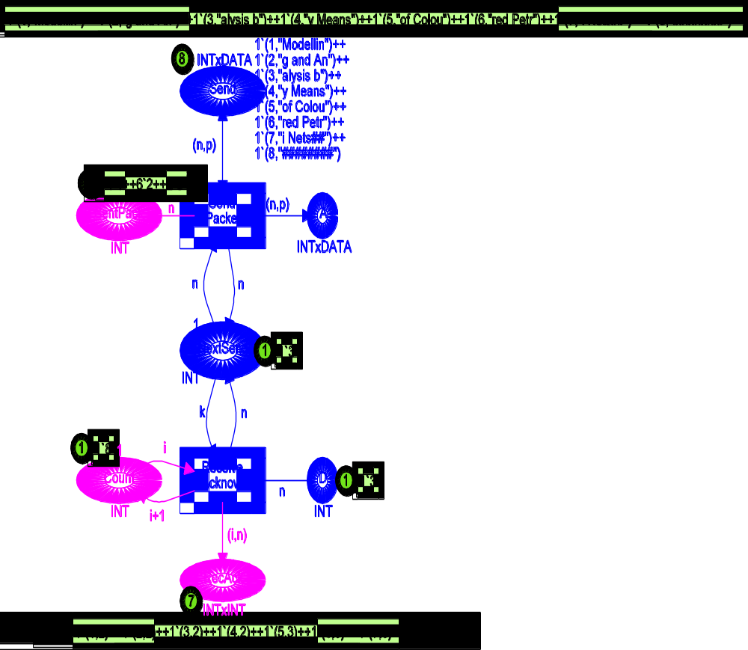
The place Lost Pack tells us about the lost packets. In our example, we have only lost one copy of packet number two. The place Lost Ack tells us how many acknowledgments we have transmitted/lost. In our example, we have lost one acknowledgment and successfully transmitted eight.
Reporting Facilities for the Network
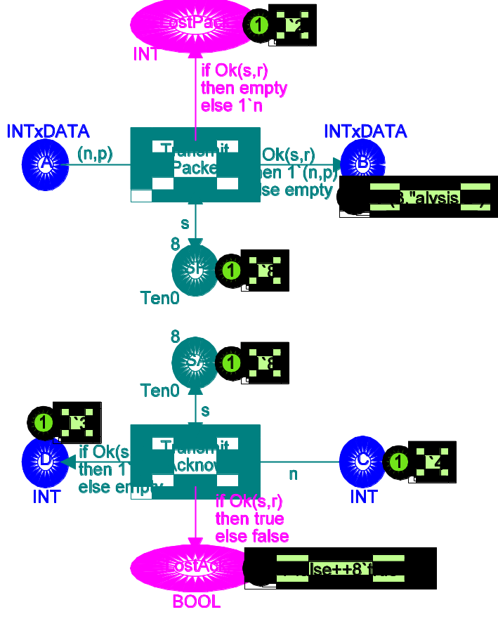

The place Rec Pack tells us about the successfully received packets (the ^^ operator at the arc from Receive Packet to Rec Pack concatenates the two lists). In our example, we have received three packets. First we received packet number one with data "Modellin", then we received packet number two with data "g and An", and finally packet number three with data "alysis b".
Reporting Facilities for the Receiver
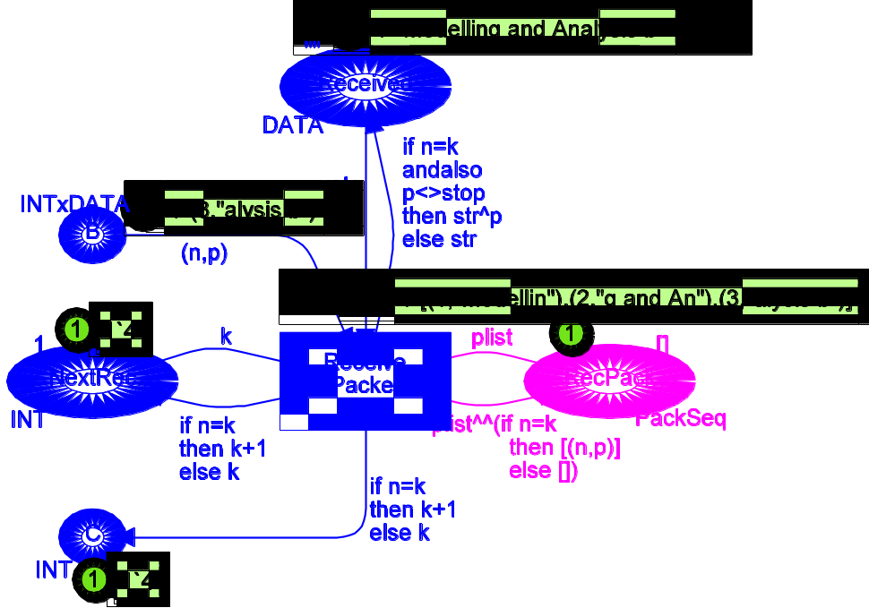
A second way to record the results of a simulation is to use code segments to write selected results on an output file. The file can then later be read – by a human being or by another computer program (e.g., a spreadsheet program). To see the use of an output file (and an input file) in CPN Tools itself, you have to use the CPN model called “SimpleProtocol_IO”. We first add a few extra declarations:
color INTxDATA = product INT * DATA;
declare output_col, input_ms;
color E = with e;
msvar packets: INTxDATA;
globref outfile = TextIO.stdOut;

The predefined function INTxDATA.output writes the value of a specified expression to a specified file. The expression must be of type INTxDATA (if the expression is a multi-set over INTxDATA, you have to use the function INTxDATA.output_ms). Analogously, the predefined function INTxDATA.input_ms reads a multi-set over INTxDATA from a specified file (if you want to read a single value of type INTxDATA, you have to use the function INTxDATA.input).
It should be noted that the variable called packets is a multi-set variable. This means that it will be bound to multi-sets over INTxDATA (instead of a single value of INTxDATA). The global reference variable outfile will be used to provide a handle to our output file. The reference variable is initialised to TextIO.stdOut (standard output), but this will later be overwritten. Next, we add a code segment to transition Receive Packet:
input (n,p,k);
action
if n=k then
(if n=1 then
outfile := TextIO.openOut(“SimpleProtocol.SimRes”)
else ();
INTxDATA.output(!outfile, (n,p));
if p=stop then TextIO.closeOut(!outfile) else ())
else ();

The first line specifies that the action part of the code segment is allowed to refer to the values of the variables n, p and k of the transition. The action part tests whether the received packet is a success (n = k) or a failure (n ≠ k). For failures nothing is done, while successes imply the following operations on the output file:
• When the first packet is received (n = 1), the output file, called SimpleProtocol.SimRes is opened. It will be created in the folder/directory of the Standard ML compiler.
• For each successfully received packet, we use the function INTxDATA.output to write the value of (n,p) to the output file (a carriage return is automatically appended).
• When the last packet is received (p = stop), the output file is closed.
After a simulation (with the usual eight packets) the output file will have the following contents:
(1, “Modellin”)
(2, “g and An”)
(3, “alysis b”)
(4, “y Means “)
(5, “of Colou”)
(6, “red Petr”)
(7, “i Nets##”)
(8, “########”)
Next let us show how an input file can be used to initialise a simulation. To do this we add an extra transition, called Initialise Packets. When a simulation starts, this transition reads a multi-set from a specified file and adds the tokens specified by the multi-set to place Send (which initially is empty).
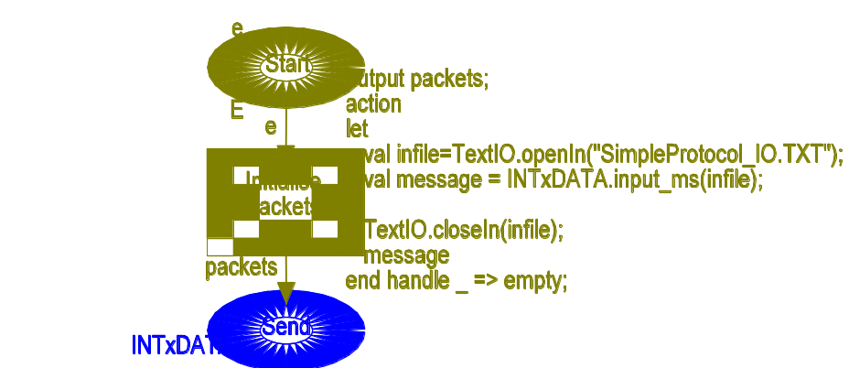

Again we use a fixed file name (as we did for the output file). First, a multi-set over INTxDATA is read and bound to the local variable message. Then the input file is closed and the value of the action part (which is the value of the last expression, message) is bound to the pattern in the output clause specified in the first line of the code segment, i.e., to the variable packets which then is used on the output arc. If the input file is not present, an exception is raised. This exception is handled in the last line of the code segment (we then bind packets to the empty multi-set).

The file “SimpleProtocol_IO.TXT” (provided together with this example) specifies a multi-set with the “usual” eight packets. It looks as follows:
%This file is used by to initialise
%the packets on Send

1`(1,"Modellin")++ % first packet
1`(2,"g and An")++ % second packet
1`(3,"alysis b")++ % third packet
1`(4,"y Means ")++ % fourth packet
1`(5,"of Colou")++ % fifth packet
1`(6,"red Petr")++ % sixth packet
1`(7,"i Nets##")++ % seventh packet
1`(8,"########") % eighth packet
It is easy to modify the CPN model for the “Simple Protocol”, e.g., to obtain a blast protocol – in which all the packets are sent immediately after each other – without waiting for acknowledgments for the individual packets. The reader is encouraged to make one or more such modifications and to use the CPN Tools simulator to validate the new protocols. It is surprisingly “easy” to get a protocol which is “nearly correct” but not totally correct. One of the problems is to be sure that we always stop. Remember that both the last packet and the last acknowledgment may be lost. If you want to investigate the new protocols by means of the existing charts, you probably have to modify the code segments (since you, e.g., may have changed the rules for sending acknowledgments).
In the present CP-net we have described that retransmissions may occur. However, we have not provided any details telling when and how often this will happen – the transition Send Packet is always enabled. As shown in “Timed Protocol” it is possible to augment the CP-net by specifying how long time the individual operations take and how long time the sender should wait before making a retransmission. With such a description it becomes possible to experiment with different waiting times to determine which one is the best – in the sense that it transmits the message fast without using the network too much (i.e. without making too many retransmissions).

Timed Protocol
Abstract
This example shows how the CP-net from “Simple Protocol” can be turned into a timed CP-net. The timed CP-net specifies how long time the individual operations take and how long time the sender should wait before it makes a retransmission. The timed CP-net can be used to experiment with different waiting times to determine which one is the best – in the sense that it transmits the message fast without using the network too much (i.e. without making too many retransmissions).

The example is taken from Sect. 5.5 of Vol. 2 of the CPN book.

Developed and Maintained by:
Kurt Jensen, Aarhus University, Denmark (kjensen@daimi.au.dk).
CPN Model

This example explains how the CP-net from “Simple Protocol” can be turned into the timed CP-net shown below. The timed net has the same net structure as the untimed net – except that a new place Wait has been added (in the left-hand side). This place is used to specify how long time the transition Send Packet should wait before retransmitting a packet..
From the declarations it can be seen that the colour set INT is timed while DATA, Ten0 and Ten1 are not. By the convention, the structured colour set INTxDATA is timed – because it contains the timed component INT.
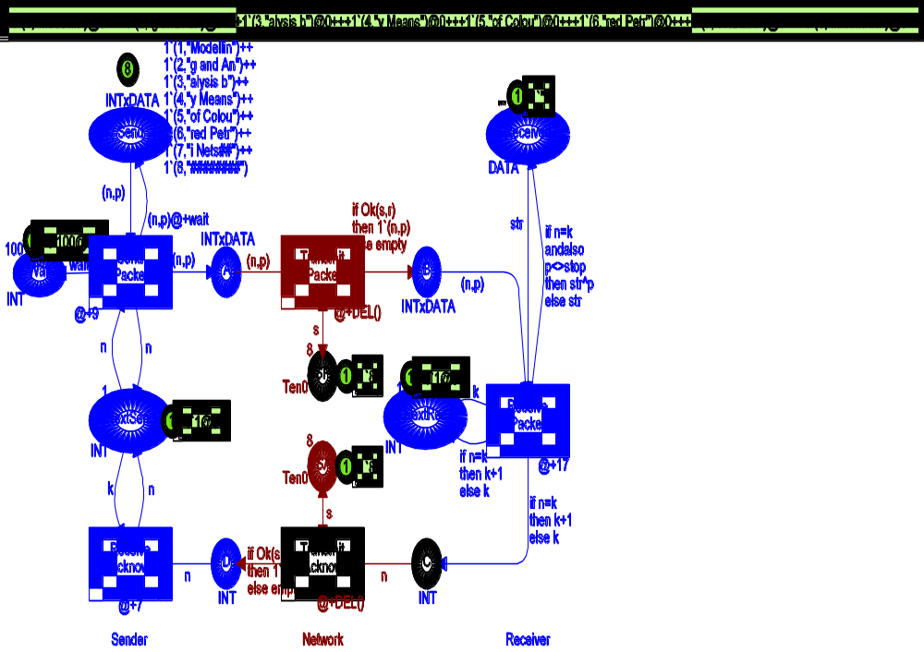

color INT = int timed;
color DATA = string;
color INTxDATA= product INT*DATA;
var n,k, wait: INT;
var p, str: DATA;
val stop = ”########”;

color Ten0 = int with 0..10;
color Ten1 = int with 1..10;
var s: Ten0; var r: Ten1;
fun Ok(s:Ten0, r:Ten1) = (r<=s);

color NetDelay = int with 25..27;
fun DEL() = NetDelay.ran();

We have added a time region (starting with @+) to each of the five transitions. Intuitively, the time region describes how long time the corresponding operation takes. Now let us take a closer look at the five different transitions in the protocol system.
Send Packet has a time region: @+ 9. This implies that a common delay of 9 time units is added to the time stamps of all output tokens. The tokens created at A and Next Send get a time stamp that is the current time r* (at which the transition occurs) plus 9. The output arc to place Send specifies an additional time delay to be used for the tokens added to Send. This token will get a time stamp which is r* + 9 + 100 (since the variable wait is bound to 100). Intuitively, the delay 9 represents the time used to send a packet, while the delay 100 represents the time that has to elapse before a retransmission, i.e., before Send Packet occurs once more for the same packet. A retransmission will only happen if the number in Next Send remains unaltered for 9 + 100 time units, i.e., if no acknowledgement for the packet is received inside this time period.
Transmit Packet has a time region: @+ DEL(), where DEL is declared to be an ML function returning a random element from the colour set NetDelay (i.e., a random integer in the interval between 25 and 75). This implies that the duration of a transmit operation may vary inside this interval.
Receive Packet and Receive Acknowledgement have time regions specifying a fixed duration (17 and 7, respectively), while Transmit Acknowledgement has a variable duration time, between 25 and 75. All time delays are specified by means of an ML expression. Hence, it is easy to use statistical functions specifying more complex types of delays (e.g., exponential distributions).
Note that the token in Next Send has a time stamp. Intuitively, this means that the sender can not start a new Send Packet or a new Receive Acknowledgement as long as one of these operations is already ongoing. If the Sender has multiple processes (threads), allowing an unlimited number of Sender operations to be performed at the same time, we simply make the colour set of Next Send untimed. A similar remark applies for the operations of the Receiver and the colour set of Next Rec.
After a number of simulation steps the timed CP-net may reach a dead final marking with the contents shown below. From the time stamp of Next Rec it can be seen that the last packet was received at time 1194. Analogously, the time stamp at Next Send tells us that the last acknowledgment was received at time 1269. The time stamps at place Send tell us the times at which the individual packets would have been retransmitted (had this become necessary). As an example, we can see that the first packet would have been retransmitted at time 218, the second at time 234, the third at 324, and so on.
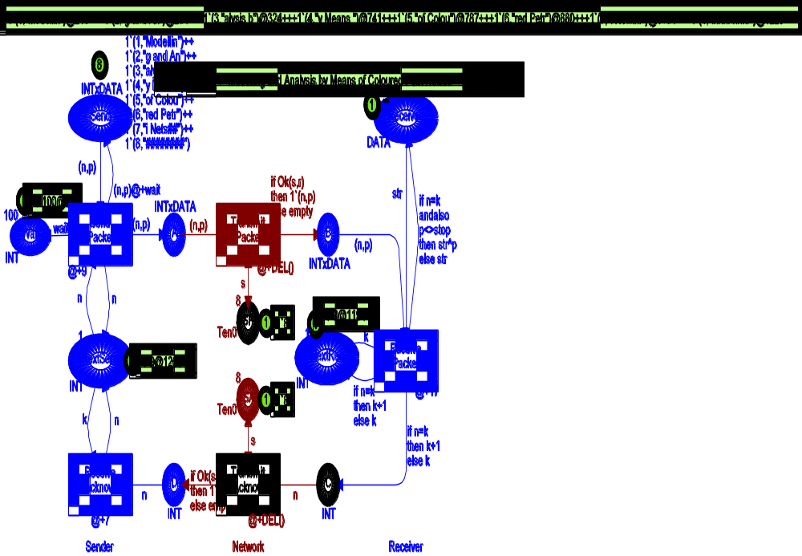
By means of our timed CPN model we can investigate the performance of the protocol, e.g., experiment with different values for the retransmission delay specified by Wait. A short delay increases the chance of making unnecessary retransmissions. It also increases the chance that a Receive Acknowledgement operation is postponed, because the Sender process is engaged in a retransmission. A long delay means it may take too long before the Sender recognises that a packet or an acknowledgement has been lost. By making a number of simulations, with different values at Wait, we can determine the optimal value for the retransmission delay.

Hierarchical Protocol
Abstract
This example shows how the CP-net from “Simple Protocol” can be turned into a hierarchical CP-net – with separate pages (subnets) for the Sender, the Network and the Receiver part. The protocol is modified to accommodate multiple Receivers.

Developed and Maintained by:
Kurt Jensen, Aarhus University, Denmark (kjensen@daimi.au.dk).
CPN Model

The most abstract page looks as shown below. It tells us that we have a Sender, a Network and two Receivers. The basic idea is that the Sender sends messages which the Network broadcasts to the two Receivers. Analogously, the Receivers send acknowledgments which the Network transmits to the Sender.
Overview
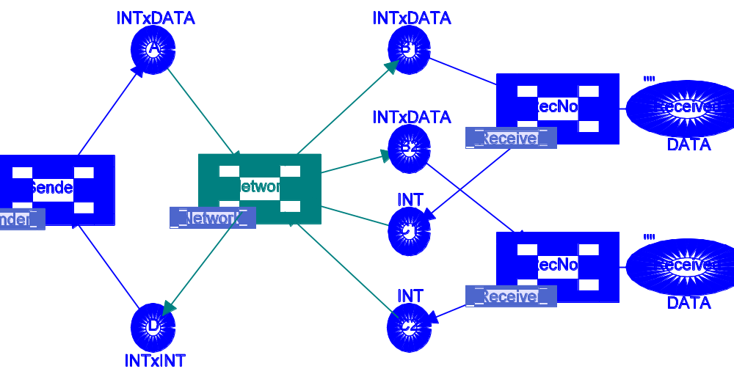
color INT = int;
color DATA = string;
color INTxDATA= product INT*DATA;
color INTxINT = product INT * INT;
var n,k, n1, n2: INT;
var p, str: DATA;
val stop = ”########”;

color Ten0 = int with 0..10;
color Ten1 = int with 1..10;
var s: Ten0; var r, r1,r2: Ten1;
fun Ok(s:Ten0, r:Ten1) = (r<=s);
The Sender part is similar to the sender part of the “Simple Protocol”. The only difference is that Receive Acknowledgment now needs an acknowledgment from each of the two Receivers in order to become enabled. Each acknowledgment is a pair where the first element is the contents, while the second element indicates whether it came from Receiver one or two. Since packets are sent by means of broadcasts, the Sender needs to wait for the slowest of the two Receivers (or the most unlucky one). Hence Next Send is updated to be the minimum of the two acknowledgment values.
Sender
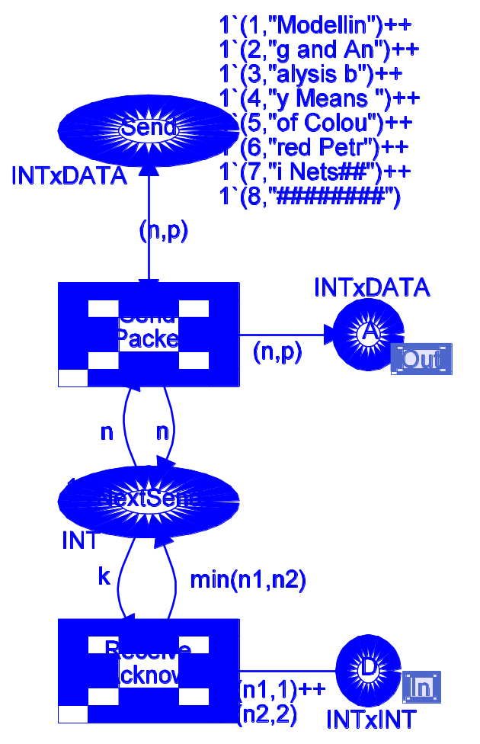
The Network part is similar to the network part of the “Simple Protocol”. However, again there are a few differences. Transmit Packet produces packets at two different output places B1 and B2. The packets at B1 are for the first Receiver, while the packets at B2 are for the second. It should be noted that we use two different variables r1 and r2 to determine whether the packets for B1 and B2 are lost or not. This means that we model a broadcast in which one of the Receivers may get a packet while the other does not. If we replace r1 and r2 with a single common variable r, we get a broadcast where the two Receivers get exactly the same packets. Transmit Acknowledgment is split in two. The upper one handles acknowledgments from the first Receiver, while the lower one handles those from the second. Both of them modify the acknowledgment, by adding information telling the Sender where the acknowledgment came from.
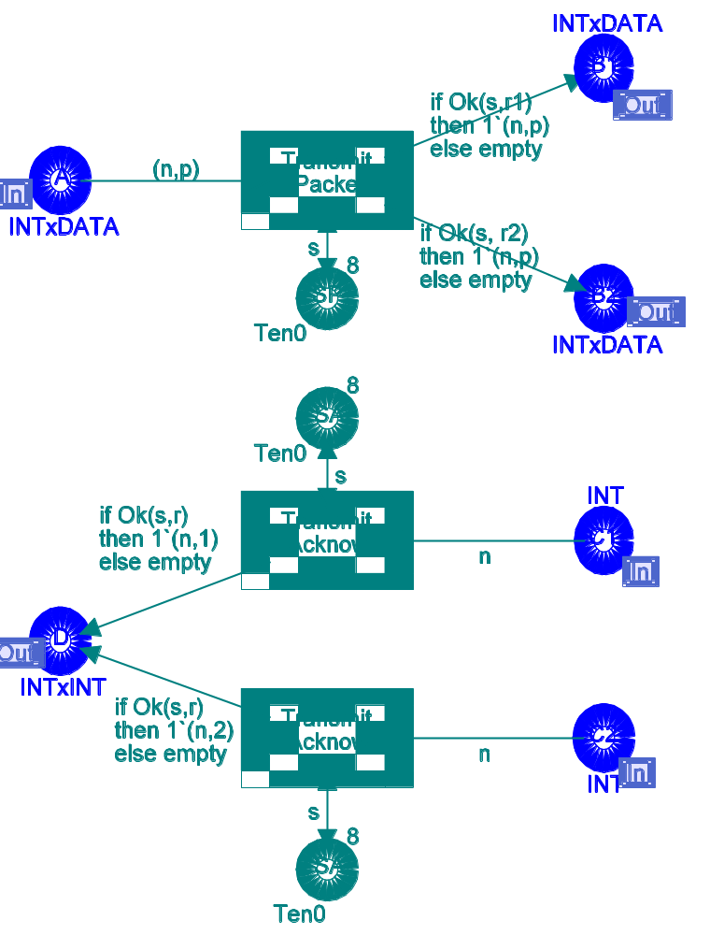
Network

The Receiver part is totally identical to the receiver part of the simple protocol. However, it should be noted that the Receiver page is used by two substitution transitions, RecNo1 and RecNo2. This means that we will have two instances of the subnet – during a simulation. The two instances may have different markings and different enabling, otherwise they will be identical. CPN Tools displays one instance in a sheet. To see another instance, the user may drag the other instance into a binder.
Receiver
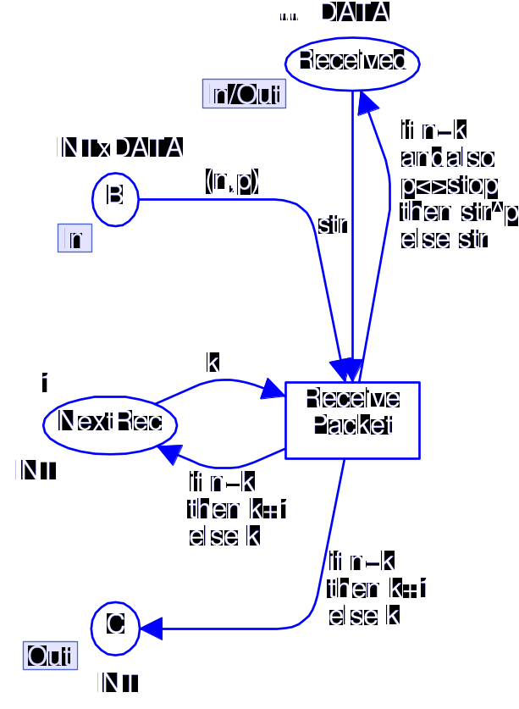

Protocol with Timer
Abstract
This example shows how the CP-net from “Simple Protocol” can be modified so that the retransmission of messages is controlled by a simple timer – modelled by means of two places and two transitions. The CP-net is not using time stamps and hence it should not be confused with the “Timed Protocol”.

Developed and Maintained by:
Kurt Jensen, Aarhus University, Denmark (kjensen@daimi.au.dk).
CPN Model

The protocol part of the CP-net is shown below. It is very similar to the CP-net for the “Simple Protocol”. However, there are two differences. The protocol is optimistic, in the sense that it assumes that each packet will be successfully received and hence immediately continues to send the succeeding packet. This can be seen from the arc expression at the arc from Send Packet to Next Send. Moreover, the receiver now only sends an acknowledgment when it receives a packet containing "########" (and already has received all the preceding packets). This can be seen from the arc expression at the arc from Receive Packet to C. By convention the acknowledgment contains the value 0. When the acknowledgment reaches the sender, the token at Next Send is removed and hence the transmission stops.
It is obvious that this simple scheme does not work alone. We also need to include a mechanism to start a retransmission – in the case where one or more packets get lost (or overtake each other). We achieve this by means of the simple timer shown on the next page. When transition Send Packet sends the last packet (the one with "########") it adds a token with value 0 to place Count (in the timer). This enables transition Clock Tick. Each occurrence of this transition increases the count (i.e., the value of the token at Count). When the count reaches a pre-set limit (determined by the token at Limit) transition Clock Tick ceases to be enabled. Instead transition Alarm becomes enabled. When it occurs it stops the timer and resets the value of the token at Next Send to 1, i.e., starts a retransmission of the entire set of packets. The two transitions in the timer may occur concurrently to the transitions in the protocol part (i.e., the other five transitions). A retransmission will occur if and only if Alarm occurs before Receive Acknowledgment. This will happen if the protocol part is “too slow” or if one or more packets get lost or overtake each other. By adjusting the timer limit it can be made more or less likely that the timer raises an alarm before the protocol part has finished.
Protocol Part
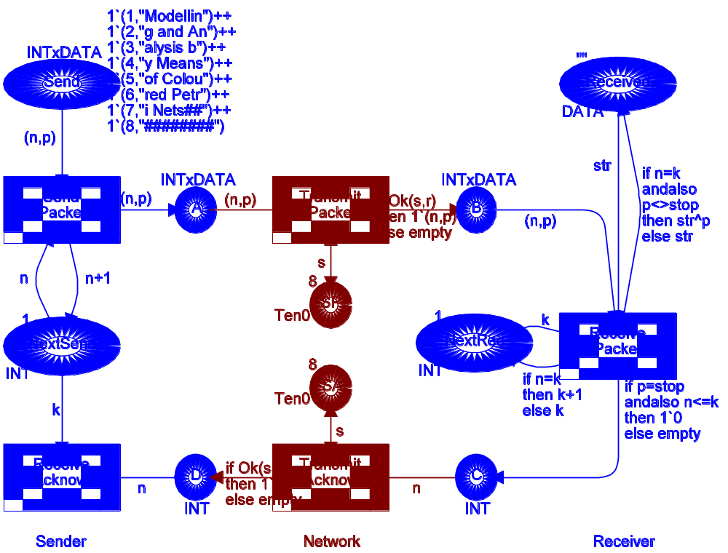

Simple Timer
