
Cytoscape 2.0 Manual

Cytoscape 2.0 Manual 1
Introduction 1
1. Launching Cytoscape 2
2. Quick Tour of Menus 3
3. Command Line Arguments 5
4. Building and Storing Interaction Networks 6
5. Loading Gene Expression Data 7
6. Node and Edge Attributes 8
7. Visualization 9
Appendix: GNU Lesser General Public License 13

Introduction

Cytoscape is an open-community software project for integrating biomolecular interaction networks with high-throughput expression data and other molecular states into a unified conceptual framework. Although applicable to any system of molecular components and interactions, Cytoscape is most powerful when used in conjunction with large databases of protein-protein, protein-DNA, and genetic interactions that are increasingly available for humans and model organisms. A software “Core” provides basic functionality to layout and query the network; to visually integrate the network with expression profiles, phenotypes, and other molecular states; and to link the network to databases of functional annotations. The Core is extensible through a straightforward plug-in architecture, allowing rapid development of additional computational analyses and features. The central organizing metaphor of Cytoscape is a network graph, with genes, proteins, and molecules represented as nodes and interactions represented as links, i.e. edges, between nodes.

Development
Cytoscape is a collaborative project between the Institute for Systems Biology (Dr. Benno Schwikowski), the University of California San Diego (Dr. Trey Ideker), and Memorial Sloan-Kettering Cancer Center (Dr. Chris Sander).

Schwikowski Lab: http://www.systemsbiology.org/personal/benno
Ideker Lab: http://www-bioeng.ucsd.edu/faculty/area/ideker_lab/
Sander Lab: http://www.cbio.mskcc.org/

License
Cytoscape is protected under the LGPL (Lesser Gnu Public License). The License is included as an appendix to this manual, but can also be found online:
http://www.gnu.org/copyleft/lesser.txt

1. Launching Cytoscape

Currently, Cytoscape runs under Java on Linux, Windows, and Mac OS X. Although Cytoscape handles arbitrary types and sizes of interaction network, it is most powerful when used in conjunction with large interaction data sets such as are currently available for species such as the yeast S. cerevisiae.

(1) Download and unpack the distribution. Cytoscape is distributed as a compressed archive (tar.gz or zip) containing the following files and directories:

cytoscape.jar Main Cytoscape application (Java archive)
cytoscape.props User-configurable properties and preferences
vizmap.props User-configurable visual mapping preferences

cytoscape.sh Shell script used to run Cytoscape (Linux, Mac OS X)
cytoscape.bat Shell script used to run Cytoscape (Windows)

LICENSE.txt Cytoscape GNU License
Cytoscape2_0Manual.pdf Cytoscape 2.0 Manual (the document you are reading now)

sampleData/
galFiltered.gml Sample molecular interaction network file *
galFiltered.sif Identical network in Simple Interaction Format *
galExpData.pvals Sample gene expression matrix file *
BINDyeast.sif Network of all yeast protein-protein interactions in the BIND database as of February, 2002 **

GO/ Directory containing Gene Ontology database entries (currently for yeast only). Info in this directory is used to associate gene names with synonyms as well as process, function, and cellular location data.

plugins/ Directory containing cytoscape plug-ins, in .jar format.

* Sample data sets taken from Ideker et al, Science 292:929 (2001)
** Obtained from data hosted at http://www.bind.ca/

(2) If necessary, install Java. If not already installed on your computer, download and install the Java 2 Runtime Environment, version 1.4.1 or higher. It can be found at:

http://java.sun.com/j2se/index.jsp

(3) Launch the application by running "cytoscape.sh" from the command line (Linux or Mac OS X) or double-clicking "cytoscape.bat" (Windows). Alternatively, you can pass the .jar file to Java directly using the command "java -jar cytoscape.jar". In Windows, it is also possible to directly double-click the .jar file to launch it. However, this does not allow specification of command-line arguments (such as the location of the GO data directory, see the Command Line Arguments section for details).

! Important Note:
For the application to work properly, ALL FILES MUST BE LEFT IN THE DIRECTORY IN WHICH THEY ARE UNPACKED. The core Cytoscape application assumes this directory structure when looking for certain files, such as cytoscape.props, vizmap.props, and the GO/ database].

Cytoscape Window
When you succeed in launching Cytoscape, a window will appear that looks like this:

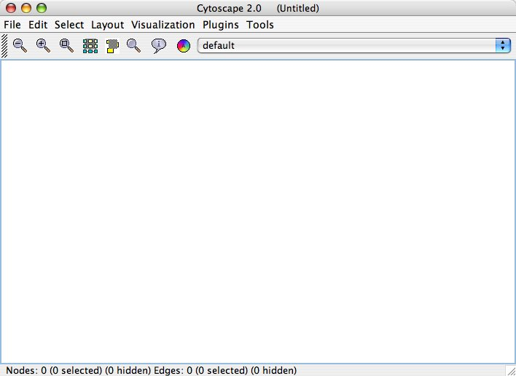

2. Quick Tour of Menus

File
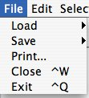
The File menu contains most basic file functionality: File / Load for loading files; File / Save for saving; File / Print for printing to either a printer or a PostScript file. File / Close closes only this window of Cytoscape, leaving other Cytoscape windows open. If this is this is the last open Cytoscape window, File / Close also exits Cytoscape. File / Exit closes all windows of Cytoscape and exits the program. Details of the Load and Save sub-menus can be found in the Building and Storing Networks section.

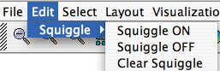
Edit
The Edit menu contains a Squiggle feature that enables you to mark up your network. This can be particularly useful during live presentations.

Select
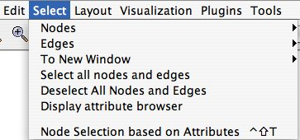
The Select menu contains methods and operations for selecting nodes and edges, operating on existing selections, and displaying the attribute browser. More details about the Nodes, Edges, and To New Window sub-menus can be found in the Selection and Filtering section.

Layout
The Layout menu has an array of features for organizing the graph visually; these features are explored in-depth in the Visualization section. The main features include arranging the entire graph according to one of several algorithms; aligning and rotating groups of nodes; and adjusting the size of the graph.

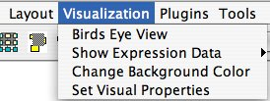
Visualization
The Visualization menu provides options for changing the mapping from biological data to a visual representation: colors of nodes, thickness of edges, etc. These features are explored in-depth in the Visualization section. This menu also provides a Bird’s Eye view of your entire graph, and multiple options for viewing expression data.

Plugins
The Plugins menu will contain all plug-ins that you have chosen to load in your cytoscape.props file.

Note: A complete list of Cytoscape PlugIns is available online at: http://cytoscape.org/plugins.html

3. Command Line Arguments

Cytoscape recognizes a number of optional command line arguments, including run-time specification of network files and expression data:

-g <GML network filename> (xxx.gml)
Loads a network file in GML format
(see 4. Building and Storing Interaction Networks)

-i <SIF interactions filename> (yyy.sif)
Loads a network file in SIF format
(see 4. Building and Storing Interaction Networks)

-b <bioData directory> (e.g. GO/annotationsAndSynonyms)
Specifies which directory to use for the BioDataServer annotations.

-e <expression filename> (zzz.pvals)
Loads an expression data file
(see 5. Loading Gene Expression Data)

-x Prevents expression file from also loading into Cytoscape’s 6. Node and Edge Attributes.

-n <nodeAttributes filename> (zero or more)
Loads a node attributes file
(see 6. Node and Edge Attributes)

-j <edgeAttributes filename> (zero or more)
Loads an edge attributes file
(see 6. Node and Edge Attributes)

-h help: display these command line arguments

-v display version

--JLD specifies a directory in which plug-in .jar’s reside.

Most data sets may also be loaded after Cytoscape is running. See the sections on 5. Loading Gene Expression Data and 6. Node and Edge Attributes for details.

Additional command line arguments that are not recognized by the Cytoscape core are passed to the plug-in modules. Please refer to the documentation for each specific plug-in for more details.

4. Building and Storing Interaction Networks

Cytoscape reads an interaction network in two ways: from a simple interaction file (SIF or .sif format) or from a universal format known as Graph Markup Language (GML or .gml format). SIF specifies nodes and interactions only, while GML stores additional information about network layout and allows network data exchange with a variety of other network display programs. Typically, SIF is used to import interactions when building a network for the first time. Once the interactions have been loaded and layout has been performed, the network may be saved to and subsequently reloaded from GML format in future Cytoscape sessions. Both SIF and GML are implemented as ASCII text files.

SIF FORMAT:
Lines in the SIF file specify a source node, an interaction type, and one or more target nodes:

geneA <interaction type> geneB
geneC <interaction type> geneA
geneD <interaction type> geneE geneF geneB
geneG
...
geneY <interaction type> geneZ

In the network specified by this file, genes are represented by nodes, and interactions are represented by edges between nodes. For compactness, a gene also represents its corresponding protein. Nodes may also be used to represent compounds and reactions instead of genes, but this is non-standard, as yet. Note that it is possible to specify an isolated node with no interactions, as in the line "geneG" above.

Gene names must be unique. If the network is to be integrated with Gene Ontology (GO) or gene expression data, the gene names must exactly match the systematic ORF names specified in the other data files. We strongly encourage naming genes and proteins by their systematic ORF name; common names may be displayed on the screen for ease of interpretation, so long as these are available to the program in the bioData directory (Cytoscape ships with all yeast ORF-to-common name mappings in a synonym table within the GO/ directory).

The tag <interaction type> must be one of:
pp .................. protein -- protein
pd .................. protein -> DNA

Additional interaction types are also possible, but as yet, nonstandard:
pr .................. protein -> reaction
rc .................. reaction -> compound
cr .................. compound -> reaction
gl .................. genetic lethal relationship

Any text string will work, but these are the conventions that have been followed thus far.
GML FORMAT:

In contrast to SIF, GML is a rich graph format language supported by many other graph visualization packages. Its file format specification is available at:

http://www.infosun.fmi.uni-passau.de/Graphlet/GML/

It is generally not necessary to modify the content of a GML file directly. Once a network is built in SIF format and then laid out, the layout is preserved by saving to and loading from GML.

COMMANDS:
Load and save network files using the File menu of Cytoscape. Network files may also be loaded directly from the command line using the –i (SIF format) or -g (GML format) options.

FOR EXAMPLE:
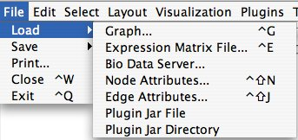
To load a sample molecular interaction network in SIF format, use the menu File / Load / Graph. In the resulting file dialog box, select the file “sampleData/galFiltered.sif”. After a few seconds, a small network of 329 nodes should appear in the main window. To load the same interaction network as a GML, use the menu: File / Load / Graph again. In the resulting file dialog box, select the file “sampleData/galFiltered.gml”. As of Cytoscape version 1.1, Plug-ins can also be loaded from the File / Load menu, as can node and edge attribute files.

5. Loading Gene Expression Data

Interaction networks are certainly useful as stand-alone models. However, they are most powerful when integrated with information about the biological states that are induced by the network, such as gene or protein expression levels. Once loaded, expression ratios/levels may be visually superimposed on the network, used in a filter to select a subset of nodes, or used to identify active modules and subsystems (see sections below). Expression data are only relevant once a network has been loaded.

FORMAT:
Gene expression ratios are specified over one or more experiments using an ASCII text file. The file consists of a number of space- or tab-delimited fields, one line per gene, with the following format:

GeneName [CommonName] ratio1 ratio2 ... ratioN [pval1 pval2 ... pvalN]

Brackets [] indicate fields that are optional. The first two fields are the systematic gene name followed by an optional common name. Expression ratios are provided for each experiment, optionally followed by a p-value per experiment or other measure of the significance of each ratio, i.e. whether the ratio represents a true change in expression. Significance values are generated by a variety of software packages for analyzing expression data generated by DNA microarrays, for instance our program VERA (http://www.systemsbiology.org/VERAandSAM). A list of other microarray analysis packages is available at: http://linkage.rockefeller.edu/wli/microarray/soft.html

COMMANDS:
Load an expression data file using the File menu of Cytoscape, or by specifying the filename using the -e option at the command line. The –x command line option indicates that the expression data should not be loaded into node attributes. This is an advanced option, and is typically only used when the number of expression conditions is sufficiently large that it becomes unwieldy in the normal user interface.

FOR EXAMPLE:
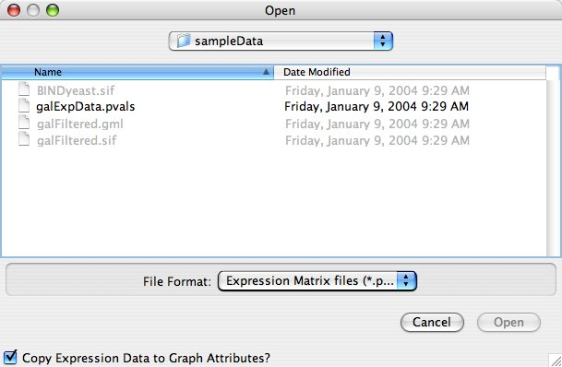
Load a sample gene expression data set using the menu: File / Load / Expression Matrix File. In the resulting file dialog box (shown at right), select the file “sampleData/galExpData.pvals”. As described in the following sections, Cytoscape is now ready to integrate these data with the underlying molecular interaction network. Note: the checkbox in the lower left corner of the file dialog asks whether to “Copy Expression Data to Graph Attributes” – un-checking this box has the same effect is as the command line option -x, and it is left checked by default.

6. Node and Edge Attributes

Node and edge attribute files are very simply formatted: A node attribute file begins with the name of the attribute on the first line, and on each following line, has the name of the node, followed by an equals sign, followed by the value of that attribute. For example:

FunctionalCategory
YAL001C = metabolism
YAR002W = apoptosis
YBL007C = ribosome

An edge attribute file has much the same structure, except that the name of the edge is the source node name, followed by the interaction type in parentheses, followed by the target node name. Directionality counts, so switching the source and target will refer to a different (or perhaps non-existent) edge. Following is an example edge attributes file:

InteractionStrength
YAL001C (pp) YBR043W = 0.82
YMR022W (pd) YDL112C = 0.441
YDL112C (pd) YMR022W = 0.9013

Note that the second and third edge attribute values refer to two different edges (source and target are reversed, though the nodes involved are the same).

Node and edge attributes may be loaded at the command line using the –n and –j options, via the File / Load menu, or using Ctrl-Shift-N and Ctrl-Shift-J.

When expression data is loaded using an expression matrix file (5. Loading Gene Expression Data), it is automatically copied into the Node Attributes data structure unless explicitly specified not to.

Edge and Node attributes can be mapped to visual properties (colors, shapes, etc.) using the 7. Visualization menu item.

7. Visualization

BASIC FEATURES:
Use the zooming buttons located on the toolbar to zoom in / out of the interaction network shown in the current network display. Zoom out and Zoom in are the two leftmost magnifying glass icons on the toolbar (below); the next magnifying icon is for zooming in to an area of selected nodes.



Navigate around the network by using the window sliders or by clicking with the right mouse button (with no nodes or edges selected) and dragging in the desired direction.

Use the left mouse button to select one or more nodes (genes). A right click then launches a node attributes panel providing detailed information about the selected nodes, including its corresponding annotation in the Gene Ontology (GO) database (if available and specified with the -b command line option). If a gene expression experiment has been selected (see below), the relevant expression data are also shown in the node attributes panel.

NETWORK LAYOUT:
Explore a variety of schemes for layout of the network in two dimensions using the "Layout" menu. First select the type of layout desired (Circular, Hierarchical, ...) and then choose "Whole graph" or "Current Selection" to perform the layout on either all nodes or only those that are currently selected. It is also possible to Align Selected Nodes vertically or horizontally, or to Rotate Selected Nodes a particular number of degrees. Saving a network in GML format (see section above) records the network topology (nodes and links) and its current layout; saving in Interaction format (.sif) will not preserve layout.

CONFIGURING AND MAPPING VISUAL PROPERTIES:
Bring up the Visual Properties dialog (shown on the next page) by choosing Visualization / Set Visual Properties. Default node and edge visual properties such as color, size, and style are specified in the upper portion of the dialog. Defaults may also be configured at run-time by editing the vizmap.props and cytoscape.props file. Please follow the models provided in the .props files that are included with this distribution.

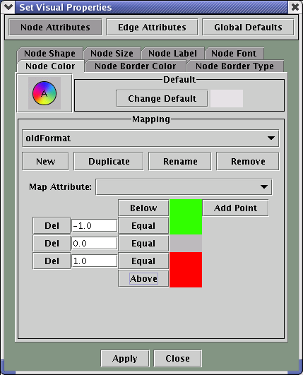
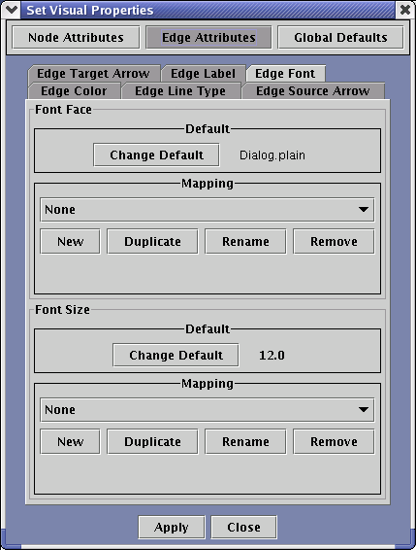
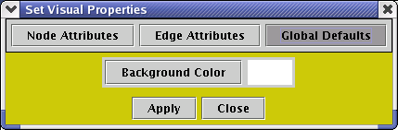

Above: The three faces of the Set Visual Properties dialog.

For every visual property of Cytoscape (the nodes’ colors, the edges’ label font, etc.), there is a menu in the Set Visual Properties dialog. For each property, there is a default, and a potential mapping. Mappings usually map an attribute of nodes or edges to visual properties; you can specify both which attribute to map and how to map the attribute to a visual property using the dialog.

For instance, Node Label may be mapped to display the gene names (canonical or common) or current gene expression values. Edge color may be used to reflect the type of interaction each edge represents, e.g. protein-protein ('pp' tag) or protein->DNA ('pd' tag). As described next, one of the most important mappings is from node color to gene expression values.

SUPERPOSITION OF EXPRESSION DATA ON THE NETWORK:
To visually map and superimpose expression data on the network, choose either Node Color or Node Border Color from the Set Visual Properties dialog. Assuming you have loaded an expression data set, or another node attribute, follow these steps:

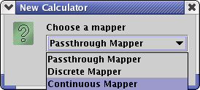
Create a new calculator by pressing the “New” button under Mapping. The New Calculator dialog will come up; select “Continuous Mapper.”

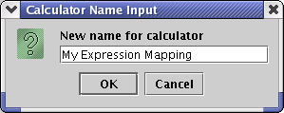
Choose a name for your new calculator.

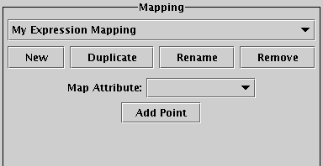
At this point, a new continuous mapping will be ready, except that it doesn’t currently map any attribute, and even if it did, that mapping hasn’t yet been defined. On to the next step.

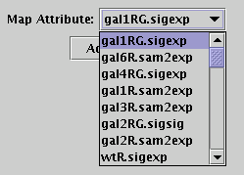
Select an attribute to map.

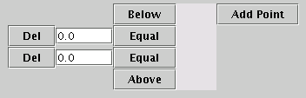
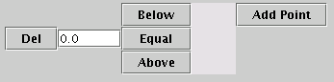
Click the “Add Point” button twice.

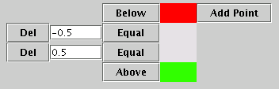
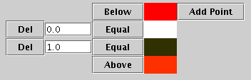
Choose colors and control points for the mapping. The mapping shown at left would color a node red whose expression level was less than -0.5 (presumably a log ratio); nodes with expression levels greater than +0.5 would be colored green; any node with an expression level between -0.5 and +0.5 would be colored gray. The continuous mapping will interpolate between colors you provide if the attribute value is between the control points you set on the left side of the dialog. For example, the mapping shown to the right will interpolate between white and black for attribute values ranging from zero to one. Numbers outside this range are colored red, in this mapping.

Once you have designed a mapping to your liking, press the Apply button at the bottom of the Set Visual Properties dialog, and see your expression data superimposed on the network!

The initial expression color mappings which Cytoscape load at run-time are specified in the vizmap.props file as a list of fields and their comma-separated RGB values; the choices of which mappings are actually used when you first bring up Cytoscape are specified in the cytoscape.props file. Follow the model provided in the .props files included with this distribution.

VISUAL STYLES – NEW WITH VERSION 1.1
Though the screenshots above are from Cytoscape 1.0, Cytoscape 1.1 and Cytoscape 2.0 offer “Visual Styles,” in which visual calculators are grouped together, so you can switch rapidly from one Cytoscape appearance to another. The choice of which style to use is saved in the cytoscape.props file as the edgeAppearanceCalculator and nodeAppearanceCalculator; the specification of all available styles is saved in the vizmap.props file.

Appendix: GNU Lesser General Public License

GNU LESSER GENERAL PUBLIC LICENSE
Version 2.1, February 1999

Copyright (C) 1991, 1999 Free Software Foundation, Inc.
59 Temple Place, Suite 330, Boston, MA 02111-1307 USA
Everyone is permitted to copy and distribute verbatim copies
of this license document, but changing it is not allowed.

[This is the first released version of the Lesser GPL. It also counts
as the successor of the GNU Library Public License, version 2, hence
the version number 2.1.]

Preamble

The licenses for most software are designed to take away your
freedom to share and change it. By contrast, the GNU General Public
Licenses are intended to guarantee your freedom to share and change
free software--to make sure the software is free for all its users.

This license, the Lesser General Public License, applies to some
specially designated software packages--typically libraries--of the
Free Software Foundation and other authors who decide to use it. You
can use it too, but we suggest you first think carefully about whether
this license or the ordinary General Public License is the better
strategy to use in any particular case, based on the explanations below.

When we speak of free software, we are referring to freedom of use,
not price. Our General Public Licenses are designed to make sure that
you have the freedom to distribute copies of free software (and charge
for this service if you wish); that you receive source code or can get
it if you want it; that you can change the software and use pieces of
it in new free programs; and that you are informed that you can do
these things.

To protect your rights, we need to make restrictions that forbid
distributors to deny you these rights or to ask you to surrender these
rights. These restrictions translate to certain responsibilities for
you if you distribute copies of the library or if you modify it.

For example, if you distribute copies of the library, whether gratis
or for a fee, you must give the recipients all the rights that we gave
you. You must make sure that they, too, receive or can get the source
code. If you link other code with the library, you must provide
complete object files to the recipients, so that they can relink them
with the library after making changes to the library and recompiling
it. And you must show them these terms so they know their rights.

We protect your rights with a two-step method: (1) we copyright the
library, and (2) we offer you this license, which gives you legal
permission to copy, distribute and/or modify the library.

To protect each distributor, we want to make it very clear that
there is no warranty for the free library. Also, if the library is
modified by someone else and passed on, the recipients should know
that what they have is not the original version, so that the original
author's reputation will not be affected by problems that might be
introduced by others.

Finally, software patents pose a constant threat to the existence of
any free program. We wish to make sure that a company cannot
effectively restrict the users of a free program by obtaining a
restrictive license from a patent holder. Therefore, we insist that
any patent license obtained for a version of the library must be
consistent with the full freedom of use specified in this license.

Most GNU software, including some libraries, is covered by the
ordinary GNU General Public License. This license, the GNU Lesser
General Public License, applies to certain designated libraries, and
is quite different from the ordinary General Public License. We use
this license for certain libraries in order to permit linking those
libraries into non-free programs.

When a program is linked with a library, whether statically or using
a shared library, the combination of the two is legally speaking a
combined work, a derivative of the original library. The ordinary
General Public License therefore permits such linking only if the
entire combination fits its criteria of freedom. The Lesser General
Public License permits more lax criteria for linking other code with
the library.

We call this license the "Lesser" General Public License because it
does Less to protect the user's freedom than the ordinary General
Public License. It also provides other free software developers Less
of an advantage over competing non-free programs. These disadvantages
are the reason we use the ordinary General Public License for many
libraries. However, the Lesser license provides advantages in certain
special circumstances.

For example, on rare occasions, there may be a special need to
encourage the widest possible use of a certain library, so that it becomes
a de-facto standard. To achieve this, non-free programs must be
allowed to use the library. A more frequent case is that a free
library does the same job as widely used non-free libraries. In this
case, there is little to gain by limiting the free library to free
software only, so we use the Lesser General Public License.

In other cases, permission to use a particular library in non-free
programs enables a greater number of people to use a large body of
free software. For example, permission to use the GNU C Library in
non-free programs enables many more people to use the whole GNU
operating system, as well as its variant, the GNU/Linux operating
system.

Although the Lesser General Public License is Less protective of the
users' freedom, it does ensure that the user of a program that is
linked with the Library has the freedom and the wherewithal to run
that program using a modified version of the Library.

The precise terms and conditions for copying, distribution and
modification follow. Pay close attention to the difference between a
"work based on the library" and a "work that uses the library". The
former contains code derived from the library, whereas the latter must
be combined with the library in order to run.

GNU LESSER GENERAL PUBLIC LICENSE
TERMS AND CONDITIONS FOR COPYING, DISTRIBUTION AND MODIFICATION

0. This License Agreement applies to any software library or other
program which contains a notice placed by the copyright holder or
other authorized party saying it may be distributed under the terms of
this Lesser General Public License (also called "this License").
Each licensee is addressed as "you".

A "library" means a collection of software functions and/or data
prepared so as to be conveniently linked with application programs
(which use some of those functions and data) to form executables.

The "Library", below, refers to any such software library or work
which has been distributed under these terms. A "work based on the
Library" means either the Library or any derivative work under
copyright law: that is to say, a work containing the Library or a
portion of it, either verbatim or with modifications and/or translated
straightforwardly into another language. (Hereinafter, translation is
included without limitation in the term "modification".)

"Source code" for a work means the preferred form of the work for
making modifications to it. For a library, complete source code means
all the source code for all modules it contains, plus any associated
interface definition files, plus the scripts used to control compilation
and installation of the library.

Activities other than copying, distribution and modification are not
covered by this License; they are outside its scope. The act of
running a program using the Library is not restricted, and output from
such a program is covered only if its contents constitute a work based
on the Library (independent of the use of the Library in a tool for
writing it). Whether that is true depends on what the Library does
and what the program that uses the Library does.

1. You may copy and distribute verbatim copies of the Library's
complete source code as you receive it, in any medium, provided that
you conspicuously and appropriately publish on each copy an
appropriate copyright notice and disclaimer of warranty; keep intact
all the notices that refer to this License and to the absence of any
warranty; and distribute a copy of this License along with the
Library.

You may charge a fee for the physical act of transferring a copy,
and you may at your option offer warranty protection in exchange for a
fee.

2. You may modify your copy or copies of the Library or any portion
of it, thus forming a work based on the Library, and copy and
distribute such modifications or work under the terms of Section 1
above, provided that you also meet all of these conditions:

a) The modified work must itself be a software library.

b) You must cause the files modified to carry prominent notices
stating that you changed the files and the date of any change.

c) You must cause the whole of the work to be licensed at no
charge to all third parties under the terms of this License.

d) If a facility in the modified Library refers to a function or a
table of data to be supplied by an application program that uses
the facility, other than as an argument passed when the facility
is invoked, then you must make a good faith effort to ensure that,
in the event an application does not supply such function or
table, the facility still operates, and performs whatever part of
its purpose remains meaningful.

(For example, a function in a library to compute square roots has
a purpose that is entirely well-defined independent of the
application. Therefore, Subsection 2d requires that any
application-supplied function or table used by this function must
be optional: if the application does not supply it, the square
root function must still compute square roots.)

These requirements apply to the modified work as a whole. If
identifiable sections of that work are not derived from the Library,
and can be reasonably considered independent and separate works in
themselves, then this License, and its terms, do not apply to those
sections when you distribute them as separate works. But when you
distribute the same sections as part of a whole which is a work based
on the Library, the distribution of the whole must be on the terms of
this License, whose permissions for other licensees extend to the
entire whole, and thus to each and every part regardless of who wrote
it.

Thus, it is not the intent of this section to claim rights or contest
your rights to work written entirely by you; rather, the intent is to
exercise the right to control the distribution of derivative or
collective works based on the Library.

In addition, mere aggregation of another work not based on the Library
with the Library (or with a work based on the Library) on a volume of
a storage or distribution medium does not bring the other work under
the scope of this License.

3. You may opt to apply the terms of the ordinary GNU General Public
License instead of this License to a given copy of the Library. To do
this, you must alter all the notices that refer to this License, so
that they refer to the ordinary GNU General Public License, version 2,
instead of to this License. (If a newer version than version 2 of the
ordinary GNU General Public License has appeared, then you can specify
that version instead if you wish.) Do not make any other change in
these notices.

Once this change is made in a given copy, it is irreversible for
that copy, so the ordinary GNU General Public License applies to all
subsequent copies and derivative works made from that copy.

This option is useful when you wish to copy part of the code of
the Library into a program that is not a library.

4. You may copy and distribute the Library (or a portion or
derivative of it, under Section 2) in object code or executable form
under the terms of Sections 1 and 2 above provided that you accompany
it with the complete corresponding machine-readable source code, which
must be distributed under the terms of Sections 1 and 2 above on a
medium customarily used for software interchange.

If distribution of object code is made by offering access to copy
from a designated place, then offering equivalent access to copy the
source code from the same place satisfies the requirement to
distribute the source code, even though third parties are not
compelled to copy the source along with the object code.

5. A program that contains no derivative of any portion of the
Library, but is designed to work with the Library by being compiled or
linked with it, is called a "work that uses the Library". Such a
work, in isolation, is not a derivative work of the Library, and
therefore falls outside the scope of this License.

However, linking a "work that uses the Library" with the Library
creates an executable that is a derivative of the Library (because it
contains portions of the Library), rather than a "work that uses the
library". The executable is therefore covered by this License.
Section 6 states terms for distribution of such executables.

When a "work that uses the Library" uses material from a header file
that is part of the Library, the object code for the work may be a
derivative work of the Library even though the source code is not.
Whether this is true is especially significant if the work can be
linked without the Library, or if the work is itself a library. The
threshold for this to be true is not precisely defined by law.

If such an object file uses only numerical parameters, data
structure layouts and accessors, and small macros and small inline
functions (ten lines or less in length), then the use of the object
file is unrestricted, regardless of whether it is legally a derivative
work. (Executables containing this object code plus portions of the
Library will still fall under Section 6.)

Otherwise, if the work is a derivative of the Library, you may
distribute the object code for the work under the terms of Section 6.
Any executables containing that work also fall under Section 6,
whether or not they are linked directly with the Library itself.

6. As an exception to the Sections above, you may also combine or
link a "work that uses the Library" with the Library to produce a
work containing portions of the Library, and distribute that work
under terms of your choice, provided that the terms permit
modification of the work for the customer's own use and reverse
engineering for debugging such modifications.

You must give prominent notice with each copy of the work that the
Library is used in it and that the Library and its use are covered by
this License. You must supply a copy of this License. If the work
during execution displays copyright notices, you must include the
copyright notice for the Library among them, as well as a reference
directing the user to the copy of this License. Also, you must do one
of these things:

a) Accompany the work with the complete corresponding
machine-readable source code for the Library including whatever
changes were used in the work (which must be distributed under
Sections 1 and 2 above); and, if the work is an executable linked
with the Library, with the complete machine-readable "work that
uses the Library", as object code and/or source code, so that the
user can modify the Library and then relink to produce a modified
executable containing the modified Library. (It is understood
that the user who changes the contents of definitions files in the
Library will not necessarily be able to recompile the application
to use the modified definitions.)

b) Use a suitable shared library mechanism for linking with the
Library. A suitable mechanism is one that (1) uses at run time a
copy of the library already present on the user's computer system,
rather than copying library functions into the executable, and (2)
will operate properly with a modified version of the library, if
the user installs one, as long as the modified version is
interface-compatible with the version that the work was made with.

c) Accompany the work with a written offer, valid for at
least three years, to give the same user the materials
specified in Subsection 6a, above, for a charge no more
than the cost of performing this distribution.

d) If distribution of the work is made by offering access to copy
from a designated place, offer equivalent access to copy the above
specified materials from the same place.

e) Verify that the user has already received a copy of these
materials or that you have already sent this user a copy.

For an executable, the required form of the "work that uses the
Library" must include any data and utility programs needed for
reproducing the executable from it. However, as a special exception,
the materials to be distributed need not include anything that is
normally distributed (in either source or binary form) with the major
components (compiler, kernel, and so on) of the operating system on
which the executable runs, unless that component itself accompanies
the executable.

It may happen that this requirement contradicts the license
restrictions of other proprietary libraries that do not normally
accompany the operating system. Such a contradiction means you cannot
use both them and the Library together in an executable that you
distribute.

7. You may place library facilities that are a work based on the
Library side-by-side in a single library together with other library
facilities not covered by this License, and distribute such a combined
library, provided that the separate distribution of the work based on
the Library and of the other library facilities is otherwise
permitted, and provided that you do these two things:

a) Accompany the combined library with a copy of the same work
based on the Library, uncombined with any other library
facilities. This must be distributed under the terms of the
Sections above.

b) Give prominent notice with the combined library of the fact
that part of it is a work based on the Library, and explaining
where to find the accompanying uncombined form of the same work.

8. You may not copy, modify, sublicense, link with, or distribute
the Library except as expressly provided under this License. Any
attempt otherwise to copy, modify, sublicense, link with, or
distribute the Library is void, and will automatically terminate your
rights under this License. However, parties who have received copies,
or rights, from you under this License will not have their licenses
terminated so long as such parties remain in full compliance.

9. You are not required to accept this License, since you have not
signed it. However, nothing else grants you permission to modify or
distribute the Library or its derivative works. These actions are
prohibited by law if you do not accept this License. Therefore, by
modifying or distributing the Library (or any work based on the
Library), you indicate your acceptance of this License to do so, and
all its terms and conditions for copying, distributing or modifying
the Library or works based on it.

10. Each time you redistribute the Library (or any work based on the
Library), the recipient automatically receives a license from the
original licensor to copy, distribute, link with or modify the Library
subject to these terms and conditions. You may not impose any further
restrictions on the recipients' exercise of the rights granted herein.
You are not responsible for enforcing compliance by third parties with
this License.

11. If, as a consequence of a court judgment or allegation of patent
infringement or for any other reason (not limited to patent issues),
conditions are imposed on you (whether by court order, agreement or
otherwise) that contradict the conditions of this License, they do not
excuse you from the conditions of this License. If you cannot
distribute so as to satisfy simultaneously your obligations under this
License and any other pertinent obligations, then as a consequence you
may not distribute the Library at all. For example, if a patent
license would not permit royalty-free redistribution of the Library by
all those who receive copies directly or indirectly through you, then
the only way you could satisfy both it and this License would be to
refrain entirely from distribution of the Library.

If any portion of this section is held invalid or unenforceable under any
particular circumstance, the balance of the section is intended to apply,
and the section as a whole is intended to apply in other circumstances.

It is not the purpose of this section to induce you to infringe any
patents or other property right claims or to contest validity of any
such claims; this section has the sole purpose of protecting the
integrity of the free software distribution system which is
implemented by public license practices. Many people have made
generous contributions to the wide range of software distributed
through that system in reliance on consistent application of that
system; it is up to the author/donor to decide if he or she is willing
to distribute software through any other system and a licensee cannot
impose that choice.

This section is intended to make thoroughly clear what is believed to
be a consequence of the rest of this License.

12. If the distribution and/or use of the Library is restricted in
certain countries either by patents or by copyrighted interfaces, the
original copyright holder who places the Library under this License may add
an explicit geographical distribution limitation excluding those countries,
so that distribution is permitted only in or among countries not thus
excluded. In such case, this License incorporates the limitation as if
written in the body of this License.

13. The Free Software Foundation may publish revised and/or new
versions of the Lesser General Public License from time to time.
Such new versions will be similar in spirit to the present version,
but may differ in detail to address new problems or concerns.

Each version is given a distinguishing version number. If the Library
specifies a version number of this License which applies to it and
"any later version", you have the option of following the terms and
conditions either of that version or of any later version published by
the Free Software Foundation. If the Library does not specify a
license version number, you may choose any version ever published by
the Free Software Foundation.

14. If you wish to incorporate parts of the Library into other free
programs whose distribution conditions are incompatible with these,
write to the author to ask for permission. For software which is
copyrighted by the Free Software Foundation, write to the Free
Software Foundation; we sometimes make exceptions for this. Our
decision will be guided by the two goals of preserving the free status
of all derivatives of our free software and of promoting the sharing
and reuse of software generally.

NO WARRANTY

15. BECAUSE THE LIBRARY IS LICENSED FREE OF CHARGE, THERE IS NO
WARRANTY FOR THE LIBRARY, TO THE EXTENT PERMITTED BY APPLICABLE LAW.
EXCEPT WHEN OTHERWISE STATED IN WRITING THE COPYRIGHT HOLDERS AND/OR
OTHER PARTIES PROVIDE THE LIBRARY "AS IS" WITHOUT WARRANTY OF ANY
KIND, EITHER EXPRESSED OR IMPLIED, INCLUDING, BUT NOT LIMITED TO, THE
IMPLIED WARRANTIES OF MERCHANTABILITY AND FITNESS FOR A PARTICULAR
PURPOSE. THE ENTIRE RISK AS TO THE QUALITY AND PERFORMANCE OF THE
LIBRARY IS WITH YOU. SHOULD THE LIBRARY PROVE DEFECTIVE, YOU ASSUME
THE COST OF ALL NECESSARY SERVICING, REPAIR OR CORRECTION.

16. IN NO EVENT UNLESS REQUIRED BY APPLICABLE LAW OR AGREED TO IN
WRITING WILL ANY COPYRIGHT HOLDER, OR ANY OTHER PARTY WHO MAY MODIFY
AND/OR REDISTRIBUTE THE LIBRARY AS PERMITTED ABOVE, BE LIABLE TO YOU
FOR DAMAGES, INCLUDING ANY GENERAL, SPECIAL, INCIDENTAL OR
CONSEQUENTIAL DAMAGES ARISING OUT OF THE USE OR INABILITY TO USE THE
LIBRARY (INCLUDING BUT NOT LIMITED TO LOSS OF DATA OR DATA BEING
RENDERED INACCURATE OR LOSSES SUSTAINED BY YOU OR THIRD PARTIES OR A
FAILURE OF THE LIBRARY TO OPERATE WITH ANY OTHER SOFTWARE), EVEN IF
SUCH HOLDER OR OTHER PARTY HAS BEEN ADVISED OF THE POSSIBILITY OF SUCH
DAMAGES.

END OF TERMS AND CONDITIONS

