Contents

1. General information 5
2. Programme overview 7
Detailed Program: Symposium Integrative Bioinformatics 8
Detailed Programme: Application Showcase and Tutorials 9
3. Speaker Resumes and Abstracts 10
Leroy Hood 10
Andrew Hopkins 11
Rogier Versteeg 12
Chris Sander 13
Peter Sorger 13
Ruedi Aebersold 14
Benno Schwikowski 14
Jean-Daniel Fekete 15
Ewan Birney 15
Trey Ideker 16
4. Cytoscape in short 17
Background and Motivation 17
Cytoscape: Current state-of-the-art 17
Organization and management 17
Importance to the biological research community 18
Education and Outreach 18
References 19
5. What is Cytoscape? 20
What’s in it? 20
Who wrote it? When and where did it start? 20
What is it used for? Is it useful for fields other than life sciences? 20
Who is using it? How many have used it? Where has it been published? 20
How much does it cost? What does open source mean? Can it be productized? 20
Who supports it? How is functionality added? 20
What’s the competition? How does it differ? Does it work with these other tools? How does it work with simulation tools? 20
What content does Cytoscape include? What databases does Cytoscape work with? What standardized formats does it support? What does this mean? 21
What is the Cytoscape Consortium? Who are its members? What does it mean to be a member? How does one become a member? 21
What is a ‘Plugin’? How are these used? How are these included with Cytoscape? 21
Where is it going in the future? What is the vision? 21
6. Plugins and Applications showcase 23
BiNGO 23
Literature Search - Hyperedges - Excentric Labels - Nature Protocols Workflow Panel - Gradient NodeViews 23
VistaClara 25
Bioscape 26
GPML plugin 26
SgdInteractionsPlugin 27
NetworkAnalyzer - DomainGraph - BiLayout 27
EnhancedSearch 28
BubbleRouter 28
ReConn 29
Cerebral 30
CyGroups - StructureViz - BatchTool 31
MetNet 32
PathwayCommons - GoSlimmer - Thematic Map 32
MIM (Molecular Interaction Map) Tools 33
Metacore Integration 33
EagleVista 33
Vispara 34
BioEdge 34
7. Tutorials 36
Cytoscape Tutorials 36
Name and contact information for tutors 36
Length of tutorial 36
Audience 36
Background required 36
Relevance of the tutorial and interest to the community 36
Tutorial Overview 36
Developer Tutorials 37
CyGroups - Layouts 37
Vizmapper 38
Webservices 38
8. Scientific Advisory Board 39
Joel Bader 39
Ewan Birney 39
Hamid Bolouri 39
Nevan Krogan 39
Manuel Peitsch 40
Ilya Shmulevich 40
David J. States 41
Marc Vidal 41
9. Board of Directors 42
Trey Ideker, President 42
Gary Bader, Vice President 42
Louis Coffman, Secretary/Treasurer 42
Chris Sander 42
Leroy Hood 42
Benno Schwikowski 42
Guy Warner 42
Annette Adler 43
Bruce Conklin 43
10. Acknowledgements 44
11. Notes 45

General information

Cytoscape Public Symposium and Developers Retreat
November 6-9, 2007 - Academic Medical Center
University of Amsterdam, Netherlands

The Cytoscape community organizes a developers Retreat each year to establish a roadmap for Cytoscape development. In addition a Public Symposium is organized for a wider audience. This year it goes by the title: Integrative Bioinformatics: At the cutting edge of network analysis and biological data integration

The goal of the 2007 Retreat is threefold:

1. Establish a development roadmap for the next year
2. Involve the large user community in Europe in Cytoscape development
3. Gather user feedback and use it to plan future development.

We want to reach these goals in a Retreat spanning four days. The first and last days (6 and 9 Nov) are mainly intended for the Cytoscape core development team and other developers who write their own Cytoscape plugins. The second and third days (7 and 8 Nov) are aimed at a wide audience of molecular biologists and bioinformaticians in the Netherlands, Europe and internationally.

Location
Conference Hall (Collegezaal) 1 and 2
Lecture rooms (Leszaal) L01-252, K-01-122 and K-01-122
Academic Medical Center - University of Amsterdam
Meibergdreef 9

Contact
Mail and internet
Retreat and Symposium: cytoretreat@cytoscape.org
www.cytoscape.org/retreat2007
Phone/Fax
AMC Department of Human Genetics:
Phone: +31-20-5665111
Fax: +31-20-6918626
Congress rooms
Conference Hall (Collegezaal) 1: +31-20-5665022
Conference Hall (Collegezaal) 2: +31-20-5664600
Lecture Room K-01-122: +31-20-5667415
Lecture Room K-01-123: +31-20-5667416
Lecture Room L-01-252: +31-20-5666236
Urgencies
Piet Molenaar; mobile: +31-6-24672827
Monique Stam; mobile: +31-6-20738851









Programme overview
Monday 5th Nov |  |  | Arrivals Day Detailed agenda: http://www.cytoscape.org/retreat2007
 |  |  |  |  |  | Location
 |  |  | 9:00 - 12:00 |  | Morning session | Amsterdam city center;
 |  |  | 13:00 - 17:00 |  | Afternoon informal hackathon | TBA
 |  |  | 17:00 - 19:00 |  | Meet and greet | TBA
Tuesday 6th Nov |  |  | Software Development Discussions  Detailed agenda: http://www.cytoscape.org/retreat2007
 |  |  | 9:00 - 18:00 |  | Software Development Discussions | K-01-123, AMC
 |  |  | 19:00 - 22:30 |  | Surprise event for attendees this day | Amsterdam city center
Wednesday 7th Nov |  |  | Tutorials and Application Showcase day
 |  |  | Detailed programme on next page
 |  | Parallel track I | 9:00 - 18:00 |  | Application Showcase / Plugins Trail | Conference Hall (Collegezaal) 2, AMC
 |  | Parallel track II | 9:00 - 18:00 |  | Hackathon Dev-Tutorial Trail | K-01-122, AMC
 |  | Parallel track III | 9:00 - 18:00 |  | Tutorial Trail | K-01-123, AMC
 |  |  | 21:00- (...) |  | City tour | Amsterdam city center
Thursday 8th Nov |  |  | Public Symposium: Integrative Bioinformatics
 |  |  | Detailed programme on next pages
 |  |  | 9:00 - 17:45 |  | Symposium | Conference Hall (Collegezaal) 1, AMC
 |  |  | 17:45 - 19:00 |  | Drinks reception | Outside Conference Hall 1
Friday 9th Nov |  |  | Cytoscape Development Planning  Detailed agenda: http://www.cytoscape.org/retreat2007
 |  |  | 9:00 - 18:00 |  | Discussions about the next steps for Cytoscape | K-01-123
 |  |  | 21:00- (...) |  | Evening at van Gogh | Amsterdam city center

Detailed Program: Symposium Integrative Bioinformatics
November 8th 2007 - Conference Hall 1 - "At the cutting edge of network analysis & biological data integration"
08:45 | Welcome - Registration - Coffee
09:15 |  |  |  | Chairman’s Welcome (Trey Ideker)
09:30 | Keynote: Leroy Hood |  |  | Biological networks and disease
10:15 | Andrew Hopkins |  |  | Network Pharmacology: chemical opportunities for systems biology
10:45 | Coffee break
11:15 | Rogier Versteeg |  |  | Oncogenic networks of cancer pathways in childhood cancer
11:45 | Chris Sander |  |  | Systems Biology of Cancer Pathways: from Molecular Perturbations to Cellular Phenotypes
12:30 | Peter Sorger |  |  | Modeling Mammalian Death and Survival Pathways
13:15 | Lunch break (Board, Speakers & SAB lunch separate)
14:15 | Ruedi Aebersold |  |  | Protein-centered networks in systems biology: Analysis and visualization
15:00 | Benno Schwikowski |  |  | Computational tools increasing sensitivity and reliability of mass spec-based proteomics
15:30 | Jean-Daniel Fekete |  |  | Visualizing Dense Networks with Enhanced and Hybrid Matrices
16:00 | Tea break
16:30 | Ewan Birney |  |  | Reactome, Networks and Genomes
17:15 | Trey Ideker |  |  | Gaining power in gene association studies with Cytoscape
17:45 | Drinks reception

Detailed Programme: Application Showcase and Tutorials
November 7th 2007 - Conference Hall 2 / K-01-122 / K-01-123
 | Track I  TUTORIALS | Track II  PLUGINS AND APPLICATION SHOWCASE |  |  | Track III  HACKATHON & DEVELOPERS TUTORIAL
 | Room: K-01-123 | Room: Conference Hall (Collegezaal) 2 |  |  | Room: K-01-122
08:45 |  | Welcome - Registration - Coffee
09:15 |  | Chairman's Welcome: Gary Bader
09:30 | Tutorial Session I | Mario Albrecht: NetworkAnalyzer | 10 | p.23 | Developers tutorial  Kei Ono - Mike Smoot: Vizmapper
 | Tutorial Session I | Dorothea Emig: DomainGraph, BiLayout | 10 |  | Developers tutorial  Kei Ono - Mike Smoot: Vizmapper
 | Tutorial Session I | Ben Hitz: SgdInteractionsPlugin | 20 |  | Developers tutorial  Kei Ono - Mike Smoot: Vizmapper
 | Tutorial Session I | Maital Ashkenazi: EnhancedSearch | 10 |  | Developers tutorial  Kei Ono - Mike Smoot: Vizmapper
 | Tutorial Session I | Willem Ligtenberg: Reconn | 20 |  | Developers tutorial  Kei Ono - Mike Smoot: Vizmapper
11:00 |  | Coffee break
11:20 | Tutorial Session II | Aaron Barsky: Cerebral | 20 |  | Developers tutorial  Scooter Morris: CyGroups, Layout
 | Tutorial Session II | Sabry Razick: Bioscape | 20 |  | Developers tutorial  Scooter Morris: CyGroups, Layout
 | Tutorial Session II | Eugene Rakhmatulin: Metacore | 20 |  | Developers tutorial  Scooter Morris: CyGroups, Layout
 | Tutorial Session II | Thomas Kelder: GPML-plugin | 20 |  | Developers tutorial  Scooter Morris: CyGroups, Layout
 | Tutorial Session II | Evrim Itir Karac: Mol. Interaction Maps | 20 |  | Developers tutorial  Scooter Morris: CyGroups, Layout
13:15 |  | Lunch break
13:45 | Tutorial Session III | Yves Deville: BioEdge | 10 |  | Developers tutorial  Kei Ono: Webservices API
 | Tutorial Session III | Robert Kincaid: VistaClara | 30 |  | Developers tutorial  Kei Ono: Webservices API
 | Tutorial Session III | Alan Kuchinsky: Lit.search; Hyp.edges; Workflow | 20 |  | Developers tutorial  Kei Ono: Webservices API
 | Tutorial Session III | Alex Pico: BubbleRouter | 10 |  | Developers tutorial  Kei Ono: Webservices API
 | Tutorial Session III | Christoph Schwarz: Vispara | 10 |  | Developers tutorial  Kei Ono: Webservices API
15:40 |  | Tea break
16:00 | Tutorial Session IV | Steven Maere: BinGO | 20 |  | Developers tutorial  Breakout sessions
 | Tutorial Session IV | Gary Bader: PathwayComm.; GoSlimmer; Thematic Map | 20 |  | Developers tutorial  Breakout sessions
 | Tutorial Session IV | July Dickerson: MetNet tools | 20 |  | Developers tutorial  Breakout sessions
 | Tutorial Session IV | Matthias Reimann: EagleVista | 20 |  | Developers tutorial  Breakout sessions
 | Tutorial Session IV | Scooter Morris: CyGroups; StructureViz; SFLDLoader | 20 |  | Developers tutorial  Breakout sessions
18:00 |  | End

Speaker Resumes and Abstracts

Leroy Hood

Position/Title/Institute
President, Institute for Systems Biology

Talk Title
Biological networks and disease

Talk Abstract
I will discuss a systems approach to disease using as an example prion infection in mice. I will show how the dynamics of protein networks derived from the dynamic analyses of brain transcriptomes superimposed on protein/protein networks from the literature and integrated together with various types of phenotypic data actually explain much of the known dynamics of the disease. I will also show how this disease-perturbed network view of disease leads to a new approach to blood diagnostics that promises to transform early disease diagnosis and following responses to therapies. I will also show how this approach is driving the development of new measurement technologies employing microfluidics and nanotechnology. These systems approaches together with the new measurement technologies are driving the emergence of a new medicine that will be predictive, personalized, preventive and participatory (P4). I will also discuss the long-term implications of P4 medicine for world health.

Biography / Awards
Dr. Hood's research has focused on the study of molecular immunology, biotechnology, and genomics. His professional career began at Caltech where he and his colleagues pioneered four instruments — the DNA gene sequencer and synthesizer, and the protein synthesizer and sequencer — which comprise the technological foundation for contemporary molecular biology. In particular, the DNA sequencer has revolutionized genomics by allowing the rapid automated sequencing of DNA, which played a crucial role in contributing to the successful mapping of the human genome during the 1990s. In 1992, Dr. Hood moved to the University of Washington as founder and Chairman of the cross-disciplinary Department of Molecular Biotechnology. In 2000, he co-founded the Institute for Systems Biology in Seattle, Washington to pioneer systems approaches to biology and medicine. Most recently, Dr. Hood's lifelong contributions to biotechnology have earned him the prestigious 2004 Biotechnology Heritage Award, and for his pioneering efforts in molecular diagnostics the 2003 Association for Molecular Pathology (AMP) Award for Excellence in Molecular Diagnostics. In 2006 he received the Heinz Award in Technology, the Economy and Employment for his extraordinary breakthroughs in biomedical science at the genetic level. In 2007 he was elected to the Inventors Hall of Fame (for the automated DNA sequencer). He has published more than 600 peer-reviewed papers, received 14 patents, and has co-authored textbooks in biochemistry, immunology, molecular biology, and genetics and is just finishing a text book on systems biology. In addition, he coauthored with Dan Keveles a popular book on the human genome project-The Code of Codes. Dr. Hood is a member of the National Academy of Sciences, the American Philosophical Society, the American Academy of Arts and Sciences, the Institute of Medicine and the National Academy of Engineering. Indeed, Dr. Hood is one of 7 (of more than 6000) scientists elected to all three academies (NAS, NAE and IOM). Dr. Hood has also played a role in founding more than 14 biotechnology companies, including Amgen, Applied Biosystems, Systemix, Darwin and Rosetta. He is currently pioneering systems medicine and the systems approach to disease.
Awards:
2005 Heinz Award for Technology,for the Economy and Employment Development and commercialization of high throughput biology (automated protein and DNA sequencing).
2003 Lemelson-MIT Prize for Invention and Innovation of an Automated DNA sequencer that made the Human Genome Project possible.
2002 Kyoto Prize for the Development of advanced biological instrumentation.

Andrew Hopkins

Position/Title/Institute
SULSA Professor of Translational Biology and Chair of Chemical Informatics, University of Dundee

Talk Title
Network Pharmacology: chemical opportunities for systems biology

Talk Abstract
In recent years, it has been appreciated that many effective drugs, in therapeutic areas as diverse as oncology, psychiatry and anti-infectives, act on multiple-gene products rather than single targets. Furthermore, the advent of chemogenomics and wide ligand profiling has provided evidence that many drugs act on multiple targets: what is known as polypharmacology. This is in contrast to the predominant paradigm in drug discovery for the past two decades in which the concept of designing exquisitely selective ligands, to avoid unwanted side effects. Polypharmacology has traditionally been viewed by drug designers as an undesirable property that needs removed or reduced to produce ‘clean’ drugs act on single targets. However, a growing body of post-genomic biology is revealing is a far more complex picture of drug action. The combination of gene-deletion observations of phenotypic robustness and network biology theory indicate that in several instances exquisitely selective compounds may exhibit a lower than desired efficacy for the treatment of disease. Thus compounds which selectively act on two or more targets of interest could increase the confidence-in-rationale or the range of efficacy. Traditionally medicinal chemists have approached the design of ligands with multiple activities with trepidation, fearing complex structure-activity relationships or conjugated ligands with high molecular weights. Here we discuss how combining chemogenomics with network biology may enable a new ‘network pharmacology’ approach to drug discovery to help rationally identify compounds that act on the level of the biological network rather than a single targets, with the hope of developing more effective medicines for complex disease.

Biography / Awards
Andrew L. Hopkins is the SULSA Research Professor of Translational Biology and Chair of Chemical Informatics in the College of Life Sciences at the University of Dundee. Before taking up his appointment at Dundee, Prof. Hopkins was spent nine years in the pharmaceutical industry, his most recent position as Associate Research Fellow and Head of Chemical Genomics at the Sandwich site of Pfizer Global Research and Development. Prof. Hopkins won a British Steel scholarship to attend the University of Manchester from where he graduated with first class honours in 1993 with a First Class B.Sc.(Hons) in Chemistry. Following a brief spell in the steel industry he won a Wellcome studentship to attend the University of Oxford, working with Professor David I. Stuart FRS. He received his D.Phil. in Structural Biology from the University of Oxford in 1998. During his doctorate research Prof. Hopkins designed a new class of anti-HIV agents which where developed to drug candidates by Glaxo-Wellcome. Following his interest in drug discovery he then joined Pfizer directly after graduating from Oxford in 1998. Over the years established various new functions for the company, including, Target Analysis in 1999, Indications Discovery in 2001 and Knowledge Discovery in 2004 and won several company awards for his efforts. Prof. Hopkins’s research involves integrating chemical and biological knowledge to identify new targets or other new opportunities for medicines. His work has involved the design and construction of informatics systems, including a hypothesis-generation system based on text-mining and ontologies and a large-scale chemogenomics integrated knowledge-base. As leader of the Indications Discovery group in he championed the initiation of several new clinical proof-of-concept studies for maraviroc, from ideas that were derived from data-mining. Prof. Hopkins is the author of over 30 scientific publications and holds 7 patents covering a diverse range of inventions, including compound design, protein engineering, new indications and informatics systems. Five of Prof Hopkins’s papers have over 100 citations and 2 of which have been classified as ‘hot papers’ by the Thomas ISI Science Citation Index. Currently Prof. Hopkins consults for the Organization of Economic Co-operation and Development and the World Health Organization Special Programme for Training and Research in Tropical Diseases and is a member of the International Federation of Pharmaceutical Manufacturers & Associations (IFPMA) Taskforce on Partnerships. In 2007 Professor Hopkins was made a Fellow of the Royal Society of Chemistry and won the Corwin Hansch Award.

Rogier Versteeg

Position/Title/Institute
Professor in Genetics, Head Dept. of Human Genetics, Academic Medical Center, University of Amsterdam

Talk Title
Oncogenic networks of cancer pathways in childhood cancer

Talk Abstract
We study a series of human childhood tumors, with an emphasis on neuroblastomas. Only few gene defects have been identified in this embryonal tumor, but a pattern of large chromosomal deletions and gains is evident. As chromosomal copy number gains strongly disturb normal development, it is likely that the copy number defects in neuroblastoma also have strong regulatory effects. The aberrant expression of the thousands of genes in the affected regions may disturb important regulatory pathways. Identification of key-regulators in neuroblastoma would therefore require an overview of the regulatory circuits affected by chromosomal defects. With the ultimate goal of identifying drugable key-players in neuroblastoma, we therefore focus on the reconstruction of the major pathways driving this tumor. Gene expression profiles of 120 Neuroblastoma tumors and a large number of manipulated cell lines were established by microarrays. The data were analyzed in our newly developed bioinformatic tool R2. R2 detects correlations, not only between genes, gene families, pathways and chromosomal domains, but also between genes and any clinical parameter, like e.g. survival, pathology and age. The role of important regulatory genes was analyzed by identifying their downstream pathways. These genes were manipulated by inducible transgene expression, inducible siRNA knockdown or lentiviral mediated siRNA knockdown. After onset of expression or silencing, time-course experiments were analyzed by microarrays. We currently have a data set of over 800 microarrays of about 20 manipulated genes in only a few cell lines. Each of the manipulated genes typically triggered significant changes in gene expression for about 200-1000 genes. Manipulations resulting in a strong phenotype showed strong transitions in expression levels, reflecting new equilibria in the cell. Manipulation of genes from very different pathways often changed the expression of overlapping sets of downstream genes, showing a high connectivity of the regulatory networks. Integration of these connectivity loops is pursued at a second level of bioinformatics analysis, using Cytoscape as a visualization and analysis tool. Data are directly imported from R2 into Cytoscape, using in house developed plugins. In Cytoscape, pathways are reconstructed based on the time-course data and transcription factor interactions.

Biography / Awards
Rogier Versteeg did his PhD study at the Dept. of Clinical Oncology, University Medical Center Leiden (1990).From 1990 onwards, he was group-leader at the Dept. of Human Genetics et the Academic Medical Center of the University of Amsterdam. From 2001-2002 he was visiting scientist at the Max Planck Institute for Molecular Genetics, Berlin. His current position is head of the Dept. of Human Genetics (2003) and Professor in Genetics (2004) at the AMC in Amsterdam. The focus of his research is childhood cancer and genome-wide expression studies related to the higher order structure of the genome. The major focus in childhood tumors is the molecular genetics of neuroblastoma, medulloblastoma and rhabdomyosarcoma. The research on childhood tumors ranges from fundamental pathway analyses to validation of candidate drug targets. Rogier Versteeg is co-founder of the European initiative ‘Innovative Therapies for Children with Cancer’ (ITCC), member of the ITCC Biology Committee and in charge of the ITCC microarray profiling and biology database.

Chris Sander

Position/Title/Institute
Computational Biology Center - Memorial Sloan Kettering Cancer Center, New York

Talk Title
Systems Biology of Cancer Pathways: from Molecular Perturbations to Cellular Phenotypes

Talk Abstract
n.a.

Biography / Awards
Chris Sander is Head of the Computational Biology Center at Memorial Sloan Kettering Cancer Center in New York and tri-institutional professor at Rockefeller and Cornell Universities. His principal research interests are in computational and systems biology, including predictive simulations of biological processes, integrated molecular profiling of disease states, gene regulation by small RNAs, structural genomics and the development of multiplex cancer therapy. He is a leader in community efforts to create Pathway Commons, an open-source information resource for biological pathways, based on the BioPAX pathway ontology.

Peter Sorger

Position/Title/Institute
Professor of Systems Biology
Center for Cell Decision Processes
Dept. of Biological Engineering, MIT and
Department of Systems Biology, Harvard Medical School

Talk Title
Modeling Mammalian Death and Survival Pathways

Talk Abstract
Caspases, the proteases that dismantle apoptotic cells, normally switch from off to on in an all-or-none process that enforces an unambiguous choice between life and death. To understand the operation of this switch in quantitative terms we have constructed a mass-action mathematical model of receptor-mediated cell death triggered by TNF and TRAIL based on known reaction pathways and trained the model on data from single cells perturbed by protein depletion, over-expression, or inhibition. We find that receptor-mediated cell death is characterized by sudden and efficient cleavage of caspase substrates (over a 10-15 min period), but only after a remarkably long delay (1 to 12 hr), whose duration and variance depend on ligand dose and identity. Thus, caspase regulatory pathways simultaneously achieve snap-action activation, long and variable delay and high efficiency; it is not sufficient that all processes be fast. We hypothesize that variable delay generates a tunable dose-dependent behavior at a population level from a binary decision at a single-cell level.

With the help of three newly designed single cell fluorescence reporters for initiator and executioner caspases and for mitochondrial membrane permeabilization, we have begun to dissect the trigger comprising pro-death and pro-survival BH3 proteins in the mitochondrial membrane. As suggested nearly a decade ago by Korsmeyer and colleagues, this trigger involves a competition between pore forming and pore-inhibiting proteins. While it would seem logical that the trigger would fire when activators exceed inhibitors modeling and measurement support the idea that the actual threshold is crossed at a ratio of ~0.6 to 0.9, reflecting the dynamics of the “race” between the two classes of regulators. Direct competition between inhibitory and activating protein-protein binding makes for a very poor switch and other processes are involved in snap-action control of caspases, including slow transport of active Bax from the cytosol to mitochondria, the concentrating effects of moving from 3D to 2D diffusion and high-order assembly of Bax-containing pores.

Once mitochondria depolarize a powerful feed-forward circuit, involving cytosolic translocation of SMAC/DIABLO and cytochrome C leads to activation of executioner caspases. Prior to that point, for up to 12 hr in the cases of low TRAIL doses active initiator caspases accumulate steadily, leading to cleavage of Caspase 3 when is then strongly repressed. The generation of such a potent and lethal protease in cells that not yet committed to death is remarkable. Moreover, under some conditions, it gives rise to unexpected failure modes in which cells commit to partial death and survive with damage to their genomes. Such an event is expected to cause genomic instability, consistent with previous suggestions that the chromosomal translocations typical of lymphoma might be caused by failures of apoptosis.

Biography / Awards
Peter Sorger, Ph.D is a Professor of Systems Biology at Harvard Medical School and holds a joint appointment in MIT’s Dept. of Biological Engineering and Center for Cancer Research. He received his A.B. from Harvard College, Ph.D. from Trinity College Cambridge, U.K. and trained as a postdoctoral fellow with Harold Varmus and Andrew Murray at the University of California, San Francisco. Sorger was co-founder of the MIT systems biology program CSBi, Merrimack Pharmaceuticals and Glencoe Software and serves on the scientific advisory and corporate boards of several other technology companies. He is currently Chair of the CSF study section of the NIH and Director of the NIH-NIGMS CDP Center for Systems Biology.

Ruedi Aebersold

Position/Title/Institute
Institute of Molecular Systems Biology, ETH - Swiss Federal Institute of Technology Zurich

Talk Title
Protein-centered networks in systems biology: Analysis and visualization

Talk Abstract
n.a.

Biography / Awards
Prof. Ruedi Aebersold is one of the pioneers in the field of proteomics. He is known for developing a series of methods that have found wide application in analytical protein chemistry and proteomics like a new class of reagents termed Isotope Coded Affinity Tag (ICAT) reagents used in quantitative mass spectrometry. Prof. Dr. Aebersold and his team of researchers use the protein profiles determined by this method to differentiate cells in different states, such as non-cancerous versus cancerous cells, and to systematically study how cells respond to external stimuli. These "snapshot" profiles indicate which cells contain abnormal levels of certain proteins. This is expected to lead to new diagnostic markers for disease and to a more complete understanding of the biochemical processes that control and constitute cell physiology.
Prof. Aebersold serves on the Scientific Advisory Committees of numerous academic and private sector research organizations and is a member of several editorial boards in the fields of protein science, genomics, and proteomics.
Prof. Aebersold is a native of Switzerland and obtained his Ph.D. in Cellular Biology at the Biocenter of the University of Basel in 1983. Since that time, he is a faculty member of the Universities of Washington and British Columbia, until 2000, when he co-founded the Institute for Systems Biology in Seattle. In 2004, he accepted a position as full professor at the Institute of Biotechnology at the Swiss Federal Institute of Technology (ETH) in Zurich, where in January 2005, his research group became the first integral part of the newly founded Institute of Molecular Systems Biology.

Benno Schwikowski

Position/Title/Institute
Chef du Laboratoire, Systems Biology Group, Institut Pasteur, Paris

Talk Title
Computational tools increasing sensitivity and reliability of mass spec-based proteomics

Talk Abstract
Mass spectrometry is one of the main technologies to survey molecular systems on the protein level. Despite the high sensitivity of mass spectrometry, the practical sensitivity and reproducibility of this technology is still limited in typical mass spec workflows. In this presentation, I will explain the nature of these limitations, and current developments to bypass them – specifically, the computational alignment of multiple experiments, and the automated visualizations to analyze the reproducibility of the analytical platform.

Biography / Awards
Trained as a mathematician and computer scientist (Ph.D. Univ. Bonn, Germany), and after holding a position as assistant professor at the Institute for Systems Biology in Seattle, Dr. Schwikowski is now leading the Systems Biology Group at Institut Pasteur in Paris, France. Dr. Schwikowski has made original contributions to a number of areas in classical bioinformatics, such as sequence analysis and phylogenetics, and DNA array design. After demonstrating, in 2000, the significance of large-scale protein interaction data for functional genomics and systems biology, he co-founded, in 2001, the Cytoscape project (with Trey Ideker). His group is now dedicated to the development of integrative approaches to biology by developing mass spectrometry algorithms for proteomic analyses, and data integration approaches that turn current large-scale data into biological insight.

Jean-Daniel Fekete

Position/Title/Institute
Research Director - Head of the AVIZ Team - INRIA, France

Talk Title
Visualizing Dense Networks with Enhanced and Hybrid Matrices

Talk Abstract
The Node-Link Diagram is the most popular visual representation for networks. However, when a network becomes dense or large, they become unreadable. The Matrix representation is known but not used by most network visualization systems. We showed in 2003 that it outperforms the Node-Link representation for large and dense networks for most low-level tasks, except path-related ones.
In this talk, we present the state of our research regarding the enhancement of visual matrices including MatrixExplorer, a dual-representation system for exploring large networks, MatLink, an augmented matrix representation and NodeTrix, a hybrid representation combining node-links and matrices.
We also argue for the addition of these representations in network visualization systems to complement and augment their analytical and exploration power.

Biography / Awards
Jean-Daniel Fekete received his PhD from Univ of Paris 11 in 1996. He headed the "Interactive Design and Modeling" group of the Ecole des Mines in Nantes in 2000, was Invited Researcher at the University of Maryland at College Park in 2001-2002. He is a researcher at INRIA since 2002, where he heads the AVIZ Research team since 2007. His research interests include Human-Computer Interaction, Information Visualization and Visual Analytics. He authored 70 articles in journals and conferences. He is editor of the "International Journal of Human-Computer Studies" and co-founder of the Information Visualization Contest, an event that takes place every year during the InfoVis Conferences since 2003.

Ewan Birney

Position/Title/Institute
Senior Scientist, European Bioinformatics Institute

Talk Title
Reactome, Networks and Genomes

Talk Abstract
Modern genomics provides a variety of datasets to understand how our genome functions, from chip-chip, chip-seq, protein-interactions and protein pathways. I will illustrate how at the EBI we have integrated these datasets to provide more insights into how the human genome functions

Biography / Awards
Dr Birney is a Senior Scientist at EMBL working at the EBI. Best known as the head of the EBI side of the Ensembl project, his group has recently merged with Rolf Apweiler's group to form the large "PANDA" group (Protein and Nucleotide Databases). Dr Birney originally trained as a Biochemist, but moved quickly into Bioinformatics. His first set of programs (Pairwise and Searchwise) were published while an undergraduate at Oxford during which time he worked with Adrian Krainer's Lab (at CSHL), Toby Gibson (at EMBL) and Iain Campbell's lab at Oxford. His PhD was with Richard Durbin at the Sanger Institute, and ha has collaborated with him since. In 2000 Dr Birney joined the EBI as a Team Leader, and I is now a Senior Scientist in EMBL (EMBL is the parent organisation of EBI) and part of the EBI Senior Management. Dr Birney has worked with many genome projects (in particular Human, Mouse and Chicken), has been an active member in the Bioperl project and has previously worked with the Pfam project.

Trey Ideker

Position/Title/Institute
Associate Professor of Bioengineering, UCSD
President of Cytoscape Consortium

Talk Title
Gaining power in gene association studies with Cytoscape

Talk Abstract
Gene association studies seek to identify significant links between a pattern of genetic markers (e.g., a panel of SNPs constituting an individual's haplotype) and the incidence of disease (e.g., as measured using the technique of Quantitative Trait Loci or QTLs). Due to the spacing of markers or the effects of linkage disequilibrium, each marker may be near many genes making it difficult to finely map the causal factors responsible for the observed disease phenotype. To address this challenge, we have developed a network-based analysis platform in Cytoscape called 'eQTL Electrical Diagrams' (eQED). This approach integrates QTLs and eQTLs with protein interaction networks by modeling the two data sets as a wiring diagram of current sources and resistors. When used to analyze a large eQTL study in yeast, we show that eQED correctly identifies 79% of known regulator-target pairs in yeast, which is significantly higher performance than three competing methods. eQED also annotates 368 protein-protein interactions with their directionality of information flow with an accuracy of approximately 75% .

Biography / Awards
The Ideker laboratory is internationally recognized for its work in genome-scale mapping and assembly of cellular models. In 2001, Ideker and Lee Hood first defined the field of “Systems Biology” in a highly-cited article in Science and an associated commentary published in Annual Reviews. While on the faculty at UCSD, Ideker has pioneered Comparative Network Analysis as a major emerging area within biology and computer science, involving integration and alignment of protein network maps across species, biological stimuli, disease states, and network types. The Ideker laboratory has recently applied these methods to construct the first system-wide model of the cellular response to DNA damage, which the lab is now using to identify new cancer biomarkers and therapeutics. This and other recent work has appeared in journals including Science, Nature, Nature Biotechnology, Nature Molecular Systems Biology, Genome Research, Bioinformatics, and PNAS, and the lab’s research has also been featured in popular news outlets such as Forbes magazine, The Scientist, and the San Diego Union Tribune.
Ideker has been twice featured by Technology Review magazine, in 2005 as one of the 35 top scientists under 35 years old, and in 2006 as having developed one of the ten most promising new technologies overall. Ideker serves as Associate Editor of the journal Bioinformatics and chairs the successful RECOMB Systems Biology conference annually. Ideker is Chairman of the Cytoscape Consortium, an international collaboration of eight universities and research institutes that develop and promote Cytoscape, an open-source platform for protein network modeling and visualization which is the industry standard.

Cytoscape in short
- Trey Ideker, October 2007

Background and Motivation
Analysis of molecular networks has exploded in recent years with the introduction of a wide variety of technologies for assembling networks of protein interactions, genetic and functional networks, and cause-and-effect interactions.
This enormous variety and number of new molecular interaction measurements requires a bioinformatic framework to filter, integrate, and interpret the resulting network data. A major goal of network analysis is to organize and place molecular interactions into models of signaling pathways, stoichiometric protein complexes, cell structural components, and other cellular machinery. This aim is the major function of Cytoscape, and it is the chief motivation behind its development.

Cytoscape: Current state-of-the-art
Cytoscape is a publicly-available bioinformatics resource for integration, visualization, and query of biological networks to derive computational models. Its central organizing metaphor is a network graph, with genes or proteins represented as nodes and intermolecular interactions represented as links, i.e. edges, between nodes. Cytoscape's core software component provides basic functionality for network import and export, integration of arbitrary data on a network, a visual representation of the network and integrated data, and network filtering and query tools. Data are integrated with the network using attributes, which map node or edge names to specific data values, such as gene expression levels or known protein functions. Cytoscape’s VizMapper enables attribute-to-visual mappings which control visual aspects of nodes and edges, such as shape, color, and size, based on the values of attributes. Such mappings allow biologists to overlay multiple types of data in a network context. Most standard interaction and pathway import/export formats are supported, including SBML (www.sbml.org), BioPax (www.biopax.org) and PSI-MI (www.psidev.info).

The Cytoscape core is extended through a straightforward plug-in architecture, allowing rapid development of advanced computational analyses and features. At present, 35 Cytoscape plug-ins are actively supported and available at www.cytoscape.org/plugins; numerous others exist as proprietary or experimental software. Importantly, the majority of plug-ins have been written by third-party developers not directly affiliated with the Cytoscape project, and approximately 15 plug-ins have themselves been published as stand-alone methods papers. These extend Cytoscape in areas such as network data query and download services(2-5); network data integration and filtering(6); attribute-directed network layout(7,8); Gene Ontology enrichment analysis(9); as well as network motif(10,11), functional module(12-14), protein complex(15), or domain interaction detection(16). The spread of Cytoscape plugin development across a large and diverse community of bioinformatics researchers attests to the importance and centrality of the Cytoscape platform as a national resource.

The Cytoscape source code is developed in Java and distributed under a permissive open-source license (the LGPL or Library General Public License) which allows for any non-profit or commercial use. This license is important because it ensures that the bioinformatic resources developed for the Cytoscape project will remain publicly available, and it also promotes development of commercial software through use of our algorithms.

Organization and management
Now in its sixth year, Cytoscape is developed by a collaborative effort involving eight partners: U. C. San Diego (Trey Ideker), the Institute for Systems Biology (Leroy Hood), Memorial Sloan-Kettering Cancer Center (Chris Sander), University of Toronto (Gary Bader), Institut Pasteur (Benno Schwikowski), U. C. San Francisco (Bruce Conklin), Unilever PLC (Guy Warner), and Agilent Technologies Inc. (Annette Adler). The Cytoscape project is governed by the Cytoscape Consortium, a 501c3 non-for-profit corporation in the State of California. The goal of this organization is to promote, manage, and disseminate the Cytoscape application and related software. The Cytoscape Consortium also holds the international trademark on the name Cytoscape, and it accepts corporate donations which have, in the past, funded several developer-wide meetings including the Annual Cytoscape Public Symposium (see below).

The Cytoscape Consortium is guided by Bylaws which provide for a Board of Directors, consisting of investigators from each of the eight partners, with elected offices including President (Trey Ideker), Vice President (Gary Bader), and Secretary / Treasurer (Louis Coffman). The Board of Directors oversees major development directions as well as fund-raising and outreach activities. It takes advice from a Scientific Advisory Board, which includes prominent scientists who generate large-scale interaction data (e.g. Marc Vidal, Nevan Krogan) as well as leaders of other major bioinformatics resources (e.g. Ewan Birney).

The Bylaws also provide for a Core Developer Team, consisting of at least one full-time software developer from each institution and lead by a Chief Architect (presently Mike Smoot, UCSD) who reviews and approves new code as it is checked into the shared code repository (implemented via the Subversion versioning system [http://subversion.tigris.org]). Core Developers converse via weekly teleconference to coordinate short- and long-term development of the Cytoscape codebase. Overall, the organizational structure is similar to that of several other well-known open-source projects, such as The Apache Foundation (www.apache.org).

Importance to the biological research community
Since its inception in late 2001, Cytoscape has grown to become a standard tool in academia and industry for protein network analysis. Its success owes mainly to its timeliness (it was one of the first tools for visualization of protein networks), open development model (it is still one of the only such tools that is open-source), and simple plug-in interface (which has attracted many third-party developers and industrial partners). Cytoscape usage has increased at a rate of approximately 50% per year and was downloaded approximately 9,000 times during the first half of 2007. It has been featured in several hundred analyses published in the recent literature, including analysis of genetic interactions(17-20), gene regulatory events(21), protein–protein interactions(22), cellular network organization(23,24) and evolution(25), and determining pathways involved in atherosclerosis(26). It is supported by an active discussion list of Cytoscape users (cytoscape-discuss@googlegroups.com) which has over 600 subscribers. Cytoscape was recently reviewed very favorably in an independent assessment of network analysis software(27). Several international databases have interfaced to Cytoscape for visualization and analysis of interactions, including Reactome (www.reactome.org), MiMI (mimi.ncibi.org), BIND (www.bind.ca), and IntAct (www.ebi.ac.uk/intact).

Education and Outreach
The Cytoscape user and developer communities are supported through the Cytoscape website (www.cytoscape.org), the use of mailing lists and Google discussion groups (see above), an on-line help system (cytoscape-helpdesk@googlegroups.com), and development of seven on-line tutorials (www.cytoscape.org/cgi-bin/moin.cgi/Presentations). Two peer-reviewed journal articles describing Cytoscape functionality have been published, in Genome Research(28) (Cytoscape v1.1) and Nature Protocols(29) (v2.5).
The Cytoscape team has been invited to present approximately 6-8 tutorials per year at the annual meetings of a diverse set of fields, including the Biomedical Engineering Society (BMES), Intelligent Systems for Molecular Biology (ISMB), American Association for Cancer Research (AACR), New Mexico Bioinformatics Symposium (NMBIS), American Association of Pharmaceutical Scientists (AAPS), and the American Society of Nephrology. These invited talks provide additional evidence of the importance of Cytoscape to a broad spectrum of researchers at the national and international level.
Since 2002, we have held an Annual Cytoscape Public Symposium and Developer’s Retreat which is open to the community. The 2006 symposium was hosted by UCSF last October. This year’s event will take place November 5 – 9 in Amsterdam, Netherlands, hosted by the Department of Human Genetics at Amsterdam Medical Center. It features invited talks by Ewan Birney (EBI), Peter Sorger (Harvard), Ruedi Aebersold (ETH), Andrew Hopkins (Pfizer), Jean-Daniel Fekete (INRIA, France), and Rogier Versteeg (Academic Medical Center) as well as talks by Cytoscape Consortium members Lee Hood, Trey Ideker, Benno Schwikowski, and Chris Sander. More details are available at the conference website: www.cytoscape.org/retreat2007. At present, over 200 scientists have registered to attend

References

1. Krogan, N.J. et al. Global landscape of protein complexes in the yeast Saccharomyces cerevisiae. Nature 440, 637-43 (2006).
2. Avila-Campillo, I., Drew, K., Lin, J., Reiss, D.J. & Bonneau, R. BioNetBuilder: automatic integration of biological networks. Bioinformatics (Oxford, England) 23, 392-3 (2007).
3. Cerami, E.G., Bader, G.D., Gross, B.E. & Sander, C. cPath: open source software for collecting, storing, and querying biological pathways. BMC bioinformatics 7, 497 (2006).
4. Jayapandian, M. et al. Michigan Molecular Interactions (MiMI): putting the jigsaw puzzle together. Nucleic Acids Res 35, D566-71 (2007).
5. Salwinski, L. & Eisenberg, D. The MiSink Plugin: Cytoscape as a graphical interface to the Database of Interacting Proteins. Bioinformatics (2007).
6. Singhal, M. & Domico, K. CABIN: Collective Analysis of Biological Interaction Networks. Comput Biol Chem 31, 222-5 (2007).
7. Garcia, O. et al. GOlorize: a Cytoscape plug-in for network visualization with Gene Ontology-based layout and coloring. Bioinformatics (Oxford, England) 23, 394-6 (2007).
8. Barsky, A., Gardy, J.L., Hancock, R.E. & Munzner, T. Cerebral: a Cytoscape plugin for layout of and interaction with biological networks using subcellular localization annotation. Bioinformatics 23, 1040-2 (2007).
9. Maere, S., Heymans, K. & Kuiper, M. BiNGO: a Cytoscape plugin to assess overrepresentation of gene ontology categories in biological networks. Bioinformatics (Oxford, England) 21, 3448-9 (2005).
10. Yip, K.Y., Yu, H., Kim, P.M., Schultz, M. & Gerstein, M. The tYNA platform for comparative interactomics: a web tool for managing, comparing and mining multiple networks. Bioinformatics (Oxford, England) 22, 2968-70 (2006).
11. Ferro, A. et al. NetMatch: a Cytoscape plugin for searching biological networks. Bioinformatics 23, 910-2 (2007).
12. Vlasblom, J. et al. GenePro: a Cytoscape plug-in for advanced visualization and analysis of interaction networks. Bioinformatics (Oxford, England) 22, 2178-9 (2006).
13. Luo, F. et al. Modular organization of protein interaction networks. Bioinformatics (Oxford, England) 23, 207-14 (2007).
14. Ideker, T., Ozier, O., Schwikowski, B. & Siegel, A.F. Discovering regulatory and signalling circuits in molecular interaction networks. Bioinformatics (Oxford, England) 18 Suppl 1, S233-40 (2002).
15. Bader, G.D. & Hogue, C.W. An automated method for finding molecular complexes in large protein interaction networks. BMC bioinformatics [electronic resource] 4, 2 (2003).
16. Albrecht, M., Huthmacher, C., Tosatto, S.C. & Lengauer, T. Decomposing protein networks into domain-domain interactions. Bioinformatics (Oxford, England) 21 Suppl 2, ii220-ii221 (2005).
17. Drees, B.L. et al. Derivation of genetic interaction networks from quantitative phenotype data. Genome Biol 6, R38 (2005).
18. Kelley, R. & Ideker, T. Systematic interpretation of genetic interactions using protein networks. Nat Biotechnol 23, 561-6 (2005).
19. Pan, X. et al. A DNA integrity network in the yeast Saccharomyces cerevisiae. Cell 124, 1069-81 (2006).
20. Tong, A.H. et al. Global mapping of the yeast genetic interaction network. Science 303, 808-13 (2004).
21. Gilchrist, M. et al. Systems biology approaches identify ATF3 as a negative regulator of Toll-like receptor 4. Nature 441, 173-8 (2006).
22. Rhodes, D.R. et al. Probabilistic model of the human protein-protein interaction network. Nat Biotechnol 23, 951-9 (2005).
23. Gunsalus, K.C. et al. Predictive models of molecular machines involved in Caenorhabditis elegans early embryogenesis. Nature 436, 861-5 (2005).
24. Gutierrez, R.A. et al. Qualitative network models and genome-wide expression data define carbon/nitrogen-responsive molecular machines in Arabidopsis. Genome Biol 8, R7 (2007).
25. Sharan, R. et al. Conserved patterns of protein interaction in multiple species. Proc Natl Acad Sci U S A 102, 1974-9 (2005).
26. King, J.Y. et al. Pathway analysis of coronary atherosclerosis. Physiol Genomics 23, 103-18 (2005).
27. Suderman, M. & Hallett, M. Tools for Visually Exploring Biological Networks. Bioinformatics (2007).
28. Shannon, P. et al. Cytoscape: a software environment for integrated models of biomolecular interaction networks. Genome Res 13, 2498-504 (2003).
29. Cline, M. et al. Integration of Biological Networks and Gene Expression Data using Cytoscape. Nature Protocols (In press).

What is Cytoscape?
What is Cytoscape?
A network visualization and analysis tool that allows users to view, manipulate, and analyze large networks of any kind. Cytoscape was developed, and continues to evolve, with the specific needs of life scientists in mind and is becoming the standard tool for representing biological networks.

What’s in it?
The Cytoscape software is made of two parts: the Core and a set of Plugins, or extensions

Who wrote it? When and where did it start?
It is a concerted effort of a group of developers working together in an open source development community. It was originally started by Trey Ideker and Benno Schwikowski, while they both worked at the Institute of Systems Biology, in 2001.

What is it used for? Is it useful for fields other than life sciences?
Cytoscape has been used for a wide variety of applications within molecular life science, ranging from representing signal transduction networks within cells, which are important in cancer and other diseases, to similarity networks for functional prediction, assignment and analysis of proteins. Other life science applications have included visualizing neuron circuits in the development of rat cortical neurons and the analysis of schizophrenia using gene expression, genotyping, and SNP data to find potentially novel drug targets.
Care has been taken to make Cytoscape as flexible as possible and so it has also been used outside of life science. For example, Cytoscape has been used for organizational modeling, in which collaboration maps of 5000 employees were developed, and entity-relation diagrams for natural language systems derived from text mining.

Who is using it? How many have used it? Where has it been published?
Cytoscape has been downloaded nearly 40,000 times in its lifetime and will exceed 20,000 downloads this year alone (over 2000 times per month!). Cytoscape has been widely cited in the scientific literature including such prominent journals as Science, Nature, and Cell.

How much does it cost? What does open source mean? Can it be productized?

Cytoscape is freely available under the GNU Library General Public License (LGPL), which allows for open use. Open source means that the code is open to users and available for extension and modification. The LGPL license, however, requires that any such changes to its code base be made open source under the same license. Cytoscape can be productized under this LGPL license, which would simply mean that the commercial vendor would offer commercial level support to the product.

Who supports it? How is functionality added?
Cytoscape is a community-based effort and many people and institutes provide support for Cytoscape and its Plugins.
The major support for the underlying Core software of Cytoscape is provided by the Core Development Team, which is funded by Cytoscape Consortium members. This Core provides the “engine” for the visualization, manipulation, layout and annotation of the networks under investigation.
The functionality of Cytoscape is further extended through ‘Plugins’ which are libraries which connect to this Core through an API. These extended pieces of functionality are one of the main differentiators of Cytoscape and are typically developed by other members of the Cytoscape community.

What’s the competition? How does it differ? Does it work with these other tools? How does it work with simulation tools?
Cytoscape is a robust informatics tool designed to be customized for any emerging research question. It has a growing suite of Plugins that give it a powerful set of extensible and flexible functionality. Additionally, Cytoscape is able to work with major biological databases and with its Import Interface, it is incredibly easy to for the user to upload his/her own data. It also has a tool for searching scientific literature (either on the Internet or within an enterprise) that allows for the extraction of biological information and the construction of Cytoscape networks.

It differs from many commercial tools in having these flexible and robust tools rather than a pre-established set of functionality aimed at more routine workflows. It also routinely deals with much larger networks than commercial tools typically handle. Cytoscape is also designed to work comfortably with other software tools, including simulation tools such as Tapestry and others.

What content does Cytoscape include? What databases does Cytoscape work with? What standardized formats does it support? What does this mean?
Cytoscape does not include content itself but rather works with and connects to major biological databases through having standardized formats and APIs. These databases include IntAct, DIP, BIND, MiMI, PathwayCommons, HPRD, and others.

In addition, Cytoscape includes an Import Interface that makes it very easy for users to import their own data.

What is the Cytoscape Consortium? Who are its members? What does it mean to be a member? How does one become a member?
The Cytoscape Consortium is made of a growing set of organizations dedicated to the use and development of Cytoscape for general use in Systems Biology. An organization can become a member by demonstrating a serious and sustained commitment to Cytoscape. For a list of current membership, please see: www.cytoscape.org/people.php

What is a ‘Plugin’? How are these used? How are these included with Cytoscape?
Plugins are extensions to the core functionality of Cytoscape which provide means of adapting Cytoscape according to individual research specific needs. They are an extremely valuable resource for the Cytoscape community at large and can be uploaded to and installed through Cytoscape itself. Further details of the available plugins can be found at: www.cytoscape.org/plugins

Where is it going in the future? What is the vision?
Looking Back:
Since its inception at the Institute of Systems Biology in 2001, Cytoscape has continued to develop rapidly and has kept pace with the revolutions in biology at the start of this new century.
Thanks to the work done by the Cytoscape Community the software has emerged as a de facto standard for network-based analysis, regardless of the field of application, and the Core software has reached new levels of performance for the visualization, manipulation and analysis of very large networks. Added to this have been the contributions of the Plugin developers who, through their position at the leading edge of research in internationally acclaimed institutes, have been able to ensure that week-by-week Cytoscape builds its functionality as fast as science is evolving.

Where we are today:
So what are we doing right now? As the Community is growing, Cytoscape needs to mature as well so that we can support this huge collaborative effort. To this end we have put in place a non-profit Consortium with a Board of Directors which represents each institute that participates in Cytoscape Core development. This group includes Systems Biology leaders such as Leroy Hood - ISB, Chris Sander – MSKCC and Trey Ideker – UCSD and also has representatives from the industrial partners such as Agilent Technologies Inc. and Unilever. In parallel we have put in place a Scientific Advisory Board with representatives from seminal institutes such as Harvard, MIT, ISB, Johns Hopkins and Novartis who are able to steer the vision for Cytoscape in the long term.
This underlying organization and the quality of its participants means that Cytoscape is in a unique position and as we look to the future we have the necessary structure and, more importantly, the genuinely world class science that will help us set our vision. But this is not enough to guarantee continued success – so, what’s next?

What is next:
With its wide acceptance and strong development community, Cytoscape has a bright future. Cytoscape’s stated aim is to be an Open Source platform for the benefit of scientific researchers everywhere and in order to address the emerging needs of scientific research in the long term we need to ensure that the Cytoscape Community can continue to rely on the Core software and Plugins for their work.

Future plans for Cytoscape development include expanding available user interfaces (i.e. via the web) to better suit scientist’s needs and modularizing the code to better use the increasing computer available in data centers and cluster environments. As a result, Cytoscape will be able to be part of high throughput analysis pipelines, easily integrating with other software and Plugins; It will be deployable over the internet allowing large institutes to use the software throughout their organization and provide a front-end visualization tool; External databases and systems will be able to easily integrate with Cytoscape and exchange data and allow the software to move beyond visualization to network-based assembly of pathway models; and Finally, it will be possible to easily customize Cytoscape for the specific research needs of our different user communities.

It is our hope that all this investment will place Cytoscape at the very heart of scientific research for the foreseeable future and its position as the standard tool for network analysis for the benefits of the scientific community as a whole will be ensured.

Plugins and Applications showcase

The facility to add functionality to Cytoscape through plugins is a quintessential part of Cytoscape. This is reflected in the wide range of applications that are implemented into Cytoscape as a plugins and as demonstrated from the featured presentations at the Retreat which are detailed below:

BiNGO
Presented: November 7th - third session - 14:00 - Conf hall 2
Developer(s): Steven Maere ea (steven.maere@psb.ugent.be)
Institute: VIB / Ghent University, Belgium
Reference: Maere, S. , Heymans, K. and Kuiper, M. (2005) BiNGO: a Cytoscape plugin to assess overrepresentation of Gene Ontology categories in biological networks. Bioinformatics 21, 3448-3449.
Plugin category: Functional Enrichment Plugins
Description: BiNGO is a Java-based tool to determine which Gene Ontology (GO)
categories are statistically overrepresented in a set of genes or a subgraph of a biological network. BiNGO is implemented as a plugin for Cytoscape, which is a an open source bioinformatics software platform for visualizing and integrating molecular interaction networks. BiNGO maps the predominant functional themes of a given gene set on the GO hierarchy, and outputs this mapping as a Cytoscape graph. Gene sets can either be selected or computed from a Cytoscape network (as subgraphs) or compiled from sources other than Cytoscape (e.g. a list of genes that
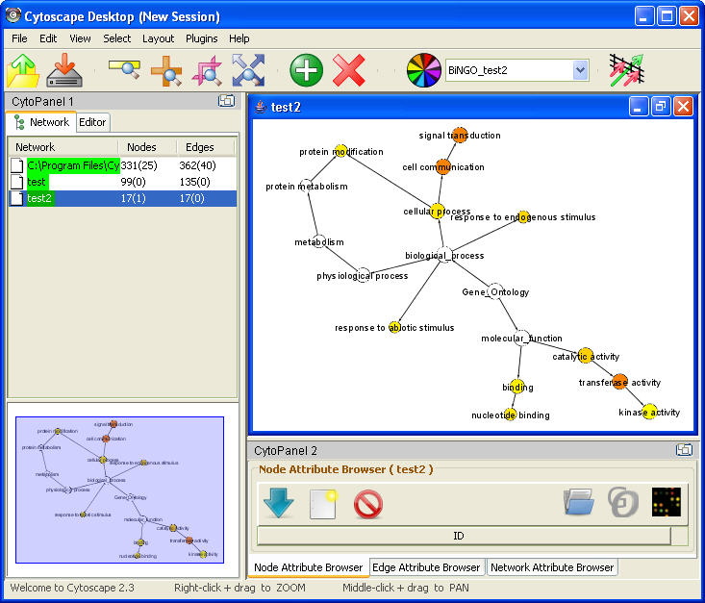
are significantly upregulated in a microarray experiment). The main advantage of BiNGO over other GO tools is the fact that it can be used directly and interactively on molecular interaction graphs. Another plus is that BiNGO takes full advantage of Cytoscape's versatile visualization environment. This allows you to produce customized high-quality figures.
Features include :
* assessing overrepresentation or underrepresentation of GO categories
* Graph or gene list input
* batch mode : analyze several clusters simultaneously using same
settings
* Different GO and GOSlim ontologies
* Wide range of organisms
* Evidence code filtering
* Hypergeometric or binomial test for overrepresentation
* Multiple testing correction using Bonferroni (FWER) or
Benjamini&Hochberg (FDR) correction
* Interactive visualization of results mapped on the GO hierarchy.
* extensive results in tab-delimited text file format
* making and using your own annotation files is easy
* open source

Literature Search - Hyperedges - Excentric Labels - Nature Protocols Workflow Panel - Gradient NodeViews
Presented: November 7th - third session - 14:00 - Conf hall 2
Developer(s): Allan Kuchinsky (allan_kuchinsky@agilent.com)
Institute: Agilent Technologies Inc.
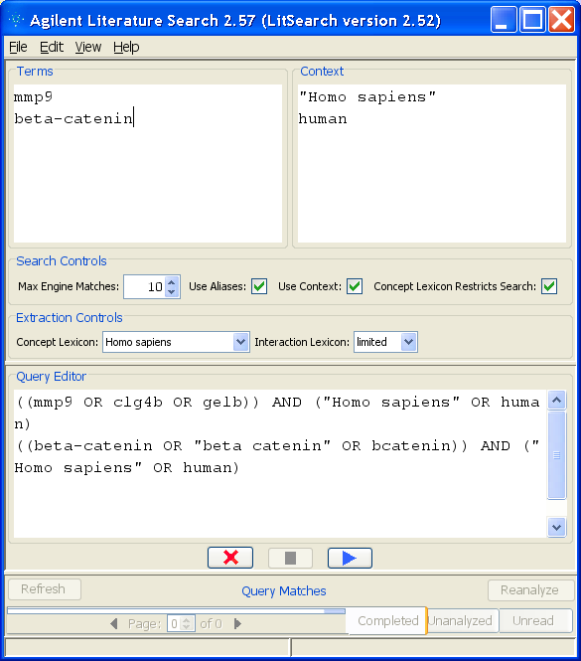
Reference: A. Vailaya, P. Bluvas, R. Kincaid, Allan Kuchinsky, M. L. Creech, A. Adler: “An architecture for biological information extraction and representation”. Bioinformatics 21(4): 430-438 (2005)
Plugin category: Network Inference, Functional Enhancement, Uncategorized
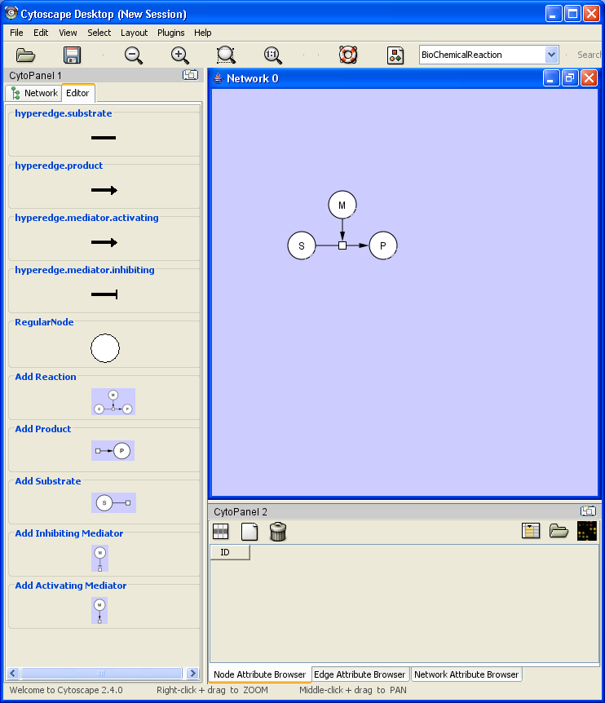
Description: (1). Agilent Literature Search is a meta-search tool for automatically querying multiple text-based search engines and extracting associations among genes/proteins of interest. Computationally extracted associations are grouped into a network that is viewed and manipulated in Cytoscape. In addition to Agilent Literature Search, I do some very quick demonstrations of plugins for enhanced expressiveness and usability in Cytoscape: (2) Hyperedges, an extension to the Cytoscape API and editor that allows for the construction and editing of biochemical networks and other networks where Edges may have more than one Node, (3) Excentric Labels: a dynamic technique of neighborhood labeling for data visualization. When the cursor stays more than one second over an area where objects are available, all labels in the neighborhood of the cursor are shown without overlap. This plugin was developed jointly with Ethan Cerami of MSKCC and based upon functionality in the InfoVis toolkit developed by Jean-Daniel Fekete at Inria, (4) Nature Protocols Workflow Panel, a vertical menu that presents to the user an ordered set of actions for importing networks, importing data, analyzing networks, and publishing results, as described in our Cytoscape publication in Nature Protocols, and (5) Gradient NodeViews, a plugin that uses Custom Node Graphics to provide a sense of depth to NodeViews via gradient color fill and beveled borders, as an approach towards publication-quality graphics output from Cytoscape. This is an early experiment and is work done with Ben Gross at MSKCC.
Figure 1: Agilent Literature Search

Figure 2: Hyperedge editor
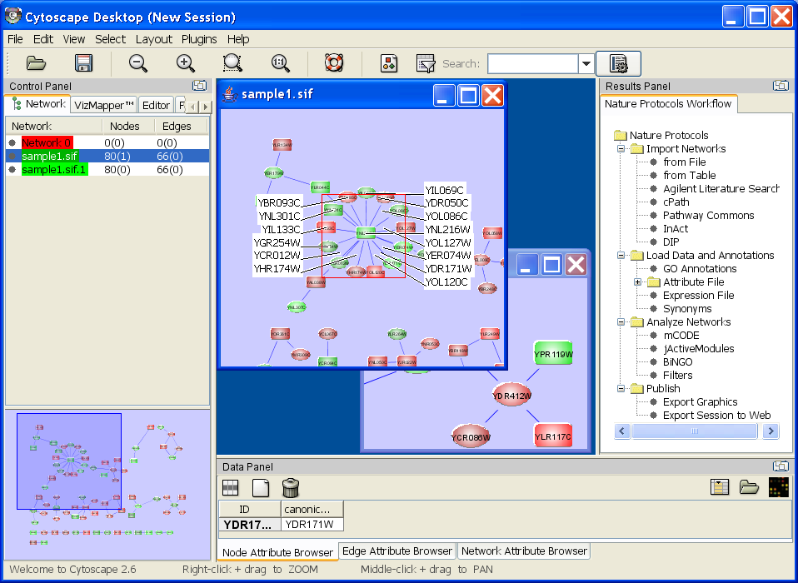
Figure 3: Gradient NodeViews, Excentric Labels, Nature Protocols Panel

VistaClara
Presented: November 7th - third session - 14:00 - Conf hall 2
Developer(s): Robert Kincaid (robert_kincaid@agilent.com)
Institute: Agilent Technologies Inc.
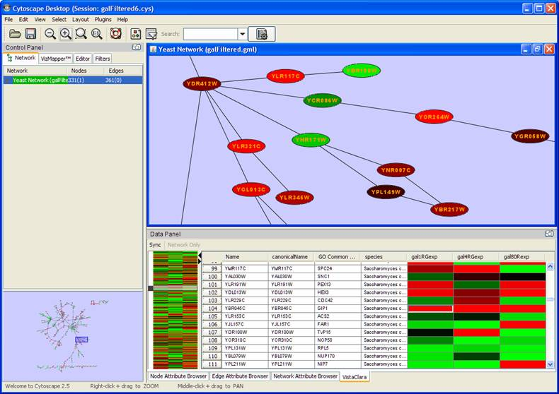
Reference: R. Kincaid, VistaClara: an interactive visualization for exploratory analysis of DNA microarrays, Proceedings of the 2004 ACM symposium on Applied computing, ACM Press, Nicosia, Cyprus 2004.
Plugin category: Functional Enrichment Plugins
Description: VistaClara was originally designed as a standalone tool for highly interactive visual analysis of gene and protein expression data. The VistaClara Plugin integrates this same functionality within Cytoscape as an additional data panel. The design employs a concept from the field of Information Visualization called the reorderable matrix. The familiar heat map view of expression data is used as the primary user interface, but also includes gene-based metadata. Such metadata might include ontology annotations, chromosome location, computational classifications, etc. Genes can be sorted by metadata columns or expression value. Experiments can be reordered as well. A graphical tabular view is coordinated with a condensed overview of the entire expression data set enabling the user to view both details and global context simultaneously. Single experiments can be quickly selected by simply clicking on a column header to cause that experiments color map to be projected onto the corresponding Cytoscape network view. This mechanism facilitates rapid selection and comparison of experiment data within the context of the network display. Selection of gene sets is synchronized between VistaClara and the active network view to allow rapid navigation of interesting features from either the expression or the network context.

Bioscape
Presented: November 7th - second session - 11:30 - Conf hall 2
Developer(s): Sabry Razick (sabry.razick@biotek.uio.no)
Institute: Biotechnology centre of Oslo, Norway
Reference: -
Plugin category: Network and Attribute I/O Plugins
Description: Communicates with the data-warehouse we are building. This plugin uses SOAP to send and receive information over network. It is useful to analyze interactions of a given protein. Special feature is it is capable of retrieving information on other proteins related to the given protein (same sequence, other proteins coded by the same gene etc..) and their interactions.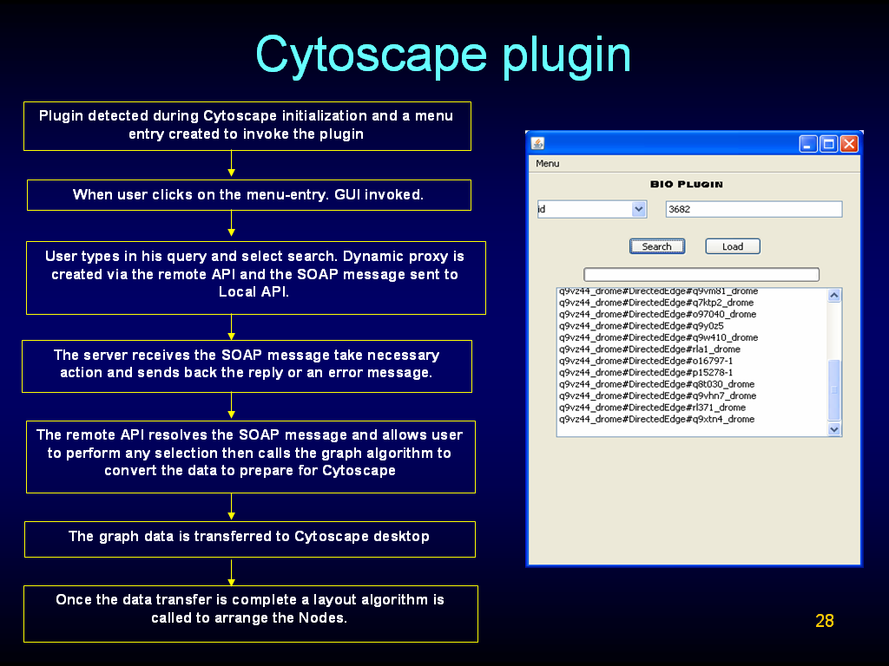

GPML plugin
Presented: November 7th - second session - 11:30 - Conf hall 2
Developer(s): Thomas Kelder (thomas.kelder@bigcat.unimaas.nl)
Institute: BigCat, Maastricht, the Netherlands
Reference:
Plugin category: Network and Attribute I/O Plugins
Description: The GPML plugin for Cytoscape is a converter between Cytoscape networks and the GPML (GenMAPP Pathway Markup Language) pathway format. Pathways in the GPML format are not restricted to nodes and edges, but can contain additional shapes and labels that serve as visual annotations. This plugin makes it possible to combine the facilities of Cytoscape and the pathway analysis tools GenMAPP and PathVisio to improve the current pathway content. The plugin provides copy/paste functionality to easily transfer (parts of) networks and pathways back and forth between these tools. It also enables Cytoscape users to include visual annotations in a Cytoscape network, for example to help interpretation or clarify images of the network for publication.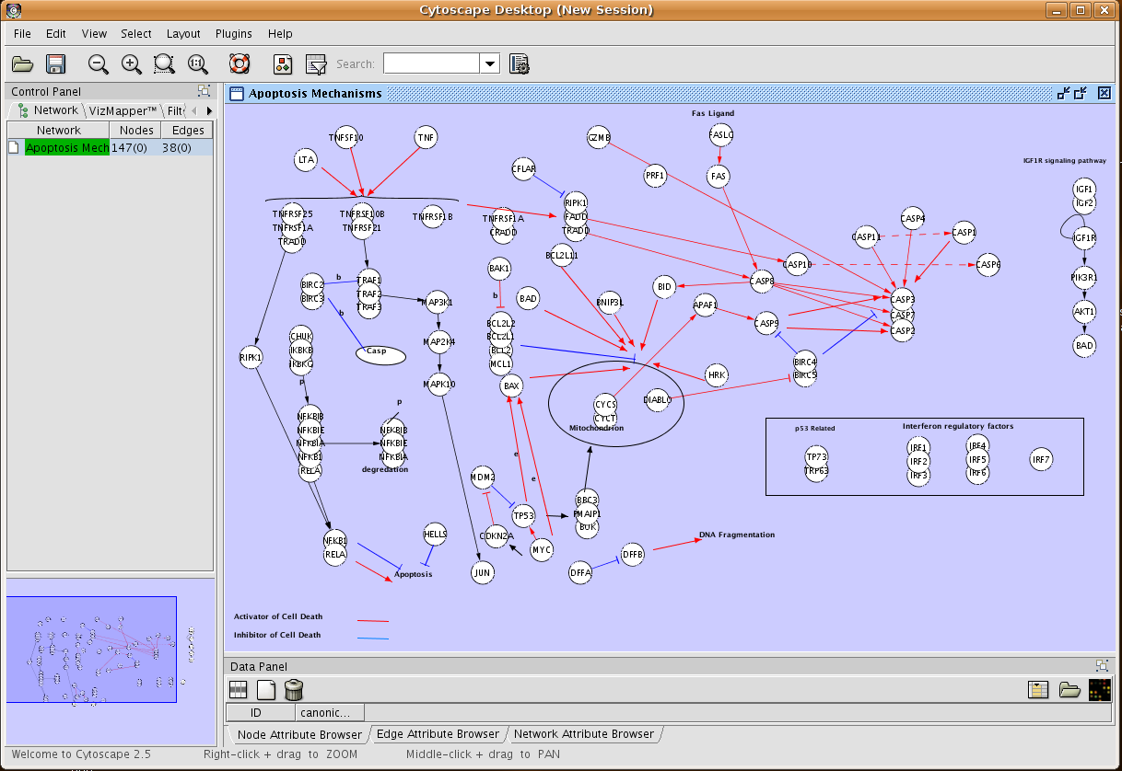

SgdInteractionsPlugin
Presented: November 7th - first session - 9:15 - Conf hall 2
Developer(s): Benjamin Hitz (hitz@genome.stanford.edu)
Institute: Stanford
Reference: -
Plugin category: Communication/Scripting Plugins
Description: An interface (in Perl) between the SGD database (interactions from BioGRID) and cytoscape using the XGMML format + webstart. The idea is to make cytoscape available to casual users of SGD, and to display networks (currently protein-protein physical & genetic interactions) in an informative and esthetically pleasing manner to someone who does not have to process files or learn the vizmapper.

NetworkAnalyzer - DomainGraph - BiLayout
Presented: November 7th - first session - 9:15 - Conf hall 2
Developer(s): Mario Albrecht (mario.albrecht@mpi-inf.mpg.de), Dorothea Emig
Institute: Max Planck Institute for Informatics, Saarbrucken, Germany
Reference: paper submitted, http://medbioinf.mpi-inf.mpg.de/
Plugin category: Analysis Plugins
Description: NetworkAnalyzer: Analysis of network topologies.
DomainGraph: Visualization of domain interaction graphs.
BiLayout: Layout of bipartite networks.
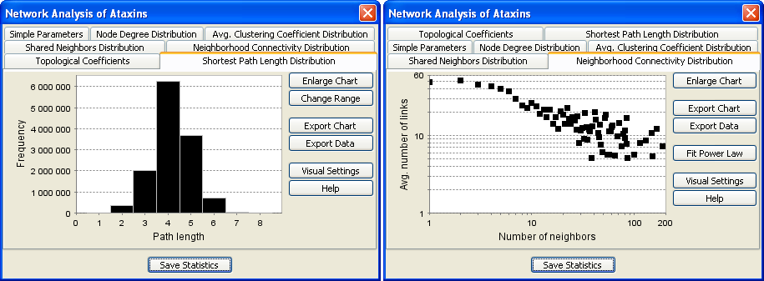

EnhancedSearch
Presented: November 7th - first session - 9:15 - Conf hall 2
Developer(s): Maital Ashkenazi (maitalik@gmail.com)
Institute: Google Summer of Code
Reference: http://conklinwolf.ucsf.edu/genmappwiki/Google_Summer_of_Code_2007/Maital
Plugin category: Analysis Plugins
Description: Cytoscape ESP (Enhanced Search Plugin) enables searching complex biological networks on multiple attribute fields using logical operators and wildcards. Queries use an intuitive syntax and simple search line interface. ESP complements existing search functions in Cytoscape, allowing users to easily identify nodes, edges and subgraphs of interest, even for very large networks. ESP is written in Java and based on the high performance open-source Lucene information retrieval library (http://lucene.apache.org/).

BubbleRouter
Presented: November 7th - third session - 14:00 - Conf hall 2
Developer(s): Alex Pico (apico@gladstone.ucsf.edu), Allan Kuchinsky, Kristina Hanspers, Nathan Salomonis
Institute: UCSF / Agilent Technologies Inc.
Reference:
Plugin category: Analysis Plugins
Description: You have a network or list of genes from an array study or literature search and you want to organize and layout the nodes in a biologically meaningful way. Instead of using the current layout algorithms that rely on network-based parameters, the Bubble Router plugin provides an interactive layout experience. You can draw rectangular regions anywhere on the canvas and then route nodes to the region by selecting an attribute and value from the available node attributes. You can also load and reference species-specific cellular component attributes that we've prepared and will distribute with the plugin, allowing layouts based on a compact set of cell compartments such as Nucleus, Cytoplasm, Extracellular, Plasma Membrane, etc. The BubbleRouter is also a test vehicle for two additional constructs we are experimenting with for Cytoscape: multi-layered canvas and arbitrary graphical annotations. The multi-layered canvas extends the current notion of a network view to also support FOREGROUND and BACKGROUND layers, which can be used to place annotations, background figures, etc. Arbitrary graphical annotations are graphical elements -- such as brackets, freestanding text, and arbitrary lines and shapes -- that are not tied to Cytoscape Nodes and Edges.
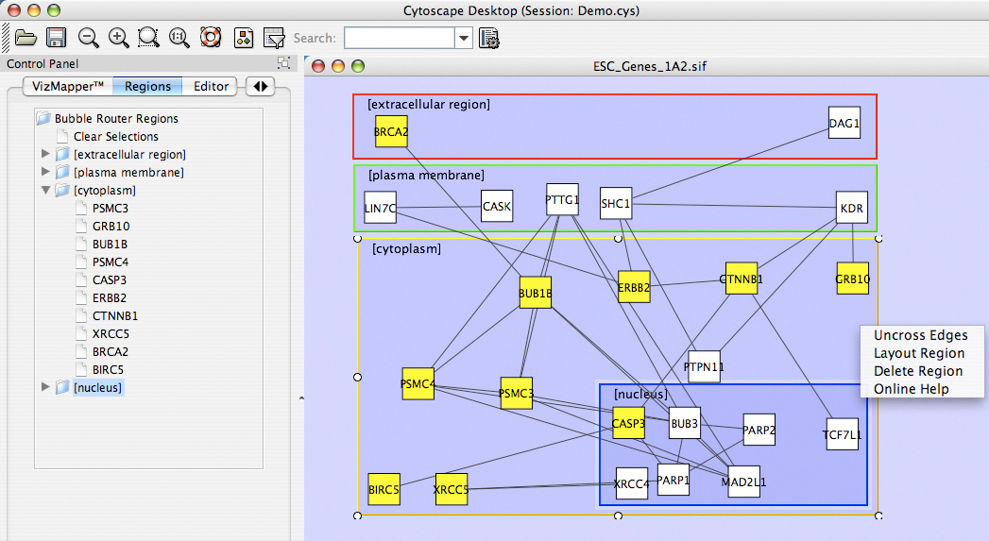

ReConn
Presented: November 7th - first session - 9:15 - Conf hall 2
Developer(s): Willem Ligtenberg (w.p.a.ligtenberg@tue.nl)
Institute: Technical University Eindhoven, Netherlands
Reference: http://bmi.bmt.tue.nl/reconn/
Plugin category: Network and Attribute I/O Plugins
Description: ReConn is a new JAVA plugin for Cytoscape to visualize pathway
information from Reactome in Cytoscape. ReConn is used for micro-array
data analysis, in silico knockout experiments and is a platform to make
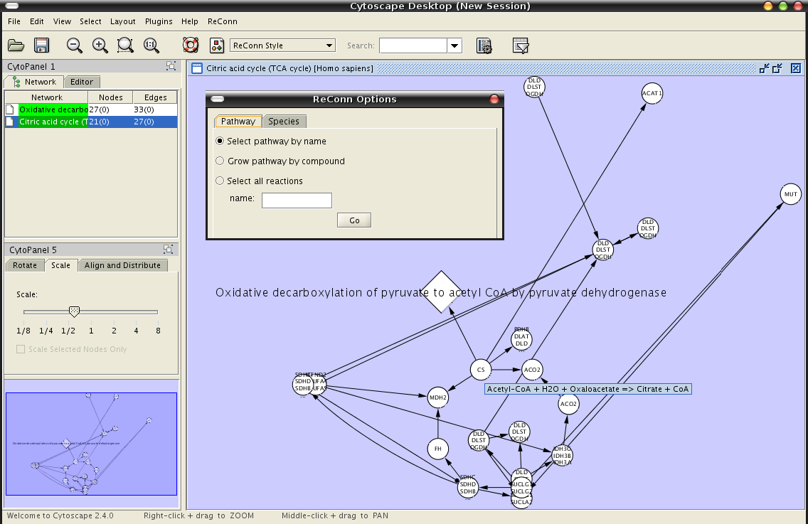
better use of the Reactome database schema. For example pathways can be grown from a compound and several organisms can be handled in one and the same view.

Cerebral
Presented: November 7th - first session - 9:15 - Conf hall 2
Developer(s): Aaron Barsky
Institute: Hancock Labs, University of British Columbia
Reference: http://www.pathogenomics.ca/cerebral/index.html ; Barsky A, Gardy JL, Hancock REW, and Munzner T. (2007) Cerebral: a Cytoscape plugin for layout of and interaction with biological networks using subcellular localization annotation. Bioinformatics 23(8):1040-2.
Plugin category: Analysis Plugins
Description: Cerebral (Cell Region-Based Rendering And Layout) is an open-source Java plugin for the Cytoscape biomolecular interaction viewer. Given an interaction network and subcellular localization annotation, Cerebral automatically generates a view of the network in the style of traditional pathway diagrams, providing an intuitive interface for the exploration of a biological pathway or system. The molecules are separated into layers according to their subcellular localization. Potential products or outcomes of the pathway can be shown at the bottom of the view, clustered according to any molecular attribute data - protein function - for example. Cerebral scales well to networks containing thousands of nodes. Version 2.0 will
allow microarray expression data analysis in the context of the
biomolecular interaction graph across multiple conditions.
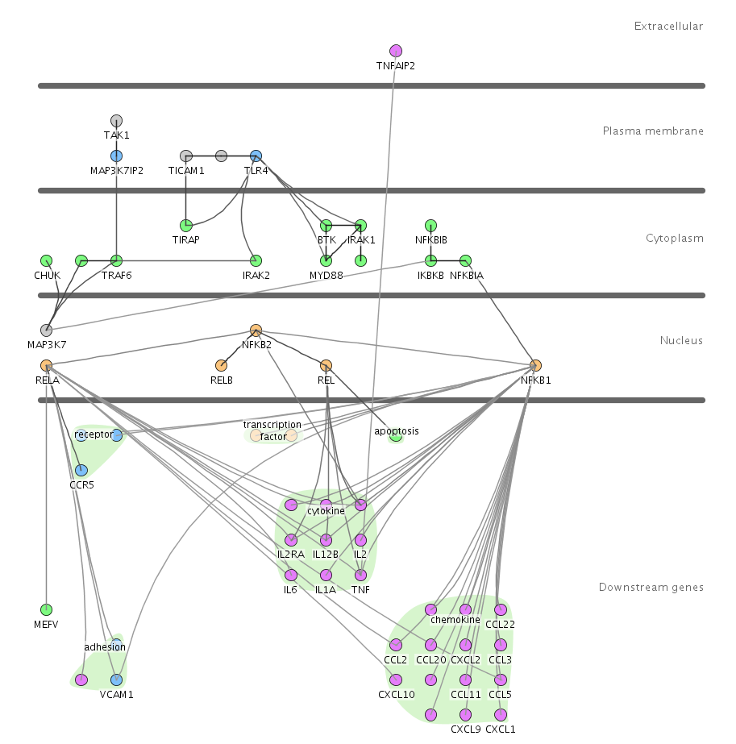

CyGroups - StructureViz - BatchTool
Presented: November 7th - last session - 16:10 - Conf hall 2
Developer(s): Scooter Morris (scooter@cgl.ucsf.edu)
Plugin category: Analysis, Functional enrichment, Network inference
Institute: UCSF

1: Structure-Function: SFLDLoader, structureViz
Reference: http://www.rbvi.ucsf.edu/Research/cytoscape; Morris J, Huang C, Babbitt P, and Ferrin T. (2007) structureViz: linking Cytoscape and UCSF Chimera. Bioinformatics 23(17): 2345-2347
Description: structureViz links the visualization of biological (and biological relationships expressed as networks) provided by Cytoscape with the visualization and analysis of macromolecular structures and sequences provided by the molecular visualization package: UCSF Chimera. structureViz uses node annotations to load appropriate structures into Chimera for visualization and analysis. If multiple structures are loaded, Chimera's alignment features may be used to compare the structures. The results of the alignment can be reflected back to the Cytoscape network by the addition of an edge, with the alignment scores added as edge attributes.
SFLDLoader provides an interface to the SFLD Database (http://sfld.rbvi.ucsf.edu) which is a highly curated database of protein superfamilies. XGMML networks downloaded from SFLD include structural information as well as sequence data that may be used by structureViz in addition to other tools.

2: CyGroups: metaNodes, namedSelections, and groupTool
Description: The new CyGroup capability within cytoscape provides the opportunity for the addition of significant functionality and visualizations that were not available (or very difficult) before. However, without group viewers, this functionality is not visible and hence of questionable utility. The namedSelectionPlugin is a group viewer that implements a simple model of groups: essentially the ability to "remember" a selected group of nodes for later reselection. The namedSelection viewer provides a JTree in CytoPanel 1 that can be used to view all of the members of a named selection, and individually select those nodes, or the entire group. The metaNodePlugin2 is a replacement for the original metaNode plugin that was developed by Iliana Avila-Compillo of the Institute for Systems Biology. metaNodePlugin2 uses the new CyGroup mechanism to implement a simple expand/contract view of groups. Finally, the groupTool plugin provides an interface to the underlying CyGroups, including providing the ability to switch the viewer associated with a group (or assign a viewer if one does not exist) and select the nodes, internal edges, or external edges of a group. The groupTool plugin is meant primarily as a tool for developers and advanced users.

3: BatchTool
Description: The batchTool plugin implements a rudimentary command language that may be used to automate some of the repetitive Cytoscape tasks. Currently, batchTool implements the following commands:
- apply mapName - applies the VizMap mapName to the current network
- exit - exits Cytoscape
- export network as [xgmml|gml|sif|psi-mi|psi-mi-1|pdf|svg|gif|png|jpg] to filename - exports the network in the indicated format to filename.
- export [edge attributes|node attributes] to filename - exports the appropriate attributes to an attributes file
- import [network|edge attributes|node attributes] filename - import the requested network or attributes file
- layout algorithm setting1=value1 setting2=value2... - lay the current network out using algorithm and with the provided settings. Note that only Cytoscape algorithms are supported (sorry, no Organic). Supported algorithms are: force-directed, grid, attributes-layout, hierarchical, circle, attribute-circle, degree-circle, isom, fruchterman-rheingold, and kamada-kawai.
- open session - open the session named session
- save [as filename] - save the session
Commands may be placed in a text file and run from the Cytoscape command line:
cytoscape.sh -S my_batch_file

MetNet
MetNet tools (subgraph, omicsviz)
Presented: November 7th - last session - 16:10 - Conf hall 2
Developer(s): Julie Dickerson (julied@iastate.edu), Josette Etzel, Kyongryun Lee, Rao
Institute: Iowa State University
Reference: http://metnet.vrac.iastate.edu/MetNet_fcmodeler.htm
Plugin category: Functional Enrichment
Description:
1: Subgraph: Functions for flexible subgraph creation, node identification, cycle finder, and path finder in directed and undirected graphs. It also has a function to select the p-neighborhood of a selected node or group of nodes which can be
selected by pathway name, node type, by a list in a file, cycles and/or pathways in
the network. This generates a set of plug-ins called: path and cycle finding, pneighborhoods and subgraph selection.
2: OmicsViz: Omics Data Translation and Viewing: the Pvals plug-in provides translation capabilities between different sets of node names such as probe sets and gene loci or between probe sets of different species. For example, probe sets from grape or soybean may be mapped onto probe sets for Arabidopsis. This allows users to see how their genes of interest map onto the pathways for Arabidopsis and to view the expression values.
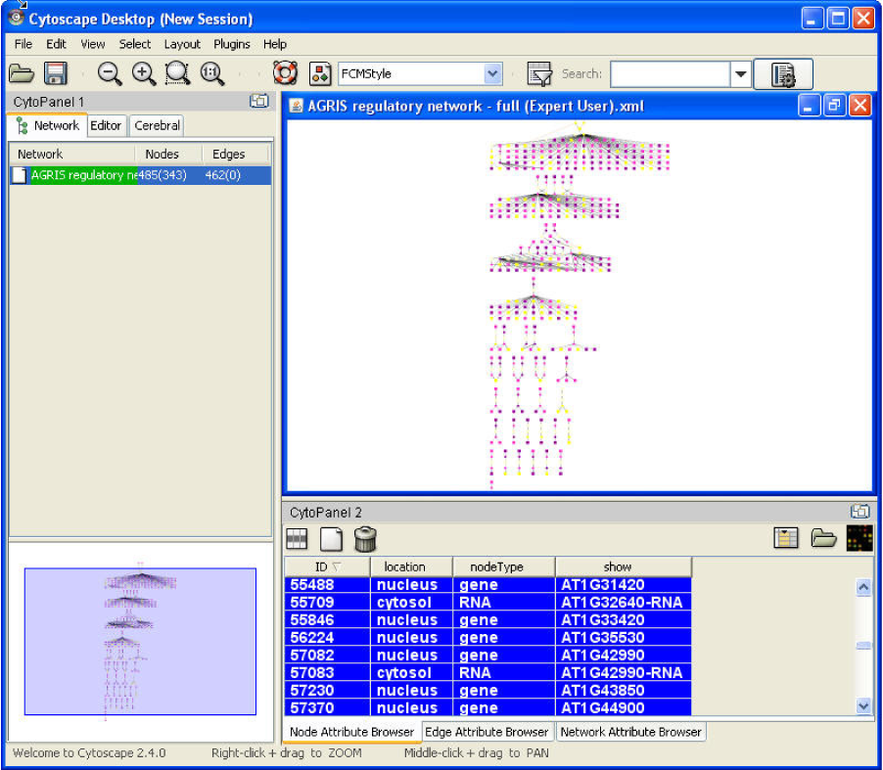

PathwayCommons - GoSlimmer - Thematic Map
Presented: November 7th - last session - 16:10 - Conf hall 2
Developer(s): Gary Bader (gary.bader@utoronto.ca) ea
Institute: University of Toronto
Reference: baderlab.org
Plugin category: Network IO, Functional Enrichment, Analysis
Description:
1: The Pathway Commons web start. Enables viewing pathways directly from the pathwaycommons.org website
2. The GO slimmer plugin, for creating a custom set of reduced GO terms
for analysis. Webstart available from http://yeastgenomics.ca/resources
3. The thematic map plugin, for linking attributes based on connectivity
between gene and protein products.

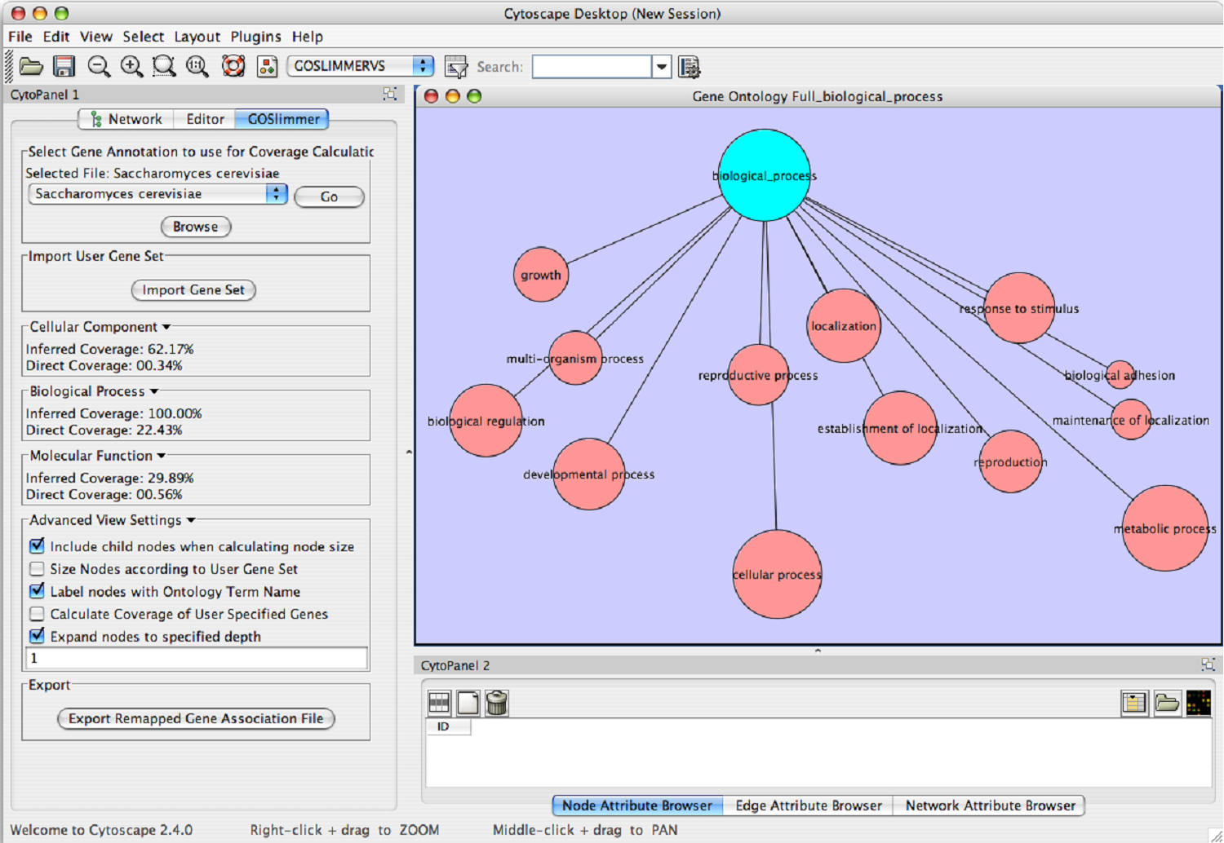

MIM (Molecular Interaction Map) Tools
(not a plugin yet)
Presented: November 7th - second session - 11:30 - Conf hall 2
Developer(s): E. Itir Karac (itir.karac@boun.edu.tr)
Institute: Bogazici University
Reference:
Plugin category: na
Description: Construction and drawing of biochemical networks in MIM
Notation and analysis of MIMs with graph theoretical algorithms. This will be implemented as a Cytoscape plugin in the near future

Metacore Integration
Presented: November 7th - second session - 11:30 - Conf hall 2
Developer(s): Eugene Rakhmatulin (eugr@genego.com)
Institute: GeneGo
Reference:
Plugin category: Network IO
Description: Communication with the commercially available network tool Metacore

EagleVista
Presented: November 7th - last session - 16:10 - Conf hall 2
Developer(s): Matthias Reimann (matthias.reimann@biotec.tu-dresden.de)
Institute:
Reference:
Plugin category: Analysis
Description: Through a novel visualization modules in networks can be detected and displayed in a way which reduces the number of edges significantly. As a result, complex networks can be displayed in a much more convenient way. The plugin includes a few algorithms to get the new visualization from a ordinary graph in cytoscape.

Vispara
(VISualization / PARAlogues)
Presented: November 7th - third session - 14:00 - Conf hall 2
Developer(s): Christoph Schwarz ea (Christoph.Schwarz.Mat@googlemail.com)
Institute:
Reference: www.vispara.org
Plugin category: Analysis
Description: The Vispara plugin is designed to bypass Cytoscape's restriction that nodes can only have one of eight predefined shapes, e.g. circles or rectangles.
More precisely it changes the appearance of the nodes in a network
representing protein interactions so that the paralogue distribution of the
proteins can be identified by their sheer looks. This is achieved by defining a visual style which covers the original nodeviews and by adding custom graphics to the single nodeviews. These custom graphics are basically common java.awt.shapes which are calculated based on the paralogous distribution of the particular proteins.

BioEdge
Presented: November 7th - second session - 11:20 - Conf hall 2
Developer(s): Yves Deville (Yves.Deville@uclouvain.be)
Institute: Comp. Science & Engineering Dpt Univ. Cath. Louvain
Reference: http://bioedge.info.ucl.ac.be
Plugin category: Analysis
Description: BioEdge is a set of tools dedicated to the analysis of (biological) networks.
The current functionalities of BioEdge tools are:
- Statistical summary of a network: average (in/out) degree, number of (weak/strong) connected components...
- Pathway inference with (constrained) shortest paths approach.
- Extraction of (weak/strong) connected components.
- Extraction of context of subgraphs (pathways).
- Motif detection.
- Extraction of relevant subgraph.

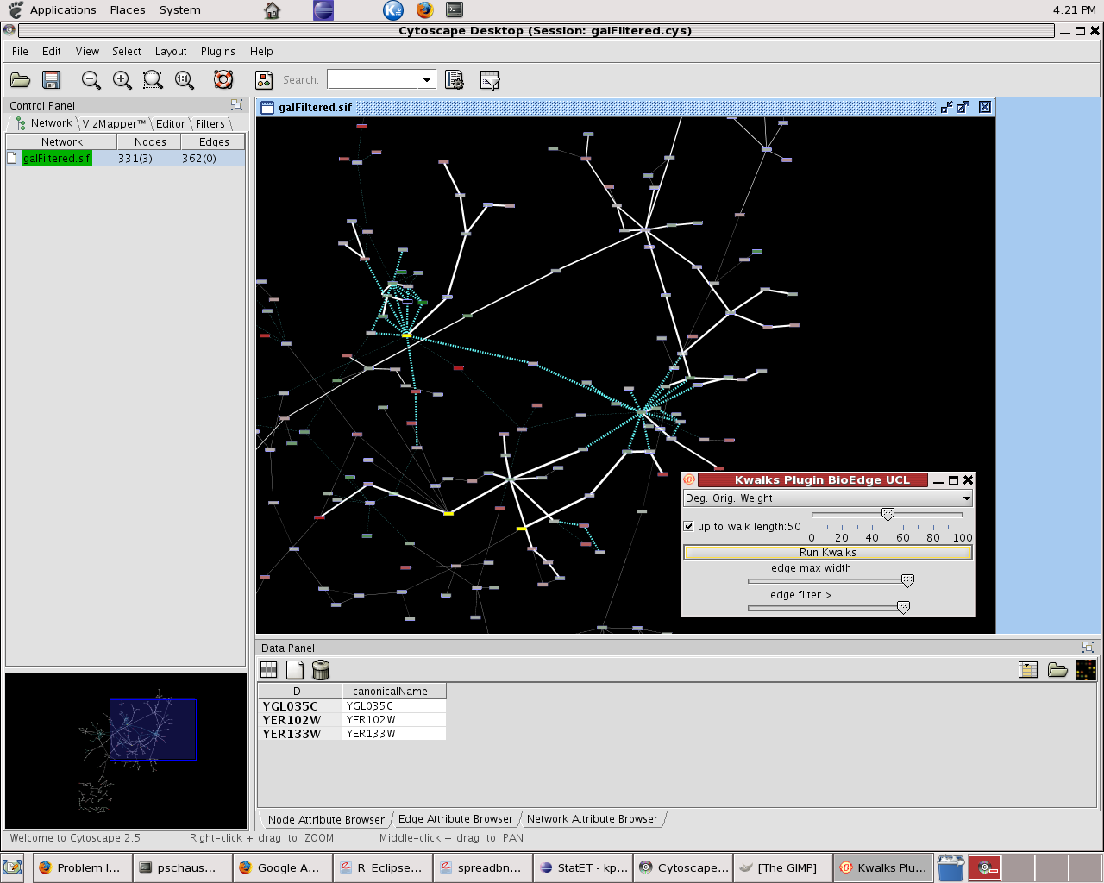

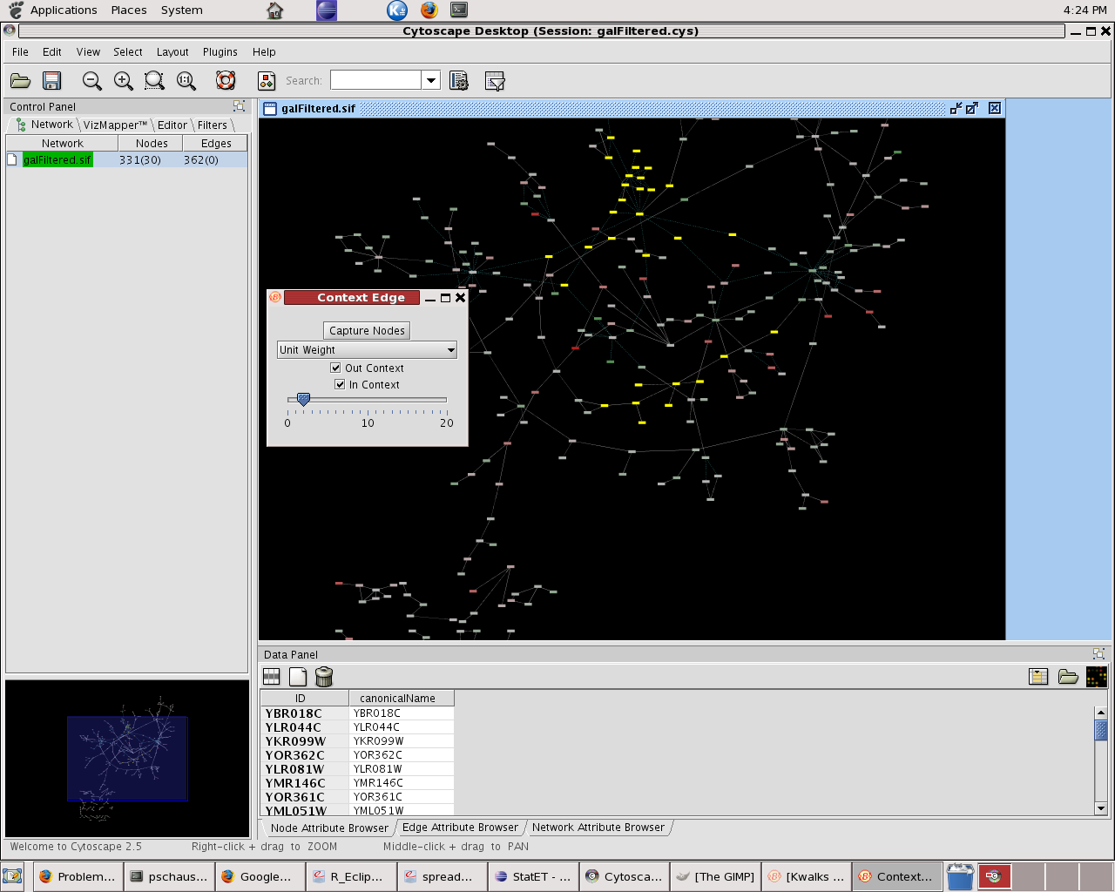

Tutorials

Cytoscape Tutorials

Name and contact information for tutors
Guy Warner, Safety & Environmental Assurance Centre, Unilever, Colworth Park, Sharnbrook, Bedfordshire MK44 1LQ. Guy.Warner@unilever.com
Andrew Garrow, Safety & Environmental Assurance Centre, Unilever, Colworth Park, Sharnbrook, Bedfordshire MK44 1LQ. Andrew.Garrow@unilever.com
Yeyejide Adeleye, Safety & Environmental Assurance Centre, Unilever, Colworth Park, Sharnbrook, Bedfordshire MK44 1LQ. Yeyejide.Adeleye@unilever.com

Length of tutorial
1.5 – 2 hours

Audience
The intended audience is end users for the software i.e. scientific researchers in fields such as bioinformatics, computational biology, molecular biology and ‘omics.

Background required
Basic understanding of molecular biology, knowledge of publicly available bioinformatics databases and some experience of gene expression analysis (or any high-throughput data analysis) is desirable but not essential

Relevance of the tutorial and interest to the community
Traditionally, the results of HTP data analysis are a list of bio-molecules that are believed to be significantly differentially expressed between experimental conditions. As data become more complex (e.g. time series data), statistical approaches such as clustering and classification have been used to reveal patterns within a data set.
However, statistical analyses of gene expression data (and any molecular state data) that list differentially expressed genes may not be sufficient to allow researchers to generate new hypothesis and to gain insights into mechanisms underlying the conditions and systems being investigated.
This is because cellular processes are carried out not through individual bio-molecules but via complex interactions between genes, proteins and metabolites: that is, through biological networks. Understanding this organisation and analysing molecular state data in the context of biological networks is crucial to obtaining a picture of cellular activity.
Cytoscape is an open-source software package for the visualisation and analysis of biological networks and the integration of molecular state data. Cytoscape provides functionality to layout and search networks; to visually integrate networks with expression profiles, phenotypes, and other molecular states; and to link to databases of functional annotations.
In this tutorial we hope to provide an introduction to network-based analysis using the Cytoscape software that will be of relevance to researchers with an interest in the analysis of biological data in the context of biological networks and pathways.

Tutorial Overview
1. Introduction to Cytoscape Graphical User Interface:
This section will introduce the Cytoscape UI and the central organising metaphors of Cytoscape such as: A network consists of genes/proteins/metabolites (nodes) and interactions represented as links (edges between nodes).
The introduction will also include an overview of Cytoscape’s core and extended functionality.

2. Constructing and Loading Biological Networks into Cytoscape:
This section will describe how to construct and load biological networks and associated annotations. Networks can be constructed from interaction data found in databases such as BIND, DIP and HPRD. Integrating data from these databases is a major bioinformatics challenge and will not be covered in this tutorial however certain Cytoscape plug-ins can be used to retrieve data from external sources and even directly from literature (Agilent Literature Plugin). Suitable biological networks will be provided for participants.
Concepts of annotating nodes (e.g. with Gene Ontology information) & edges (e.g. published evidence for interactions) and the ability to link out to external sources of information will be covered.
File formats; Saving sessions; Exporting visualisations; etc will also be covered.

3. Visualisation and Analysis of Biological Networks:
After loading a biological network and associated annotations, participants will be shown how to visualise and manipulate networks using the various graphical layout algorithms available in Cytoscape.
The ability to set visual aspects of the nodes and edges (e.g. shape, colour, size) based on attribute values will be demonstrated.
Biological networks can be very large and complex, therefore participants will be shown how to reduce this complexity using some of Cytoscape’s functionality. For example: identifying highly connected regions of the network (MCODE); determining shortest paths between nodes of interest.
Also included within this section would be how to query biological networks using Cytoscape search functions.

4. Integration of Molecular State Data with Biological Networks:
This section will cover the integration of molecular state data onto biological networks in order to analyse high throughput data in a biological context. DNA microarray data will be used as an example throughout the tutorial however, it should be noted that any type of data can be used.
A certain amount of processing (normalisation, quality control, differential gene expression analysis) is required prior to loading any expression data into Cytoscape. These topics are out of scope for this tutorial but suitable datasets will be provided to participants. File formats for the expression data will be discussed.
After integrating molecular state data with biological networks, participants will be shown how to use visual styles (e.g. colouring nodes by expression values, node size according to P-values etc) to aid network analysis and visualisation.

5. Advanced Sub-network Identification (Data driven):
Participants will be show how to find sub-networks of importance by searching the network to identify regions of importance using Cytoscape’s filtering capabilities.
Other more complex methods of sub-network identification using both expression and interaction data will be covered: The jActiveModules Plugin is used to identify ‘active’ sub-networks containing genes (nodes) that are not only significantly expressed (over particular conditions) but that are also highly connected. In this way, areas of the network affected by a particular experimental condition can be identified.

6. Questions and Answer Session (10 mins):
Brief Q&A session to wrap-up the tutorial and provide further support to delegates as necessary.

Developer Tutorials

CyGroups - Layouts
Tutorial: CyGroups and Implementing a CyGroupViewer
Tutor: Scooter Morris
Description: This tutorial will introduce the new CyGroups mechanism in Cytoscape and walk through the implementation of a CyGroupViewer. The namedSelection and metaNodePlugin2 group viewers will be used as examples.
Tutorial: Layouts - how to implement a new layout algorithm in cytoscape
Tutor: Scooter Morris
Description: This tutorial will walk through some of the steps required to implement a new layout algorithm into Cytoscape. It will cover the CyLayoutAlgorithm interface and the AbstractLayout class that can be used as a starting point. We will also cover the new "Tunables" approach to constructing a Settings panel for users to use to tune the algorithm.

Vizmapper
Tutorial: Vizmapper -- how to adapt visual properties of Cytoscape programmatically
Tutor: Keichiri Ono
Description: t.b.a.

Webservices
Tutorial: Webservices -- how to use the newly developed webservices api.
Tutor: Keichiri Ono
Description: t.b.a.

Scientific Advisory Board

Joel Bader
Position/Title/Institute: Assistant Professor - Whitaker Biomedical Engineering Institute - Whiting School of Engineering - Johns Hopkins University

Biography / Awards: (Source: http://www.hopkinsmedicine.org/ibbs/research/TCNP/investigators/bader/bader-tcnp_biosk.pdf)
2003-current, Assistant Professor, High Throughput Biology (HiT) Center (within the Institute of Basic Biomedical Sciences) and Department of Biomedical Engineering, Johns Hopkins University
1995-2003, Curagen Corporation
1992-95, Post-Doctoral Position, Columbia University, Theoretical Chemistry
1991, Ph.D., University of California, Berkeley, Theoretical Chemistry
1986, B.S., Lehigh University, Biochemistry

Dr. Bader’s research interest’s focus on wiring diagrams for cells and organisms, anchoring protein pathways with genetic screens, evolution of biological networks, synthetic biology, and computational systems biology. See: http://macbeth.clark.jhu.edu/baderlab/index.php/Main_Page

Ewan Birney
For a resume see chapter 3.

Hamid Bolouri
Position/Title/Institute: Visiting Associate Faculty (& Professor) California Institute of Technology

Biography / Awards: Hamid Bolouri is visiting associate faculty in the division of biology at the California Institute of Technology. He co-founded and led the development of
- the Systems Biology Markup Language (SBML.org)
- the BioTapestry (BioTapestry.org) and Dizzy
(http://magnet.systemsbiology.net/software/Dizzy/) programs for modeling genetic regulatory networks
- the BioArray software (licensed to Genetix plc, Genetix.com) for processing images from spotted nylon macroarrays.
Bolouri was Professor of Computational Biology at the Institute for Systems Biology 2002-2005, and Professor of Neural Systems at the University of Hertfordshire, UK 1998-2002.

Nevan Krogan
Position/Title/Institute: Assistant Research- Biochemist, University of California, San Francisco
Biography / Awards: (Source: http://kroganlab-cmp.ucsf.edu/)
2006 Assistant Professor, Department of Cellular and Molecular Pharmacology, University of California, San Francisco
2005 - PhD, University of Toronto, Toronto, Canada
1999 - MSc (Cell Biology), University of Regina,Regina, Saskatchewan, Canada
1997 - BSc, University of Regina,Regina, Saskatchewan, Canada
Dr. Krogan’s research focuses on the development of tools that allows for the generation, analysis and visualization of large-scale, quantitative genetic and physical interaction maps with the ultimate goal of further understanding cell physiology. His work has primarily been targeted towards simpler systems such as S. cerevisiae, S. pombe and E. coli but his intention is to extend this research to multiple-cellular organisms.
He uses these maps to formulate hypotheses about various biological processes, including transcriptional regulation, DNA repair/replication and RNA processing, that we ultimately test.
His lab also develops tools and software to help facilitate integration and navigation of these different datasets with the ultimate goal of further understanding cell physiology.

Manuel Peitsch
Position/Title/Institute: Professor Manuel Peitsch - Global Head of Systems Biology, Novartis Institute for BioMedical Research

Biography / Awards: Prof. Manuel C. Peitsch, Ph.D. has been the Global Head of Systems Biology at the Novartis Institutes for BioMedical Research since May 2005. In this position, he directs a department spanning experimental sciences (Proteomics), Computational Systems Biology, Computational Knowledge Management and Text Mining as well as Information Sciences. Prior to his current position, Manuel was the Global Head of Informatics and Knowledge Management for Novartis. Before joining Novartis, Manuel was Global Head of Scientific Computing for GlaxoWellcome from 1997 to 2000 when he became Global Head of Informatics and Knowledge Management for GSK R&D. When he joined the industry in 1994 he was responsible for setting up Bioinformatics at the Glaxo Institute for Molecular Biology in Geneva.
In 1997 Manuel co-founded the start-up company Geneva Bioinformatics and a new research site for GlaxoWellcome in Geneva. In 1998 he co-founded the Swiss Institute of Bioinformatics and later played a crucial role in extending this institute to Basel. In 2003 he co-founded the SwissBioGRID.
Manuel obtained his M.S. (Biology and Physical Chemistry) and Ph.D. (Biochemistry) from the University of Lausanne in Switzerland. He spent his post-doctoral years at the National Cancer Institute of the NIH (Dr. J. V. Maizel Jr) and at the University of Lausanne (Prof. J. Tschopp). Since 2002 he was a professor for Bioinformatics with the University of Basel.
In addition to his work at Novartis, Manuel serves on several boards, including the Research Council of the Swiss National Science Foundation and as the President of the Executive Board of the Swiss Institute of Bioinformatics.

Ilya Shmulevich
Position/Title/Institute: Associate Professor - Institute for Systems Biology

Biography / Awards: Dr. Shmulevich joined the ISB faculty in April 2005. His work focuses on the computational, mathematical, and statistical aspects of systems biology, complex systems theory, and applications of signal processing and machine learning to genomics and proteomics. A major emphasis of his work has been on building models that capture the complex dynamical interplay of genes interacting in genetic networks, developing statistically robust and computationally efficient methods for inferring such multivariate relationships between genes from measurement data, and using the inferred models to make predictions about the dynamical behavior of genes.

This has resulted in a class of models called Probabilistic Boolean Networks, which have been used in studies involving melanoma and glioma by Dr. Shmulevich and colleagues at M. D. Anderson Cancer Center, Texas A&M University, Houston, TX, and the Translational Genomics Research Institute, Phoenix, AZ. He is currently leading a five-year effort, with support from NIGMS, to further develop and refine these mathematical and computational methods and models, while closely integrating computational and experimental approaches.

The overarching goal of this research direction is to improve our understanding of how a cell´s behavior is governed by a complex dynamical system of genetic interactions and how these systems fail in disease, such as cancer. In a related project, also supported by NIGMS, Dr. Shmulevich, together with colleagues at the M. D. Anderson Cancer Center and the Institute for Biocomplexity and Informatics at the University of Calgary, are studying the processes of cellular differentiation and homeostasis from a dynamical systems perspective, using human promyelocytic leukemia cells (HL60) as a model system.

Another emphasis is on the development of algorithms and statistical methods for classifying subtypes of cancers on the basis of their transcriptional profiles, especially when such classification is clinically significant in terms of survival or response to therapy, but difficult or impossible to achieve by traditional histopathological assays. An important aspect of this work is the design of robust classification algorithms that have high predictive accuracy and do not suffer from overfitting, especially in the context of small sample sizes often encountered in clinical studies.

Dr. Shmulevich also has been actively involved in developing and improving new and existing high-throughput technologies for measuring gene and protein expression, with an emphasis on measurement accuracy and quality control. These efforts resulted in the development of so-called composite microarrays, robust methods for quantifying protein expression with protein lysate microarrays, and a co-authored book on microarray quality control.

Ilya received his Ph.D. degree in Electrical and Computer Engineering from Purdue University, West Lafayette, IN, USA, in 1997. In 1997-1998, he was a postdoctoral researcher at the Nijmegen Institute for Cognition and Information at the University of Nijmegen and National Research Institute for Mathematics and Computer Science at the University of Amsterdam in The Netherlands, where he studied computational models of music perception and recognition. In 1998-2000, he worked as a senior researcher at the Institute of Signal Processing in Tampere University of Technology, Tampere, Finland. Prior to joining the ISB, he was an Assistant Professor in the Department of Pathology at The University of Texas M. D. Anderson Cancer Center and also held an Adjunct Professor position in the Department of Statistics in Rice University.

David J. States
Position/Title/Institute: Professor Human Genetics, Department of Human Genetics, Director, Bioinformatics Training Program University of Michigan Medical School

Biography / Awards:
Harvard College Scholar, graduate of Harvard College with magnu cum laude honors
Dreyfus Foundation Summer Undergraduate Research Fellowship, Harvard College
NIH Medical Scientist Training Program Fellowship for M.D., Ph.D., Harvard Medical
School
Howard Hughes Medical Research Fellowship with Prof. Laurence Kedes, Stanford
University
Member of Strathmore's Who's Who
Nominated for membership in the American College of Medical Informatics

Marc Vidal
Position/Title/Institute: Associate Professor, Dana-Farber Cancer Institute, Department of Cancer Biology

Biography / Awards: Dr. Vidal received his PhD in 1991 from Gembloux University (Belgium) for work performed at Northwestern University. He identified the yeast genes SIN3 and RPD3, and demonstrated that they encode global transcriptional regulators. During postdoctoral training at the Massachusetts General Hospital Cancer Center, he developed the reverse two-hybrid system to genetically characterize protein-protein interactions. In 2000, he joined DFCI, where his research focuses on understanding global and local properties of interactome networks.

Recent Awards
Chaire Francqui, Fondation Francqui, Belgium, 2005
Abbott Bioresearch Award, Boston, MA, 2003
Chercheur Qualifiee du Fonds National de la Recherche Scientifique (Belgium), Permanent Position, 1997

Board of Directors

Trey Ideker, President
For a resume see chapter 3.

Gary Bader, Vice President

Position/Title/Institute: Assistant Professor, Banting and Best Department of Medical Research
Terrence Donnelly Centre for Cellular and Biomolecular Research (CCBR), University of Toronto
Associate Investigator, Samuel Lunenfeld Research Institute, Mount Sinai Hospital

Biography / Awards: Gary D. Bader works on biological network analysis and pathway information resources as an Assistant Professor at the Terrence Donnelly Centre for Cellular and Biomolecular Research (CCBR) at the University of Toronto. He recently completed post-doctoral work in the group of Chris Sander in the Computational Biology Center (cBio) at Memorial Sloan-Kettering Cancer Center in New York. Gary developed the Biomolecular Interaction Network Database (BIND) during his Ph.D. in the lab of Christopher Hogue in the Department of Biochemistry at the University of Toronto and the Samuel Lunenfeld Research Institute at Mount Sinai Hospital in Toronto. He completed a B.Sc. in Biochemistry at McGill University in Montreal. Gary was born in South Africa, but grew up in Canada. See http://baderlab.org

Louis Coffman, Secretary/Treasurer

Chris Sander
For a resume see chapter 3.

Leroy Hood
For a resume see chapter 3.

Benno Schwikowski
For a resume see chapter 3.

Guy Warner

Position/Title/Institute: Group Leader, Bioinformatics & Systems Biology, Safety and Environmental Assurance Centre, Unilever

Biography / Awards: In 2001, following a PhD in Bioinformatics at the University of Leeds, Guy Warner joined Unilever Corporate Research as a Bioinformatician where he worked on coronary heart disease risk prediction and the epidemiology of ageing.

Since 2004 he has been leading the Bioinformatics & Systems Biology group in Unilever’s Safety and Environmental Assurance Centre (SEAC). Unilever are committed to developing improved approaches for Safety Assessment and part of this work involves the delivery and application of new analytical technologies and modeling approaches in the areas of Risk Assessment & Toxicology. In this work, Guy is responsible for efforts to analyse and model toxicological processes in humans. A wide range of expertise is therefore needed, spanning the areas of fundamental biology, toxicology, computational science and mathematical modeling. In this respect, Guy is greatly supported by the other members of the group and SEAC as a whole.

Specific activities include the application of a Systems Biology platform for the integration and mining of public and commercial pathway databases to model inflammatory process in Human; development of an organisation-wide Informatics platform for importing, storing, manipulating and exporting clinical and multi-omics data; In silico modeling of immunological processes and subsequent generation & evaluation of hypotheses; and Genomic Phenotyping for the elucidation of carcinogen-induced toxicity

Guy is a member of several academic and industrial networks including the Cytoscape Board of Directors; the European Bioinformatics Institute, Industry Partners Group; Dutch ToxicoGenomics Initiative, Steering Group; and several EU Framework Projects. He is also responsible for collaborations with key academic groups such as UCSD (Cytoscape) and MIT (Genomic Phenotyping).

Annette Adler
Position/Title/Institute: Manager, Systems Biology Program, Agilent Labs, Agilent Technologies, Inc.

Biography / Awards: Annette Adler joined Agilent Labs in 2000 to lead their new bioinformatics program, following over 20 years studying users, most recently 8 years at Xerox PARC where she was a Principal Scientist working on technology-mediated collaboration and systems architecture.

Since 2004 she has led the Systems Biology program within Agilent Labs, including proteomics, metabolomics, primary informatics and systems informatics. Her own research interests include annotation, the handling of biological time and location and how different needs of different types of scientists working together can best be served.

Bruce Conklin
Position/Title/Institute: Senior Investigator, Gladstone Institute of Cardiovascular Disease
Professor Department of Medicine, University of California, San Francisco

Biography / Awards: Dr. Bruce Conklin uses genetics and molecular biology to investigate basic issues in molecular pharmacology (how drugs work). Specifically, he studies how G protein-coupled receptors (GPCRs) control processes including heart rate and the development of embryonic stem cells. In the heart, brain, and other tissues GPCRs orchestrate hundreds of biological processes such as vision and memory. GPCRs are often the target of drugs, with over half of the world’s pharmaceutical sales working via this mechanism. To better understand how GPCRs work, the Conklin laboratory made a series of new GPCRs that allow novel control mechanism in transgenic animals. These new receptors are called RASSLs (receptors activated solely by a synthetic ligand) and are beginning used for studies that range from taste perception to bone growth. Dr. Conklin’s interest in genomics led to the development of a freely distributed software package called GenMAPP that allows for the rapid analysis of large amounts of genetic data in the context of known biochemical or signaling pathways (see www.GenMAPP.org). Over 15,000 people world-wide have registered to use this free open source software.
Dr. Conklin received his A.B. in public health from the University of California, Berkeley in 1982. He completed his M.D. at Case Western Reserve University in Cleveland in 1988. During his last two years of medical school, he had the privilege of working in the laboratory of Nobel laureate Dr. Julius Axelrod at the National Institutes of Health. He then completed his residency at the Johns Hopkins Hospital and a postdoctoral fellowship in the laboratory of Dr. Henry Bourne at the University of California, San Francisco (UCSF).
Dr. Conklin was the founding director of the Gladstone Genomics Core and is currently the founding director of the Gladstone Stem Cell Core. He is a professor of medicine and of cellular and molecular pharmacology at UCSF. From 1995 to 2001, Dr. Conklin was the associate director of the General Clinical Resource Center at San Francisco General Hospital. In 2003 he was inducted into the American Society for Clinical Investigation. He is an active member of four different graduate student programs at UCSF. Dr. Conklin is also involved in public science education which includes the establishment of the San Francisco Exploratorium Stem Cell exhibit.

Acknowledgements

Organization Committee
Piet Molenaar – Academic Medical Center, Amsterdam
Annette Adler - Agilent Technologies Inc.
Guy Warner - Unilever

Organization support
Monique Stam - AMC
Eelco Roos - AMC

...and a big thank you for all help we received from individual people from the Cytoscape Community, NBIC and AMC Human Genetics!!!

Sponsors
Unilever
Agilent Technologies Inc
AstraZeneca
Netherlands Bioinformatics Center
Cytoscape Consortium



Notes
Following pages are reserved for your notes....

