Supplementary Methods
Data sources. We assembled protein-protein interaction networks for Plasmodium falciparum¹, the budding yeast Saccharomyces cerevisiae², the nematode worm Caenorhabditis elegans³, the fruit fly Drosophila melanogaster⁴, and the bacterial pathogen Helicobacter pylori⁵ in the context of the Cytoscape network visualization and modeling environment⁶. Annotation and amino-acid sequence of each interacting protein in Plasmodium was obtained from PlasmoDB⁷. To obtain data for other species, we downloaded interactions from the Database of Interacting Proteins (DIP)² as of December 2004. The yeast interactions were attributed to a combination of two-hybrid studies^{8,9}, co-immunoprecipitation studies^{10,11}, and classical small-scale experiments. Interaction sets for worm, fly, and bacteria were each drawn from single two-hybrid studies³⁻⁵. Corresponding protein sequences were obtained from the Saccharomyces Genome Database¹², WormBase¹³, FlyBase¹⁴, or The Institute for Genomic Research (TIGR)¹⁴, respectively.
Interaction confidence scores. Analysis of protein networks is complicated by false-positive interactions¹⁵. We estimate our confidence that each measured protein interaction is true using a probability score similar to a method employed by Bader et al.¹⁶ In addition to the small world topological characteristic¹⁷ used in that method, we also assign confidence based on mRNA expression correlation between interacting pairs of proteins¹⁸ and the number of times the interaction was observed experimentally. For yeast, worm and fly, mRNA expression data was obtained from the Stanford Array Database¹⁹ as of 5/01/2004. Expression correlation among P. falciparum genes was estimated from 48 arrays of mRNA expression collected across the different lifecycle stages by Bozdech et al.²⁰ The overall probability of an interaction was given by fitting the above factors to a logarithmic distribution, as described²¹. We call this method ‘Modified Bader’.
In order to test the biological significance of the confidence scores we assign, we assessed the enrichment for biological function of yeast single-species complexes generated by our method using three different confidence scores: a set of equal confidences assigned to each interaction, those confidence scores generated by Bader et al¹⁶, and the Modified Bader confidences. We assessed the biological significance of each resulting set of complexes by its enrichment for Gene Ontological²² functions using a hyper-geometric test²³ (see Supplementary Table 4). Of the three methods used for confidence assignment, the Modified Bader approach resulted in the identification of single-species complexes that were better connected (denser) and more significant with respect to annotated biological function.
Plasmodium protein interactions do not appear to be affected by expression level. The protein interactions present in this study were obtained from expression of asexual lifecycle stage Plasmodium falciparum cDNA constructs (LaCount et al.¹). To investigate the potential relationship between protein interactions and mRNA expression, we plotted the number of interactions of each protein in the Plasmodium network as a function of its mRNA expression level. Plasmodium genome-wide expression data were obtained from Le Roch et al.²⁴ which includes experiments from the erythrocytic (asexual) stages as well as the mosquito salivary-gland sporozoite stage and the sexual gametocyte stage. As shown in Supplementary Figure 1, we found no relation between the number of protein interactions and expression level (in any stage). Thus, the bias in protein sampling does not appear to affect the specific topology of the network.
Simulating false-positives and negatives in protein networks. The percentage of false positives and false negatives in each interaction network was increased (Figure 3b x-axis) by randomizing the interactions in the network, keeping the degree distribution fixed. At each iteration, two interactions were selected (at random, say ‘a-b’ and ‘A-B’) and their targets exchanged, creating new interactions (‘a-B’ and ‘A-b’). The shuffling was performed only if the newly created interactions did not already exist in the original network. When choosing an interaction partner at random (as above), there is a far greater chance that the resulting unobserved interaction does not occur in vivo (false positive) than vice versa (true positive). Therefore, each time a “true” edge is moved during randomization, the shuffling process replaces the true edge with a false negative and, the vast majority of the time, creates a false positive edge in its place. This process of network randomization simultaneously introduces both types of errors (conversely, reassigning a “false” edge has little effect on either measure).
Decay of certain global properties and signal to noise ratio (SNR)²⁵ was recorded during this process. We calculated the average clustering coefficient²⁶, and the overlap of the data set with previously established domain interactions²⁷. Domain overlap was calculated as the fraction of interactions whose interacting proteins had domains that interact as defined in the Pfam database²⁷. These measurements are shown in Supplementary Table 3.
Further analysis of Fig. 1 complexes. Analysis of the yeast-Plasmodium conserved complex shown in Fig. 1a is presented in the main text. The conserved complexes shown in Figs. 1b,c contain yeast proteins involved in the unfolded protein response (UPR) pathway in the endoplasmic reticulum, which is linked to increased chaperone production, proteosomal degradation and specific gene expression changes²⁸. The proteins Rpt1-5 comprise the regulatory subunit of the proteasome (Fig. 1b). Rpt3 interacts with Lhs1, which is regulated by the UPR pathway²⁹. These proteins are connected to a mesh of mitogen-activated (MAP) and serine/threonine kinases associated with maintenance of cell wall integrity; it is possible that these kinases also transmit signals to the mini-chromosome maintenance (MCM) complex as part of the UPR. Interestingly, the MCM complex links many of the same kinases as the UPR in both species. Whether these connections are coordinated with or independent of the unfolded protein response remains to be investigated.
Of the 29 complexes distinct to Plasmodium, three have the further distinction that the majority of their proteins have no homologs in human or yeast (at a BLAST E-value < 1×10⁻²). One such example is shown in Fig. 1f. Six of the 13 proteins in this complex have predicted trans-membrane domains²². PF14_0678 is a 35 kDa exported protein located at the membrane of the parasitophorous vacuole of the infected erythrocyte³⁰. The remaining proteins in this complex are unannotated due to lack of homology with other organisms. The complex in Fig. 1d suggests a link between translation (several translation initiation factors and ribosomal subunits) and exported proteins involved in cell invasion. The latter proteins include MSP1, MSP9, several rhoptry proteins and antigen 332, associated with cytoadherence³¹. MSP9 (PFL1385c) is central to this complex. Individual interactions among proteins in all 29 complexes are provided in Supplementary Table 7.
Conservation statistics of Plasmodium-specific complexes. An important question regarding the 29 Plasmodium-specific complexes is whether these complexes are truly unique to the pathogen or, alternatively, scored just below the significance threshold in other species despite having homologous proteins and protein interactions. To investigate this question, Supplementary Table 5 lists the number of Plasmodium proteins covered by the Plasmodium-specific complexes that had homologs in yeast, fly and/or worm. Also listed are the number of interactions within each complex that are conserved across species (BLAST E-value ≤ 1×10⁻⁴). From the table, it is apparent that although the complexes unique to Plasmodium have a number of proteins with homologs across species, these homologs have very few interactions conserved. Hence, we conclude that these complexes are not seen in yeast, worm or fly, at least in the interaction networks that are currently available. It is not the case that these complexes scored just below a threshold cutoff.
Distribution of GO Cellular Component across species. We plotted the distributions of known functional annotations (Gene Ontology Cellular Component Level Three²²) among the proteins, protein interactions, and conserved interactions for Plasmodium, yeast, worm and fly (Fig. 4 and Supplemental Figures 2a-c). The functional categories listed in Figure 4b (membrane, extra-organismal space) were represented among Plasmodium proteins and protein interactions, but these interactions were generally not conserved with other species. These findings are reinforced by complementary analyses for yeast, worm, and fly in Suppl. Fig. 2. For instance, a set of interactions among membrane proteins is found in all networks, and this set is typically conserved across yeast/worm/fly, but the membrane interactions set in Plasmodium shows no homology to other species (compare blue to red bars). Extra-organismal proteins and protein interactions are much more abundant in Plasmodium than in other species (especially yeast and fly; a few are conserved between Plasmodium and worm). Accordingly, the functional categories listed in Fig. 4b are of interest as potentially containing protein interactions that are unique to the pathogen, especially considering that many of the proteins known to participate in pathogenesis and cellular invasion come from these categories.
Categories in Figure 4c were represented in the Plasmodium genome but generally absent from its interaction network, indicating possible false negatives. In Supplementary Figure 2, we can see that some of these categories, such as proteasome and cytoskeleton, are in fact well represented in the protein networks of yeast, worm, and fly. On other hand, the 43S preinitiation complex is absent not only from the network of Plasmodium, but the other three networks also. This functional complex may have therefore been consistently missed by two-hybrid experiments. Supplementary Table 6 provides a list of Plasmodium interactions within each functional category.
Supplementary References
1. LaCount, D. J. et al. A protein interaction network of the malarial parasite Plasmodium falciparum. Nature (Accepted).
2. Xenarios, I. et al. DIP, the Database of Interacting Proteins: a research tool for studying cellular networks of protein interactions. Nucleic Acids Res 30, 303-5 (2002).
3. Li, S. et al. A map of the interactome network of the metazoan C. elegans. Science 303, 540-3 (2004).
4. Giot, L. et al. A protein interaction map of Drosophila melanogaster. Science 302, 1727-36 (2003).
5. Rain, J. C. et al. The protein-protein interaction map of Helicobacter pylori. Nature 409, 211-5 (2001).
6. Shannon, P. et al. Cytoscape: a software environment for integrated models of biomolecular interaction networks. Genome Res 13, 2498-504 (2003).
7. Fraunholz, M. J. & Roos, D. S. PlasmoDB: exploring genomics and post-genomics data of the malaria parasite, Plasmodium falciparum. Redox Rep 8, 317-20 (2003).
8. Uetz, P. et al. A comprehensive analysis of protein-protein interactions in Saccharomyces cerevisiae. Nature 403, 623-7 (2000).
9. Ito, T. et al. A comprehensive two-hybrid analysis to explore the yeast protein interactome. Proc Natl Acad Sci U S A 98, 4569-74 (2001).
10. Gavin, A. C. et al. Functional organization of the yeast proteome by systematic analysis of protein complexes. Nature 415, 141-7 (2002).
11. Ho, Y. et al. Systematic identification of protein complexes in Saccharomyces cerevisiae by mass spectrometry. Nature 415, 180-3 (2002).
12. Christie, K. R. et al. Saccharomyces Genome Database (SGD) provides tools to identify and analyze sequences from Saccharomyces cerevisiae and related sequences from other organisms. Nucleic Acids Res 32, D311-4 (2004).
13. Chen, N. et al. WormBase: a comprehensive data resource for Caenorhabditis biology and genomics. Nucleic Acids Res 33 Database Issue, D383-9 (2005).
14. The FlyBase database of the Drosophila genome projects and community literature. Nucleic Acids Res 31, 172-5 (2003).
15. von Mering, C. et al. Comparative assessment of large-scale data sets of protein-protein interactions. Nature 417, 399-403 (2002).
16. Bader, J. S., Chaudhuri, A., Rothberg, J. M. & Chant, J. Gaining confidence in high-throughput protein interaction networks. Nat Biotechnol 22, 78-85 (2004).
17. Goldberg, D. S. & Roth, F. P. Assessing experimentally derived interactions in a small world. Proc Natl Acad Sci U S A 100, 4372-6 (2003).
18. Grigoriev, A. A relationship between gene expression and protein interactions on the proteome scale: analysis of the bacteriophage T7 and the yeast Saccharomyces cerevisiae. Nucleic Acids Res 29, 3513-9 (2001).
19. Ball, C. A. et al. The Stanford Microarray Database accommodates additional microarray platforms and data formats. Nucleic Acids Res 33, D580-2 (2005).
20. Bozdech, Z. et al. Expression profiling of the schizont and trophozoite stages of Plasmodium falciparum with a long-oligonucleotide microarray. Genome Biol 4, R9 (2003).
21. Sharan, R. et al. Conserved patterns of protein interaction in multiple species. Proc Natl Acad Sci U S A 102, 1974-9 (2005).
22. Ashburner, M. et al. Gene ontology: tool for the unification of biology. The Gene Ontology Consortium. Nat Genet 25, 25-9 (2000).
23. Sokal, R. R. & Rohlf, F. J. Biometry : the principles and practice of statistics in biological research (W.H. Freeman, New York, 1995).
24. Le Roch, K. G. et al. Discovery of gene function by expression profiling of the malaria parasite life cycle. Science 301, 1503-8 (2003).
25. Shanmugam, K. S. Digital and analog communication systems (Wiley, New York, 1979).
26. Barabasi, A. L. & Oltvai, Z. N. Network biology: understanding the cell's functional organization. Nat Rev Genet 5, 101-13 (2004).
27. Finn, R. D., Marshall, M. & Bateman, A. iPfam: visualization of protein-protein interactions in PDB at domain and amino acid resolutions. Bioinformatics 21, 410-2 (2005).
28. Mori, K. Frame switch splicing and regulated intramembrane proteolysis: key words to understand the unfolded protein response. Traffic 4, 519-28 (2003).
29. Baxter, B. K., James, P., Evans, T. & Craig, E. A. SSI1 encodes a novel Hsp70 of the Saccharomyces cerevisiae endoplasmic reticulum. Mol Cell Biol 16, 6444-56 (1996).
30. Johnson, D. et al. Characterization of membrane proteins exported from Plasmodium falciparum into the host erythrocyte. Parasitology 109 ( Pt 1), 1-9 (1994).

31. Mattei, D. & Scherf, A. The Pf332 gene of Plasmodium falciparum codes for a giant protein that is translocated from the parasite to the membrane of infected erythrocytes. Gene 110, 71-9 (1992).

Supplementary Figure 1. Number of interactions per protein versus mRNA expression level. Absolute expression levels were obtained from Le Roch et al. ²⁴, which includes experiments from the erythrocytic asexual stages (blue diamonds), the mosquito salivary-gland sporozoite stage (red squares) and the sexual gametocyte stage (green triangles). No significant correlation was observed for any stage.
Supplementary Figure 2. Gene Ontology (GO) enrichment among cellular components in yeast (a), worm (b), and fly (c). These histograms are complementary to Figure 4 and indicate the representation of common cellular components in each species’ genome (green), set of interactions (blue), conserved interactions (red), and conserved complexes (yellow). The percentages of conserved interactions are combined over the separate pairwise comparisons for each species (eg. in panel [a], data from yeast vs. worm, fly or Plasmodium comparison was used). Note that a protein or interaction can participate in multiple categories.
Supplementary Figure 3. Overview of the PathBLAST algorithm. The analysis combines protein interaction data that are available for each of two species with homology information based on the corresponding expressed protein sequences. We employ a detailed probabilistic model to identify protein complexes within the ‘aligned network’ (see Methods), which are conserved across the two species. Each node in this ‘aligned network’ is a pair of homologous proteins (one from each species) and each link is a conserved interaction.

Supplementary Figure 1

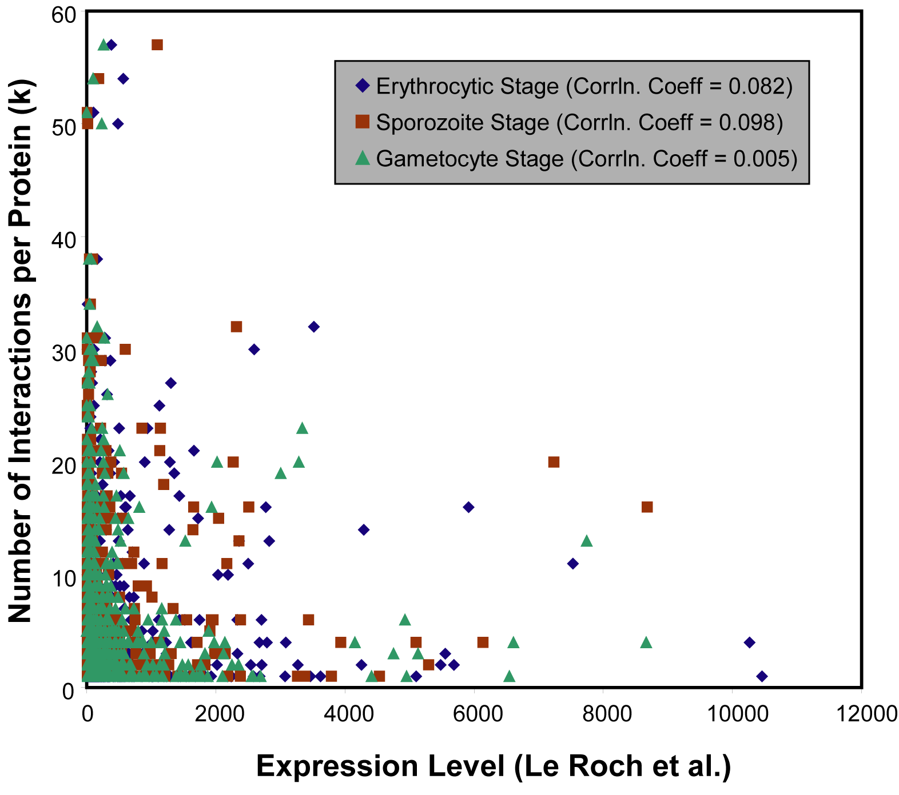

Supplementary Figure 2
a. Yeast
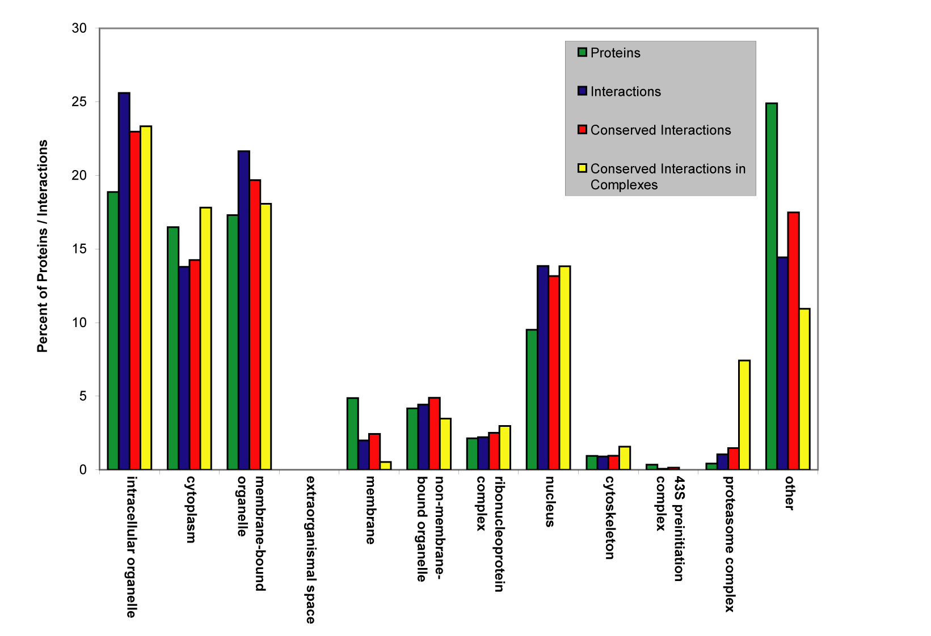

b. Worm

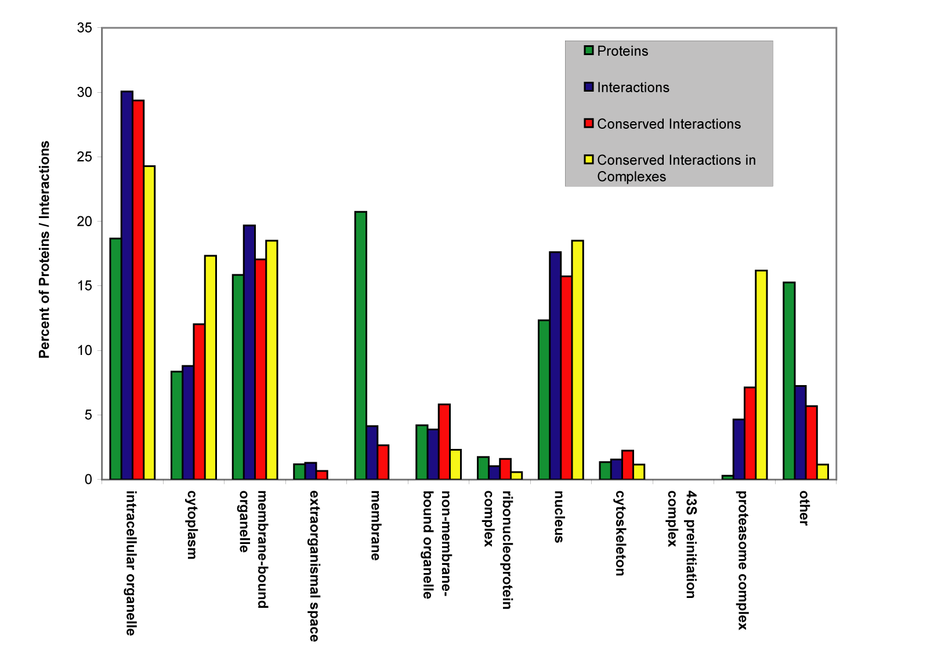

c. Fly

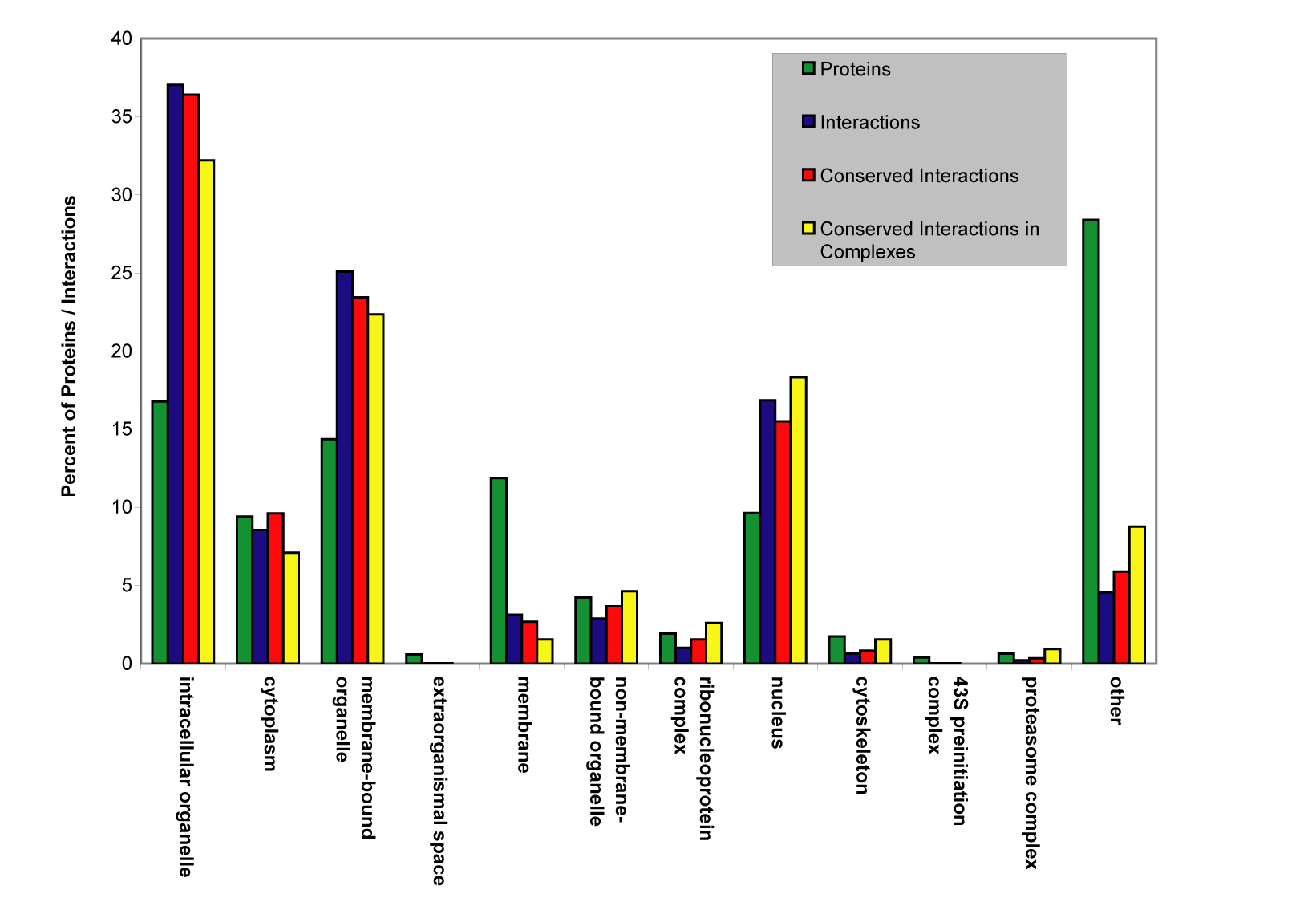

Supplementary Figure 3
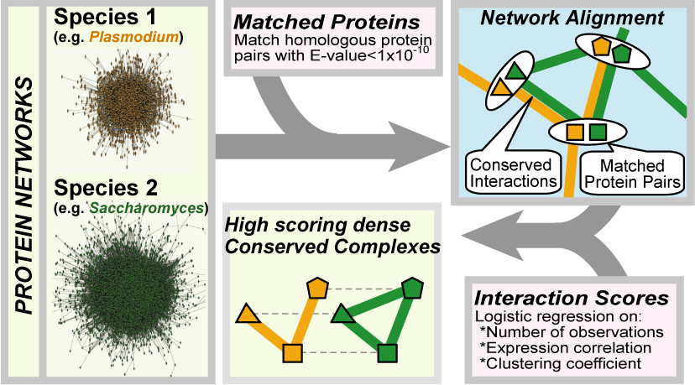

Supplementary Table 1: The Plasmodium network is enriched for proteins that have homologs in other species.

 | P. falciparum /  C. elegans | P. falciparum /  D. melanogaster | P. falciparum /  S. cerevisiae
Conserved Plasmodium Proteins (BLAST E-value ≤ 1x10E-4) | 2169 | 2520 | 2177
Conserved Plasmodium Proteins  in the interaction network | 714 | 857 | 737
Hyper-geometric p-value | 1.97 E-28 | 1.33 E-47 | 2.97 E-35

Supplementary Table 2: Comparison of number of conserved interactions across species
 | Species 1 |  |  | Species 2
Comparison  (Species 1 / Species 2) | Total Interactions | t₁ | c₁ | Total Interactions | t₂ | c₂
P. falciparum / S. cerevisiae | 2,847 | 488 | 45 | 14,319 | 1,524 | 79
P. falciparum / D. melanogaster | 2,847 | 801 | 50 | 20,720 | 1,446 | 67
P. falciparum / C. elegans | 2,847 | 392 | 23 | 3,926 | 324 | 32
P. falciparum / H. pylori | 2,847 | 8 | 0 | 1,465 | 78 | 0
C. elegans / S. cerevisiae | 3,926 | 454 | 121 | 14,319 | 2,670 | 284
C. elegans / D. melanogaster | 3,926 | 1,111 | 152 | 20,720 | 3,745 | 201
S. cerevisiae / D. melanogaster | 14,319 | 6,178 | 565 | 20,720 | 3,183 | 392
H. pylori / C. elegans | 1,465 | 17 | 1 | 3,926 | 9 | 1
H. pylori / D. melanogaster | 1,465 | 80 | 2 | 20,720 | 49 | 3
H. pylori / S. cerevisiae | 1,465 | 77 | 2 | 14,319 | 154 | 2
t₁ = Species 1 interactions whose proteins have homologs in species 2.
c₁ = The subset of interactions from t₁ that are conserved with interactions in species 2.
t₂ = Species 2 interactions whose proteins have homologs in species 1.
c₂ = The subset of interactions from t₂ that are conserved with interactions in species 1.

Supplementary Table 3: Decay of global properties with increase in randomization
Species | Randomizations per Interaction | % FP* produced | Avg. Clustering Coefficient | % Intr covered by Domain Intr
P. falciparum | 0 | 0 | 0.032 | 0.59
P. falciparum | 0.01 | 9.45 | 0.031 | 0.55
P. falciparum | 0.1 | 48.16 | 0.028 | 0.38
P. falciparum | 1 | 86.46 | 0.027 | 0.29
P. falciparum | 10 | 95.58 | 0.027 | 0.27
P. falciparum | 1000 | 97.32 | 0.027 | 0.25
S. cerevisiae | 0 | 0 | 0.193 | 4.78
S. cerevisiae | 0.01 | 9.4 | 0.17 | 4.59
S. cerevisiae | 0.1 | 44.97 | 0.0864 | 3.08
S. cerevisiae | 1 | 85.8 | 0.0314 | 1.86
S. cerevisiae | 10 | 97.37 | 0.025 | 1.06
S. cerevisiae | 1000 | 98.46 | 0.0248 | 0.9
S. cerevisiae (Uetz et al.) | 0 | 0 | 0.049 | 5.94
S. cerevisiae (Uetz et al.) | 0.01 | 9.74 | 0.041 | 5.52
S. cerevisiae (Uetz et al.) | 0.1 | 55.9 | 0.015 | 3.35
S. cerevisiae (Uetz et al.) | 1 | 95.6 | 0.005 | 1.32
S. cerevisiae (Uetz et al.) | 10 | 99.25 | 0.0049 | 1.18
S. cerevisiae (Uetz et al.) | 1000 | 99.2 | 0.0049 | 1.19
D. melanogaster | 0 | 0 | 0.019 | 0.16
D. melanogaster | 0.01 | 9.6 | 0.015 | 0.12
D. melanogaster | 0.1 | 45.69 | 0.0132 | 0.09
D. melanogaster | 1 | 86.85 | 0.0126 | 0.05
D. melanogaster | 10 | 98.41 | 0.0103 | 0.04
D. melanogaster | 1000 | 99.2 | 0.0103 | 0.037
C. elegans | 0 | 0 | 0.031 | 1.12
C. elegans | 0.01 | 9.84 | 0.032 | 1.04
C. elegans | 0.1 | 51.4 | 0.034 | 0.73
C. elegans | 1 | 87.4 | 0.029 | 0.475
C. elegans | 10 | 95.2 | 0.02 | 0.29
C. elegans | 1000 | 98.3 | 0.017 | 0.17
H. pylori | 0 | 0 | 0.063 | 1.98
H. pylori | 0.01 | 13.74 | 0.033 | 0.34
H. pylori | 0.1 | 55.04 | 0.04 | 0.23
H. pylori | 1 | 92.9 | 0.048 | 0.069
H. pylori | 10 | 96.64 | 0.049 | 0.045
H. pylori | 1000 | 96.64 | 0.049 | 0.05

*FP = False-positive interactions

Supplementary Table 4: Comparison of different methods for assigning confidence scores to interactions

 | Modified Bader | Bader et al. | Equal
Percent Enrichment:  GO Molecular Function | 63.6% | 59.1% | 52.4%
Combined Enrichment over:  GO Molecular Function  GO Biological Process  GO Cellular Component | 56.1% | 53.0% | 55.6%

Supplementary Table 5: Conservation statistics of Plasmodium-specific complexes
Plasmodium- specific complex | Total # of Plasmodium proteins | # proteins conserved in yeast | # proteins conserved in worm | # proteins conserved in fly | Total # of Plasmodium interactions | # interxns conserved in yeast | # interxns conserved in worm | # interxns conserved in fly
1 | 15 | 12 | 10 | 12 | 48 | 2 | 0 | 0
2 | 15 | 10 | 11 | 9 | 27 | 0 | 0 | 1
3 | 15 | 11 | 10 | 11 | 25 | 0 | 0 | 0
4 | 15 | 8 | 8 | 7 | 26 | 0 | 0 | 0
5 | 15 | 9 | 8 | 8 | 30 | 1 | 0 | 0
6 | 15 | 8 | 6 | 11 | 28 | 1 | 0 | 0
7 | 15 | 8 | 8 | 10 | 27 | 0 | 0 | 0
8 | 15 | 9 | 10 | 10 | 25 | 0 | 2 | 0
9 | 15 | 9 | 8 | 9 | 27 | 0 | 0 | 2
10 | 15 | 9 | 9 | 10 | 27 | 0 | 0 | 0
11 | 15 | 10 | 9 | 10 | 29 | 0 | 0 | 0
12 | 15 | 8 | 5 | 7 | 27 | 0 | 0 | 0
13 | 15 | 10 | 9 | 9 | 35 | 0 | 1 | 0
14 | 15 | 10 | 7 | 11 | 31 | 1 | 0 | 0
15 | 15 | 9 | 9 | 12 | 33 | 1 | 0 | 0
16 | 15 | 9 | 6 | 8 | 33 | 0 | 0 | 0
17 | 15 | 8 | 8 | 8 | 60 | 1 | 1 | 2
18 | 15 | 9 | 8 | 10 | 28 | 0 | 0 | 0
19 | 15 | 12 | 7 | 8 | 29 | 0 | 0 | 0
20 | 15 | 6 | 7 | 8 | 30 | 0 | 0 | 0
21 | 15 | 6 | 6 | 9 | 32 | 1 | 0 | 0
22 | 15 | 8 | 8 | 9 | 29 | 0 | 0 | 0
23 | 15 | 12 | 8 | 10 | 29 | 0 | 0 | 0
24 | 15 | 5 | 4 | 7 | 29 | 2 | 0 | 0
25 | 15 | 11 | 10 | 11 | 30 | 0 | 0 | 1
26 | 15 | 8 | 8 | 9 | 30 | 1 | 0 | 0
27 | 15 | 12 | 11 | 10 | 27 | 1 | 0 | 0
28 | 15 | 8 | 8 | 8 | 28 | 0 | 0 | 0
29 | 15 | 8 | 9 | 10 | 31 | 0 | 0 | 1

Supplementary Table 6: List of interactions among proteins with shared gene ontology (GO cellular components)
GO Cellular Component | Interaction
cytoplasm | MAL13P1.114 | PF10_0026
cytoplasm | MAL13P1.114 | PF10_0111
cytoplasm | MAL13P1.114 | PF13_0268
cytoplasm | MAL13P1.343 | PF11_0098
cytoplasm | MAL13P1.56 | PF10_0186
cytoplasm | MAL7P1.166 | PF10_0217
cytoplasm | MAL7P1.81 | PF11_0218
cytoplasm | PF08_0001 | PF10_0217
cytoplasm | PF08_0045 | PF13_0305
cytoplasm | PF10_0111 | PF11_0245
cytoplasm | PF10_0111 | PF14_0270
cytoplasm | PF10_0155 | PF14_0598
cytoplasm | PF11_0175 | PF11_0175
cytoplasm | PF11_0278 | PF13_0049
cytoplasm | PF11_0464 | PF13_0213
cytoplasm | PF11_0503 | PF14_0352
cytoplasm | PF13_0109 | PF13_0228
cytoplasm | PF14_0329 | PF14_0329
cytoplasm | PF14_0448 | PF14_0448
cytosolic small ribosomal subunit | PF14_0448 | PF14_0448
eukaryotic 43S preinitiation complex | PF14_0448 | PF14_0448
eukaryotic 48S initiation complex | PF14_0448 | PF14_0448
intracellular | MAL13P1.114 | PF10_0026
intracellular | MAL13P1.114 | PF10_0111
intracellular | MAL13P1.114 | PF13_0268
intracellular | MAL13P1.148 | PF07_0105
intracellular | MAL13P1.193 | PF14_0463
intracellular | MAL13P1.343 | PF11_0098
intracellular | MAL13P1.56 | PF10_0186
intracellular | MAL7P1.166 | PF10_0217
intracellular | MAL7P1.81 | PF11_0218
intracellular | PF07_0105 | PF10_0084
intracellular | PF08_0001 | PF10_0217
intracellular | PF08_0045 | PF13_0305
intracellular | PF08_0049 | PF11_0055
intracellular | PF10_0111 | PF11_0245
intracellular | PF10_0111 | PF14_0270
intracellular | PF10_0155 | PF14_0598
intracellular | PF11_0175 | PF11_0175
intracellular | PF11_0250 | PF14_0198
intracellular | PF11_0278 | PF13_0049
intracellular | PF11_0464 | PF13_0213
intracellular | PF11_0465 | PF14_0678
intracellular | PF11_0503 | PF14_0352
intracellular | PF13_0109 | PF13_0228
intracellular | PF13_0265 | PF14_0463
intracellular | PF14_0025 | PF14_0194
intracellular | PF14_0329 | PF14_0329
intracellular | PF14_0448 | PF14_0448
intracellular | PF14_0463 | PF14_0678
intracellular membrane-bound organelle | MAL13P1.114 | PF10_0026
intracellular membrane-bound organelle | MAL13P1.114 | PF10_0111
intracellular membrane-bound organelle | MAL13P1.193 | PF14_0463
intracellular membrane-bound organelle | MAL13P1.343 | PF11_0098
intracellular membrane-bound organelle | MAL13P1.56 | PF10_0186
intracellular membrane-bound organelle | PF08_0001 | PF10_0217
intracellular membrane-bound organelle | PF08_0049 | PF11_0055
intracellular membrane-bound organelle | PF10_0111 | PF14_0270
intracellular membrane-bound organelle | PF11_0175 | PF11_0175
intracellular membrane-bound organelle | PF11_0250 | PF14_0198
intracellular membrane-bound organelle | PF13_0265 | PF14_0463
intracellular membrane-bound organelle | PF14_0025 | PF14_0194
intracellular membrane-bound organelle | PF14_0329 | PF14_0329
intracellular membrane-bound organelle | PF14_0463 | PF14_0678
intracellular non-membrane-bound organelle | PF14_0448 | PF14_0448
intracellular organelle | MAL13P1.114 | PF10_0026
intracellular organelle | MAL13P1.114 | PF10_0111
intracellular organelle | MAL13P1.114 | PF13_0268
intracellular organelle | MAL13P1.148 | PF07_0105
intracellular organelle | MAL13P1.193 | PF14_0463
intracellular organelle | MAL13P1.343 | PF11_0098
intracellular organelle | MAL13P1.56 | PF10_0186
intracellular organelle | PF07_0105 | PF10_0084
intracellular organelle | PF08_0001 | PF10_0217
intracellular organelle | PF08_0049 | PF11_0055
intracellular organelle | PF10_0111 | PF14_0270
intracellular organelle | PF11_0175 | PF11_0175
intracellular organelle | PF11_0250 | PF14_0198
intracellular organelle | PF11_0278 | PF13_0049
intracellular organelle | PF11_0464 | PF13_0213
intracellular organelle | PF11_0465 | PF14_0678
intracellular organelle | PF13_0109 | PF13_0228
intracellular organelle | PF13_0265 | PF14_0463
intracellular organelle | PF14_0025 | PF14_0194
intracellular organelle | PF14_0329 | PF14_0329
intracellular organelle | PF14_0448 | PF14_0448
intracellular organelle | PF14_0463 | PF14_0678
membrane | MAL13P1.114 | PF10_0026
membrane | MAL13P1.114 | PF10_0335
membrane | MAL13P1.114 | PF14_0201
membrane | MAL13P1.206 | PF10_0143
membrane | MAL13P1.206 | PF13_0197
membrane | MAL13P1.206 | PF14_0678
membrane | PF10_0135 | PF10_0135
membrane | PF10_0281 | PF11_0224
membrane | PF11_0069 | PF11_0069
membrane | PF11_0069 | PF11_0156
membrane | PF11_0127 | PF11_0507
membrane | PF11_0127 | PF13_0198
membrane | PF11_0165 | PF14_0735
membrane | PF11_0278 | PF14_0201
membrane | PF11_0341 | PF14_0029
membrane | PF11_0507 | PF14_0372
membrane | PF13_0197 | PF14_0201
membrane | PF14_0054 | PF14_0708
membrane | PF14_0123 | PF14_0123
membrane | PF14_0315 | PF14_0678
membrane | PF14_0315 | PF14_0735
membrane | PF14_0613 | PF14_0735
membrane-bound organelle | MAL13P1.114 | PF10_0026
membrane-bound organelle | MAL13P1.114 | PF10_0111
membrane-bound organelle | MAL13P1.193 | PF14_0463
membrane-bound organelle | MAL13P1.343 | PF11_0098
membrane-bound organelle | MAL13P1.56 | PF10_0186
membrane-bound organelle | PF08_0001 | PF10_0217
membrane-bound organelle | PF08_0049 | PF11_0055
membrane-bound organelle | PF10_0111 | PF14_0270
membrane-bound organelle | PF11_0175 | PF11_0175
membrane-bound organelle | PF11_0250 | PF14_0198
membrane-bound organelle | PF13_0265 | PF14_0463
membrane-bound organelle | PF14_0025 | PF14_0194
membrane-bound organelle | PF14_0329 | PF14_0329
membrane-bound organelle | PF14_0463 | PF14_0678
non-membrane-bound organelle | PF14_0448 | PF14_0448
nucleus | PF14_0025 | PF14_0194
ribonucleoprotein complex | PF14_0448 | PF14_0448
ribosome | PF14_0448 | PF14_0448

Supplementary Table 7: Interactions in all significant Plasmodium complexes
Complex | Interaction
1 | MAL6P1.125 | MAL6P1.147
 | MAL6P1.125 | MAL8P1.153
 | MAL6P1.125 | PFI0225W
 | MAL6P1.131 | MAL6P1.147
 | MAL6P1.131 | PF11_0241
 | MAL6P1.131 | PFI0225W
 | MAL6P1.147 | MAL6P1.304
 | MAL6P1.147 | PF08_0034
 | MAL6P1.147 | PF11_0241
 | MAL6P1.147 | PFB0540W
 | MAL6P1.147 | PFI0225W
 | MAL6P1.304 | MAL6P1.48
 | MAL6P1.304 | MAL8P1.104
 | MAL6P1.304 | MAL8P1.153
 | MAL6P1.304 | PF08_0034
 | MAL6P1.304 | PF08_0060
 | MAL6P1.304 | PFB0540W
 | MAL6P1.304 | PFI0225W
 | MAL6P1.304 | PFL0275W
 | MAL6P1.304 | PFL0350C
 | MAL6P1.48 | MAL8P1.153
 | MAL6P1.48 | PF08_0034
 | MAL6P1.48 | PFE0130C
 | MAL8P1.104 | MAL8P1.153
 | MAL8P1.104 | PF08_0034
 | MAL8P1.104 | PF08_0060
 | MAL8P1.104 | PF11_0241
 | MAL8P1.104 | PFE0130C
 | MAL8P1.104 | PFI0225W
 | MAL8P1.104 | PFL0275W
 | MAL8P1.104 | PFL0350C
 | MAL8P1.153 | PF08_0034
 | MAL8P1.153 | PFB0540W
 | MAL8P1.153 | PFI0225W
 | PF08_0034 | PF08_0060
 | PF08_0034 | PF11_0241
 | PF08_0034 | PFB0540W
 | PF08_0034 | PFE0130C
 | PF08_0034 | PFI0225W
 | PF08_0034 | PFL0275W
 | PF08_0034 | PFL0350C
 | PF08_0060 | PFI0225W
 | PF11_0241 | PFI0225W
 | PF11_0241 | PFL0275W
 | PFB0540W | PFI0225W
 | PFE0130C | PFI0225W
 | PFI0225W | PFL0275W
 | PFI0225W | PFL0350C
2 | MAL8P1.69 | PF10_0114
 | MAL8P1.69 | PF10_0242
 | MAL8P1.69 | PF11_0303
 | MAL8P1.69 | PF14_0201
 | MAL8P1.69 | PFC0105W
 | MAL8P1.69 | PFE0835W
 | MAL8P1.69 | PFI1445W
 | PF08_0081 | PF10_0114
 | PF08_0081 | PF13_0315
 | PF08_0081 | PF14_0598
 | PF08_0081 | PFE0040C
 | PF10_0242 | PF14_0598
 | PF10_0242 | PFL1385C
 | PF11_0303 | PFE0040C
 | PF13_0197 | PF14_0201
 | PF13_0197 | PF14_0598
 | PF13_0197 | PFC0105W
 | PF13_0197 | PFL1385C
 | PF14_0201 | PFI1445W
 | PF14_0201 | PFL0350C
 | PF14_0598 | PFE0040C
 | PF14_0598 | PFE0835W
 | PF14_0598 | PFL0350C
 | PFC0105W | PFE0040C
 | PFE0040C | PFI1445W
 | PFE0040C | PFL1385C
 | PFI1445W | PFL1385C
3 | MAL13P1.56 | PFE0750C
 | MAL13P1.56 | PFI0975C
 | PF08_0126 | PF14_0102
 | PF08_0126 | PFE0750C
 | PF08_0126 | PFI0975C
 | PF13_0315 | PFC0760C
 | PF13_0315 | PFE0750C
 | PF14_0102 | PFC0150W
 | PF14_0102 | PFI1445W
 | PF14_0102 | PFL0350C
 | PF14_0102 | PFL2335W
 | PF14_0678 | PFC0760C
 | PF14_0678 | PFI0975C
 | PFA0125C | PFI0975C
 | PFA0125C | PFI1445W
 | PFA0125C | PFL0830W
 | PFA0125C | PFL2335W
 | PFC0150W | PFC0760C
 | PFC0760C | PFI0975C
 | PFC0760C | PFL0350C
 | PFE0750C | PFL0830W
 | PFE0750C | PFL1930W
 | PFI0975C | PFL0350C
 | PFI0975C | PFL2335W
 | PFL0350C | PFL1930W
4 | MAL13P1.214 | PF10_0115
 | MAL13P1.214 | PF14_0257
 | MAL13P1.214 | PF14_0344
 | MAL13P1.308 | PF10_0115
 | MAL13P1.308 | PF14_0344
 | MAL13P1.308 | PF14_0652
 | MAL13P1.308 | PFB0640C
 | MAL13P1.308 | PFI1475W
 | PF08_0055 | PF14_0344
 | PF08_0055 | PFA0410W
 | PF08_0055 | PFD0090C
 | PF08_0055 | PFD0450C
 | PF10_0115 | PF14_0344
 | PF11_0291 | PFA0110W
 | PF11_0291 | PFD0090C
 | PF14_0257 | PFA0110W
 | PF14_0257 | PFA0410W
 | PF14_0344 | PFA0110W
 | PF14_0344 | PFI1475W
 | PF14_0344 | PFL2505C
 | PF14_0652 | PFB0640C
 | PF14_0652 | PFD0090C
 | PFA0110W | PFD0090C
 | PFA0410W | PFB0640C
 | PFB0640C | PFL2505C
 | PFD0090C | PFI1475W
5 | MAL6P1.254 | PF10_0232
 | MAL6P1.254 | PF13_0041
 | MAL6P1.254 | PFD0090C
 | MAL8P1.23 | PF10_0232
 | MAL8P1.23 | PF14_0059
 | MAL8P1.23 | PF14_0463
 | MAL8P1.23 | PFD0985W
 | MAL8P1.23 | PFI1780W
 | PF10_0232 | PF11_0507
 | PF10_0232 | PF14_0059
 | PF10_0232 | PFL1385C
 | PF11_0291 | PFA0110W
 | PF11_0291 | PFD0090C
 | PF11_0291 | PFL1385C
 | PF11_0507 | PF13_0041
 | PF11_0507 | PF13_0322
 | PF11_0507 | PF14_0463
 | PF11_0507 | PFD0985W
 | PF11_0507 | PFI1780W
 | PF11_0507 | PFL1385C
 | PF13_0041 | PFD0985W
 | PF13_0041 | PFL0635C
 | PF13_0322 | PFA0110W
 | PF14_0059 | PF14_0463
 | PF14_0463 | PFL0635C
 | PF14_0463 | PFL1385C
 | PFA0110W | PFD0090C
 | PFA0110W | PFI1780W
 | PFA0110W | PFL0635C
 | PFA0110W | PFL1385C
6 | MAL7P1.19 | PF14_0678
 | MAL7P1.19 | PFE1590W
 | MAL7P1.19 | PFI0495W
 | PF07_0097 | PF13_0094
 | PF07_0097 | PF13_0161
 | PF10_0146 | PF10_0232
 | PF10_0146 | PF11_0504
 | PF10_0146 | PF14_0487
 | PF10_0232 | PF11_0504
 | PF10_0232 | PF14_0487
 | PF10_0232 | PF14_0499
 | PF10_0232 | PFE1590W
 | PF10_0232 | PFI0495W
 | PF10_0232 | PFL0815W
 | PF11_0504 | PF13_0094
 | PF11_0504 | PF13_0161
 | PF11_0504 | PF13_0170
 | PF11_0504 | PF14_0230
 | PF11_0504 | PF14_0499
 | PF11_0504 | PF14_0678
 | PF11_0504 | PFI0495W
 | PF11_0504 | PFL0815W
 | PF13_0161 | PFL0815W
 | PF14_0230 | PFL0815W
 | PF14_0487 | PF14_0499
 | PF14_0487 | PFE1590W
 | PF14_0499 | PF14_0678
 | PF14_0499 | PFE1590W
7 | CHR7_000020 | MAL8P1.153
 | CHR7_000020 | MAL8P1.23
 | CHR7_000020 | PF11_0098
 | CHR7_000020 | PF13_0076
 | MAL8P1.153 | MAL8P1.23
 | MAL8P1.153 | PF10_0131
 | MAL8P1.153 | PF10_0232
 | MAL8P1.153 | PF14_0679
 | MAL8P1.23 | PF10_0232
 | MAL8P1.23 | PF14_0059
 | MAL8P1.23 | PF14_0463
 | MAL8P1.23 | PFI0875W
 | PF10_0131 | PF10_0232
 | PF10_0232 | PF11_0378
 | PF10_0232 | PF13_0076
 | PF10_0232 | PF14_0059
 | PF10_0232 | PF14_0644
 | PF10_0232 | PFD0495C
 | PF11_0098 | PF11_0378
 | PF11_0098 | PF14_0613
 | PF13_0076 | PF14_0463
 | PF13_0076 | PF14_0613
 | PF13_0076 | PF14_0679
 | PF14_0059 | PF14_0463
 | PF14_0059 | PF14_0644
 | PF14_0059 | PFD0495C
 | PF14_0613 | PFI0875W
8 | CHR13_2000027 | PF14_0594
 | CHR13_2000027 | PFE0070W
 | CHR7_000020 | PF10_0155
 | CHR7_000020 | PF14_0594
 | CHR7_000020 | PFC0390W
 | CHR7_000020 | PFE0070W
 | MAL6P1.106 | PF10_0155
 | MAL6P1.106 | PF14_0495
 | MAL6P1.106 | PF14_0700
 | MAL6P1.106 | PFD1185W
 | MAL6P1.106 | PFL0280C
 | MAL6P1.248 | PF14_0700
 | MAL6P1.248 | PFL0280C
 | MAL7P1.19 | PF14_0495
 | MAL7P1.19 | PFE0070W
 | MAL7P1.19 | PFE1590W
 | PF10_0155 | PFL0280C
 | PF11_0507 | PF14_0594
 | PF11_0507 | PF14_0700
 | PF11_0507 | PFE0070W
 | PF11_0507 | PFE1590W
 | PF14_0700 | PFE0070W
 | PF14_0700 | PFE1590W
 | PFC0390W | PFE1590W
 | PFE1590W | PFL0280C
9 | CHR7_000020 | PF10_0155
 | CHR7_000020 | PFC1045C
 | CHR7_000020 | PFL1705W
 | MAL13P1.140 | MAL13P1.308
 | MAL13P1.140 | PF11_0507
 | MAL13P1.308 | PF10_0155
 | MAL13P1.308 | PF14_0673
 | MAL13P1.308 | PFL1340C
 | PF10_0155 | PF14_0673
 | PF10_0155 | PFI0930C
 | PF10_0155 | PFL1385C
 | PF10_0232 | PF11_0507
 | PF10_0232 | PFL1385C
 | PF10_0232 | PFL1705W
 | PF11_0242 | PF11_0507
 | PF11_0242 | PFI0930C
 | PF11_0242 | PFL1705W
 | PF11_0507 | PF13_0215
 | PF11_0507 | PFL1385C
 | PF13_0215 | PF14_0673
 | PF14_0673 | PFC1045C
 | PF14_0673 | PFL1705W
 | PFC1045C | PFI0930C
 | PFC1045C | PFL1745C
 | PFL1340C | PFL1745C
 | PFL1385C | PFL1705W
 | PFL1705W | PFL1745C
10 | MAL6P1.304 | MAL6P1.48
 | MAL6P1.304 | MAL8P1.153
 | MAL6P1.304 | PF08_0034
 | MAL6P1.304 | PF10_0114
 | MAL6P1.304 | PFB0540W
 | MAL6P1.304 | PFL1395C
 | MAL6P1.48 | MAL8P1.153
 | MAL6P1.48 | MAL8P1.69
 | MAL6P1.48 | PF08_0034
 | MAL6P1.48 | PF10_0114
 | MAL6P1.48 | PFI1755C
 | MAL8P1.153 | PF08_0034
 | MAL8P1.153 | PFB0540W
 | MAL8P1.153 | PFI1715W
 | MAL8P1.153 | PFL1395C
 | MAL8P1.69 | PF10_0114
 | MAL8P1.69 | PF11_0303
 | MAL8P1.69 | PFB0194W
 | MAL8P1.69 | PFE0245C
 | MAL8P1.69 | PFI1715W
 | MAL8P1.69 | PFL1245W
 | PF08_0034 | PFB0540W
 | PF08_0034 | PFL1395C
 | PF10_0114 | PFB0540W
 | PF11_0303 | PF14_0337
 | PFI1715W | PFL1395C
 | PFI1755C | PFL1245W
11(Fig. 1d) | MAL7P1.19 | PF07_0062
 | MAL7P1.19 | PF14_0463
 | MAL7P1.19 | PF14_0678
 | MAL7P1.19 | PFI1475W
 | MAL7P1.81 | PF07_0062
 | MAL7P1.81 | PFL1385C
 | PF07_0062 | PFC0120W
 | PF07_0062 | PFD0545W
 | PF07_0062 | PFE0185C
 | PF10_0038 | PF11_0507
 | PF10_0038 | PFD0545W
 | PF11_0507 | PF14_0463
 | PF11_0507 | PFL1385C
 | PF14_0463 | PF14_0678
 | PF14_0463 | PFL1385C
 | PF14_0678 | PFC0120W
 | PFC0120W | PFE0040C
 | PFC0120W | PFI1475W
 | PFD0545W | PFD1055W
 | PFD1055W | PFI1445W
 | PFE0040C | PFI1445W
 | PFE0040C | PFI1475W
 | PFE0040C | PFL1385C
 | PFE0185C | PFL1385C
 | PFI1445W | PFL1385C
 | PFI1475W | PFL1385C
12 | MAL13P1.14 | PF10_0232
 | MAL13P1.14 | PFD0210C
 | MAL13P1.14 | PFD0885C
 | MAL13P1.14 | PFE1345C
 | MAL13P1.193 | MAL6P1.44
 | MAL13P1.193 | PF10_0232
 | MAL6P1.44 | PF10_0160
 | MAL6P1.44 | PFD0210C
 | MAL7P1.7 | PF10_0232
 | MAL7P1.7 | PF10_0361
 | MAL7P1.7 | PF11_0351
 | MAL7P1.7 | PFD0210C
 | MAL7P1.7 | PFE1345C
 | MAL7P1.7 | PFL1385C
 | PF10_0160 | PFA0620C
 | PF10_0160 | PFD0210C
 | PF10_0160 | PFE0060W
 | PF10_0232 | PFD0885C
 | PF10_0232 | PFI1475W
 | PF10_0232 | PFL1385C
 | PF10_0361 | PFL1385C
 | PF11_0351 | PFA0620C
 | PF11_0351 | PFL1385C
 | PFA0620C | PFD0885C
 | PFD0885C | PFL1385C
 | PFE1345C | PFI1475W
 | PFI1475W | PFL1385C
13 | CHR13_2000027 | PF08_0132
 | CHR13_2000027 | PF14_0323
 | CHR13_2000027 | PFB0340C
 | CHR13_2000027 | PFD0080C
 | MAL7P1.7 | PF08_0132
 | MAL7P1.7 | PF10_0232
 | MAL7P1.7 | PF10_0244
 | MAL7P1.7 | PF11_0351
 | MAL7P1.7 | PFL1385C
 | MAL8P1.17 | PF08_0132
 | MAL8P1.17 | PF14_0323
 | MAL8P1.17 | PFE0570W
 | MAL8P1.17 | PFL1385C
 | PF08_0132 | PFD0080C
 | PF08_0132 | PFI1475W
 | PF10_0232 | PF14_0442
 | PF10_0232 | PFB0340C
 | PF10_0232 | PFD0080C
 | PF10_0232 | PFI1475W
 | PF10_0232 | PFL1385C
 | PF10_0244 | PFB0340C
 | PF11_0291 | PF11_0351
 | PF11_0291 | PFL1385C
 | PF11_0351 | PF14_0442
 | PF11_0351 | PFB0340C
 | PF11_0351 | PFD0080C
 | PF11_0351 | PFE0570W
 | PF11_0351 | PFL1385C
 | PF14_0323 | PFB0340C
 | PF14_0323 | PFI1475W
 | PF14_0442 | PFB0340C
 | PFB0340C | PFE0570W
 | PFD0080C | PFI1475W
 | PFE0570W | PFL1385C
 | PFI1475W | PFL1385C
14 | MAL13P1.336 | MAL6P1.304
 | MAL13P1.336 | PF08_0034
 | MAL13P1.336 | PF10_0075
 | MAL13P1.336 | PF14_0257
 | MAL13P1.336 | PF14_0329
 | MAL13P1.336 | PF14_0487
 | MAL13P1.336 | PFD0475C
 | MAL13P1.336 | PFL2440W
 | MAL6P1.304 | MAL8P1.153
 | MAL6P1.304 | PF08_0034
 | MAL6P1.304 | PF13_0155
 | MAL6P1.304 | PF14_0329
 | MAL6P1.304 | PFI0225W
 | MAL8P1.153 | PF08_0034
 | MAL8P1.153 | PF10_0075
 | MAL8P1.153 | PFD0475C
 | MAL8P1.153 | PFI0225W
 | PF08_0034 | PF10_0075
 | PF08_0034 | PF13_0156
 | PF08_0034 | PFI0225W
 | PF10_0075 | PF13_0156
 | PF10_0075 | PFA0285C
 | PF10_0075 | PFA0410W
 | PF10_0075 | PFI0225W
 | PF10_0075 | PFL2440W
 | PF13_0155 | PFA0410W
 | PF13_0155 | PFL2440W
 | PF14_0257 | PF14_0487
 | PF14_0257 | PFA0410W
 | PFA0285C | PFD0475C
 | PFA0410W | PFI0225W
15 | MAL13P1.63 | MAL6P1.304
 | MAL13P1.63 | MAL8P1.23
 | MAL13P1.63 | PFB0760W
 | MAL13P1.63 | PFI0495W
 | MAL6P1.304 | MAL8P1.104
 | MAL6P1.304 | MAL8P1.153
 | MAL6P1.304 | PF08_0034
 | MAL6P1.304 | PF10_0146
 | MAL6P1.304 | PFI0225W
 | MAL6P1.304 | PFL1385C
 | MAL8P1.104 | MAL8P1.153
 | MAL8P1.104 | PF08_0034
 | MAL8P1.104 | PFB0760W
 | MAL8P1.104 | PFI0225W
 | MAL8P1.153 | MAL8P1.23
 | MAL8P1.153 | PF08_0034
 | MAL8P1.153 | PF10_0232
 | MAL8P1.153 | PFI0225W
 | MAL8P1.23 | PF10_0232
 | MAL8P1.23 | PF11_0504
 | MAL8P1.23 | PFB0760W
 | MAL8P1.34 | PFB0760W
 | PF08_0034 | PF11_0504
 | PF08_0034 | PFI0225W
 | PF10_0146 | PF10_0232
 | PF10_0146 | PF11_0504
 | PF10_0146 | PFL1385C
 | PF10_0232 | PF11_0504
 | PF10_0232 | PFI0495W
 | PF10_0232 | PFL1385C
 | PF11_0504 | PF13_0268
 | PF11_0504 | PFI0495W
 | PF13_0268 | PFB0760W
16 | MAL13P1.193 | PF10_0232
 | MAL13P1.193 | PF14_0463
 | MAL13P1.193 | PFD0785C
 | MAL7P1.19 | PF14_0463
 | MAL7P1.19 | PF14_0678
 | MAL7P1.19 | PFI0495W
 | MAL7P1.19 | PFI1475W
 | MAL8P1.23 | PF10_0232
 | MAL8P1.23 | PF11_0504
 | MAL8P1.23 | PF14_0463
 | MAL8P1.23 | PFI1475W
 | PF10_0232 | PF11_0504
 | PF10_0232 | PF14_0123
 | PF10_0232 | PFC0760C
 | PF10_0232 | PFI0495W
 | PF10_0232 | PFI1475W
 | PF10_0232 | PFL1385C
 | PF10_0232 | PFL1865W
 | PF11_0504 | PF14_0678
 | PF11_0504 | PFI0495W
 | PF14_0123 | PFL1865W
 | PF14_0463 | PF14_0678
 | PF14_0463 | PFC0760C
 | PF14_0463 | PFL1385C
 | PF14_0463 | PFL1865W
 | PF14_0678 | PFC0760C
 | PF14_0678 | PFI1475W
 | PFD0785C | PFI0495W
 | PFD0785C | PFL1385C
 | PFD0785C | PFL1865W
 | PFD0875C | PFI0495W
 | PFD0875C | PFL1865W
 | PFI1475W | PFL1385C
17 | MAL13P1.336 | MAL6P1.304
 | MAL13P1.336 | PF08_0034
 | MAL13P1.336 | PF11_0477
 | MAL13P1.336 | PF14_0329
 | MAL13P1.336 | PFD0080C
 | MAL6P1.304 | MAL8P1.104
 | MAL6P1.304 | MAL8P1.72
 | MAL6P1.304 | PF08_0034
 | MAL6P1.304 | PF14_0329
 | MAL6P1.304 | PFD0985W
 | MAL6P1.304 | PFL0275W
 | MAL8P1.104 | PF08_0034
 | MAL8P1.104 | PFL0275W
 | MAL8P1.72 | PF07_0126
 | MAL8P1.72 | PF11_0507
 | PF07_0126 | PF11_0477
 | PF07_0126 | PF11_0507
 | PF07_0126 | PFD0985W
 | PF08_0034 | PFL0275W
 | PF11_0242 | PF11_0507
 | PF11_0242 | PFD0080C
 | PF11_0242 | PFL0275W
 | PF11_0477 | PFL0275W
 | PF11_0507 | PF13_0041
 | PF11_0507 | PFD0985W
 | PF13_0041 | PFD0985W
 | PF13_0162 | PFD0985W
 | PF13_0162 | PFL0275W
 | PF14_0329 | PFD0985W
 | PFD0080C | PFD0985W
18 | MAL13P1.310 | MAL7P1.155
 | MAL13P1.310 | PFC0760C
 | MAL6P1.245 | MAL7P1.155
 | MAL6P1.245 | PF11_0477
 | MAL6P1.245 | PF14_0678
 | MAL6P1.245 | PFC0760C
 | MAL7P1.155 | PF07_0053
 | MAL7P1.155 | PF11_0111
 | MAL7P1.155 | PFA0220W
 | MAL7P1.19 | PF07_0126
 | MAL7P1.19 | PF14_0463
 | MAL7P1.19 | PF14_0678
 | PF07_0053 | PF07_0126
 | PF07_0053 | PF11_0111
 | PF07_0053 | PFC0760C
 | PF07_0126 | PF11_0477
 | PF07_0126 | PF14_0315
 | PF07_0126 | PFI0975C
 | PF11_0111 | PF11_0477
 | PF11_0477 | PF14_0170
 | PF11_0477 | PFA0220W
 | PF14_0170 | PFC0760C
 | PF14_0315 | PF14_0678
 | PF14_0463 | PF14_0678
 | PF14_0463 | PFC0760C
 | PF14_0678 | PFC0760C
 | PF14_0678 | PFI0975C
 | PFC0760C | PFI0975C
19 | CHR7_000020 | MAL6P1.183
 | CHR7_000020 | MAL8P1.153
 | CHR7_000020 | PFC0390W
 | MAL13P1.206 | MAL6P1.183
 | MAL13P1.206 | PF10_0143
 | MAL13P1.206 | PF11_0142
 | MAL6P1.183 | MAL8P1.104
 | MAL6P1.183 | PF08_0060
 | MAL6P1.183 | PFE0905W
 | MAL6P1.183 | PFE1590W
 | MAL8P1.104 | MAL8P1.153
 | MAL8P1.104 | PF08_0034
 | MAL8P1.104 | PF08_0060
 | MAL8P1.104 | PF11_0142
 | MAL8P1.104 | PFE1590W
 | MAL8P1.153 | PF08_0034
 | MAL8P1.153 | PF11_0142
 | MAL8P1.153 | PFE1590W
 | PF07_0086 | PF08_0060
 | PF07_0086 | PF10_0143
 | PF07_0086 | PFC0390W
 | PF08_0034 | PF08_0060
 | PF10_0143 | PF11_0142
 | PF10_0143 | PFA0130C
 | PF11_0142 | PFE1590W
 | PF14_0636 | PFE1590W
 | PFA0130C | PFE0905W
 | PFA0130C | PFE1590W
 | PFC0390W | PFE1590W
20 | MAL13P1.269 | PF07_0044
 | MAL13P1.269 | PF11_0351
 | MAL13P1.269 | PF13_0132
 | MAL13P1.269 | PFC0150W
 | MAL13P1.269 | PFD0885C
 | MAL13P1.323 | PF13_0132
 | MAL13P1.323 | PFD0080C
 | MAL13P1.323 | PFE1335C
 | PF07_0044 | PFE1590W
 | PF10_0232 | PF11_0127
 | PF10_0232 | PF11_0507
 | PF10_0232 | PFC0760C
 | PF10_0232 | PFD0080C
 | PF10_0232 | PFD0885C
 | PF10_0232 | PFE1590W
 | PF10_0232 | PFL1385C
 | PF11_0127 | PF11_0507
 | PF11_0127 | PFD0080C
 | PF11_0127 | PFD0885C
 | PF11_0351 | PFD0080C
 | PF11_0351 | PFL1385C
 | PF11_0507 | PF13_0132
 | PF11_0507 | PFE1590W
 | PF11_0507 | PFL1385C
 | PFC0150W | PFC0760C
 | PFC0760C | PFE1335C
 | PFD0885C | PFE1335C
 | PFD0885C | PFE1590W
 | PFD0885C | PFL1385C
 | PFE1335C | PFL1385C
21 | MAL6P1.237 | PF10_0232
 | MAL6P1.237 | PF11_0507
 | MAL6P1.237 | PF14_0487
 | MAL8P1.153 | PF10_0232
 | MAL8P1.153 | PF11_0342
 | MAL8P1.153 | PFE1590W
 | MAL8P1.153 | PFI1715W
 | MAL8P1.153 | PFL2335W
 | PF08_0114 | PFC0925W
 | PF08_0114 | PFI1715W
 | PF10_0232 | PF11_0127
 | PF10_0232 | PF11_0507
 | PF10_0232 | PF14_0487
 | PF10_0232 | PF14_0499
 | PF10_0232 | PFD0885C
 | PF10_0232 | PFE1590W
 | PF10_0232 | PFI1715W
 | PF11_0127 | PF11_0507
 | PF11_0127 | PFC0925W
 | PF11_0127 | PFD0885C
 | PF11_0342 | PF11_0507
 | PF11_0342 | PF14_0487
 | PF11_0507 | PFC0925W
 | PF11_0507 | PFE1590W
 | PF14_0487 | PF14_0499
 | PF14_0487 | PFE1590W
 | PF14_0487 | PFL2335W
 | PF14_0499 | PFE1590W
 | PF14_0499 | PFL2335W
 | PFC0320W | PFI1715W
 | PFD0885C | PFE1590W
 | PFI1715W | PFL2335W
22 | MAL13P1.206 | PF10_0143
 | MAL13P1.206 | PF14_0678
 | MAL13P1.206 | PFC0120W
 | MAL13P1.206 | PFC0760C
 | PF10_0143 | PFC1060C
 | PF10_0143 | PFE0040C
 | PF11_0465 | PF14_0678
 | PF11_0465 | PFE0040C
 | PF14_0315 | PF14_0678
 | PF14_0315 | PFE0040C
 | PF14_0315 | PFL0815W
 | PF14_0678 | PFC0120W
 | PF14_0678 | PFC0760C
 | PF14_0678 | PFC1060C
 | PF14_0678 | PFE0065W
 | PF14_0678 | PFI1720W
 | PFC0120W | PFE0040C
 | PFC0120W | PFE0065W
 | PFC0120W | PFI1475W
 | PFC0760C | PFI1780W
 | PFC1060C | PFI1780W
 | PFE0040C | PFE0065W
 | PFE0040C | PFI1475W
 | PFE0040C | PFI1720W
 | PFE0040C | PFL0815W
 | PFI1475W | PFI1720W
23 | MAL13P1.308 | PF11_0401
 | MAL13P1.308 | PF11_0477
 | MAL13P1.308 | PFD0150W
 | MAL13P1.308 | PFE0430W
 | MAL13P1.308 | PFI1475W
 | MAL13P1.308 | PFL0625C
 | MAL6P1.286 | MAL8P1.69
 | MAL6P1.286 | PF11_0111
 | MAL6P1.286 | PF11_0401
 | MAL6P1.286 | PFD0080C
 | MAL6P1.286 | PFI1475W
 | MAL8P1.69 | PF14_0201
 | MAL8P1.69 | PFB0680W
 | MAL8P1.69 | PFE0430W
 | MAL8P1.69 | PFI1475W
 | PF11_0111 | PF11_0477
 | PF11_0111 | PFD0080C
 | PF11_0401 | PFL0625C
 | PF11_0477 | PF13_0036
 | PF11_0477 | PFD0150W
 | PF13_0036 | PF14_0201
 | PF13_0036 | PFI1475W
 | PF13_0036 | PFL0625C
 | PF13_0161 | PFB0680W
 | PF13_0161 | PFL0625C
 | PF14_0201 | PFL0625C
 | PFB0680W | PFL0625C
 | PFD0080C | PFI1475W
 | PFE0430W | PFI1475W
24 (Fig. 1f) | MAL13P1.193 | MAL13P1.336
 | MAL13P1.193 | PF11_0347
 | MAL13P1.193 | PF14_0463
 | MAL13P1.336 | PF11_0156
 | MAL13P1.336 | PF13_0076
 | MAL13P1.336 | PF14_0487
 | MAL13P1.336 | PF14_0499
 | MAL13P1.336 | PFB0115W
 | PF11_0156 | PF14_0463
 | PF11_0156 | PFI1715W
 | PF11_0347 | PFB0115W
 | PF11_0347 | PFI1720W
 | PF14_0463 | PF14_0678
 | PF14_0463 | PFB0115W
 | PF14_0487 | PF14_0499
 | PF14_0487 | PFI1720W
 | PF14_0499 | PF14_0678
 | PF14_0499 | PFL2335W
 | PF14_0678 | PFI1720W
 | PFB0115W | PFI1715W
 | PFI1715W | PFL2335W
25 | MAL13P1.202 | MAL7P1.155
 | MAL13P1.202 | PF11_0507
 | MAL13P1.202 | PFE1590W
 | MAL13P1.310 | MAL7P1.155
 | MAL13P1.310 | PF13_0045
 | MAL13P1.310 | PFE1590W
 | MAL6P1.245 | PF11_0507
 | MAL7P1.155 | PF10_0232
 | MAL7P1.155 | PF13_0305
 | MAL7P1.155 | PF14_0334
 | MAL8P1.104 | MAL8P1.153
 | MAL8P1.104 | PF14_0334
 | MAL8P1.104 | PFE1590W
 | MAL8P1.153 | PF10_0232
 | MAL8P1.153 | PF11_0142
 | MAL8P1.153 | PFE1590W
 | PF08_0132 | PF13_0305
 | PF08_0132 | PF14_0334
 | PF08_0132 | PFD0885C
 | PF10_0232 | PF11_0507
 | PF10_0232 | PFD0885C
 | PF10_0232 | PFE1590W
 | PF11_0142 | PFE1590W
 | PF11_0507 | PF13_0045
 | PF11_0507 | PF13_0305
 | PF11_0507 | PFE1590W
 | PFD0885C | PFE1590W
26 | CHR7_000020 | MAL8P1.153
 | CHR7_000020 | MAL8P1.23
 | MAL6P1.304 | MAL8P1.153
 | MAL6P1.304 | PF08_0034
 | MAL6P1.304 | PFB0540W
 | MAL6P1.304 | PFD0985W
 | MAL6P1.304 | PFI0225W
 | MAL6P1.304 | PFL1395C
 | MAL8P1.153 | MAL8P1.23
 | MAL8P1.153 | PF08_0034
 | MAL8P1.153 | PF13_0102
 | MAL8P1.153 | PFB0540W
 | MAL8P1.153 | PFC0965W
 | MAL8P1.153 | PFE1605W
 | MAL8P1.153 | PFI0225W
 | MAL8P1.153 | PFL1395C
 | MAL8P1.23 | PFC0965W
 | MAL8P1.23 | PFD0985W
 | MAL8P1.23 | PFE1605W
 | MAL8P1.23 | PFI1780W
 | PF08_0034 | PFB0540W
 | PF08_0034 | PFI0225W
 | PF08_0034 | PFL1395C
 | PF10_0358 | PFI1780W
 | PF13_0102 | PFI1780W
 | PFB0540W | PFI0225W
 | PFB0640C | PFD0985W
 | PFB0640C | PFE1605W
 | PFB0640C | PFI1780W
27 (Fig. 1e) | MAL6P1.183 | PF07_0033
 | MAL6P1.183 | PF11_0429
 | MAL6P1.183 | PF13_0036
 | MAL6P1.183 | PFI0930C
 | PF07_0029 | PF07_0033
 | PF07_0029 | PFI0930C
 | PF07_0029 | PFL0130C
 | PF08_0001 | PFL0130C
 | PF08_0001 | PFL0625C
 | PF08_0060 | PF11_0429
 | PF08_0060 | PFB0765W
 | PF08_0060 | PFL0625C
 | PF11_0429 | PFL0625C
 | PF13_0036 | PF14_0201
 | PF13_0036 | PFL0625C
 | PF14_0201 | PFL0625C
 | PFB0765W | PFD0685C
 | PFB0765W | PFL0625C
 | PFD0685C | PFL0130C
 | PFD0685C | PFL0625C
 | PFI0930C | PFL0155C
 | PFL0130C | PFL0625C
 | PFL0155C | PFL0625C
28 | CHR13_2000027 | PF08_0132
 | CHR13_2000027 | PFD0080C
 | CHR13_2000027 | PFE1345C
 | MAL13P1.14 | MAL6P1.131
 | MAL13P1.14 | PF10_0232
 | MAL13P1.14 | PFD0885C
 | MAL13P1.14 | PFE1345C
 | MAL13P1.209 | PFD0885C
 | MAL6P1.131 | PF11_0191
 | MAL6P1.48 | PF11_0165
 | MAL6P1.48 | PF11_0191
 | MAL6P1.63 | PF08_0132
 | MAL6P1.63 | PF11_0165
 | MAL6P1.63 | PFD0080C
 | PF08_0132 | PF11_0165
 | PF08_0132 | PFD0080C
 | PF08_0132 | PFD0885C
 | PF08_0132 | PFI1475W
 | PF10_0232 | PF11_0127
 | PF10_0232 | PF11_0191
 | PF10_0232 | PFD0080C
 | PF10_0232 | PFD0885C
 | PF10_0232 | PFI1475W
 | PF11_0127 | PFD0080C
 | PF11_0127 | PFD0885C
 | PF11_0191 | PFD0885C
 | PFD0080C | PFI1475W
 | PFE1345C | PFI1475W
29 | MAL6P1.286 | PFB0300C
 | MAL6P1.286 | PFD0080C
 | MAL6P1.286 | PFI1475W
 | PF07_0104 | PFC0155C
 | PF07_0104 | PFD0080C
 | PF10_0232 | PF11_0127
 | PF10_0232 | PF11_0507
 | PF10_0232 | PFI1475W
 | PF10_0232 | PFL1385C
 | PF11_0127 | PF11_0507
 | PF11_0127 | PFB0300C
 | PF11_0127 | PFC0925W
 | PF11_0127 | PFD0070C
 | PF11_0127 | PFD0080C
 | PF11_0242 | PFD0080C
 | PF11_0507 | PFB0300C
 | PF11_0507 | PFC0925W
 | PF11_0507 | PFD0070C
 | PF11_0507 | PFL1385C
 | PFB0300C | PFC0155C
 | PFC0155C | PFE0040C
 | PFD0080C | PFI1475W
 | PFD0785C | PFL1385C
 | PFE0040C | PFI1475W
 | PFE0040C | PFL1385C
 | PFI1475W | PFL1385C

